SOP

CNC X-CARVE PRO

OPERATION MANUAL
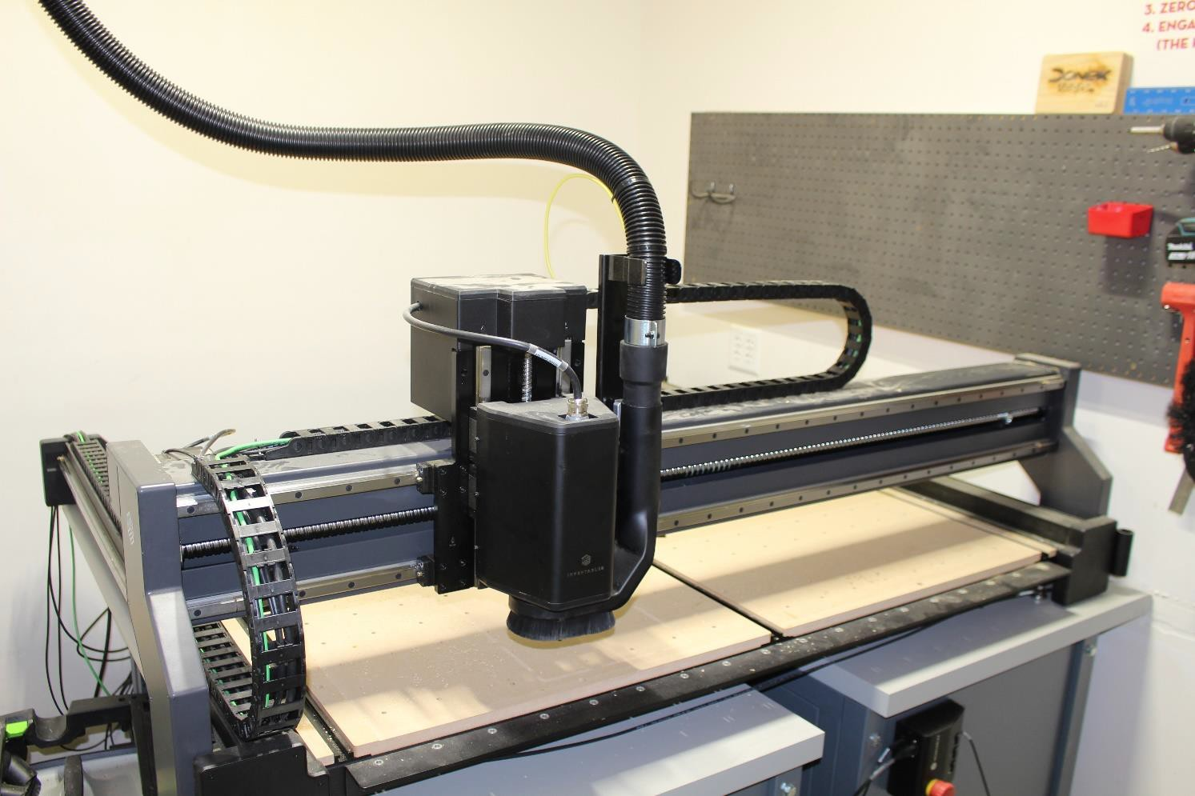
Training is required before using this equipment Eye Protection Required

MATERIAL LIMITATIONS

ALLOWED MATERIALS
- Plywood
- Hardwoods
- Softwoods
- MDF
- HDPE
- Delrin
- Polycarbonate
- Acrylic
- Corian
METALS ARE STRICTLY PROHIBITED FROM BEING CUT ON THE XCARVE PRO

SIZE LIMITATIONS
- Your material must be 48” x 48” or smaller

CALIPERING MATERIAL
- Grab calipers from the peg board.
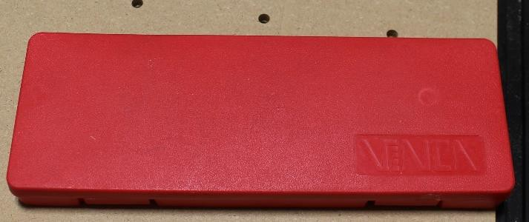
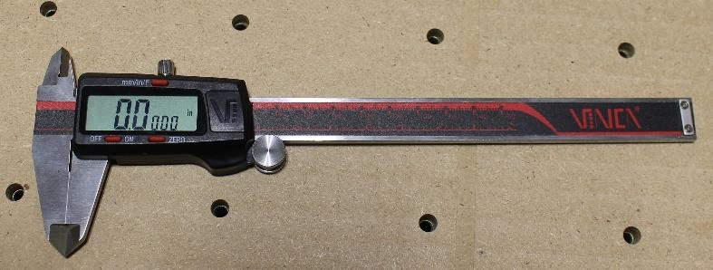
- Open the box and turn the calipers on.
- Open the calipers and slide jaws over your material.
- Close the jaws and read the measurement.
  - This EXACT measurement will be used in Easel.

SECURING MATERIAL
YOU MUST USE AT LEAST THREE CLAMPS TO SECURE YOUR MATERIAL
- Place material onto XCarve Pro.
- Open the second drawer of the cabinet.
- Grab the metal clamps from the drawer.

- Place the bolt onto the rail system of the XCarve Pro

- Slide the clamp over to your material.
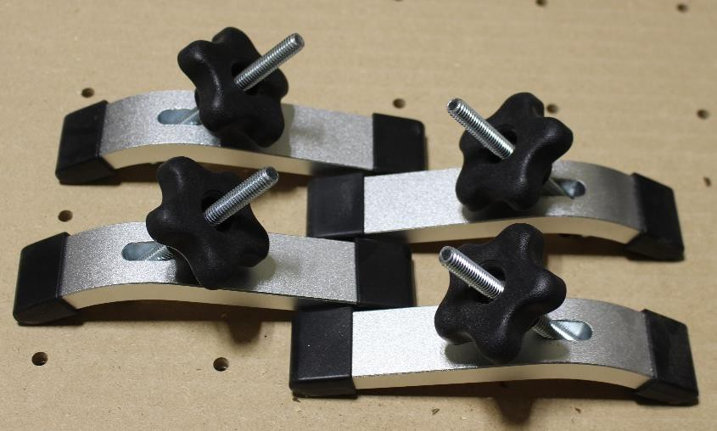

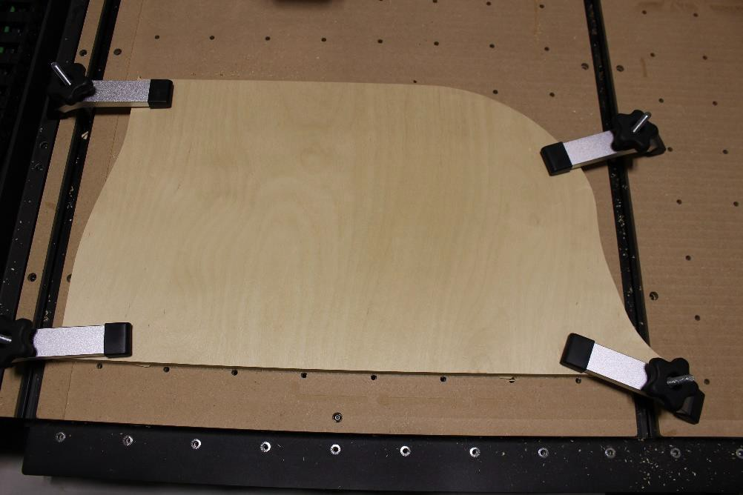
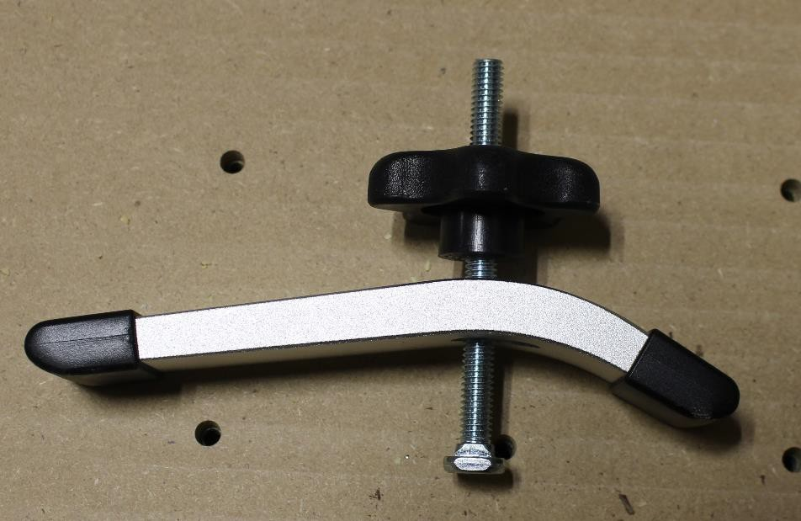
- Place the longer end of the clamp over your material.
Long end
Tightening Nut
- Tighten the nut to secure the clamp to your material.

- Repeat these steps for all clamps being used.

ENSURE THE BIT WILL NOT MAKE CONTACT WITH THE METAL CLAMPS WHILE CUTTING

TURNING MACHINE ON
- Ensure the control panel cable is connected to the computer.
- Twist the Emergency Stop on the control panel to power on.
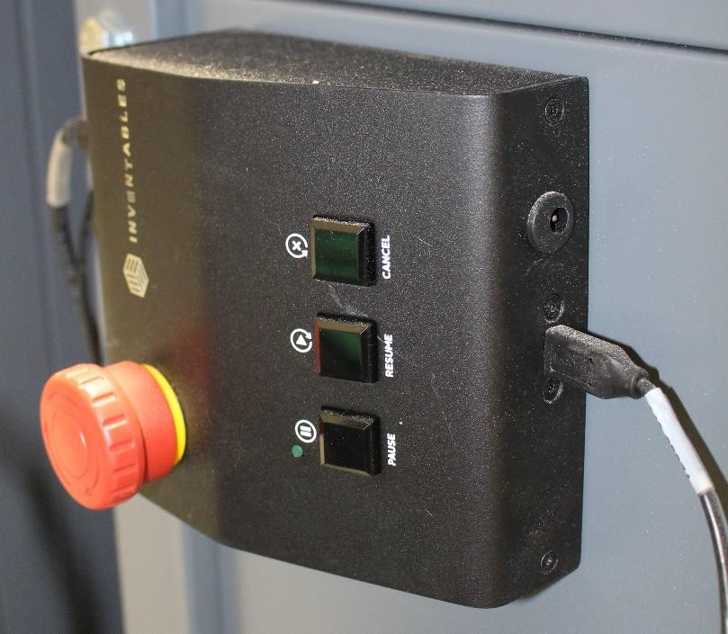
Emergency Stop
Control Cable

OPENING YOUR EASLE FILE
- Open Google Chrome.
- Type in https://easel.inventables.com/users/sign_in
  - Username: Innovationstudio@unl.edu
  - Password: 2021Transformation
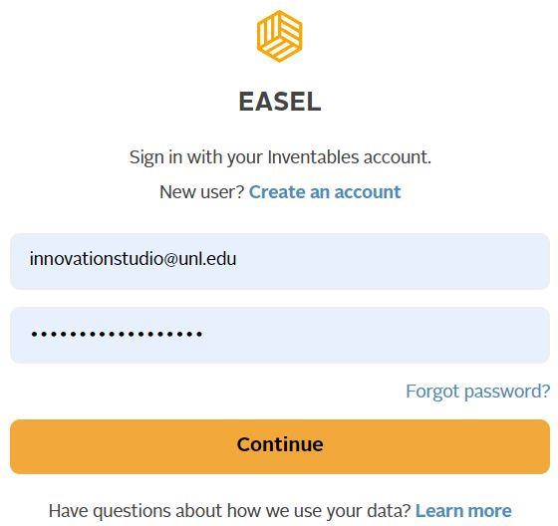

- Locate your Easel file.
  - All files are saved to the cloud on the studio account.
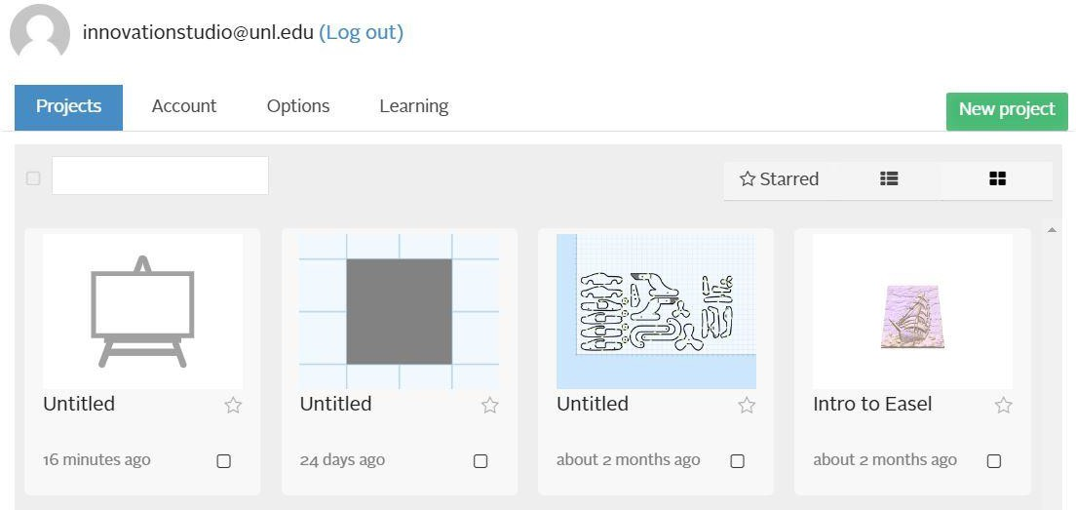

INSTALLING BIT

NIS DOES NOT PROVIDE BITS
- Open the second drawer of the cabinet.
- Grab the two wrenches from the drawer.
  - 17mm and 22mm
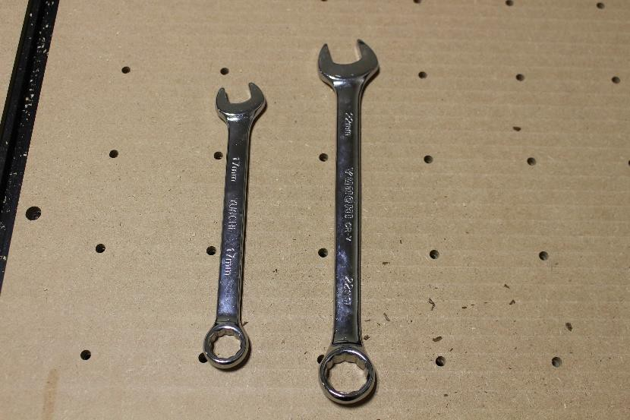
17mm
22mm

- Locate the red bucket on the peg board and grab the correct collet size for your router bit.
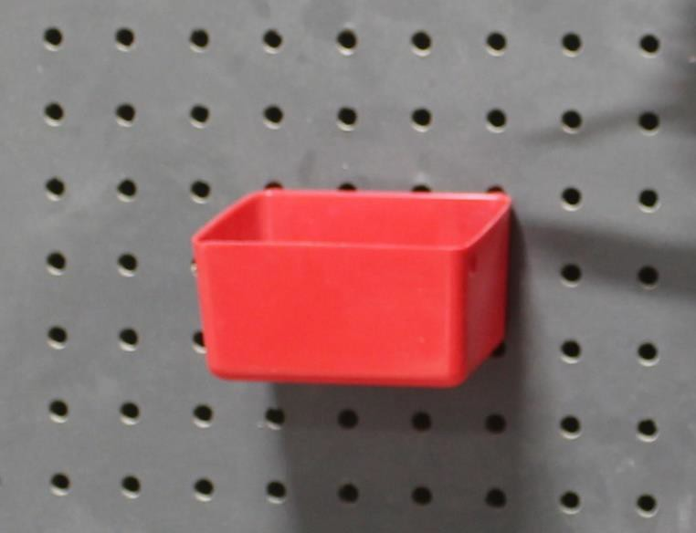

- Insert the collet into the spindle.
- Place your bit into the collet and hand tighten.
  - Ensure bit is placed in correctly.

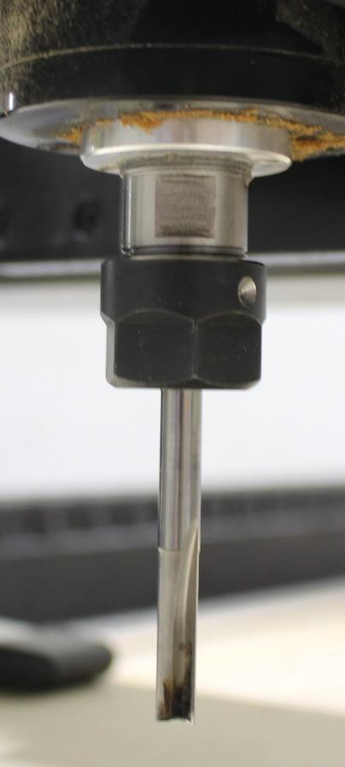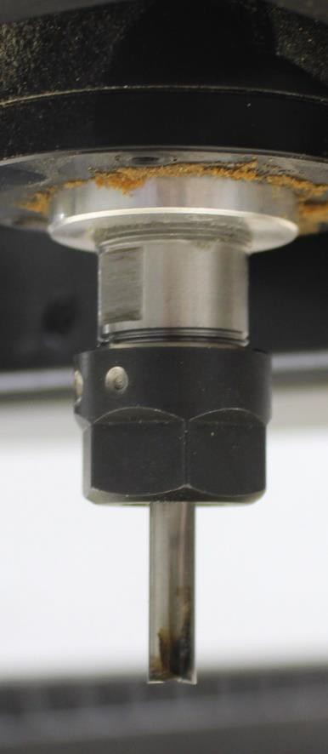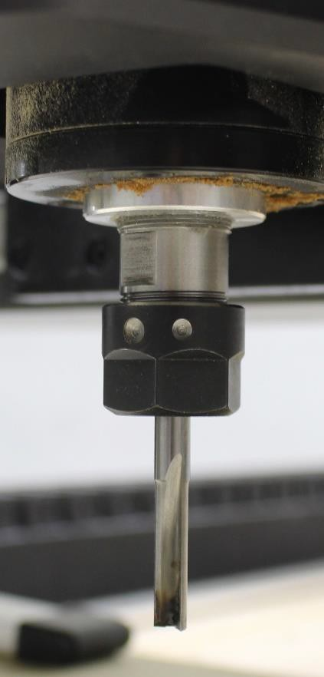
Bit too far out
Bit too far in
Bit Correct

- Place the 17 mm wrench on the top of the spindle.
- Place the 22 mm wrench on the bottom of the spindle.
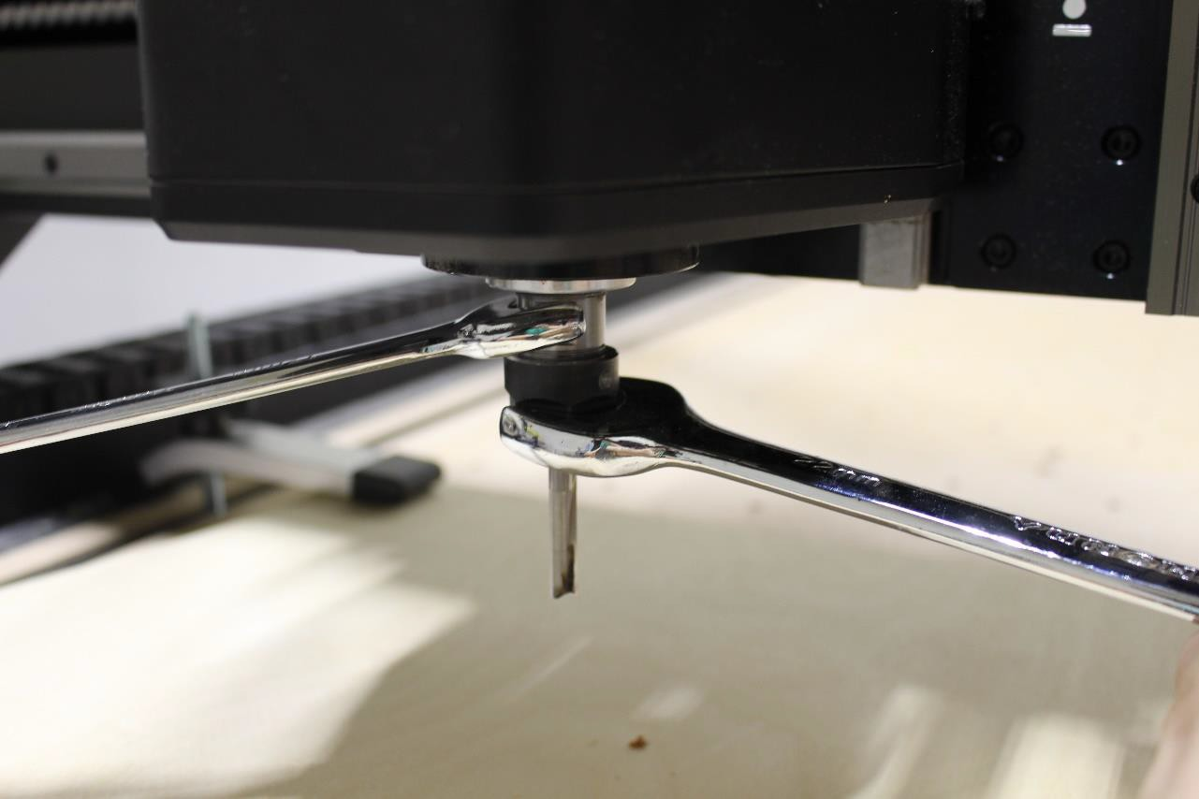

- Push both wrenches away from yourself to tighten.
  - The bit must be very tight!
- Return both wrenches to the second drawer.

MACHINE SET UP
- Ensure your design is finished and is ready to cut
BEFORE starting your reservation for the XCarve.
- Click on the ‘Carve’ icon in the top right corner.

- Click on the ‘Home Machine’ icon.
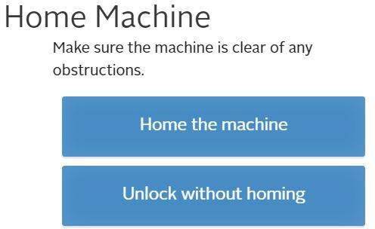
- Ensure that your material thickness on Easel matches your calipered material thickness EXACTLY.
- Select the closest material type to what you are cutting.
- Click Confirm Material Thickness
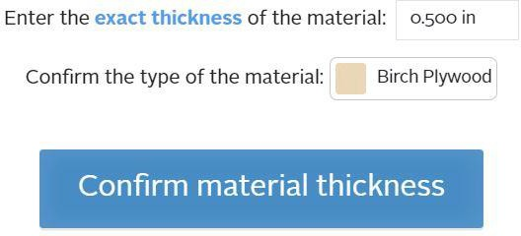

- Ensure material is properly secured and click the
‘Material is Secure’ icon.

- Ensure the router bit is properly installed and selected.
  - If your bit is not listed select the closest one, you will have to change the feed rate and spindle speed later.
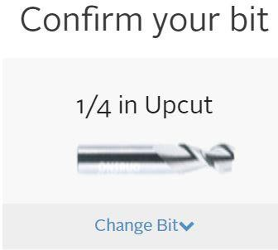
- Click the ‘Confirm Bit Size’ icon.


SETTING Z-AXIS ZERO
- Click the ‘Probe’ icon.
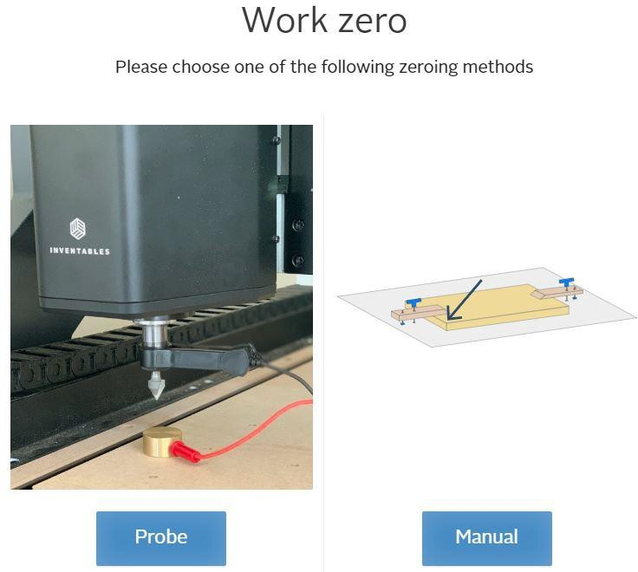
- Jog the machine using the arrow keys on the browser window.
  - Ensure bit is fully over your material.
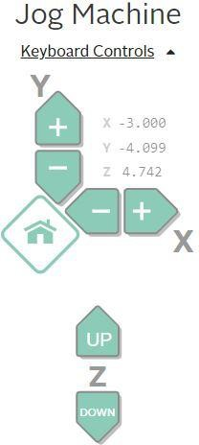

- Click the ‘Confirm Position’ icon.

- Open the second drawer of the cabinet.
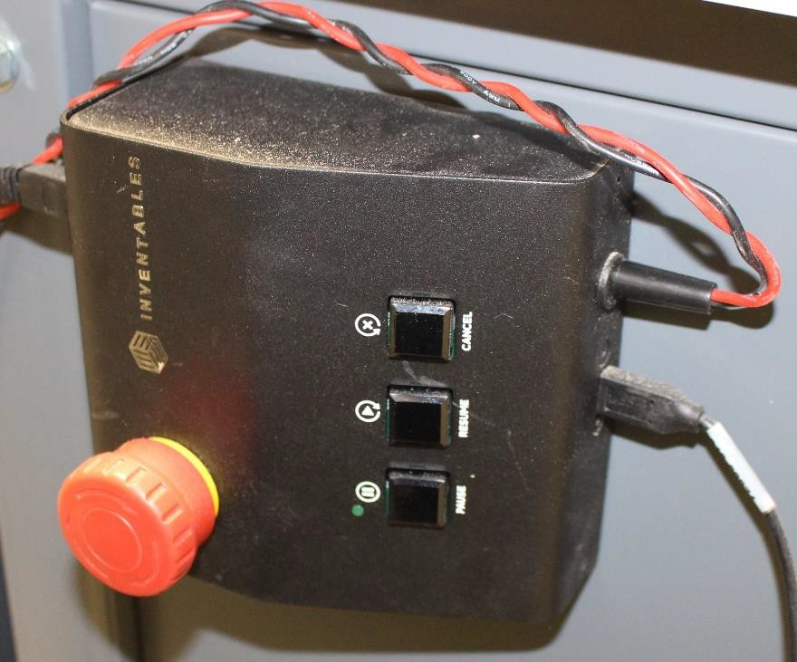
- Grab the Z-Axis Zero Plate.
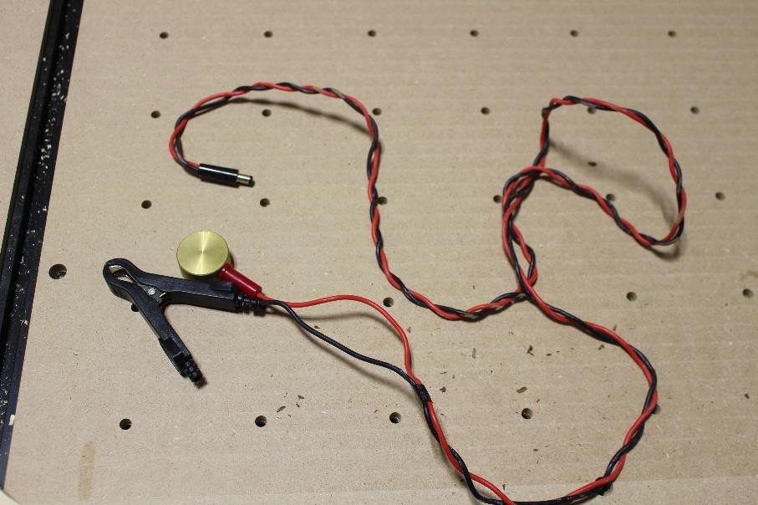
- Plug the lead into the control box.

- Clip the alligator clip onto the spindle and click the ‘Clip is Attached’ icon.
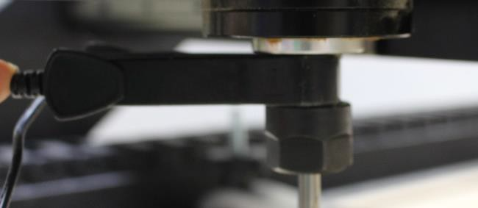
- Place the metal touch plate under your bit.
- Touch the plate to your bit.
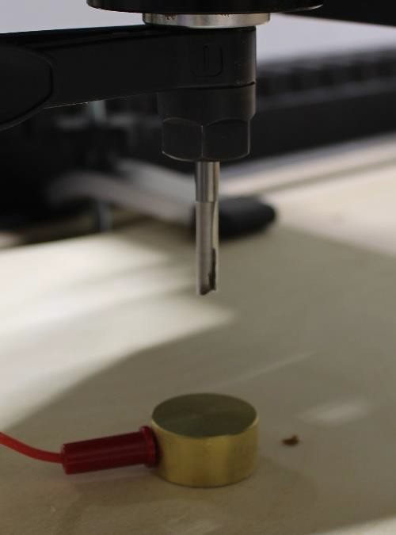
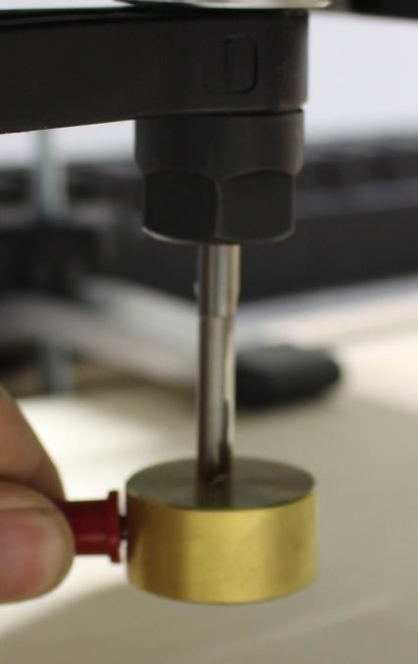

- Place the metal touch plate under your bit and click the
‘Touch Plate is in Place’ icon.


- Click the ‘Start Probing’ icon.
- After your Z-Axis is calibrated remove the alligator clip from the spindle and the plug from the control box.
- Click the ‘Z-Probe is Put Away’ icon when everything is
disconnected and placed back into the second drawer.
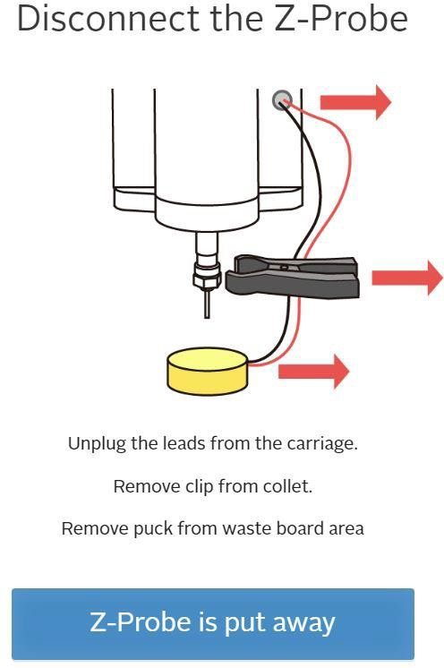

SETTING X-Y AXIS ZEROS
- Jog the machine using the arrow icons on the right panel.
- Jog the machine to the bottom left corner of the machine.
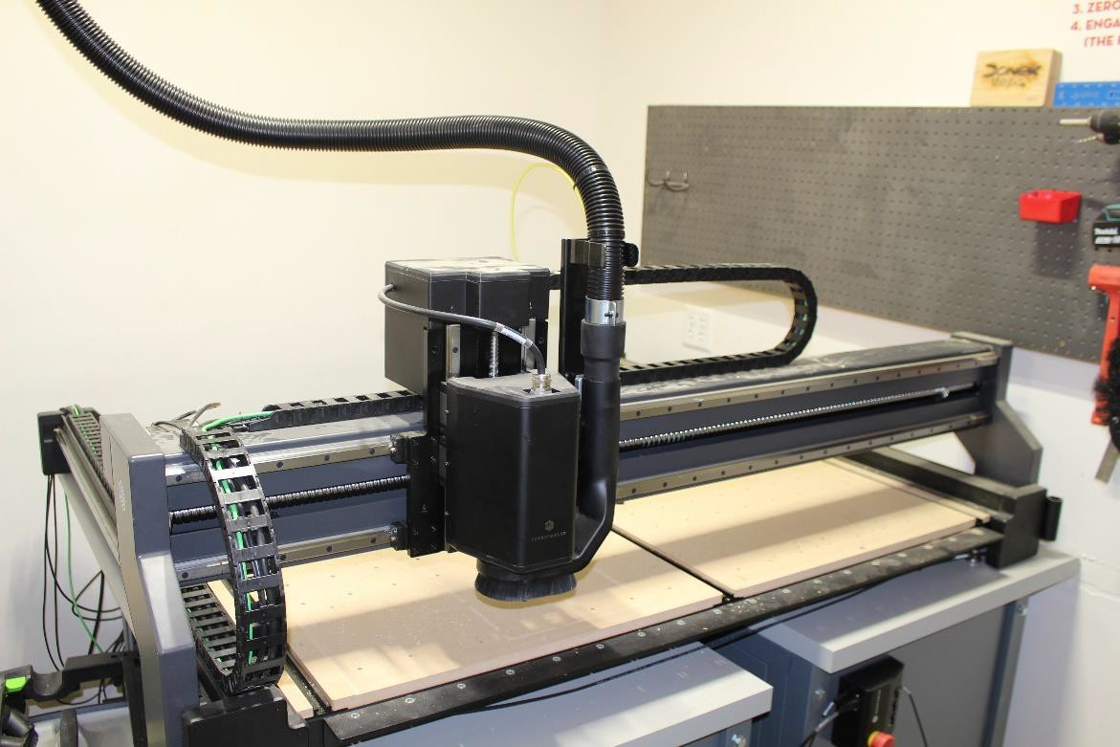
- Click the ‘Set XY Zero’ icon.

INSTALLING DUST BOOT
- Click the 'Raise to Attach Dust Boot’ icon.


- Open the second drawer of the cabinet.
- Locate and grab the dust boot.
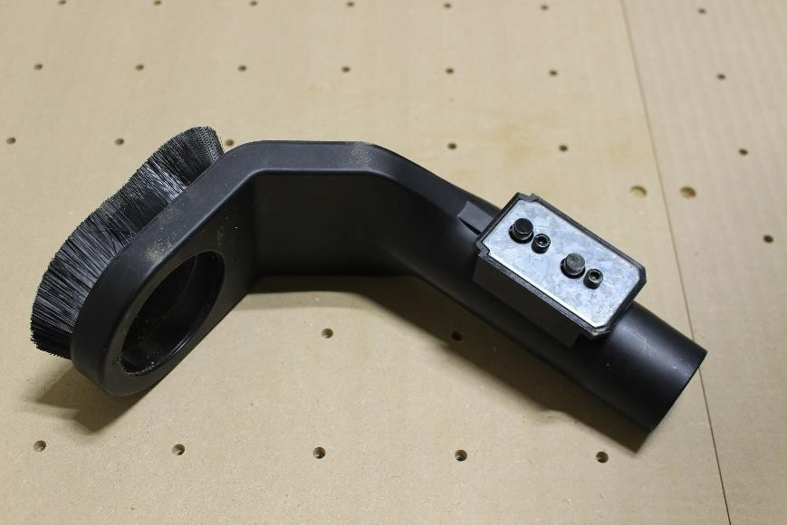

- Ensure Silver lever is in the full up position.
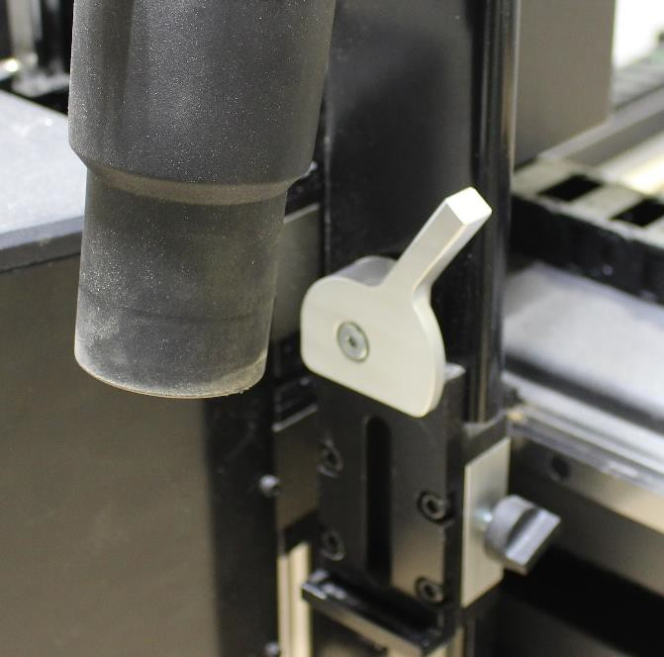

- Slide the dust boot under your bit.
- Place the dust boot shaft into the slot below the silver lever.
- Push the silver lever into the full down position to lock the dust boot in place.
- Loosen the nut on the right side of the dust boot to change the height of the dust boot.
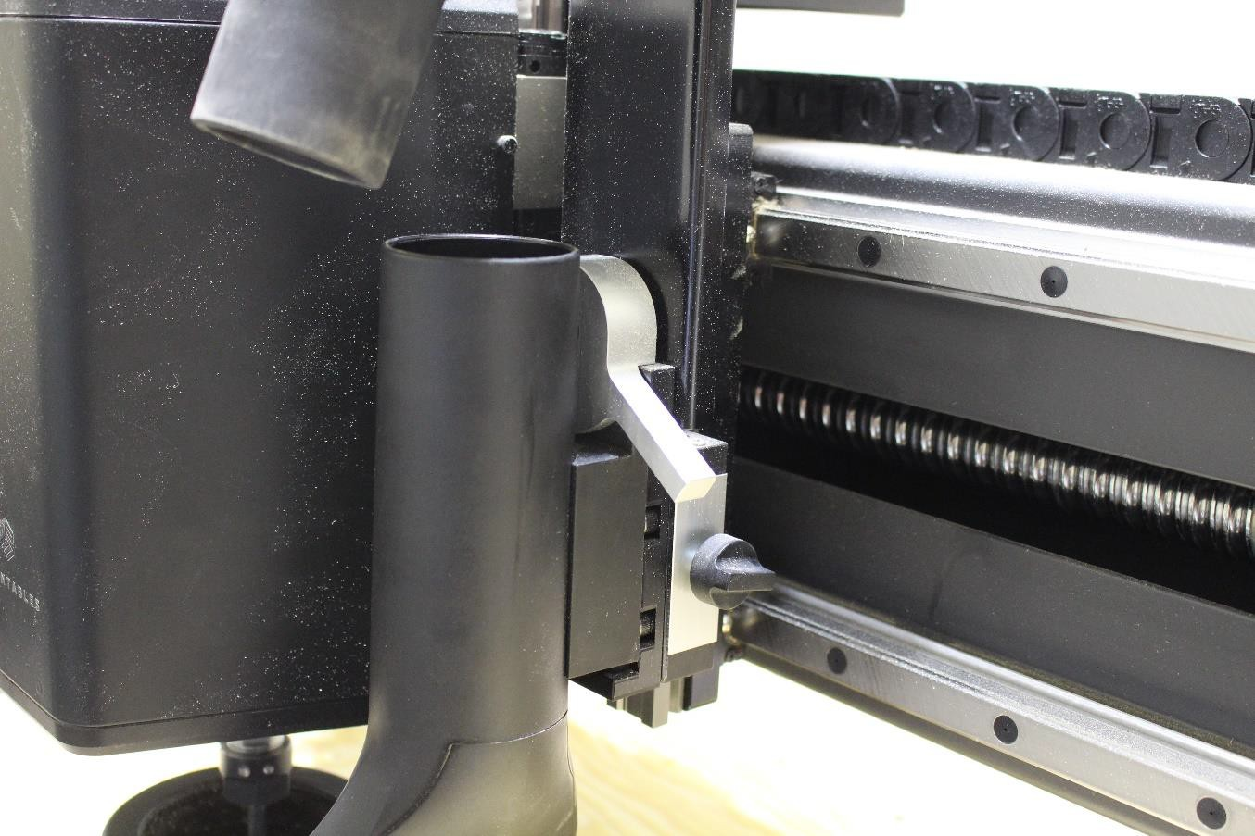
Adjustment Nut
Silver Lever

- Lower the dust boot until the bristles are making contact with your material.
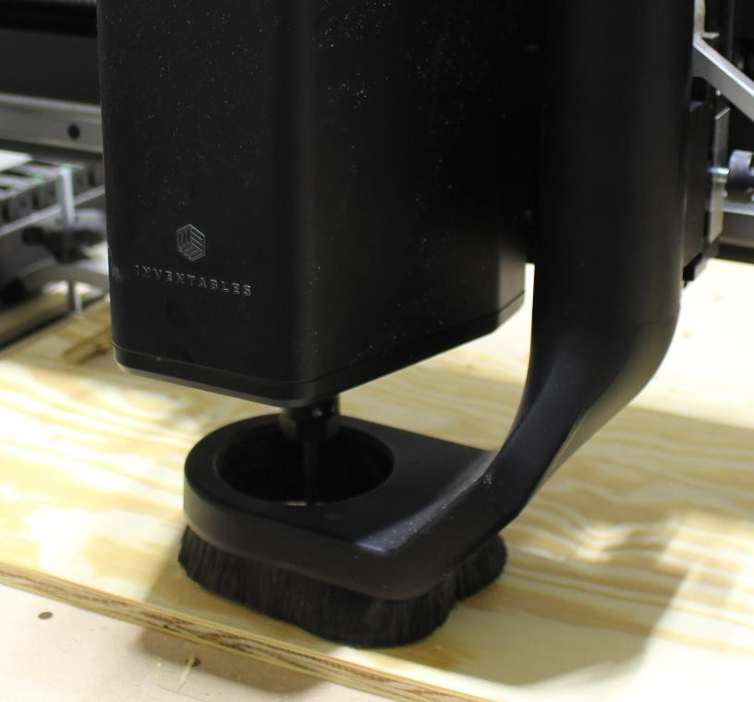

- Attach dust collection tube to the dust boot.
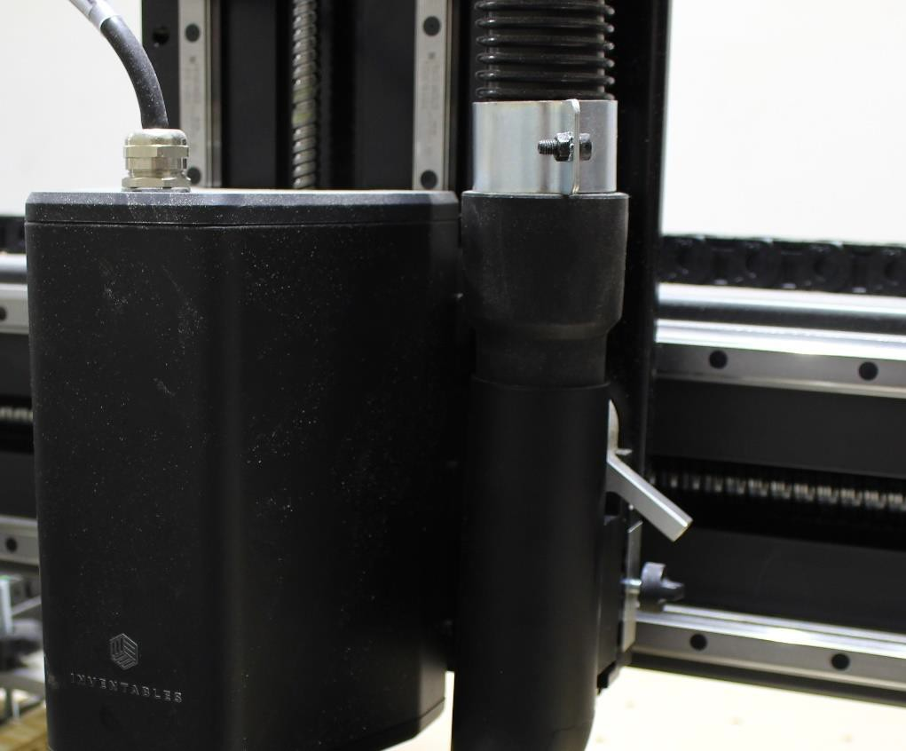

START CUTTING
- Click the ‘Turn on the Spindle’ icon to start the spindle.
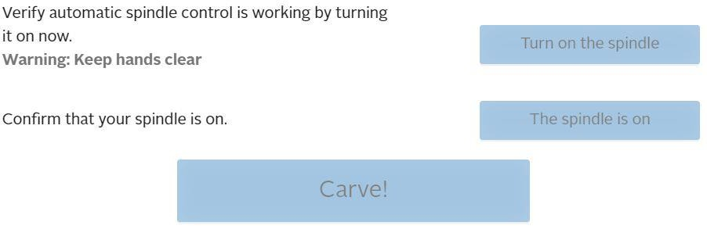
- Ensure Spindle is on and spinning properly.
- Click the ‘The Spindle is On’ icon.
- Click the ‘CARVE!’ icon when you are ready to start
cutting.
YOU MUST BE IN THE CNC ROOM WATCHING THE XCARVE AT ALL TIMES WHILE IT IS RUNNING

UNINSTALLING DUST BOOT
- Disconnect the dust collection tube from the dust boot.
- Raise the silver lever to the full up position.
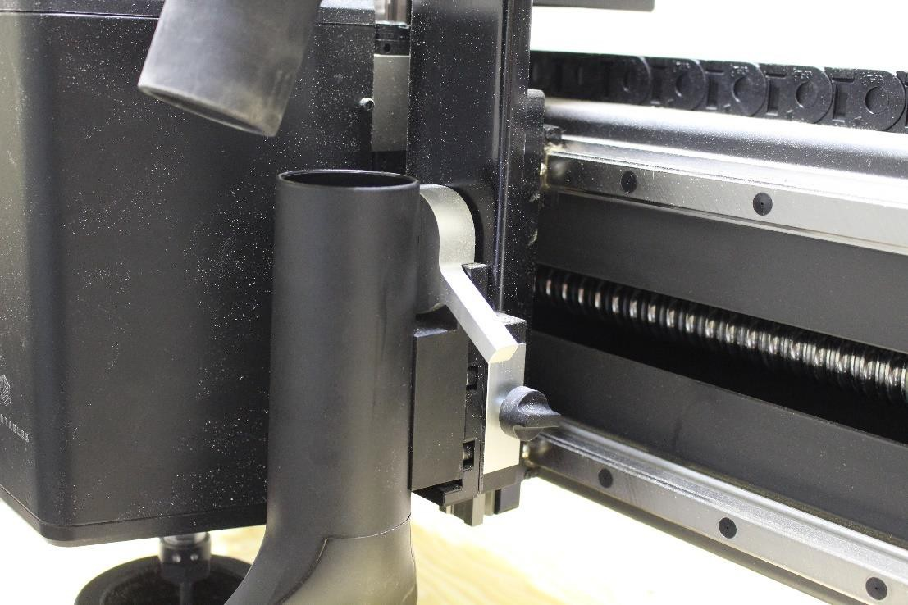
- Pull the dust boot out of the locking slot.
- Slide the dust boot under the bit.
- Place the dust boot back into the second drawer of the cabinet.

UNINSTALLING BIT
- Open the second drawer of the cabinet.
- Grab the two wrenches from the drawer.
  - 17mm and 22mm
17mm
22mm

- Place the 17 mm wrench on the top of the spindle.
- Place the 22 mm wrench on the bottom of the spindle.

- Pull both wrenches toward yourself to pop loose.
- Continue to loosen by hand until reaching another tight spot.
- Use wrenches again to pop the bit loose fully.
- Remove your bit and the collet completely from the spindle.
- Return both wrenches to the second drawer.
- Return the collet to the red bucket on the peg board.

STATION CLEANUP
- Remove all clamps from your material.
- Return all clamps to the second drawer of the cabinet.
- Press the red Emergency Stop button on the control panel to turn the XCarve Pro off.

