SOP

VINYL CUTTER

Training is required before using this equipment
Reservations are required when using this equipment

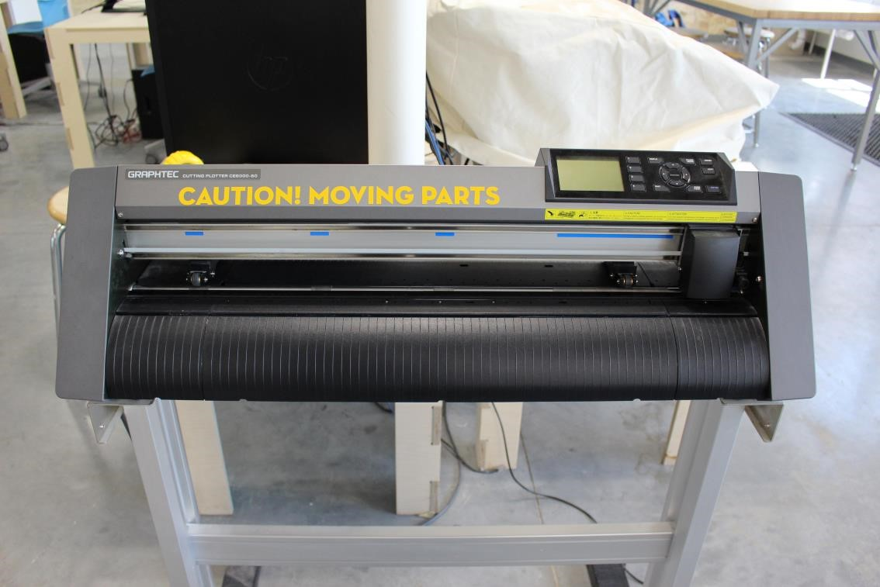

Diagrams of the Vinyl Cutter:

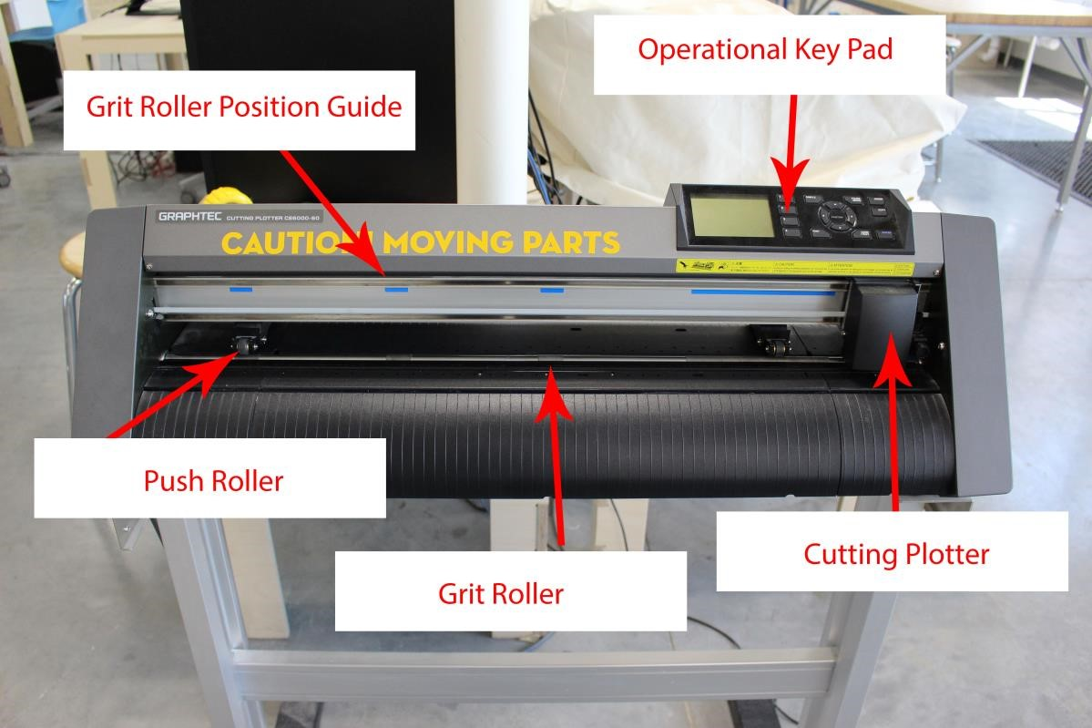

Close up Diagram of Cutting Plotter:
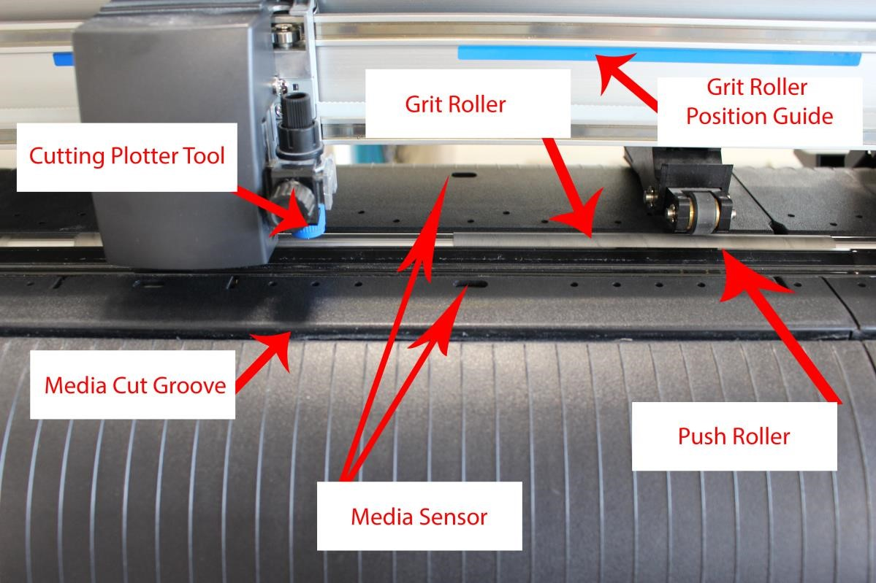

Diagram of Back of Vinyl Cutter:

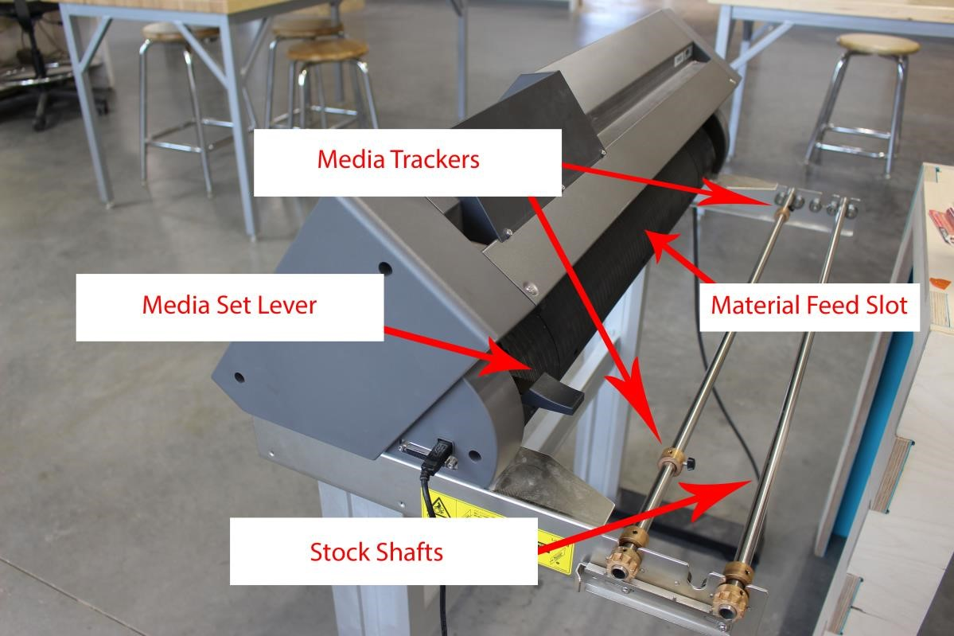

CAUTION MOVING PARTS!!!
DO NOT PLACE YOUR HANDS IN
FRONT OF THE CUTTER!!

Setting up the Vinyl Cutter:

Step 1: Uncover your machine, and power on the Cutting Plotter. Standing in front of the machine, the On/Off switch is located on the left side of the cutting plotter. Turn on the machine.

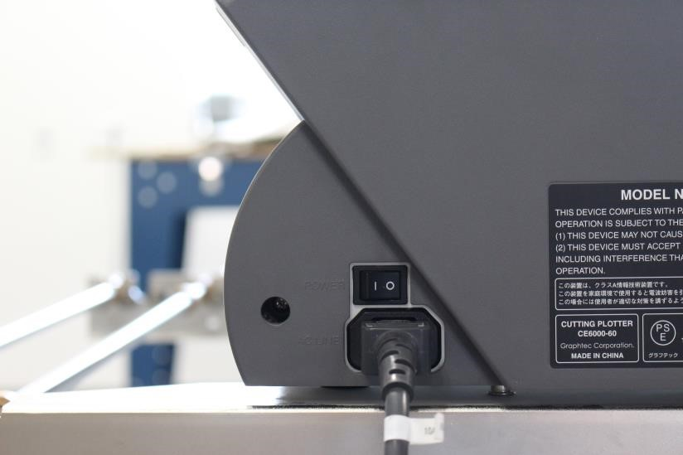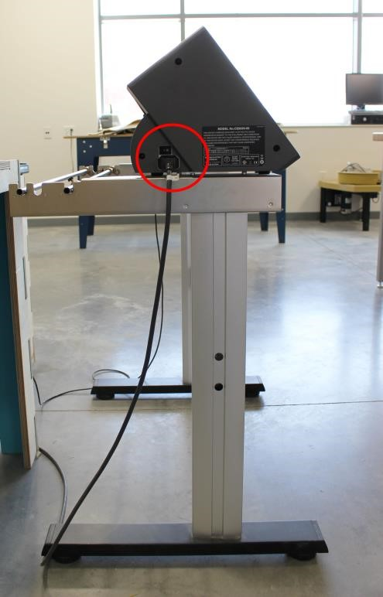

Step 2: Lower the media lever behind the operational keypad. This will release the pusher rollers for you to insert your media.

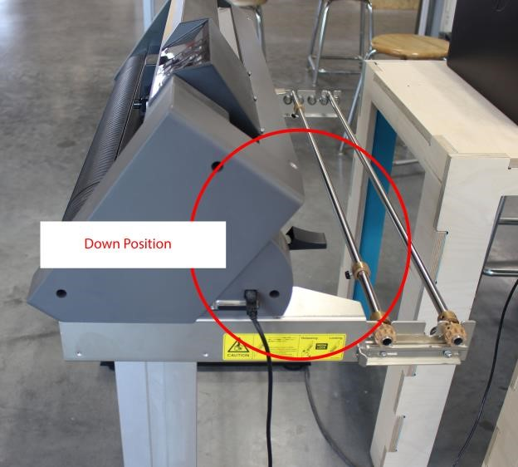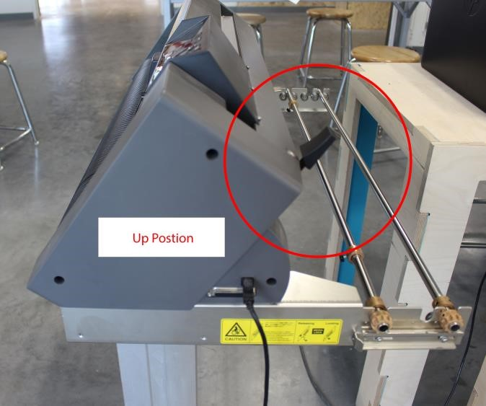

Step 3: Loading Your Media

- Place your roll on the stock shafts.

- Push the tip of the roll media forward from the back of the machine.

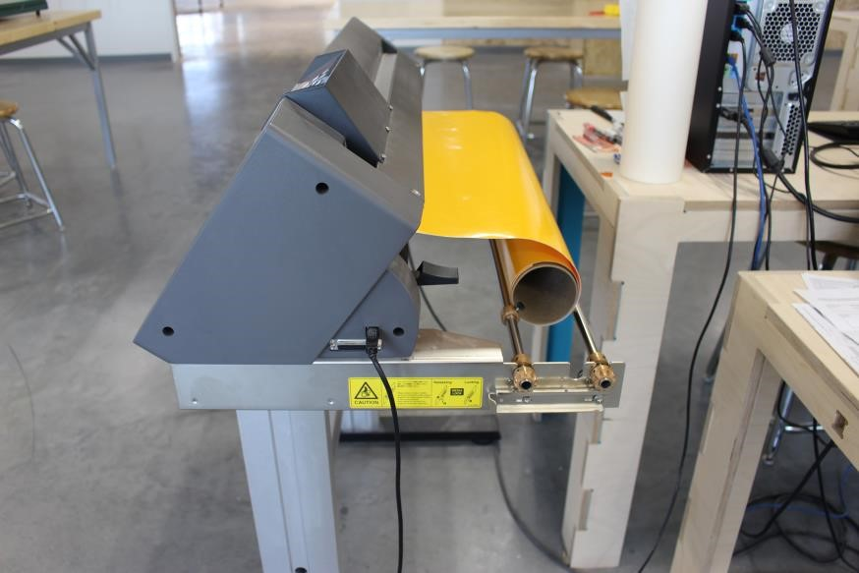

Step 4: Adjusting the Push Rollers

- The push rollers must be over top of the grit rollers. You cannot see the grit rollers once your media is fed through the back of the machine. Use the grit roller position guides (blue markers) to make sure the push rollers are positioned correctly.

- To adjust the push rollers, the media lever must be in the down position. Place your thumb and index finger on either side of the push roller and it will slide back and forth.

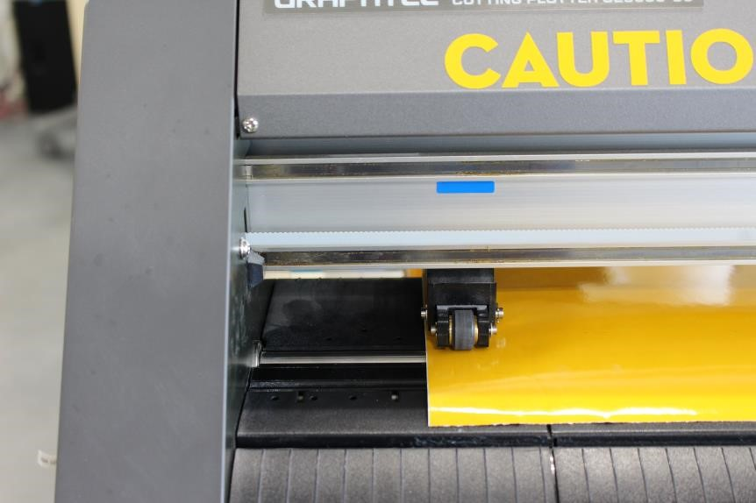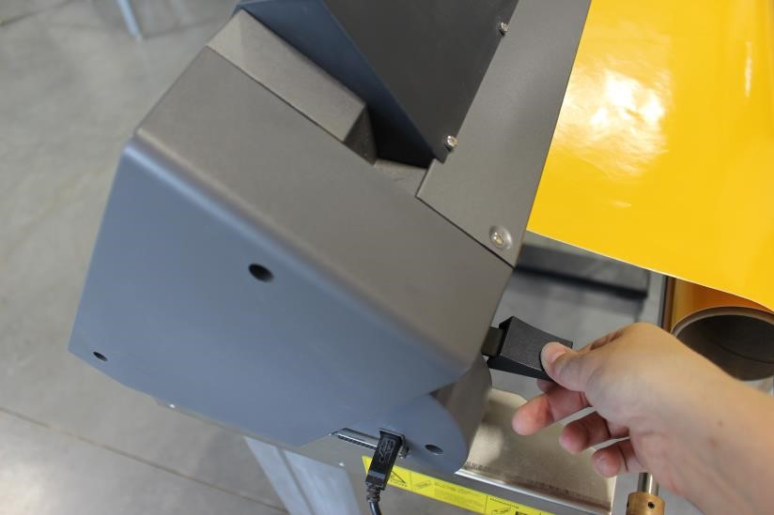

- Place the Push Rollers as far to the left and right of your material as possible still keeping the push rollers over top of the grit rollers.

- Your media must also be covering both media sensors. This is essential when loading rolls smaller than 24” wide and sheet material. For smaller media, you would move the far left push roller over top of a middle grit roller. Then adjust the right push roller on the longer grit roller so your media is covering the media sensor.

NOTE: The cutting plotter can only cut out your design between the push rollers. You will lose about 1” on either side of cutting space of your roll for the push rollers to be placed correctly. Design for about a 22” section of vinyl to be safe!

Step 5: Locking the Placement of your Media

- Now that your push rollers are in place, pull the media forward to the media cut groove.

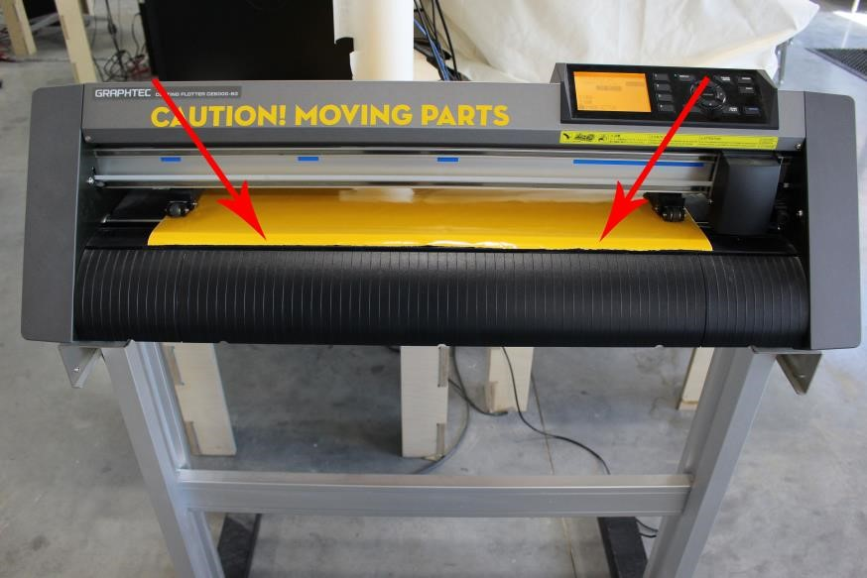
- Next, raise the media lever to lower the push rollers. This will lock your media in place.

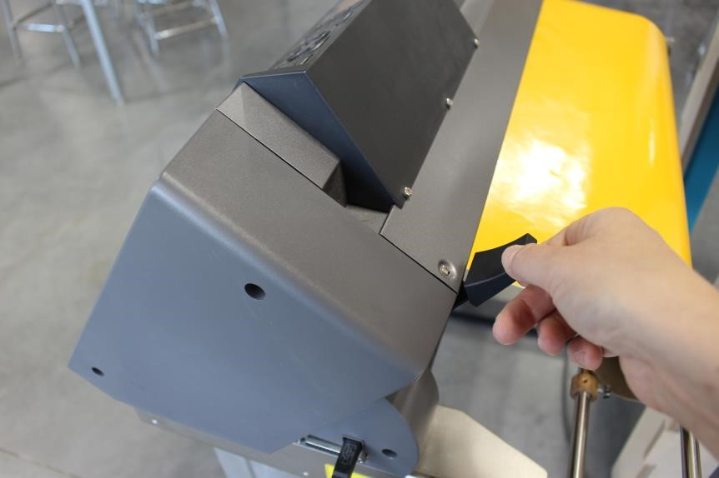
- After your media is locked in place, you will want to set the media trackers on the stock shafts. Unscrew the knob of the media tracker and adjust the both the left and right media tracker so they are pressing against your roll media. Then tighten the knobs. This will keep the media from traveling as it feeds through the slot.

- Next give your vinyl some SLACK!

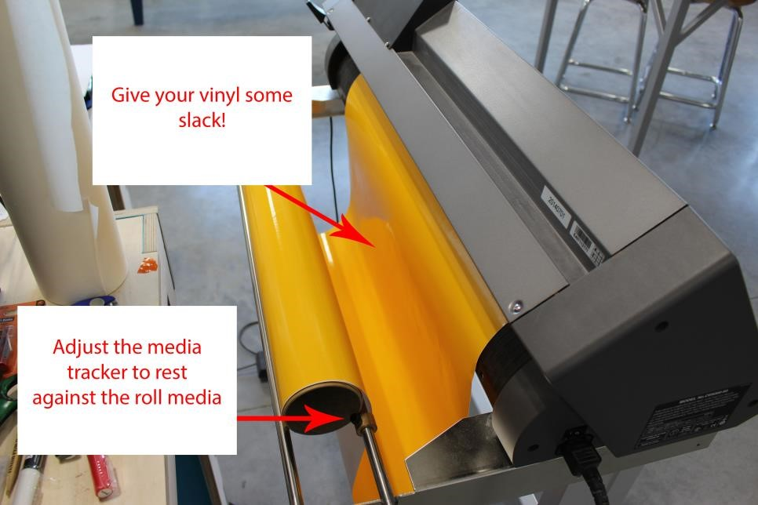

Step 6: Defining the Edge of your Media.

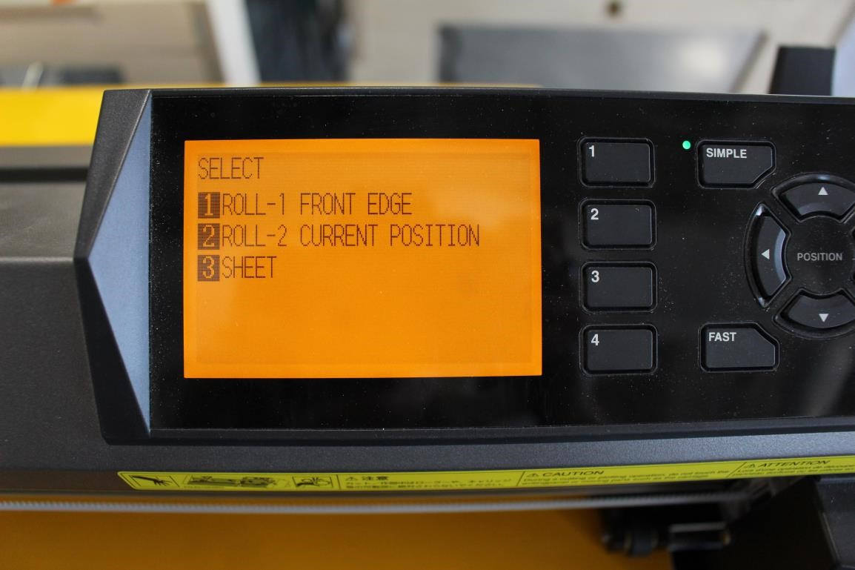
Once the media lever is raised, the vinyl cutter will give you three choices:

- Roll 1 – Front edge – highly recommend for less vinyl used

- Roll 2 – Current position – if you have tears or previous used sections before the area you want to start cutting on.

- Sheet – We work in rolls never press “sheet” unless you have brought in your own.

Press 1 for front edge.

CAUTION FOR MOVING PARTS AND BLADES

Now your machine is ready to cut!

Creating Your Design: In Adobe Illustrator

Step 1: Open Adobe Illustrator and design your file. Keep in mind we do have multiple colors of vinyl and you can layer flat patterns to create a multiple color vinyl decal.

• When designing your file keep your design within the Vinyl Cutter’s limit. The Roll sizes for the Cutter are:

** NOTE ROLL WIDTH IS 24”, about an inch on either side will be waste. Set up your design file to be 22” wide**

Step 2: Define your artboard
If you did not define your art board (white background of document) before you created your design follow the below steps:

- Go to <Document Set-up> in the <Tool Bar>

- Click on <Edit ArtBaords>
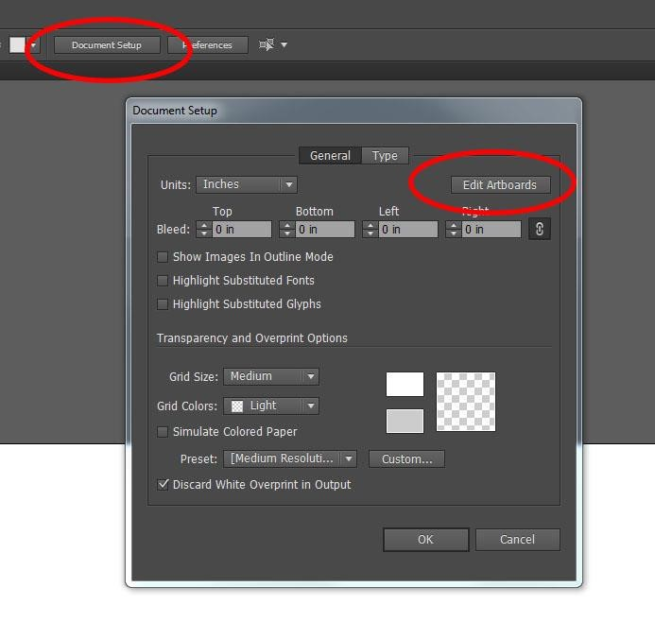
- In the <Tool Bar> Change the <W: to be 22> and the

<H: to be the height of your design>

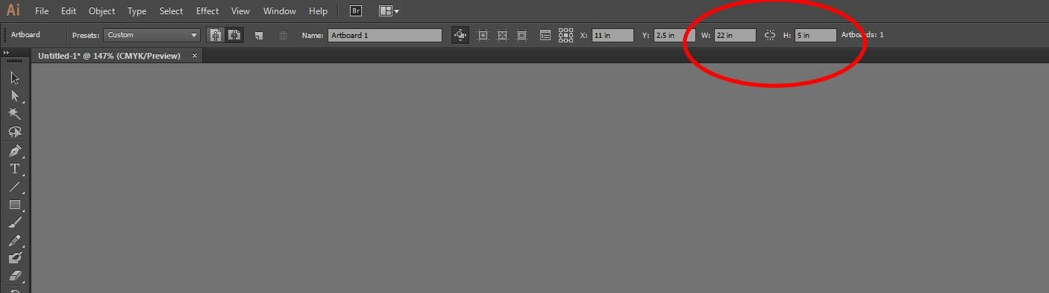

- Reposition your design to fit within the parameters of the new art board. Modify artboard (White background) or design to fit within the art board’s parameters

Step 3. When designing your objects to be cut, you want to place them on the bottom of the page. The cutter will always start at the bottom of the job and cut up through the document.

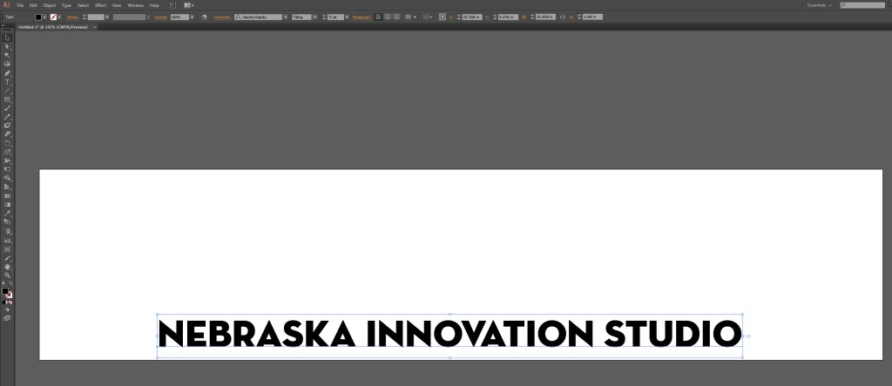

Step 4. Send your file to Cutting Master 4
**Cutting Master 4 is an Adobe plug-in**
- Go to <File> in the <Menu Bar>
- Hover over <Cutting Master 4>
- Click on <Send to Cutting Master 4/Cut Plot>

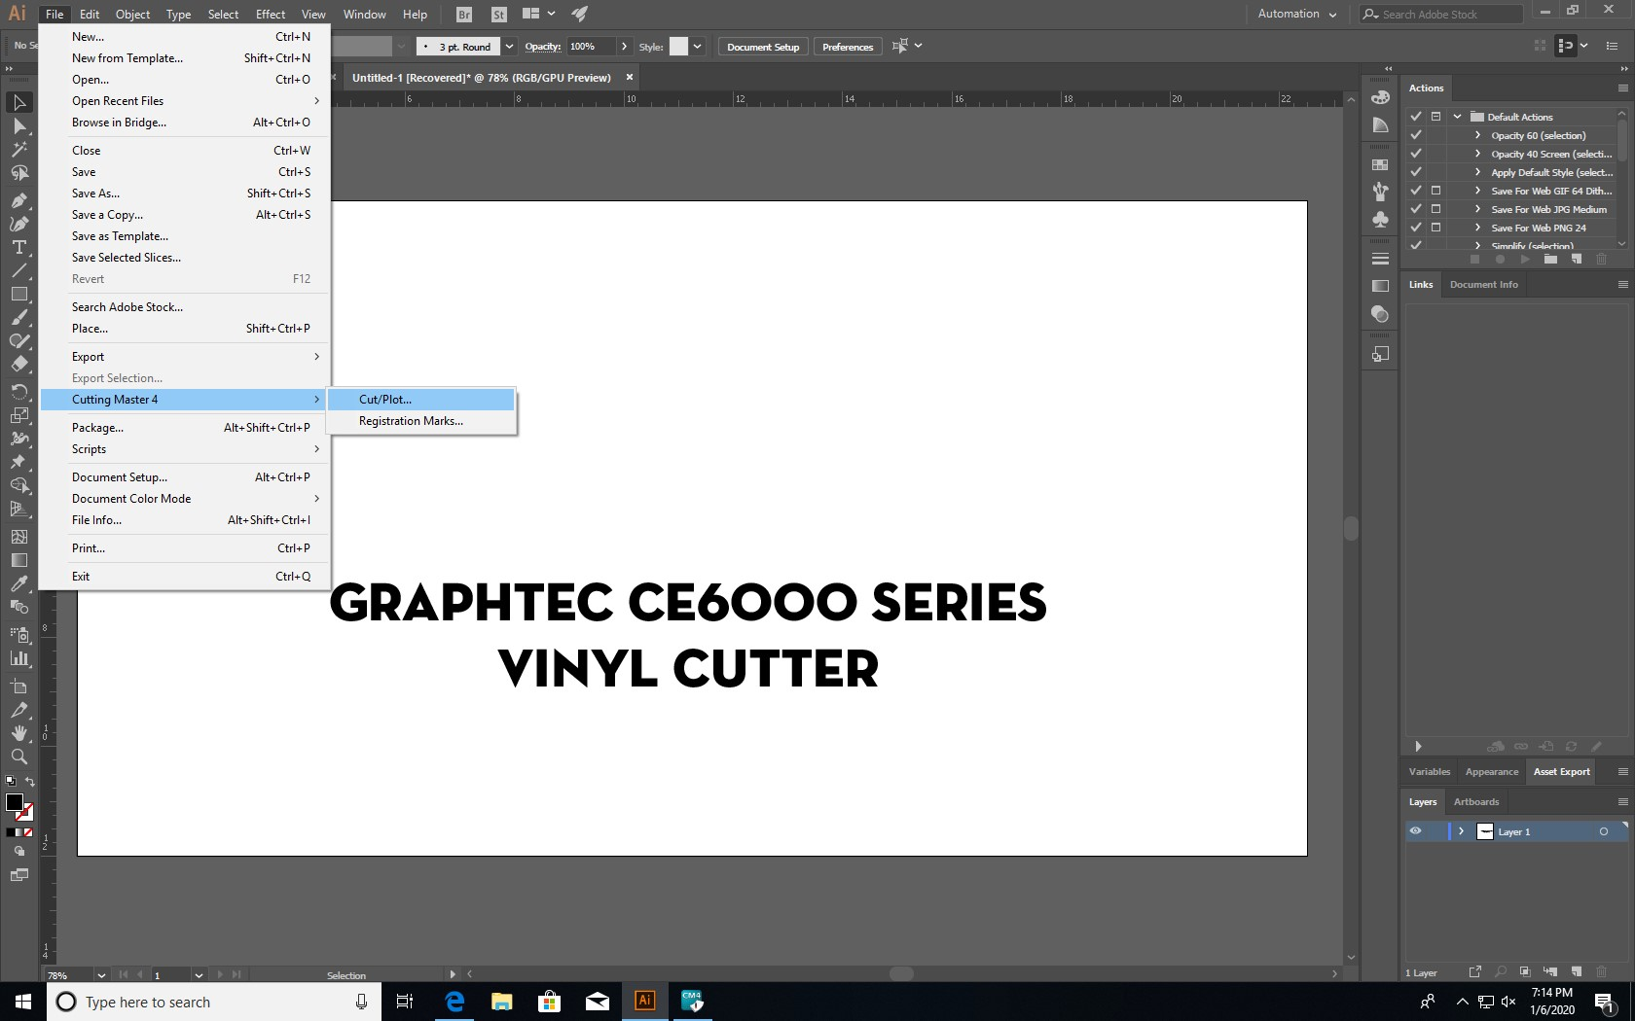

The first time you use Cutting Master you will be asked to set up a Sai Cloud account. Go ahead and set up an account.

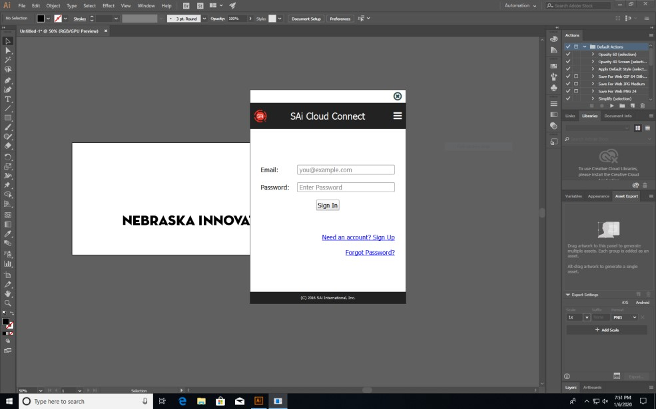

Step 5: Cutting Master 4

• Your screen will be divided into 2 sections.
- The large screen is the preview of the vinyl roll on the right.
- The smaller is the driver controls on the left.
- You may also see a window showing Cutting Master 4 jobs. Do not X out of this. Simply click on the window behind that contains your art board.

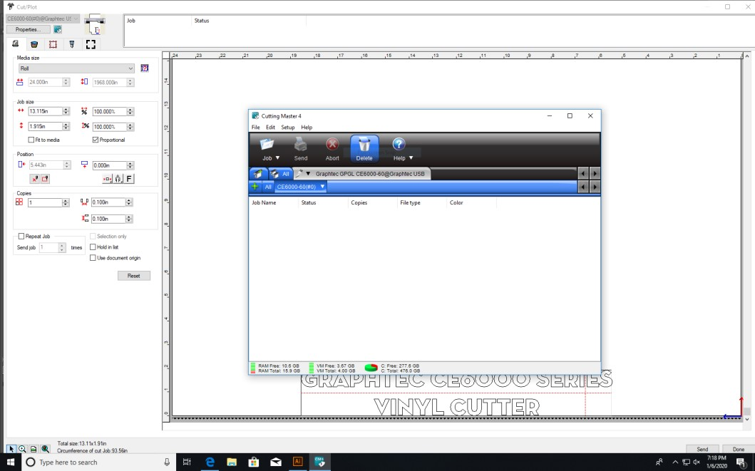

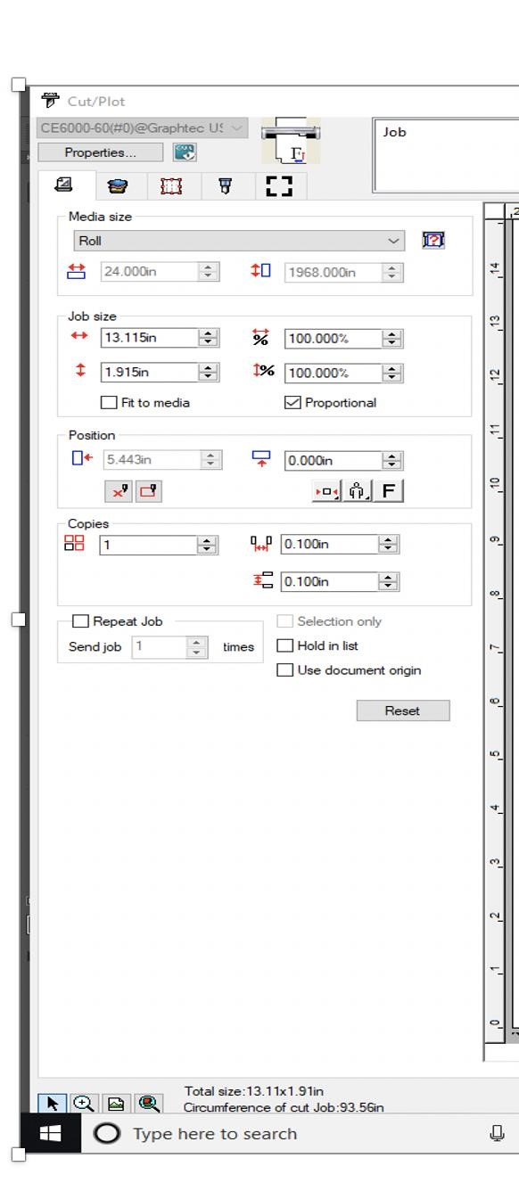

On the
main page of Cutter
Master 4 you will be able to
make
basic changes to your
image.

You can change the size of the
project
, either by changing the
dimensions or by altering the
size by a specific per
centage.

You can also mirror your
project.

Reorient your
project

vertically
or horizontally (remember
you
pay for the linear inches)
.

Center or make other changes
in the
position
of
your
project
on the vinyl,

You can also make more copies of
your design. If you want to add
space between rows or columns,
you
can use these tools.

Step 6: Weed Settings

Weed lines are extra lines the vinyl cut makes in your design to make it easier to remove the vinyl you don’t want. Additional weed lines are typically helpful. You do not want additional weed lines if you plan to use your vinyl as a stencil.

To get to the weed setting click on this tab.
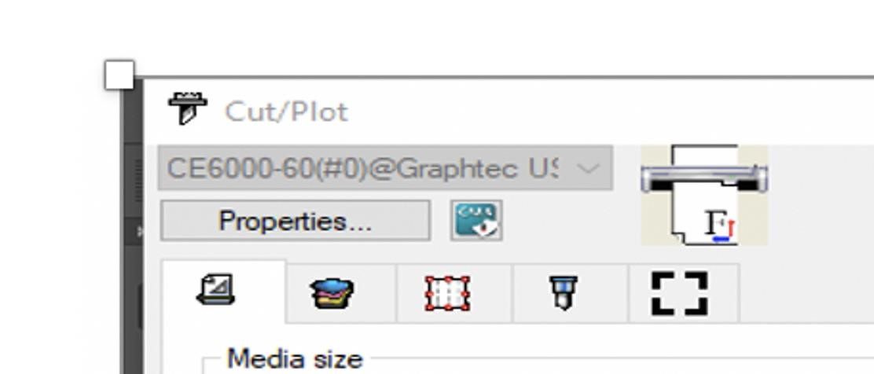

That will take you to a new page where you are able to add weed lines by checking the appropriate boxes.
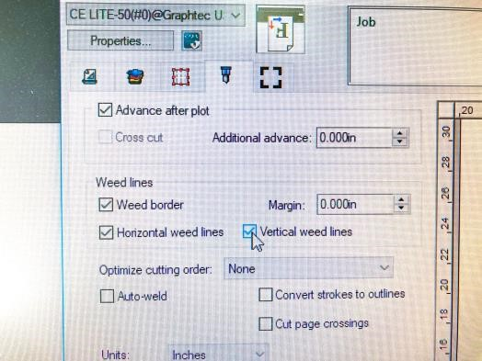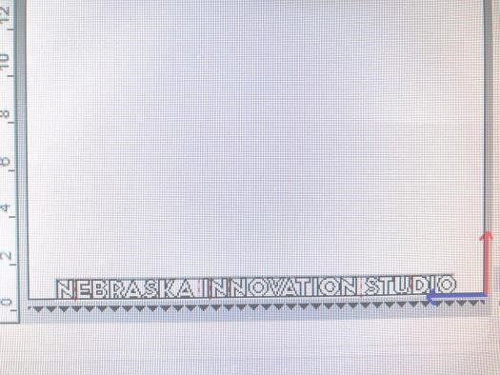

The additional cuts the vinyl cutter will make appear in red.

Step 7: Sending job to Cutter

In the lower righthand corner of the screen in Cutter Maser 4, you will see a SEND button. Simply click on the send button to send project to the vinyl cutter.

Step 8: Removing your vinyl from the machine

After the machine has stopped moving and has finished your cut job, you will need to release the back lever and manually advance your vinyl roll.

Advance the vinyl so your design is below the cutting groove in the machine. If you do not advance your vinyl far enough, you will cut off some of your design. Use a Exacto knife and cut into the groove cutting off your vinyl from the roll.

Step 9: Removing Excess Vinyl, Applying Transfer Paper

Peel away all excess vinyl that is not part of your design. Take your time. We have pointed dental tools and Exacto knives for the detailed work. Take your time!

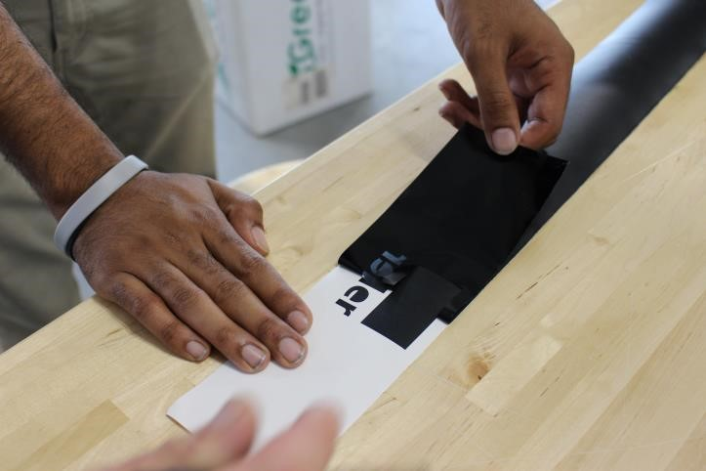

Roll out transfer paper sticky side up
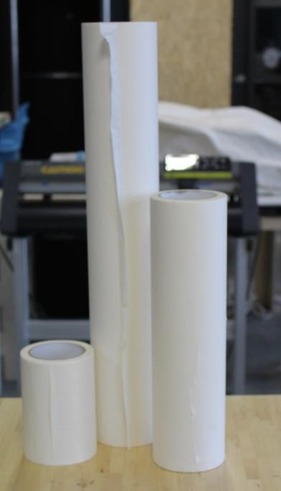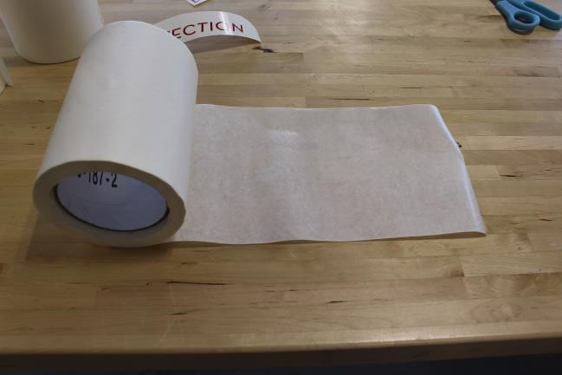
•

Place your design,
vinyl
side
down
,

onto the sticky side of the transfer
paper

- Use a plastic scraper and rub the back of the design o Start from the center and work your way out o This will reduce the bubbles in your design

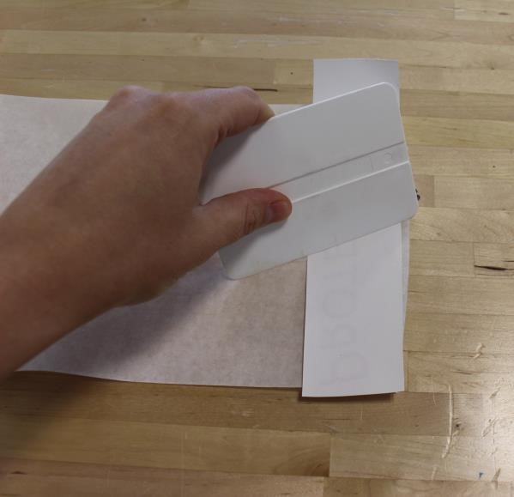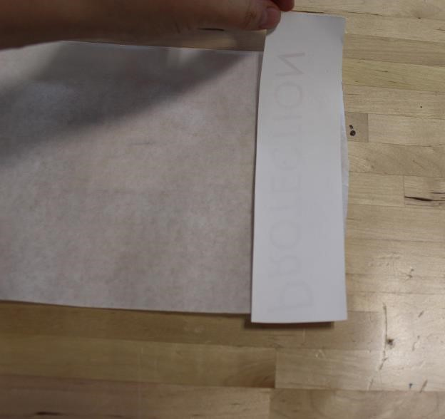

- Cut apart your design from the transfer paper

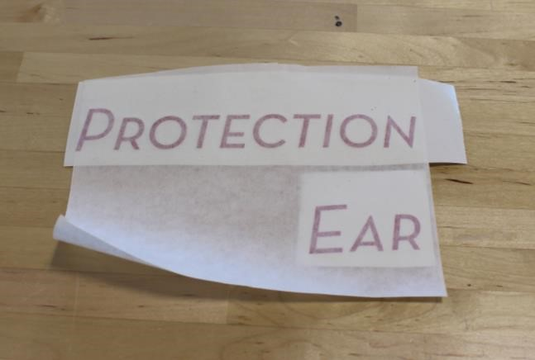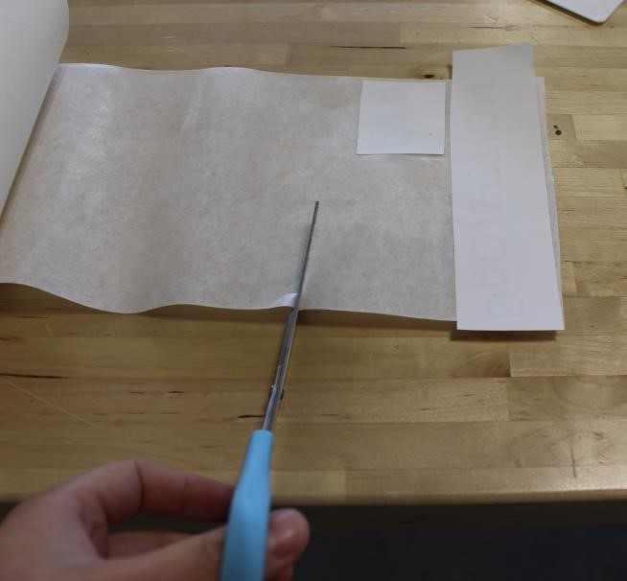

Step 10: Applying Design to Object

• Before you remove the transfer paper, rub over the design with the plastic scraper again to stick the design more firmly to the object

• Peel away the white backing paper

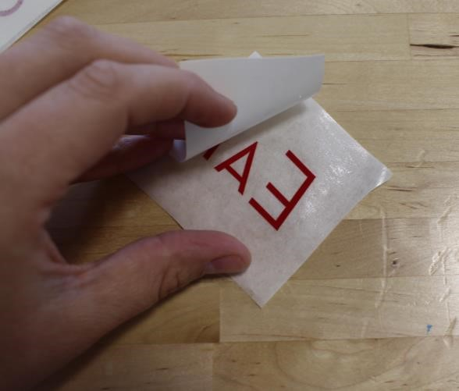
- Adhere your design to your object/wall/etc. Vinyl works best on flat, non-porous surfaces.
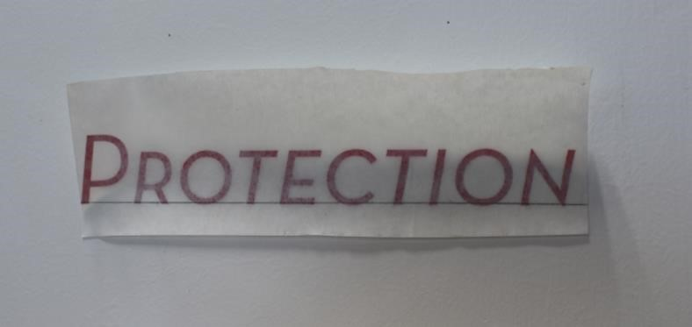

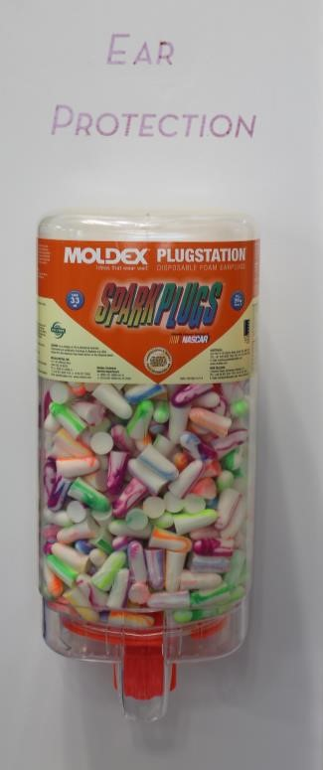
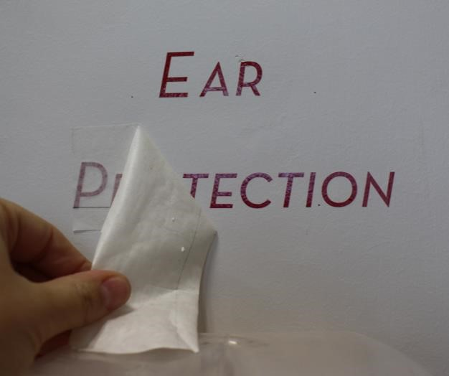
- Peel the away the transfer paper and you are finished!

