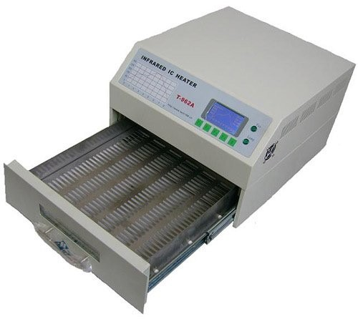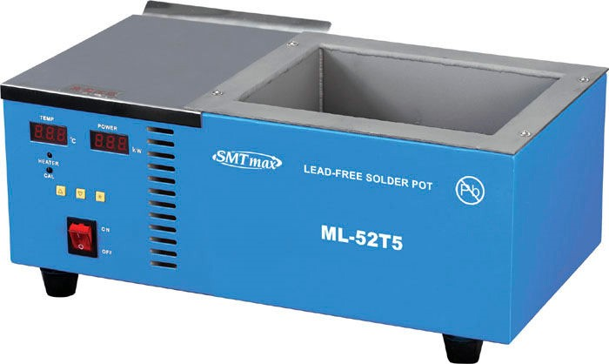
Soldering at
Nebraska Innovation Studio
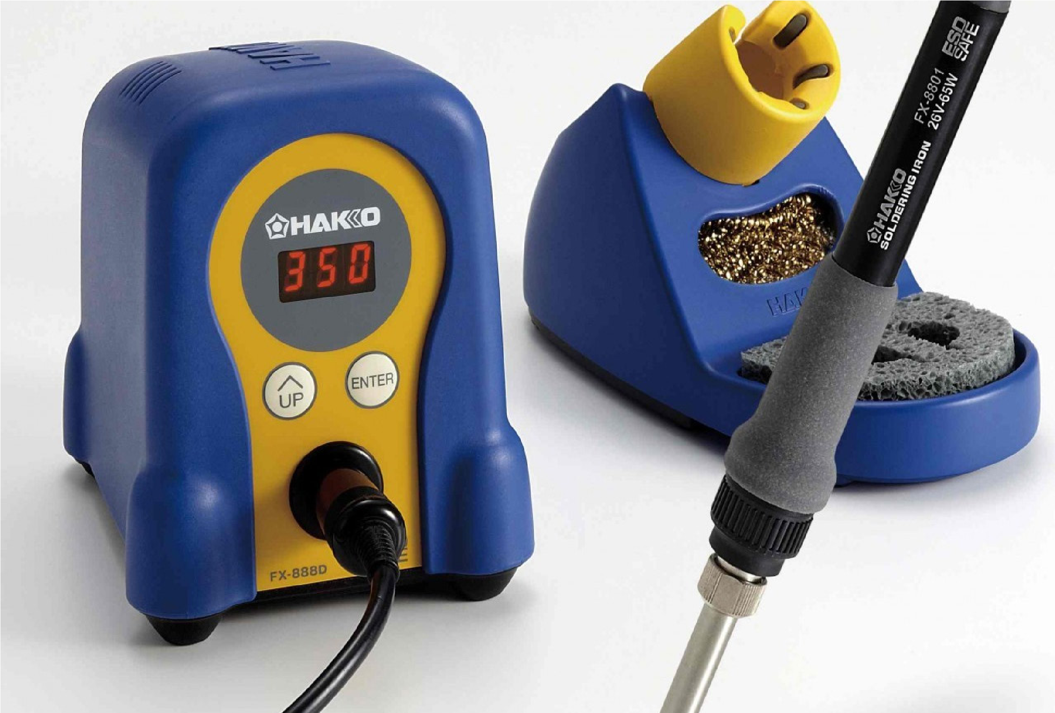

Quick Reference

GENERAL SAFETY
» Never assume that something isn’t hot. Everything involving solder — equipment, PCBs, components, holders, and solder itself — get very hot when soldering. These items also tend to stay hot for a long time. It may be difficult to detect if something is hot, since soldering involved highly-localized heat.
» Never leave the room while soldering equipment is on. Many substances will ignite when exposed to soldering temperatures, so if you have to leave the room, turn off the soldering equipment and wait a moment for it to cool down. Our irons, hot air guns, and dip-soldering equipment are designed to heat up very quickly, so you won’t have to wait long to get back to work when you return.
» Dispose of waste properly. All electronic waste should be disposed of in the properly-marked containers next to the workstations.
» Wash your hands. Leaded solder is toxic when ingested, so always wash your hands when you’re done. Soldering workstations should be wiped down regularly.

PENCIL SOLDERING
» Keep your iron between 600 and 750 degrees. The iron should be hot enough so that solder will wet the tip without dripping off, while also not being too hot to rapidly oxidize the solder.
» Always keep a wet tip — even when removing solder. Solder conducts heat better than air, and helps protect the tip. Always clean the tip and coat it with fresh solder when you’re done.
» Use plenty of flux. Flux reduces oxidation, so it promotes beautiful, strong solder joints that are properly wetted. Apply it liberally to all through-hole, SMD, and wire interconnects. We keep no-clean flux on hand in pen, spray, and bulk forms.
» For through-hole soldering, heat the joint, then solder. The basic through-hole soldering technique is to apply even heat to all parts of the joint with the soldering iron, and then once the joint is heated up, apply solder.
» For surface-mount (SMD/SMT) soldering, tack and drag. Wet your tip with solder, tack the component down in one spot to hold it in place, and then drag-solder the rest of the component’s pins while keeping a wet tip.
» Get in and get out. To avoid stressing the components or the board, try to solder each joint as quickly as possible. It should take about one second to heat a through-hole joint and apply solder to it. If it’s taking longer, ensure your iron is hot enough, you have a clean tip, and you’re using correct technique.
» Be nice to your tips. Never, ever attempt to clean tips with anything abrasive. Keep the iron off when not in use.

HAKKO FX-888D SOLDERING STATION
» Changing the temperature. Hold down the Enter button until the first digit starts flashing. Press the Up button to set the first digit of the desired temperature. Press Enter and repeat the process for the remaining characters.
» Changing the tip. Turn off the iron, and wait for it to cool down. Use a rag to get a good grip on the nut (while protecting your hand from the potentially hot iron), and remove the nipple from the iron. Slide on a new tip over the ceramic element, replace the nipple, and tighten the nut down to secure the assembly in place.

SOLDER POT
» Spray-flux your board. Fluxing is not optional when dip-soldering — use the flux spray or flux pen to douse the solder-side of your board in flux.
» Remove the dross. The dross is the layer of oxidized solder that forms on the top of the pot. It protects solder underneath it from oxidizing, so only scrape the dross when you’re about to dip a board.
REFLOW SOLDERING
» Use the right profile. Always make sure the right solder profile is selected before starting the oven.

Soldering Overview
In the most general sense, soldering is the process of joining pieces of metals together using an additional metal. This contrasts with welding, which actually fuses work pieces together while adding additional material tot he joint. SOldering is nondestructive to the work pieces — solder can be (somewhat) easily removed, and the work pieces can be rearranged as necessary.
Soldering uses a filler metal that melts at a much lower temperature than the work pieces. Solder, itself, comes in three forms:
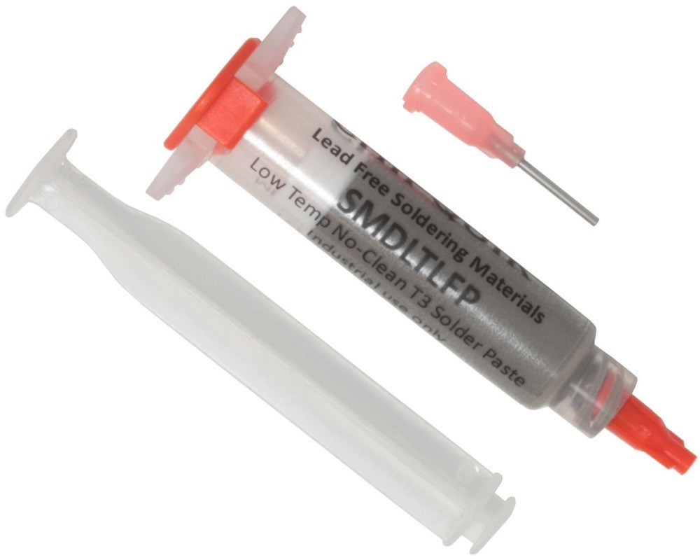
» Wire solder. Consists of a spool of soldering wire available in various gauges (thicknesses). Usually has rosin flux inside. Different people have preferences for different soldering gauges — we lean toward extremely fine-gauge wire, since it helps nudge people away from putting too much solder on joints.
» Solder paste. Solder paste consists of tiny balls of solder suspended in liquid flux. This is usually stenciled onto a board with a squeegee, though it is also commonly found in syringes for selective applications. Solder paste must be stored in a refrigerator. If it is left out for more than a few hours, it will dry up and be ruined.
» Bar solder. Solid bars of solder are almost exclusively used for
filling solder pots, solder fountains, and wave soldering equipment. | SOURCE CHIPQUICK  Syringes are a useful tool for dispensing solder paste on smaller boards, or for rework applications.
There are two classes of solder that are commonly used in electronics:
» Tin/lead solder. This is the primary type of solder in use at Nebraska Innovation Studio. This solder is an alloy between tin (Sn) and lead (Pb); the ratio between the amount of tin and lead in the solder determines the melting point. We recommend using Sn63/Pb37 when possible, but Sn60/Pb40 is also commonly used. The advantage of 63/37 solder — the eutectic alloy of tin and lead, for the chemists playing along at home — is that it has an extremely low melting point of 361 °F. This reduces the temperature requirements of the soldering process, which reduces stress on electronic components and printed circuit boards (PCBs).
» Lead-free solder. In an effort to reduce the amount of hazardous waste entering landfills, many countries are restricting the use of solder containing lead. Lead-free solders come in a wide variety of alloys; the most common alloy metals include Tin (Sn), Silver (Ag), Copper (Cu), Antimony (Sb), Indium (In), Zinc (Zn), and Bismuth (Bi), and these metals are combined in all sorts of different ratios (some of them patented) to achieve different characteristics. Unfortunately, no one has figured out how to make a lead-free solder that works as well as classic Sn63/Pb37. All lead-free solders suffer from a combination of having a high melting point, producing brittle joints, having poor wetting behavior, and being expensive. FLUX
Flux is a strong reducing agent which prevents oxides from forming on the surface of joints that are being soldered. Most soldering wire contains flux, and all solder paste does as well. While not necessary, for the best-looking, strongest solder joints, consider applying additional flux to the work pieces using a flux pen or spray bottle when pencil soldering.
While all soldering fluxes perform the same duties, fluxes vary widely in what they are made of, if they need to be removed, and which solvents they are compatible with. No-clean fluxes are the most common — we recommend “low solids” no-clean flux for all soldering work. No-clean flux is non-conductive, and has decent dielectric properties, so most

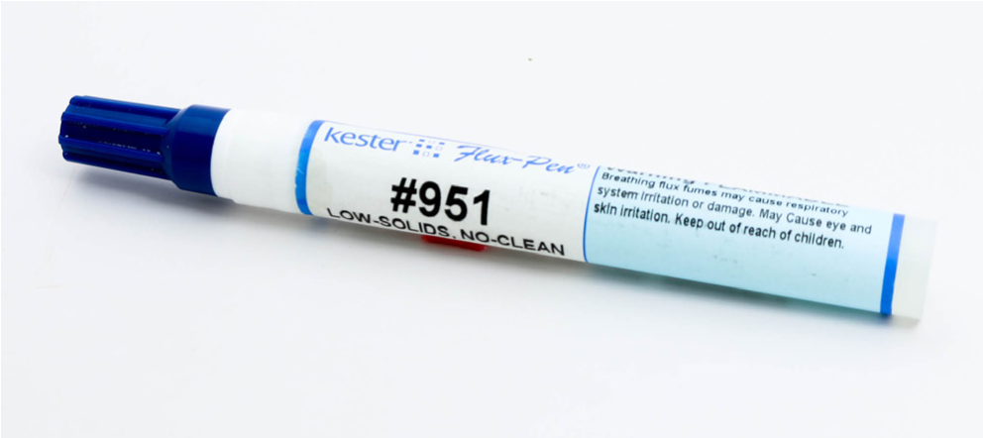

SOURCE: KESTER
Low-solids, no-clean flux pens are a convenient way of applying controlled amounts of flux for pencil soldering.
designs will work fine even if the flux isn’t removed. Having said that, you may wish to remove no-clean flux for aesthetic reasons — the film it leaves is somewhat tacky-feeling and clouds up the high-gloss soldermask, which may be undesirable if your board is exposed in your project. Since it is alcohol-based, we recommend using ethylene (though isopropyl will remove it faster, it’s a more caustic solvent that may damage some plastics — stick to ethylene if unsure).
Rosin — the same stuff used by violinists, athletes, and artists — is an excellent flux that is naturally-derived from pine tree resin.

Rosin, like solvents-based no-clean flux, is non-conductive and has excellent dielectric properties, meaning that cleaning flux residue is only necessary for aesthetic reasons. The most effective way to remove rosin is with a proprietary rosin flux cleaner (like Chemtronics Flux-Off® Rosin) or TCE (trichloroethylene — also called “trike”), though ethyl alcohol will also work.
For completeness, we’ll mention the existence of water-based flux; it is conductive, so it must be removed after soldering.
It is also acidic, so you must be careful not to get it on clothing or skin. It is rarely used in prototyping applications.
Regardless of the type of flux you use, we recommend wearing gloves — while most fluxes pose no skin contact hazard, fluxes are sticky, hydrophobic, and difficult to remove without solvents. HAZARDOUS MATERIAL WARNING
The on-going and long-term safety and welfare of our members is our primary concern; we have the same precautions in place that are used to protect career workers at professional assembly houses. When followed properly, these procedures almost completely eliminate any long-term exposure risks to lead and other hazardous chemicals.
» Lead is a known neurotoxin and can cause abdominal pain, headaches, anemia, reproductive problems, irritability, kidney disease and low appetite. Luckily, the primary vector for lead poisoning — ingestion — is easy to prevent. Always thoroughly wash your hands with soap and water after you’ve handled anything containing lead, or anything you suspect contains lead. Workstations should be wiped down with a standard cleaning solution every day to remove any lead dust that may have collected. Dispose of all electronic waste in the appropriate containers, even if you don’t think it contains lead (there are lots of other nasty metals present in electronics that we want to keep out of the landfill).
» When soldering, a moderate amount of fumes will be released. Most of these fumes are actually from the flux; while flux doesn’t contain lead, it contains chemicals that are eye and lung irritants, so if your soldering is producing a lot of fumes, consider moving to the chemicals room, which is mechanically ventilated. REWORK
If you are using soldering equipment to remove, replace, or clean up components that are already soldered to your board, you are reworking. Reworking is much more challenging than soldering a bare board — it requires experience to prevent damaging PCBs or components. It also requires a different set of tools than soldering. When a tool or technique can be used for rework, we will explicitly mention it in this document. There will be a separate section on reworking techniques, as well.

SOLDERING EQUIPMENT
There are three primary pieces of equipment used to solder at Innovation Studio:
» Soldering iron. Most people are familiar with soldering irons; they are inexpensive, small, and versatile — they can be used for soldering up bare PCBs, reworking and repairing PCBs, and soldering wiring harnesses. They can be used for
all through-hole components as well as many SMD parts. Pencil soldering, however, requires good technique to be useful, and is an inefficient way to solder boards. At Innovation Studio, soldering irons are primarily used for rework and soldering wiring harnesses, as we have more specialized equipment designed to quickly solder bare PCBs.
» Reflow oven. Reflow ovens work by melting solder paste that has been sandwiched between surface-mount parts and the PCB. They can solder an entire board (which may contain hundreds of parts) in just a few minutes, so they’re extremely efficient. When possible, use a reflow oven to solder the SMD components on your PCB.
» Solder pot. Dip-soldering is a way to solder through-hole (and glued-on SMD) parts all at once by lowering the entire solder side of the PCB assembly in a bath of molten solder for a few seconds. Dip-soldering produces beautiful through-hole joints with minimal stress to the PCB. When possible, use the solder pot to dip-solder the through-hole parts on your PCB.

Reflow Oven
The reflow oven is used to quickly solder an entire PCB at once. Reflow soldering is almost exclusively used for mounting SMT parts, though there are some tricks you can use to mount through-hole parts using reflow soldering. First, solder paste is applied to the bare PCBs by either squeegeeing it through a solder stencil, or by placing dots of paste directly on the board using a syringe. Then, components are placed onto the board — the tackiness of the solder paste is usually strong enough to keep them in place while working. The populated boards are then placed in a reflow oven, the temperature profile is selected, and the process is started. As soon as the boards are finished (after 6 to 10 minutes, usually), they are removed, optionally cleaned, and any through-hole parts on the board are soldered using dip or pencil soldering.
Reflow soldering is by far the easiest, fastest, safest, and most reliable method to solder modern PCB designs. Most modern ICs actually require reflow soldering, as they have pads on the bottom side of the chip that are not accessible to pencil or dip-soldering. When you are designing PCBs, you should plan on making them reflow compatible by using SMT parts whenever possible; it will allow you to easily go into production at any scale when you are satisfied with your board.
The main downside to reflow soldering is that solder paste must either be applied with a syringe (which is time-consuming for large designs) or a squeegee and a solder stencil (which requires another fabrication step). Nebraska Innovation Studio has tools and equipment which can make either of these methods relatively easy and inexpensive.
Double-sided PCBs (where components are mounted to both sides of the PCB) can usually be reflowed without problems. To make it easy to solder double-sided boards, ensure that the bottom side only contains small passives — interestingly, the surface tension of molten solder is strong enough to hold small parts, even when the board is upside down in the reflow oven! Typically, the bottom side of the board is reflowed first, then the board is removed from the oven, the top side components are placed, and the board is put into the reflow oven again.

APPLYING SOLDER PASTE
There are two main ways of applying solder paste to the board: » Syringe method. Let the syringe of solder paste come up to room temperature. Either with a hand-operated plunger, or using the air-assist liquid dispenser, apply small dots of paste to each pad of the board. The liquid dispenser has settings for air pressure and time — manipulate these two parameters to obtain the desired dot sizes. For leaded solder, the size and placement precision of dots is much less critical than most people think. Most people tend to put too much — and not too little — paste onto pads.
» Stencil method. Solder stencils can be ordered from most

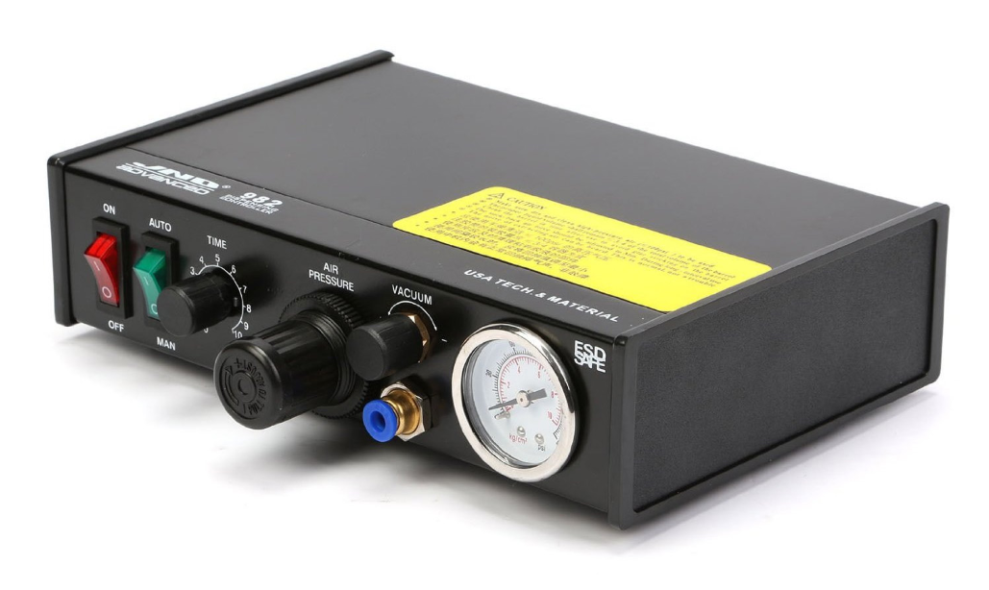

SOURCE: DANGEROUS PROTOTYPES
A compressor-operated syringe dispenser greatly speeds up the process of pasting up a board without needing a solder stencil.
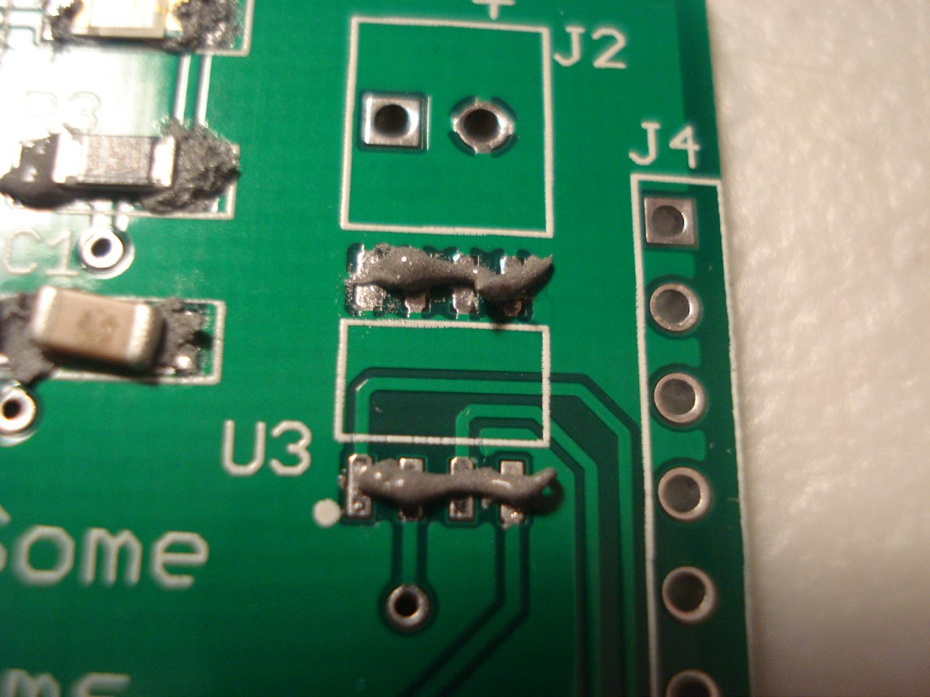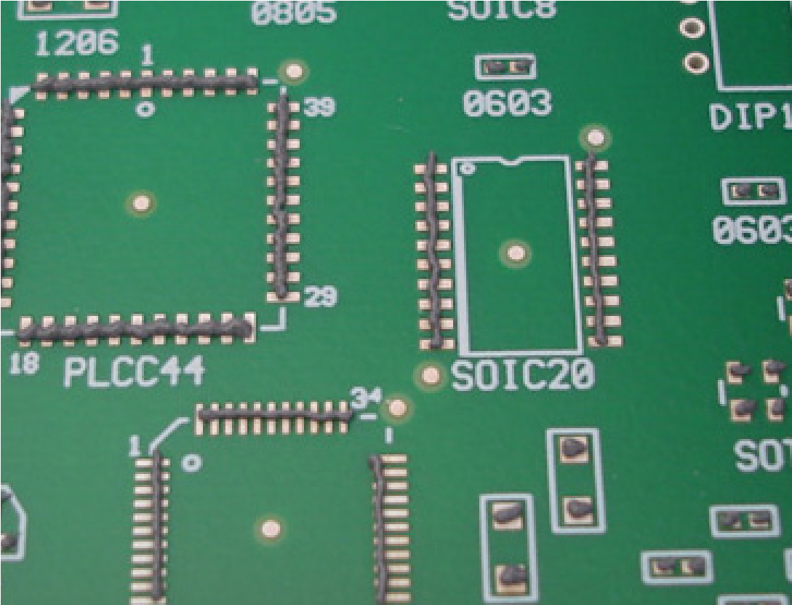

SOURCE: DANGEROUS PROTOTYPES
As can be seen, applying solder paste has a large margin for error. Because of the effectiveness of solder resist mask (the green film on the PCB) and the natural surface tension of solder, it is unlikely that solder will jumper between these pads when reflowed.
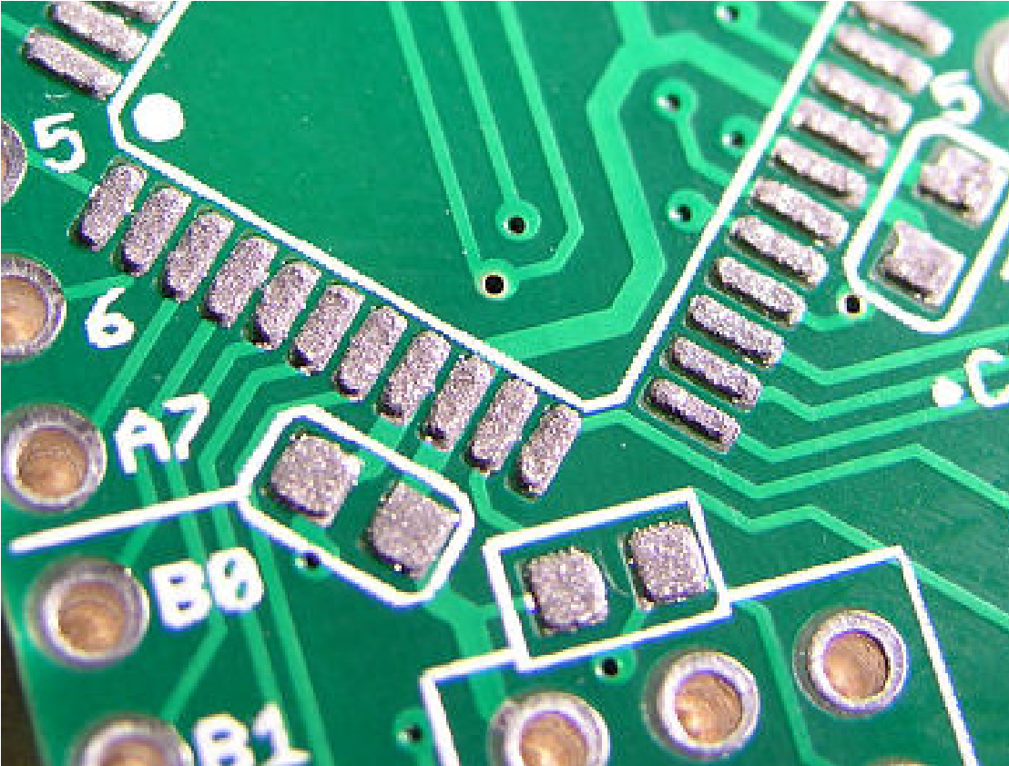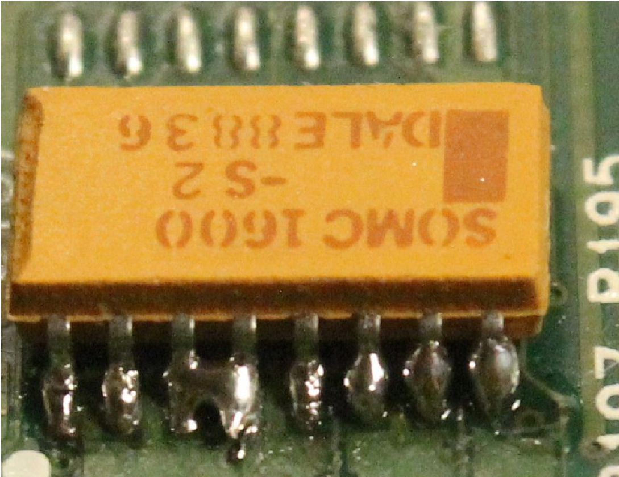

SOURCE: DANGEROUS PROTOTYPES
If you’re producing more than a few boards, or you’re placing high-density parts, we recommend ordering or fabricating a solder stencil, as it provides extremely high quality solderpaste masking that takes only a few seconds per board to apply.
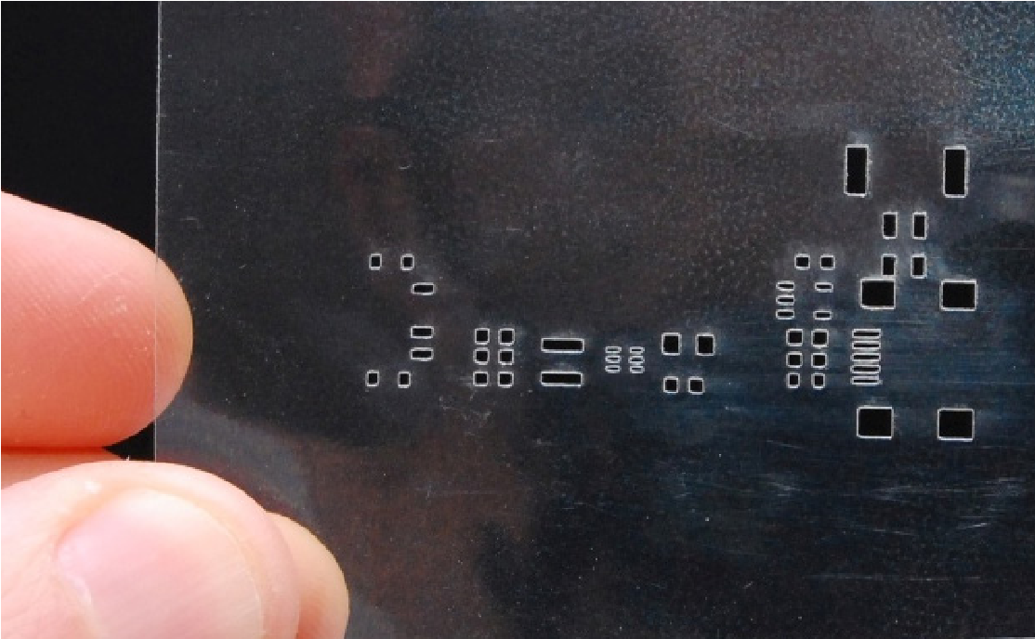
SOURCE: LOW POWER LAB A solder stencil cut out of myler using a laser cutter.

SOURCE: ELECTRONICS POINT
It is common for beginners to apply way more solderpaste than is needed to properly solder components. This causes large, bulging solder joints and solder jumpers. Luckily, this is easily cleaned up with solder wick and a soldering iron.
PCB suppliers along with your PCBs. As an alternative, Nebraska Innovation Studio has equipment that can be used to produce solder stencils that may be suitable for your PCB. While directions to do this are outside the scope of this manual, consider using the laser cutter or vinyl cutter (with a 60° blade) to cut Kapton or other plastic sheets; or use the exposure unit and chemicals room to develop and etch stainless steel or aluminum stencils. Stencils can be framed (which allows them to be used with Innovation Studio’s stencil printer), but loose stencils can be used, too. Once you have your stencil in hand, put a small amount of solder paste on your solder stencil and return the jar of solder paste to the refrigerator. Let the dollop of solder paste come up to temperature. Align your board with the stencil and, with firm pressure on one side of the stencil, pull the squeegee across the board, away from the side of the stencil you’re supporting. Try to pull the entire board in one shot. Peel up the stencil, making sure not to disturb the paste. Inspect the board for even application. If you made a mistake, run the squeegee over the board to clean off the paste, and do it again. It is far easier to fix mistakes now then later, so a careful check is important! PLACING COMPONENTS
Once the board has solder paste on it, place the components on the board. This can be accomplished by hand or with a pick-andplace machine (which is outside the scope of this manual). We recommend using the SMD vac to place parts — though tweezers can also be used. Once all of the components are placed, carefully inspect the board using the magnifier to ensure components are placed properly. Don’t worry about getting alignment perfect; the high surface-tension of leaded solder will pull components into place. The only part especially difficult to place is the 0402 passive; these are notorious for coming out of the reflow oven tombstoned, mis-oriented, or otherwise incorrectly soldered, so pay extra attention to them at this point to reduce the amount of work required to rework these parts later on.

REFLOWING THE BOARD
To reflow the board in Innovation Studio’s T-962 reflow oven, start by turning on the machine. A menu will appear on the LCD. The five buttons (F1, F2, F3, F4, S) are used to interact with the machine. The F4 button is used to change the language of the machine from English to Chinese. Press the F3 button to select your temperature profile. You can read a description of the profile by pressing F3 (“DE”). Arrow through the profiles with the F1 and F2 keys. When you have found the profile you would like to use, hit F4 (“OK”). Once you return to the main menu, press F1 to start the machine.
While the machine is running, you can watch the display get updated regularly with the current temperature. The fan and lamp lights illuminate to indicate what the machine is doing.
Once soldering is complete, the machine will beep at you. Don’t worry about leaving your board in the oven too long — since the temperature is controlled in both directions, the oven will be quite cool by the time the reflow profile ends. Having said that, the boards will be quite warm to the touch; exercise caution when removing them from the reflow oven.
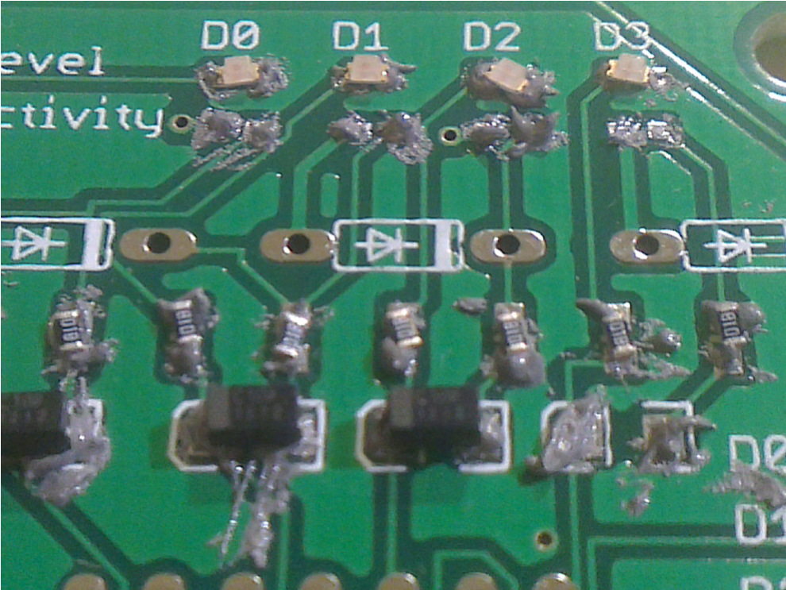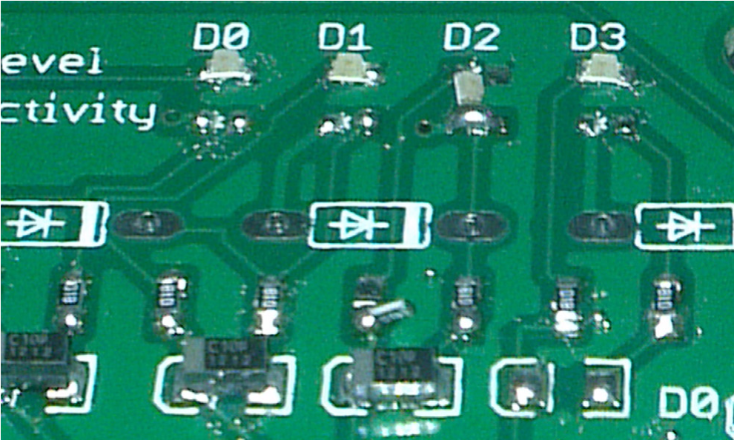

SOURCE: KEVIN MODZELEWSKI
Placement accuracy of SMD parts is surprisngly lax. Even with ridiculously inaccurate placement (top), the components are easily pulled into alignment during reflow (bottom) due to the surface tension of solder. Accurate placement is more critical for smaller components, and can’t be completely ignored; as can be seen, the 4th resistor and the third LED were misaligned enough to be pulled out of placement. While these soldering errors can be corrected with a hot-air gun, this process is tedious, so it’s best to inspect the board thoroughly before reflow.
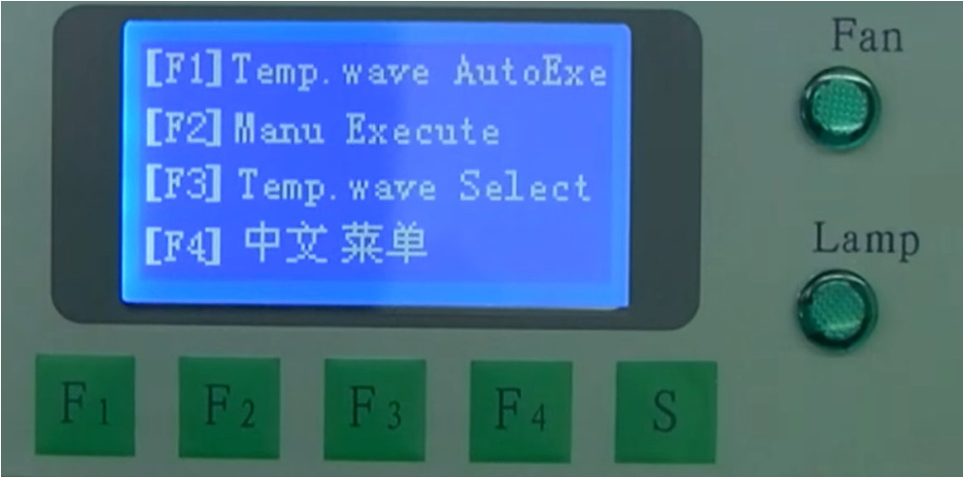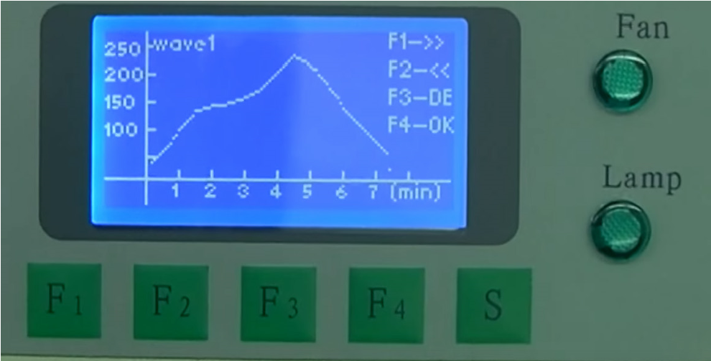

SOURCE: TECH169
The T-962 supports different soldering profiles for different types of solder. We’ve found that Wave1 is suitable for most PCB designs, but a wide selection of built-in profiles are available to choose from. Always press F3 to inspect the profile before you begin AutoExec.

REWORK, THROUGH-HOLE WORK
Once the boards come out of the oven, inspect them carefully for tombstoned parts and solder bridging. Use the solder pencil and/or hot air gun to make any fixes to the board.
If your board contains through-hole parts, you may now insert those components and dip-solder them.

CLEAN-UP
Because of the tight process control of the solder paste’s flux content and the reflow oven’s profile, no board cleaning is required in most cases — however, if you placed solderpaste by hand with a syringe, some flux residue may remain. Noclean flux residue can stay on the board without causing any electrical issues, but for cleaner aesthetics, wash the board with ethylene or TRK.

Dip-Soldering
Dip-soldering is the standard process used to manually solder boards with through-hole components. To dip-solder a board, through-hole components are loaded into a board, the leads are trimmed back, flux is sprayed on the board, and it is floated in a molten bath of solder for just a few seconds, then removed.
Note that dip-soldering has significant yield issues when not using a soldermask, so we recommend against trying to dip solder “bare copper” boards. Most board houses around the world apply soldermasks by default, so this shouldn’t be an issue if you’re ordering your PCBs from a manufacturing house; however, if you’re making your boards by yourself, Innovation Studio has tools and supplies needed to apply a liquid or film-based soldermask to your board, which we highly recommend doing, regardless of the method you plan to use to solder parts.

INSTALL THE COMPONENTS
Install all through-hole parts in your board, bend the leads outward slightly to retain the part, and trim the leads back to your desired amount (usually about 1/8” or less).
Dip-soldering can also be used in limited circumstances to solder SMD parts. The parts must be glued down beforehand using “red glue” (SMD Adhesive D 125 F-DR is the most common product in use). The board cures in a 120 °C (250 °F) oven for 2.5 minutes. While the surface tension of solder helps pull parts into the correct place during reflow soldering, glued-down SMD parts do not move; therefore, placement accuracy is very important.

TURNING ON THE SOLDER POT
At this point, we recommend turning on the solder pot to let it come to temperature. There is no “ideal” temperature setting for the solder pot — 260 °C (500 °F) is a good place to start, but if your board is large, it might have a significant thermal load that prevents good wetting, in which case, you should increase the temperature.

FLUXING THE BOARD
Next, spray an even coat of flux on the solder side of the board. We recommend using a no-clean flux. For optimal results, preheat the boards by setting them on a rack on top of the pot for a few minutes once you’ve fluxed them; this will evaporate off the alcohol, leaving the flux residue on the board. This process (called “preheating”) is not critical, though, and can probably be skipped unless you’re noticing yield issues.

DIP THE BOARD
Ensure the pot is at the proper temperature by dipping the corner of a piece of paper in the solder — the solder should be molten and the paper should turn brown. Right before you start dipping, clean off the layer of oxidized solder (called dross). Once you clean the dross, you want to dip boards quickly (while still being safe), since oxidized solder will not wet joints well at all. If you’re dipping a lot of boards, you may have to scrape the dross off between some of the dips to keep the solder fresh. Since a thin layer of dross prevents additional oxidation, don’t clean the dross off until you’re ready to solder; otherwise, it just wastes solder.
Dipping the board requires a bit of a technique. We recommend slowly lowering the board at a slight angle (5-15°) until one side is touching the bath of solder. Keep that side as a pivot point to angle in the rest of the board until the entire board is sitting in the solder. Wait a second or two for the joint to be soldered, then slowly angle the board up, using the opposite edge of the board as the pivot point.
This is the only part of the process that may require some technique to become proficient at dip-soldering. You should angle the boards out of the solder slow enough so that the solder can run down the side of the board without getting trapped.
If your board comes out of the dip with lots of jumpers or open solder joints, you can either re-spray and re-dip your board, or fix it manually with a soldering iron. The more times you re-dip a board, the higher chance of component failure.
Dipping a board more than three or four times is not recommended.

CLEAN-UP
You can remove any flux residue on your completed boards using ethylene or TCE. Turn off the solder pot when finished, and make sure it cools down completely before you try to move it.

Pencil Soldering
“Pencil soldering” refers to the technique of soldering with a soldering iron (also called a soldering pencil). Joints are heated directly by the iron; solder wire is introduced to the joint, where it melts and wets the joint; then the iron is removed, leaving a completed solder joint. Pencil soldering is the easiest process to understand, and is the most versatile and ubiquitous way to solder. But it’s also the most inefficient, dangerous, and difficult process to learn.

IRON TEMPERATURE
Pencil soldering is quite stressful to components when compared to other soldering techniques. Your iron should be hot enough to heat component joints quickly; if the iron is too cold, the rest of the component might be subjected to overheating while you wait for the joint to heat up enough. However, a hot iron will rapidly oxidize the solder, which will lead to poor wetting (cold joints).
If solder drips off the tip of the iron when you touch it, your iron is too cold; if you notice a lot of smoke coming from the soldering, your iron is too hot. Actual temperature settings can vary depending on the quality and age of the tip, however, we recommend keeping the iron at 650-800 °F.

THROUGH-HOLE SOLDERING
To solder through-hole components, place the component into the board, and bend the leads outward to retain. Before soldering, we recommend clipping component leads such that no more than a centimeter is exposed — this helps localize the heat from the iron on the joint. Most wire solder contains some flux; however, additional flux can be applied to make soldering faster (and improve the quality of the joints).
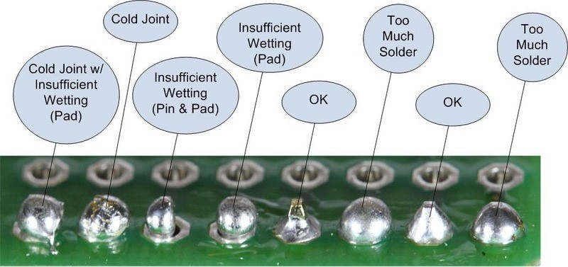

SOURCE: ADAFRUIT.COM
Next, clean the tip of the iron and apply a small amount of solder wire to the tip of the iron. Then, apply the soldering iron to the joint, making sure to touch both the component lead, and the PCB pad. Bring the wire solder into the joint, then remove the iron and let the joint cool off.

SURFACE-MOUNT SOLDERING
Soldering surface-mount parts with a soldering iron is easy to do, but requires a totally different technique than soldering through-hole parts. Since surface-mount parts are typically not mechanically restrained to the board, they must be tacked down to the board with solder to hold them in place while soldering. To do this, apply a bit of solder to one of the component’s pads on the PCB. With the iron still on the pad, place the component using tweezers, a vacuum pen, or your fingers.
Remove the iron from the pad. The component is now tacked to the board.
Next, solder the remaining pad(s). For parts with long rows of pins (like integrated circuits), apply liquid flux to all the pins on the package; then, apply a generous amount of solder to the tip of the iron and slowly drag the broad side of the tip along the pads to be soldered. With sufficient flux and the proper soldering iron temperature, the solder will naturally wick into the pads without jumping.

REWORK SOLDERING
Pencil soldering is extremely effective for cleaning up many types of defective solder joints. The most common tools used for pencil rework soldering include flux, soldering wick, and a desoldering pump.
» Solder jumpers. Most solder jumpers between pads can be removed by fluxing the joint, and touching the jumper with the soldering iron. If there’s significantly too much solder on the joint, you may need to press some wick into the jumper with the iron to wick some solder away. In extreme situations, you may find a desoldering pump is more effective at removing solder than solder wick.
» Removing a Through-Hole Part. Two-terminal through-hole parts can be removed by heating up each of the two pins one by one and removing them from the board. For components with more pins, consider using the hot-air gun or the solder pot.
» Removing surface-mount parts. Two-terminal parts can be removed by applying a large blob of solder to the iron and touching the middle of the component with the blob of solder; this should heat up both pads simultaneously, allowing the component to be removed with tweezers. For components with more pins, consider using the hot-air gun.

