SOP

CNC Router
Shopbot PRS Alpha

Training is required before using this equipment
Closed Toed Shoes required
Eye & Ear Protection required
Never leave machine unattended while operating
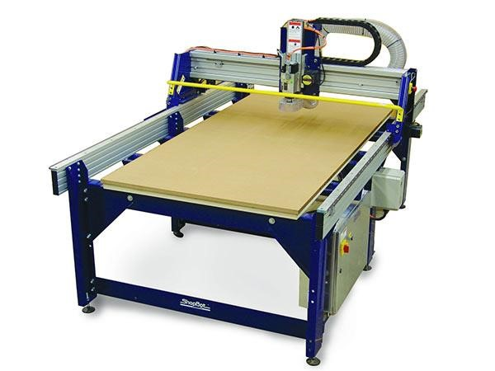

Shopbot CNC Router SOP Rev A 12/15/2020

Reference Sheet
Size of bed
48” x 96” x 8” of vertical travel

Collets
1/8” 1/4" 3/8” 1/2" NIS uses ER 25 collets

Approved materials
Hardwoods Softwoods Engineered wood products
Foam HDPE

Banned materials
Metal Delrin Composites

Safety

CNC Routers spin sharp metal bits at high rates of speed. Bit breakage can occur and care should be taken in toolpath generation to ensure speeds and feeds are appropriate for the material being machined and bit being used.

Gantry motors are very powerful. Maintain safe distance from gantry when operating.

Multiple pinch points exist on CNC machines. Keep hands away as the machine is running.

Dull bits can generate an excess of heat leading to fires.

Unattended CNC Routers can run into multiple problems. You must remain with the Shopbot while it is operating.

Machine Layout

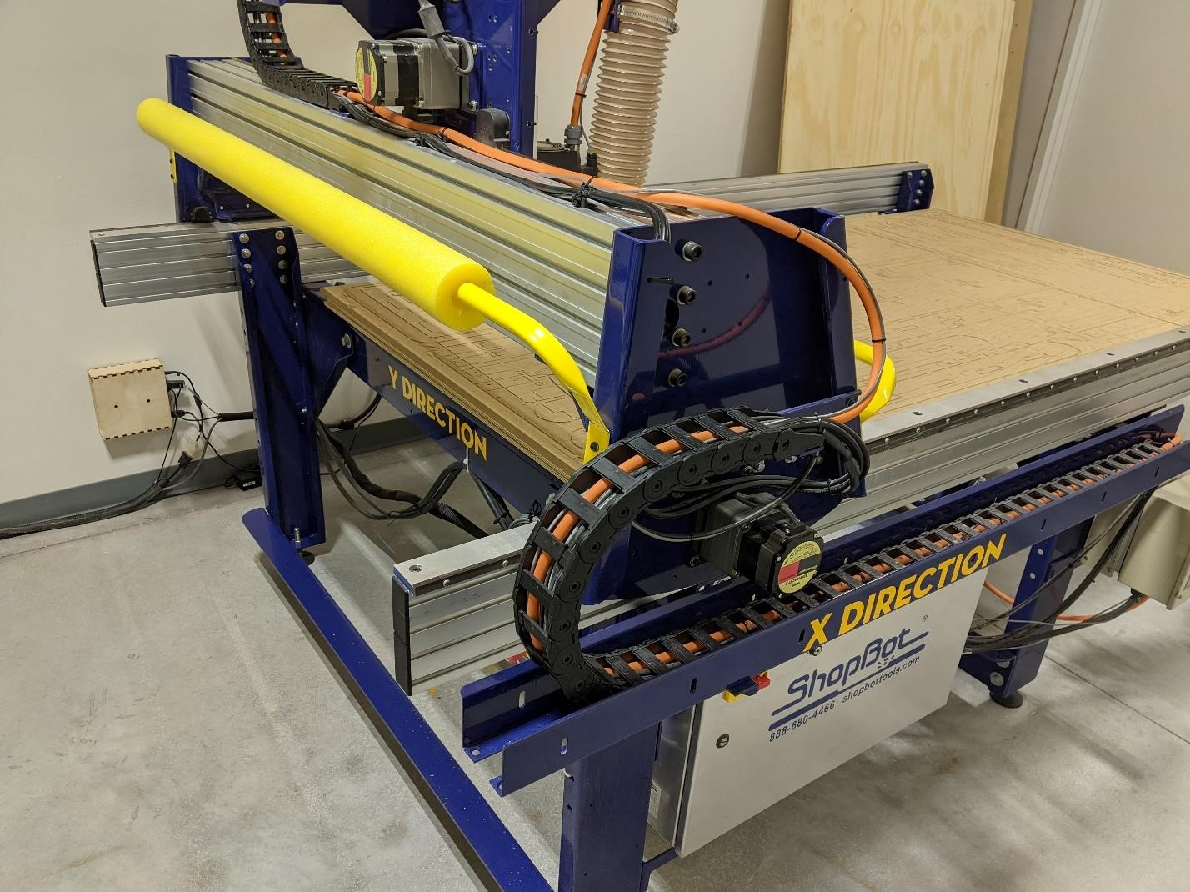

Gantry

Control
Not shown: Z axis protruding vertically from the table

Safety Features

This Shopbot comes equipped with two main safety features; the interlock override key and the emergency stop buttons.

The interlock override key is used to activate spindle operation. Without this key inserted the Shopbot will move in all three axes but it will not rotate the spindle head.
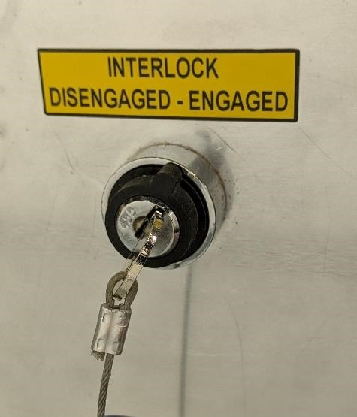

To arm the spindle, or allow the spindle motor to spin, insert the interlock override key into the keyhole in the control box of the Shopbot and turn the key ¼ turn clockwise to “ENGAGED”. Note that this key can be overturned and underturned, both of which will not allow the spindle to turn. Do not over rotate key or damage will occur.

This key should only be inserted into the machine right before a job is going to be run and it should be removed as soon as a job is finished. Failure to remove the override key as soon as a job is finished may cause unexpected spin ups of the spindle.

The emergency stop buttons are located on the desktop near the operator’s right hand and mounted onto the Shopbot near the control box.
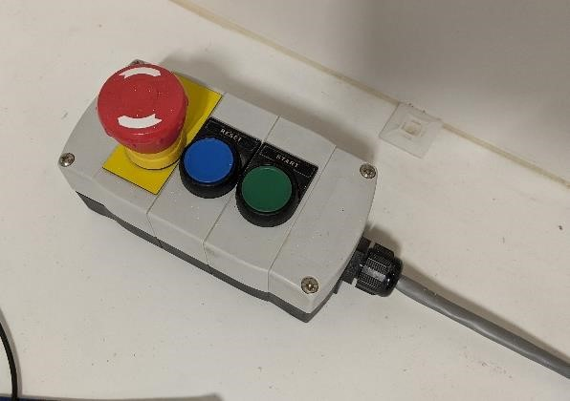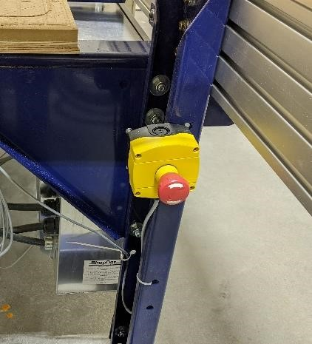

To activate the emergency stop press down on the red button. If you activate an emergency stop ask for assistance from NIS Staff immediately. Activating
the emergency stop is a last resort. All job progress will be lost. Pause the job by using the space if possible.

Turning on the Shopbot
- Begin by turning the Shopbot on. The power switch is located on the control box of the Shopbot.
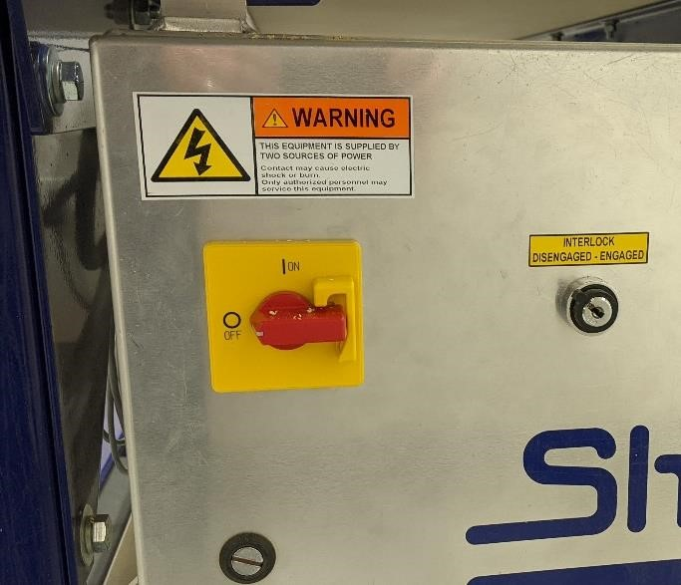

- To open the Shopbot Interface click on the Shopbot button on the start bar.

- When opening the Shopbot Interface a window will come up reminding you to press the reset button. Pressing this button allows the Shopbot to figure out where it is in 3D space. Press the reset button on the control switch to the right of the computer. After pressing the reset button click
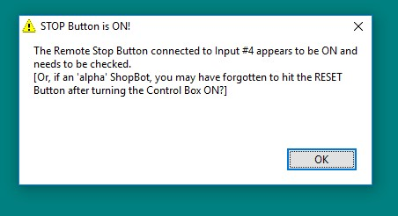
“Ok”.

- The Shopbot Interface is designed to look like a traditional CNC interface, as a result all of the commands are accessible via keyboard as well as mouse.

- The Shopbot Interface consists of two main screens,

  - The Green Screen is where commands are input and the current job is read out.
  - The Red Screen shows the current X, Y, and Z coordinates of the machine
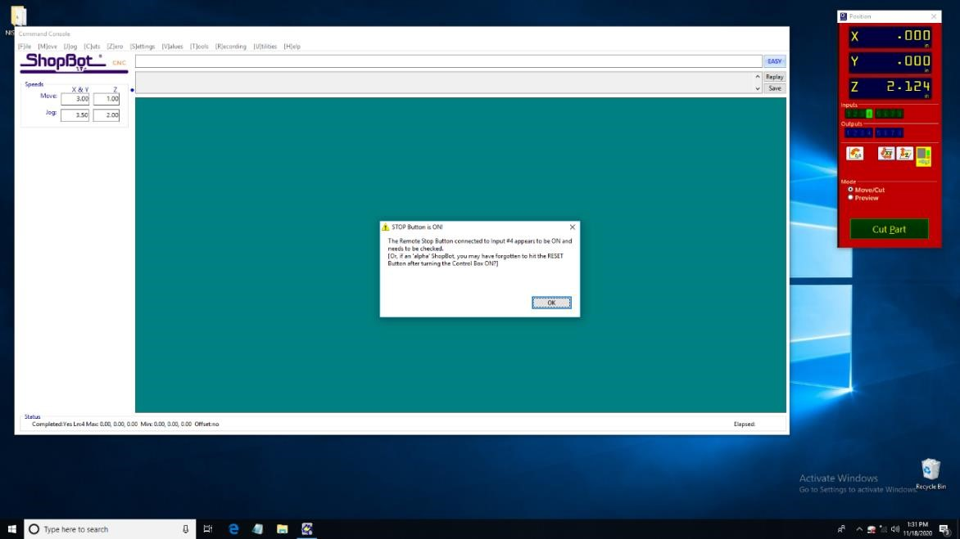
- If you see a window that shows a preview then you’ve accidentally entered “Preview mode” switch out of this by clicking on “Move/Cut” in the red window.
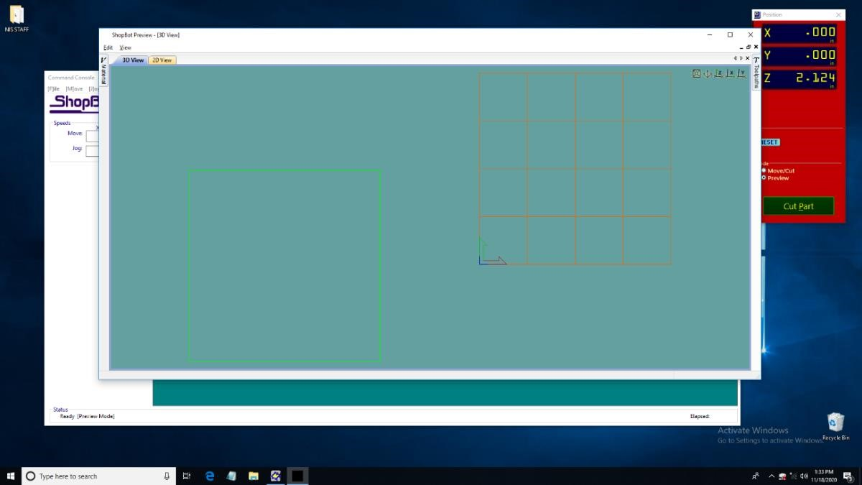

Every Day Tasks
Once per day the “Spindle Warmup Routine” must be run to prepare the machine for use. If you are unsure whether or not this procedure has been done, consult with NIS staff.

- If the Spindle Warmup Routine has not been run today, begin by powering on the Shopbot and opening the Shopbot Interface.

- Verify the spindle does not have a collet or bit installed.

- Arm the spindle by inserting the override key into the keyhole on the side of the control box. Insert the key and rotate it ¼ turn clockwise to “ENGAGED”. Note that this key can be overturned and underturned, both of which will not allow the spindle to turn (See: Safety Features “Interlock Override Key”).

- Place the attached wrench on top of the control box. This will prevent it from pulling down on the override switch.

- In the Shopbot interface begin the Spindle Warmup Routine by selecting “Cuts” and then selecting “C5 – Spindle Warmup Routine”.

- When prompted press the green start button on the right side of the desk.
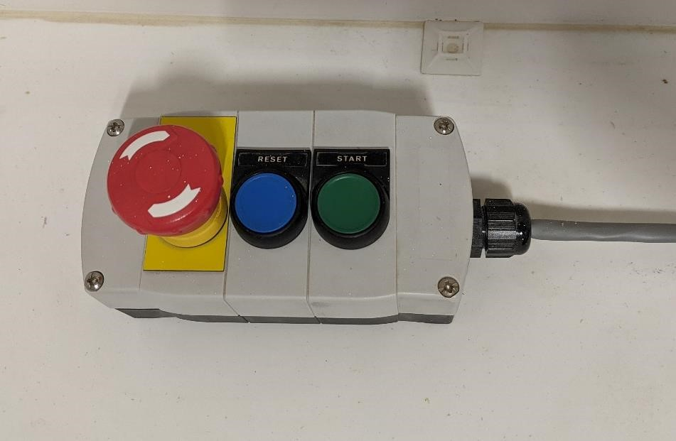

- The Spindle Warmup will take approximately 10 minutes during which time the computer will be locked down.

- When the spindle warmup routine is complete remove the Interlock Override Key and return it to the pegboard.

Every Job Tasks
Once per cutting session the “Home X/Y axes using prox switches” routine must be run. This will check that the limit switches are working so that the machine does not run into itself or “crash”.

- Verify that the router and gantry are not resting on prox switches.

- In the Shopbot interface begin the Home X/Y axes using prox switches routine by selecting “Cuts” and then selecting “C3 – Home X/Y axes using prox switches”.

- The Shopbot will begin moving and check that the prox switches are functioning properly.

- A successful test will result in a screen that says “Tool is now zeroed in the X and Y axes”.

- If the test is unsuccessful consult with NIS Staff.

Securing Material
- Place your material onto the table.

- Align your material to the corner you have chosen to be your origin (usually the lower left hand corner).
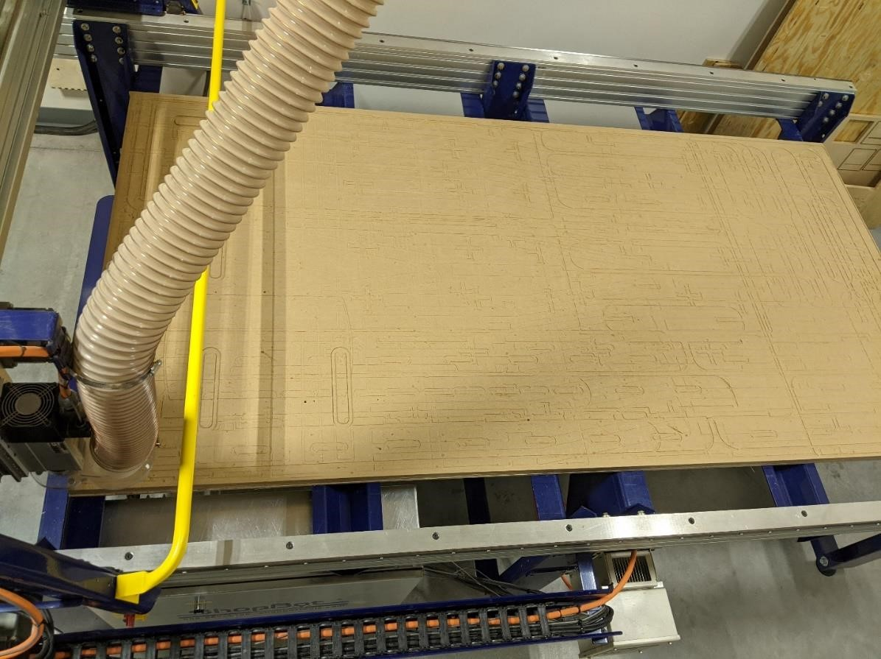
Align to
this corner

- Material must be secured to the table before it can be cut, there are three main ways to secure your material.

  - Composite nails – Using the nail gun in the Shopbot room nail your material to the bed. These nails are made of plastic and will not interfere with your cut.

  - Drywall screws – Drive screws through your material to secure it to the bed, verify all screws are not in the toolpath as they will break bits and create sparks.

  - L Bracket and Cams – If neither of the above options work for your material consult with NIS staff for help.

Installing Bits
Nebraska Innovation Studio does not supply CNC Bits. Consult with NIS Staff if you are unsure of what bit to get for your project or where to source bits.

Warning! CNC bits are sharp and will cut you. Use caution when handling bits.

- Bits are installed into the Shopbot using a collet nut and a collet that is chosen to match the diameter of the bit. NIS has collets for 1/8” 1/4" 3/8” and 1/2" sized router bits. Consult with NIS Staff for bits outside of these diameters.
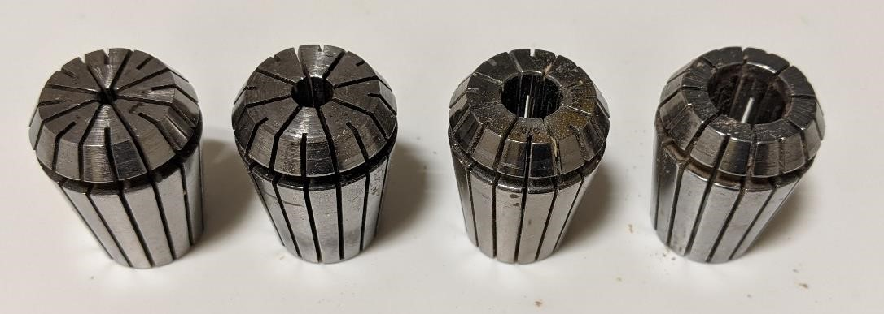

- Remove the collet from the collet nut by pressing the collet out while simultaneously pulling the collet down. Consult with NIS Staff for stuck collets.

- Remove any loose debris from inside the collet nut using an air gun or by tamping it on the spoil board.

- Insert the correct sized collet into the collet nut by pressing it into place, a properly installed collet will *click* into place.
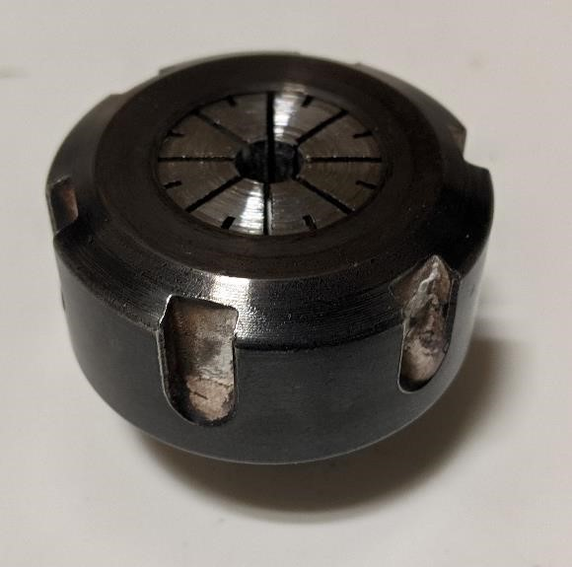

- On the Shopbot interface click on the yellow box inside the red window.
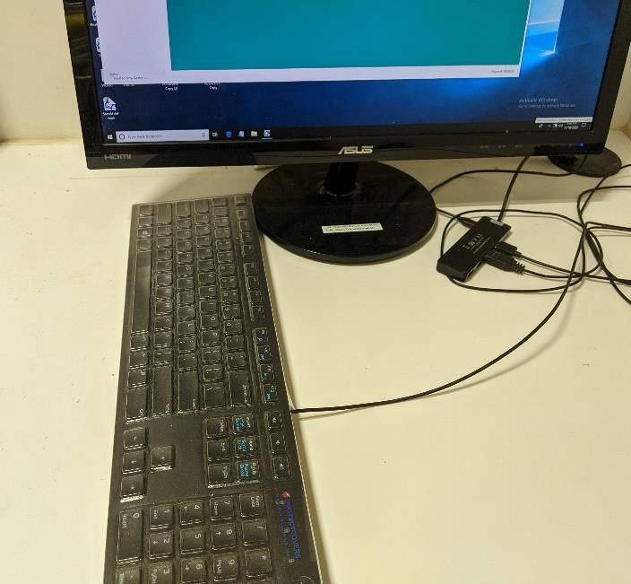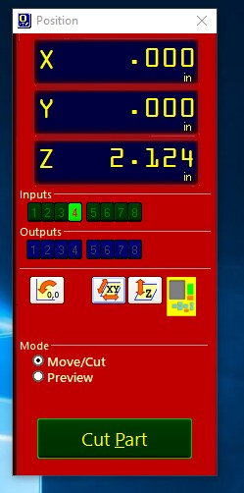
6.

Click Here

- Rotate the keyboard clockwise 90 degrees. The arrow keys on the keyboard are now aligned to the machine. Pressing an arrow key will cause the router head to move in that direction.

Press arrow keys individually, and pause between key presses. The Shopbot does not work well if the arrow keys are pressed and released quickly. This will cause a stutter effect and it will lock the system up.

- Move the spindle over the bed. If a bit were to fall out of the spindle it should fall onto the table and not the floor, which would damage the bit.

- Tighten the collet nut onto the Shopbot spindle a couple of turns, using one hand to secure the spindle from rotating and the other hand to tighten the collet nut.

- Insert the bit into the collet and tighten by hand. Ensure that the bit shaft is fully inserted into the collet and the flute, or cutting edges of bit, are fully exposed. Note that before the collet nut is tight bits have the tendency to fall out of the collet nut.

- Tighten the collet nut using the two wrenches. Begin by holding the smaller wrench in your left hand and the toothed wrench in your right hand.
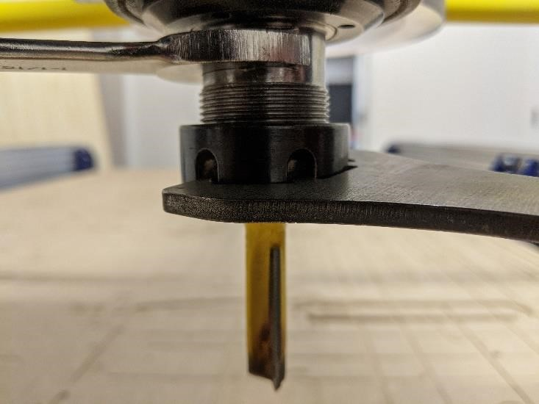

- Slide the smaller wrench onto the spindle and bring the toothed wrench up from below the collet nut.

- Push the wrenches away from you to tighten the collet nut.

If you fail to properly tighten the collet bit will slip
out in the middle of the job.

Zeroing X and Y Axes
- After running the “Home X/Y axes using prox switch” function, the X/Y (0/0) location is set to an arbitrary location. You must now set the X/Y home position for your job.

- On the Shopbot interface click on the yellow box inside the red window.

Click Here

- Rotate the keyboard clockwise 90 degrees. The arrow keys on the keyboard are now aligned to the machine. Pressing an arrow key will cause the router head to move in that direction.

Press arrow keys individually, and pause between key presses. The Shopbot does not work well if the arrow keys are pressed and released quickly. This will cause a stutter effect and it will lock the system up.

- Using the keyboard move the router head to your chosen origin (0,0) (usually the lower right hand corner of your material).

- On the keyboard press Esc to exit out of the manual movement mode

- Click on the word “[Z]ero” and choose “zero [2] axes (X and Y)” The tool is now zeroed in the X and Y axes.

Zeroing the Z Axis

- On the Shopbot interface click on the yellow box inside the red window.

Click Here

- Rotate the keyboard clockwise 90 degrees. The arrow keys on the keyboard are now aligned to the machine. Pressing an arrow key will cause the router head to move in that direction.

Press arrow keys individually, and pause between key presses. The Shopbot does not work well if the arrow keys are pressed and released quickly. This will cause a stutter effect and it will lock the system up.

- Using the keyboard move the router bit to roughly the middle of your material.

- Press Esc to get out of the manual movement interface.

- Get the Z Zero Plate from the pegboard.

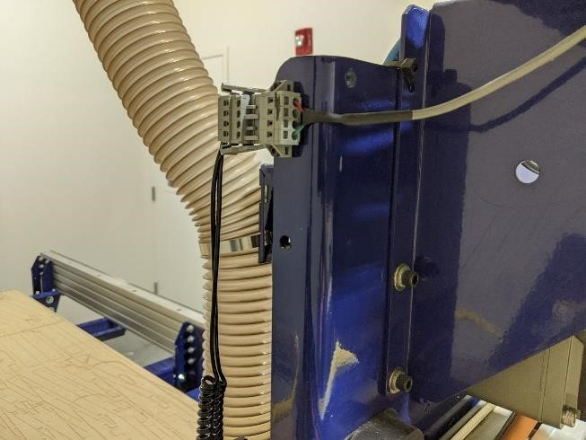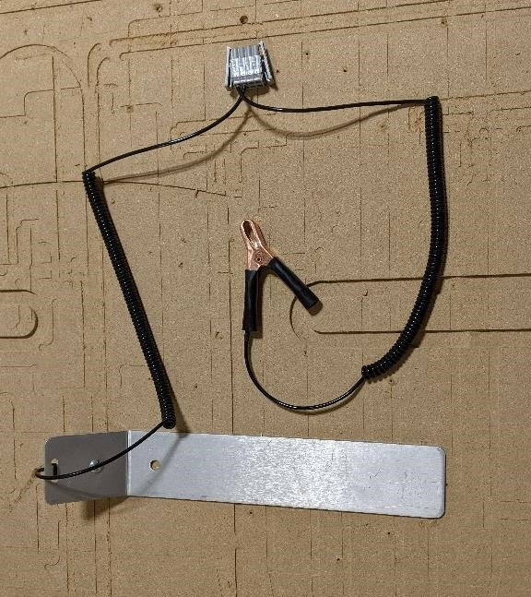

Wires on
bottom

- Plug the grey connector into the Shopbot. The wires must be located at the bottom of the connector.

- Clip the alligator clip onto your bit or onto the collet nut.
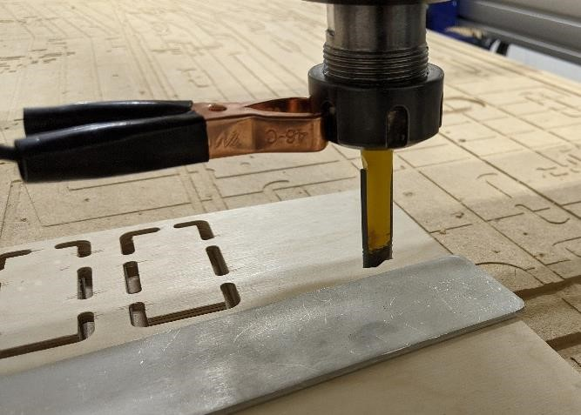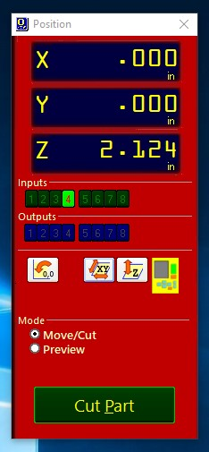
Input 4

- Verify the Z Zero Plate connection by touching the plate to the tip of the bit. On the computer screen look at the red window and check that Input 4 lights up green when you touch the Z Zero Plate to the bottom of your bit. Consult NIS Staff if Input 4 doesn’t light up.

- After a successful connection test place the Z Zero Plate immediately below the bit.

- On the computer select Cuts -> “C2 – Zero Z axis with Z Zero Plate”

- The Shopbot will begin a routine where the head lowers until the bit comes into contact with the Z Zero Plate and raises up. It will perform this function twice to confirm the measurement.

- On screen the Shopbot will report “Tool is now zeroed in the Z Axis, remember to put away the Z Zero Plate”

- Remove the Z Zero Plate and return it to the pegboard.

- On screen click “Ok”. The tool is now zeroed in the Z Axis.

Starting a Job
- Attach the dust boot to the router head, it will magnetically attach.

- Arm the spindle by inserting the override key into the keyhole on the front of the control box. Insert the key and rotate it ¼ turn clockwise to”ENGAGED”. Note that this key can be overturned and underturned, both of which will not allow the spindle to turn (See: Safety Features “Interlock Override Key”).

- Place the attached wrench on top of the control box. This will prevent it from pulling down on the override switch.

Do not contact spindle after spindle has been activated or injuries may occur
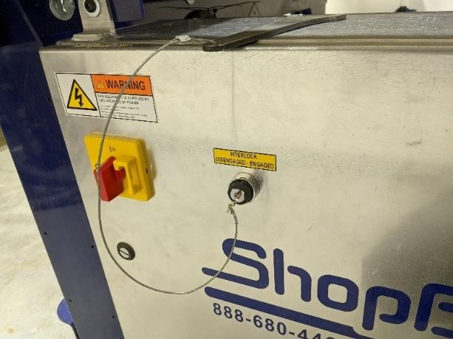

- Load the part file by selecting [F]ile -> [P]ART FILE LOAD. Select your file.

- The notepad window can be ignored. Click on the green “Start” button.

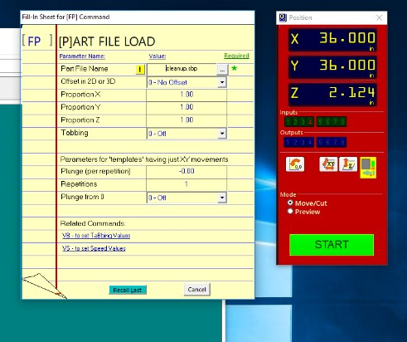
Click Here

- The software may prompt you to ask if a certain tool is loaded, or if it has been zeroed in the Z axis, verify these and continue.

- The final screen before the CNC begins prompts you to start the router with the start button. Press the start button on the right hand side of the computer.

You must press the start button before pressing “OK” failure to do so will result in bit breakage.
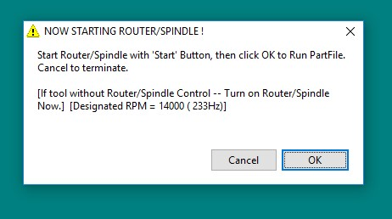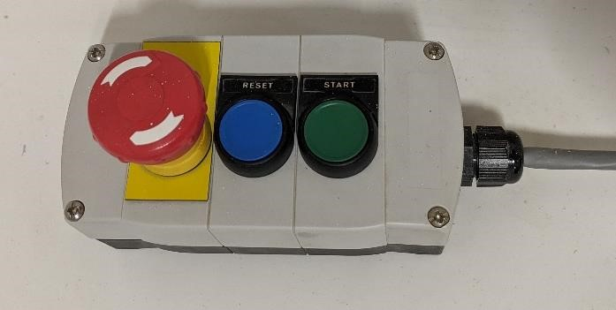

- Verify that the router has begun spinning, if it is not spinning stop and consult with NIS Staff.

- On the computer click “OK”.

- Hover your hand over the space bar, pressing the space bar will pause the job.

- The emergency stop is the last resort, all data is lost when the E Stop is pressed.

- The router will begin cutting.

- You must remain in the router room while it is running, if you need to leave the router must be stopped. Press the spacebar button to pause the job.

Shutdown Procedure
- After the Shopbot has finished running the current job it will return to the designated origin and stop spinning.

- Turn the Safety Override Key to “DISENGAGED” and remove it from the Interlock.

- Power down the Shopbot by rotating the red switch on the control box.

- Remove the bit and collet from the Shopbot.

- Remove your material from the Shopbot bed.

- Vacuum the Shopbot bed and floor around the machine.

- Put away any tools, either on the pegboard or in their toolboxes.

