SOP
Screen Printing
Training is required before using this equipment.
Reservations are required when using this equipment. NIS USES WATER BASED INKS AND CLEANING PRODUCTS

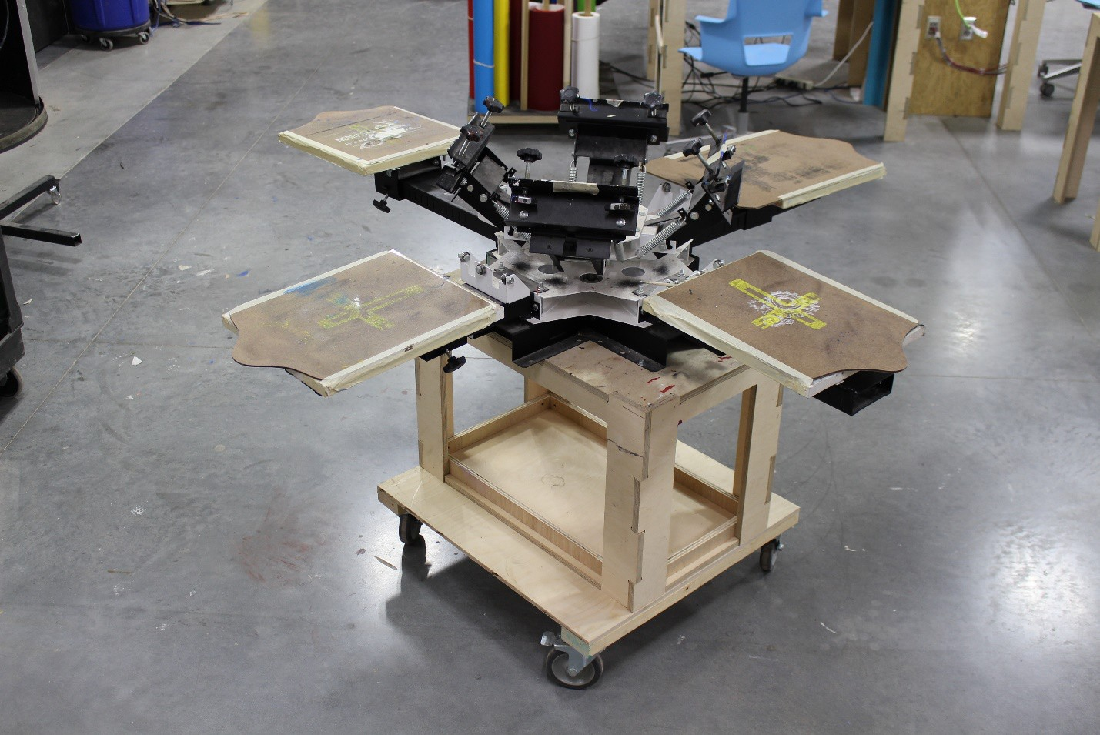

Screen Print Pricing

Screen Rental
21” x 28” $7.00 per screen for 2 weeks
23” x 31” $9.00 per screen for 2 weeks
4” x 6” $3.00 per screen for 2 weeks

Mark your screen by writing your name and today’s date on a piece of masking tape and adhering it to the short side of the screen frame edge so it is visible when stored.

Transparency Film – 0.25₵ per linear inch
Transparency film is sold by the linear inch. You are paying for the number of linear inches you remove from the roll, not the width. Be sure to orient your image(s) along the width of the transparency in order to use the least amount of transparency as possible.
Your artboard (in illustrator) should always be 17” wide as that is the width of the transparency.

Water Based Ink
Base color $1.50 per ounce Custom color $1.50 per ounce
Base colors are used straight out of the container. To determine how much ink you will use first weigh the entire container and write it down. When you have completed your print job for the day weigh the container again and pay for the difference.
Custom colors are yours to keep forever. Mix your color in a studio supplied container and weigh your custom color before you start your project. You pay for and take home all the ink you custom mix.

NIS carries a variety of t shirts in a variety of colors. See NIS staff for specifics.

CHEMICALS

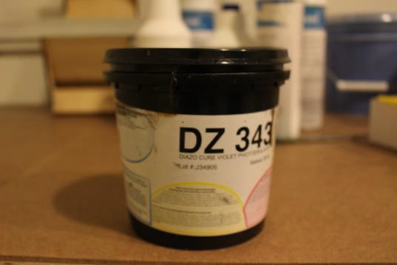
Photo Emulsion:
A light sensitive liquid that is applied to a clean screen. When unexposed to light our emulsion is an army green or brown color. When exposed to light it turns violet. Emulsion has an approximate
1.5 hour dry time before it can be used to expose your image. Make sure to clean top lip & seal container tightly and store in refrigerator.

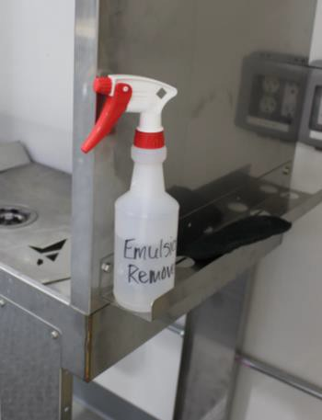
Emulsion Remover:
A chemical that removes the photo emulsion from your screen so you can reclaim the screen.
To reclaim your screen:
Spray both sides of your screen with emulsion remover and allow the remover to sit on the screen for 1 minute. Scrub the screen lightly with Scotchbrite and use the power washer with COLD water to remove the emulsion. Aim the power washer 4-8 inches away from your screen.

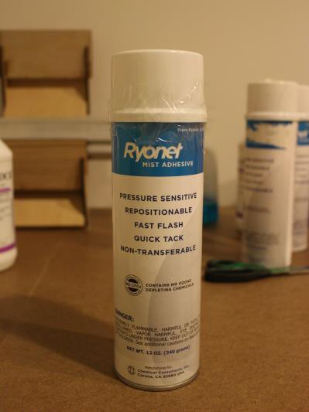
Adhesive Spray:
This spray is applied to the platen and will help to align your registrant as well as adhere your media to the platen so that it does not move during the inking process.

Ink:

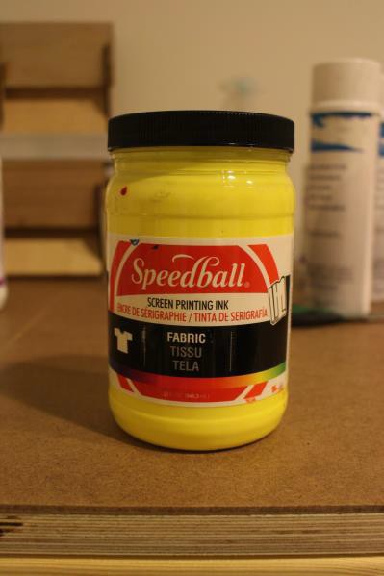
NIS purchases water based inks in a variety of colors. For non-custom colors (ink used directly out of the container) you pay for what you use. For custom mixed colors you pay for what you mix.

Screen Cleaner:
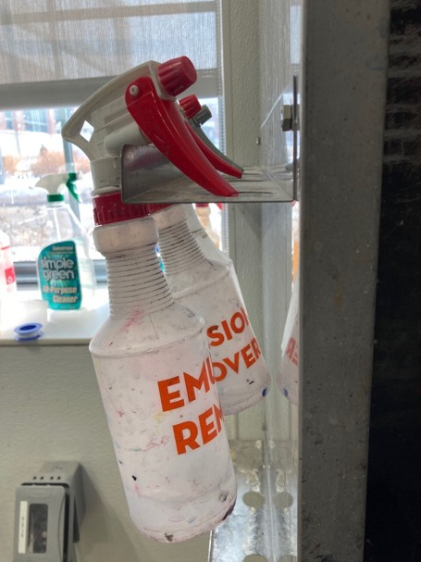
Emulsion remover is used when you are reclaiming your screen or when you need to perform a deep clean on a screen you are about to use. Place the screen in the wash station and spray the screen liberally with emulsion remover. Using a scotchbrite pad scrub the screen lightly until you have removed as much ink and dirt as possible. Rinse your screen using the power washer.

TOOLS AND EQUIPMENT

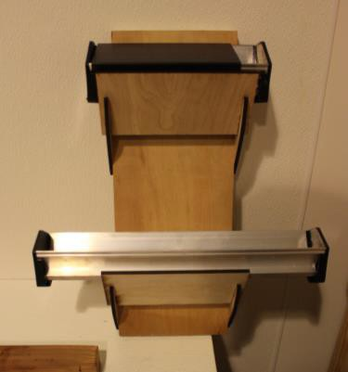
Scoop Coaters:

Scoop coaters are metal trays that dipsense the emulsion when coating your screens. We save all unused emulsion by scooping/placing it back in the container. Make sure to rinse out the scoop coater, squeegees and spatulas well after you are finished coating your screens. We have multiple sizes of scoop coaters at NIS. Choose which one works the best for your image.

Squeegees:

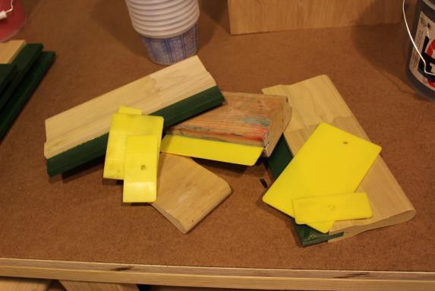
Squeegees are used for applying your ink. We have various sizes, types and rigidity available. Choose a squeegee that will fully cover the stencil part on your exposed screen-not necessarily the whole screen.

Screens:

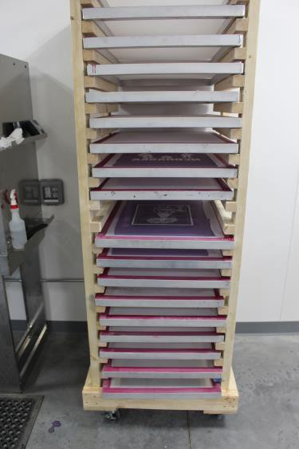
NIS provides 160 mesh screens that are available for members to rent for 2 weeks at a time. See pricing guide for more details.

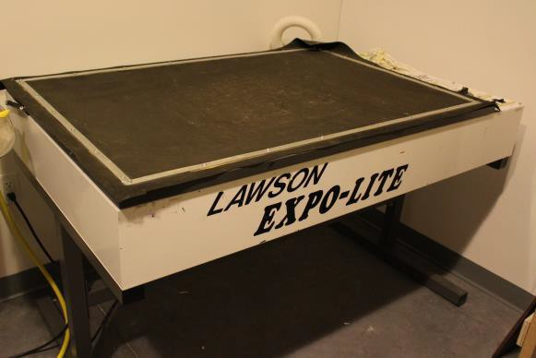
Exposure Unit:
We have a 32” x 48” vacuum exposure table that pulls your screen to your film while exposing. There are 3 switches on the right side of the table that control the vacuum, light and main power. Make sure the light and vacuum switches are in the on position before turning the Master switch on. The standard exposure time is 5 minutes.

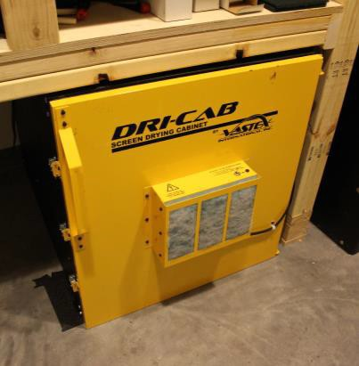
Drying Cabinet:
When screens have been coated with emulsion they must cure in the drying cabinet for approximately 1 to 2 hours. Always place your screen on the most bottom rack and well side up so your emulsion is contained.
Your emulsion must be completely dry before burning your image.

Drying Rack:

After you have cleaned the emulsion out of your image with the pressure washer to reveal your image, or have reclaimed your screen, you will need to place your screen to dry on our rack beside the wash-out booth.
Always place your wet screen on the lowest rung. You may need to move other screens to create space.

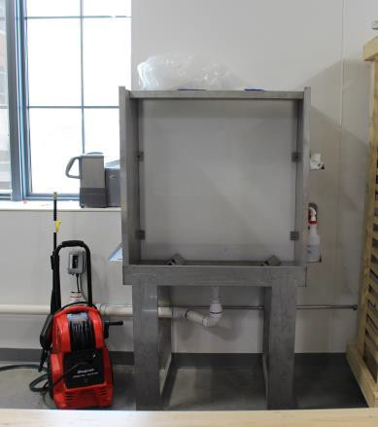
Pressure Washer & Washout Booth:
Our pressure washer & washout booth are located in the art studio. Do not use sinks to wash out screens. Never place any part of your body in front of the nozzle as serious injuries will occur.

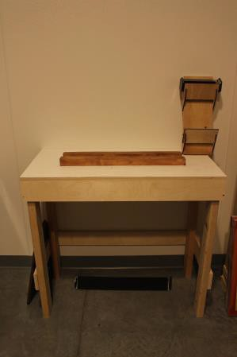
Emulsion Station:
In the darkroom there is a designated table with a slot for placing screens when coating with emulsion.

Four Station Press:
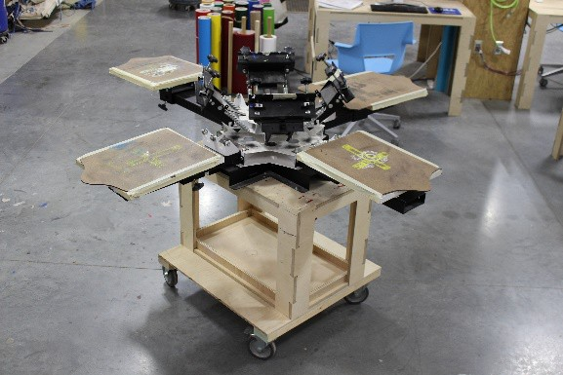
The four station press will allow you to print anywhere from single color to four color prints. The press will allow you to adjust print locations up, down, left, & right. We have two sizes of platens for different size shirts.

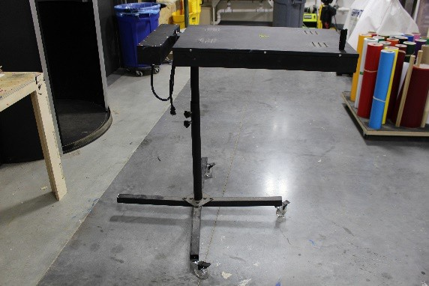
Flash Dryer:
The flash dryer will speed up your ink drying process to approximately 90 seconds. After your ink has been applied, place the flash dryer over your item and let it set for between 90 and 120 seconds. You will then be able to safely remove your screened item without the possibility of ruining it due to wet ink.

Step 1: CREATING YOUR DESIGN
There are a number of ways that you can import a file or image that you want to print.
- Create a vector file using Adobe Illustrator.
- Import a design from other design software.
- Import a design from the internet.
- Most t shirt images are less than 10” wide.
-Your design must be solid black. If you want gray scale use half-tone and design it in photoshop.

Step 2: PRINTING YOUR TRANSPARENCY

- Print your image on the Epson 4900 Large Format Printer using the transparency roll.
- Your image can be no wider than 17” due print area limitations.
- Your image must be printed in solid black ink. You will select your final image color using the water based ink.
  - You can draw on a transparency with a sharpie or paint as well as cut out a shape that is opaque enough to block out the light when you are exposing your screen
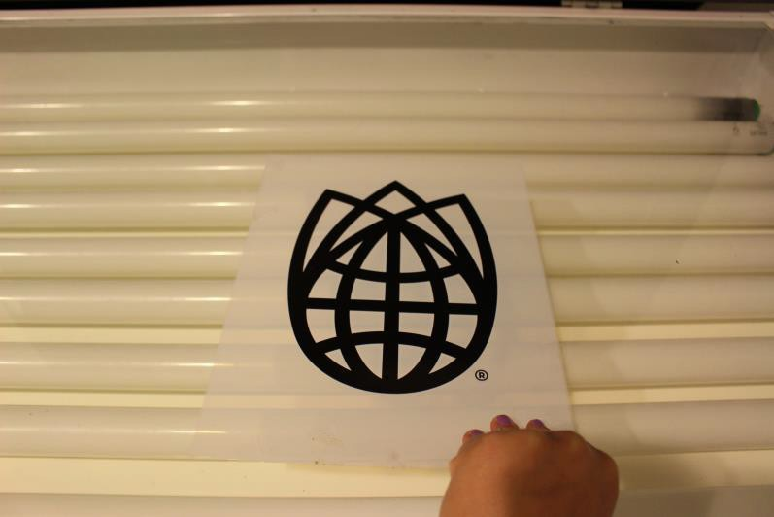

Step 3: APPLYING EMULSION

- Place your screen in the slot, well side out
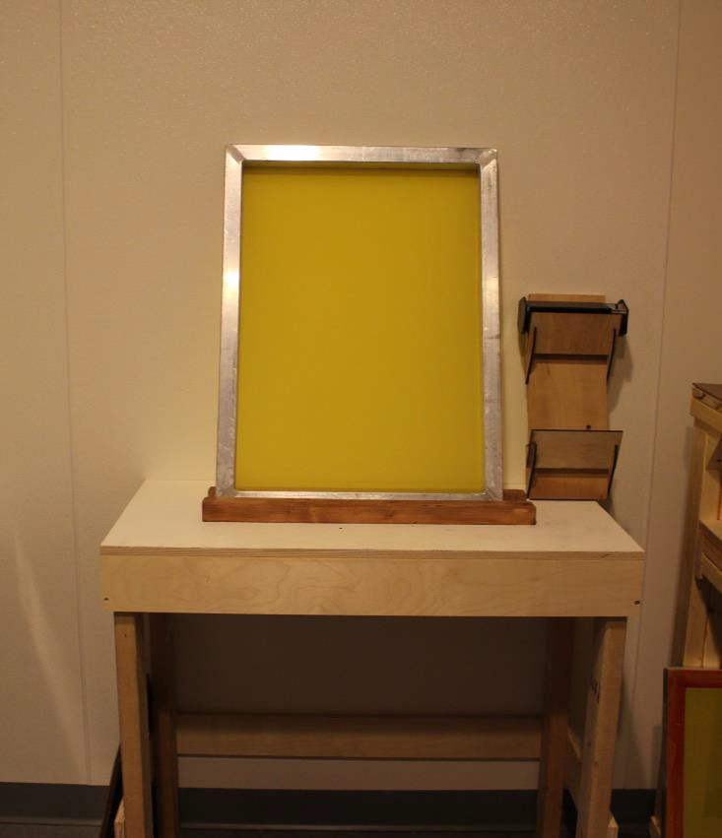
- Select a scoop coater that fits inside the well of the screen and is slightly larger than your image.
- Remove the emulsion from the refrigerator.
- Pour emulsion into the scoop coater.
- Allow the emulsion to level off in the scoop coater.
- The scoop coater has a thick and a thin metal edge on each of the long sides. Use the thin side to apply your emulsion.
- Rest the thin side of the scoop coater against the bottom of the screen.
- Tip the scoop coater forward until the black plastic edges of the scoop coater are resting against the screen.
- Wait for the emulsion to run forward and is contacting the screen.
- Apply a thin layer of emulsion to the screen by dragging the scoop coater from the bottom to the top of the screen, using a fluid and steady motion, applying equal pressure during the entire process.
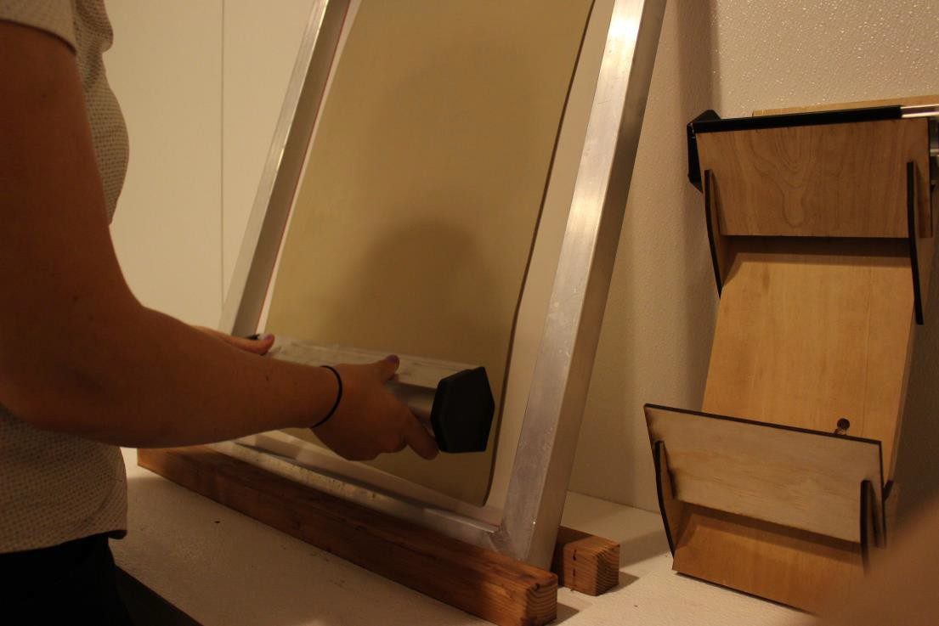

- Tip the emulsion coater back so only the metal edge is resting on the screen and remove the coater from the screen.
- If the application is uneven or has voids you can repeat this process.
- If there is too much emulsion on the screen you can “scrape” off the excess emulsion using just the metal edge. You may need to do this on the front and back side of the screen to achieve optimal application.
- Place the screen well side up and in the lowest location in the Dri-Cab. You may need to move other screens up to create space for your wet screen. Make sure the door is fully closed and latched. Turn on the cabinet if it is not already on.
- Using a spatula, scrape all unused emulsion back into the emulsion container and store the container in the fridge.
- Immediately rinse the scoop coater, spatula, and any other tools that came in contact with the emulsion.
- Rinse the sink thoroughly.

Your screen will need to dry for up to 2 hours.
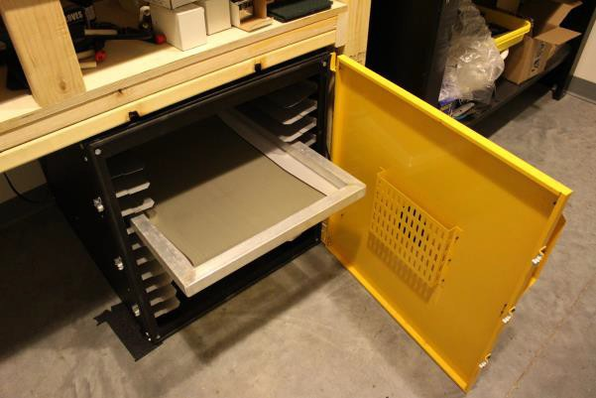

Step 4: EXPOSING YOUR IMAGE

When your screen is dry you are ready to expose your image onto your prepared screen.
- Place your printed image right side up, on the exposure unit.
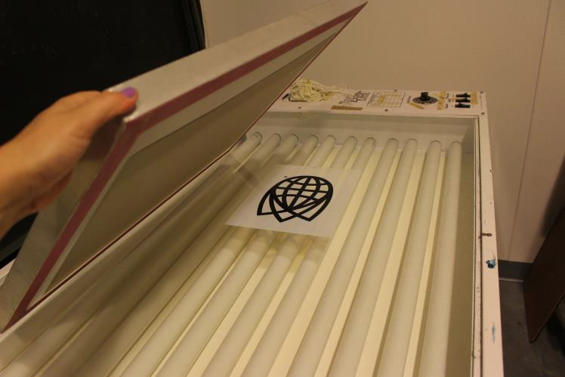
  - Remove your emulsion coated screen from the dri-cab and place well side up on top of your transparency
  - When using the 4 station press or a platen it is best to align you image just below the center of the screen.
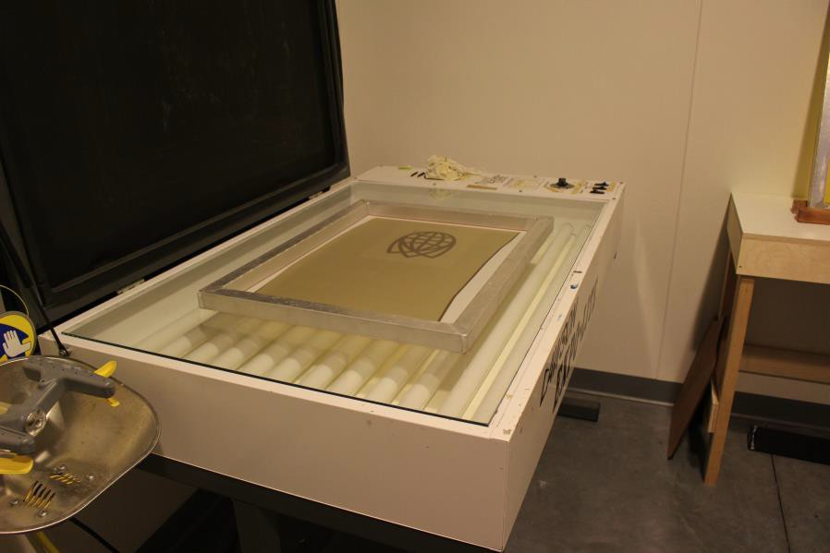
  - Your image must fit in the emulsion area.
•

  - Lower the lid of the exposure unit.

There are 3 switches on the exposure unit:
  - The far left switch is the master switch.
  - The middle switch is for the lights.
  - The far right switch is for the vacuum.
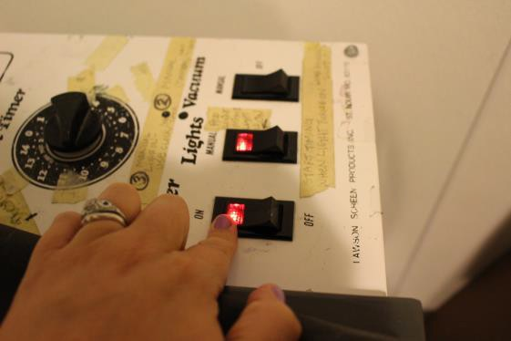
  - Set the middle and the right switches to manual.
  - Flip the Master switch to ‘ON’

Expose your screen for 5 minutes
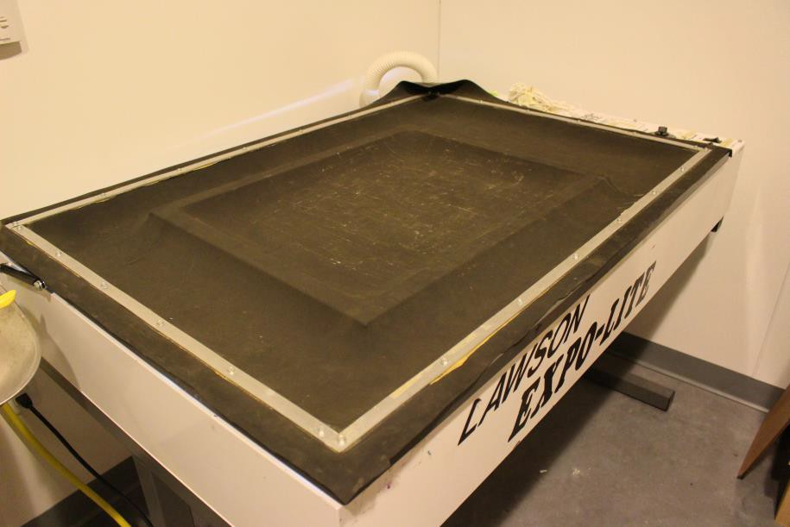
  - Turn off the Master switch, allow vacuum to evacuate, lift the lid and remove your screen.
-

The exposed area of your screen should now be purple. The un-exposed area (image area) should be yellow. If not, find an NIS staff member.

Step 5: WASHING OUT YOUR SCREEN
- Rinsing your screen is a critical step. If you do not follow this procedure as stated you may ruin the screen.
- Place your screen in the wash out booth.
- Turn on the pressure washer and the COLD water faucet.
- Hold the pressure washer no closer than 12 inches from your screen, pull and hold the trigger. Move the wand in slow and consistent movements. If you get closer than 12 inches you will damage your image and screen.
- Your screen is correctly washed out when there is no more green/yellow emulsion in your image area and you see nothing but clear mesh in the image area. Make sure to look closely at all areas as even small amounts of emulsion left in the screen will create failures during printing.
- Place your screen in the lowest position on the drying rack by moving all other screens up.
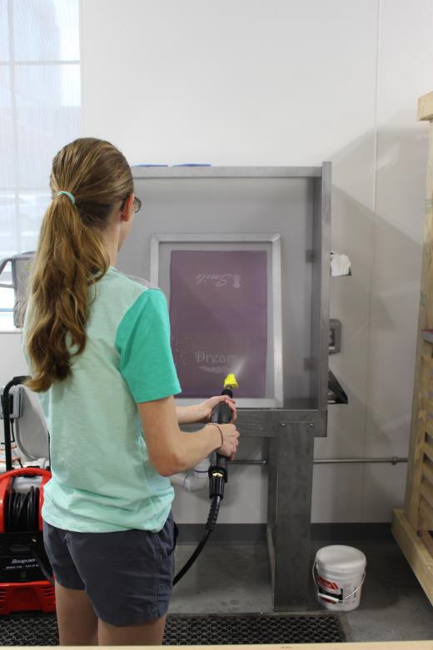

Step 6: SCREEN REGISTRATION
  - There are multiple ways you can print on your desired object
    - 4 station 4 color press
    - Large platen board with hinged clamps
  - When printing something 14” x 16” or smaller (t-shirt, bag, etc.) use the 4 station press.
  - Spray the platen board with a light mist of the fabric adhesive spray.
  - Slide your shirt over the platen and line up the neck, shoulder and sleeve stitch lines so your shirt is centered and square.
  - Plug in and turn on the flash dryer.
  - Use masking tape to seal the areas around the screen frame where there is no emulsion. This will prevent ink bleeding through onto your media.
  - Place masking tape across the screen approximately 4” above and below your image to assist with the ink application location.
  - Place your transparency on your print media at the location you want to print.
  - Secure the screen in the clamps with the well side up. Adjust your left to right position to line up with your transparency before tightening clamps.
  - Adjust the platen with the lower arm knob to move the platen in and out so it lines up with your transparency. Lift up on the platen and tighten knob so that the platen will be level.
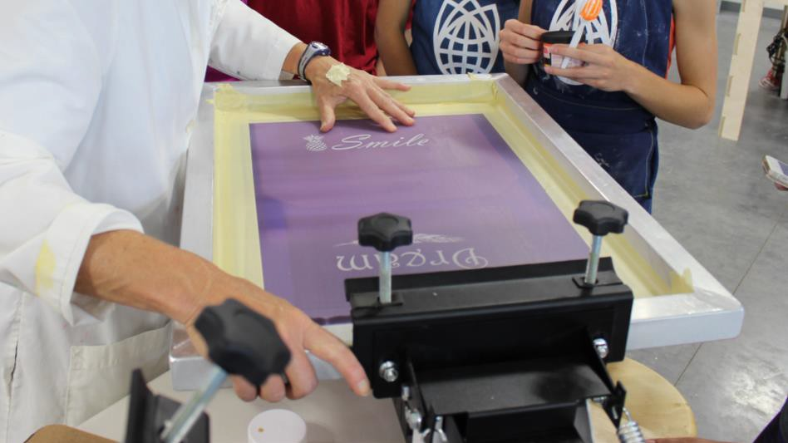

  - WEIGH THE INK CONTAINER IN OUNCES BEFORE PROCEEDING. Write
the weight down on a piece of paper.
  - For custom colors you will pay for all ink mixed. For non-custom colors you will pay for what you used.

  - Lower your screen to the half way point and place your desired ink color in a line above your image and just below the tape located above your image.
  - Select a squeegee that is just wider than your design.
  - Place the squeegee at a 45° on your screen with the ink between the squeegee and image. Using two hands, apply equal pressure on the squeegee and pull towards you, stopping at the tape just below your image.
  - Flip your squeegee so the edge with the ink is now facing away from you and push the squeegee away from you.
  - For multiple prints use the squeegee to lay a thick coat of ink over your print area. This will prevent the screen from drying out between screenings.
  - Place your squeegee against the frame bracket and lift your screen to check the ink application. If more ink application is needed, repeat this process.
  - Place the flash dryer no closer than 6” above your printed image for 90 to 120 seconds. The ink should be dry to the touch.
  - When your print is finished, remove your project from the platen. If you are printing multiples continue printing the rest of your prints
  - To permanently set the ink on a tshirt or fabric item, place it in a clothes dryer for 20 minutes on high heat before washing.

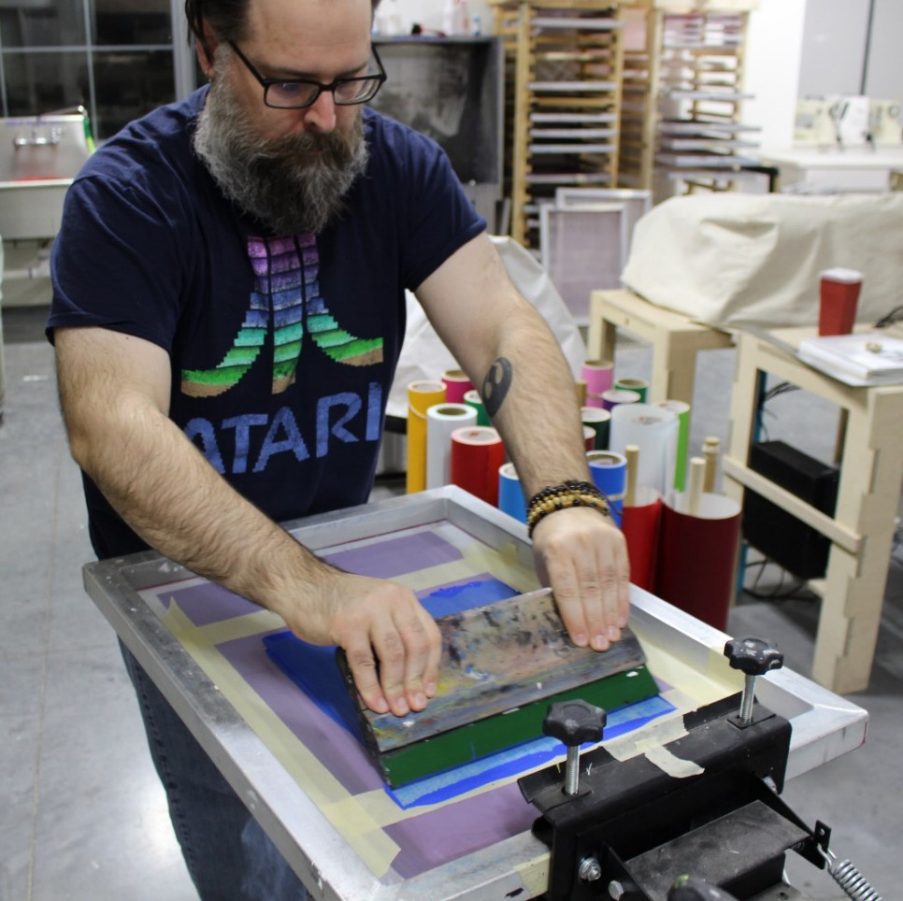

Step 7: CLEANING YOUR SCREEN
- Scoop all excess ink from the screen and place it back into the container.
- Weigh the ink container again. Document this number along with the weight prior to printing. You will pay the difference.
- For custom colors you pay for all the ink you mixed.
- Remove all tape from the screen.
- Wipe any remaining excess ink from the screen with a paper towel.
- Place screen in wash station.
- Turn on power washer and cold water.
- Hold pressure washer nozzle two feet from screen and remove excess ink. This will prevent excessive splashing. When most of the ink has been removed move the nozzle no closer than twelve inches from the screen and using slow and steady motions, removing the remaining ink. You may need to flip the screen and wash the back.
- If there is a lot of ink residue remaining you can use the Blue Mac stain remover. Apply a conservative amount directly to the screen and scrub lightly with a scotchbrite pad.
- Rinse again using power washer.
- Place your screen on the lowest rung of the drying rack. You may need to move other screens up.
- Rinse squeegees, spatulas, and any other items you used in the sink.
- Thoroughly rinse the sink.
- Thoroughly rinse out the wash station. Clear the drain by removing all chunks of ink, emulsion and any other objects.
- Turn off the power washer and the water. Place the washer nozzle in the sink to drain off the water line.

Step 8: RECLAIMING YOUR SCREEN
Screens are rented for two weeks at a time. At the end of the two weeks you may either renew your rental or continue to use the screen or reclaim your screen and return it for other members to use.
During your two week rental period you may reuse your screen with your original image as many times as you wish.
During your two week rental period you may also apply new images to your screen. Every new image application requires a $2.00 emulsion application fee due at the time of application.

To reclaim your screen:
- Place your screen in the washout booth.
- Spray both sides of your screen with Emulsion Remover and let it rest for one minute.
- Lightly scrub the screen on both sides with a scotchbrite pad.
- Turn on the cold water and power washer.
- Hold the nozzle no closer than 6” from the screen.
- Using very slow and fluid up and down motions, spray your screen. Your speed is correct when the emulsion is being removed in a single pass.
- Re-apply emulsion remover and spray screen until all the emulsion has been removed.
- Some areas may not remove easily. Apply more emulsion remover, Blue Mac stain remover, and flip the screen around so that large chunks of emulsion are being pushed off the screen rather than through the screen.
- Place your screen on the lowest rung of the drying rack. You may need to move other screens up.
- Thoroughly rinse out the wash station. Clear the drain by removing all chunks of ink, emulsion and any other objects.
- Turn off the power washer and the water. Place the washer nozzle in the sink to drain off the water line.

Step 9: CLEANUP
- Wipe down ink bottles and store in closet.
- Clean and put away all squeegees & spatulas.
- Store adhesive spray, masking tape, tape measure, etc. on the screen printing cart.
- Unplug and put away flash dryer and extension cord.
- Wipe down work areas.
- Rinse out sink and wash station.
- Mop floor and put up wet floor sign.

