SOP
CNC FIBER LASER

OPERATOR MANUAL
Training is required before using this equipment
Closed Toed Shoes required
Steel Toe Protection required
Eye & Ear Protection required
Safety Gloves required
Never leave machine unattended while operating
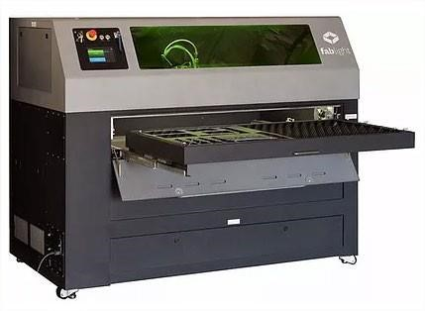

FIBER LASER SPECIFICATIONS
MAXIMUM MATERIAL DIMENSIONS:
SHEET
Width x height (X,Y): 50” X 25”
Thickness: SEE ‘APPROVED MATERIAL’
SQUARE/RECTANGLE/ROUND TUBE
Diameter:0.5” to 2”
Length: 3” to 80”
Tube must be 3” longer (1½” per side) than the size of the job being cut.
APPROVED MATERIAL:
MILD STEEL – 0.25 MAX CUT THICKNESS - COLD ROLLED ONLY
ALUMINUM – 0.188 MAX CUT THICKNESS
COPPER – 0.0480 MAX CUT THICKNESS
BRASS – 0.0800 MAX CUT THICKNESS
STAINLESS STEEL – 0.188 MAX CUT THICKNESS
(also see ‘Material Cutting Instructions’)
TITANIUM – 0.0350 MAX CUT THICKNESS (also see ‘Material Cutting Instructions’)
bronze, nickel, gold, inconel, nitinol, silicon steels, silver, titanium, 4130 chromoly, and more. (See NIS Staff)

OPERATIONS:
CUT
ENGRAVE
RASTER
This SOP covers the Fiber Laser software, FabCreator. FabCreator is loaded on all studio PC’s. FabCreator is a subscription software and is not available for download. To operate the fiber laser see the Operator Manual SOP.

MATERIAL CUTTING INSTRUCTIONS
Hot rolled steel may never be cut, rastered, or engraved on this laser. Hot rolled steel contains mill scale and will destroy the laser lens.
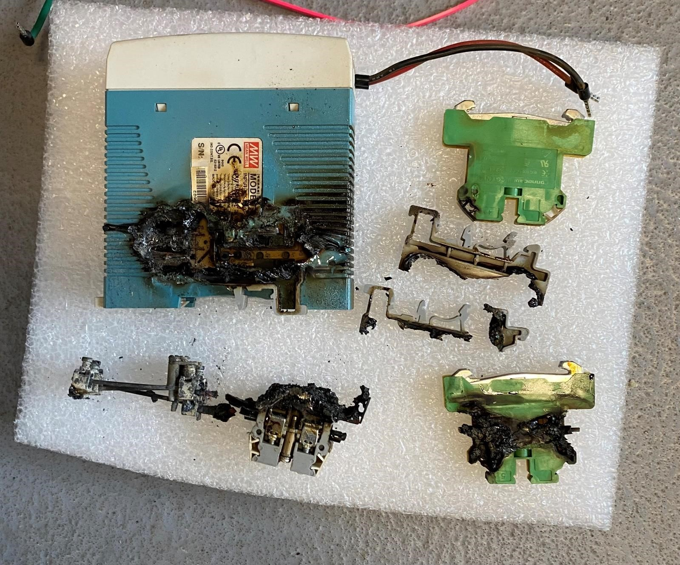

Only cold rolled steel is allowed.
Material must be free of all oils, grease, paint, and any other foreign residue.
Cutting of cold rolled steel, aluminum, copper, and certain gauges of stainless steel is performed using pressurized air.
Stainless steel thicknesses of 7 gauge (0.188) may require the use of nitrogen to obtain satisfactory results. Test your cut with air first. If you do not obtain the desired results you will need to use nitrogen.
Titanium will require the use of nitrogen for all cuts.
There is an additional per-minute charge for cuts when using nitrogen. When you create your cut files using FabCreator you will need to make a note of the total cut time and pay when your job is complete. See NIS staff for current cost.
For cut time instructions see the ‘JOB’ TAB’ section under ‘Step & Repeat’ in the FabCreator Software SOP.
To set up the laser for nitrogen use see the ‘Gas Feed Selection’ section of the Operator Manual.

FIBER LASER COMPONENTS

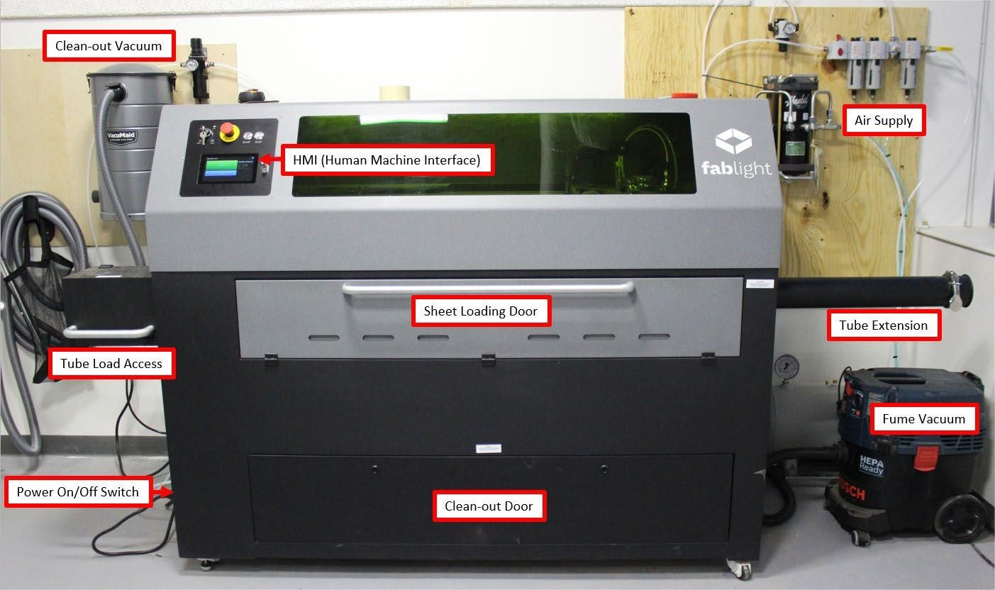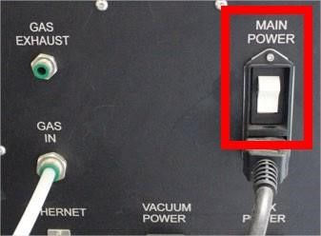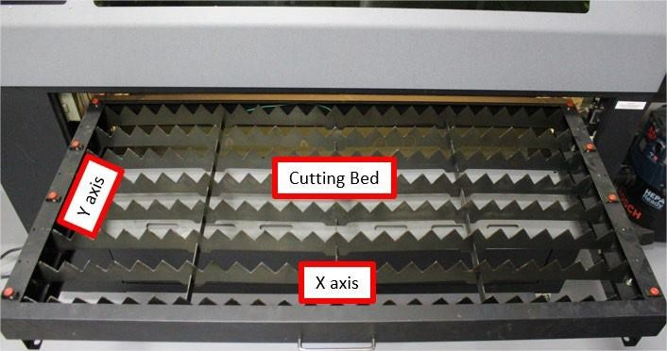

FIBER LASER SAFETY
- Fiber lasers use lethal voltage levels when operating.
- Moving components inside the machine can cause serious bodily harm.
- Laser cutting or engraving of metals creates hazardous fumes.
- Fiber lasers will pierce flesh and cause blindness.
- While the fiber laser is operating all doors and all access panels MUST BE CLOSED and securely fastened and the fume extraction vacuum MUST BE ON.
- Fiber Lasers require very specific PSI gas flow settings.
  - DO NOT adjust any gauges or regulators. o DO NOT disconnect any tubing.
  - DO NOT open or close any valves unless specifically mentioned in this SOP.

MATERIAL CUTTING INSTRUCTIONS
Hot rolled steel may never be cut, rastered, or engraved on this laser. Hot rolled steel contains mill scale and will destroy the laser lens.
Only cold rolled steel is allowed.
Material must be free of all oils, grease, paint, and any other foreign residue.
Cutting of cold rolled steel, aluminum, copper, and certain gauges of stainless steel is performed using pressurized air.
Stainless steel thicknesses of 7 gauge (0.188) may require the use of nitrogen to obtain satisfactory results. Test your cut with air first. If you do not obtain the desired results you will need to use nitrogen.
Titanium will require the use of nitrogen for all cuts.
There is an additional per-minute charge for cuts when using nitrogen. When you create your cut files using FabCreator you will need to make a note of the total cut time and pay when your job is complete. See NIS staff for current cost.
For cut time instructions see the ‘JOB’ TAB’ section under ‘Step & Repeat’ in the FabCreator Software SOP.
To set up the laser for nitrogen use see the ‘Gas Feed Selection’ section of this manual.

POWERING ON THE LASER
The Control Panel contains the controls for operating the laser cutter.

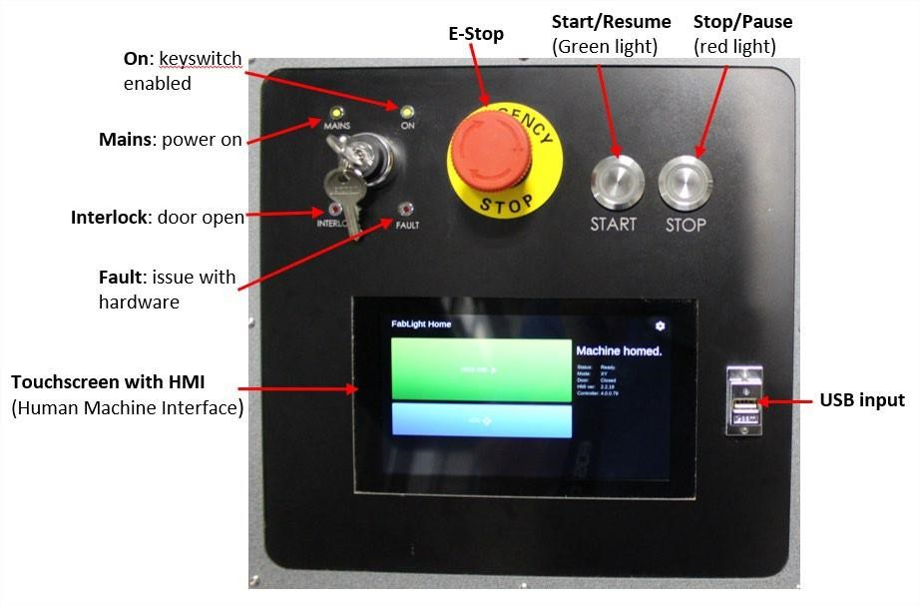
- Activate the ‘MAIN POWER’ switch located on the lower left side panel.

- Verify the E-STOP is released by rotating it clockwise.
- Turn the key from MAINS to ON and release.
- Verify the MAINS and ON lights are illuminated. If INTERLOCK and/or FAULT are illuminated, see NIS staff.
- When the HMI is at full display, insert your USB drive
- The laser automatically powers on the vacuum to the right of the machine when your job starts.
- Verify that all access panels are closed and securely fastened.

LOADING YOUR MATERIAL
All material must be free of oil, paint, adhesives, grease, or any other residue before cutting. These substances will cause damage to the optics in the cutting head if not removed. Reference the ‘FIBER LASER SPECIFICATIONS’ on page 2 of this SOP for approved material specifications.

LOADING SHEET
- Open the material loading door on the front of the laser.

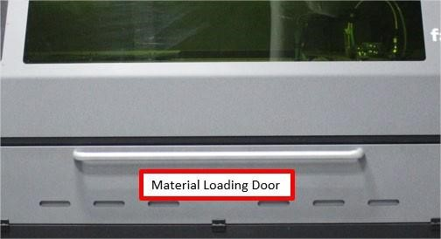
- Verify the right side rotary tool idler is located all the way to the right.

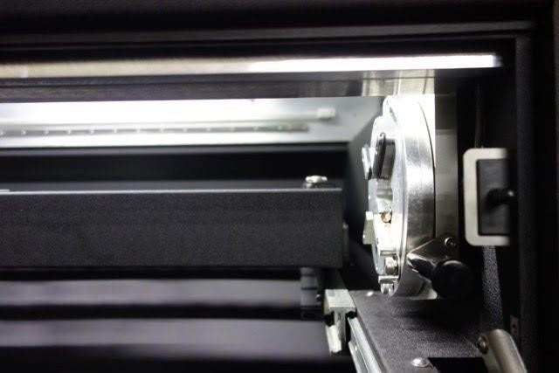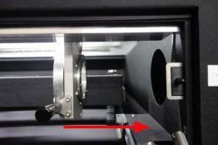
- Pull the sheet material pallet all the way out and set your sheet on the material bed at the X,Y/0,0 location (bottom left). Line up the X side of your material with the frame of the bed. Use the material fastening clips on the Y axis to secure your material to the bed. Notice that you will lose approximately 1” of material on the Y side when inserted into clips.
- Push the sheet material pallet back into the machine slowly. When the pallet is approximately 4” inside the machine you will feel the pallet drop into position. If the pallet is not in the correct location you will get a warning when homing the machine, at which point you can open the door and readjust the pallet.
- Close the material loading door.
- Go to ‘HOMING THE LASER’ section.

LOADING TUBE
Square and round tube can be loaded into the standard rotary jaw chucks. Rectangle tube requires installation of specialized jaw chucks. See NIS staff for assistance. The chucks can accommodate tubes between 0.5” and 2” outer diameter (OD). Your tube must be 3” longer than the finished part as 1.5” of “extra” tube is needed on each end of your tube to secure the tube into the chucks correctly. The maximum standard length of tube the laser can accommodate is 50”. With modification to your file, tube up to 80” can be cut.
- Push the sheet material pallet to the back of the laser until it stops.

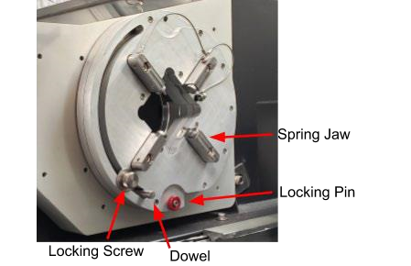
- Activate the locking pin on both the chuck (left side) and idler (right side). The locking pin must be at the 6 o’clock position to lock into place then push it in.
- Retract the jaws on the chuck and idler by loosening the locking screw and sliding the dowel to the lowest position.
- Move the idler to the left until the distance between the idler and chuck is slightly greater than the length of your tube.
- Insert the tube into the chuck side and, while supporting the tube in the chuck, move the idler to the left until the tube can be inserted into the idler. The tube must be inserted past the jaws to the point that it is fully supported by the rotary tool (approximately 1”).
- Lightly close the jaws on idler side by sliding the dowel upwards while wiggling the tube. This will ensure the tube is correctly centered in the jaws.
- Push firmly up on tube while simultaneously pushing up on the dowel on the chuck side and tighten the locking screw. Repeat on the idler side. You may need to perform this process twice to make sure the tube is securely fastened in the rotary jaws.
- Retract the locking pins on the chuck and idler side.

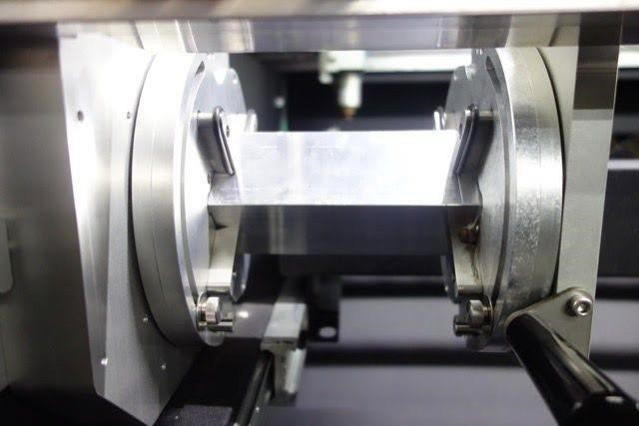
Correctly secured square tube

HOMING THE LASER

When the laser is powered up the HMI will state “Status: Machine Not Homed.” You must run through a homing process to find the cutting head limits. This must be done at initial power up and if the E-Stop button has been pressed.
- On the HMI press ‘HOME MACHINE’. When complete the HMI will state “Machine is homed”
- Press ‘CONTINUE’.

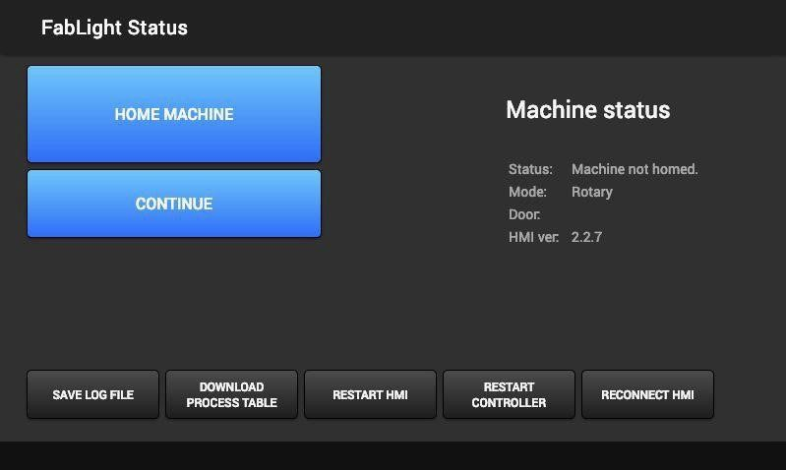
- If the ‘HOME MACHINE’ button is not highlighted, tap on ‘RESTART HMI’. If the issue persists, see NIS staff.
- When the laser is correctly homed you will the ‘Machine homed’ statement on the right side of the Home screen.

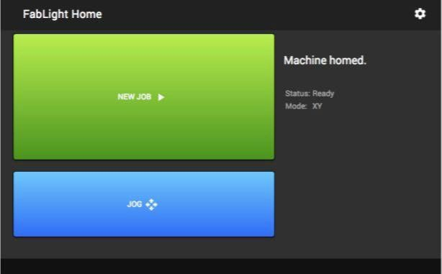

SETTING UP YOUR HOME POSITION
After the laser has been homed the HMI home screen will show “NEW JOB” and “JOG” on the left side and machine status on the right. In this image the machine is homed, status is ready, and in the XY mode (sheet).

JOG FUNCTION
Pressing the ‘JOG’ function allows you to move the cutting head around on the X,Y plane to set your home position.
- Drag on the flags on each axis to set the desired home position on your material.
- For more precise movement, double tap on the blue box, tap clear, and enter the desired coordinate directly.
- Press ‘Done’ when your home position has been established.

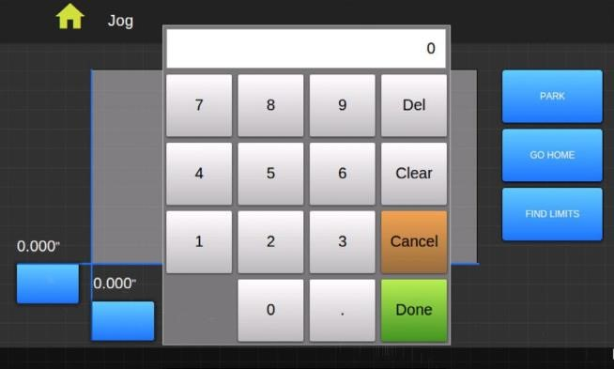
On the right side of the screen are three buttons:
- PARK moves the cutting head to the back corner of the cutting area.
- GO HOME moves the cutting head to the last home position, or the most recent job start position.
- FIND LIMITS re-homes the cutting head back to the laser origin (0,0).

GAS FEED SELECTION
A gas feed is required when cutting, engraving, or rastering with the fiber laser.
Pressurized air is the default gas used when cutting CR (Cold Rolled) steel, aluminum, copper, and lighter gauge stainless.
Nitrogen is REQUIRED when cutting titanium.
Stainless thicknesses of 7 gauge to 3 gauge (3/16 to ¼) may require the use of nitrogen to obtain satisfactory results. Test your cut with air first. If you do not obtain the desired results you will need to use nitrogen. Nitrogen use is based on a per-minute-use fee. See NIS staff for current cost.
YOU MUST VERIFY THE CORRECT GAS FEED IS SELECTED EVERY TIME YOU OPERATE THE LASER.
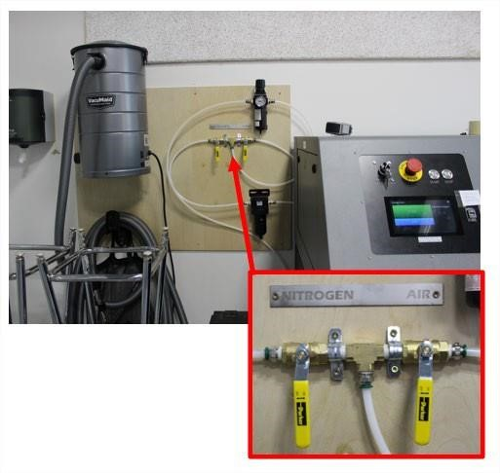

AIR FEED SELECTION
- Verify that the ‘AIR’ valve is open and the ‘NITROGEN’ valve is closed.

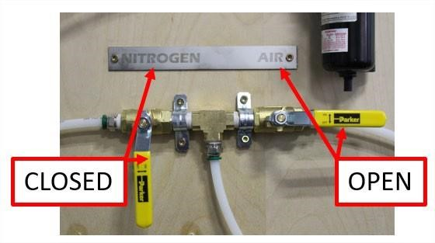
- Rotate the AIR supply valve, located on the right side of laser, to the horizontal, or open position.
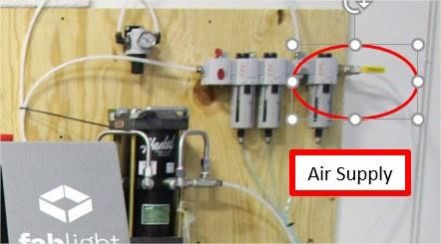

- Wait for the air pump to finish cycling then verify that the gauge located to the left of the laser reads 170 psi. If it does not, see NIS staff.
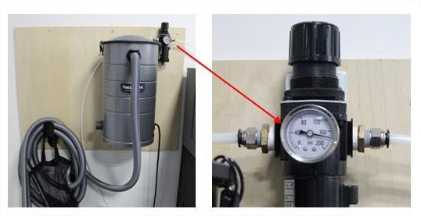

- Click on the ‘SETTINGS’ icon in the top right corner of the HMI.

- Select ‘AIR’ under the ‘MACHINE GAS’ options, then click ‘SAVE’.

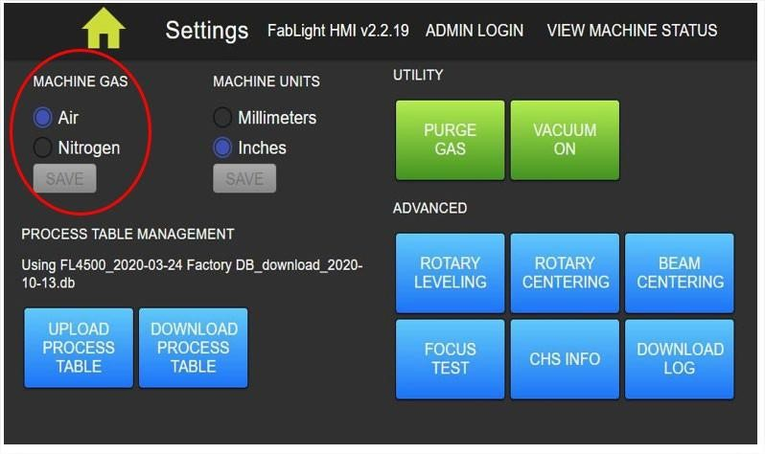
- Press ‘PURGE GAS’ under the ‘UTILITY’ section.

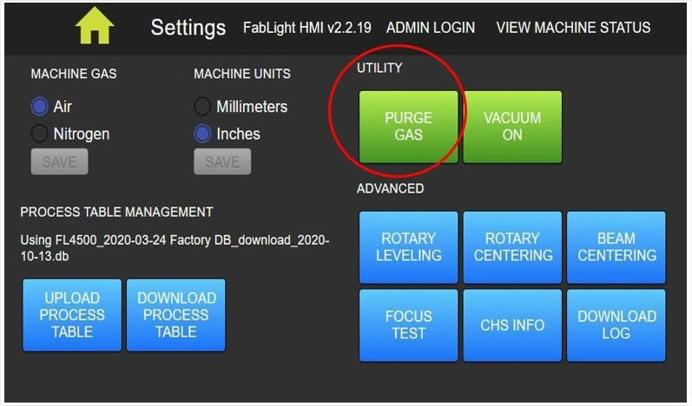
- Press the ‘HOME’ icon to return to job screen.

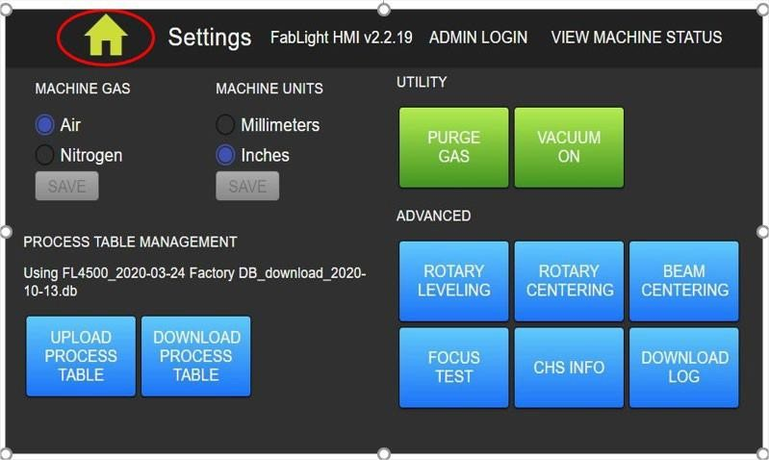

NITROGEN FEED SELECTION
- Verify that the ‘NITROGEN’ feed valve is open and the ‘AIR’ feed valve is closed.

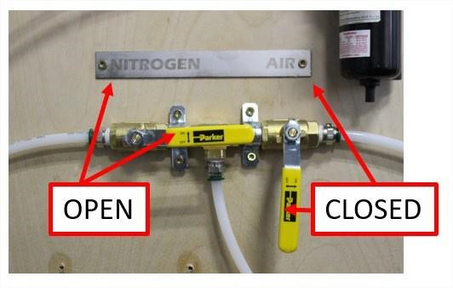
- Turn on the nitrogen supply valve located on the upper left-hand side of the nitrogen tank cart. The valve to open is a stand-alone valve in which the ‘SMITH’ brand gauges are directly attached to.
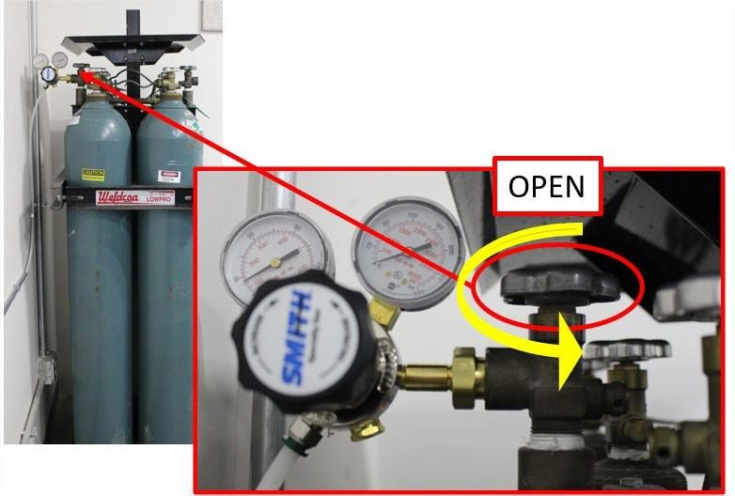

- Verify that the gauge located to the left of the laser reads 170 psi. If it does not, see NIS staff.

- Click on the ‘SETTINGS’ icon in the top right corner of the HMI.

- Select ‘NITROGEN’ under the ‘MACHINE GAS’ options, then click ‘SAVE’.

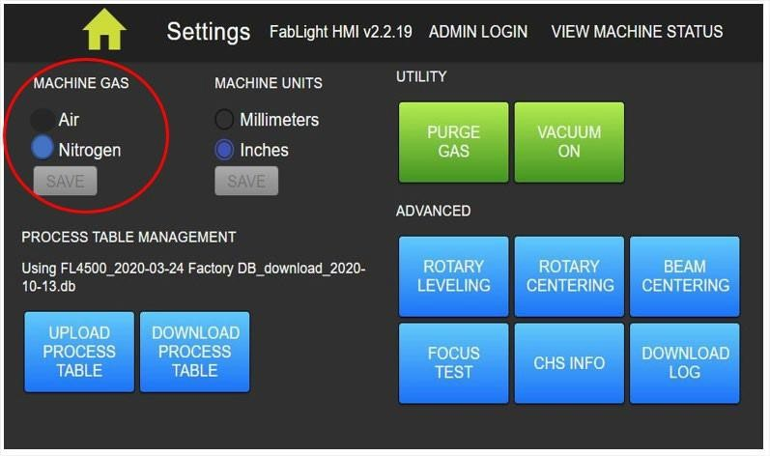
- Press ‘PURGE GAS’ under the ‘UTILITY’ section.

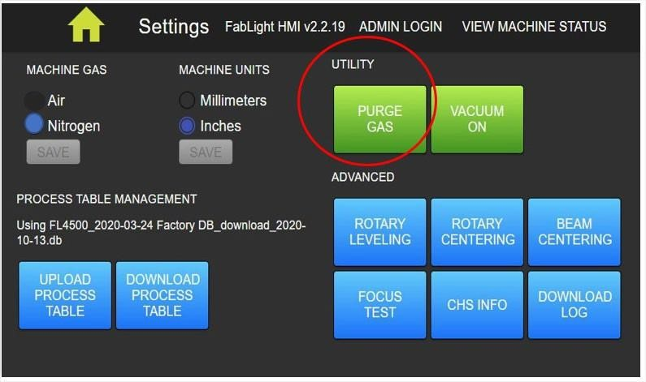
- Press the ‘HOME’ icon to return to job screen.

WHEN YOUR JOB IS COMPLETE YOU MUST TURN OFF NITROGEN SUPPLY AT THE TANK SUPPLY VALVE
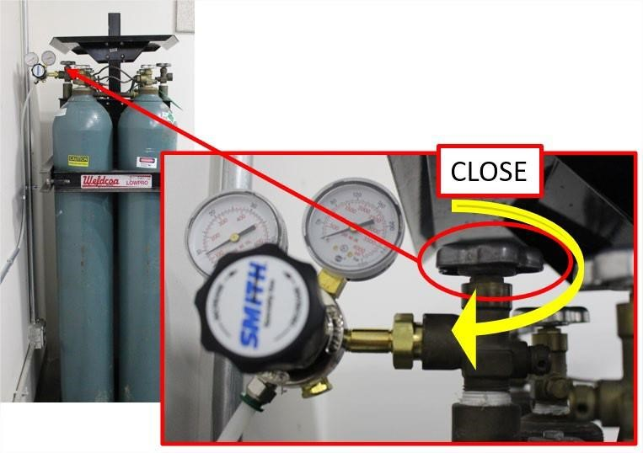

LOADING YOUR .FAB FILE
- Insert your USB into the USB port. Your USB must not be attached to a keychain or any other heavy object. • On the HOME screen, tap ‘NEW JOB’
- Tap ‘REFRESH USB’ if prompted.
- Scroll to find your .fab file and tap to highlight.
- Tap ‘SELECT FILE’ • Verify the correct gas is selected.
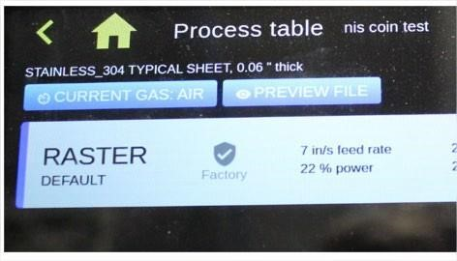
By clicking on the ‘Preview File’ button you may preview your file to verify that your cut, engrave, and raster selections made when creating your .fab file are correct. Green=cut, red=engrave, blue=raster. You may zoom in or out using a 2-finger pinch. The eye logo in the bottom right corner will reset the view. If correct, click on the green check mark. If not correct, you will need to correct your file in FabCreator, then reload the .fab file onto the laser.

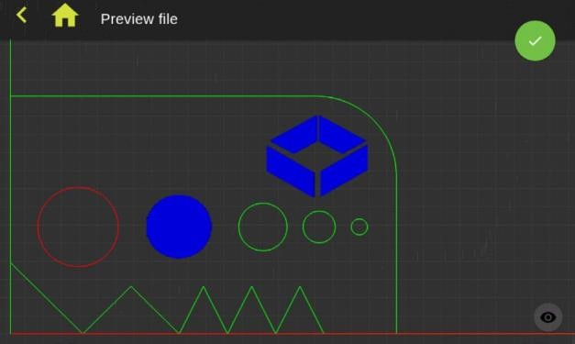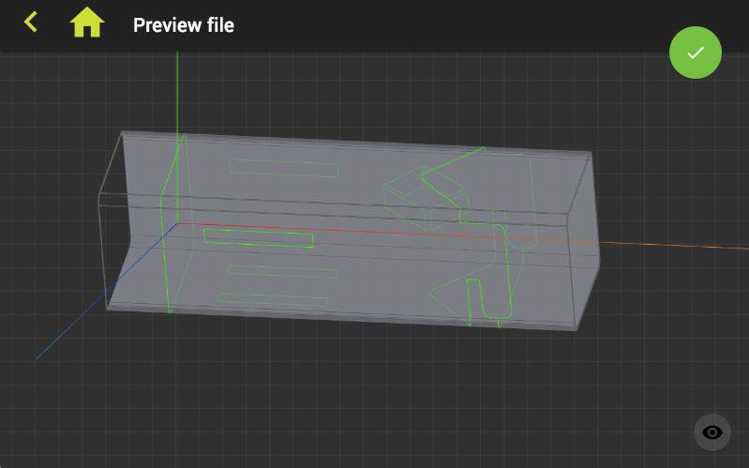

- Click on the green check mark when you are satisfied with the air and file settings. You will now be back at the HOME screen and you are ready to run your job.

PREPARING TO RUN YOUR JOB

POSITIONING THE BOUNDING BOX
The Bounding Box represents the maximum extent of material needed to run your job and is shown in green. All of the parts in your .fab file will fit into the Bounding Box. The left image is sheet, the right image is tube.
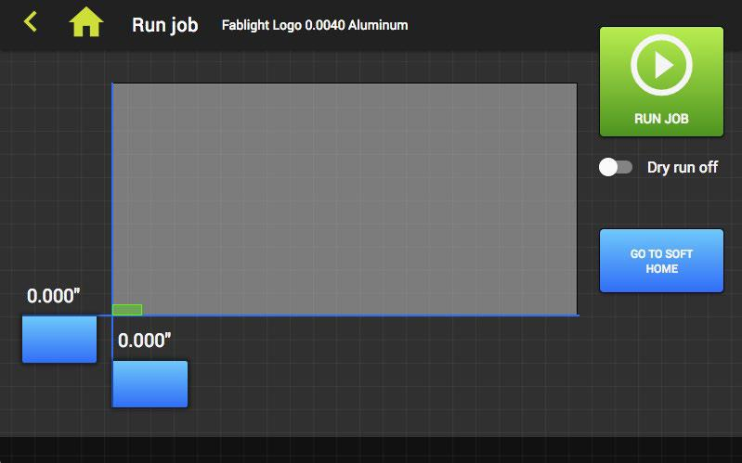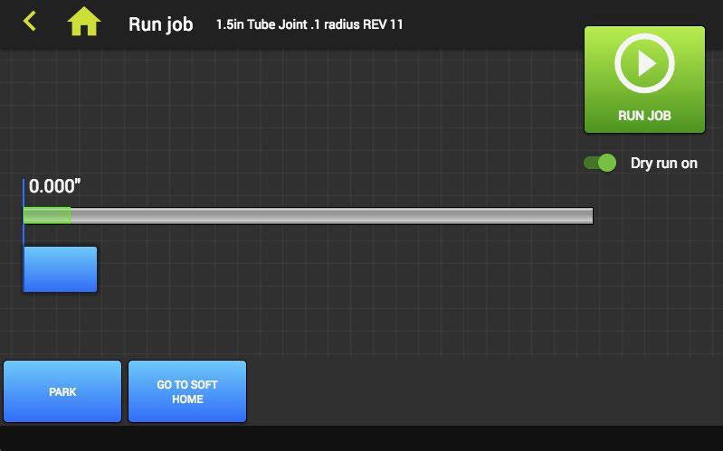
You may reposition the Bounding Box by dragging the flags or double tapping on the blue boxes and entering a value directly. The cutter head will move correspondingly. This is useful if you are using material that has already had cuts performed and you want to cut from a section other than the machine and material X,Y/ 0,0 position.

*This new position is now the temporary SOFT HOME, or your 0,0 position.
This position is not recognized by the laser until you perform a ‘dry run’ or a ‘cut’ function. After one of these functions have been performed, the laser will return to your home position by tapping the ‘GO TO SOFT HOME’ button.* PERFORMING A DRY RUN

Completing a Dry Run is highly recommended. The cutter head will “ghost cut” your job file without actually firing the laser, verifying that your job will fit on your material and in the space allocated. It will also lock in your home position you set in the previous steps.
- Tap the ‘Dry Run Off’ switch under the ‘RUN JOB’ button. The verbiage will now say ‘Dry Run On’ and will be green.
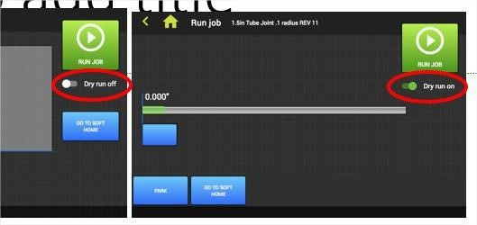

- Tap the ‘RUN JOB’ button.
- The ‘START’ button above the HMI will flash green. Press the ‘START’ button and observe the dry run through the window and verify that the laser head moves within your set parameters.
- If all is correct, tap the ‘Dry Run On’ switch and it will change to ‘Dry Run Off’. If all is not correct, make the necessary changes to your file, home position, or material location and perform the Dry Run again.

RUNNING YOUR JOB
You are now ready to run your job. Before starting your job, make sure you understand the functions of the Start and Stop buttons as they perform more than just one function.
When the job is sent to the laser, the START button will flash green. To start the job, press the START button. The START button will be solid green and the STOP button will be solid red.
To pause the job, press the STOP button once. Both buttons will flash.
To resume the job, press the START button. Both buttons will be solid. To cancel the job from pause, press the STOP button again. Both buttons will be dark.
To run the job again after a complete stop has been initiated, you must restart the job from the HMI.
IT IS CRITICAL THAT YOU OBSERVE THE LASER AS IT CUTS. IF SPARKS APPEAR ABOVE THE CUT, OR ON THE TOP OF YOUR MATERIAL,
IMMEDIATELY HIT THE STOP BUTTON AND SEE AN NIS STAFF PERSON. YOU MAY NOT LEAVE THE LASER UNATTENDED WHEN RUNNING.
This is caused by incorrect material settings and will destroy the laser lens. It is an indication that the laser is not cutting all the way through your material. You will see sparks on the top side of your material as the laser is cutting and will hear a noticeable change in the sound of the laser as it cuts. This could happen at the beginning, middle or end of your cut so you must observe the laser operation the entire time it is running.
- Wear ear protection.
- Wear eye protection.
- Close CNC room door.
- Verify ‘Dry Run Off’ status on the Run Job screen.
- Tap ‘RUN JOB’
- The ‘START’ button above the HMI will now flash green. Press the ‘START’ button and the laser will begin to cut your job.

CLEANUP
Our motto has always been “leave it cleaner than you found it”. This motto applies to all equipment at NIS.
- Open the clean-out door using the red handled allen wrench by turning the two fasteners to the left until the door releases.
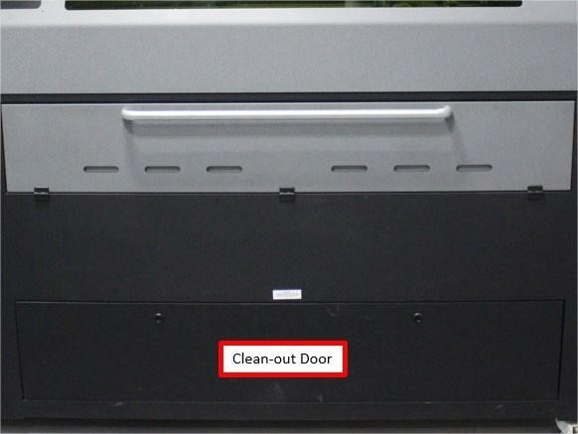

- Lift door out of track.
- Wearing gloves, remove larger metal pieces. Pick up remaining large pieces with a magnet, if possible.
- Using vacuum mounted on wall to the left side of laser, vacuum all remaining debris from base of laser.
- Replace clean-out door and engage fasteners by turning them clockwise.
- Sweep floor.
- Throw away all scrap metal in scrap metal bins.
- Remove your flash drive and power off laser at lower left hand power switch.
- TURN OFF AIR AND/OR NITROGEN SUPPLY.
- Enjoy the rest of your day.

