SOP

CANON IMAGEPROGRAF PRO-4100 PRINTER

\Training is required before using this equipment Reservations are required when using this equipment

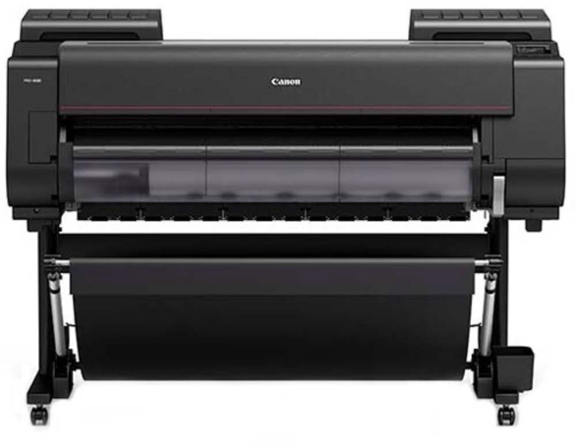

V 1.0

MATERIAL SPECIFICATIONS

The Canon Pro-4100 will print on roll or sheet paper or roll vinyl. NIS has Canon Pro-Luster paper in widths of 24” and 42” and Canon roll vinyl 24” wide. PLEASE ASK NIS STAFF TO CHANGE ROLLS.

Members can supply their own sheet paper. Sheet paper must be 8.5” x 11” or larger or the printer will not “see” it.
Printing costs $3.75 per square foot of roll paper (regardless of the image size). If you supply your own paper, the cost is $3 per square foot.

BASIC CONTROLS

The on-off button is on the top right of the machine. This is also where you can change paper type from Pro Luster to other papers or to Canon vinyl by using the touch screen. This printer will only work with Canon white vinyl. Do not attempt to print on other NIS vinyl. The home screen will also tell you how much paper (or vinyl) remains on the roll.

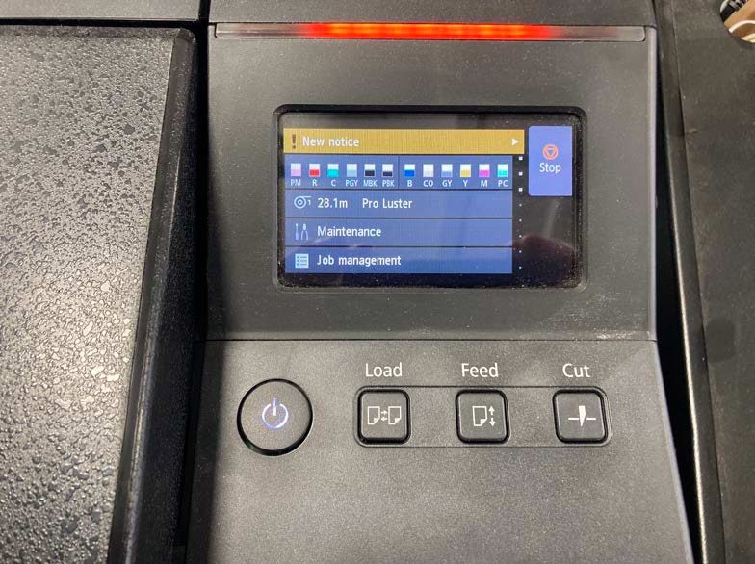

To change paper type, touch PRO LUSTER and then scroll down to the category and specific paper you are using.

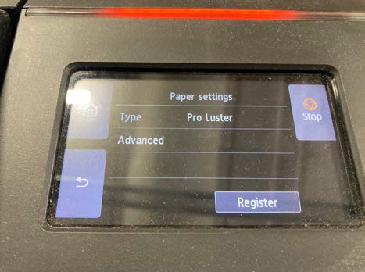
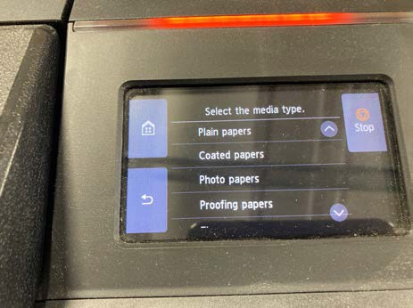

You will have the opportunity to choose between:

- Plain papers
- Coated papers
- Photo papers
- Proofing papers
- Fine art papers
- Sign
- CAD papers

Within each of those categories are choices for specific papers. The printer will automatically adjust ink settings based on the paper you select.
If you are using roll paper and want to print images smaller than 24” inches wide, you can place multiple images in the same Photoshop file and cut them on the paper cutter after printing on the Canon.

USING SHEET PAPER
To switch from roll paper to sheet paper, follow these steps:

- Press the LOAD button on the main control panel.

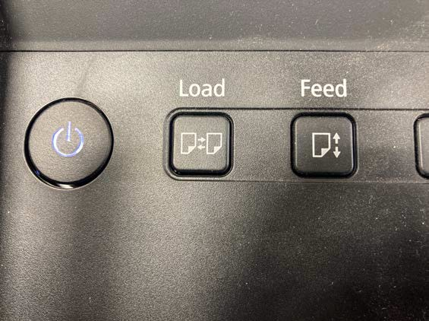


The printer will then give a series of instructions on loading paper.
- To put your paper in the printer, lift the release handle on the lower right of the machine.
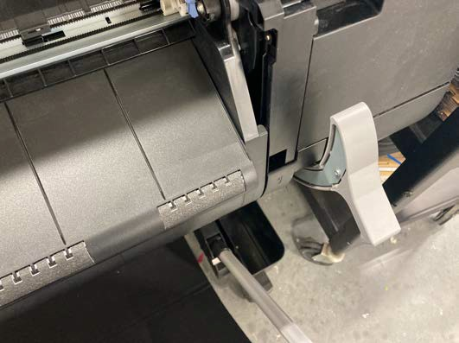


- Lifting the lever will create a gap for the paper to slide in. Align the top and right side of your paper using the orange guides in the printer.

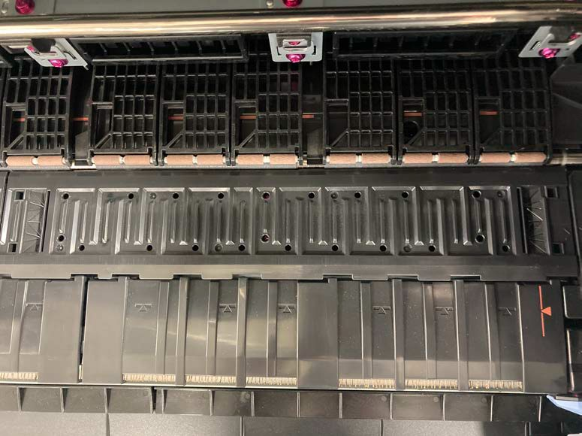


To help align the top of your paper, the printer will offer to apply suction to the paper. Choose STANDARD suction.

PRINTING PHOTOS

Using the Mac, you can print photos from Photoshop or ImagePrint. This SOP
will cover printing from Photoshop. ImagePrint software, preferred by professional photographers, is available but not supported.
The cost of printing is $3.75 per square foot for roll paper or vinyl and $3 for member-supplied paper.
Open your photo in Photoshop. Go to FILE > PRINT > PRINT SETTINGS

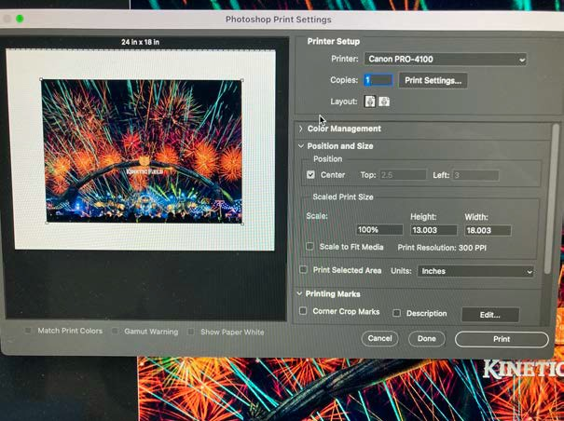


NOTE:
The photo is 18” x 13”

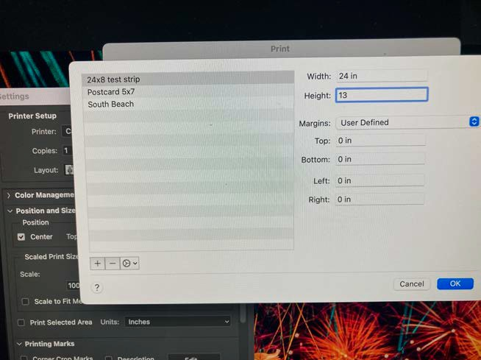


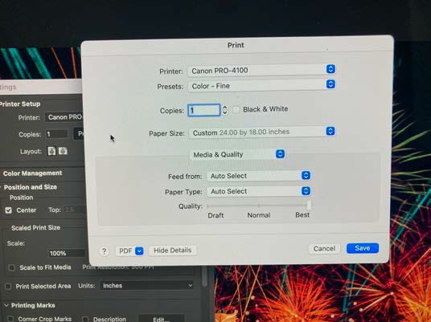
CLICK the arrow next to PAPER SIZE and scroll down to MANAGE CUSTOM SIZES
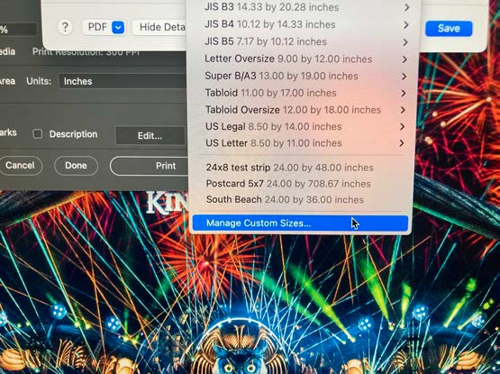
Click on MANAGE CUSTOM SIZES

Put in the dimensions of your image. In this case, the width is 24” because that is the size of the roll. The height is 13”.
Once you’ve typed in the dimensions, click OK.

You will get a screen showing your image bounded by the print size you selected. Double check to make sure your image fits.
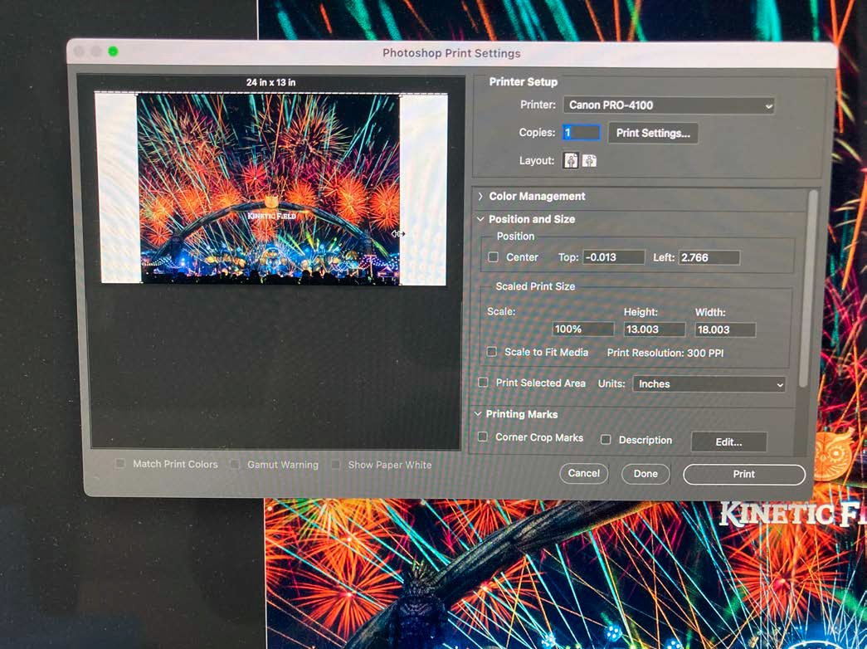



All you need to do now is hit print.

