SOP
Trotec Engraving Laser
Engraving Only
No Cutting/Vectoring
Training is required before using this equipment
Reservations are required when using this equipment
YOU MUST WATCH THE LASER AT ALL TIMES
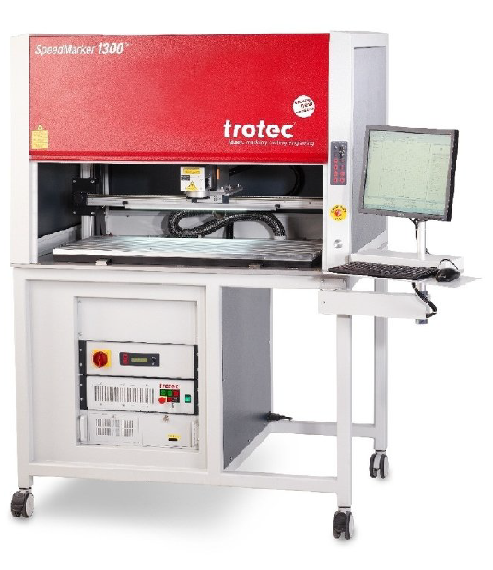

Updated: 11/13/2025

YOU MUST WATCH THE LASER AT ALL TIMES
THIS LASER IS VERY POWERFUL

TROTEC SPECIFICATIONS
MAXIMUM MATERIAL DIMENSIONS – 39” x 17”
MAXIMUM MATERIAL THICKNESS FOR ENGRAVING – 20”

BANNED MATERIALS
Materials containing chlorine (PVC, Moleskin)
Polycarbonate (Barlo, Calibre, Hyzod, Lexan, Makralon, Palsun, Sustanat, Tecanat, Tristar, Makroclear, Arcoplus)
Fr4 Boards (resin reinforced fiberglass composite)
Fiberglass
Metals (No Bare Metal)

SAFETY
Make sure ventilation is on prior to use. The button to start the ventilation is located on the west wall and pulls to activate. This will pull smoke from all the lasers. Confirm the ventilation is on before using the laser.
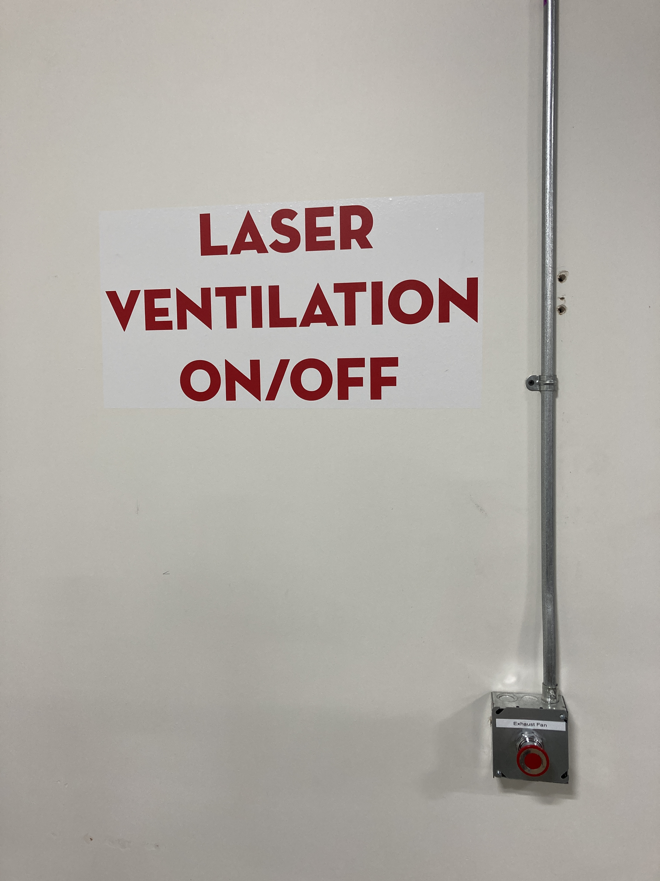
If you are done with your laser, and nobody else is using the lasers, turn the ventilation system off.

As an engraving machine, there should be few or no flames. If the flame persists or your material is on fire, push the pause button on the top of the laser.
You may also spray water on it or smother it with scrap plywood. If a fire extinguisher is needed, contact NIS staff immediately.

The laser will not fire when the door is open.

Never leave the laser while it is in operation.
Never operate more than one laser simultaneously.

TURN ON THE LASER & ACCESSORIES
- Turn on the Chiller
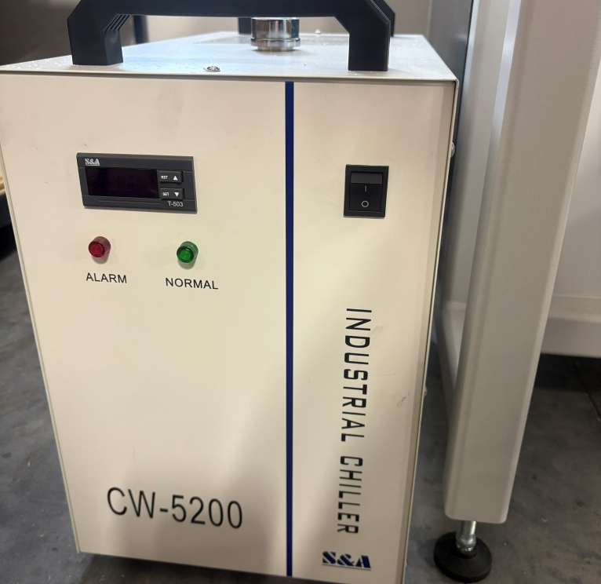
TEMPERATURE
ON/OFF SWITCH
- Wait approximately 5 minutes for the chiller to cool. It should be approximately 22 °C.
- Turn the Master Breaker to the vertical position. The system should start turning on
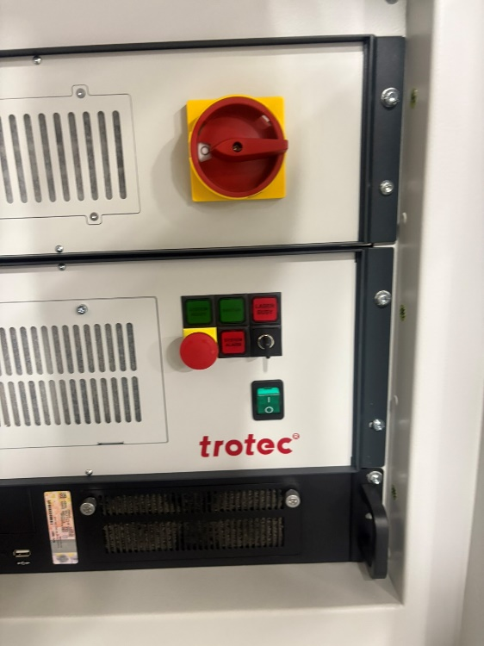
MASTER BREAKER

- Wait approximately 10 seconds.
- Turn on the green Laser Power switch.
LASER POWER
- Wait approximately 10 seconds.
- Turn the laser arming key so that it is horizontal.
KEY

- The computer should automatically turn on, log into Guest.
- The SpeedMark software should automatically load. It takes a few minutes.
- If asked to Reference Axis, select Yes. 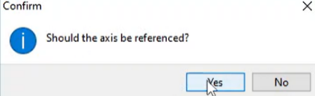

- Once the laser and computer have booted on, press the ON/ü button. This must be done when the laser first turns on, and also after any emergency stop.
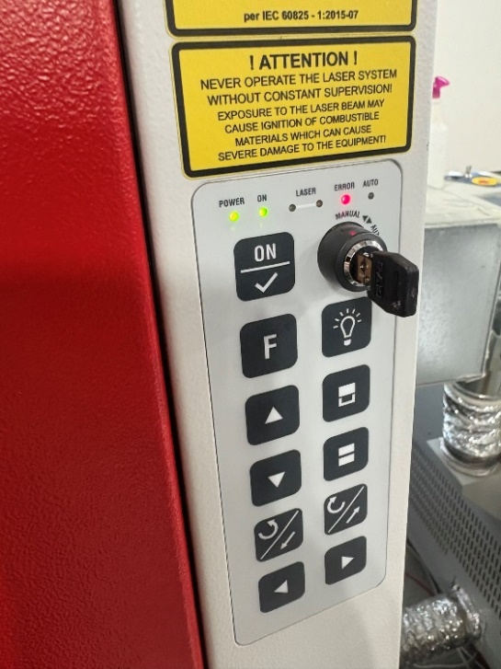
ON BUTTON
- If the Laser Alarm button is on, press it to reset the laser. This must be done when the laser first turns on, and also after any emergency stop.
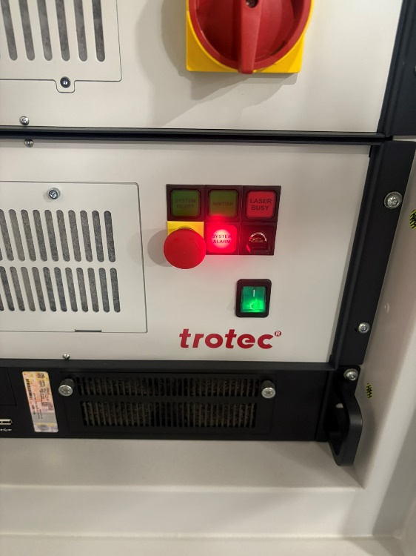
LASER RESET BUTTON
- Press the ON/ü button again.

CONTROL PANEL & FOCUS LASER
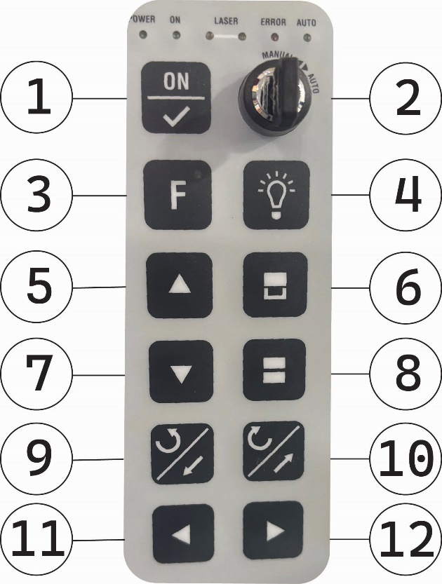
- Use the control panel to prepare the laser
Button | Function
1 | ON /ü
2 | Manual/Automatic Key (should be set to Manual)
3 | Function Key (not normally used)
4 | Interior Lighting On/Off
5 | Move Laser Up (Used to Focus)
6 | Door Open
7 | Move Laser Down (Used to Focus)
8 | Door Close
9 | Move Laser Bed Forward
10 | Move Laser Bed Backward
11 | Move Laser Bed to Left
12 | Move Laser Bed to Right
- Open the Door (button 6) and place your workpiece.
- Move the laser bed forward/backward (buttons 9/10) and the laser head left/right (buttons 11/12) until the laser dot is on your workpiece.
- Focus the laser by moving it up and down (buttons 5/7) until the two red laser dots are at the same location. (The laser mount will be approximately 1 foot above the workpiece)
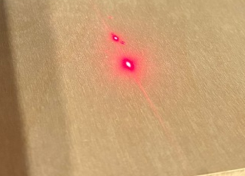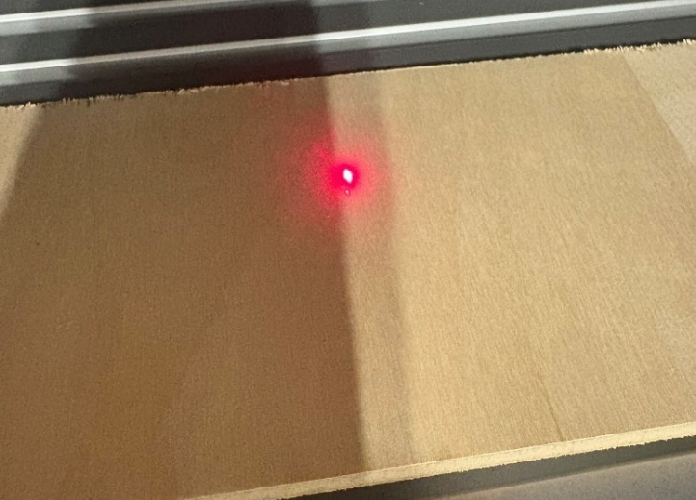
Two dots = Not in Focus Dots overlapping = Focused

SETTING UP YOUR FILE TO PRINT
- If you only need simple text or shapes
  - Create directly with SpeedMark built-in tools
  - Skip this section and proceed to ‘Speedmark’ section

- There are two general types of files. They will engrave differently.
  - Vector files (recommended)
More options and faster engraving.

    - Created from lines and shapes. With line thickness and fill.
    - Standard in Adobe Illustrator
    - Common file types: SVG, DXF

  - Pixel images
Fewer options and slower engraving.

    - Created from pixels to form an image.
    - Standard in Adobe Photoshop
    - Common file types: JPG, PNG

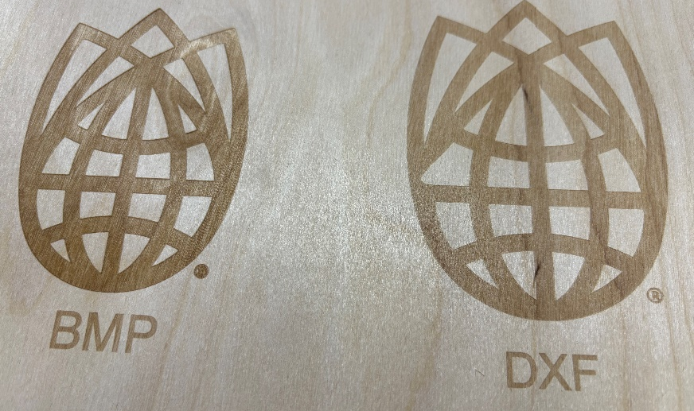
Wood: Pixel image on left, Vector file on right.
Pixel image is darker/deeper.

Acrylic: Vector file is on the left, Pixel image is on the right .
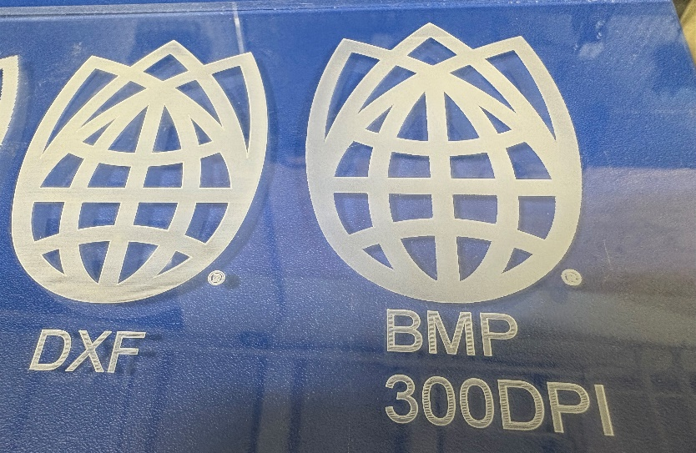
Pixel image is deeper and has ‘frosted glass’ effect, Vector file will retain the lines, making it feel like ridged holographic cards.

It is recommended to utilize Vector files. To convert a pixel image into a vector file, utilize Adobe Illustrators’ Image Trace command.

- Save your file onto a flashdrive, insert into the computer.
- Unlike the Epilog lasers, this laser will not utilize the Print option within Adobe Illustrator. Instead, we will import the file directly into the laser software, Speedmark.

SPEEDMARK
- SpeedMark should automatically open when the system turns on
- The default workspace is approximately 5”x 5”
  - For Larger jobs see Segmenting section
- If you only need simple text or shapes
  - Create with SpeedMark built-in tools
  - For Text: Outline Text is recommended.

- For more advanced designs, you will need to import your file into SpeedMark. Many file types can be imported.
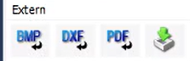
- Import an allowed file using the import options:
  - BMP – Bit Map
    - Pixel images
    - File Types: bmp, jpg, jpeg, png
    - Use if you have an image file

  - DXF (Recommended)
    - Vector files
    - File Types: DXF, SVG, HPGL
    - Uses: CAD Drawings, Vectorized Drawings
    - Recommended: Export Adobe Illustrator as DXF file
  - PDF
    - Vector files
    - File Types: PDF
    - Uses: Adobe Illustrator exported PDFs
    - Use if you have a vectorized file from Adobe Illustrator
  - Import
    - Translates vector files into pixel images
    - File Types: DXF, SVG, HPGL
    - Uses: automatically translated DXF/PDF files into pixel image
    - Recommended: Only use if you want your vector file to be engraved to look like a pixel image file.

- Click the work area where you would like to place your file.
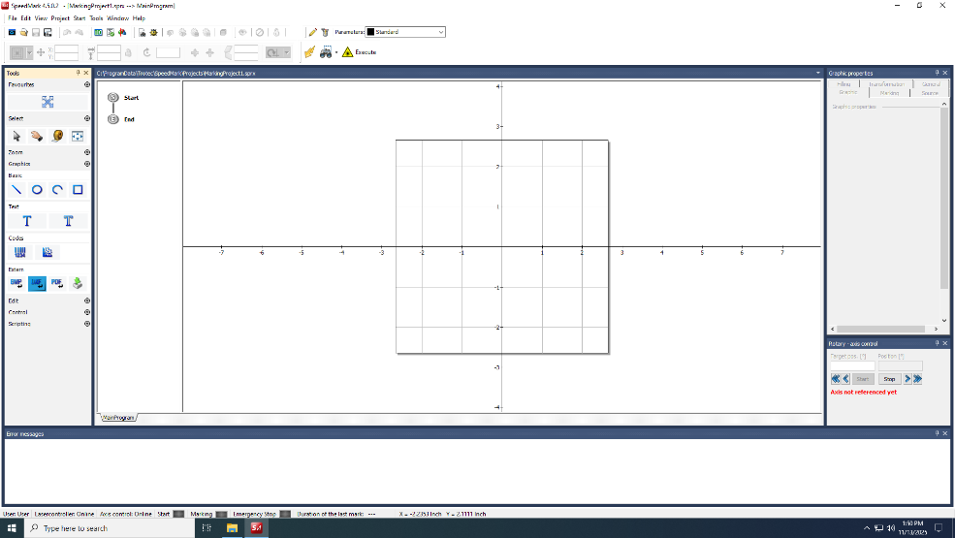
Second, click the mouse anywhere in the work area
First, click your file type

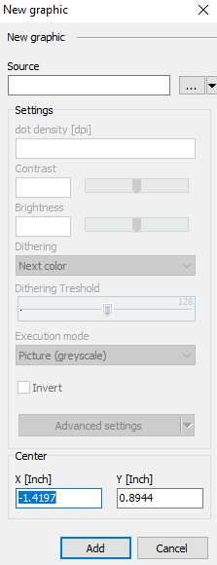
- A New Graphic window will appear.
  - Select the three dots next to source (…)
  - Locate your file
  - Select Add

- [For some files] A Material window will appear
  - Select OK. (We will change material later)
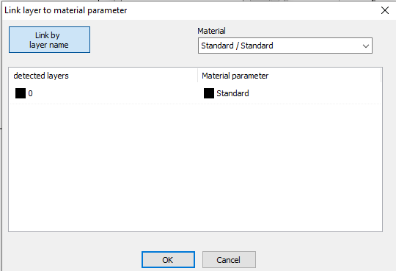

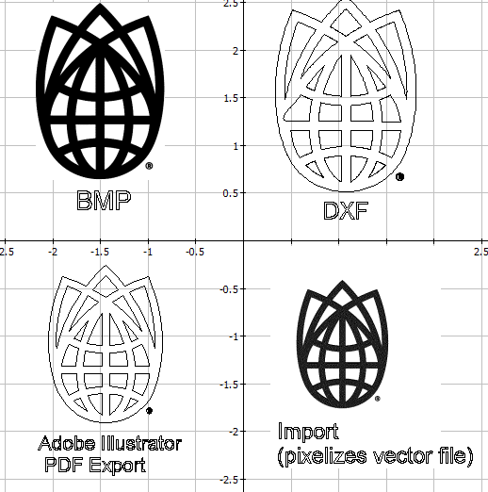
- Once placed, you can move and resize with the select command.
- Note: different file types will appear differently.
  - Pixel images will appear fully colored. (They may be very pixelated, we will fix that soon)
  - Vector files will only show their vector lines, with blank infill. (We will add infill soon.)

GRAPHIC PROPERTIES
- The graphic properties section has 6 tabs to fine tune the lasering process. To change properties you must select your image by clicking it.
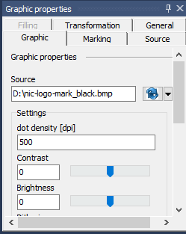
- Graphic: Controls graphical settings for pixel images
  - Pixel images.
    - Dot Density (dpi). Controls how many dots per inch. Increase to make a more smooth image, but will take longer to engrave.
    - Can also modify Contrast, Brightness, Dithering, etc.
  - Vector files.
    - No graphic options.

- Filling. Controls the infill for our vector files
  - Pixel images.
    - No filling options
  - Vector files.
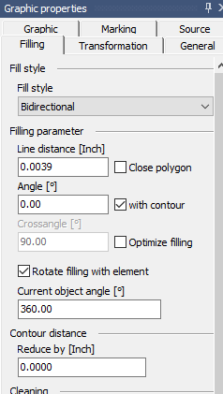
    - Fill Style. Controls which direction you want to fill the vector. Recommended: Bidirectional or Cross lines (bidirectional).
    - Line distance. Will control the distance between fill lines.
      - Smaller distance = darker image, longer time
      - Larger distance = lighter image, shorter time
      - Recommended: Keep at default, around 0.0039
      - Recommended: Zoom in with the mouse scroll wheel to see the fill lines:
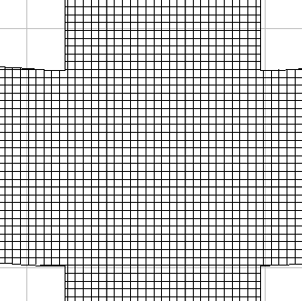
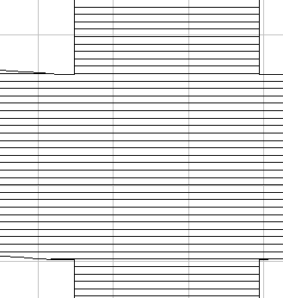
Parallel or Bidirectional Crosslines or Crosslines bidirectional

- Transformation: Move and rotate the design
  - Position: Move object to defined X-Y position.
  - Size: Resize object to be larger or smaller.
  - Rotation: Rotate object .
- Marking: Select Laser Settings (most important tab)
  - Material Parameter: Select which material is in use (first dropdown) and which setting – standard, light, deep (second dropdown).
  - Adjustment: Can increase or decrease power and speed from the preset values.
  - Parameter Settings: DO NOT CHANGE. Should match with the preset settings table at the back of this SOP.
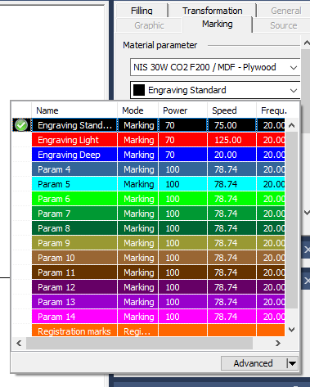
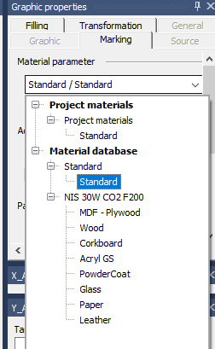
Material Selection Engraving Depth

- General: Not useful
- Source: For text created within the Speedmark software. Can automatically create a Date/Time, Serial number.

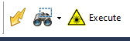
ENGRAVING
- Select the Boarder Marking Preview button (binoculars).
- Select All.
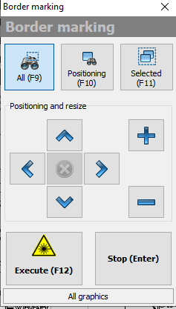
- This will create red outline of where the engraving will occur. If not in the correct location:
  - Move your art piece
  - Move the laser with the control panel buttons.
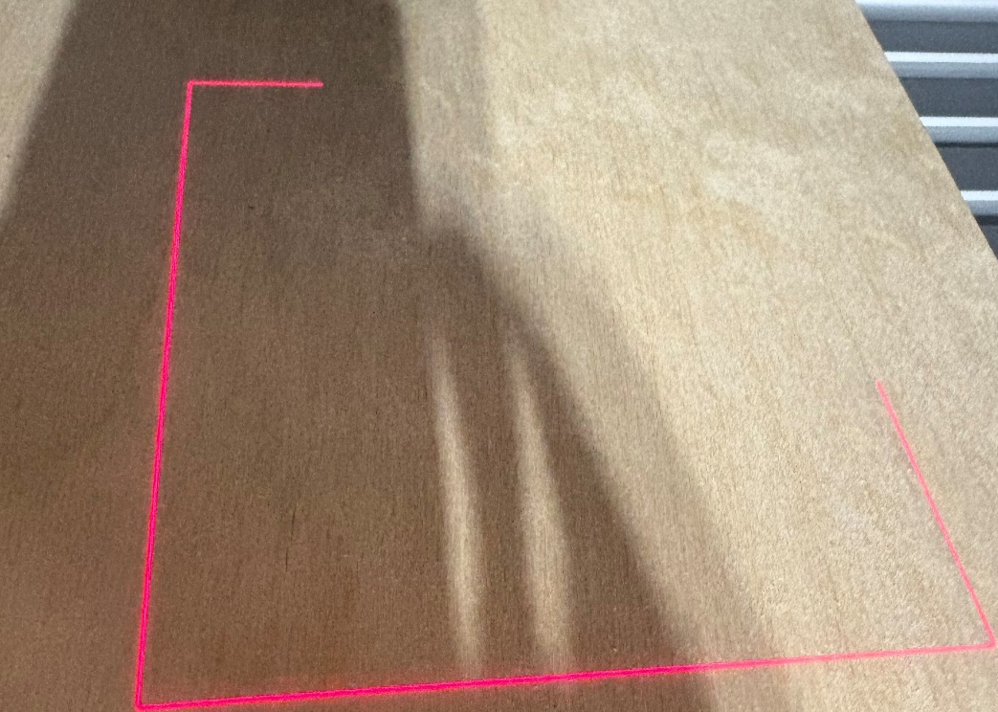

- Use the side panel to close the door.
- Select Execute, the laser will begin engraving immediately.

You must monitor the laser while it is running. This laser is very fast and powerful. If incorrectly set-up it can cause fires. As with the epilog lasers, some flames are acceptable, but they should not persist.

If a fire occurs, immediately push the emergency stop button. Spray with water. Notify staff.

FINISH & CLEAN UP
- When the laser is finished engraving, open the door by pushing the side panel button. Remove Piece.
- When finished, turn off the system in reverse order of how we turned on.
  - Turn the laser arming key vertical.
  - Turn off green laser switch
  - Turn off red master breaker.
  - Turn off chiller.
- If you are the last person using a laser, turn off room ventilation as well.

SEGMENTING
- Segmenting is required for engravings larger than the 5”x5” work area. Segmenting is also utilized for the rotary tool, see the “Rotary Tool” section for more details.
- Select the Segmentation icon.
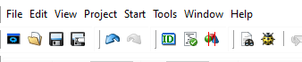
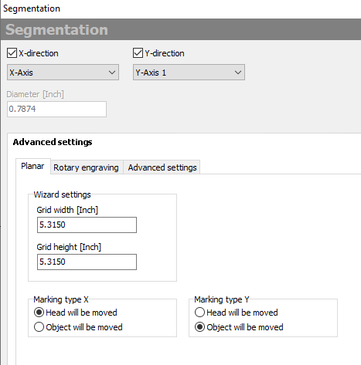
- Ensure that the correct drop-down option is selected:
  - X-direction: X-Axis
  - Y-direction: Y-Axis 1
- Select Advanced Settings:
  - Marking type X: Head will be moved
  - Marking type Y: Object will be moved
- Select OK
- The print area should now appear larger, mirroring the allowable engraving area of the machine. Additionally the ‘Making Segments’ window should automatically open.
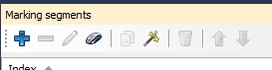
- The blue square is the current location of the laser. We must divide the large work area into smaller segments. There are multiple buttons on the marking segments menu.
  - + symbol. Add a segment with XY coordinates. Not recommended.
  - – symbol. Delete a selected segment.
  - Pencil. Modify a selected segment.
  - Manual segmenting (Computer Mouse symbol). This option lets you create your own segments.
  - Auto Segmenting (Magic Wand symbol). This option will segment the entire work area into 24 segments. This option is fast, but may result in sub optimal segments.
  - Trash can. Removes all segments.
  - Up/Down arrows. Re-order the segments
  - Possible concern: where segments meet, there is the possibility that a noticeable marking line will be present on your piece. It is recommended to optimally place the segments so that the segment lines are not over your art (as best as possible).

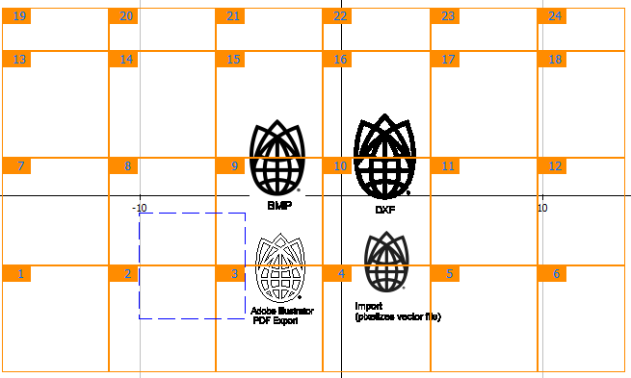
Blue square is laser’s current location
Auto Segmenting

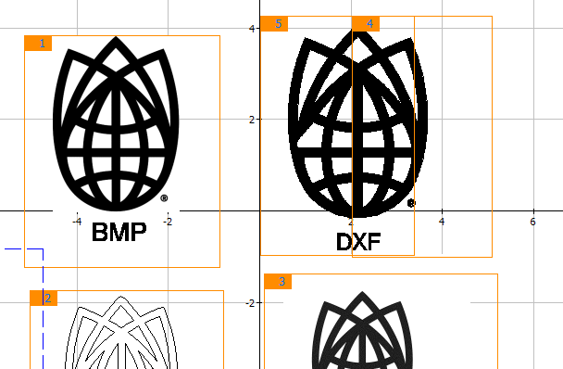
Manual Segmenting

- Recommendation: Try to place segments so that they do not go through your artwork, as best you can.
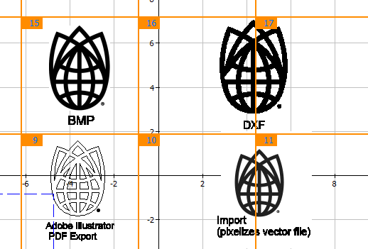
Good Segmentation Bad Segmentation
- Notes for manual segmenting.
  - Overlapping is good. You can ensure everything is included. It will not double engrave.
  - Anything not included within segments will not engrave.
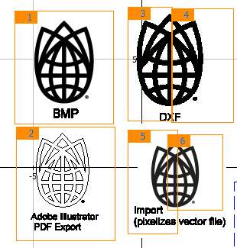
“Vector file)” Won’t be engraved
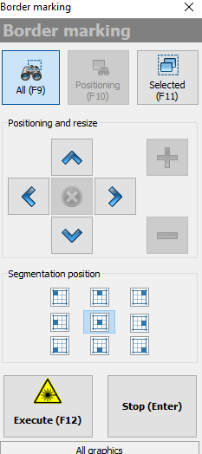
- Preview with the binoculars.
  - The segmentation position will move the laser to various locations on your workpiece.
  - Recommended: select top-left and bottom-right to ensure your workpiece is in the proper location.
- Use the side panel to close the door.
- Select Execute.
- Note: The laser may auto-home to the bottom left corner of the bed. This is normal.

ROTARY TOOL
- This laser has a built in Rotary tool for marking on cylindrical objects.
- You will need to know the diameter of the object. Measure.
- Utilize the rotary key, secure your object in the rotary vice.
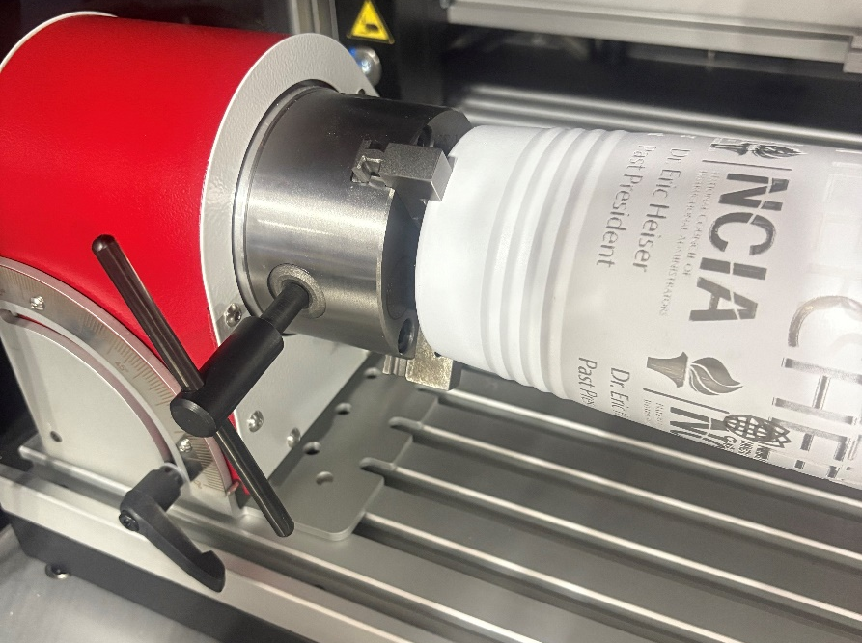
- Remove Rotary key, place in storage location.
- The engraving surface should be level. Loosen the angle lock, manually position your object so that the engraving surface is level. Lock in place. CAREFUL the rotary tool is quite heavy. Have a firm grasp on it before you unlock the positioning lever.
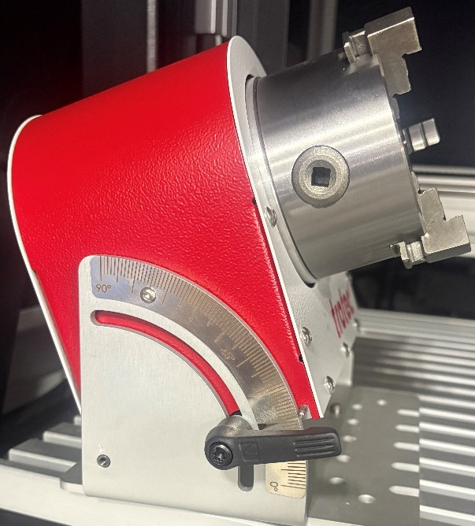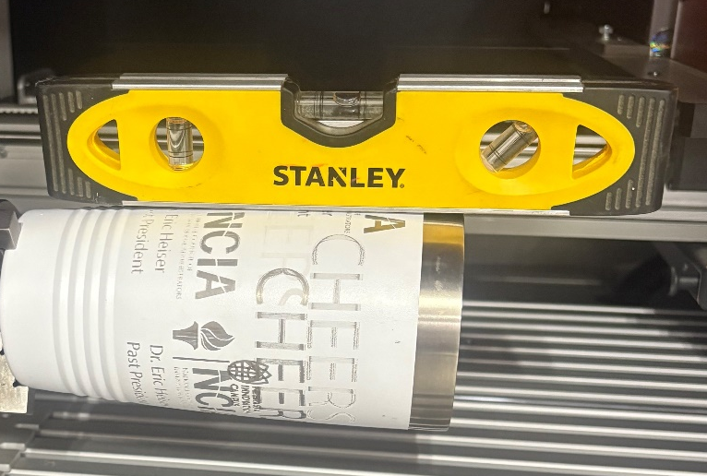
Angle Rotary Tool. Surface should be level.
Lock with Lever.
- Focus the laser so that the two targeting dots overlap.
- Select the Segmentation icon.
  - X-direction: Not selected
  - Y-direction: A-Axis

- Enter the diameter of your object.
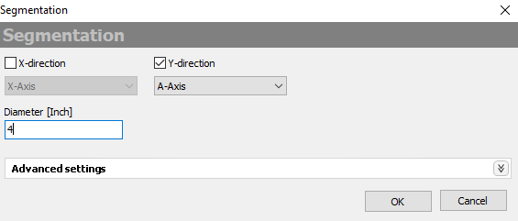
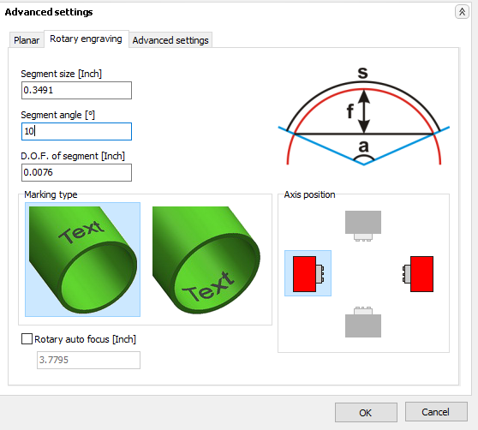
- Select Advanced Settings -> Rotary Engraving
  - The Segment Angle option will control how much the object is rotated for each segment.
  - Default is 5°. This will provide good detail, but will take longer.
  - Recommended: Increase to 10° or 15° for faster engraving.
- Select OK
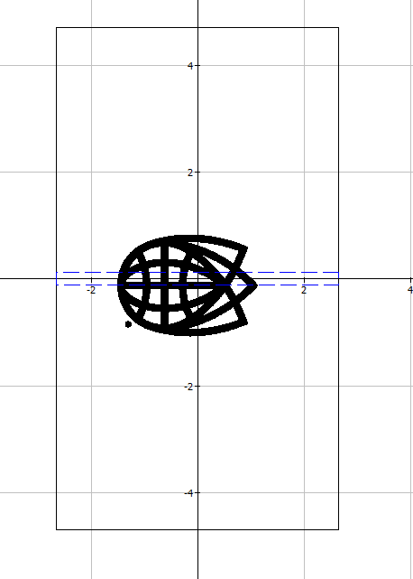
- The print area should now resemble a long rectangle, with a thin blue dashed rectangle indicating where the laser is currently located.

Blue rectangle is laser’s current location

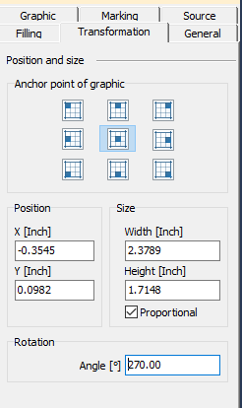
- Note: You may need to rotate the image 270° to align with the workpiece with the Transformation menu.

- To engrave at a different location on your object, Utilize the Rotary Axis Control window as follows.
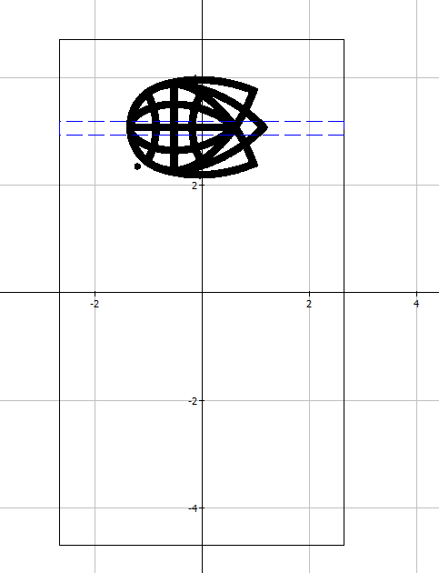
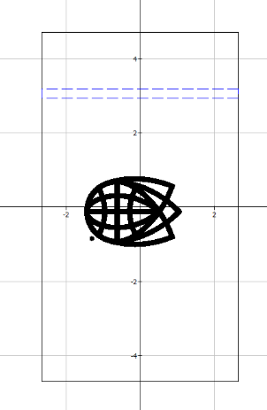
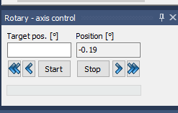

Blue rectangle is laser’s current location
Rotate object with arrow tools
Move design to that location

- We must divide the large work area into smaller segments. See ‘Segmenting’ section for more details.
  - Recommended: Auto segmenting (magic wand symbol)
  - Possible concern: where segments meet, there is the possibility that a noticeable marking line will be present on your piece. It is recommended to optimally place the segments so that the segment lines are not over your art (as best as possible).
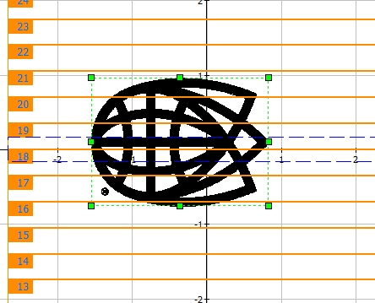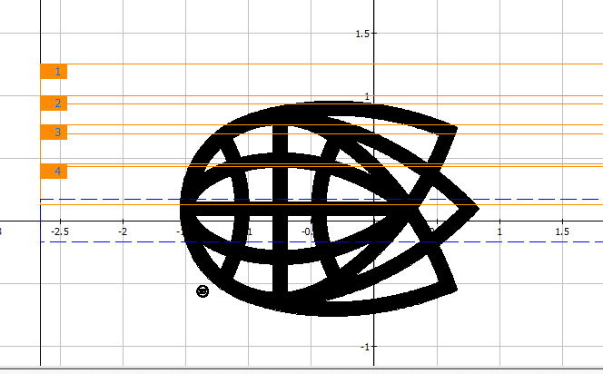
This bottom half won’t engrave currently. Need to add more segments
Auto segmenting Manual Segmenting
- Notes for manual segmenting.
  - Overlapping is good. You can ensure everything is included. It will not double engrave.
  - Anything not included within segments will not engrave.
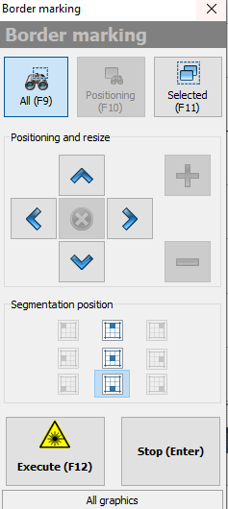
- Preview with the binoculars.
  - The segmentation position will move the laser to various locations on your workpiece.
  - Recommended: select top and bottom to ensure your workpiece is in the proper location.

- Use the side panel to close the door.
- Select Execute.

PRESET MATERIAL SETTINGS
MATERIAL | MATERIALPARAMETER | POWER | Marking Speed | FREQUENCY
Standard | Standard - Plywood | 70 | 75 | 20
MDF - Plywood | Engraving Standard | 70 | 75 | 20
MDF - Plywood | Engraving Light | 70 | 125 | 20
MDF - Plywood | Engraving Deep | 70 | 25 | 20
Wood | Engraving Standard | 70 | 75 | 20
Wood | Engraving Light | 70 | 125 | 20
Wood | Engraving Deep | 70 | 25 | 20
Corkboard/Cardboard | Engraving Standard | 75 | 75 | 20
Corkboard/Cardboard | Engraving Light | 25 | 75 | 20
Corkboard/Cardboard | Engraving Deep | 75 | 25 | 20
Acryl GS | Engraving Standard | 25 | 75 | 20
Acryl GS | Engraving Light | 25 | 125 | 20
Acryl GS | Engraving Deep | 25 | 25 | 20
Powdercoated Aluminium | Engraving | 100 | 25 | 20
Glass | Engraving | 25 | 25 | 20
Paper | Engraving Standard | 20 | 75 | 20
Paper | Engraving Light | 20 | 125 | 20
Paper | Engraving Deep | 20 | 50 | 20
Leather (Real only) | Engraving Standard | 100 | 75 | 20
Leather (Real only) | Engraving Light | 100 | 125 | 20
Leather (Real only) | Engraving Deep | 100 | 25 | 20

TRAINING CHECKLIST
- ONLY ENGRAVING. NO VECTOR/CUTTING.
- Do not manually open the door.
- Let Chiller run for 5 minutes
- Turn on Room Ventilation
- In order: Turn on red master breaker, green laser switch, activation key (horizontal) with 10 second waits between
- Focus Laser
- Pixel image vs Vector files
- Select Material under Marking tab
- Turn off when finished in reverse order: activation key (vertical), green laser switch, red master breaker.

YOU MUST WATCH THE LASER AT ALL TIMES
THIS LASER IS VERY POWERFUL

Frequently Asked Questions (FAQs)
- Can I cut/vector with this laser.
  - No. The Trotec is only for engraving
- Illustrator needs a login.
  - Members should utilize their personal Adobe login information. Account is free.

- Error displayed.
  - Press the OK/ü button to clear errors.
  - If that doesn’t work, contact NIS staff.

- The build chamber is filled with smoke after a wood engraving.
  - Close the door, let it sit for 5 minutes and the ventilation will remove the smoke.

