SOP
Laser #1
EPILOG 24 MINI
60 W Laser

Training is required before using this equipment
Reservations are required when using this equipment
Closed Toed Shoes required

NEVER LEAVE THE LASER CUTTER UNATTENDED
WHEN IT IS OPERATING
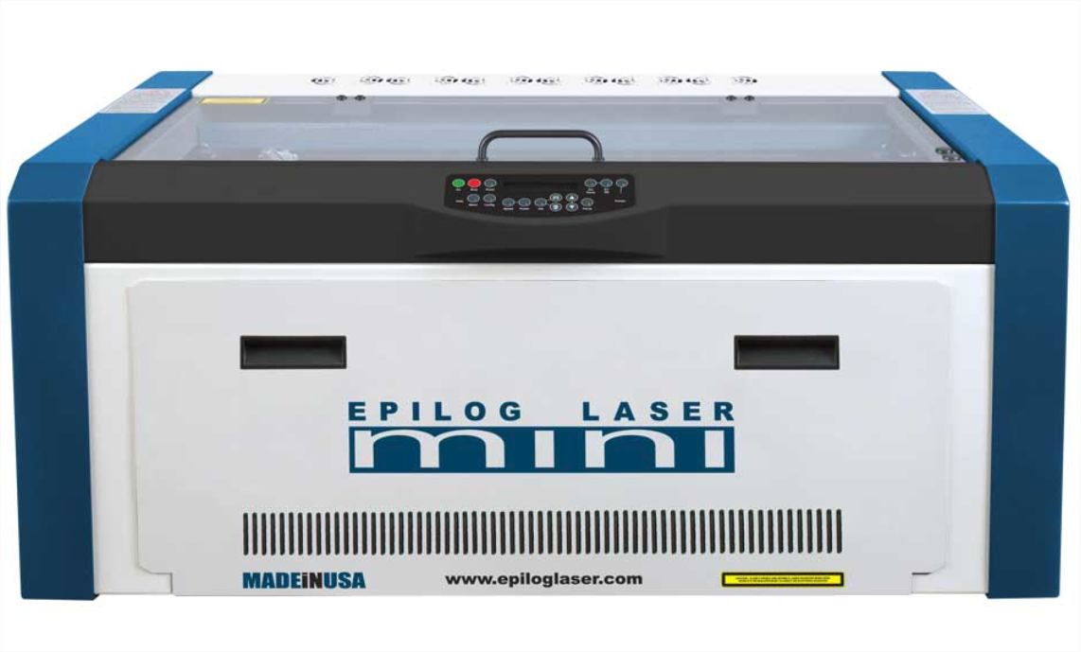

Quick Start

- Turn on Room Ventilation
- Turn on Air Assistance Pump
- Turn on Laser
- Open File in Adobe Illustrator
- File →Print
- Job Manager should open automatically
- Position Design as needed
- Change Speed/Power/Frequency
- Click Print Button
- Focus Laser
- Select Start on Laser

MINI 24 SPECIFICATIONS
  - Maximum material dimensions: 24” x 12” (609mm x 304 mm)
  - Maximum material thickness, vector cutting: 3/8”
  - Maximum material thickness, engraving: 8”

  - Approved Materials:
    - Acrylic/Plexiglass
    - Plywood
    - Chipboard
    - Mat Board
    - Solid Wood
    - Poster Board
    - Paper
    - ABS plastics
    - Laserable Stamp Material
    - Glass (etch only)
    - Alumna mark
    - Corian
    - Anodized Aluminum (etch only)
    - Powder coated or painted metals (etch only)
    - Metals with etching spray applied (etch only)

  - Banned Materials
    - Materials containing Chlorine (PVC, Moleskin)
    - Polycarbonate (Barlo, Calibre, Hyzod, Makralon, Palsun, Sustanat, Tecanat, Tristar, Makroclear, Arcoplus)
    - Lexan
    - Fr4 Boards
    - Fiberglass
    - Vinyl

- METAL CAN BE ETCHED BUT CANNOT BE CUT ON THIS MACHINE. Treated metal (painted, powdercoated, anodized) can be etched directly. Untreated metal must have Cermark spray applied, available for $5.00 per application.
- If your selected material is not on this list please contact an NIS staff member. Provide Safety Data Sheets for materials requiring approval.

SAFETY
Make sure ventilation is on prior to use. The button to start the ventilation is located on the west wall and pulls to activate. This will pull smoke from all the lasers. Confirm the ventilation is on before using the laser.
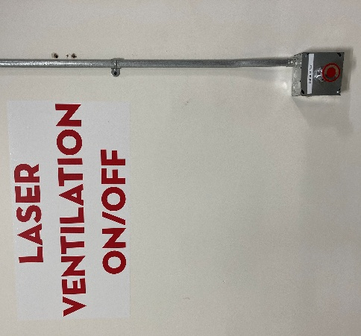
If you are done with your laser, and nobody else is using the lasers, turn the ventilation system off.
Turn on the air assist pump that is located next to the laser or on the floor.
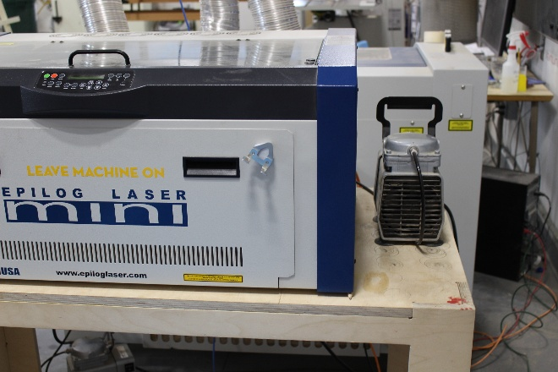
2” Flame is okay for short lengths during a cutting pass. If the flame persists or your material is on fire, push the pause button the top of the laser.
If the flame persists, open the laser and mist the flames with plain water from the spray bottle.
If a fire extinguisher is needed, contact NIS staff immediately.

The laser will not fire when the lid is open.

Never leave the laser while it is in operation.
Never operate more than one laser simultaneously.

PREPARING THE LASER
The Laser must always be turned on to receive your job.

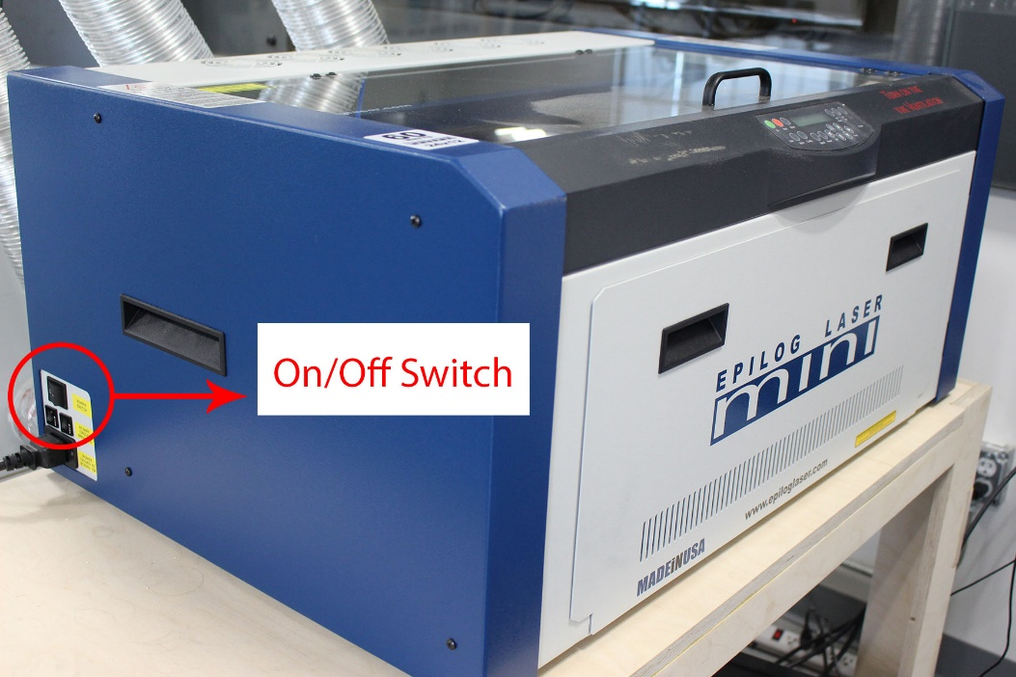

The lens will move and reset its position to home in the upper left hand corner When this is complete the operational keypad should read <JOB:>

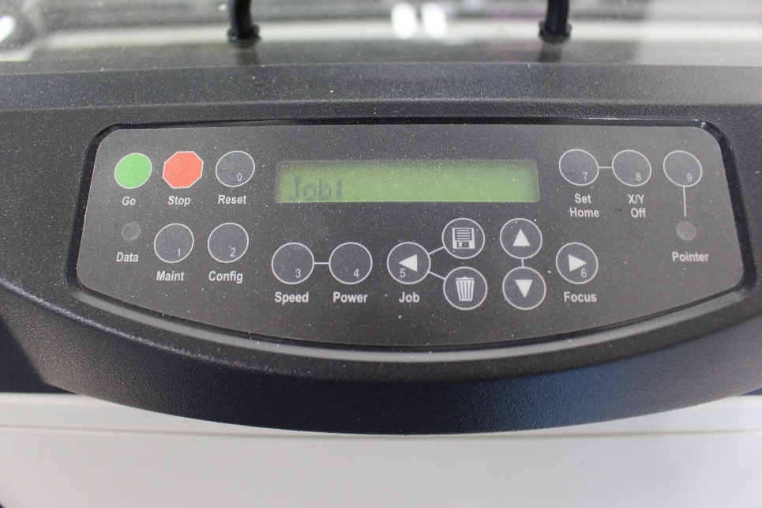

SELECT PLATE

- The Vector Cutting Grid must be used when vector cutting.
- The Task Plate must be used when rastering heavy objects.
Vector Cutting Grid
Task Plate

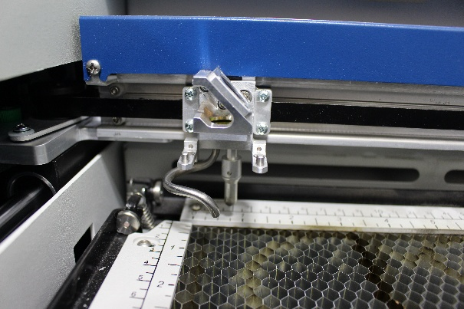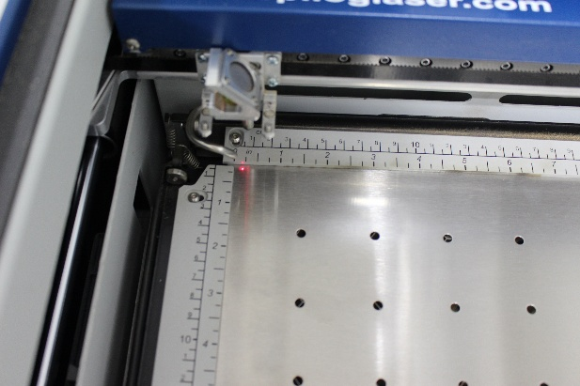

- To remove and install the task plate and vector grid press down the black metal angle that is attached to the outside of each of the three rulers so the ruler flips up and out of the way. Then lift out it out of the laser.

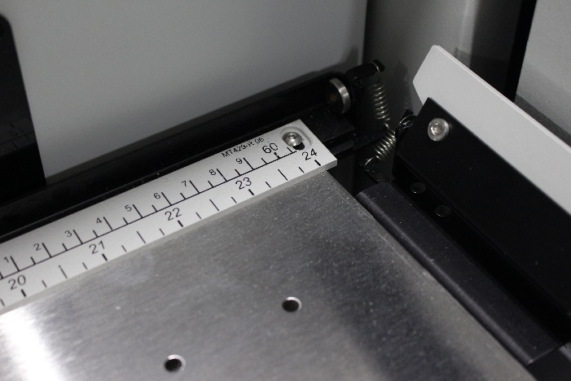

Place your material in the upper left hand corner of the print bed. Do not push down on the Vector Cutting Grid. Use masking tape to secure your material to the rulers to aid in flattening.
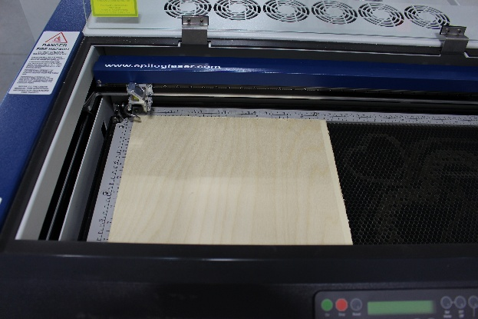
FAQ: My material is too tall. It does not fit under the laser.
Answer: Press the focus key
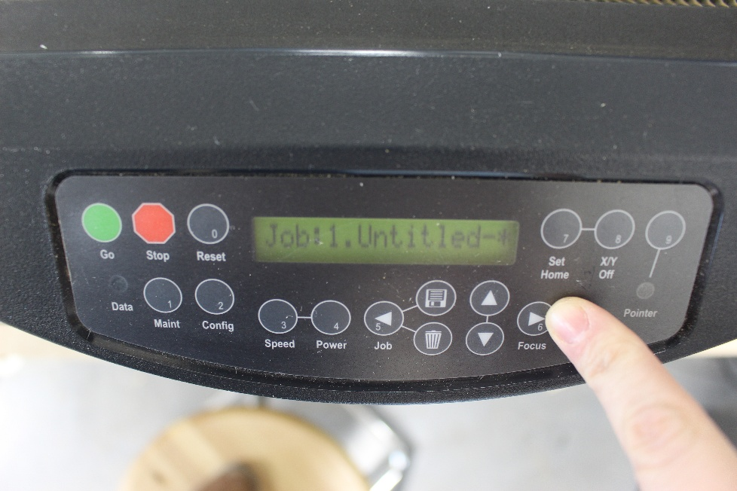

- Press the down arrow key to lower the bed to allow enough space to fit your object into the laser.

- Open your project using Adobe Illustrator
- Make sure your project’s artboard is defined as the same size as your piece of material, and no larger than the print bed (24” x 12”).
  - MAXIMUM MATERIAL SIZE IS 24” X 12”
  - Your Artboard is the white area in Illustrator.
- To Vector (cut) lines must have a stroke size of .21 points or smaller. NIS recommends .001 stroke width (“hairlines”) to avoid confusion and for consistency between AutoCad and Illustrator.
- To Engrave (Raster) stroke lines must be .22 points or thicker.
- Align your artwork to the top-left corner of your artboard. The top-left corner of the laser is square, and will give you the most precise results.
- Epilog Job Manager also allows you to separate cuts/engraving by color to enable you to have different speed/power settings for different parts of your job. To do that, simply make each section of the project a different color.

SENDING YOUR FILE TO THE JOB MANAGER
- Save your file before sending to the printer
- Select File >> Print in Illustrator
- Select the following options:
  - Printer: Epilog Engraver
  - PPD: Epilog Post Script Driver
  - Ignore Atrboards: Not Selected
  - Media Size: Custom
  - Width: 24 in
  - Height: 12 in
- Select Print

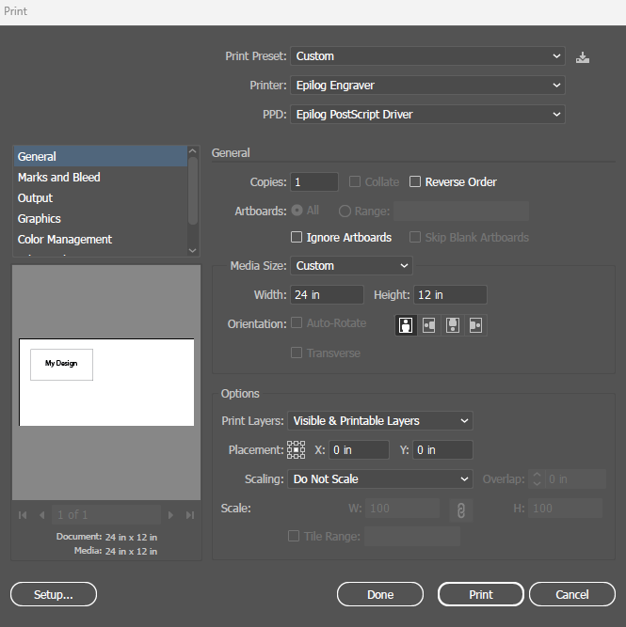

- If you are the first user of the day, you may have to open the job manager.


USING THE JOB MANAGER
- Epilog Job Manager should automatically open and show your design.

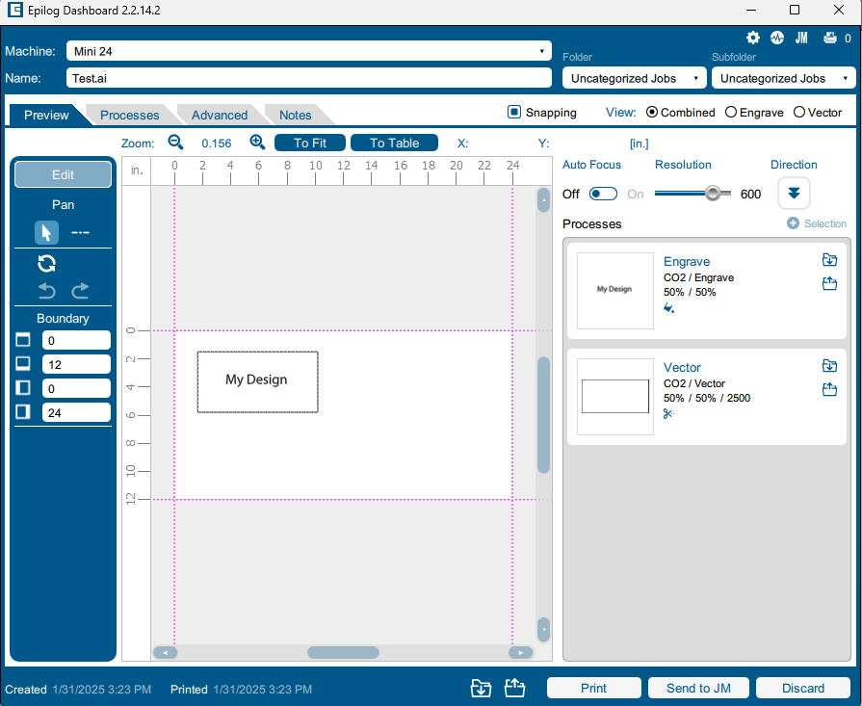
- FAQ: I don’t see my design?
- Answer: It may be located to the bottom right of the board. Scroll out to find it.

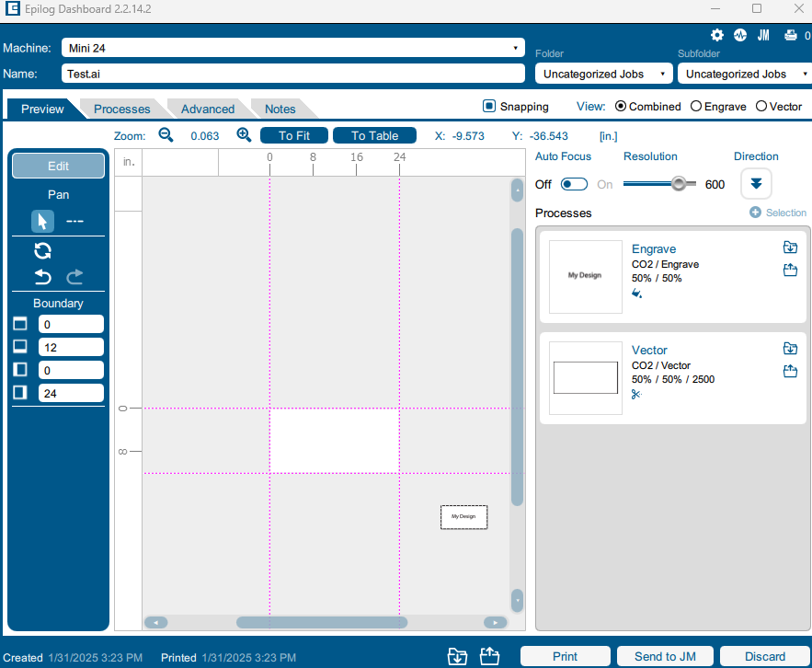

- You can move the design around and resize it by selecting.

POSITIONING YOUR ARTWORK
- The top-left corner of the print area corresponds to the top-left corner of the laser print bed. Position your art piece accordingly.
- The print area is contained within the dashed purple lines. Any design that is outside of the print area will not print.
- You can move the design around and resize it by click-and-drag.
- You can also move the design utilizing the boundary dimensions.
- If everything in your Illustrator file is in the position you want it on your material, your artboard is the same size as your material and you place your material in the top left corner of the laser, your art will be in the correct position already.

- You can manually change the home/origin on the laser. For most jobs this is not necessary. See later section if needed.

Note: You can position the laser to different reference points on your material (such as for center engraving). This is not recommended for new users. This is a multi-step process:
- Go to the Advanced tab.
- Find Center Engraving.
- Click the dropdown, and you will see many options for reference points.
- Select an option.

PROCESSES & CHOOSING YOUR SETTINGS FOR ENGRAVING AND VECTORING
Make sure Auto Focus is off. We will manually focus later.

PROCESSES: AN OVERVIEW
- On the right side of the screen, you will see boxes labeled “Engrave” or “Vector.” These are called processes and are the steps the laser will take to create your design.
- You will set independent settings for each process.
- The laser will automatically split your file into any applicable processes.
  - Your shapes and images with a stroke width of .22 or greater will be placed in an Engrave process, and your shapes with a stroke with of .001 pt will be split into a Vector process.
- If it did not split your file automatically, and you see one Engrave process when you expect a vector process, click Split By: Hairlines. This will likely fix the issue.
- Otherwise, check your file to confirm line thickness.
- If you have used color to designate areas in your file you want engraved or cut with different settings, the software has likely automatically split them for you.
  - If it has not, find the process with your colors in it, and click Split By: Color.

CHOOSING YOUR SETTINGS

ENGRAVING PROCESSES
This is where we will set the settings we want the laser to use while engraving.
Resolution: Sets the amount of detail in your design, in dots per inch (DPI). Higher numbers will look better but will take longer.  Speed & Power: You will retrieve these values from the settings chart attached to the desk. Both lasers are 60 watts.  Frequency: will be enabled if using the fiber laser.  Laser (not pictured): Determines whether the process should use the CO₂ or Fiber laser. Only available on Laser #5.  Dithering: This changes the arrangement of the dots that make up your image. Standard works most of the time, but some materials/projects may need others.  Direction: Determines whether the laser will engrave from the top-down, or from the bottom-up. | 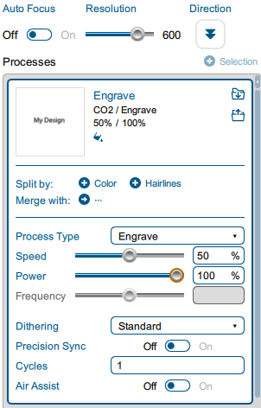

VECTOR PROCESSES
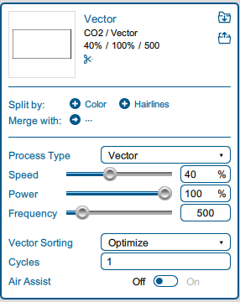
Speed and Power: Found using the same settings sheets as engraving.
Frequency: This can also be found in the settings charts, in the second column, next to the preset name.
Vector Sorting: changes the order the laser will execute cuts.

**NOTE: The Mini 24 has very different vector frequencies than the other lasers:
Plywood 500 hz
Acrylic 5000 hz
Wood, Paper, Leather, Mat board, Fabric 2500hz
If your materials are burning too much or melting adjust your frequency to a lower number. Check the Owner’s Manual for recommended settings.

TRIPLE CHECK YOUR SPEED, POWER, AND FREQUENCY. MAKE SURE YOU ARE USING THE CORRECT WATTAGE (60 WATTS).

Once you have input your settings for all of your processes, you can click the “Print” button at the bottom of the screen. This will send your job to the laser.

THE LASER CONTROL PANEL
- The control Panel Should show the name of your job
- <JOB: (#)Title of piece>

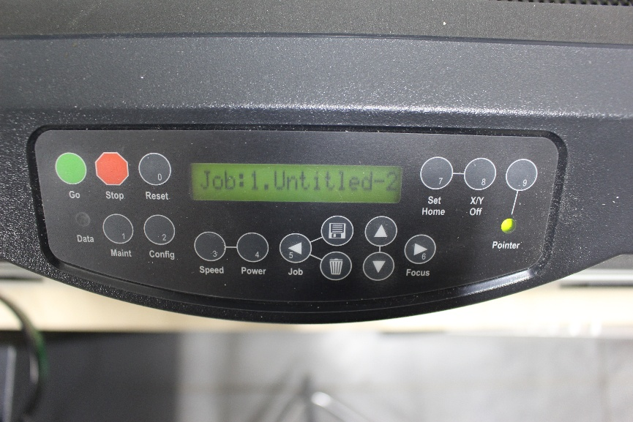
- There is no print time estimation on this machine.

FOCUS LASER
You must manually focus your laser before every job. Material thickness differences require a new focus point.

- Press the <FOCUS> button. The print head should move away from the home position
- Place the focus tool on the 2 pins located on the front of the laser head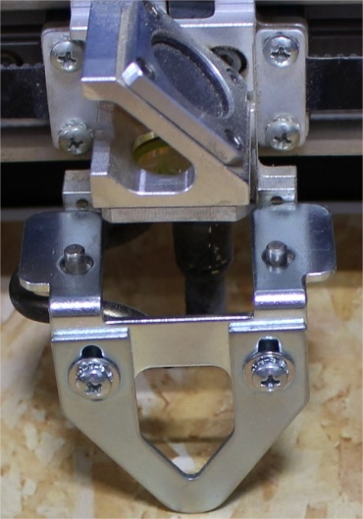
- Raise or lower the bed using the up and down arrows until the focus tool just barely makes contact with your material
- Remove the focus tool and place it back on the magnet.
- Your focus distance is now set (there is no set button-the laser will focus at the point you left it)
- Push the <RESET> button to exit focus mode and return to the <JOB> screen

WHILE RUNNING
While the laser is running, you must watch for signs of fire.
- Hit the <GO> button on the control panel.
- Hitting <STOP> will pause your print. Hit <GO> again to resume your printing.
- Hitting <RESET> will cancel you current job and reset laser to the home position.

MONITORING RULES:
- Watch laser for signs of fire
- You cannot leave the laser unattended.
  - If you must leave the laser <STOP> the job. Hit <GO> when you return

IN CASE OF FIRE:
A 2” flame is okay for a short period of time during cutting passes only, as long as the flame is following the laser as it cuts. If either condition is not true, you must intervene.
- Press the pause button on the machine. During cut passes, the laser may take a second to stop cutting.
- Begin fighting the fire.
  - Find a spray bottle of water (marked H20). Check the bottle before spraying.
  - Spray water at the base of the flame.
  - If you are able to put the fire out with water alone, and your material is still salvageable, you can continue cutting.
  - However, if another fire happens you must stop running your project. Confirm your settings and material composition.
- If water is unable to put the fire out, attempt and use other material to smother the fire. Grab scrap wood from the bin, whatever is needed. If this fails, IMMEDIATELY GET NIS STAFF.

CHANGING THE HOME POSITION

RESET HOME:
The laser cutter has a default home position in the upper left hand corner. If the default home position has been changed by a previous user you can reset the default home position by doing the following:
  - Press the #1 button marked “Maint”
  - The display should now read “1. Restore Home” If not, press the down arrow until Restore Home appears
  - Press the “Go” button

The print head should now move itself to the home position

CHANGE HOME: Manually Setting the <X/Y> Home Position

- Turn on the Pointer (9) on the operational key pad

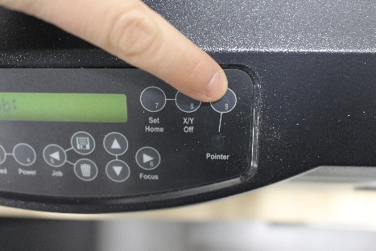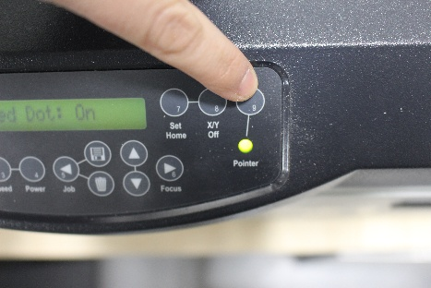

- THERE IS NO JOG FEATURE ON THIS MACHINE
  - You must disable the laser carriage.
  - Press the X/Y Off Key

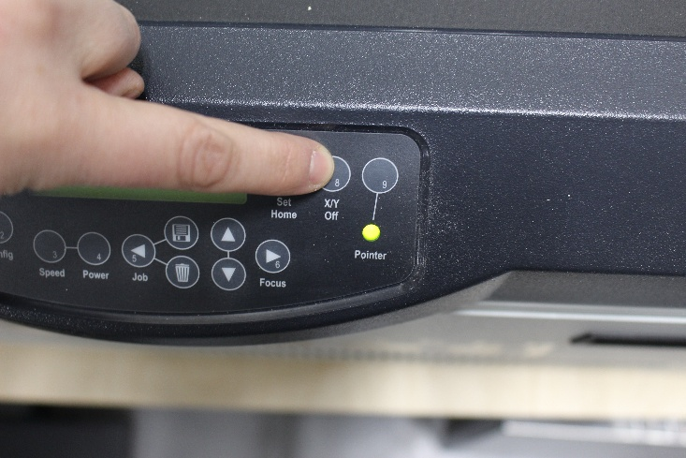
- The read out on the keypad will say < X/Y Off? GO/STOP
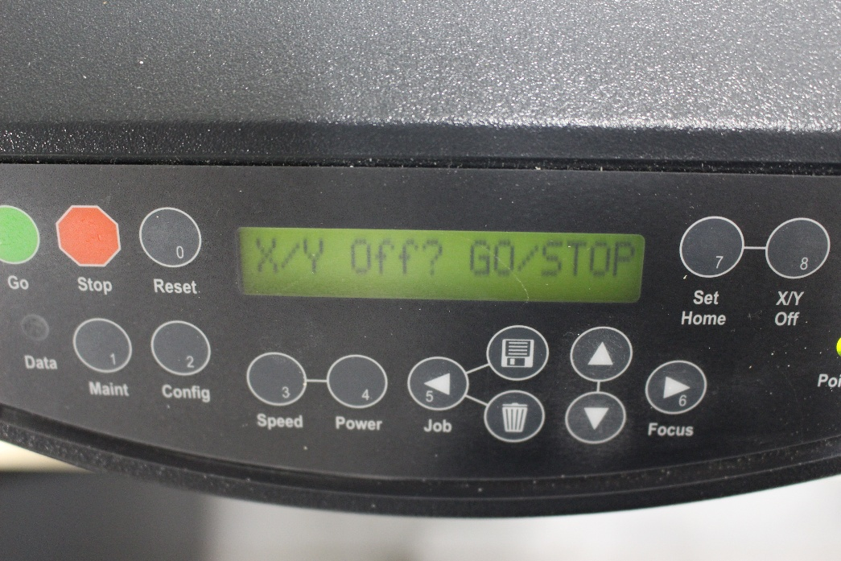

- Press the Green GO Button for Yes

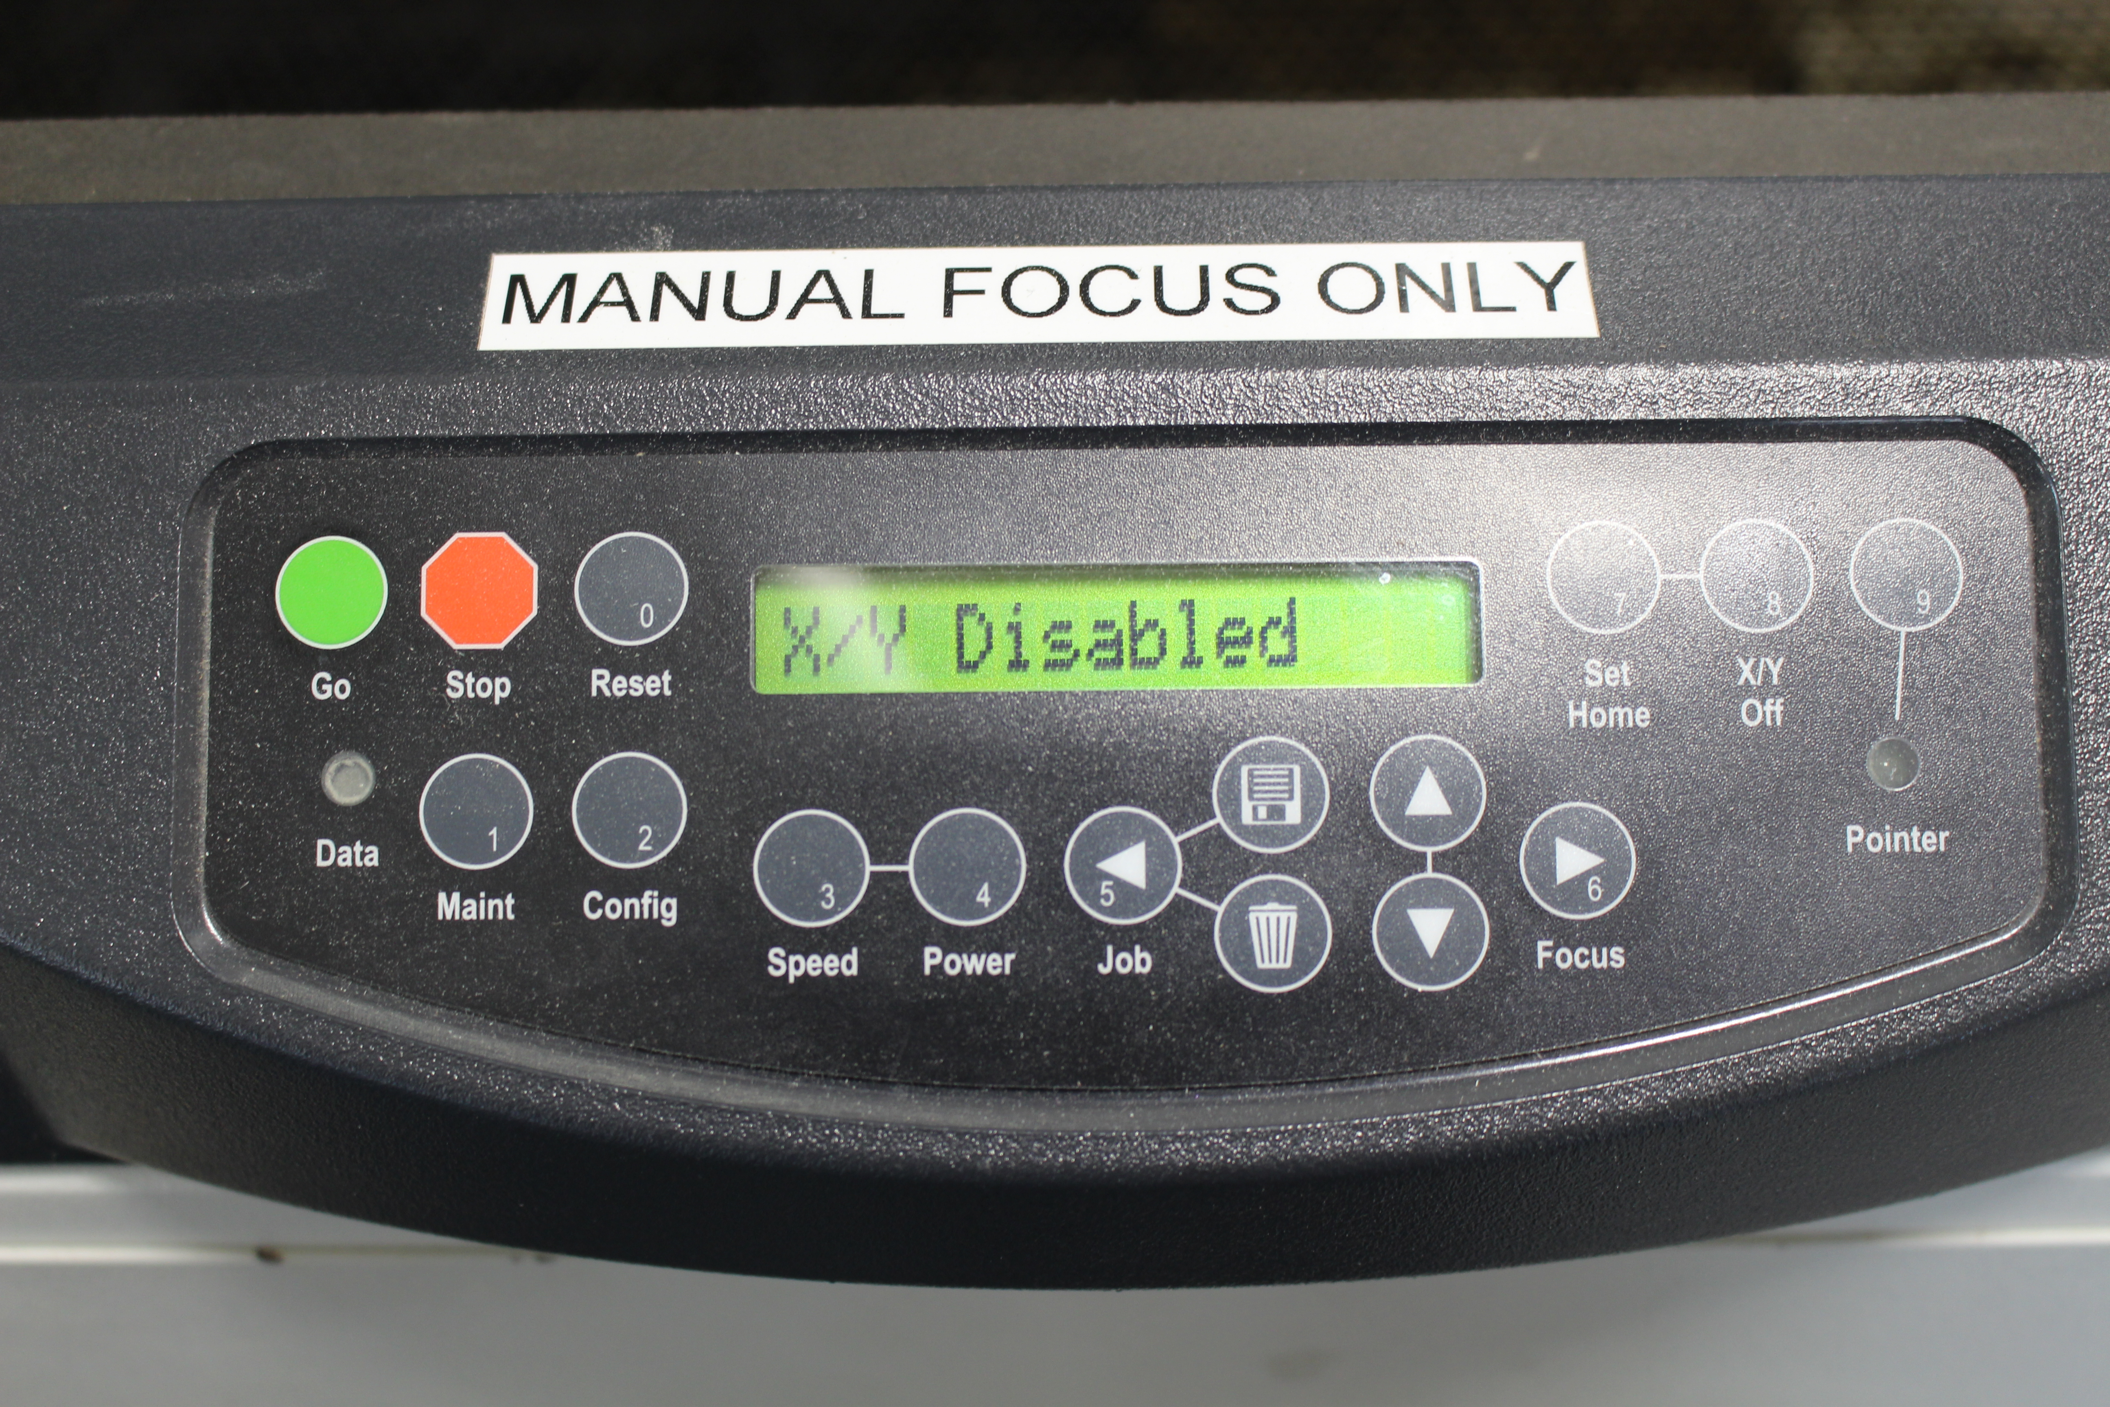

- The screen should now read <X/Y Disabled>

- Now you will be able to manually move the laser carriage by hand to your desired position

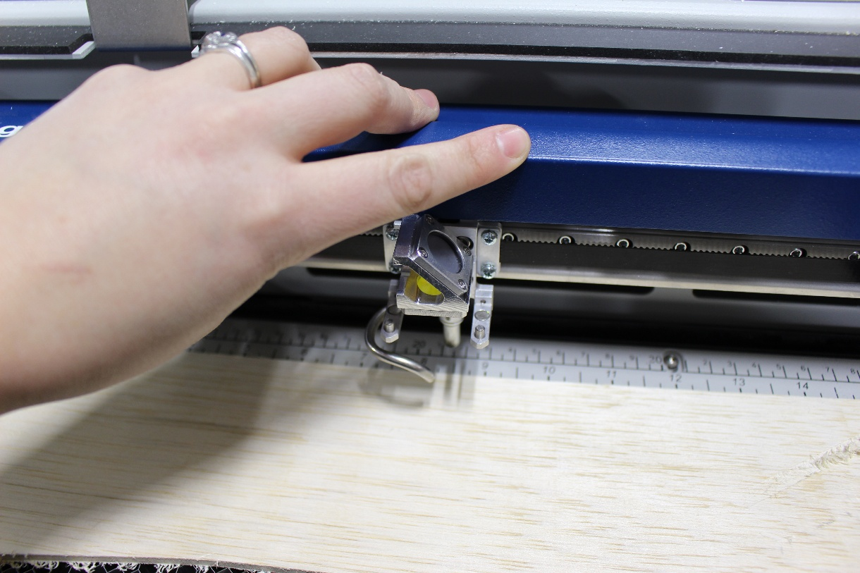

- Press the Set Home Key

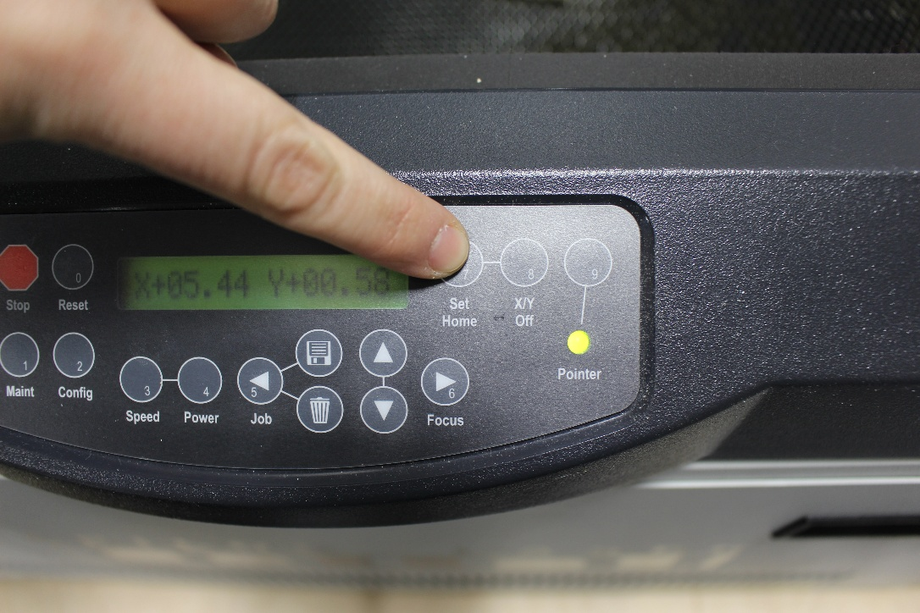

- Your New Home Position/Origin has been set.

FINISH & CLEAN UP
- Remove your material.
- Remove scrap.
  - Small pieces go in trash can
  - Large pieces go in donation box
- If lots of small scrap pieces fell through the laser cutting bed, remove the bed and dispose of the scrap.
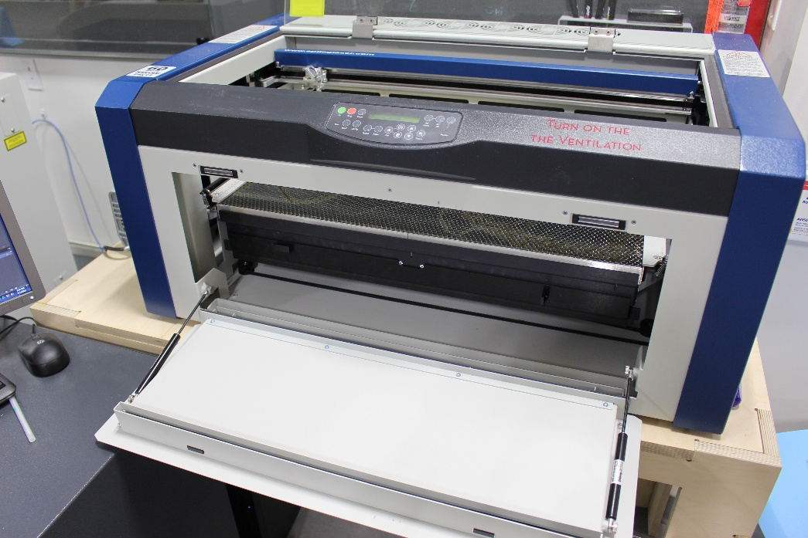

- Turn off Laser.
- If you are the last person using the lasers, turn off room ventilation.

Frequently Asked Questions (FAQs)
- Illustrator needs a login.
  - Members should utilize their personal Adobe login information. Account is free.

- My piece did not cut all the way through.
  - Is your piece flat? Warped or bent pieces may not cut.
    - Tape down.
    - Refocus.
  - Did you focus the laser?
  - Cutting ¼”? Lasers may struggle with this thickness.
    - Lower speed setting.

- I don’t see my design in Epilog Job Manager.
  - It may be located to the bottom right of the board. Scroll out to find it. Move into the design area.

- The material I am using is not on sheet.
  - Find a similar, more conservative substitute.
    - Want to cut 3/16”, try the settings for 1/4”
  - Ask NIS staff.

- Laser does not run. Zero run time.
  - Probably an issue with your Adobe illustrator design.
    - Check your lines. Do they intersect?
  - Did you create your original in Rhino or Solidworks?
    - Try exporting as a different file type.
    - Use the VCarve trick
      - Load SVG into VCarve, join lines, re-save as an SVG, reload into Illustrator.

