SOP
Laser #2
FusionPro 36 (100W Laser)
Training is required before using this equipment
Reservations are required when using this equipment
Closed Toed Shoes required
YOU MUST WATCH THE LASER AT ALL TIMES
YOU MAY ONLY OPERATE ONE LASER AT A TIME
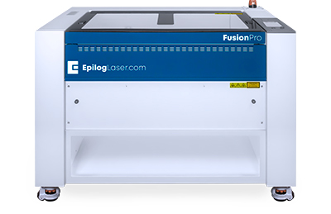


Quick Start
- Turn on Room Ventilation
- Turn on Laser
- Open File in Adobe Illustrator
- File →Print
- Job Manager should open automatically
- Position Design as needed
- Change Speed/Power/Frequency
- Click Print Button
- Focus Laser
- Select Start on Laser

YOU MUST WATCH THE LASER AT ALL TIMES
THIS LASER IS VERY POWERFUL

FUSION PRO 36 SPECIFICATIONS
MAXIMUM MATERIAL DIMENSIONS – 36” x 24”
MAXIMUM MATERIAL THICKNESS FOR CUTTING – ½ ”
MAXIMUM MATERIAL THICKNESS FOR ENGRAVING – 9””

BANNED MATERIALS
Materials containing chlorine (PVC, Moleskin)
Polycarbonate (Barlo, Calibre, Hyzod, Lexan, Makralon, Palsun, Sustanat, Tecanat, Tristar, Makroclear, Arcoplus)
Fr4 Boards (resin reinforced fiberglass composite)
Fiberglass

MATERIALS (CO2)
Material | Engrave | Cut
Acrylic | Yes | Yes
Anodized Aluminum | Yes
Ceramic | Yes
Cloth | Yes | Yes
Coated Metals | Yes
Corian | Yes | Yes
Cork | Yes | Yes
Delrin | Yes | Yes
Fabric | Yes | Yes
Fiberglass | Yes | Yes
Glass | Yes
Leather | Yes | Yes
Marble | Yes
Matte Board | Yes | Yes
Melamine | Yes | Yes
Mother of Pearl | Yes | Yes
Mylar | Yes | Yes
Painted Metals | Yes
Paper | Yes | Yes
Plastic | Yes | Yes
Powder Coated Metals | Yes
Pressboard | Yes | Yes
Rubber | Yes | Yes
Tile | Yes
Wood | Yes | Yes
Wood Veneer | Yes | Yes
Bare Metals | *
Brass | *
Stainless Steel | *
Titanium | *
* CO2 lasers will mark bare metals when coated with a metal marking solution.

MATERIAL (FIBER)
Material | MARK
303 Stainless | Yes
4043 Steel | Yes
6061 Aluminum | Yes
Bayer 2807 Makrolon polycarbonate | Yes
Bayers Bayblend FR 110 | Yes
Black/White ABS | Yes
Brass | Yes
Brushed Aluminum | Yes
Carbon Nanotube | Yes
Clear Coat Anodized Aluminum | Yes
Cobalt Chrome Steel | Yes
Colored Delrin (Black/White) | Yes
Compacted Powder Iron w/Iron Phosphate Coating | Yes
Copper | Yes
DAP – Diallyl Phthalate | Yes
GE Plastics Polycarbonate Resin 121-R | Yes
Glass Filled PEEK | Yes
Glass Filled Telfon | Yes
Hard Coat Anodized Aluminum | Yes
Machine Tool Steel | Yes
Magnesium | Yes
Metal Plated Ceramics | Yes
Molybdenum | Yes
Nickel Plated 1215 Mild Steel | Yes
Nylon | Yes
Polybutylene Terephthalate | Yes
Polysulphone | Yes
Rynite PET | Yes
Santoprene | Yes
Silicon Carbide, Steel, Wafers | Yes
Various Inconel Metals (Nickel-Chromium Super Alloys) | Yes
White PEEK | Yes
Yellow Chromate Aluminum | Yes
Zinc Plated Mild Steel | Yes

SAFETY
Make sure ventilation is on prior to use. The button to start the ventilation is located on the west wall and pulls to activate. This will pull smoke from all the lasers. Confirm the ventilation is on before using the laser.
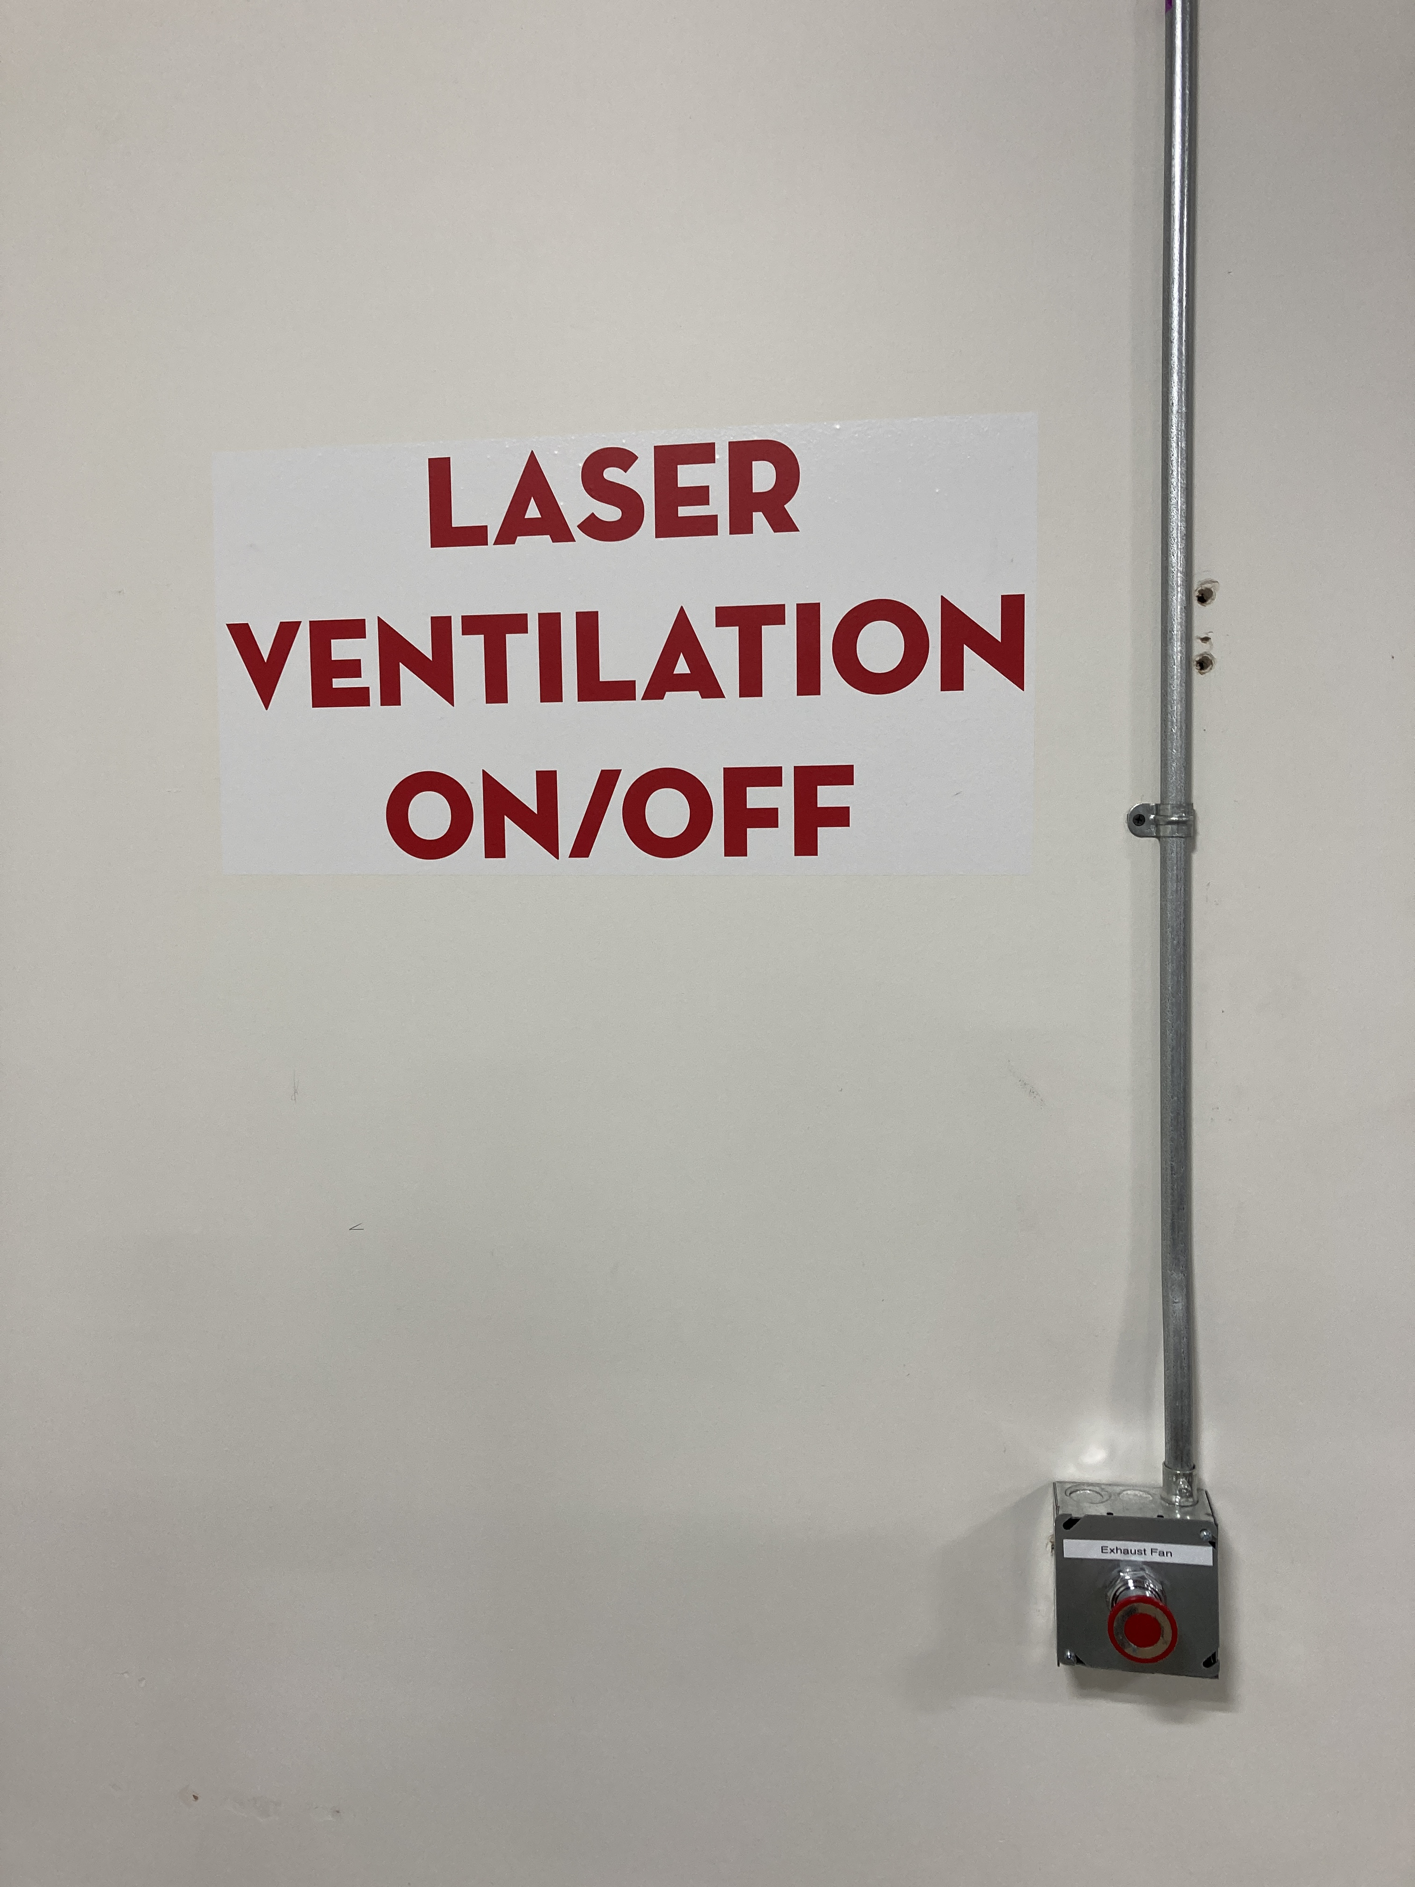
If you are done with your laser, and nobody else is using the lasers, turn the ventilation system off.
2” Flame is okay for short lengths during a cutting pass. If the flame persists or your material is on fire, push the pause button the top of the laser.
If the flame persists, open the laser and mist the flames with plain water from the spray bottle.
You may also blow on it, or smother it with scrap plywood. If a fire extinguisher is needed, contact NIS staff immediately.

The laser will not fire when the lid is open.

Never leave the laser while it is in operation.
Never operate more than one laser simultaneously.

TURN ON THE LASER
The on/off switch for the Epilog FusionPro 36 is on the right side of the machine, toward the back.
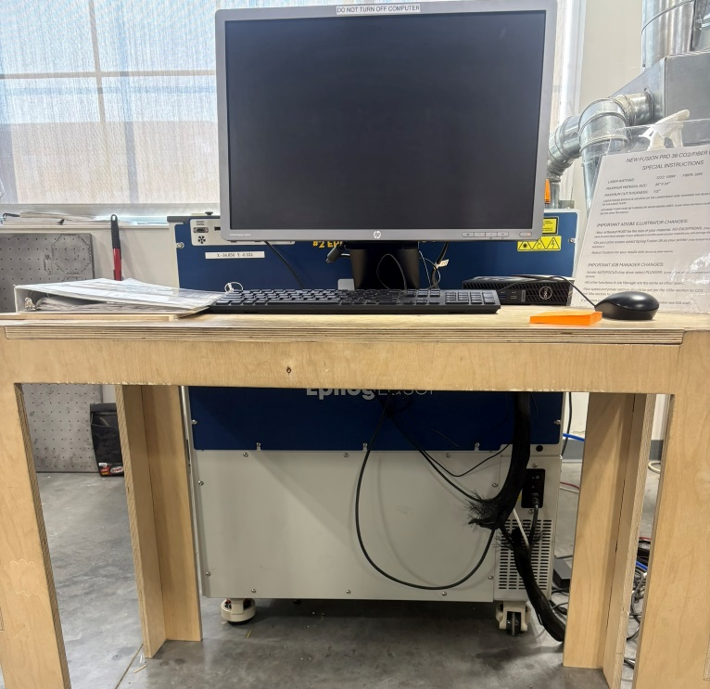
ON/OFF SWITCH
The laser must be turned on to receive your job.
The Air Assist Pump should switch on automatically when the machine is turned on.
If not, the switch is on the back-right side of the pump.
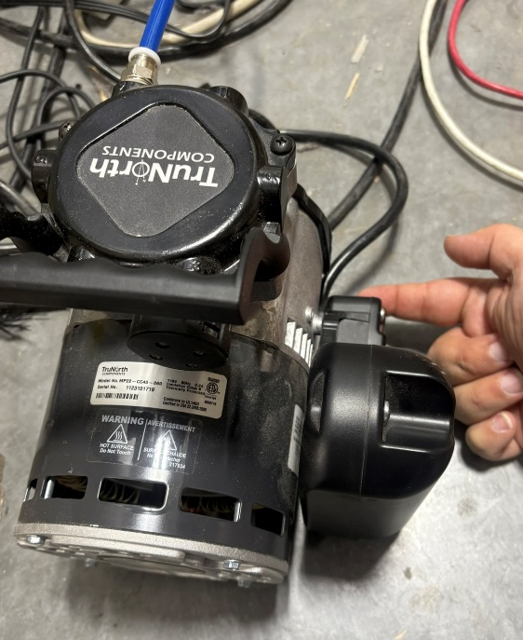
ON/OFF SWITCH

SETTING UP YOUR FILE TO PRINT
- Open your project using Adobe Illustrator.

- Make sure your project’s artboard is the same size as your material. Making sure to place objects on your Illustrator artboard where you want them on your material will make things much easier later.

- Your artboard is the white area in your design in Illustrator.

- The top left of the artboard corresponds to the top left of the material.

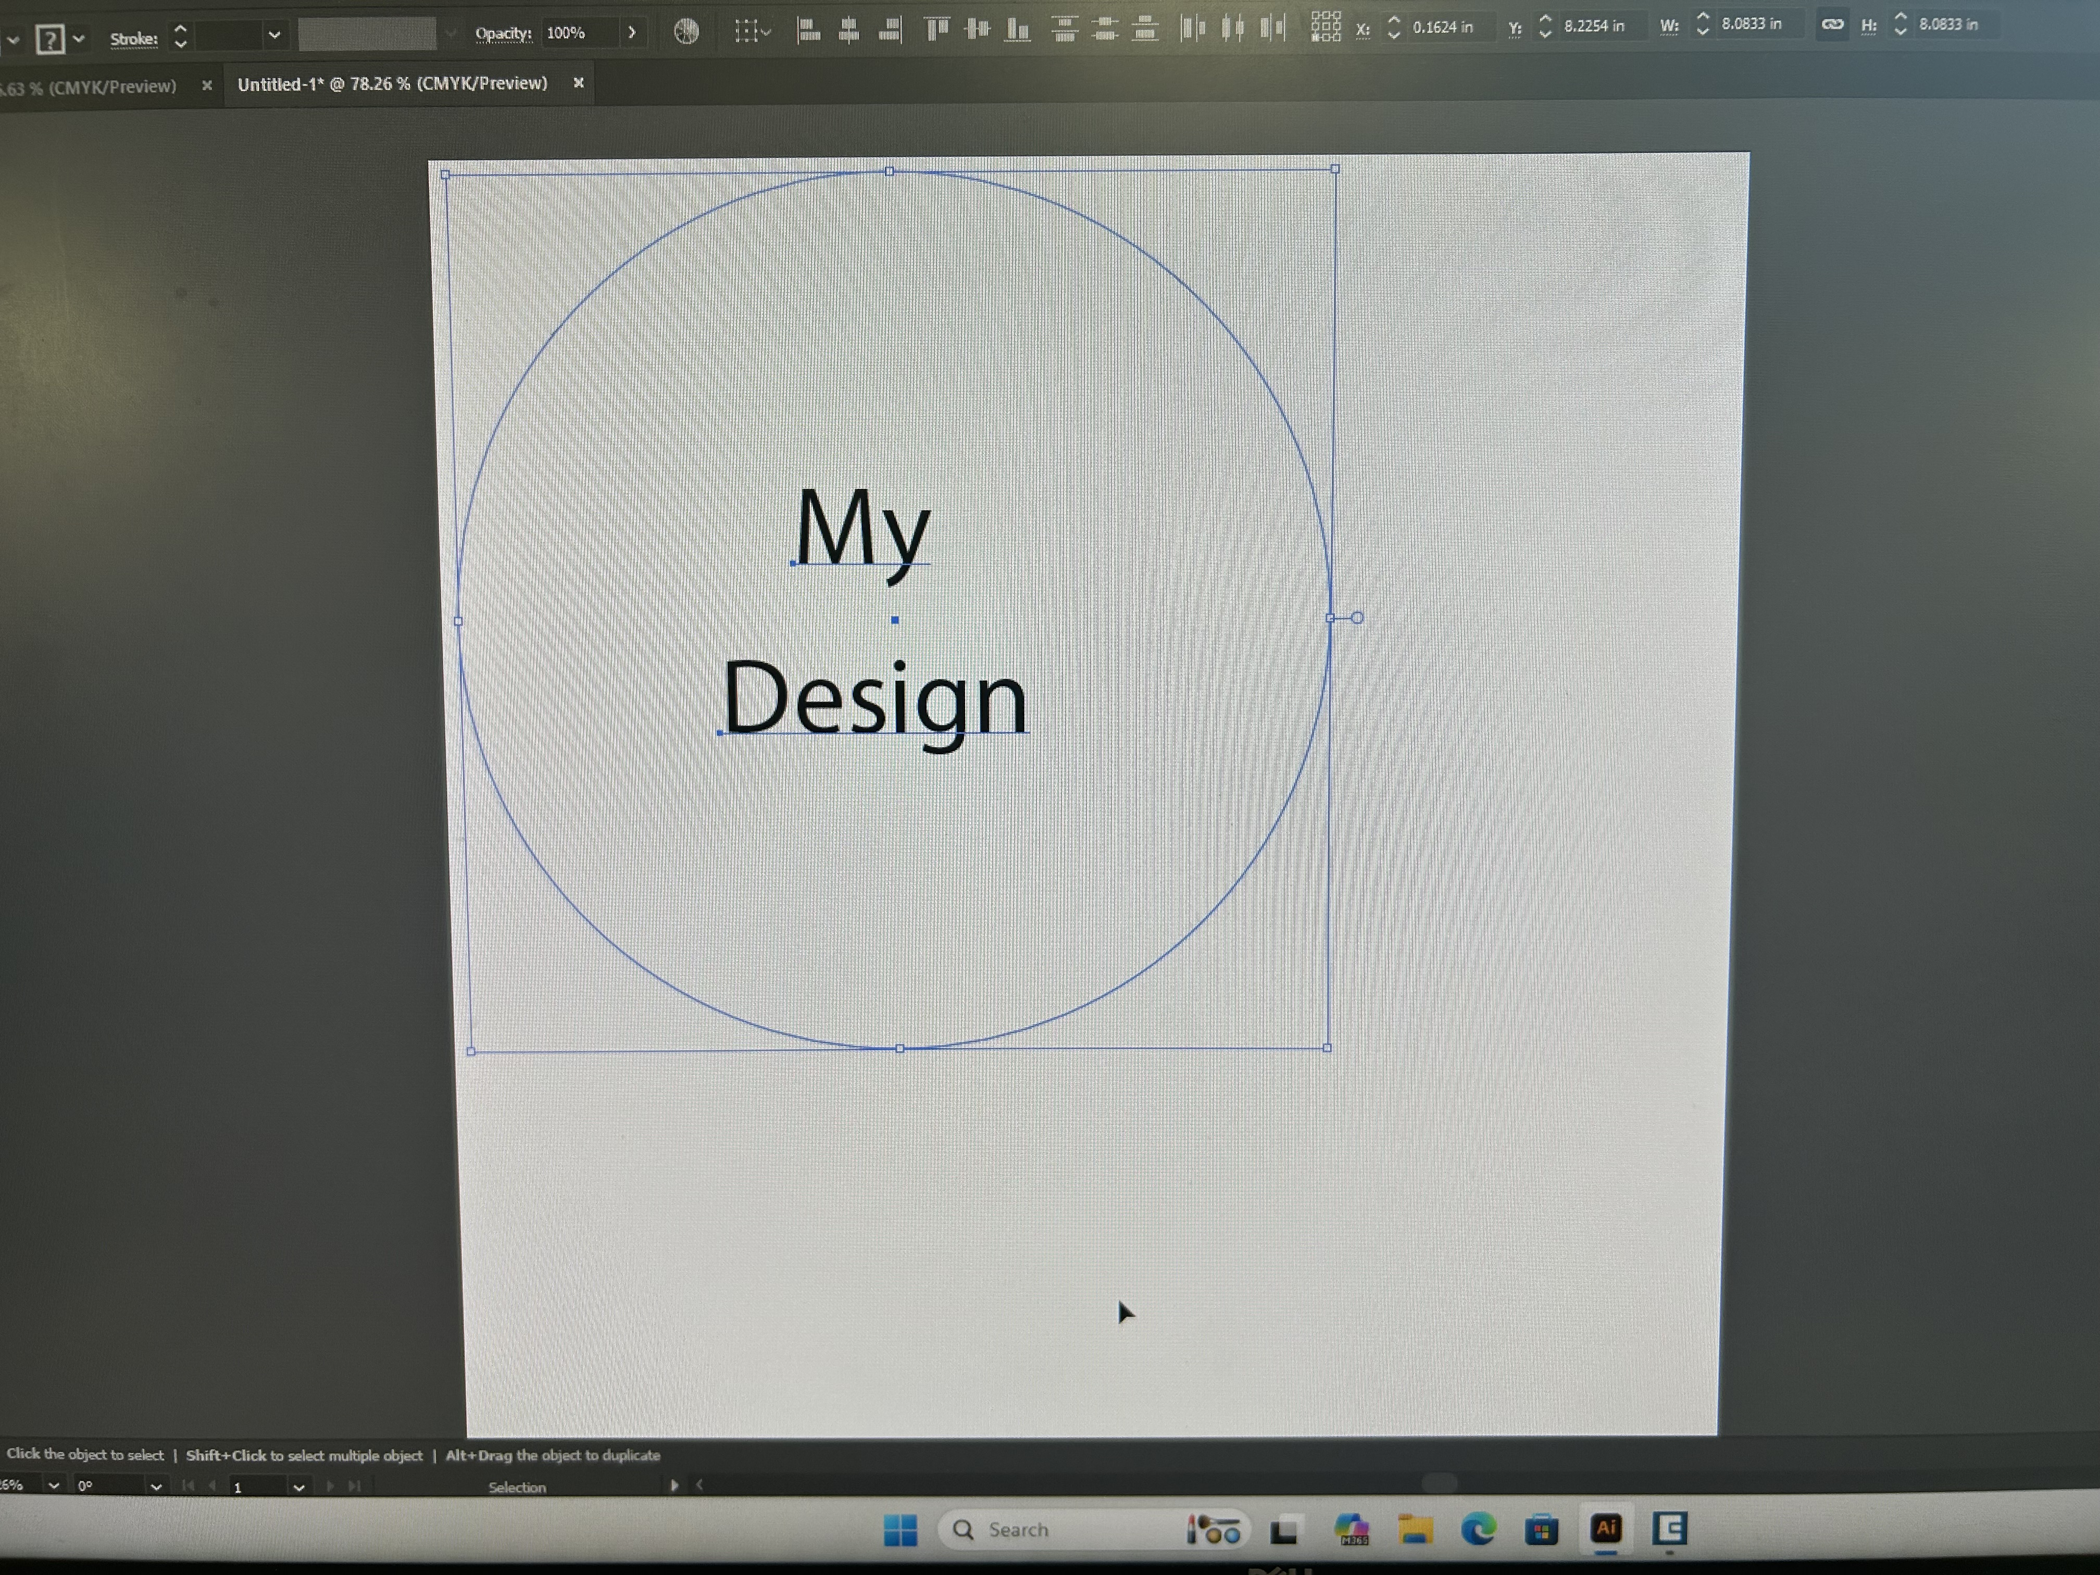

- To Vector (cut) lines must have a .001 stroke width (“hairlines”) to avoid confusion and for consistency between AutoCad and Illustrator.

- To Engrave (Raster) stroke lines must be .22 points or thicker.

- Epilog Job Manager also allows you to separate cuts/engraving by color to enable you to have different speed/power settings for different parts of your job. To do that, simply make each section of the project a different color.

SENDING YOUR FILE TO THE JOB MANAGER

Make sure your file is saved to a name you will recognize.
- In Illustrator, FILE >PRINT.

- Under MEDIA SIZE use the drop-down menu to change the setting from DEFINED BY DRIVER to CUSTOM
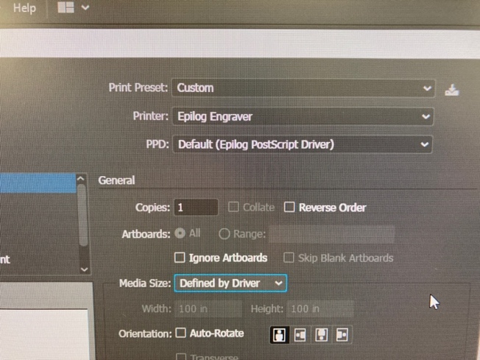 | 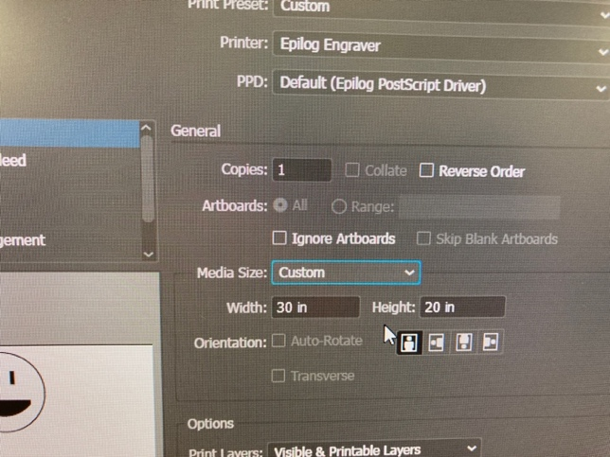
- This will resize your artboard to the correct size and place it properly on the laser.

- Click PRINT to send the file to the JOB MANAGER.
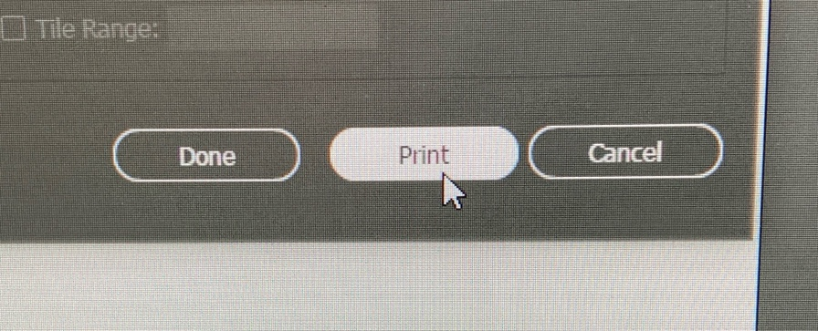

- If you are the first user of the day, you may have to open the job manager.
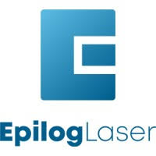

USING THE JOB MANAGER
- Epilog Job Manager should automatically open and show your design superimposed over your material.

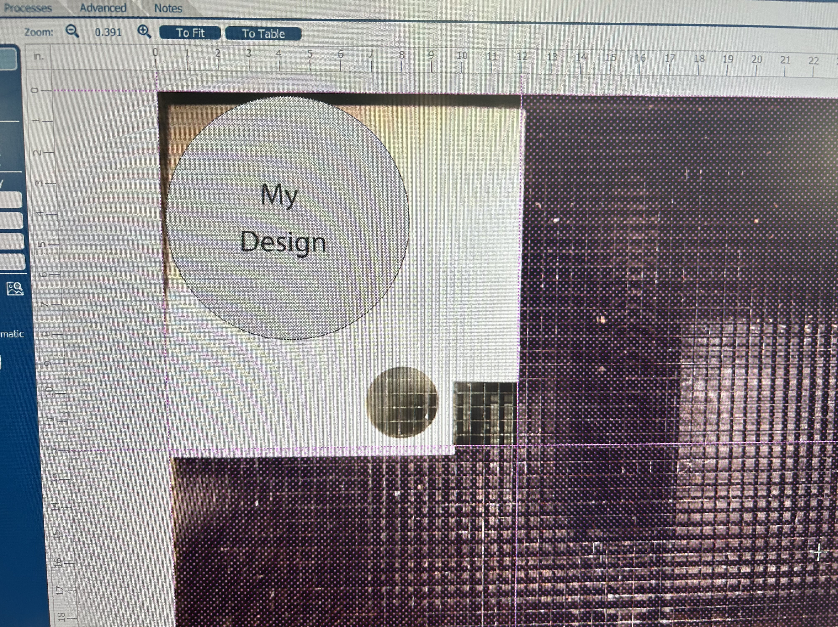

- If you don’t see your design, scroll out. It may be located to the bottom right of the board.

POSITIONING YOUR ARTWORK
- The print area is contained within the dashed purple lines. Any design that is outside of the print area will not print.

- Use the camera to check to make sure that your artwork is in approximately the right place.

- You can move the design around or resize it by click-and-drag or using the arrow keys on the keyboard.

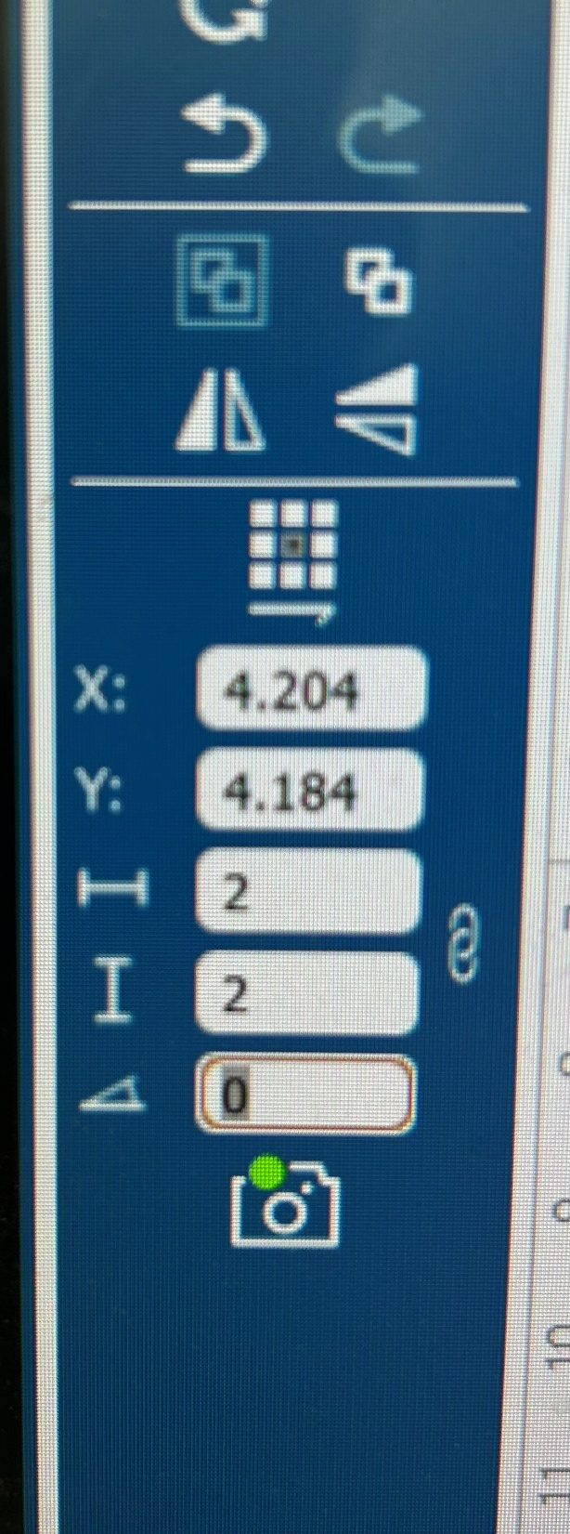

You can also use the information on the left column to rotate your design or type in new values for the size or X/Y positions.

CENTER ENGRAVING
You can set the home position in the center of your material by center engraving.

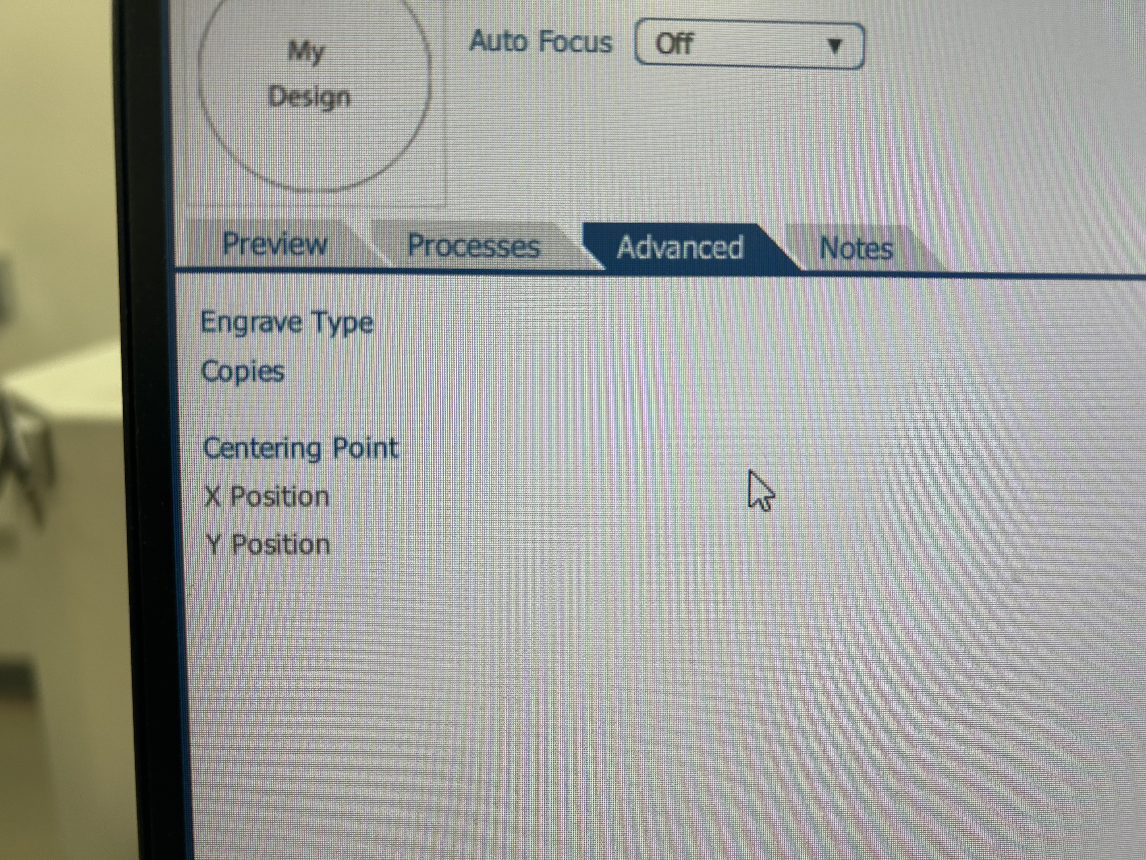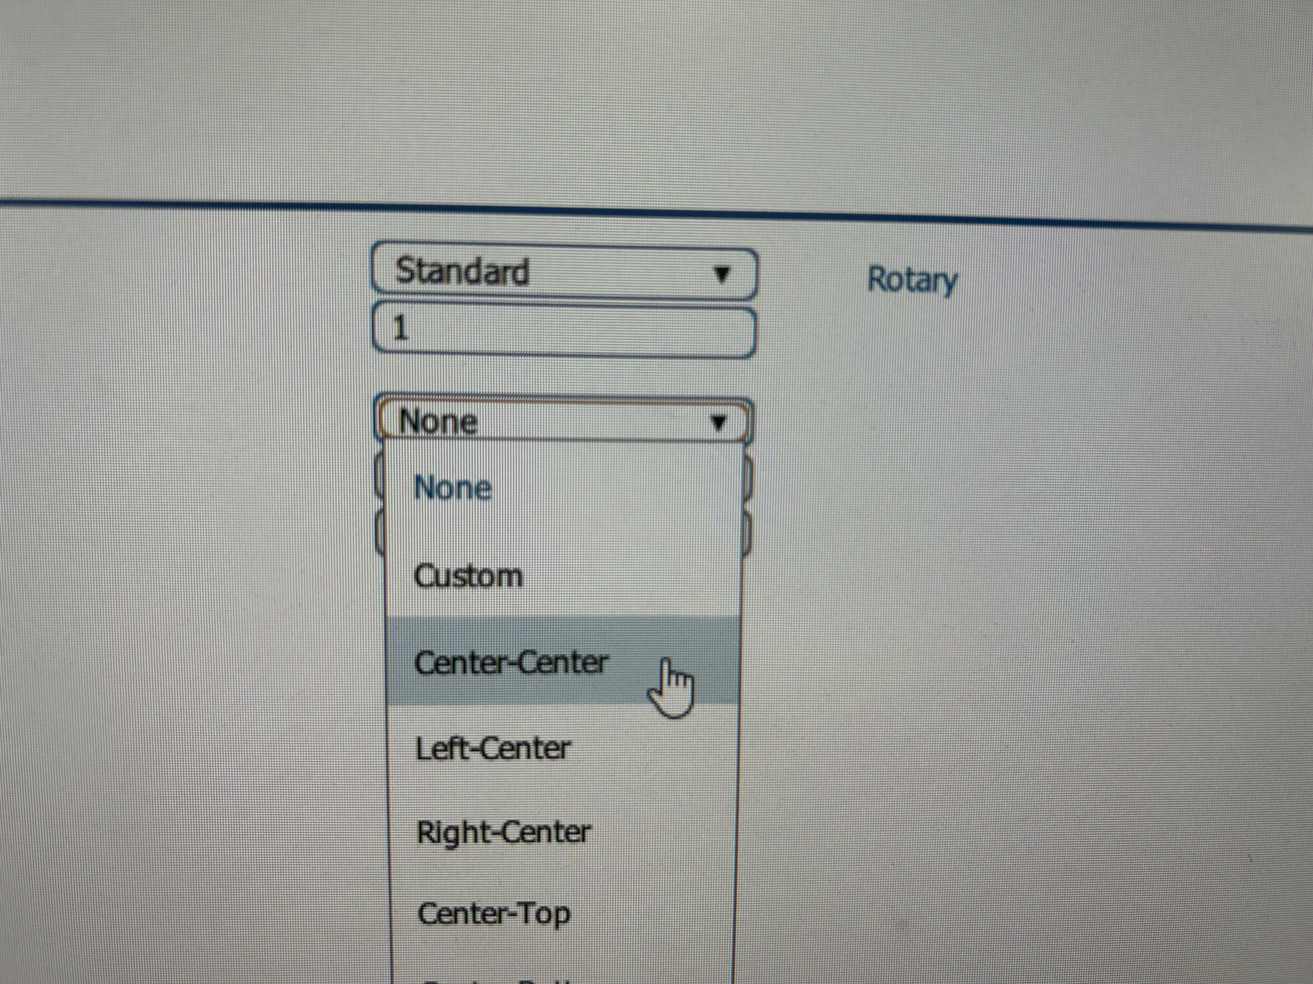
- Find Center Engraving.
- Click the dropdown, and you will see many options for reference points.
- Select an option.

PROCESSES & CHOOSING YOUR SETTINGS FOR ENGRAVING AND VECTORING
Make sure Auto Focus is off. We will manually focus later.

PROCESSES: AN OVERVIEW
- On the right side of the screen, you will see boxes labeled “Engrave” or “Vector.” These are called processes and are the steps the laser will take to create your design.
- You will set independent settings for each process.
- The laser will automatically split your file into any applicable processes.
  - Your shapes and images with a stroke width of .22 or greater will be placed in an Engrave process, and your shapes with a stroke with of .001 pt will be split into a Vector process.
- If it did not split your file automatically, and you see one Engrave process when you expect a vector process, click Split By: Hairlines. This will likely fix the issue.
- Otherwise, check your file to confirm line thickness.
- If you have used color to designate areas in your file you want engraved or cut with different settings, the software has likely automatically split them for you.
  - If it has not, find the process with your colors in it, and click Split By: Color.

CHOOSING YOUR SETTINGS

ENGRAVING PROCESSES
This is where we will set the settings we want the laser to use while engraving.
Resolution: Sets the amount of detail in your design, in dots per inch (DPI). Higher numbers will look better but will take longer.  Speed & Power: You will retrieve these values from the settings chart attached to the desk. Both lasers are 60 watts.  Frequency: will be enabled if using the fiber laser.  Laser (not pictured): Determines whether the process should use the CO₂ or Fiber laser. Only available on Laser #5.  Dithering: This changes the arrangement of the dots that make up your image. Standard works most of the time, but some materials/projects may need others.  Direction: Determines whether the laser will engrave from the top-down, or from the bottom-up. | 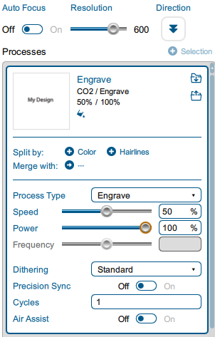

VECTOR PROCESSES
Speed and Power: Found using the same settings sheets as engraving.  Frequency: This can also be found in the settings charts, in the second column, next to the preset name.  Vector Sorting: changes the order the laser will execute cuts. | 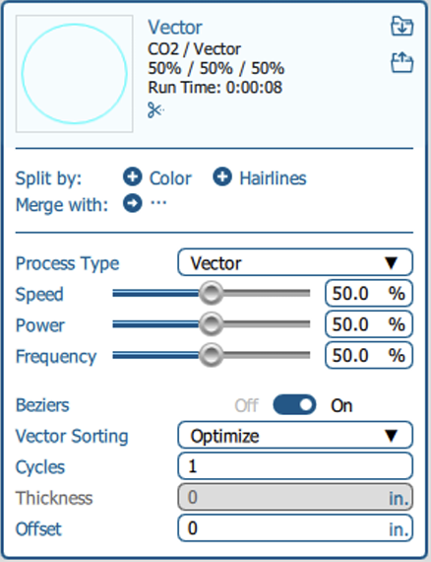

TRIPLE CHECK YOUR SPEED, POWER, AND FREQUENCY. MAKE SURE YOU ARE USING THE CORRECT WATTAGE (100 WATTS).

Once you have input your settings for all of your processes, you can click the “Print” button at the bottom of the screen. This will send your job to the laser.

THE LASER CONTROL PANEL
Here is where we will focus the laser to our material, set our home position (if applicable), and verify that our object is in the correct spot.

THE JOB VIEW & NAVIGATION
This menu shows all jobs sent to the laser since it was turned on. Tap your job to select it & hold it to see more info.  The buttons at the bottom are used to navigate between different views & useful laser functions. | 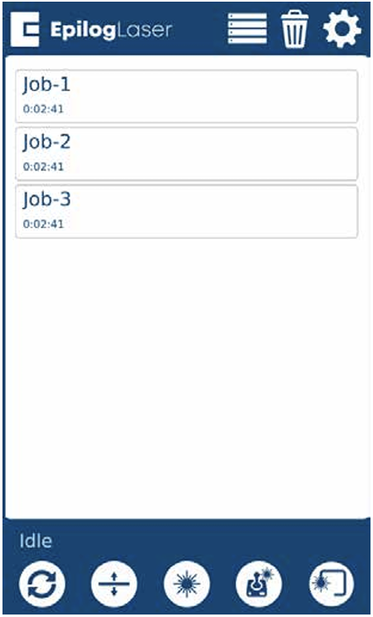
   | Returns the laser to its home position.
  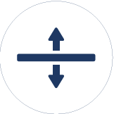 | Focus Menu
   | Enables a red dot pointer.
   | Jog Menu
   | Traces where your art will be placed.
   | Returns to the Job View from any other screen.

JOG MENU
The Jog Menu allows you to adjust the current X and Y axis positions of the laser head. You may change the current position of the laser head either using the Joystick, or by entering precise coordinates under “Move To”.
Centering Point:  - Pressing this button tells the laser where you want the center of your artwork to be.  - While jogging the laser head across the table, use the red dot pointer to help identify the center point of your engraving.  - The Centering Point feature is used with Center-Engraving enabled jobs (see note earlier)  Recommendation: Jog to the center of what you plan to laser. | 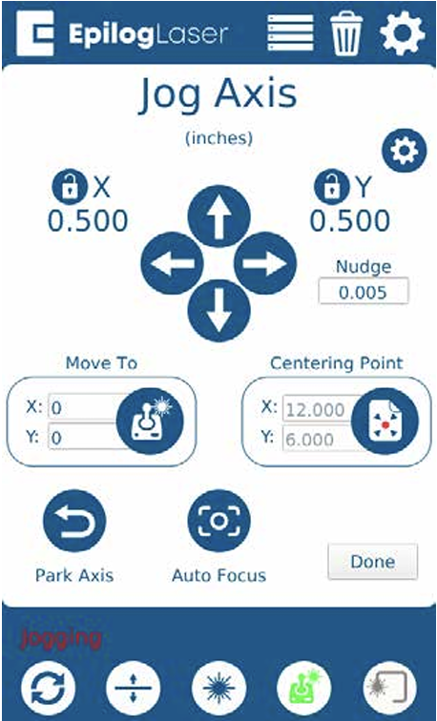

FOCUS THE LASER -MANUAL FOCUS
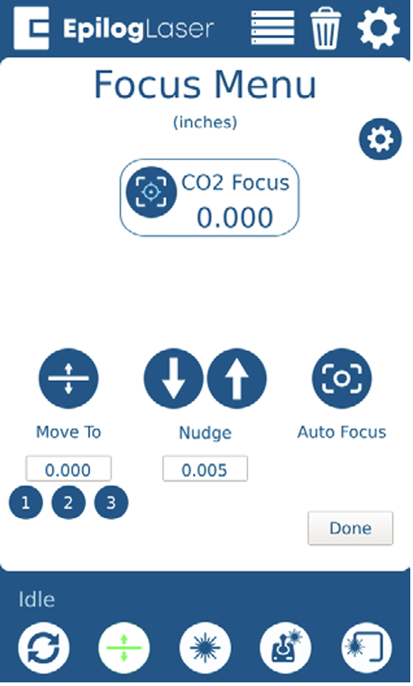
The Focus menu is used to move the laser table up and down in order to make sure that the laser beam is in focus.
- Attach the focus tool
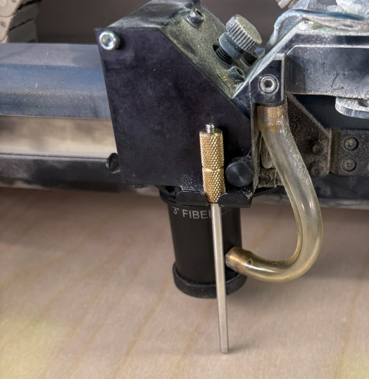
- Use joystick to move table until the focus tool barely touches your material.
- Use the Nudge arrows for precise movement.

FINAL STEPS: CONFIRM & GO
Before you begin your job, you must complete the following checklist:
- Select the Trace option (button 5) and confirm the print location is on your material.
- Confirm ventilation is on.
- Check:
  - Did you focus the laser?
  - Did you trace the job?
- Confirm your settings.
  - For engraving processes, from left to right: Speed, Power, DPI.
  - For Vector processes, from left to right: Speed, power, frequency.
- Once your settings are correct, press the play/pause button on the machine to start your job!

WHILE RUNNING
While the laser is running, you must watch for signs of fire.

MONITORING RULES:
- Watch laser for signs of fire
- You cannot leave the laser unattended.
  - If you must leave the laser, pause the job and resume when you return

IN CASE OF FIRE:
A 2” flame is okay for a short period of time during cutting passes only, as long as the flame is following the laser as it cuts. If either condition is not true, you must intervene.
- Press the pause button on the machine. During cut passes, the laser may take a second to stop cutting.
- Begin fighting the fire.
  - Find a spray bottle of water (marked H20). Check the bottle before spraying.
  - Spray water at the base of the flame.
  - If you are able to put the fire out with water alone, and your material is still salvageable, you can continue cutting.
  - However, if another fire happens you must stop running your project. Confirm your settings and material composition.
- If water is unable to put the fire out, attempt and use other material to smother the fire. Grab scrap wood from the bin, whatever is needed. If this fails, IMMEDIATELY GET NIS STAFF.

FINISH & CLEAN UP
- Remove your material.
- Remove scrap.
  - Small pieces go in trash can
  - Large pieces go in donation box
- If lots of small scrap pieces fell through the laser cutting bed, remove the bed and dispose of the scrap.
- Turn off Laser.
- If you are the last person using the lasers, turn off room ventilation.

THE ROTARY TOOL
The Rotary Tool is used to engrave around cylindrical objects, such as glasses, metal water bottles, and tumblers.

INSTALLING THE ROTARY TOOL
- Lower the bed of the laser to at least 6 inches.
- Turn off the machine. Open the lid, and optionally, the front gate.
- Remove the vector grid from the machine. Place it to the side.
- Remove the metal bars underneath the grid. Place them off to the side.
- Place the silver table into the laser.
  - This table is for ENGRAVING ONLY. Do not vector any objects on this table.
- Grab the rotary tool (on top of the material shelf).
- Place the rotary tool into the top-left corner of the machine.
- 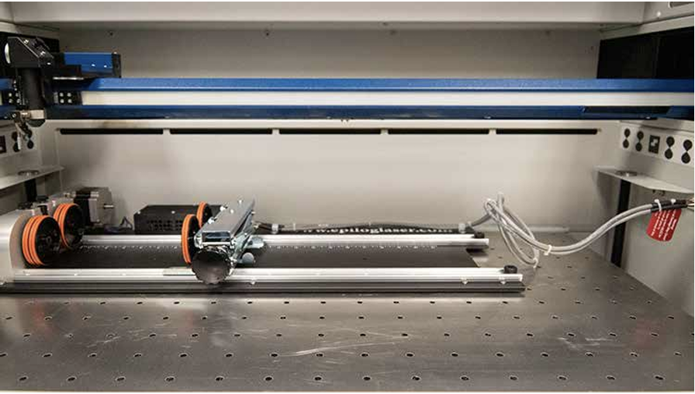
- Plug the connector into the port on the right side of the machine.
- Turn on the laser.

DESIGNING YOUR FILE
File setup for the Rotary Tool is slightly different than normal, but fundamentally the same.

FILE CREATION
We will still be creating an Illustrator artboard the same size as our material, but since our material is round, we must “unwrap” it.

- The width of your file in Illustrator should be the length of your glass.
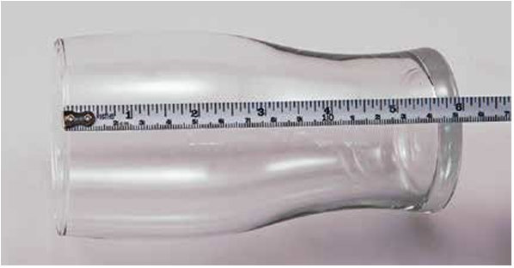
- The height of your file in Illustrator should be the circumference of your object at its largest diameter. There is a flexible tape measure for this purpose.
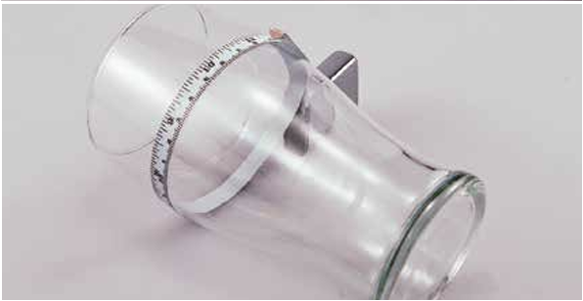

DESIGNING YOUR ARTWORK
- When designing your project, place your art towards the top of the file.
- You may need to rotate your design:
WRONG
Adobe Illustrator Engraved
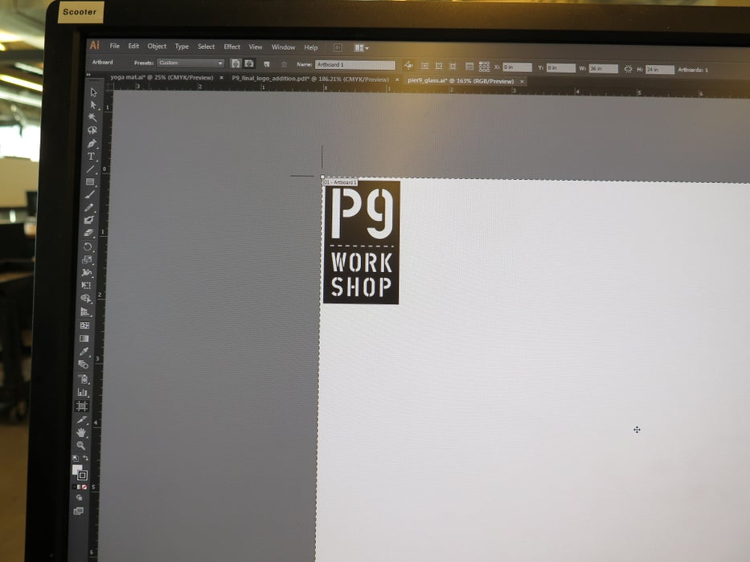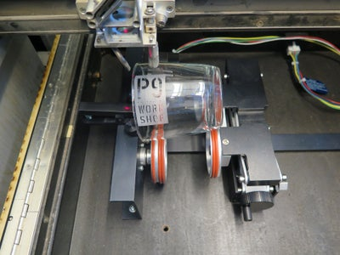
CORRECT
Adobe Illustrator Engraved
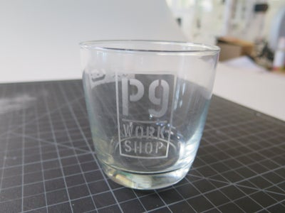
- When the job starts, the first part of the process is for the cylinder to rotate through any white space that is between the top of your page and the top of your artwork.

SENDING YOUR JOB TO THE LASER
The process of sending your job to the laser is identical to the process without a rotary tool, with one exception:
- In the Epilog Dashboard, go to Advanced.
- EXPLAIN CENTER/CENTER?
- Enable the Rotary option.
- Choose the correct type of rotary tool (likely the Rim-Drive).
- Proceed as normal with setup and hit print.

Frequently Asked Questions (FAQs)
- Illustrator needs a login.
  - Members should utilize their personal Adobe login information. Account is free.

- My piece did not cut all the way through.
  - Did you focus the laser?
  - Is your piece flat? Warped or bent pieces may not cut.
    - Tape down. Refocus.
  - Cutting ¼” – Lasers may struggle with this thickness.
    - Lower speed setting.

- I don’t see my design in Epilog Job Manager.
  - It may be located to the bottom right of the board. Scroll out to find it. Move into the design area.

- The material I am using is not on sheet.
  - For size difference, find a similar, conservative substitute.
    - Want to cut 3/16”, try the settings for 1/4”
  - For different material, Ask NIS Staff. Some materials cannot be lasered and will cause health risks

- Laser does not run. Zero run time.
  - Probably an issue with your Adobe illustrator design.
    - Check your lines. Do they intersect?
  - Did you create your original in Rhino or Solidworks?
    - Try exporting as a different file type.
    - Use the VCarve trick
      - Load SVG into VCarve
      - Check Duplicates: Edit → Selection → Select All Duplicate Vectors → Delete
      - Join lines
      - Re-save as a new SVG, reload into Illustrator.

