SOP
Laser #4
Fusion Pro 32
60W CO2 Laser
Training is required before using this equipment
Reservations are required when using this equipment
NEVER LEAVE THE LASER UNATTENDED
WHEN IT IS OPERATING
YOU MAY ONLY OPERATE ONE LASER AT A TIME
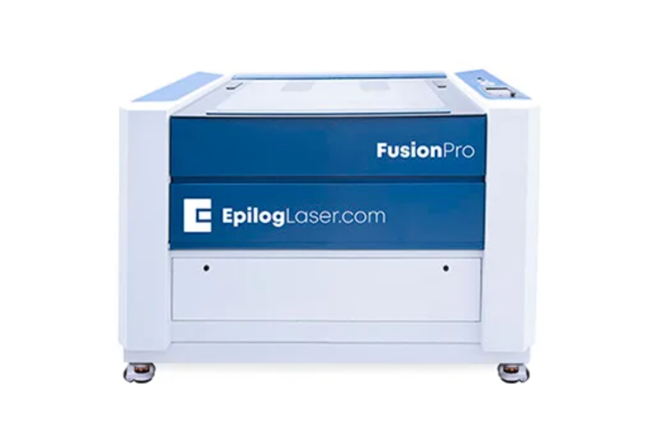

Quick Start
- Turn on Room Ventilation
- Turn on Laser
- Open File in Adobe Illustrator
- File →Print
- Job Manager should open automatically
- Position Design as needed
- Change Speed/Power/Frequency
- Click Print Button
- Focus Laser
- Select Start on Laser

YOU MUST WATCH THE LASER AT ALL TIMES
THIS LASER IS VERY POWERFUL

FUSION PRO 32 SPECIFICATIONS

MAXIMUM MATERIAL DIMENSIONS – 32” x 20”
MAXIMUM MATERIAL THICKNESS FOR CUTTING – ¼”
MAXIMUM MATERIAL THICKNESS FOR ENGRAVING – 11.25”

BANNED MATERIALS
Materials containing chlorine (PVC, Moleskin)
Polycarbonate (Barlo, Calibre, Hyzod, Lexan, Makralon, Palsun, Sustanat, Tecanat, Tristar, Makroclear, Arcoplus)
Fr4 Boards (resin reinforced fiberglass composite)
Fiberglass

MATERIAL COMPATIBILITY (CO2)
Material | Engrave | Cut
Acrylic | Yes | Yes
Anodized Aluminum | Yes
Ceramic | Yes
Cloth | Yes | Yes
Coated Metals | Yes
Corian | Yes | Yes
Cork | Yes | Yes
Delrin | Yes | Yes
Fabric | Yes | Yes
Fiberglass | Yes | Yes
Glass | Yes
Leather | Yes | Yes
Marble | Yes
Matte Board | Yes | Yes
Melamine | Yes | Yes
Mother of Pearl | Yes | Yes
Mylar | Yes | Yes
Painted Metals | Yes
Paper | Yes | Yes
Plastic | Yes | Yes
Powder Coated Metals | Yes
Pressboard | Yes | Yes
Rubber | Yes | Yes
Tile | Yes
Wood | Yes | Yes
Wood Veneer | Yes | Yes
Bare Metals | *
Brass | *
Stainless Steel | *
Titanium | *
* CO2 lasers will mark bare metals when coated with a metal marking solution.

SAFETY
Make sure ventilation is on prior to use. The button to start the ventilation is located on the west wall and pulls to activate. This will pull smoke from all the lasers. Confirm the ventilation is on before using the laser.
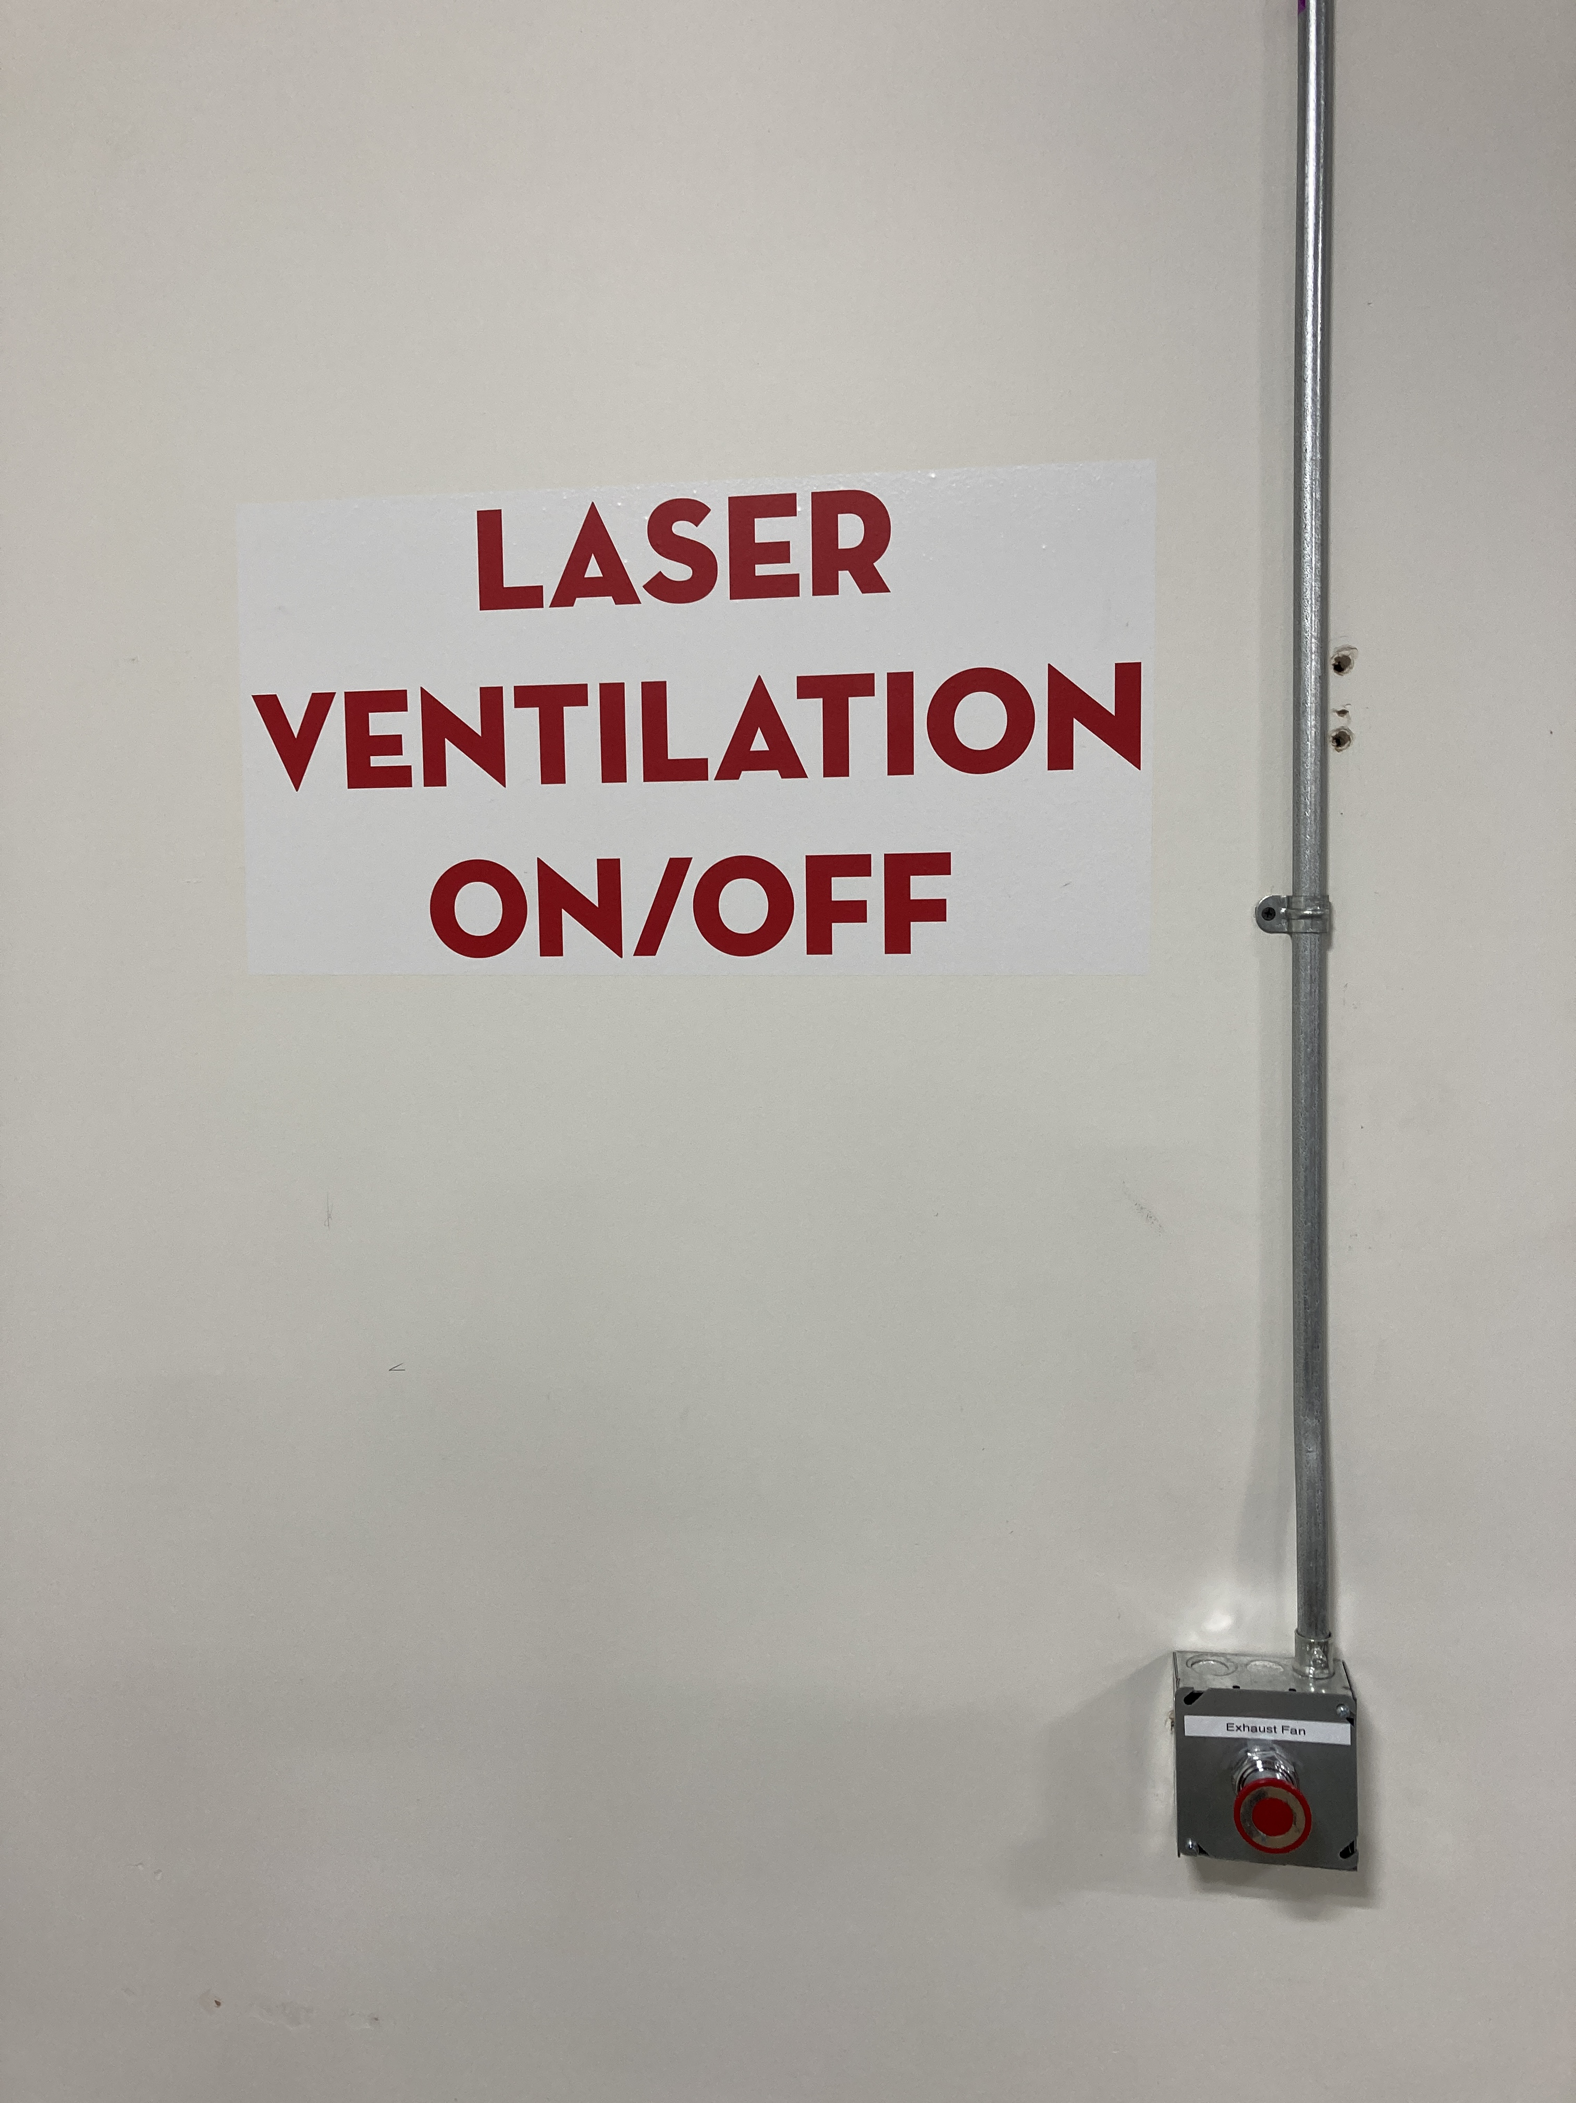
If you are done with your laser, and nobody else is using any of the other lasers, turn the ventilation system off.
A 2” Flame is okay for short lengths during a cutting pass. If the flame persists or your material is on fire, push the pause button on top of the laser.
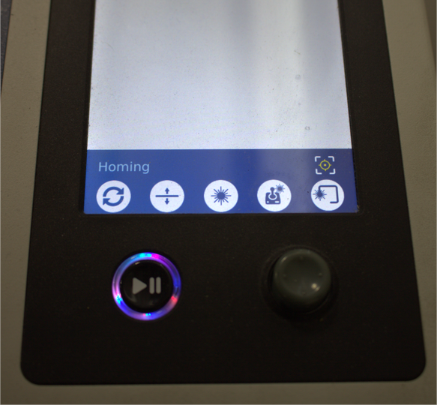
Open the laser and blow on the flames, or smother it with scrap plywood. If this does not extinguish the flames you may use a spray bottle filled with water to mist the flames until extinguished.
If these steps do not extinguish the fire contact NIS staff immediately. DO NOT USE A FIRE EXTINGUISHER.

Never leave the laser unattended while it is in operation.
Never operate more than one laser simultaneously.

POWERING ON THE LASER

The Epilog Fusion Pro 32 turns on with a key on top of the laser.

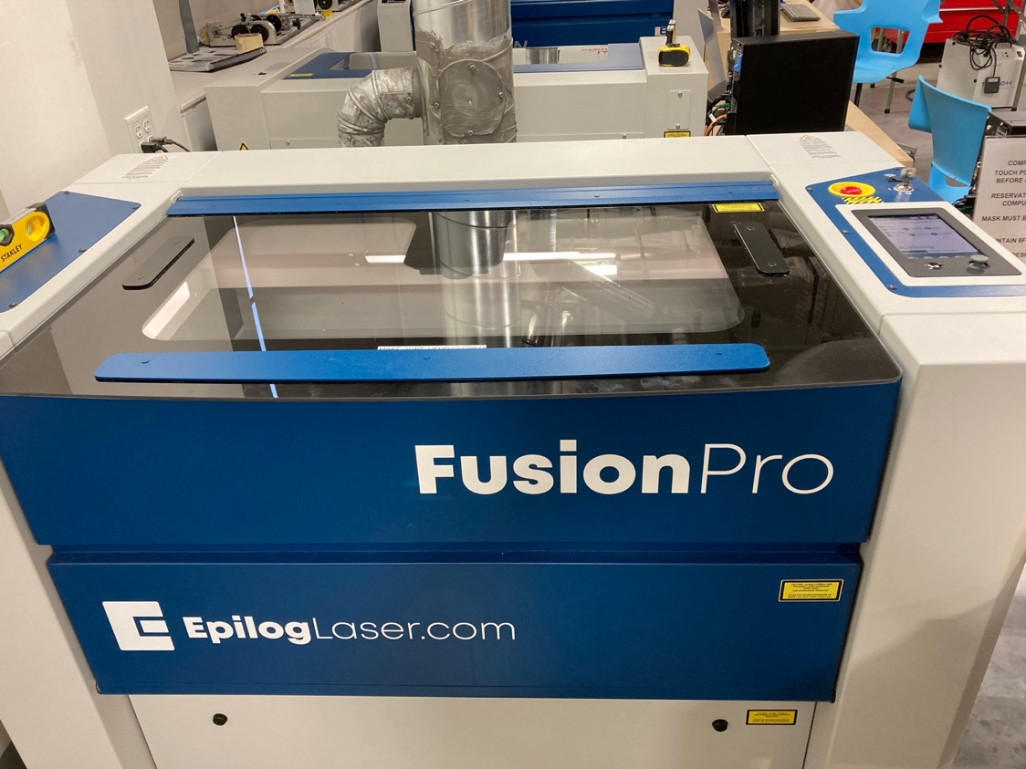
ON/OFF KEY

The laser must be turned on to receive your job.

SETTING UP YOUR FILE TO PRINT
- Open your project using Adobe Illustrator.
- Make sure your project’s artboard (white area) is the same size as your piece of material.
- To Vector (cut) lines must have a .001 stroke width (“hairlines”).
- To Engrave (Raster) lines must be .13 stroke or thicker.
- Epilog Job Manager also allows you to separate cuts/engraving by color to enable you to have different speed/power settings for different parts of your job. To do that, simply make each section of the project a different color.

POSITIONING YOUR ARTWORK
The top left corner of your Illustrator artboard corresponds with the top left corner of your Job Manager and the laser print bed.

The best method to have your project positioned in a specific location on your material is to make sure your artboard and material size are the same, place your file on your Illustrator artboard exactly where you want it to be located on your material, and use the X/Y zero position on the laser.
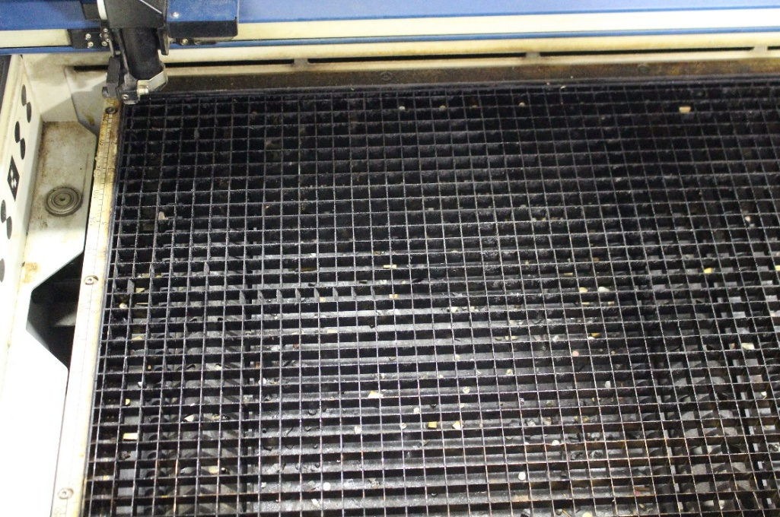
X/Y - 0/0
You may also use the center/center feature in the Job Manager. (see CENTER POSITIONING USING JOB MANAGER section).

SENDING YOUR FILE TO THE JOB MANAGER

Make sure your file is saved to a name you will recognize.
- In Illustrator, select FILE >PRINT.
- If Auto Rotate is selected, Unselect it.
- Under MEDIA SIZE use the drop down menu to change the setting from DEFINED BY DRIVER to CUSTOM. 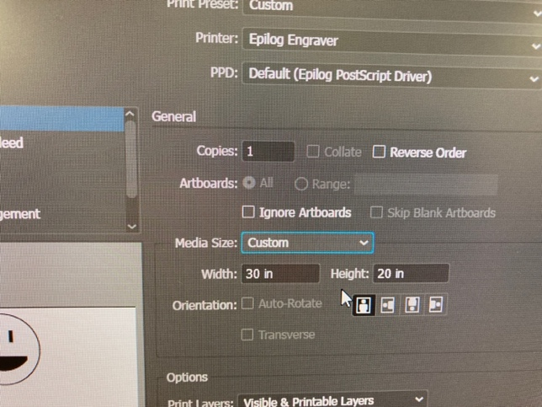
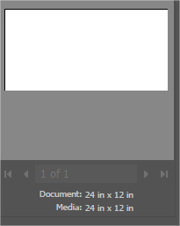
- This will change your media size to match your Illustrator artboard size.
- Click PRINT to send the file to the JOB MANAGER.
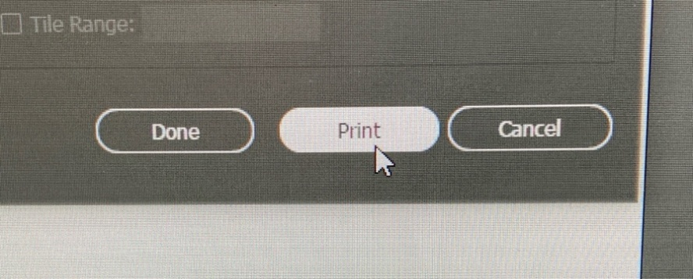

USING THE JOB MANAGER
- The Epilog Job Manager should automatically open and show your design.
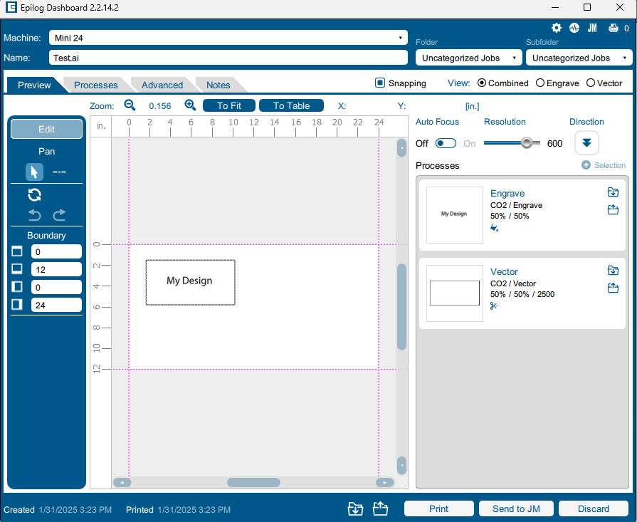
- FAQ: I don’t see my design?
- Answer: It may be located to the bottom right of the board. Scroll out to find it.
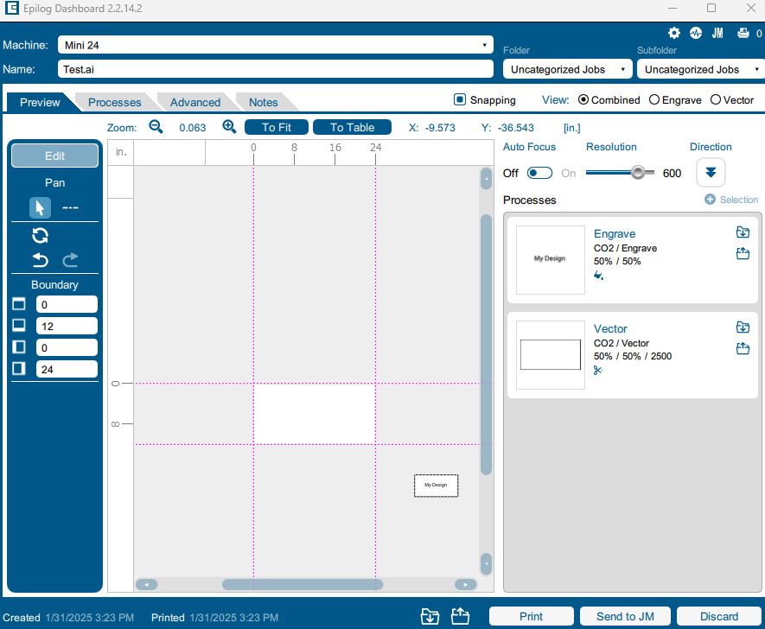

ENGRAVE AND VECTOR SETTINGS
Make sure Auto Focus is turned off. We will manually focus later.
On the right side of the screen, you will see boxes labeled “Engrave” or “Vector.” These are called processes and are the steps the laser will take to create your design.
- You will set independent settings for each process.
- The laser will automatically split your file into any applicable processes.
  - Your shapes and images with a stroke width of .13 or greater will be placed in an Engrave process, and your shapes with a stroke with of .001 pt will be split into a Vector process.
- If it did not split your file automatically, and you see one Engrave process when you expect a vector process:
  - click Split By: Hairlines. This will likely fix the issue.
  - Check your Illustrator file to confirm line thicknesses.
- If you have used color to designate areas in your file you want engraved or cut with different settings, the software has likely automatically split them for you.
  - If it has not, find the process with your colors in it, and click Split By: Color.
- If none of these processes work, see NIS staff.

CHOOSING YOUR SETTINGS

ENGRAVING PROCESSES
Auto Focus: Confirm OFF is
selected
Resolution: Sets the amount of detail in your design, in dots per inch (DPI). Higher numbers will look better but will take longer.  Direction: Determines whether the laser will engrave from the top-down or bottom-up.  Speed & Power: You will retrieve these values from the settings chart attached to the desk. Laser #4 is 60 watts.  Frequency: Not applicable to engraving process.  Dithering: Adjusts the arrangement of the dots that make up your image. Standard works most of the time, but some materials/projects may need others.  Direction: Determines whether the laser will engrave from the top-down, or from the bottom-up. | 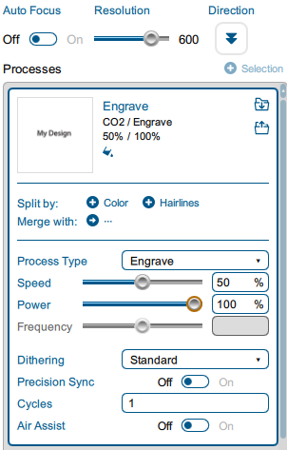

VECTOR PROCESSES
Speed and Power: Found using the settings charts. Make sure you are using the correct settings for the wattage laser you are using.  Frequency: This can also be found in the settings charts, in the second column, next to the preset name.  Vector Sorting: changes the order the laser will execute cuts. | 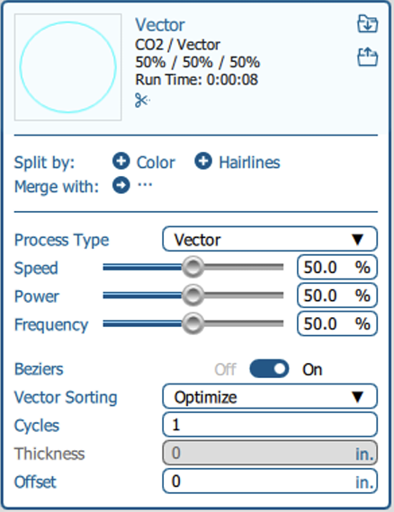

TRIPLE CHECK YOUR SPEED, POWER, AND FREQUENCY. MAKE SURE YOU ARE USING THE CORRECT SETTINGS BASED ON YOUR LASER WATTAGE.

Once you have input your settings for all of your processes, you can click the “Print” button at the bottom of the screen. This will send your job to the laser.

THE LASER CONTROL PANEL
The laser control panel allows you to focus the laser to your material, set your home position (if applicable), and verify that your object is in the correct position.

THE JOB VIEW & NAVIGATION
This menu shows all jobs sent to the laser since it was last powered on.  The buttons at the bottom are used to navigate between different views & laser functions. | 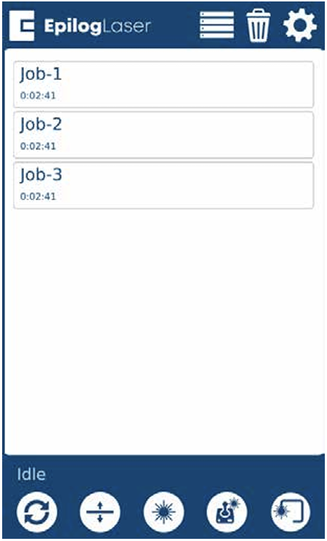
   | Returns the laser to the home position.
   | Used to focus the laser on the Z axis.
   | Enables the red dot pointer.
   | Moves the laser head on the X and Y axes.
   | Traces the total area where your art will be placed.
   | Returns to the Job View from any other screen.

JOG MENU
The Jog Menu allows you to adjust the current X and Y axis positions of the laser head. You may change the current position of the laser head either using the Joystick, or by entering precise coordinates under “Move To”.

Centering Point:  - Pressing this button tells the laser where you want the center of your artwork to be.  - While jogging the laser head across the table, use the red dot pointer to help identify the center point of your engraving.  - The Centering Point feature is used with Center-Engraving enabled jobs (see Center Positioning Using Job Manager) | 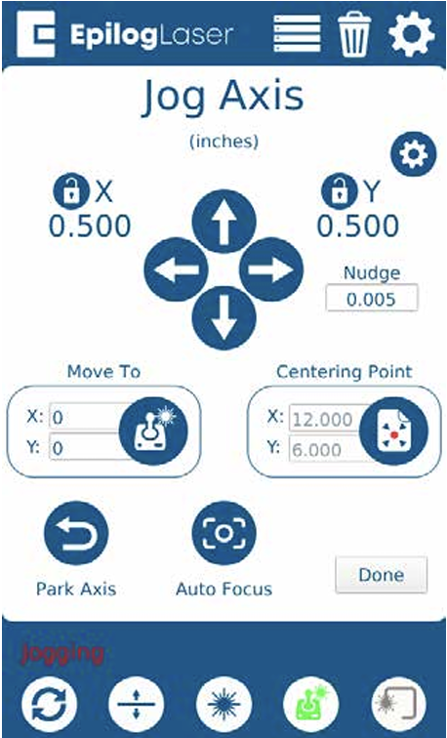

FOCUSING THE LASER
The Focus menu is used to move the laser table up and down in order to make sure that the laser beam is in focus.
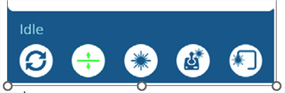
- Select the focus button (2nd from left)

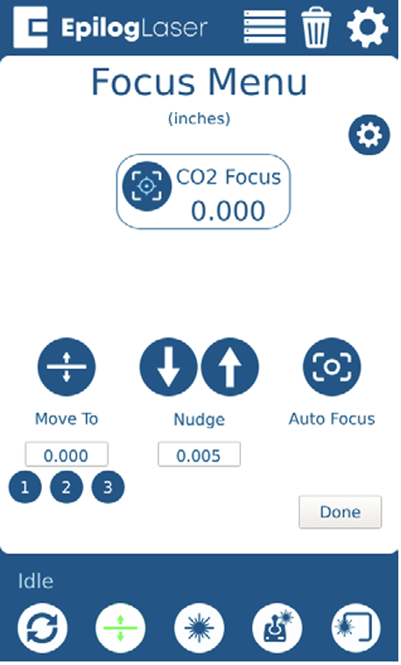
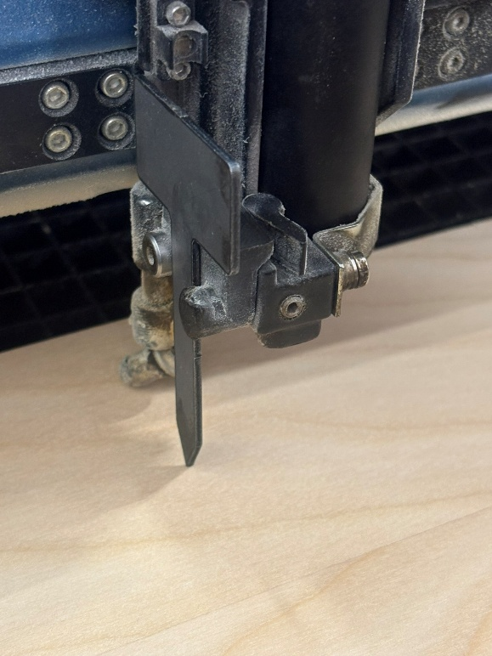

- Attach the focus tool. The focus tool is attached to a magnet on the right side of the laser. You may need to lower the bed to allow focus tool installation.
- Use the joystick to move table up until the focus tool barely touches your material.
- Use the Nudge arrows for precise movement.
PRECISE FOCUSING OF THE LASER IS CRUCIAL TO THE SUCCESS OF YOUR JOB.
- Press Done.

CENTER POSITIONING USING JOB MANAGER
Positioning your artwork on the center of your material can also be accomplished using the Center-Center feature in the Job Manager. This process will ignore the location of your artwork on your Illustrator artboard and only reference your artwork.
There are 2 methods to accomplish the Center-Center feature.
Method 1 allows you to use a user specified center point in coordination with aligning your material to the laser bed ruler guides. This method works best if you DO need to have your material square to the artwork
Method 2 allows you to use the laser bed center point. You will align the center of your material with the red dot pointer when the laser head is located at the laser bed center. This method works well if you DO NOT need to have your material square to your job.
METHOD 1
- Follow the steps to send your Illustrator file to the Job Manager.
- Go to the Advanced tab in Epilog Job Manager
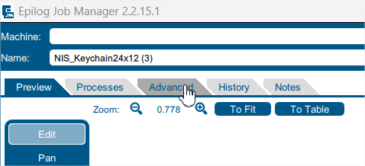
- Under Centering Point select Center-Center
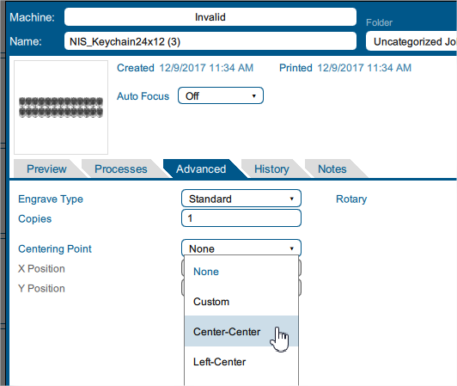
- Click on the Preview tab and adjust your vector and engrave settings per your requirements found in the settings chart.
- Send your job to the laser by clicking Print.
- Locate and make a mark on your material where the center of your artwork will be.
- Turn on the red dot pointer.
- Place your material against either or both the X/Y axis rulers on the laser bed.
- Using the joystick move function move the laser head to the center mark on your material. This will ensure that your artwork is square to your material.
- Select the Jog Axis function on the keypad.
- Touch the Centering Point box on the screen.
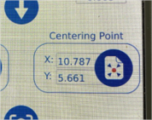
- The numerical X/Y values shown in the Centering Point box and on the main screen should now match. If they do not match repeat this function.
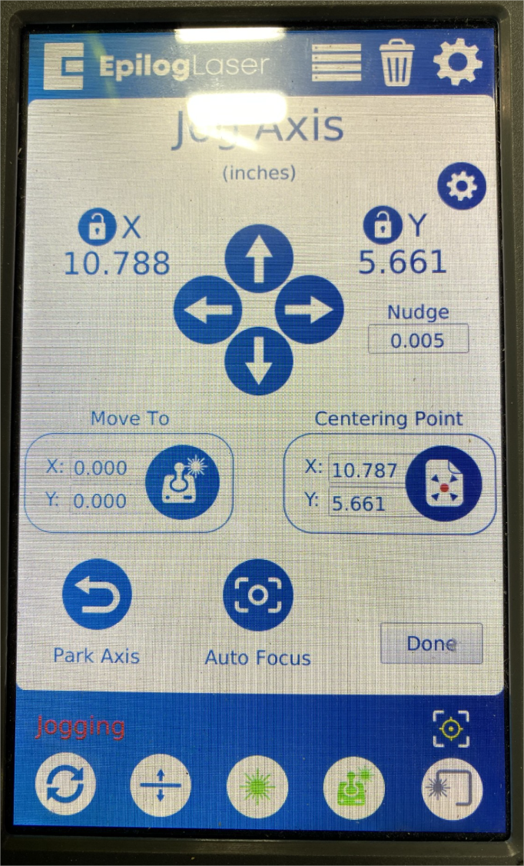
METHOD 2
- Follow the steps to send your Illustrator file to the Job Manager.
- Go to the Advanced tab in Epilog Job Manager

- Under Centering Point select Center-Center

- Click on the Preview tab and adjust your vector and engrave settings per your requirements found in the settings chart.
- Send your job to the laser by clicking Print.
- Locate and make a mark on your material where the center of your artwork will be.
- Turn on the red dot pointer.
- With the laser lid open, select the Run/Pause button. This will start your job without the laser actually firing.
- Let your job run for a couple seconds and select the Run/Pause button again.
- Select the reset button. This will move the laser to the center point of the laser bed.
- Place your material center point directly below the red dot pointer.
- Manually focus the laser.
- You may use the Trace function to ensure your artwork will engrave/cut in the correct location.
- Ensure ventilation is on and click Print.

WHILE RUNNING
While the laser is running you must stand and observe the laser as it is operating.
You may not leave the laser as it is running.
You may not ask another member to watch your laser in your absence.

IN CASE OF FIRE:
A 2” flame is okay for a short period of time during cutting passes only and if the flame is following the laser as it cuts and not setting your material on fire. If either condition is not true, you must do the following:
- Press the pause button on the machine. During cut passes, the laser may not stop cutting immediately. If this is the case then you must open the laser lid and the laser will stop firing but will continue to move until it reaches the end of the vector cut .
- Blow on the flames or smother it with scrap plywood. If this does not extinguish the flames you can use a spray bottle filled with water to mist the flames until extinguished.
CONFIRM THAT THE BOTTLE CONTAINS WATER BEFORE APPLYING IT TO THE LASER FIRE.
Squeeze bottles DO NOT contain water. Squirt bottles DO contain water.
- If these steps do not extinguish the fire contact NIS staff immediately.
DO NOT USE A FIRE EXTINGUISHER.

Never leave the laser unattended while it is in operation.
- Never operate more than one laser simultaneously.

FINAL STEPS: CONFIRM & GO
Before you begin your job, you must complete the following checklist:
- Select the Trace option and confirm the print location on your material.
- Confirm ventilation is on.
- Confirm that you focused the laser.
- Confirm that your X/Y home is set correctly.
- Confirm your cut and engrave settings by returning to the job menu and pressing & holding on your job file .
  - For engraving processes, from left to right: Speed, Power, DPI.
  - For Vector processes, from left to right: Speed, power, frequency.
- Once your settings are correct, press the Go/Pause button on the machine and your job will start.

FINISH & CLEAN UP
- Remove your material.
- Remove scrap.
  - Small pieces go in trash can
  - Large pieces go in donation box
- If lots of small scrap pieces fell through the laser cutting bed, remove the bed and dispose of the scrap.
- If you are the last person using the lasers, turn off room ventilation.
- PAY FOR THE MATERIAL THAT YOU USED.

THE ROTARY TOOL
The Rotary Tool is used to engrave cylindrical objects, such as glasses, metal water bottles, and tumblers.
A CO2 laser cannot engrave on raw metal. A CO2 laser can engrave on glass, painted or powder coated metal.

INSTALLING THE ROTARY TOOL
- Lower the bed of the laser to at least 6 inches.
- Turn off the machine. The laser must be powered off prior to installing the rotary tool or it will not recognize the tool.
- Open the lid, and optionally, the front gate.
- Remove the vector grid from the machine and place it to the side.
- Remove the black metal frame that is underneath the grid and place it to the side.
- Place the silver engrave table into the laser.
- Grab the SINGLE PLUG rotary tool
- MAKE SURE THAT YOU ARE USING THE SINGLE PLUG ROTARY TOOL
IN LASERS 2, 4 & 5. FAILURE TO DO SO WILL RESULT IN DAMAGE TO THE LASER.
- Place the rotary tool at the X/Y-0/0 position at the top-left corner of the laser bed.
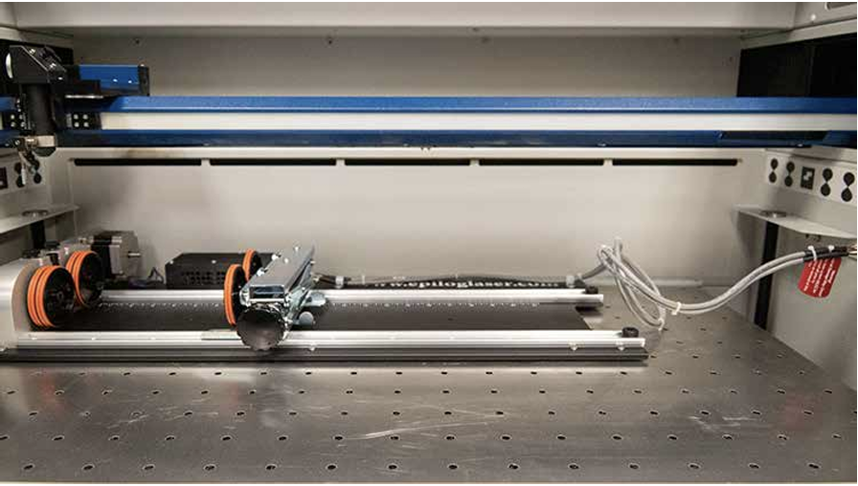

- Plug the connector into the port on the right side of the machine.
- Turn on the laser.

PLACING YOUR OBJECT
- Locate your object by placing it on the left hand and right hand wheels. Leave a small gap between your object and the left side of the rotary tool metal frame.
- Use the clip wheel on the left side of the rotary tool to secure it.
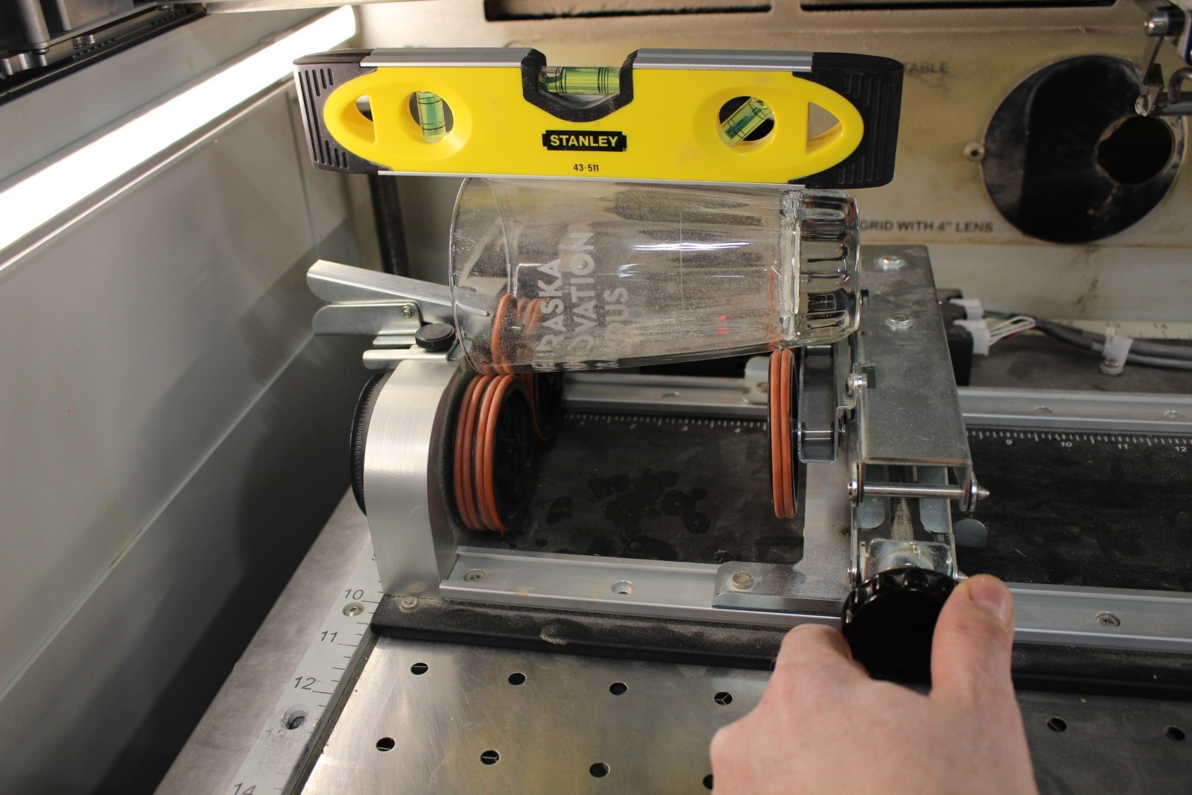

- Place the micro level on the area you will raster and adjust the leveling wheel to raise or lower your object until it is level.
- Select the focus function on the keypad. The laser will move to the correct focus point on your object. If the laser does not move over your object see NIS staff before proceeding.
- Turn on the red dot pointer and select the Joystick function. Move the laser to the top rim of your object, or to the location you want the top of your artwork to be located. The red dot pointer is not visible when engraving on glass so you may place a small piece of paper or plywood on top of your object so the red dot pointer is more visible.

DESIGNING YOUR FILE
You will need to create your Illustrator artboard the same size as your material, but since our material is round, we must “unwrap” it and rotate it 90°.
- The width of your file in Illustrator should be the length, or height of your glass. You may also set a width that matches the flattest engravable area where your image will be placed.
- The laser will not engrave on areas with varying Z heights. Engrave on the “flattest” area of your object. In the image below there is approximately 2.5 inches of engravable area.
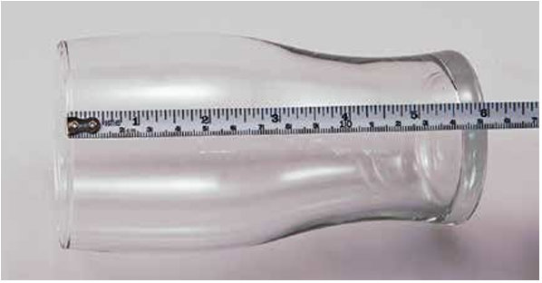
- The height of your file in Illustrator should be the circumference of your object at the location your will engrave your file. There is a flexible tape measure for this purpose.
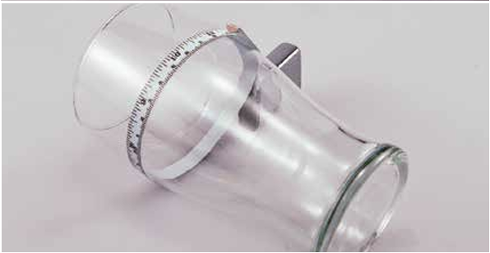

DESIGNING YOUR ARTWORK
- Your Y axis 0 is the same as the top rim of your object. Placing your file 1” from your Y axis will mean the top of your artwork will be 1” from the top rim of your object.
- The X axis determines the amount of rotation that will occur when you start your job. Placing your artwork 1” from the X axis means the rotary tool will rotate your object 1” before engraving. It is recommended to place your artwork as close to the X axis 0 as possible and then place your object in the rotary tool so the engrave area is at the apex of the object.
- For most jobs you will need to rotate your design 90° as your glass is also rotated 90° in the rotary tool.
INCORRECT
Adobe Illustrator Engraved
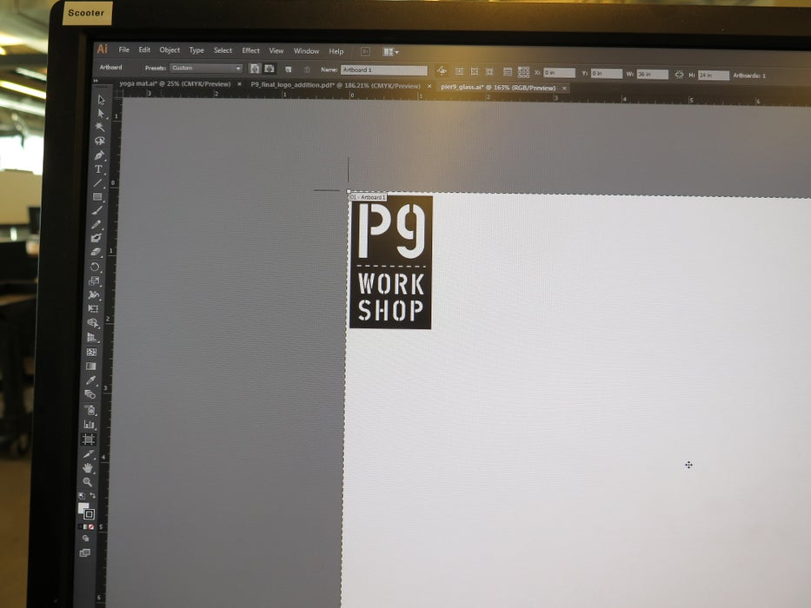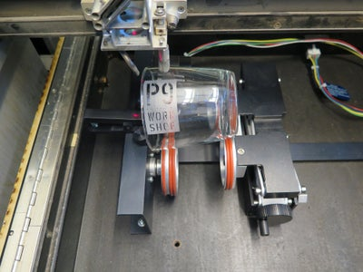
CORRECT
Adobe Illustrator Engraved
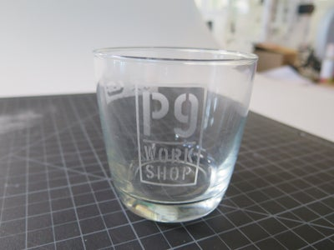

SENDING YOUR JOB TO THE LASER
The process of sending your job to the laser is identical to the process without a rotary tool, with one exception:
- In the Epilog Dashboard, go to Advanced.
- Enable the Rotary option.
- Choose the correct type of rotary tool (rim-drive or 3 jaw chuck).
- Select the correct engrave settings.
- Your Dithering settings can make a difference in the quality of your image, especially on glass. The settings chart on the laser table lists recommended adjustments for engraving on glass.
- Select print.
- Verify ventilation is on.
- Leave the lid open and perform “ghost run” to make sure your job runs as desired.
- Close the lid and hit print on the laser.

Frequently Asked Questions (FAQs)
- Illustrator needs a login.
  - Members should utilize their personal Adobe login information. Account is free.

- My piece did not cut all the way through.
  - Did you focus the laser?
  - Is your piece flat? Warped or bent pieces may not cut.
    - Tape down. Refocus.
  - Cutting ¼” – Lasers may struggle with this thickness.
    - Lower speed setting.

- I don’t see my design in Epilog Job Manager.
  - It may be located to the bottom right of the board. Scroll out to find it. Move into the design area.

- The material I am using is not on sheet.
  - For size difference, find a similar, conservative substitute.
    - Want to cut 3/16”, try the settings for 1/4”
  - For different material, Ask NIS Staff. Some materials cannot be lasered and will cause health risks

- Laser does not run. Zero run time.
  - Probably an issue with your Adobe illustrator design.
    - Check your lines. Do they intersect?
  - Did you create your original in Rhino or Solidworks?
    - Try exporting as a different file type.
    - Use the VCarve trick
      - Load SVG into VCarve
      - Check Duplicates: Edit → Selection → Select All Duplicate Vectors → Delete
      - Join lines
      - Re-save as a new SVG, reload into Illustrator.

SOP
Laser #4
Fusion Pro 32
60W CO2 Laser
Training is required before using this equipment
Reservations are required when using this equipment
NEVER LEAVE THE LASER UNATTENDED
WHEN IT IS OPERATING
YOU MAY ONLY OPERATE ONE LASER AT A TIME


