SOP
Keyence VL-770 3D
Scanner
OPERATION MANUAL
Training is required before using this equipment Reservations are required to use this equipment
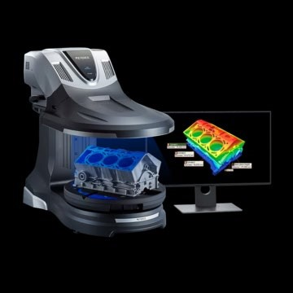

Scanner Capabilities
- Full Color Scanning
- Measurement Accuracy: up to ±10 μm
MAXIMUM OBJECT WEIGHT: 50kg or 110lbs MAXIMUM SCAN AREA:
- 11.81” Radius x 7.87” Height

LAUNCHING VL-700 SERIES SOFTWARE
Locate software on desktop or through search window.
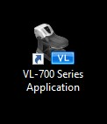
To begin scanning select “New Data Acquisition” as seen below.
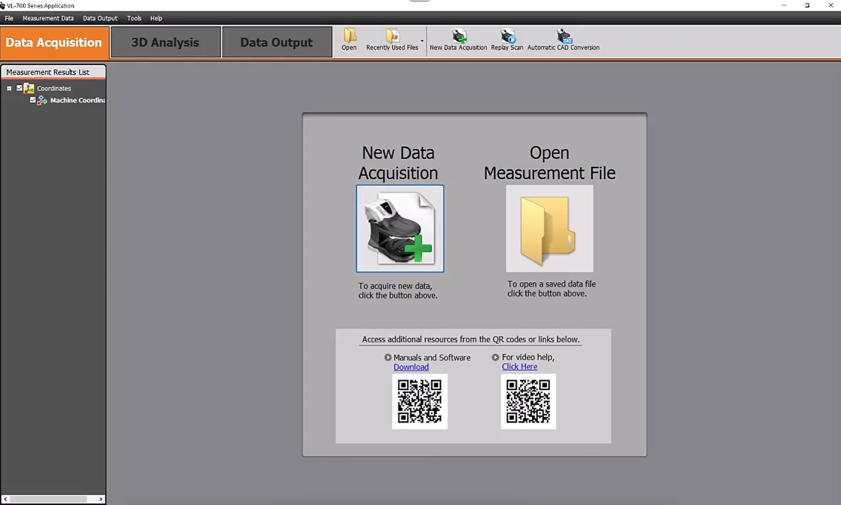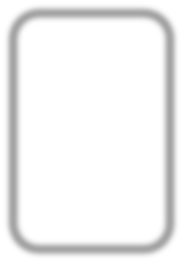

DATA ACQUISITION
- Place plate on measurement platform near the center as seen below.
- Select magnification based on object size (select high magnification when the object it’s between the three triangles in the center of the build platform o low mag: 3” wide by 3” tall o high mag: 20” wide by 8" tall
- Select “stitch” under “measurement method”
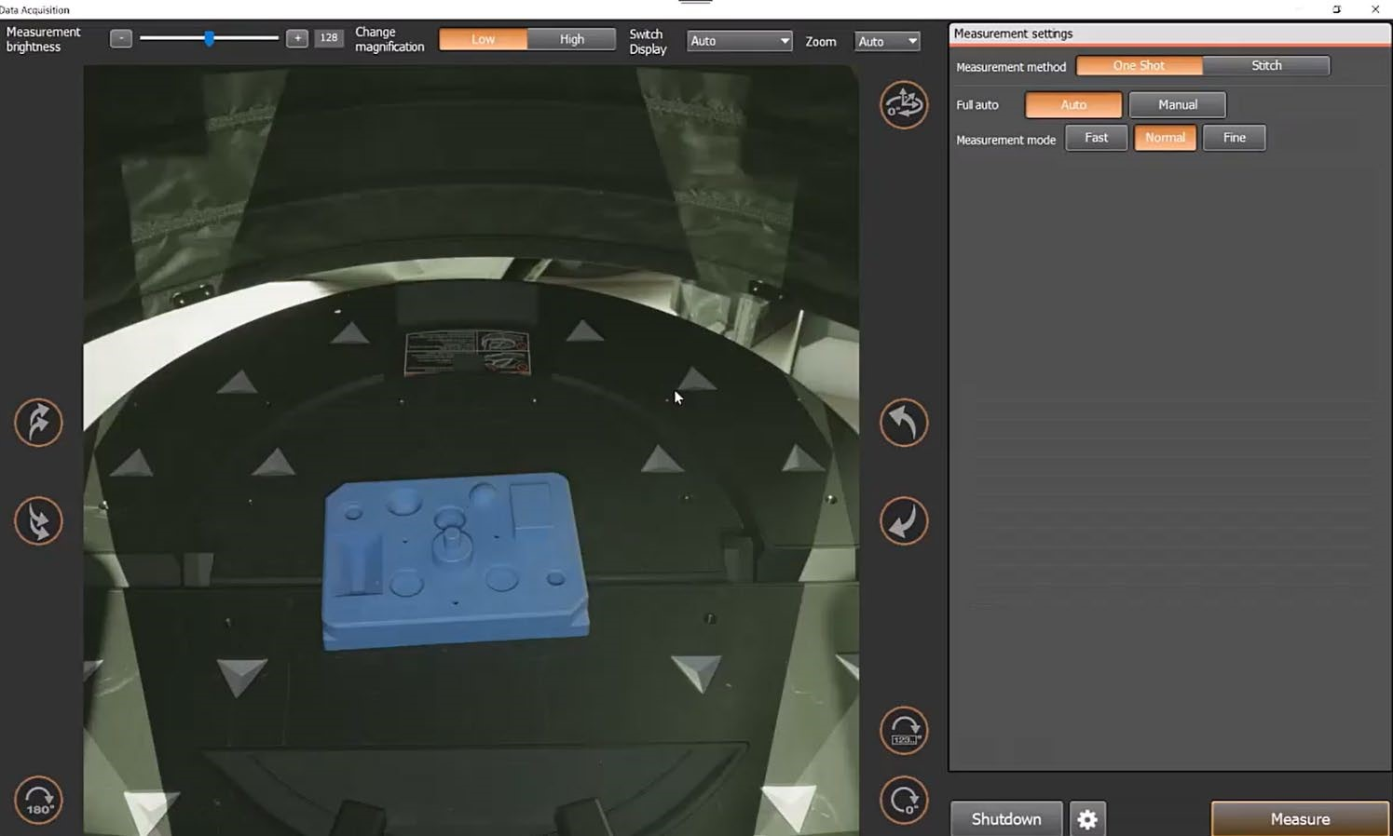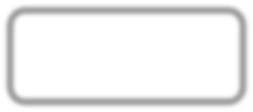

MEASUREMENT SETTINGS
- “Auto” is recommended, this does 6 evenly spaced scan locations
  - Manual will allow manual control of scan locations and spacing
- Select a measurement mode o Fast does lower resolution, useful for quick scans where color/texture is not important (.25 million data points per scan position)
  - Normal is good for most objects where texture is needed but ultra fine detail is not critical (9 million data points per scan position)
  - Fine is the highest resolution per scan, scan will take a bit longer but so will processing times and will result in a larger file (36 million data points per scan position)
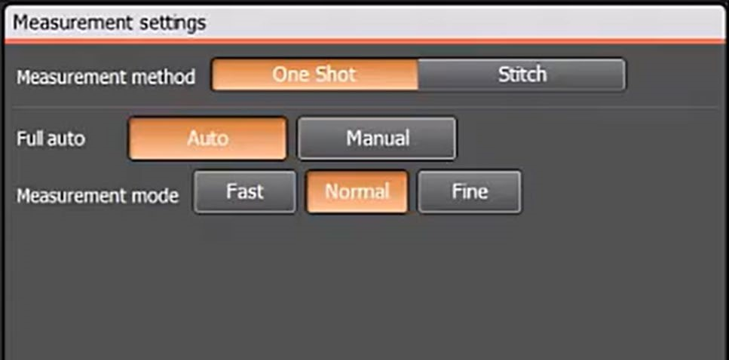

- Close the curtain on the scanner and select Measure in the bottom right
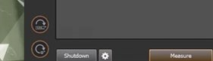

SCANNING
- When scanning has commenced a scan preview window will appear
  - This preview is a low fidelity version of the raw data, once processed the majority of scans appear much “cleaner”
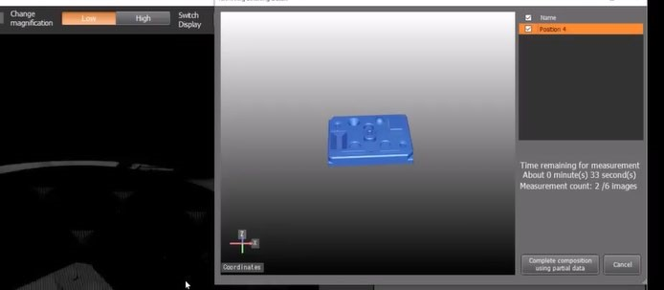
- After all scan positions are captured, another window will open allowing a user to Complete Data Acquisition o If an error occurred during scanning like the part was moved or the curtain was opened mid-scan, under “retrieved data” that capture can be ignored during the creation of the 3d model by unselecting its checkbox
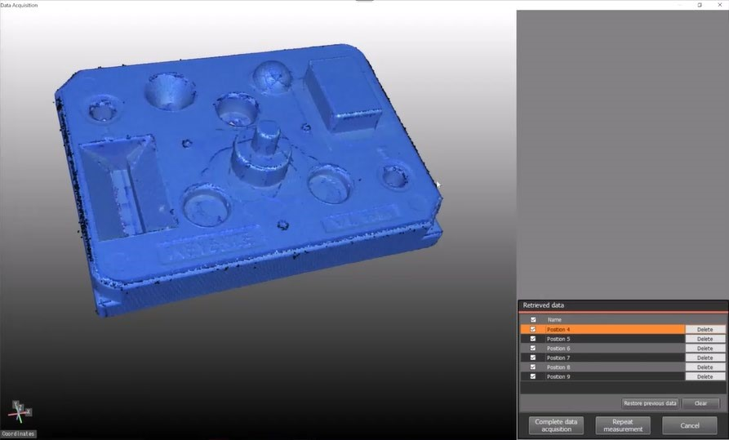

- After data processes, the “Delete Data/Fill Missing Data” window will appear o If the object appears on its own without any mounting features or scanning errors hit OK
o If the object has sections that you would not like to include in the
final scan (mounting fixtures, scanning errors, etc.) skip to
Delete/Fill Data section of the SOP for detailed instructions
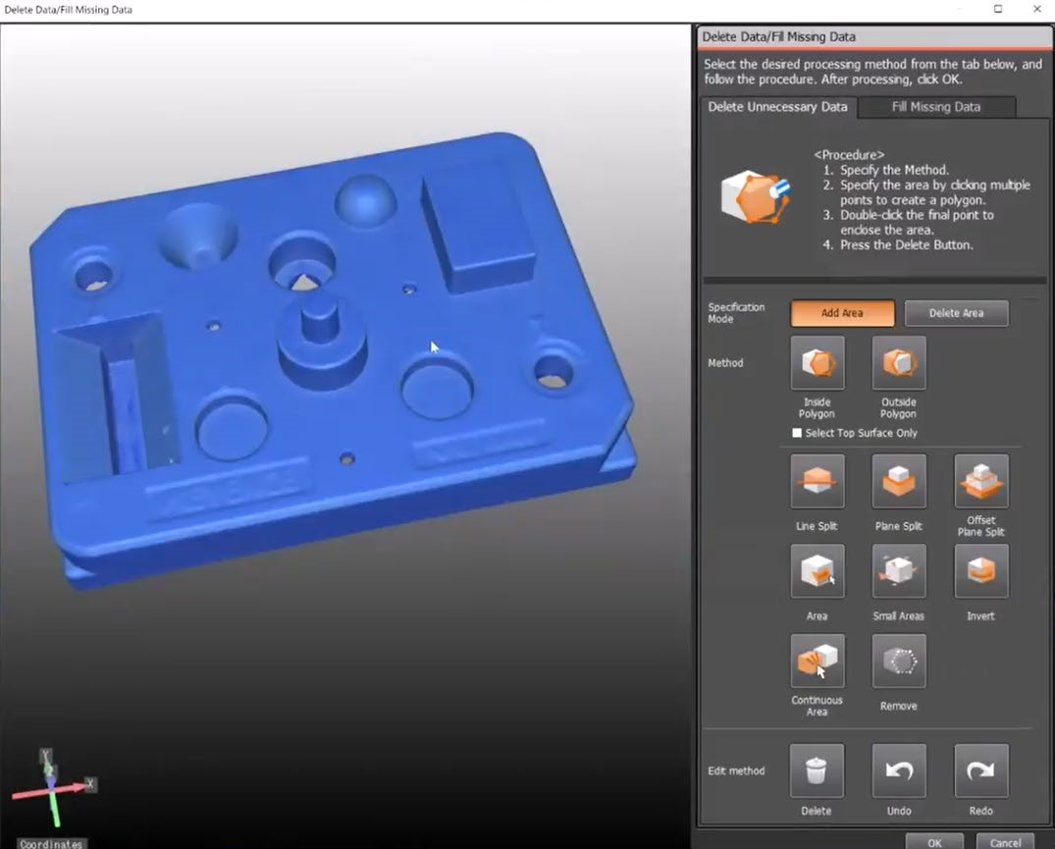

- The scan data will process and you will be returned to the “Measurement Results” page where you can manipulate, save, or edit your scan.
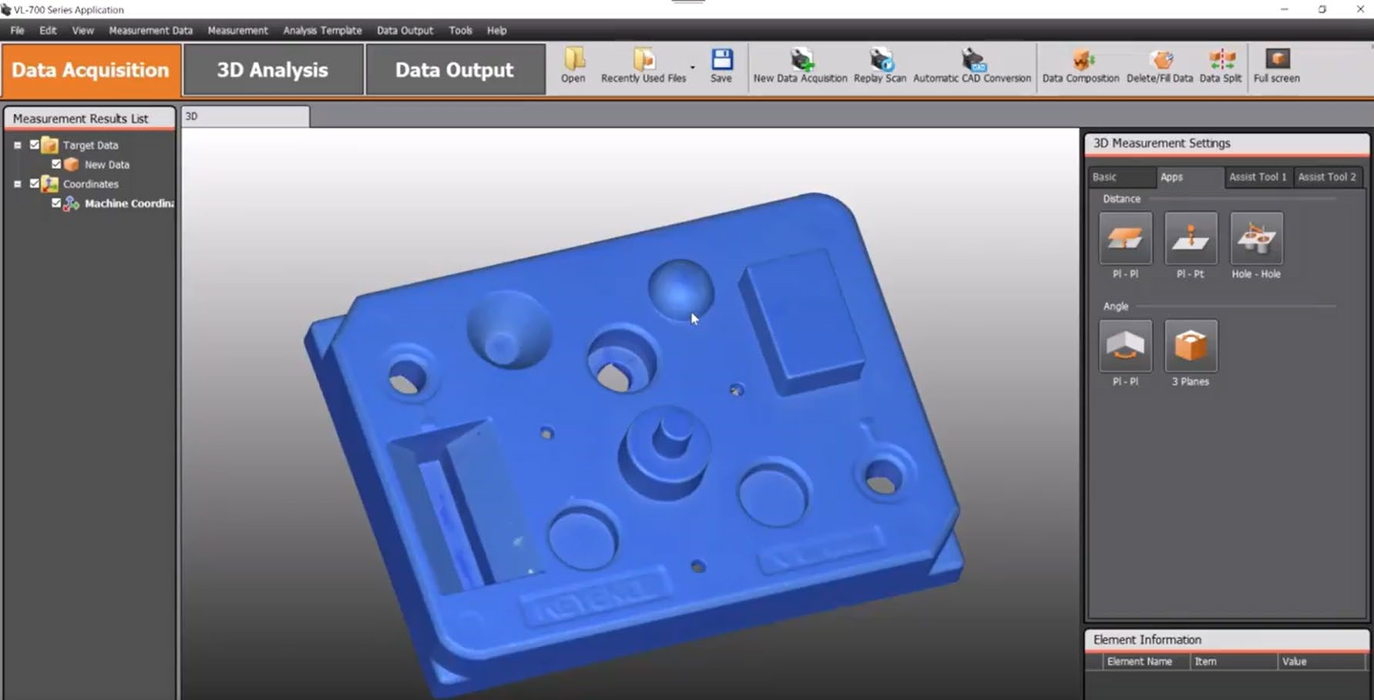
- Save your scan file to a USB (Scans saved locally will be automatically deleted when the computer shuts down)
- To get a fully closed, or “watertight” 3D model as is often needed for 3D printing, select New Data Acquisition and repeat the Data Acquisition steps for the portions of the model not captured in the first scan, e.g. flip your part over and repeat

o NOTE: To properly merge scans, partial overlap of scanned areas is necessary. Having edges, markings or features that can be seen in both scan positions makes merging significantly easier.

DATA COMPOSITION
This section focuses on joining together separate scans that have been completed
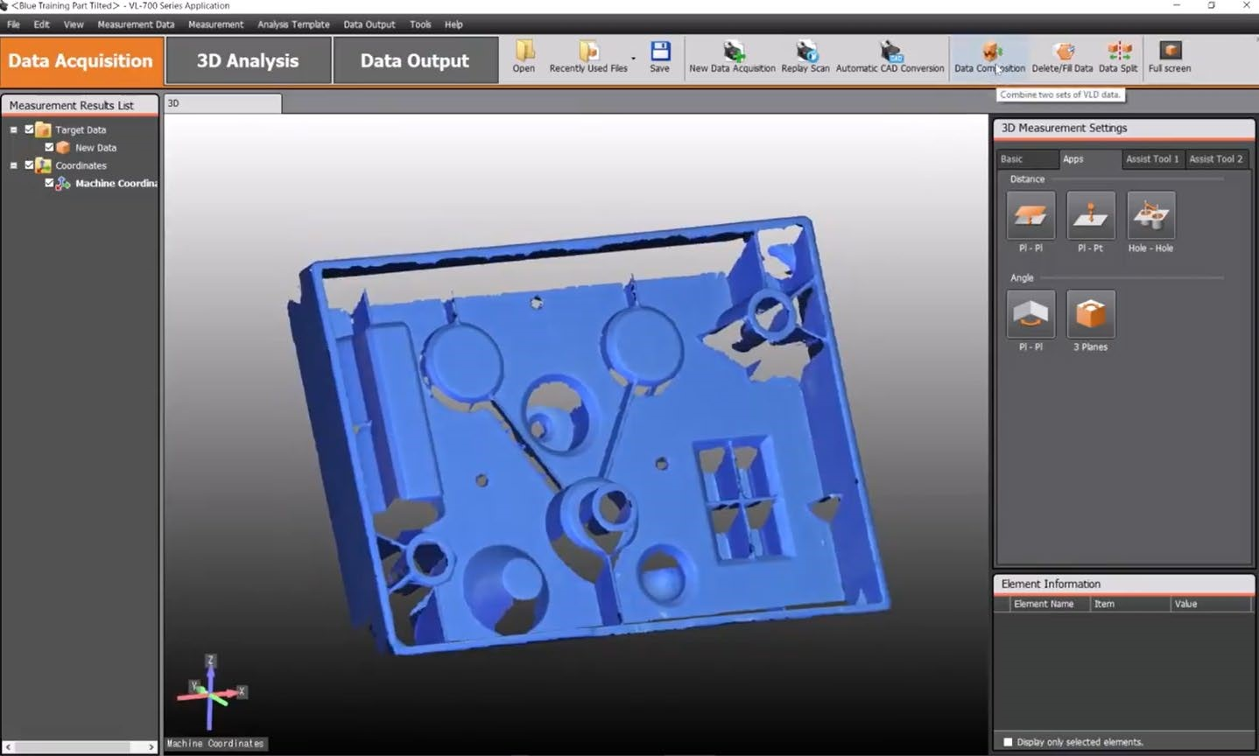

- Select Data Composition from the top bar as seen above
- Select “Compose from Measured Data”

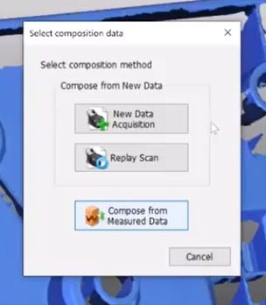
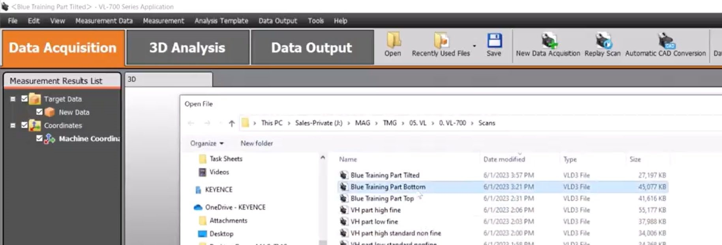
- Select the scan which you would like to combine with the file that is currently open.
  - NOTE: Scans must have overlap in order to be combined successfully
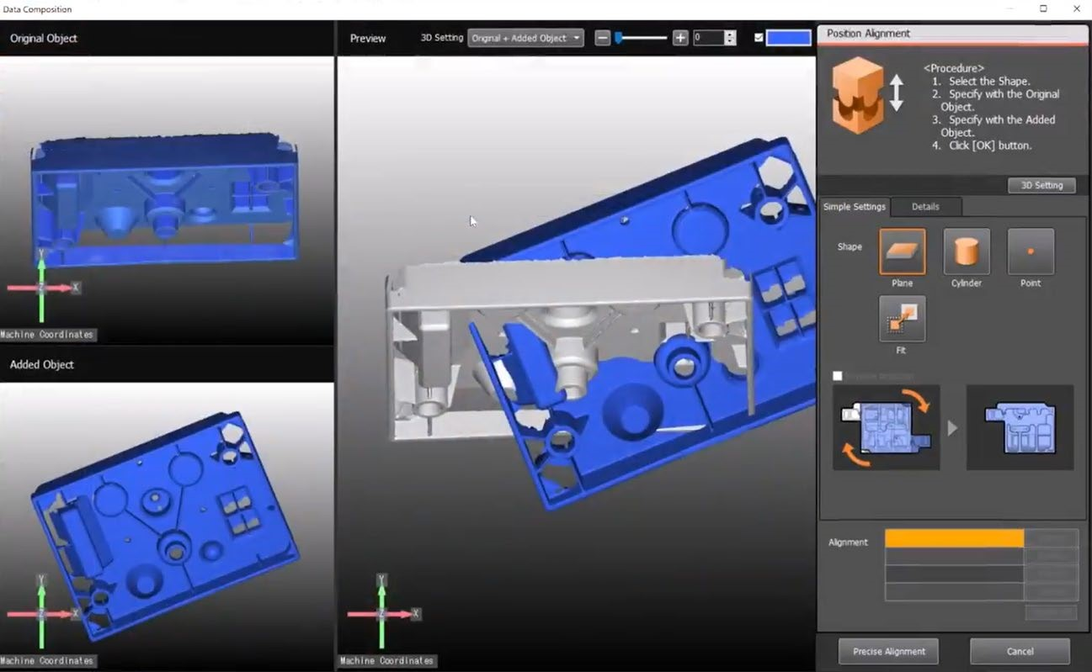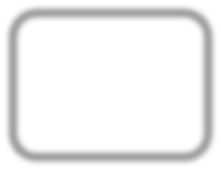

- Three windows will appear, labeled above as: Original Object, Added Object, and Preview
- To properly align the scans for combination, three common features need to be selected o The “simple features” that can be selected are Plane, Cylinder, and
Point o Fit should only be selected when the scans are roughly aligned with three other features

PLANE SELECTION
- The software can recognize last surfaces on a scan, in the Original Object
Window double click on a last area to create an alignment reference o Repeat with the same surface on the Added Object Window.
o If the same surface does not exist on both scans, a different selection will need to be used. Delete the selection under the “Alignment” section
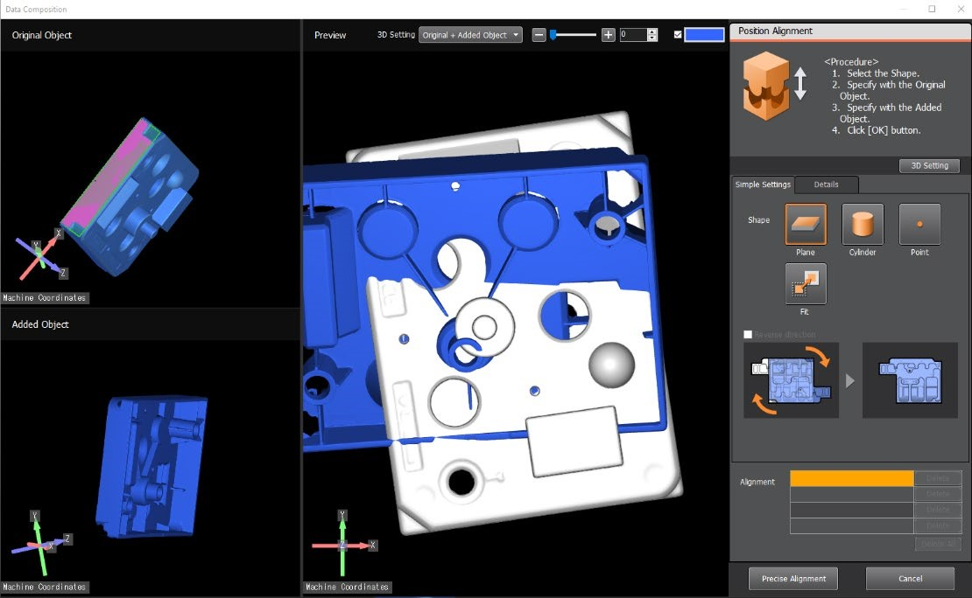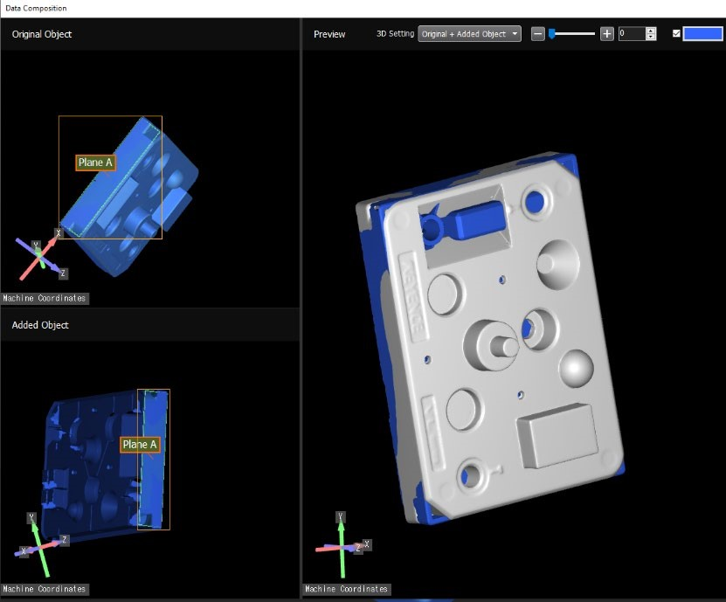

- A selected plane may be in the right place but “reversed” by default selection, to correct this, while the alignment feature is selected in the alignment window, select check box that reads “Reverse the direction of the element…”
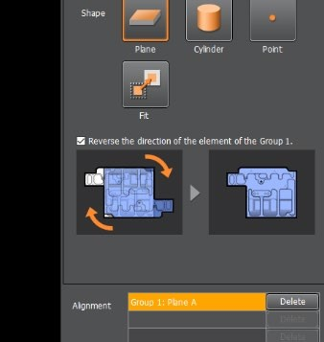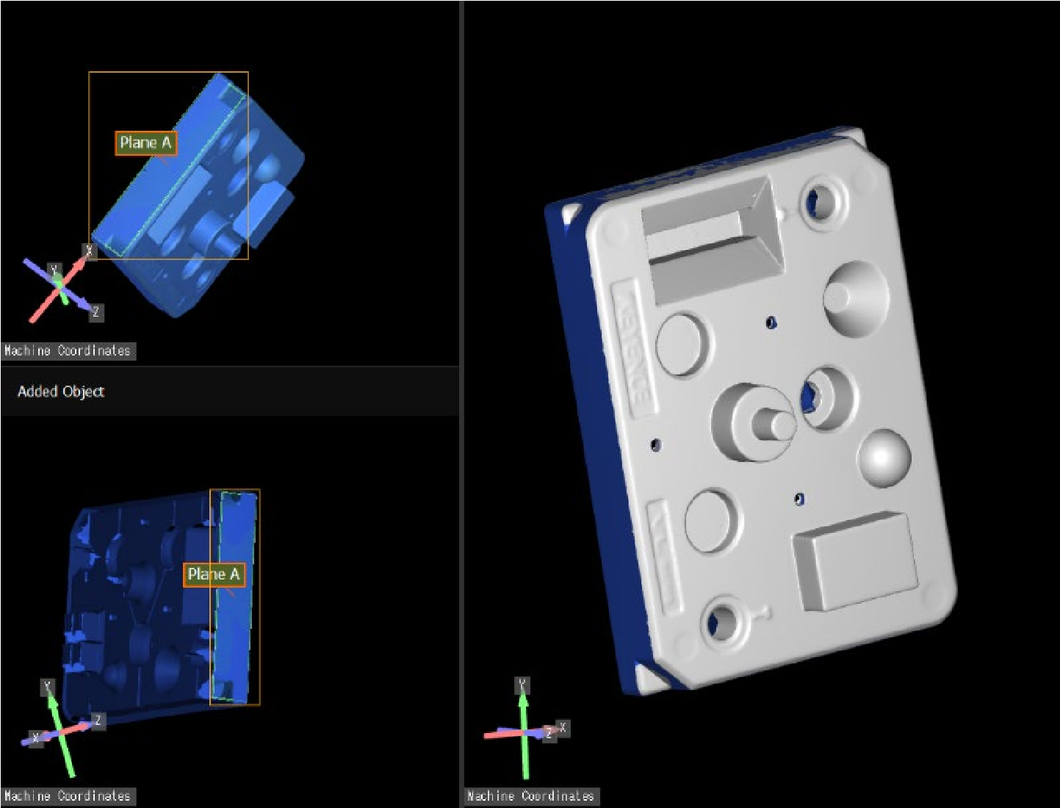

CYLINDER SELECTION
• The software can recognize cylindrical surfaces on a scan, in the Original Object Window double click on a cylindrical area to create an alignment reference o Repeat with the same surface on the Added Object Window.
o If the same surface does not exist on both scans, a different selection will need to be used. Delete the selection under the “Alignment” section
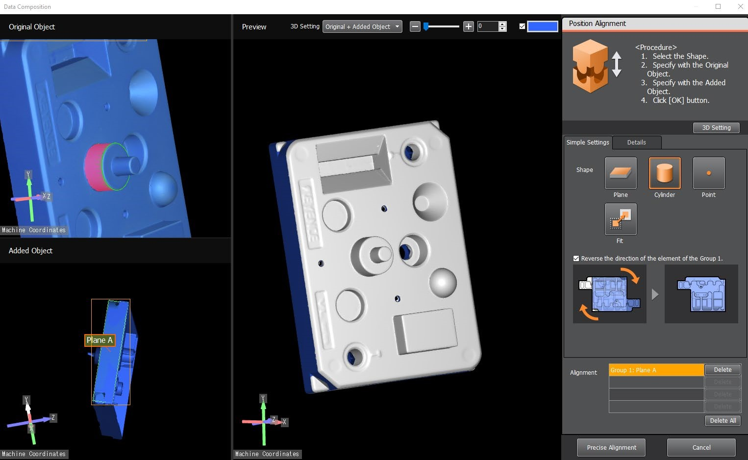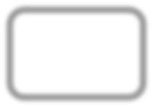

POINT SELECTION
• Select any recognizable point, in the Original Object Window double click on a point to create an alignment reference.
NOTE: Point selections need to be more accurate between models, best practice is to select a recognizable feature e.g. the edge of a letter printed on the model, a manually added marking, or similar.
- Repeat with the same point on the Added Object Window.
- If the same point does not exist on both scans, a different selection will need to be used. Delete the selection under the “Alignment” section
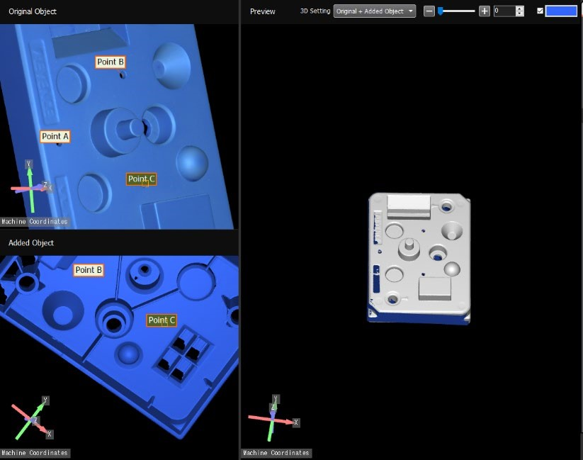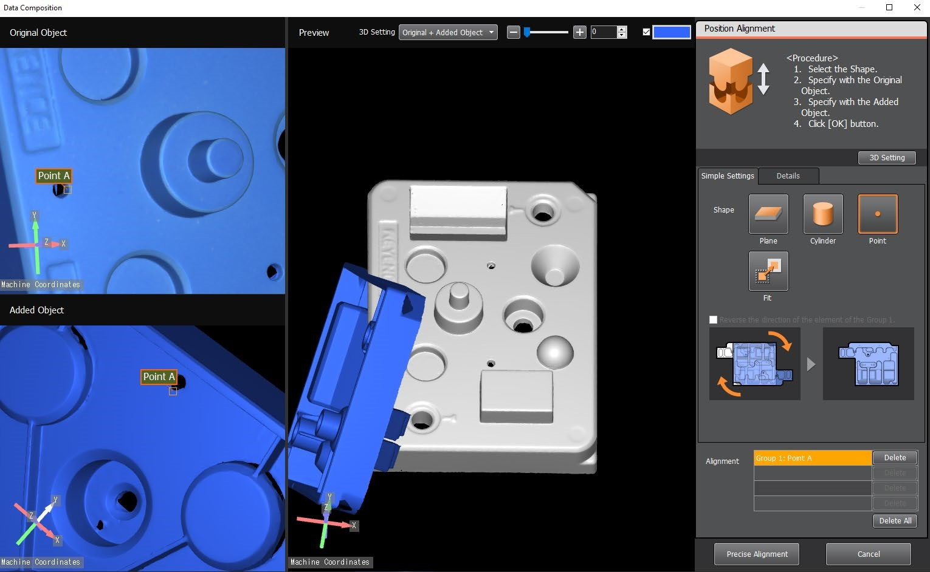

FIT
- Once three alignment features have been selected, double click on anywhere on the scan in the Original Object Window double click anywhere on the model to create an alignment reference.
o Repeat with any point on the scan in the Added Object Window o Wait for calculation to complete then assess if the model in the Preview window looks properly aligned
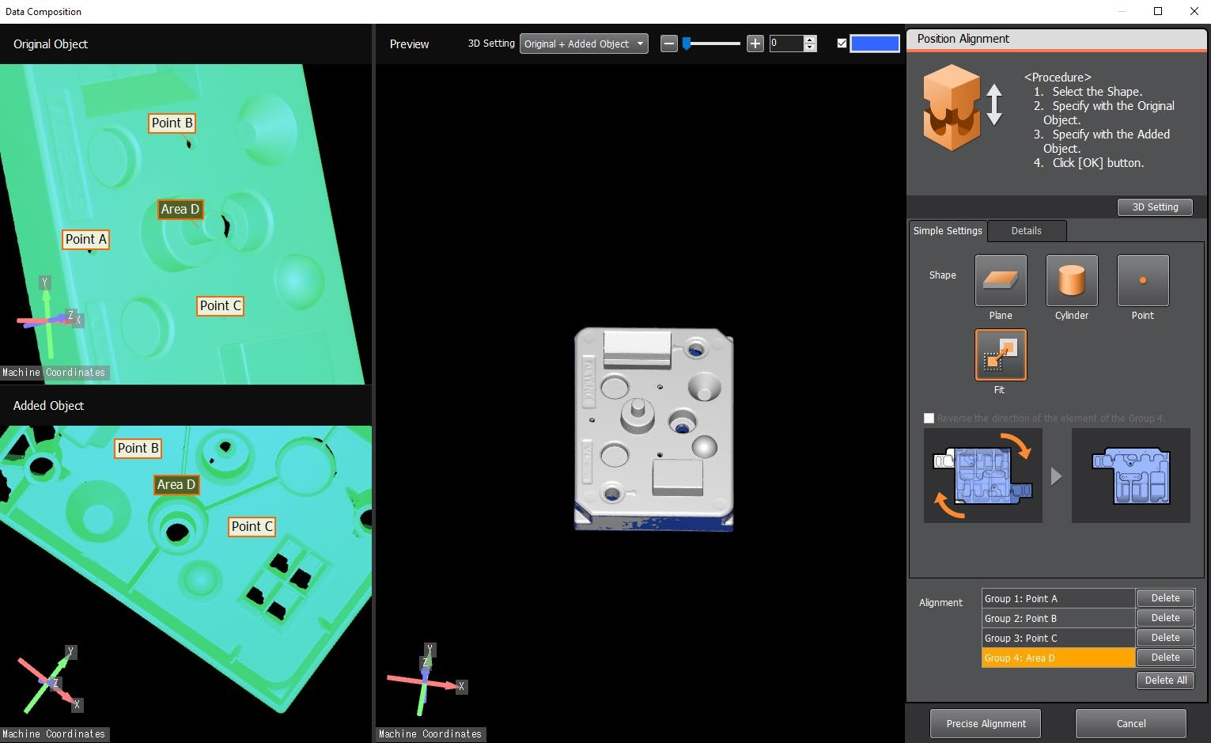

- Select Precise Alignment in the bottom right and allow the model to calculate and merge the scans

- You have now successfully merged your scans, either move on to saving and exporting your file or Fill/Delete Missing Data

DELETE/FILL DATA
• A scan may be incomplete even after merging multiple scans together. It is possible and necessary to ill gaps in a scan before 3D printing. It is also possible to remove unwanted data with this method e.g. a clamp or mount used to prop up an object during scanning.

DELETE UNNECCESARY DATA
• Under “Specification Mode” you have the options Add Area and Delete Area. Add Area when will create selection that can be removed with the Delete button at the bottom. Delete Area will remove areas from an active selection, it will not remove portions of the scan.

NOTE: This can be confusing, to delete portions of the scan, select Add
Area -> Use preferred Selection Method -> Select Delete, using the Delete Area Specification mode alone will appear to do nothing if a selection area has not already been created.

• Choose a Selection Method: Inside Polygon, Plane Split, and
Continuous Area are the most common selections. Remove is also used often to clear all selections o Inside Polygon: click to set vertices and draw a polygon around the area you wish to select, double click to close the polygon or add a final vertex in the same place as the first. Use the “Select Top Surface
Only” check box if you only wish to include visible polygons o Plane Split: double click on a planar section of the scan, everything below that plane will be selected, use Invert to change the selection to everything above the top surface
o Continuous Area: double click on an area and it will select all parts of the scan connected to it.
• Under Edit Method select Delete to remove the current selection. Select OK to confirm at the bottom

FILL MISSING DATA
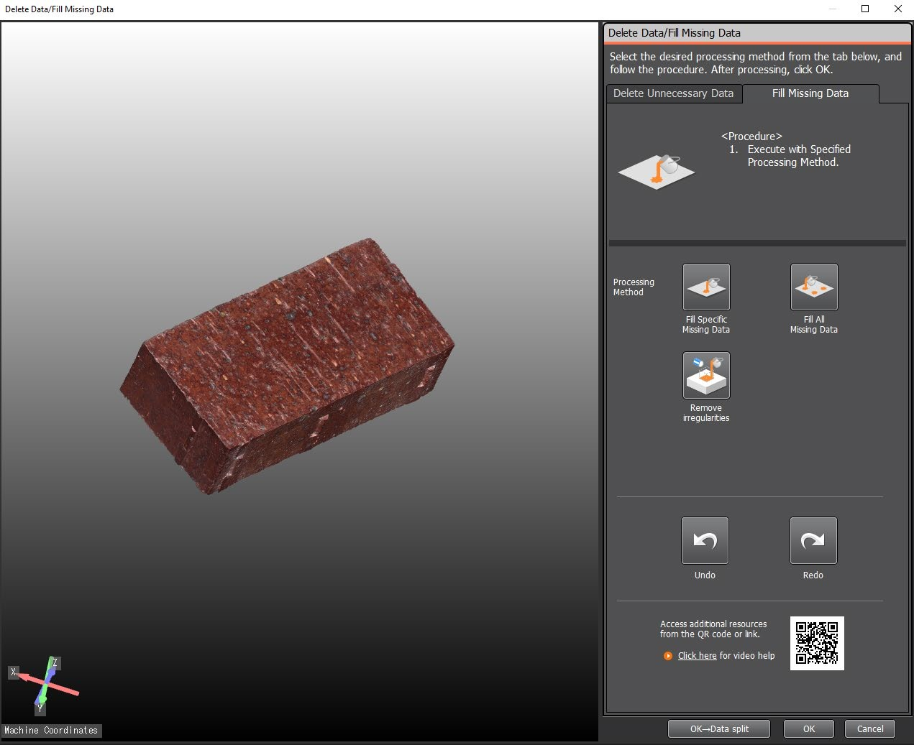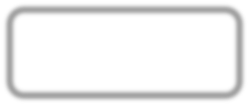

- Under Processing Method, either Fill Specific Missing Data or Fill All Missing Data can be selected.

- Fill All Missing Data will attempt to close all holes automatically, selecting this will take some up to a few minutes to process. Only use this method when the mesh appears mostly closed with only small gaps.

- Fill Specific Missing Data this method highlights all holes in the model and lists them by perimeter length. Either Plane Fill or Curvature Fill can be selected.
  - Select one or multiple points to patch with the checkboxes seen on the right
  - Select “Ok->Next” to ill those holes, depending on the size of the models
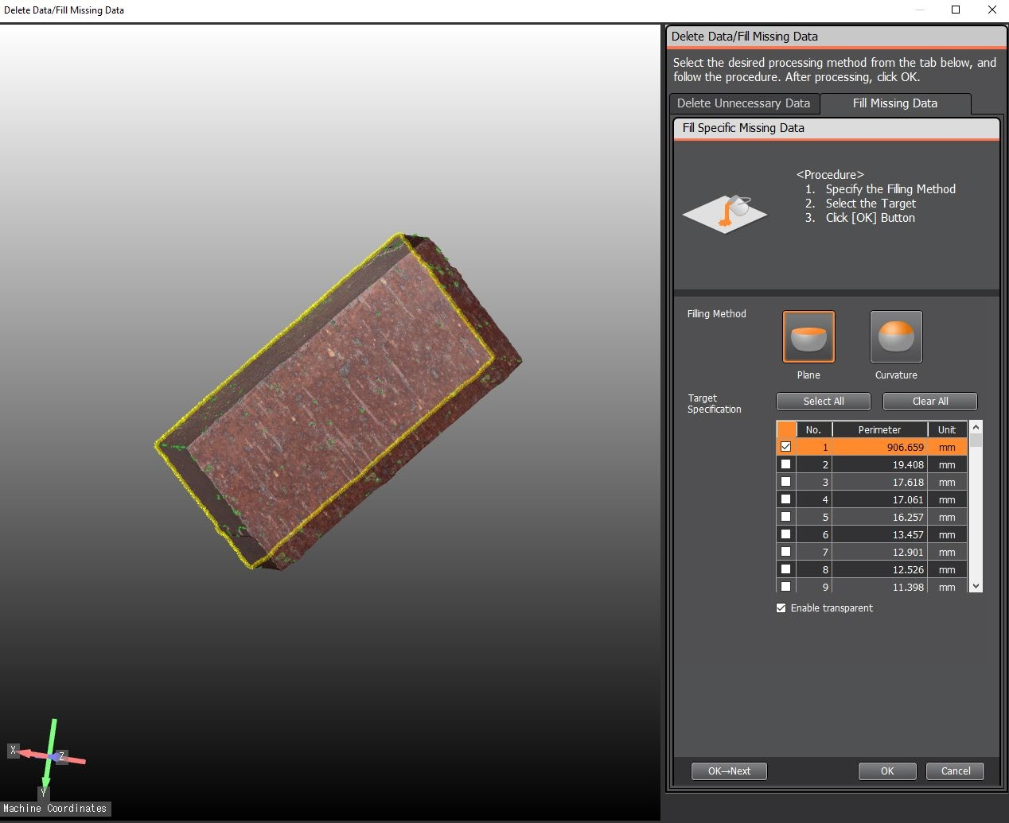

SAVE and EXPORT
• Select Data Output at the top of the screen. A raw scan file can be saved here to edit later, select Save to save as a .vl3d file.
o NOTE: .vl3d scan files can only be opened in the Keyence Software, to use these files in various 3D Modeling or 3D Printing programs you must export as the appropriate file type.
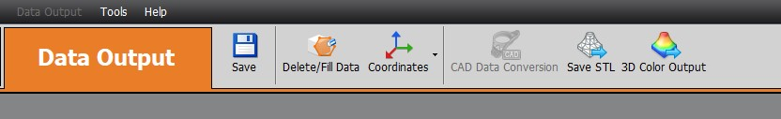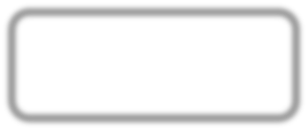

Export STL
- To export an STL select Save STL under the Data Output Menu


- Under the STL Export menu three options are available
  - Choose either Binary or Ascii under output format, Binary will result in a smaller file
o Downsampling Ratio will reduce the resolution of the output mesh to reduce the file size

o “Automatically Fill Missing Data During Output” will try to ill small holes during export

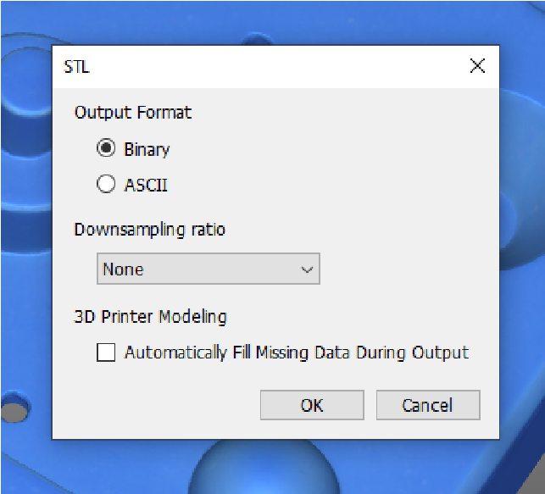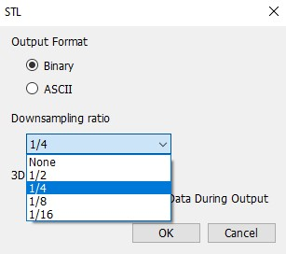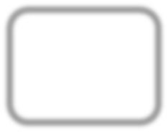

EXPORT OBJ OR 3MF
- To export an OBJ or 3MF select 3D Color Output under the Data Output Menu
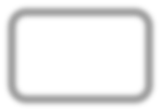

- Under the 3D Color menu three options are available o Output Format, select OBJ or 3MF
  - Downsampling Ratio will reduce the resolution of the output mesh to reduce the file size
  - Compress Color will compress the image texture for a smaller file size at the cost of some color accuracy
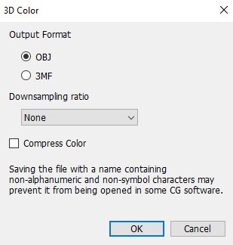
NOTE: OBJs will save image textures to .mtl and .png files with the same name, make sure all associated files are saved when you want to use an OBJ with color

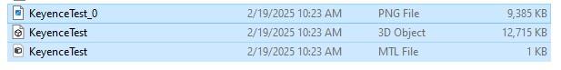

SOP
Keyence VL-770 3D
Scanner
OPERATION MANUAL
Training is required before using this equipment Reservations are required to use this equipment

