SOP
Formlabs Fuse 1
OPERATION MANUAL
Training is required before using this equipment.
Reservations are required to use this equipment.

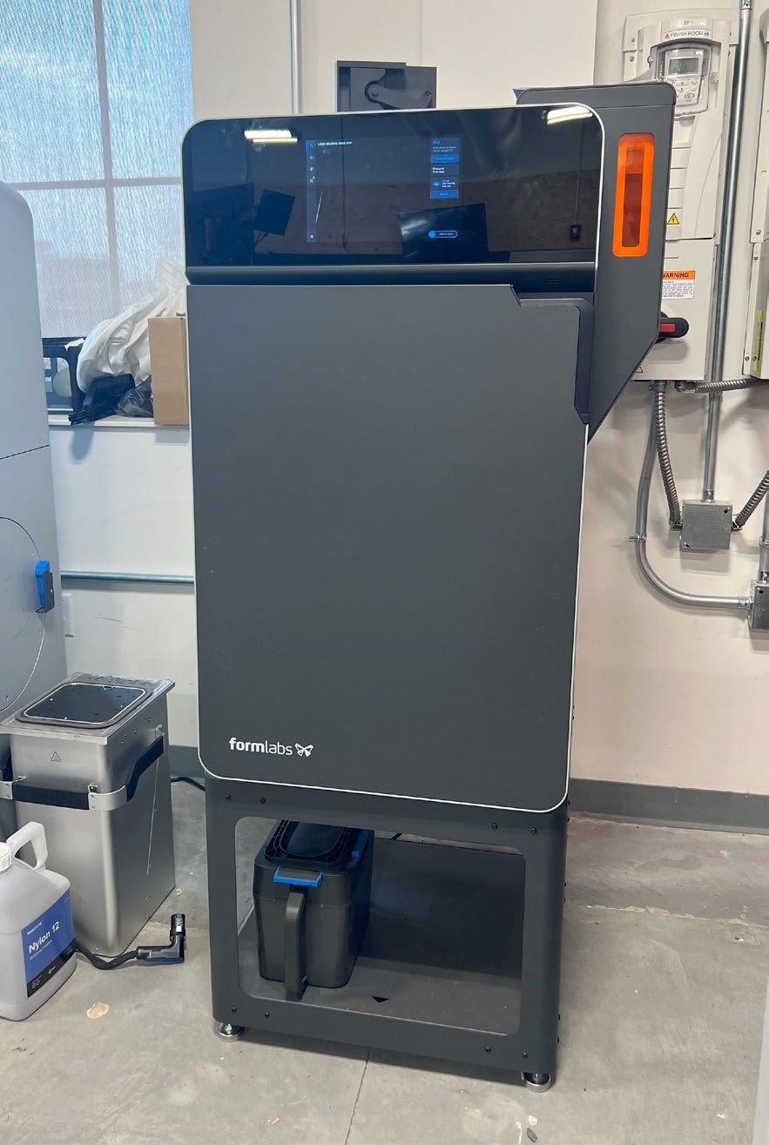

AVAILABLE MATERIALS
- Nylon 12
THIS IS THE ONLY MATERIAL AVAILABLE
FOR USE ON THIS MACHINE MAXIMUM SIZE
- 159mm x 159mm x 295mm (6.3in x 6.3in x 11.6in)

LAUNCHING PREFORM SOFTWARE
Open PreForm software on a lab computer.

• Login using the following credentials: Username: innovationstudio@unl.edu Password: 2021Transformation
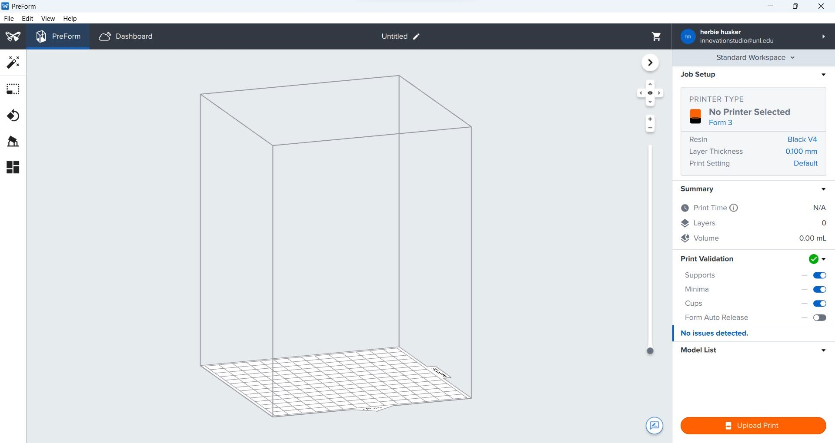

Selecting the Correct Printer
- On the home screen, select “Printer Type” under Job Setup
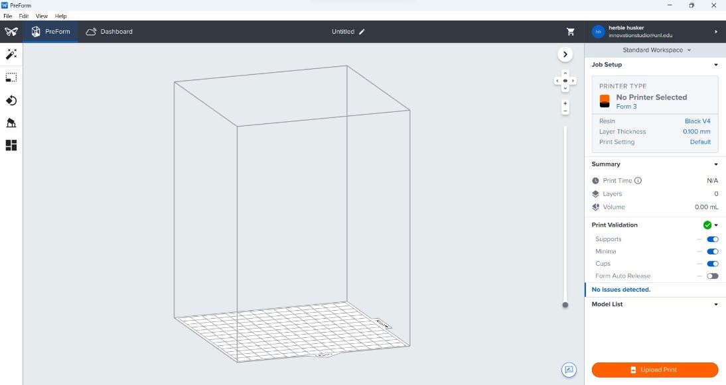

- This will take you to the Job Setup page.
- Scroll down to select Giddy Mantella, the Fuse 1 30W printer
- Verify Nylon 12 is selected for your material.
- After that click “Apply”
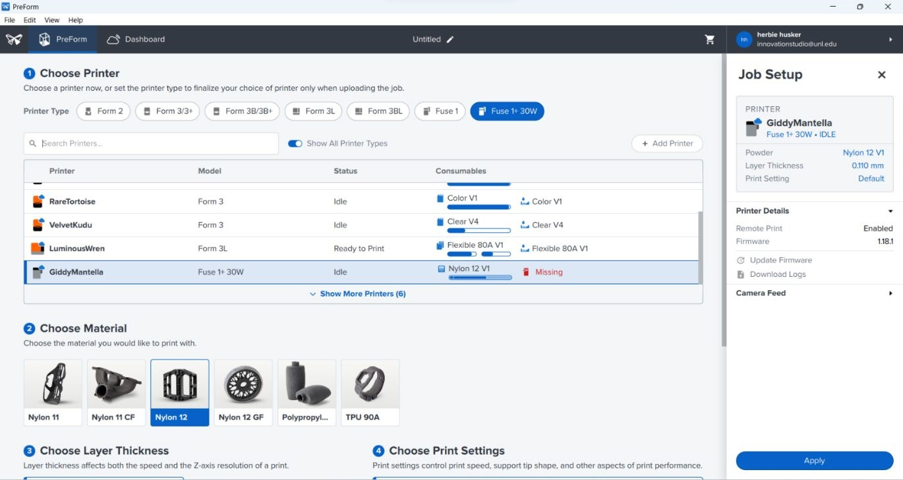

Your print workspace should now look like this:
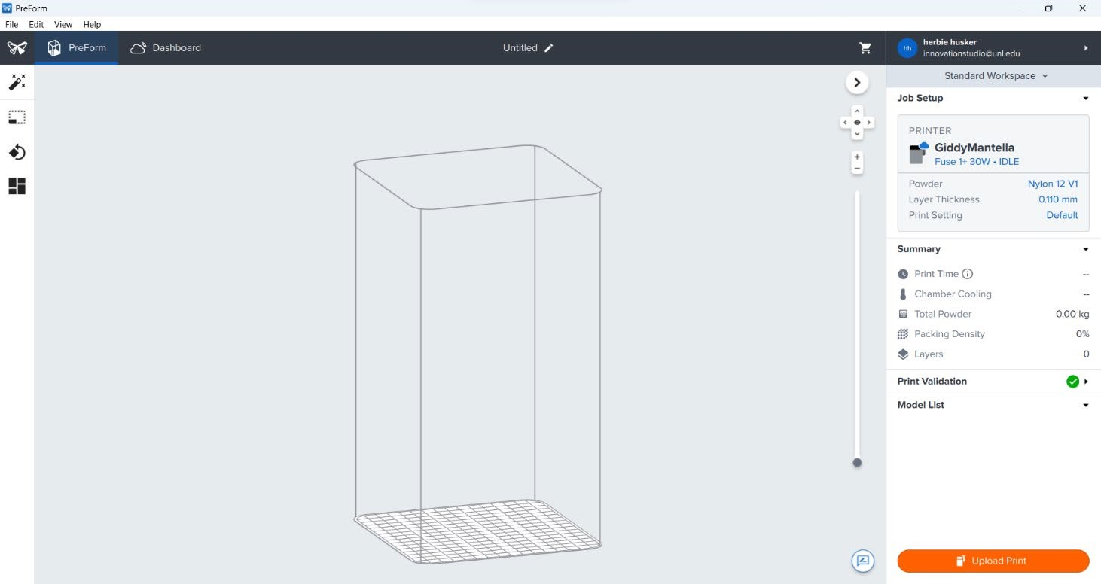

IMPORTING YOUR FILE
Import your iles by going to File > Open
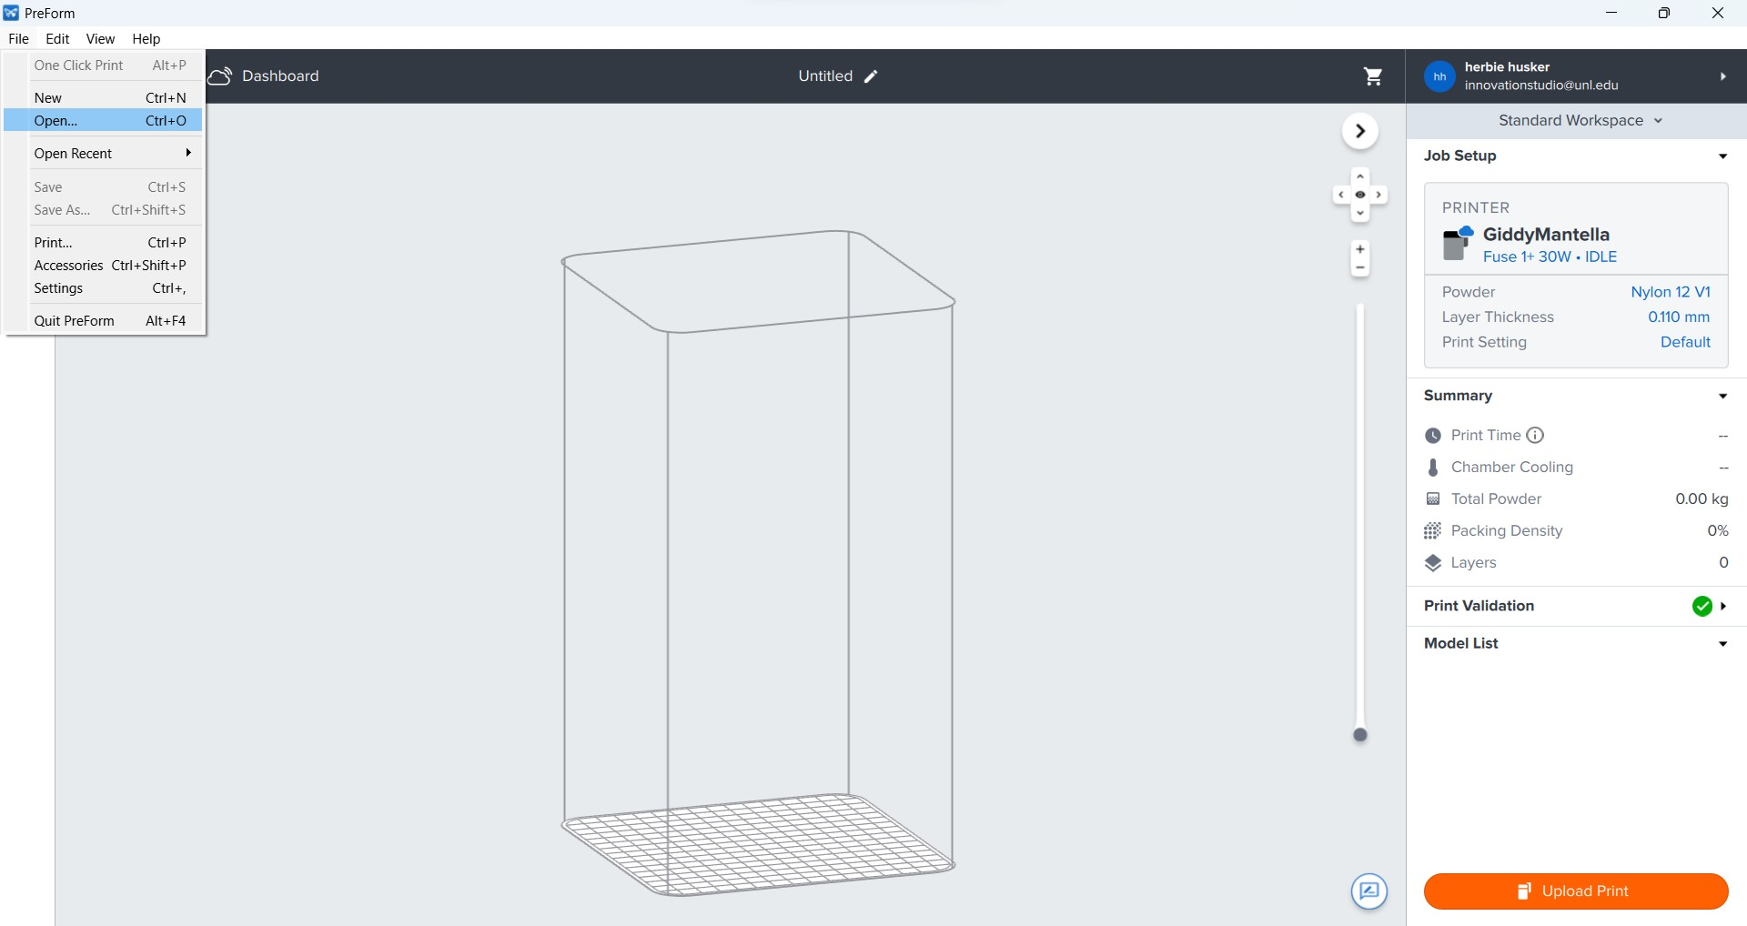
• Accepted iletypes are currently .obj, .stl, .3mf, .form

ORIENTING YOUR PART(S)
- Click on the part you want to orient.
- Click and drag on selected part to manually move and rotate the part around the build plate

IT IS ESSENTIAL TO MAKE SURE MODELS ARE ARRANGED AS CLOSE TO THE BUILD PLATE AS POSSIBLE.

Preform will allow you to print in “mid air” which will waste a large amount of material. Your print costs are based on material used for both your print and the waste material associated with your print.

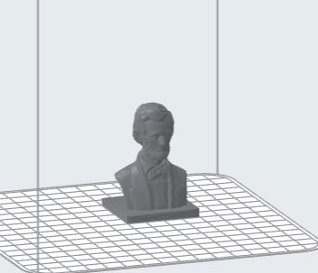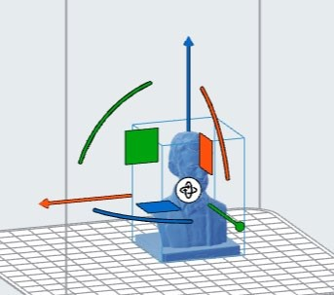
- With part selected, choose the Orientation tool in the left side Toolbar.
o Here, you can precisely control the orientation of your model. o To lay a speciic face lat, click “Select Base” under Orient To Face o Then click any face of your model to align it lat to the plate.

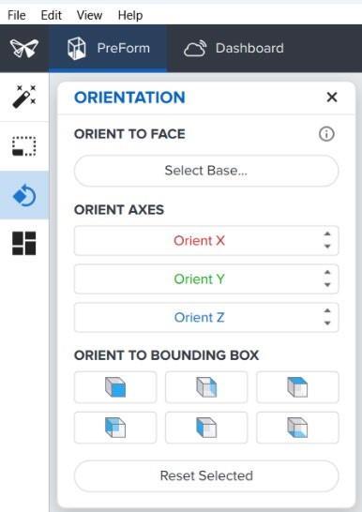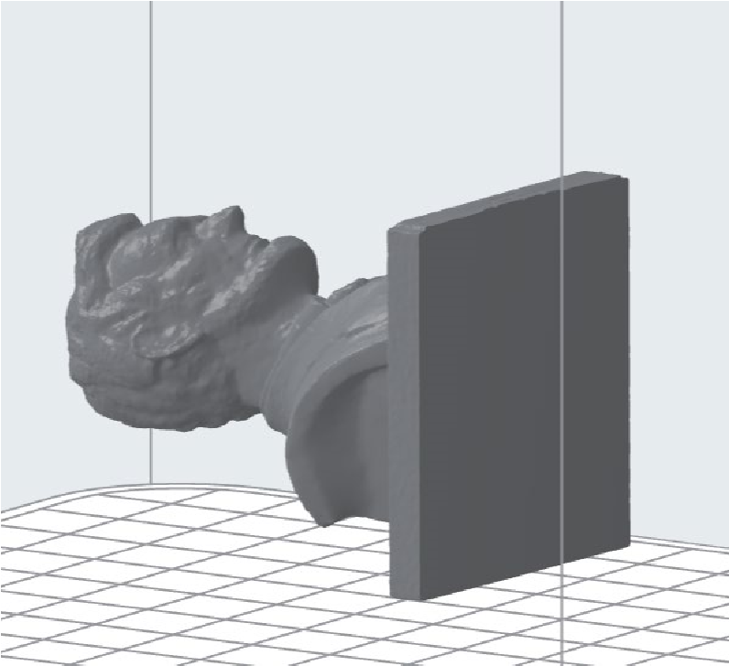

DUPLICATING & PACKING YOUR PART(S)

If you wish to print multiple parts or create duplicates, you can arrange them automatically. Once all models are loaded in, click “Pack All Models”.
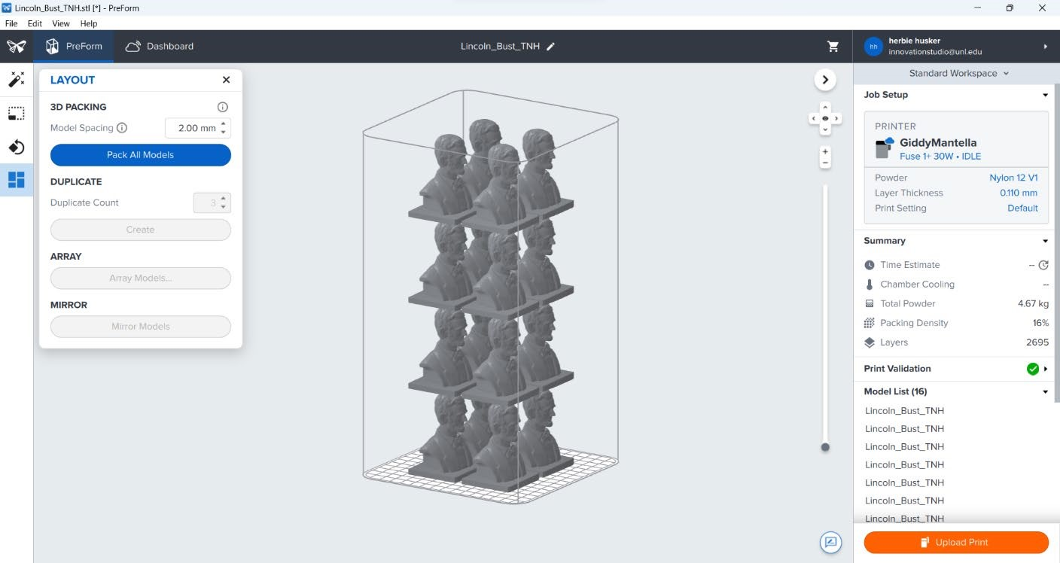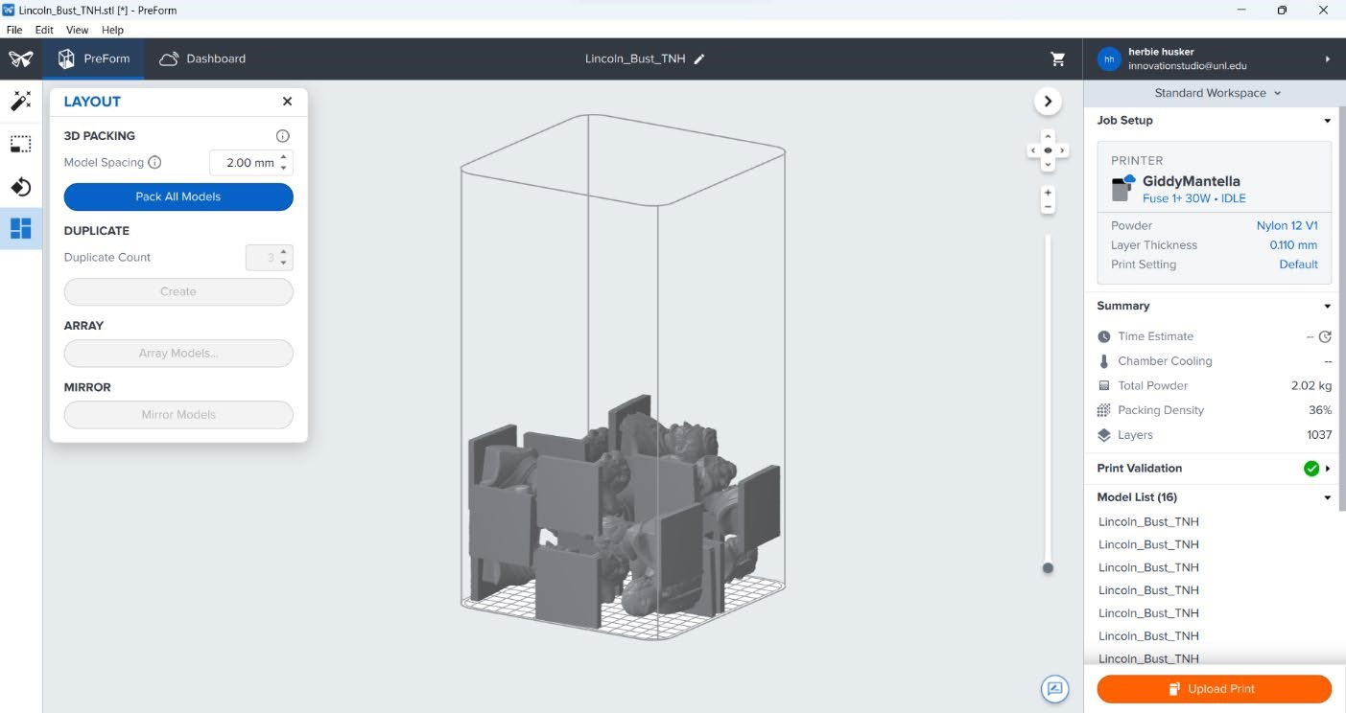

Layout before
clicking “Pack All
Models”
Layout after clicking “Pack All Models”. Notice it’s much more efficient with a packing density of 36%

It is critical to pack multiple models as closely together as possible. The higher your packing density, the more eficient and cost effective your print will be. NIS charges by Total Powder used for both your inal print and the waste material associated with your print.

ESTIMATING YOUR PRINT COSTS AND TIME
- On the right panel of your screen, click Time Estimate to see how long your print is going to take.
- Once your print is ready to upload to the printer, take a picture of the summary panel. This is required so that you know how long to reserve your printer for and how much material you need to pay for.

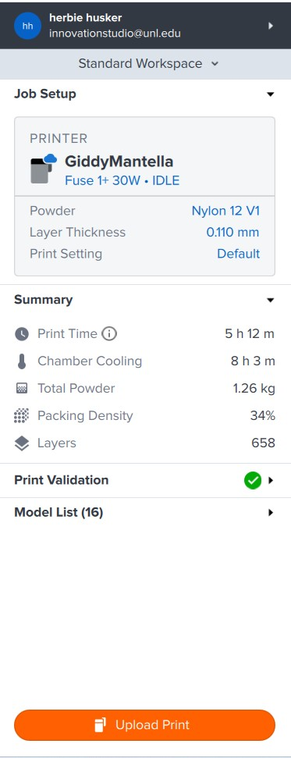
YOU ARE REQUIRED TO PHOTOGRAPH THIS SCREEN IN ORDER TO PAY FOR YOUR PRINT.

- Once this is done, click Upload Print to send to the printer.

STARTING YOUR PRINT
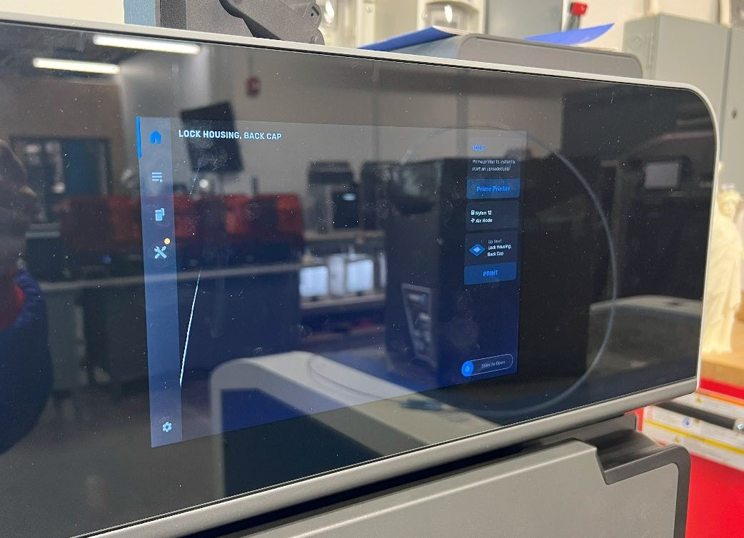
•

At the Fuse 1 and
•

verify your print has
uploaded by clicking the
Prints icon on the left side
of the screen.

•

Select the job you
uploaded and click “Print”

- The printer will now walk you through a series of checklists to ensure your print will start successfully.
- First, the printer will prompt you to clean the machine with a vacuum. Open the door of the printer and follow the prompts onscreen to vacuum each location until no excess Nylon residue remains.
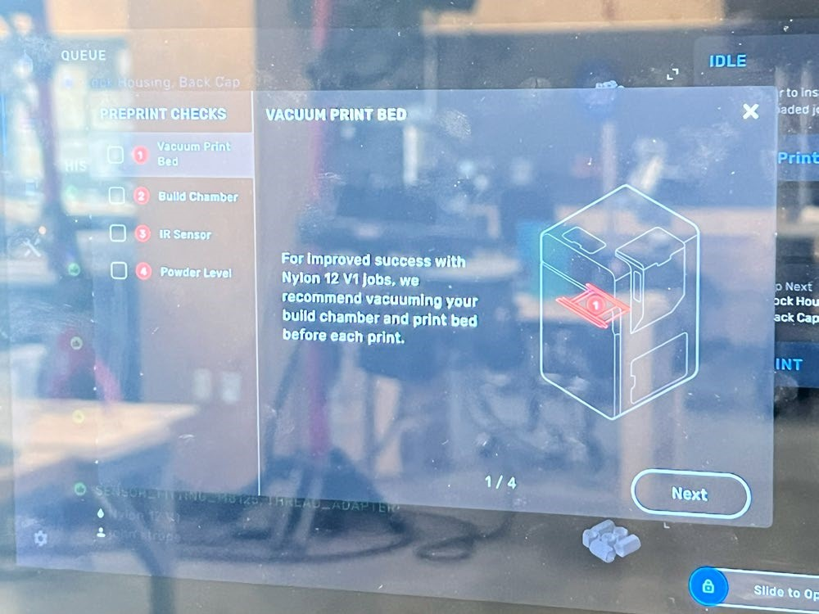
  Click to advance through checklist once each step is finished.
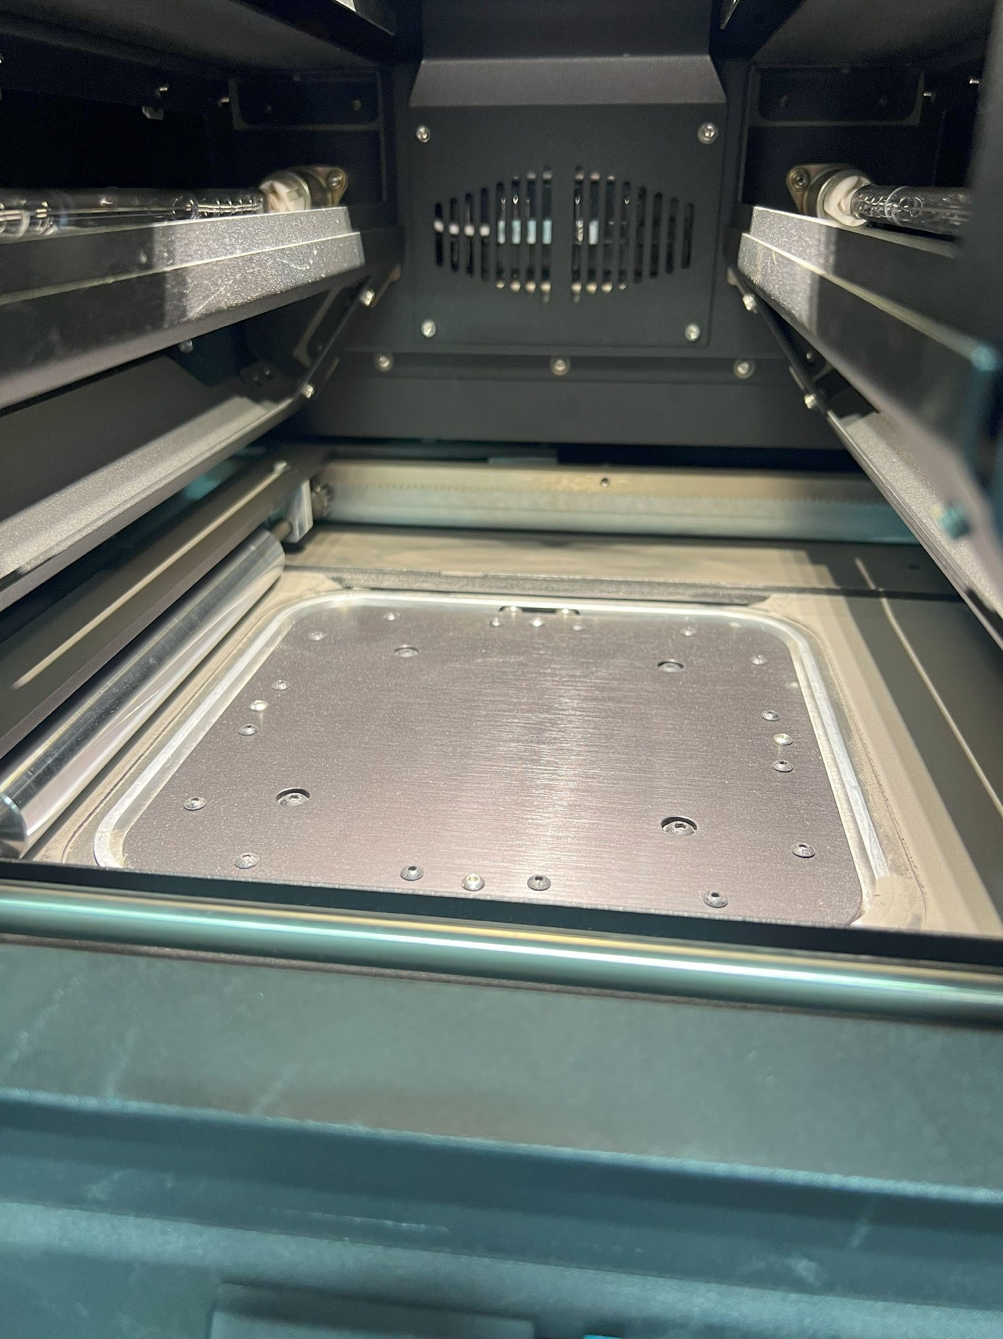

Common powder
buildup areas

- Next, the printer will prompt you to insert a build chamber. Open the door of the machine to verify it is installed correctly. If you do not see one, check the Sift cabinet next to the machine. Follow the instructions to ensure the chamber is secured and plug inserted correctly.
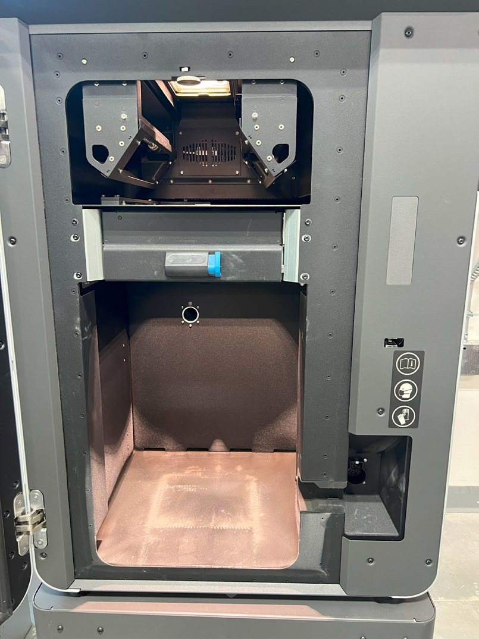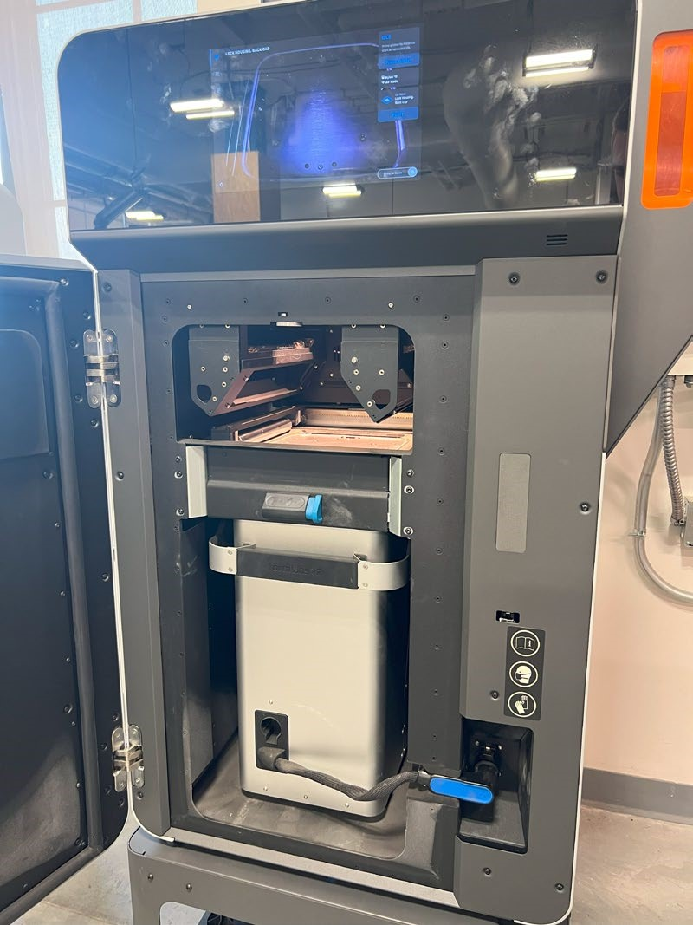

Latch is fully closed
and plug is correctly
seated

No build chamber

Close up:
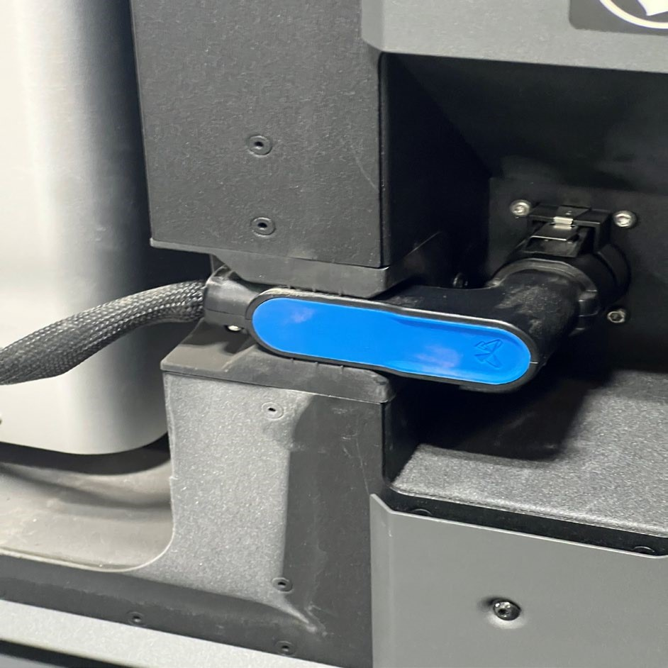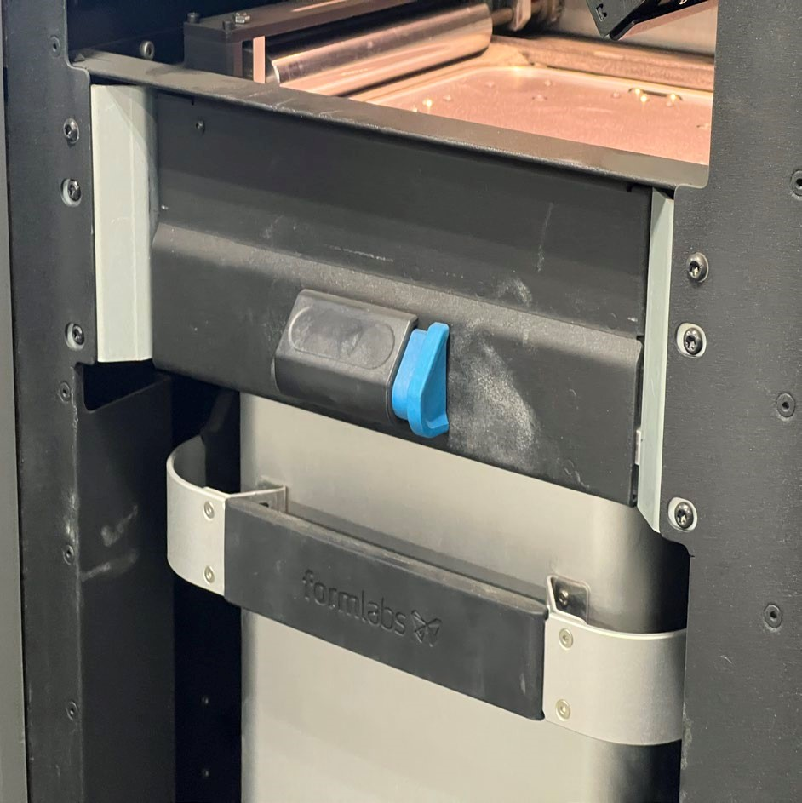

- IR Sensor inspection is not necessary and is handled by NIS staff members. Bypass this step by clicking the checkbox on the left of the screen.
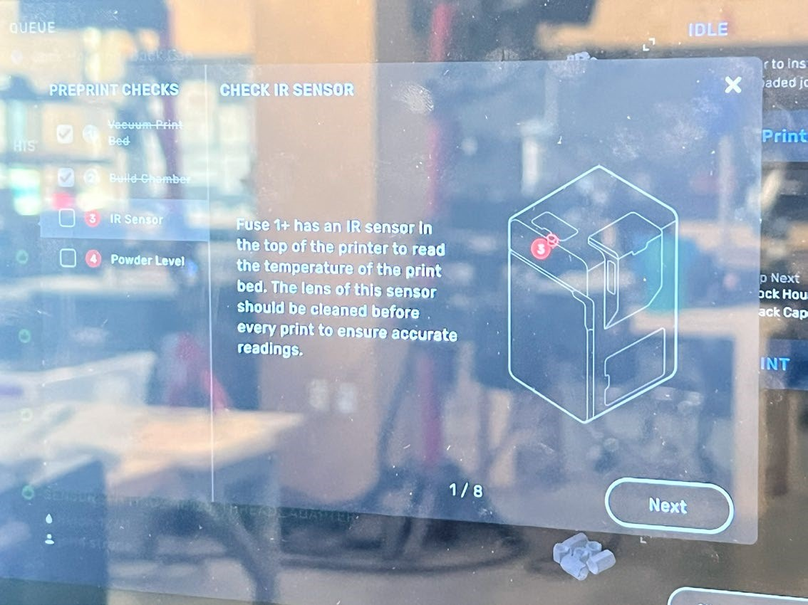

- Ensure that enough material is loaded into the printer. For a rough approximation, 6L in the hopper is equivalent to approximately 3kg.
- If you think the amount in the hopper is not suficient for your print, ind an NIS staff member and request more material be added.
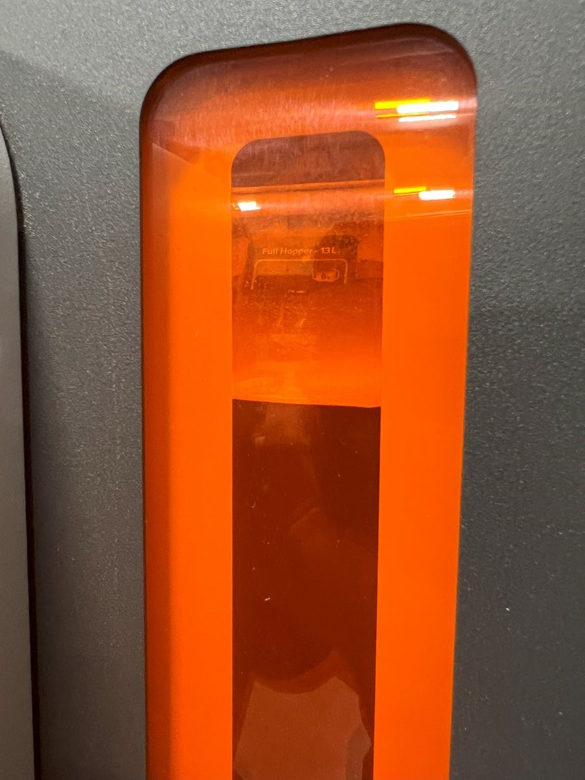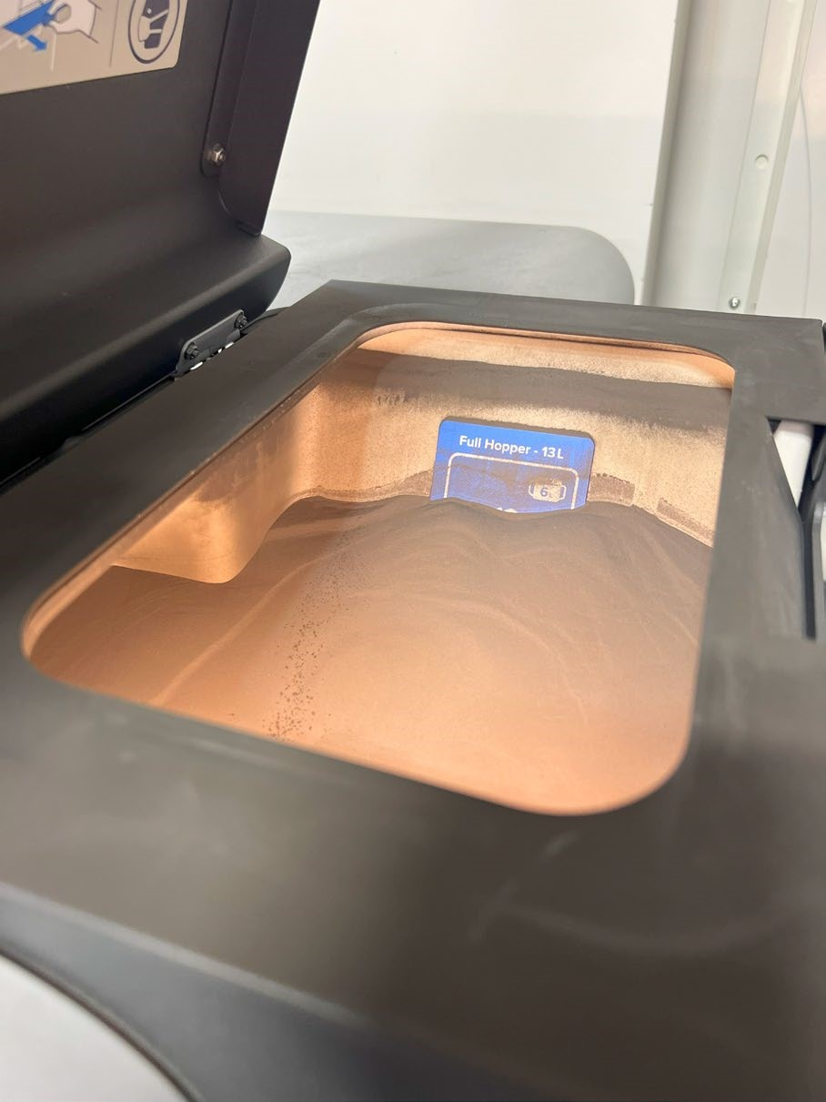
- Once this is complete, press “Begin Print”. The machine will begin printing!

Loading your 3D Print into the Sift
- Once your print has completed and adequately cooled, the printer will have a message onscreen saying that it’s ready to be sifted and removed.
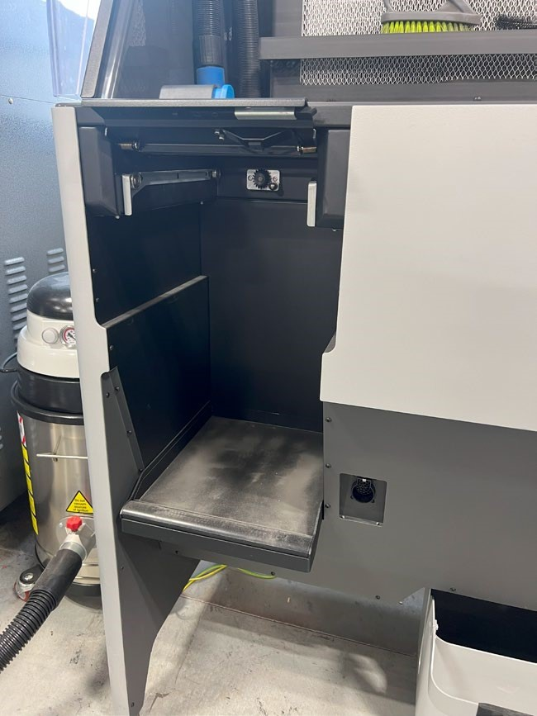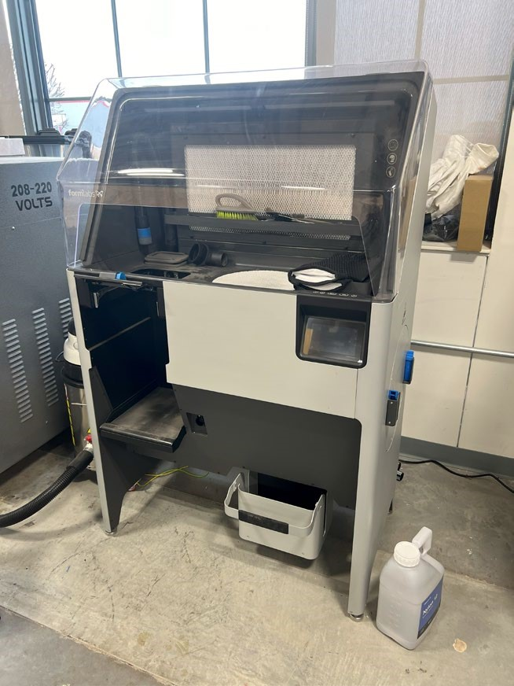

- Walk to the Sift cabinet, ensuring it is powered on and that the slot for the build chamber is empty and ready to receive your print.
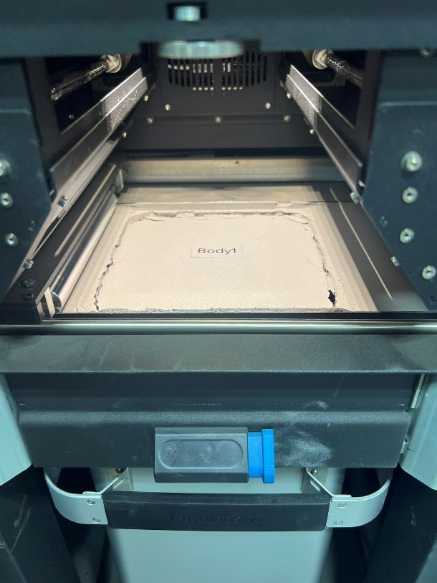
- Remove the build chamber containing your print from the Fuse printer, sliding the chamber out towards you and gripping it firmly so that you do not drop it, and carry it to the Sift cabinet.
- Insert the chamber into the Sift cabinet, seat the plug, and engage the chamber door latch.
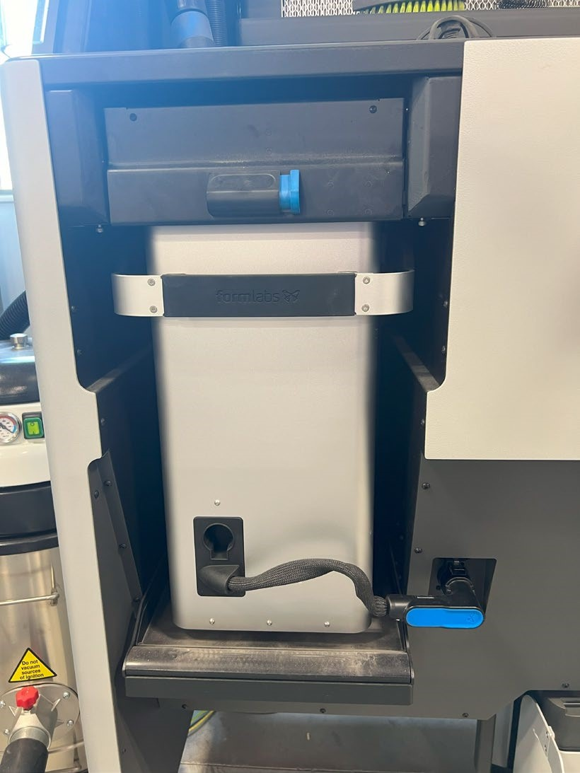
- You may now close the door for the Fuse printer or prepare it for a new job. The remainder of work will be on the Sift.

Sifting your 3D print
- Put on a pair of gloves before handling the raw nylon powder.
- Ensure that the build chamber cover is removed on the Sift.
- Turn on the Sift lights so that you can adequately see your parts.
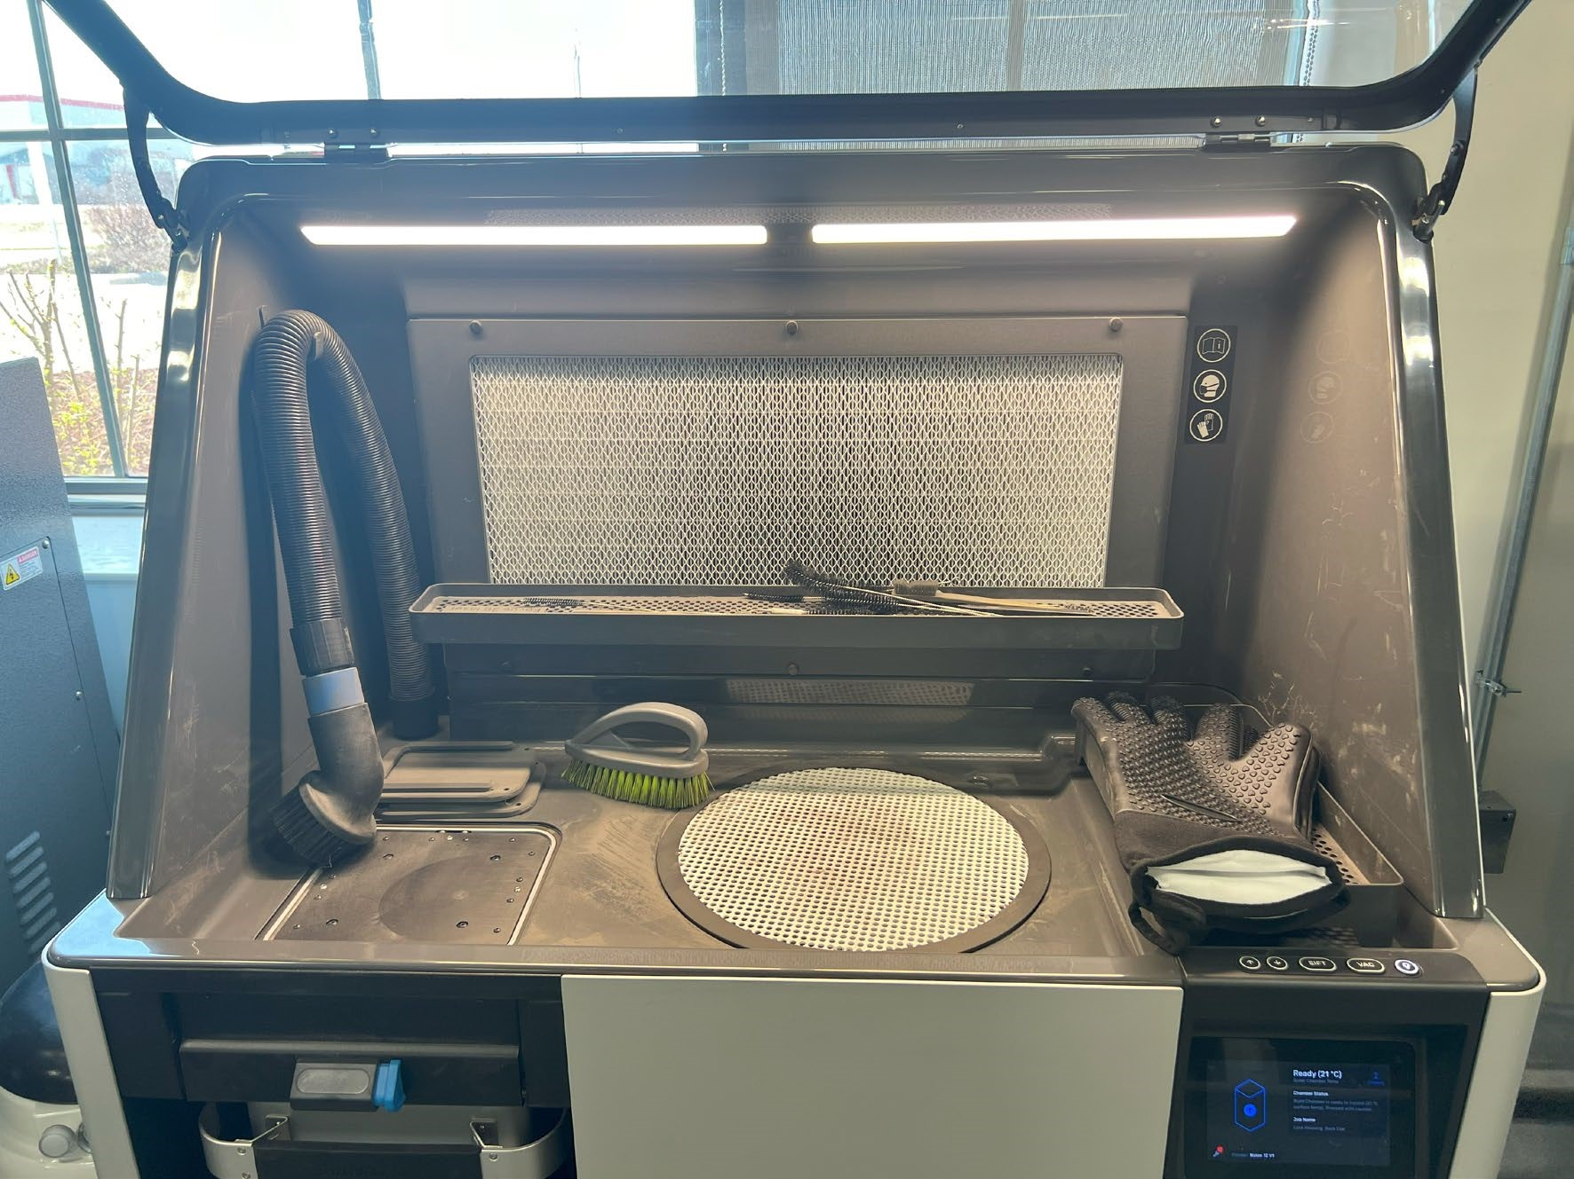
Light Switch
Sifter
Build Chamber (Cover Removed)

Cleaning Tool Tray

- On the touch screen of the Sift, press “Unpack”. The cake of powder containing your print will now rise out of thebuild chamber.

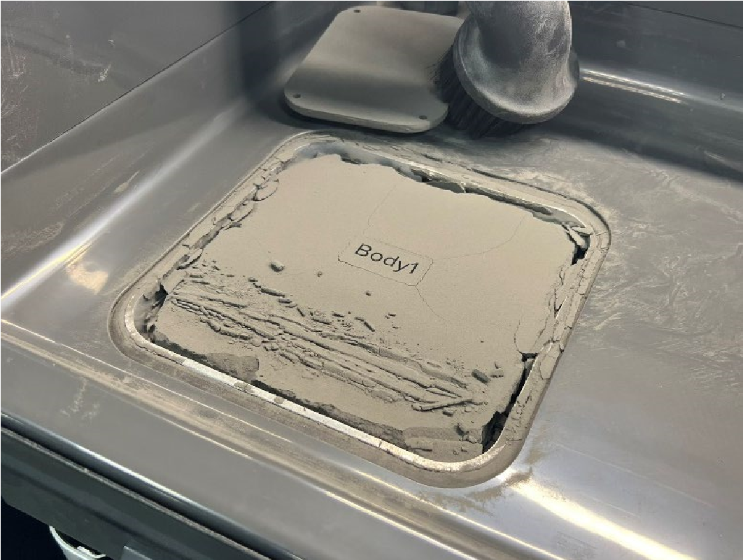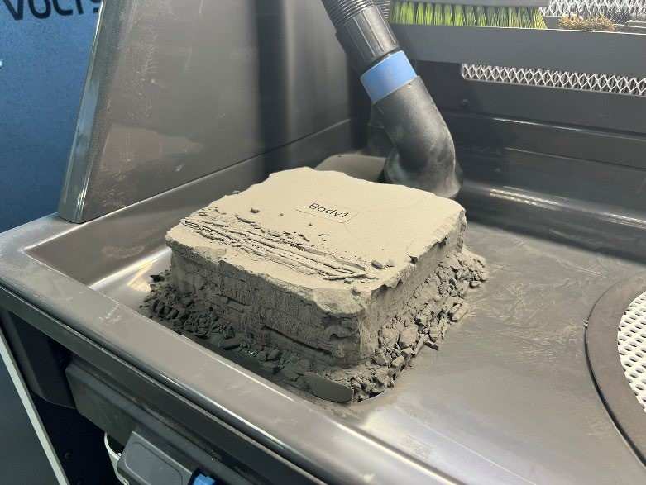
- Take the cake of powder containing your print and place it on to the Sift Hopper.
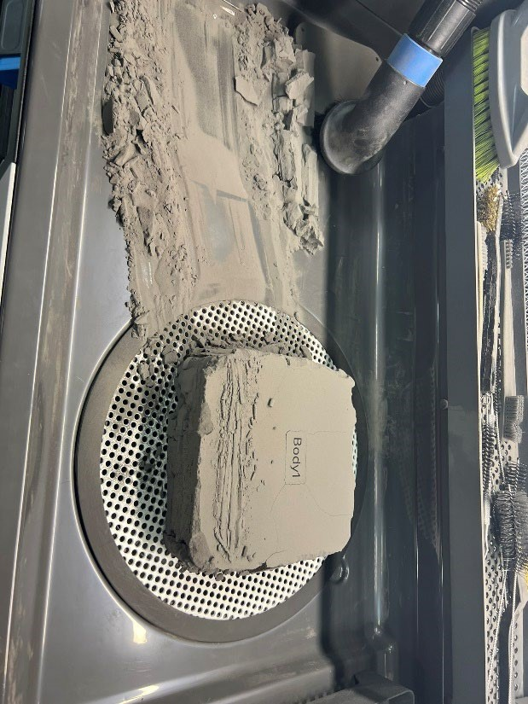
- Press the “Sift” button on the touchscreen. This will begin the Sifting process, where you will scrub the excess powder away to reveal your parts. It is important to get as much excess powder down into the hopper as possible so that it can be reused and recycled – any material that goes into the vacuum or air filtration is wasted.
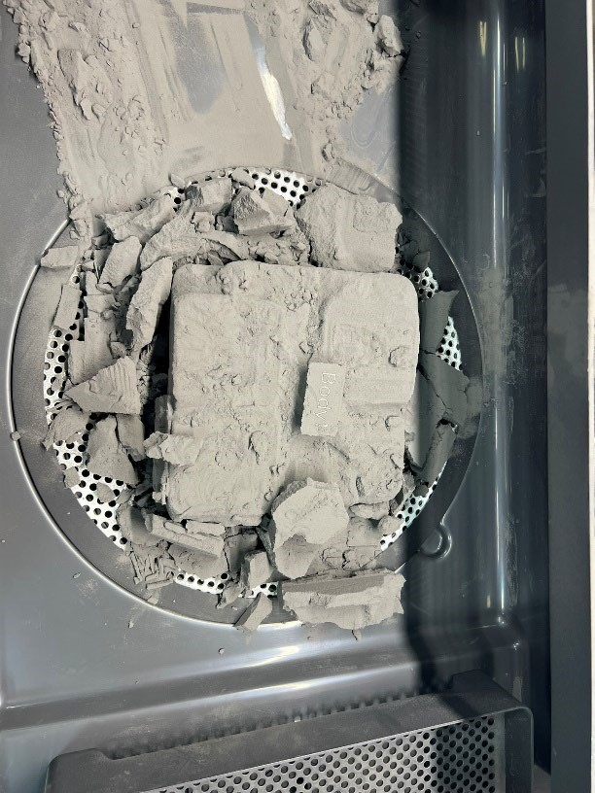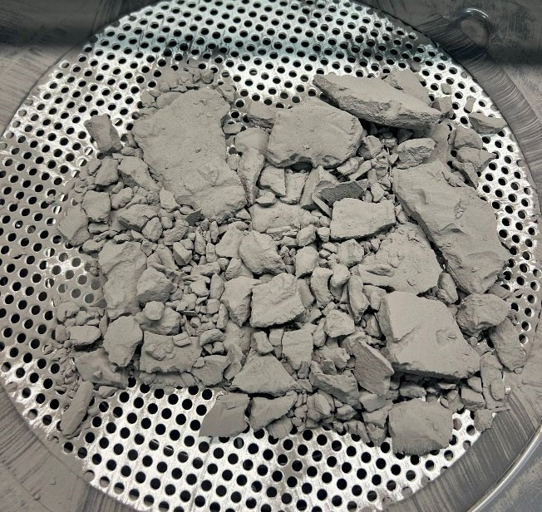
- A selection of brushes, scrapers, and dental picks are available in the cleaning tool tray to help scrub the excess powder from your parts. Take care to keep your parts and tools within the hood at all times – this helps contain powder spills and prevent respiratory risk.
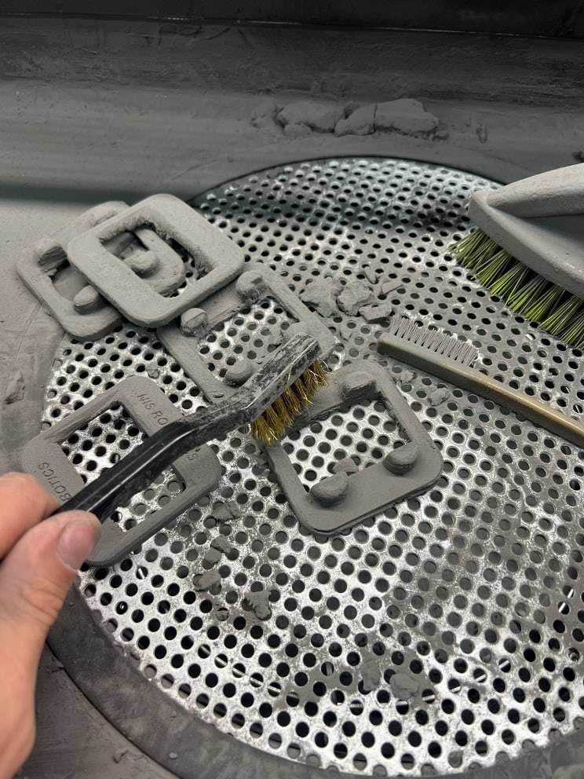
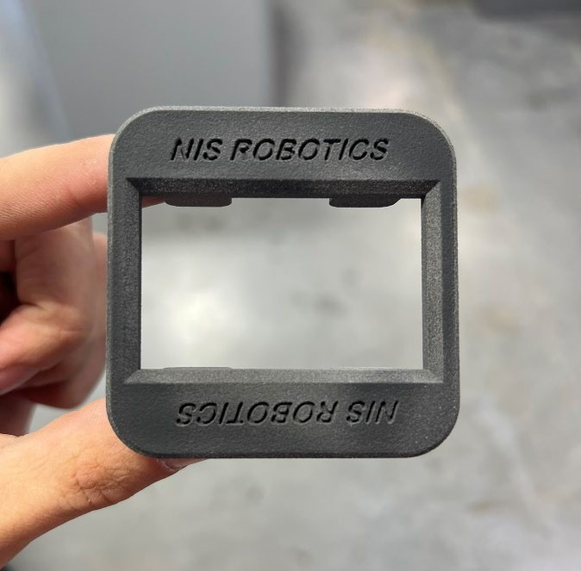
- Do not attempt to use water to clean your parts. This will create a stubborn “mud” that is hard to remove.

- OPTIONAL: If you desire a better surface finish, you can process parts in a media blaster. Doing so yields a more uniform sheen.

Cleaning the Sift
- Once your parts have been cleaned and excess powder sifted away, it is time to clean the Sift chamber for next users.
- Remove the lid of the Sift hopper, activate the Vacuum button and thoroughly clean excess powder from the mesh screen, edges, and underside of the hopper lid.
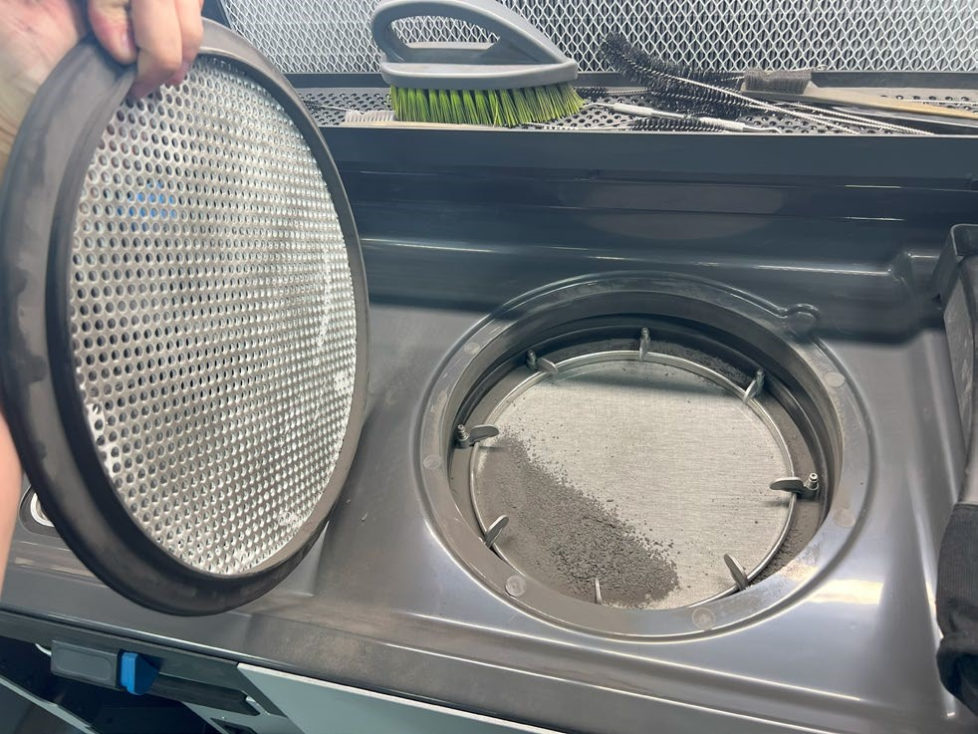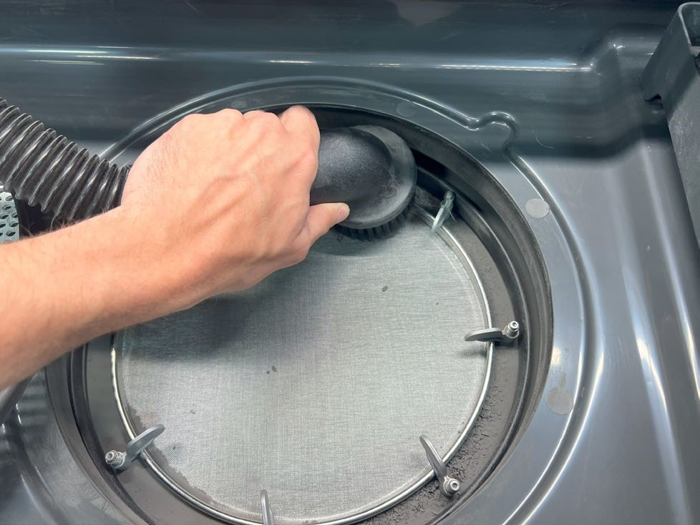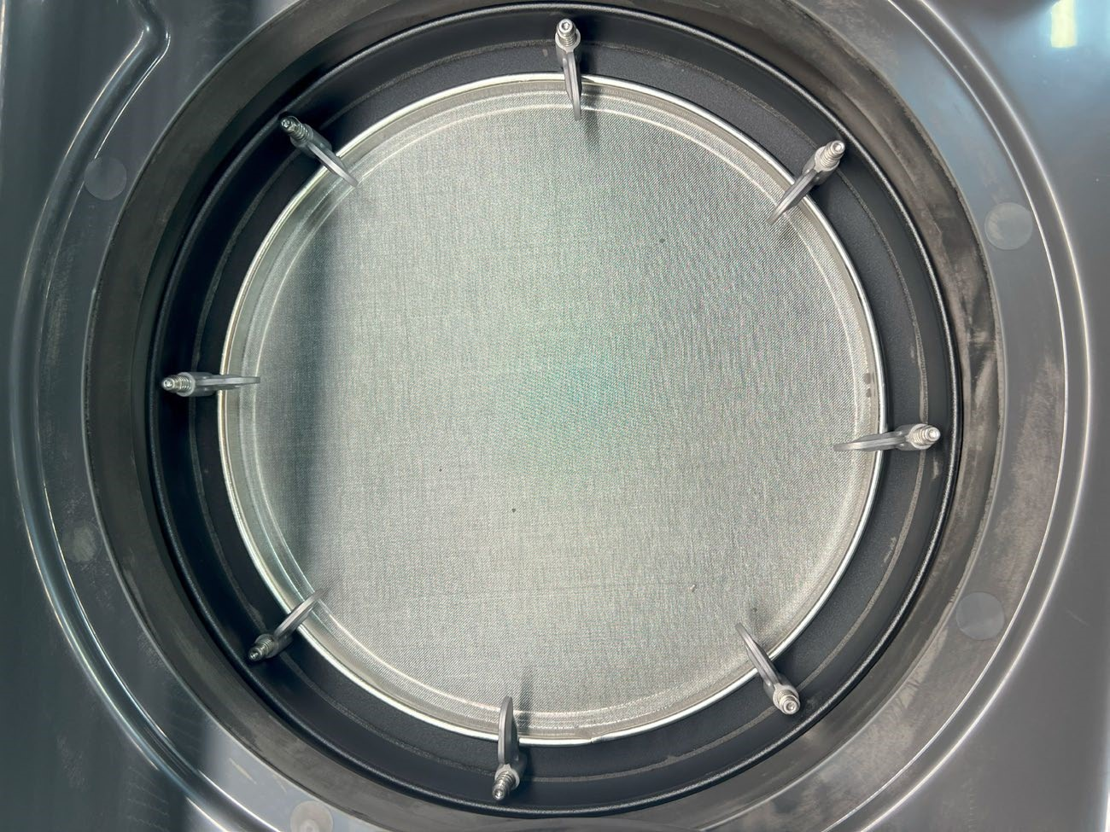

- Replace the hopper lid. Vacuum the top surface of the empty build chamber as well as all remaining surfaces of the Sift cabinet.
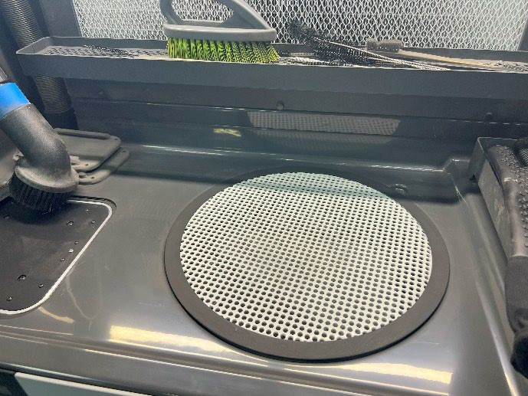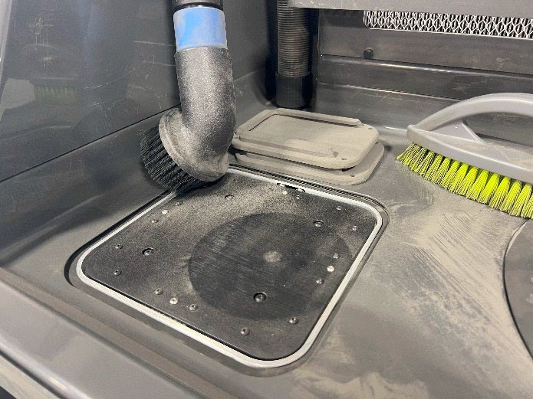

- Power down the Sift, stow the vacuum hose, and lower the cabinet lid.
- Don’t forget to show your print estimate to a staff member to pay for materials cost!

