SOP
EPSON F2270 DTG/DTF FABRIC PRINTER
OPERATION MANUAL
Training is required before using this equipment.
Reservations are required to use this equipment.
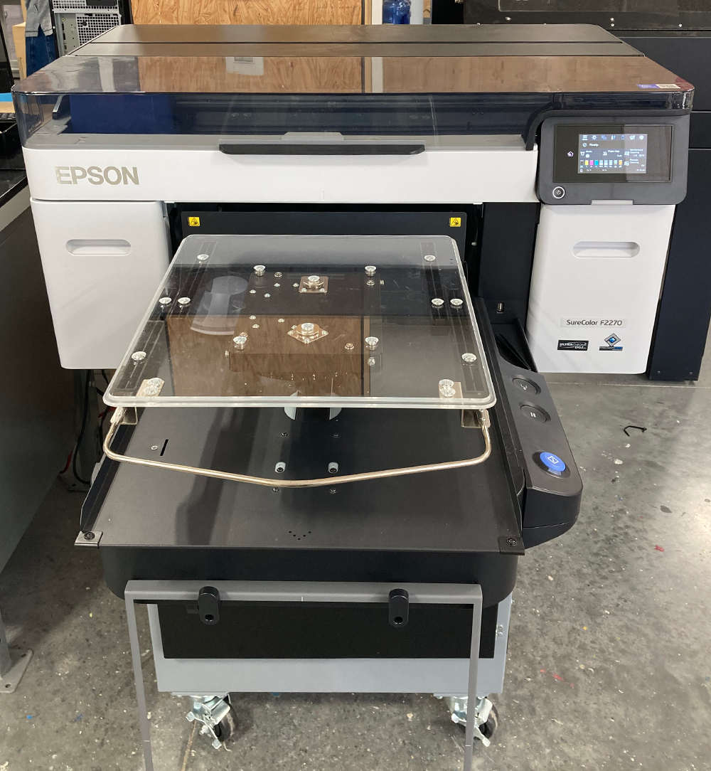

PRINTING PROCESSES
DTG
Direct To Garment printing can be done on any fabric that is 70% or more cotton. It can be used to print on shirts, jackets, sweatshirts and fabric; it cannot be used to print on denim, sleeves, hats, or pants. The printer will first lay down a base layer of white, then print the colors on top of that to ensure they stand out against the garment. Once cured, the printed design can withstand being washed and dried.

DTF
Direct To Film printing is used to transfer designs onto fabrics. It can be used on fabrics that cannot be printed on via DTG such as denim, 70% or less cotton fabric, and hats. This is done by printing directly onto a film rather than the garment. Once the film is cured, it is laid on the fabric and cured again to ensure it fuses with the fabric. Garments with DTF designs can withstand being washed and dried when turned inside out.

DIGITAL FACTORY
This software is used to import images to be printed. It allows you to adjust the size, placement, and rotation of your image to format for printing. You can print multiple images in one go by nesting them on the page.

GARMENT CREATOR
This software is to be used for PRICING ONLY. Once you upload your design, this program will tell how many mL of ink will be used to print the design. Take a picture or write down how many mL of ink will be used and the cost.

MATERIAL LIMITATIONS
- DTG can only be done on fabrics that are 70% or more cotton.
*Denim cannot be printed on.
- DTF can be used on fabrics that cannot be printed on such as denim, fabrics made of less than 70% cotton, and hats.

Pretreating
- For colored fabrics, the saturation of the hue will determine whether you need to pretreat the fabric before printing on it.
- Colors above the line should not need to be pretreated, colors below the line would have best results if pretreated first.
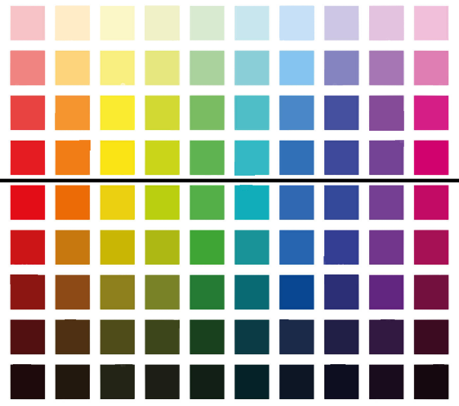
*You do not need to pretreat fabrics for DTF.

- Turn on the Master switch on the right side of the Lawson pretreatment machine.
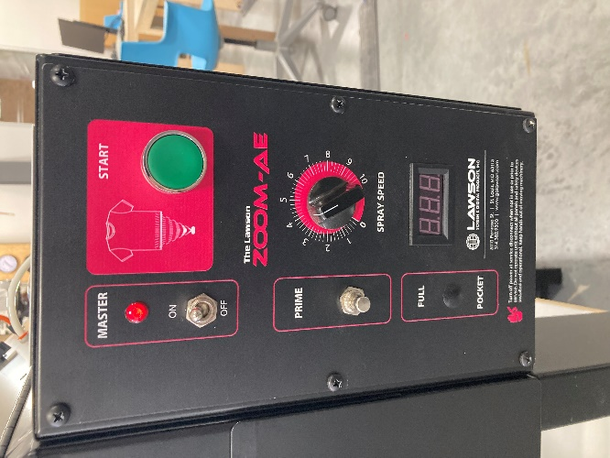
*Do not adjust the spray speed knob

- Turn on the heat press. The switch is located on the underside of the swing arm and above the heat platen.
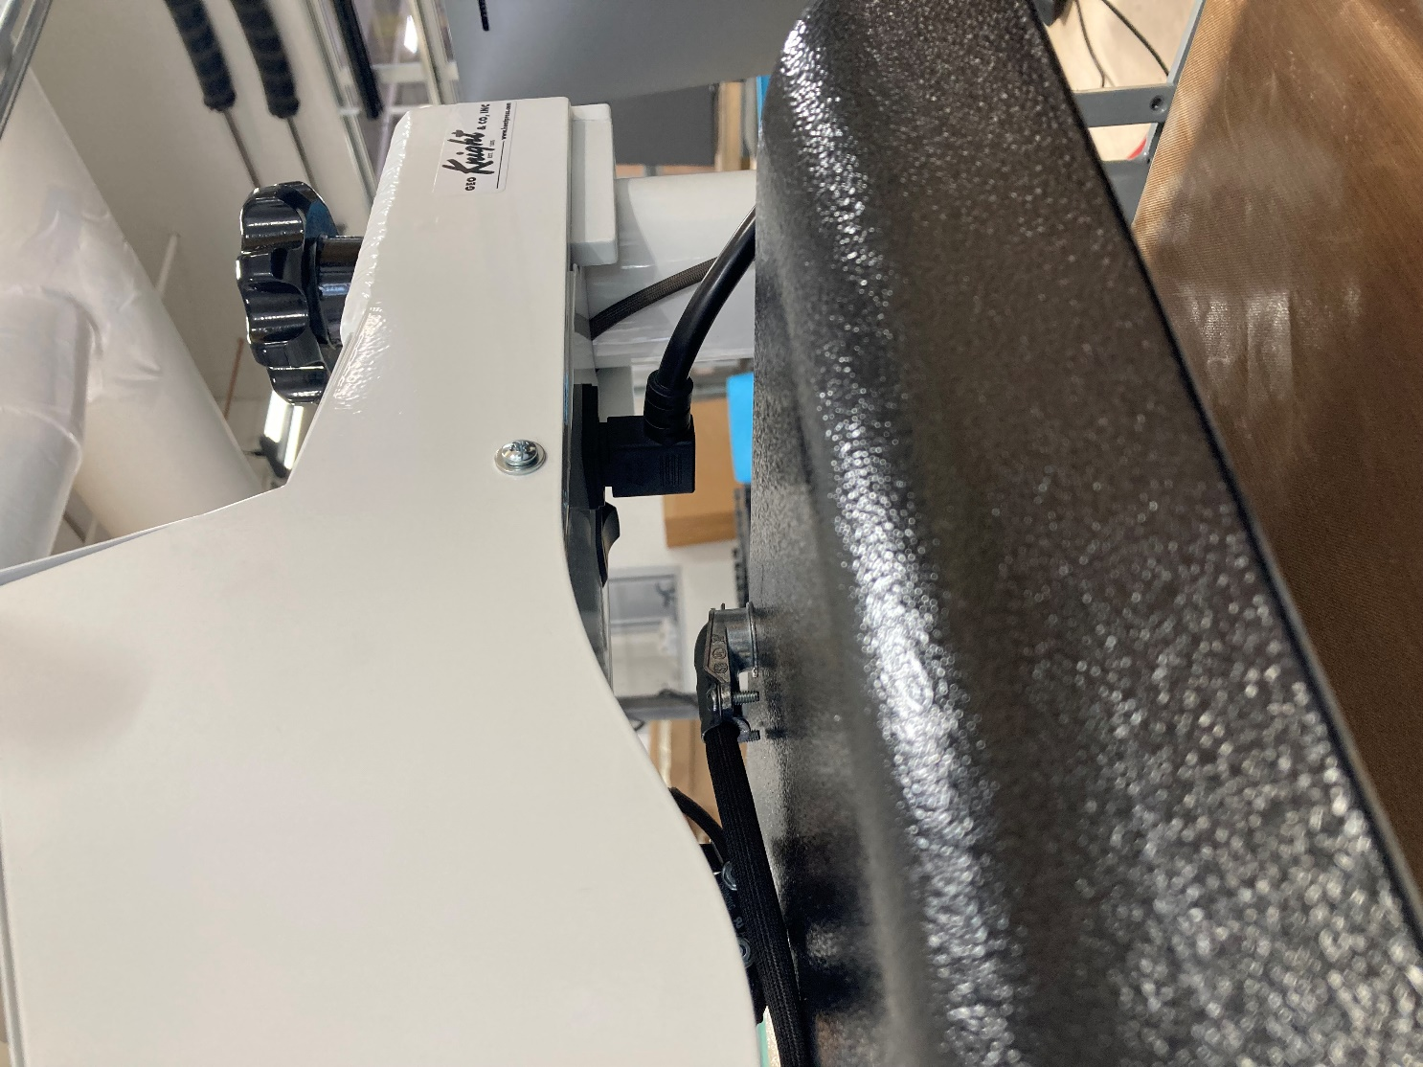
- DO NOT adjust any settings on the heat press- it will beep when at full heat.
- The heat press is programmed for a 5 second pre-press and a 15 second cure press
- Verify that there is fluid in both jugs. If fluid level is below quarter full, see NIS staff before proceeding.
- On the back of the machine, ensure that the distilled water line (2) is switched on and the pre-treat line (1) is turned off.
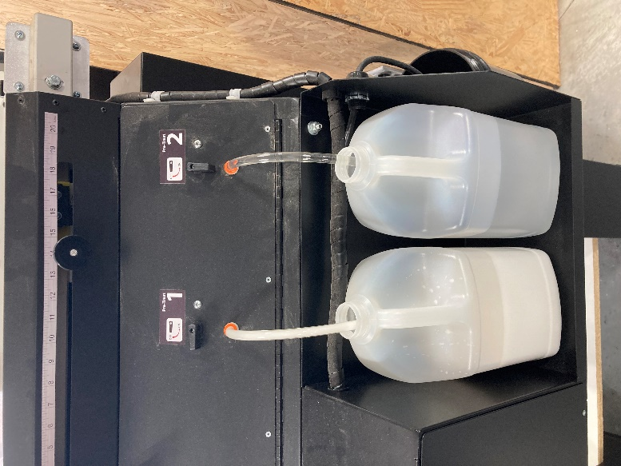
- Open the front compartment.
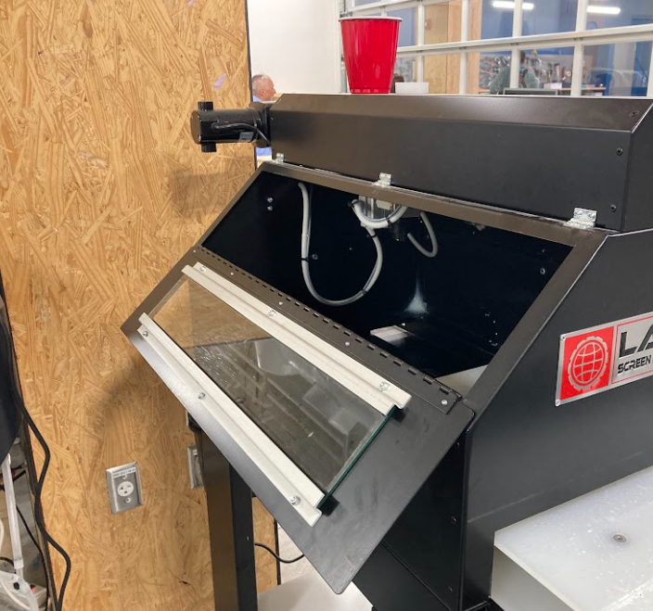
- Hold a cup under the nozzle and push the prime button until the line runs completely clear.
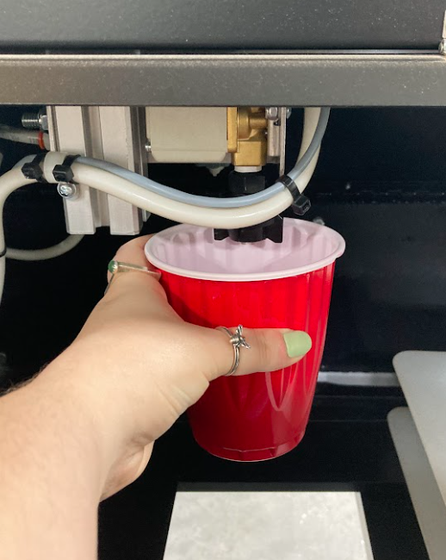
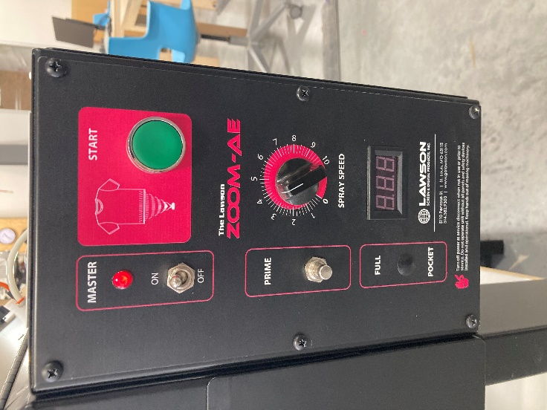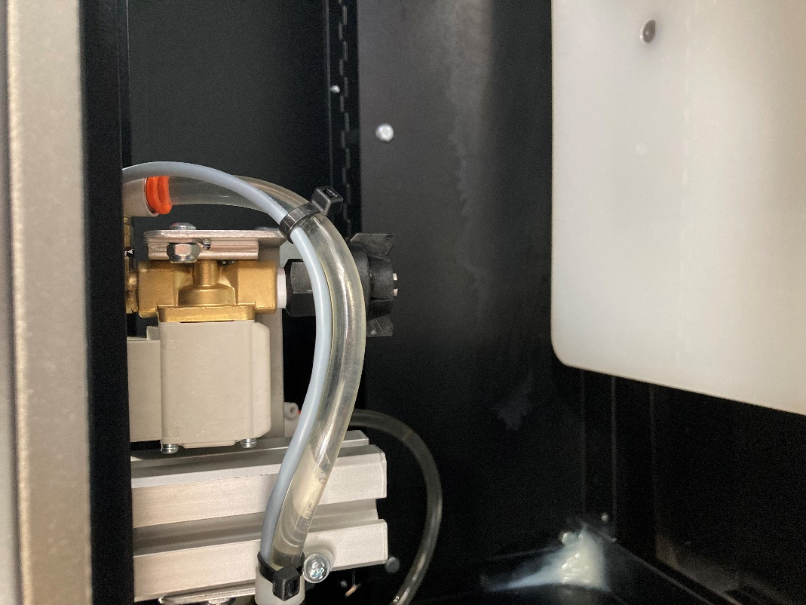
Clean Line
Nozzle
- Once clear, switch the distilled water line to the off position, and switch the pretreat line to the on position.
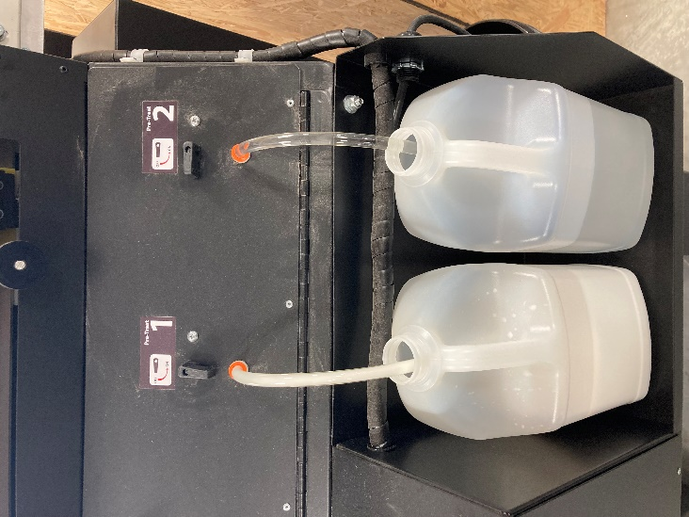
- Hold a cup under the nozzle and push the prime button until the line runs completely white through the nozzle.
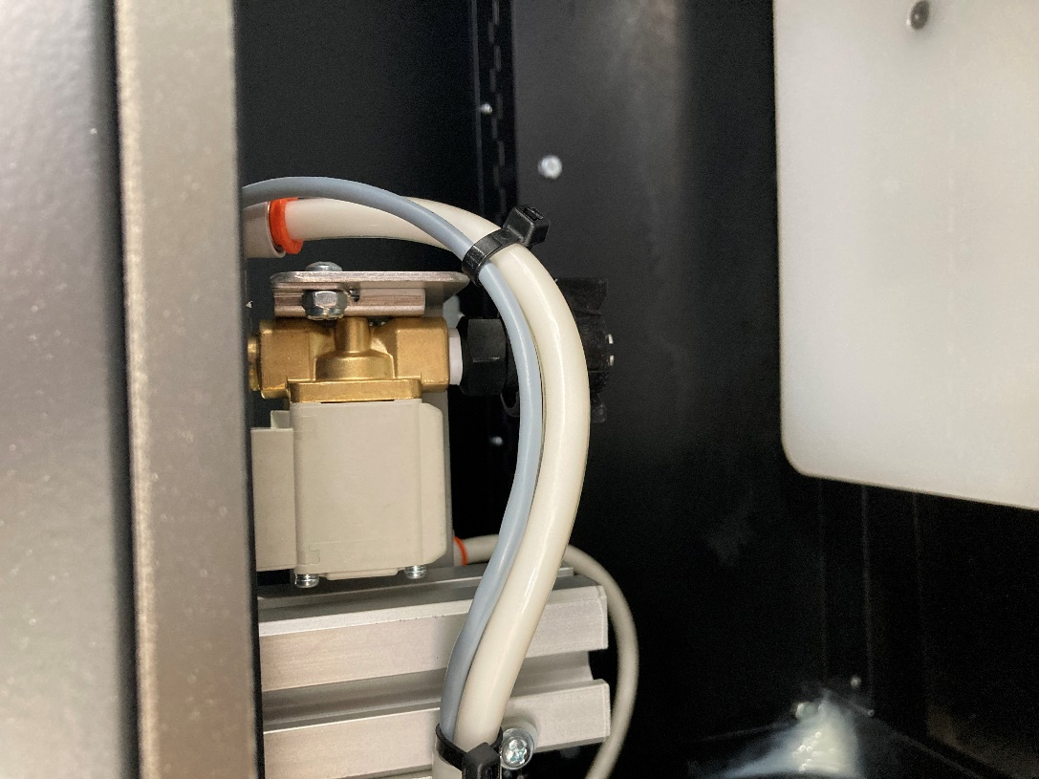
Line with pretreat
- Once the nozzle is primed, close the front compartment.

- Pull the drawer out and place your fabric on the platen.
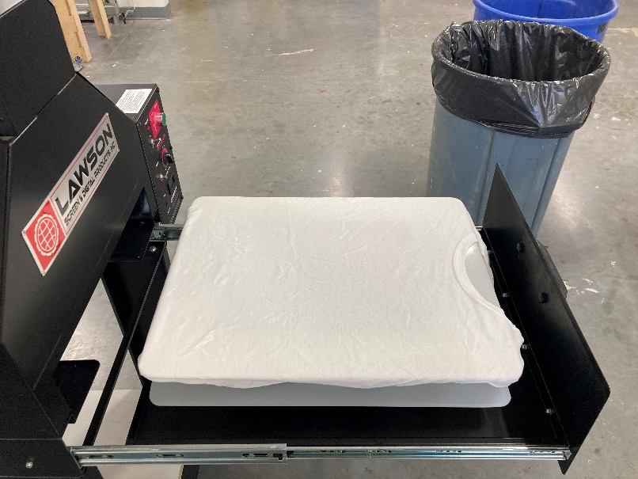
- If applicable, adjust the spray length to cover more or less of the shirt.
*Setting the length at 16” will cover the platen completely.
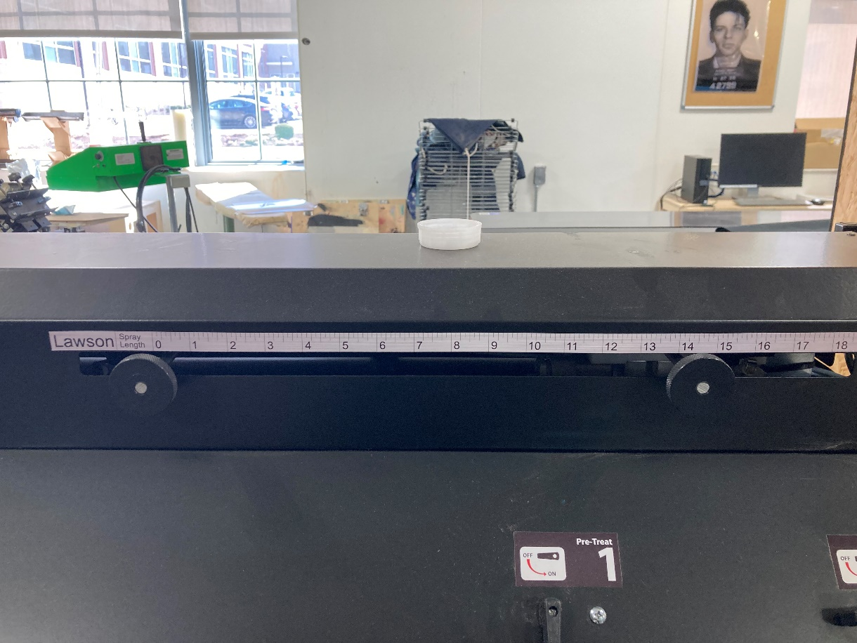
- Close the drawer completely and press START.
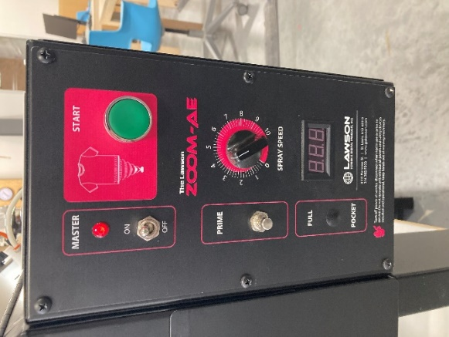
- Carefully move your shirt to the heat press.
- Raise the heating element and swing it to the side to place your fabric on the platen.
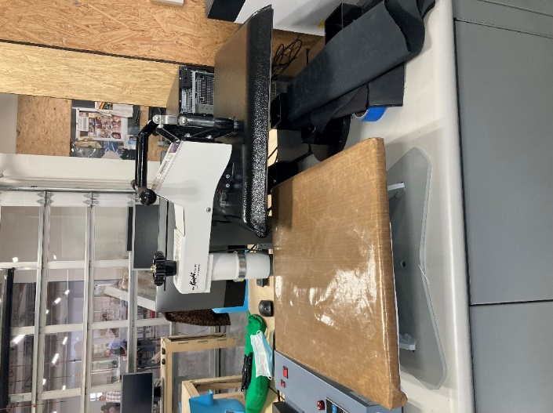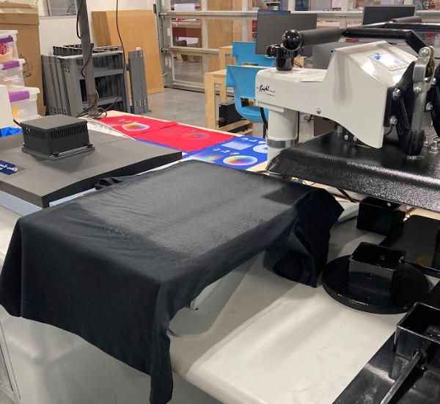
- Return the heating element above the fabric and use the lever to press the fabric.
*The heating element must be locked in place by moving the lever completely down, not just set on the platen
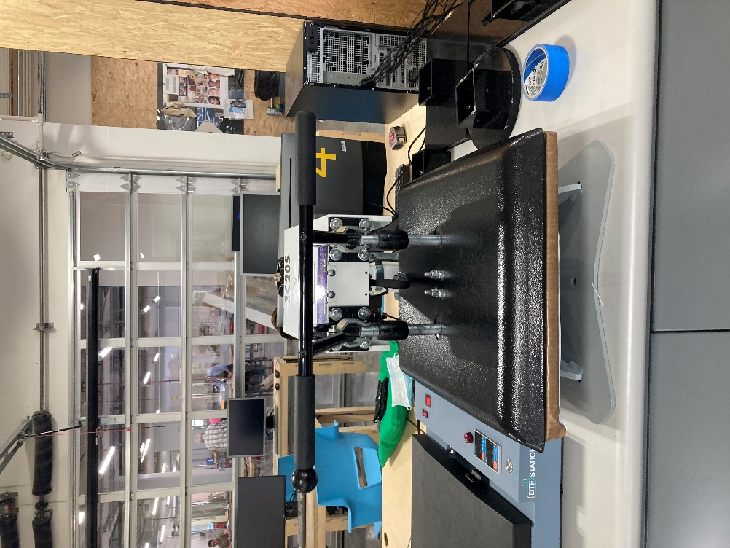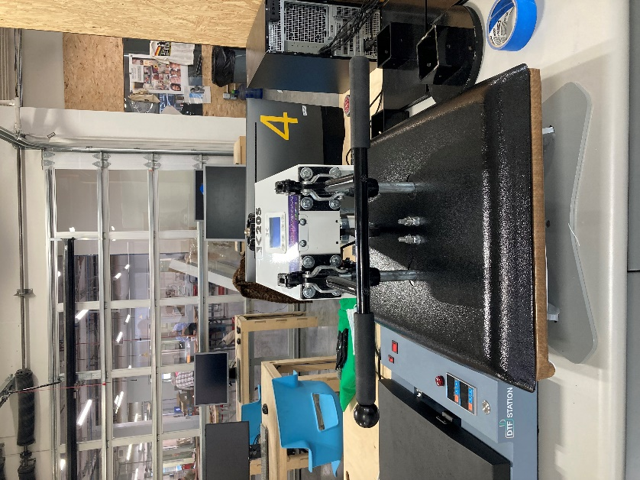
Correct: locked
Wrong: not locked

- When your timer goes off, release the lock and raise the heating element off the platen, swing to the side and remove your fabric from the platen.
- When finished with all pretreating, turn off the pretreat line and turn on the distilled water line, put a cup under nozzle, push the prime button until line is clear.
- Clean off excess pretreat within the machine and on the platen with a wet paper towel. Dry completely.

USING DIGITAL FACTORY SOFTWARE
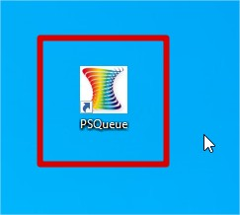
- In Digital Factory, chose the correct tab for what type of printing you’re doing.
Precision Dot DTF is for Direct to Film.
Precision Dot White is for Direct to Garment.
*Do not use the other tabs to the left.
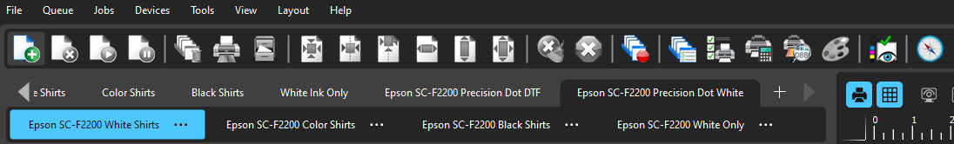
DO NOT USE
- Within that tab, select the color of fabric you will be using.
-White Shirts will eliminate all white from your design, it will not print white ink, it will use the garment color (white) in place of white ink.
-Black Shirts will eliminate all black from your design, it will not print black ink, it will use the garment color (black) in place of black ink.
-Color Shirts will print all colors present in your design.
-White Only will print only the white underlayer, it will not print any of the color present in the design.
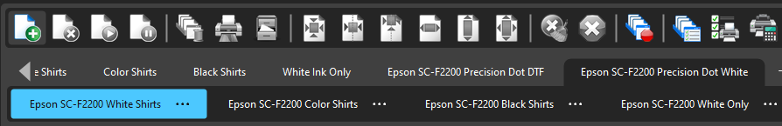
- Once you have selected the correct tab for your project, you can upload your image using the open button in the top left of the toolbar. Accepted file types include .jpg/.jpeg, .png
*If using DTF, the program will automatically mirror your design.
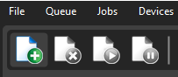
- You can adjust the placement and size of your image using the buttons in the toolbar for alignment or in the properties to the right. You can scale your image using the corners of the bounding box.
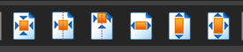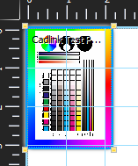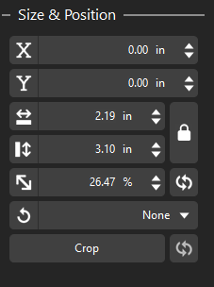
Properties
Scale
Alignment Tools

- You can import multiple images onto a page to print them all in one go. To fit them all on the same page right click on the page and click “Auto-nest all content”
- When your design is to your liking, select your image on the preview or in the active jobs list and click the print button in the toolbar.
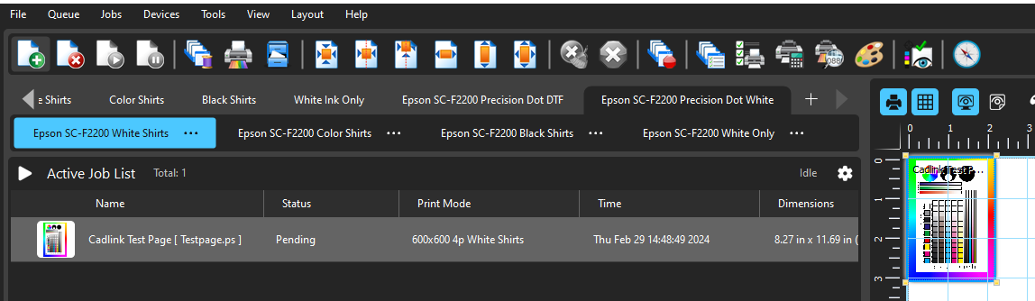
Preview

PRICING IN GARMENT CREATOR
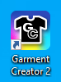
- Once you’ve created your design in Digital Factory, you must upload the same design into garment creator using this button.
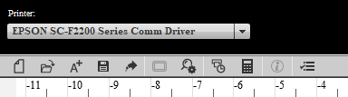
- Ensure your design is using the same print settings (i.e. black shirts vs white shirts, DTG vs DTF) and is the same size in both softwares. The latter can be done using layout settings.
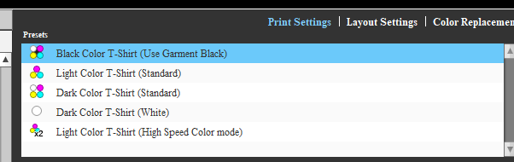
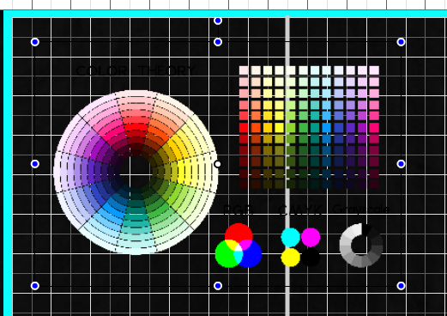
Click anywhere on the image and drag to adjust position.
Use the top point to rotate your design.
Use the outer points to scale your design.
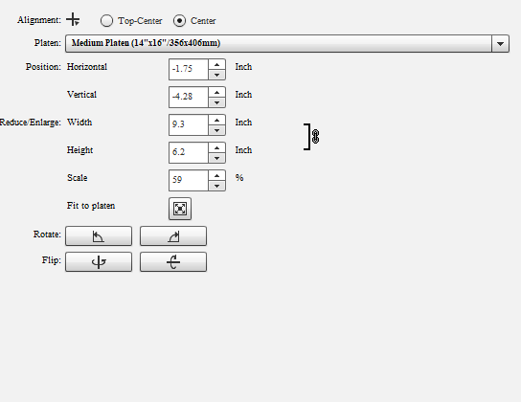
You can also make adjustments using the layout settings
Ensure you’re using the correct platen size.
- Next, click the calculator button to begin pricing.
- Ensure you’re using the “Epson Ink” settings as shown.
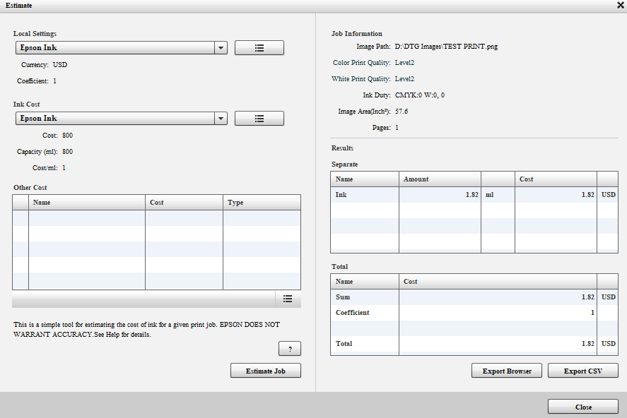
- Next, click “Estimate Job” at the bottom.
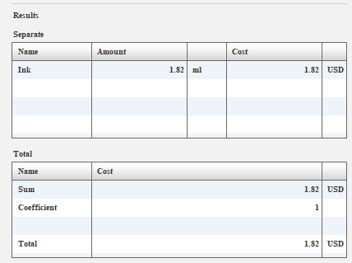
- In the results tab on the right, you will see the cost for printing the imported design once.
- Take a picture of this tab or write down both the mL of ink used AND the cost.
- Repeat this process for each new design.
- If you’re nesting images in Digital Factory, you must do this process for each individual image. You cannot nest images in Garment Creator.
Direct to Garment Printing
- Using the maintenance tab on the printer interface, run a light nozzle cleaning.
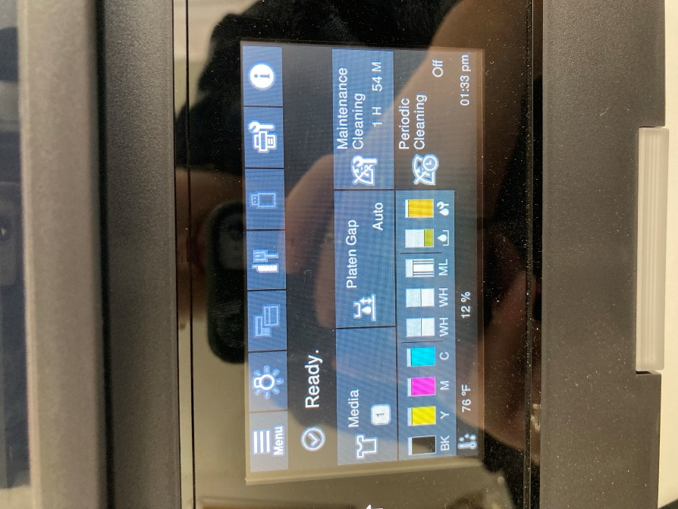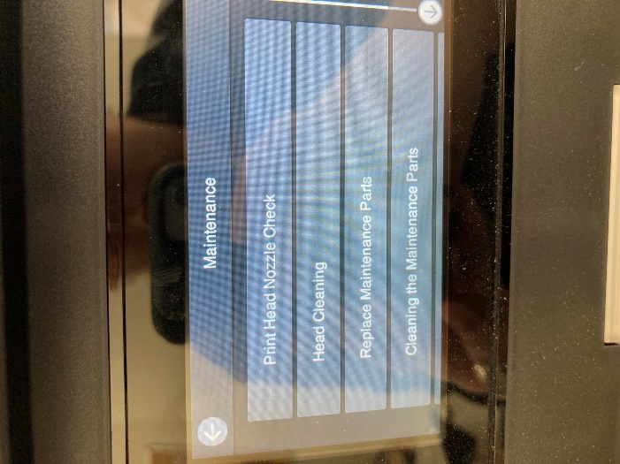
- Once the nozzle cleaning is complete, it will prompt you to print a pattern to check the nozzles, press the blue button on the printer interface to print the pattern.
*The pattern will print directly on the platen.
- Check the pattern for breaks in the lines for each nozzle column. Minor skips in lines will not affect the quality of your print.
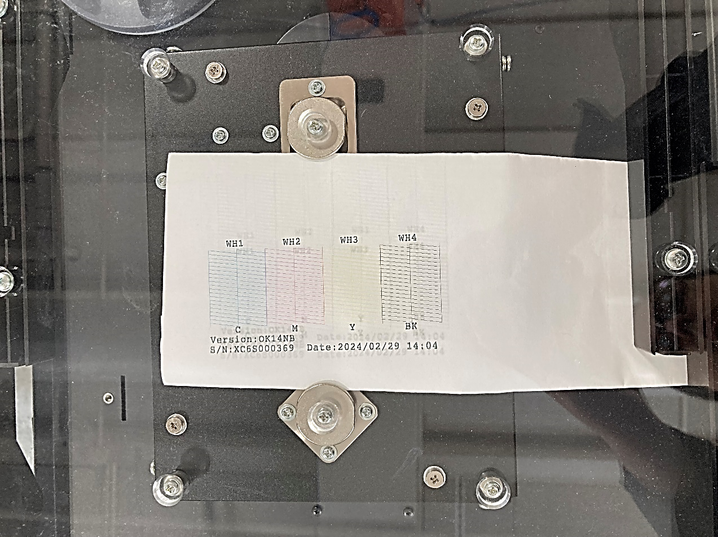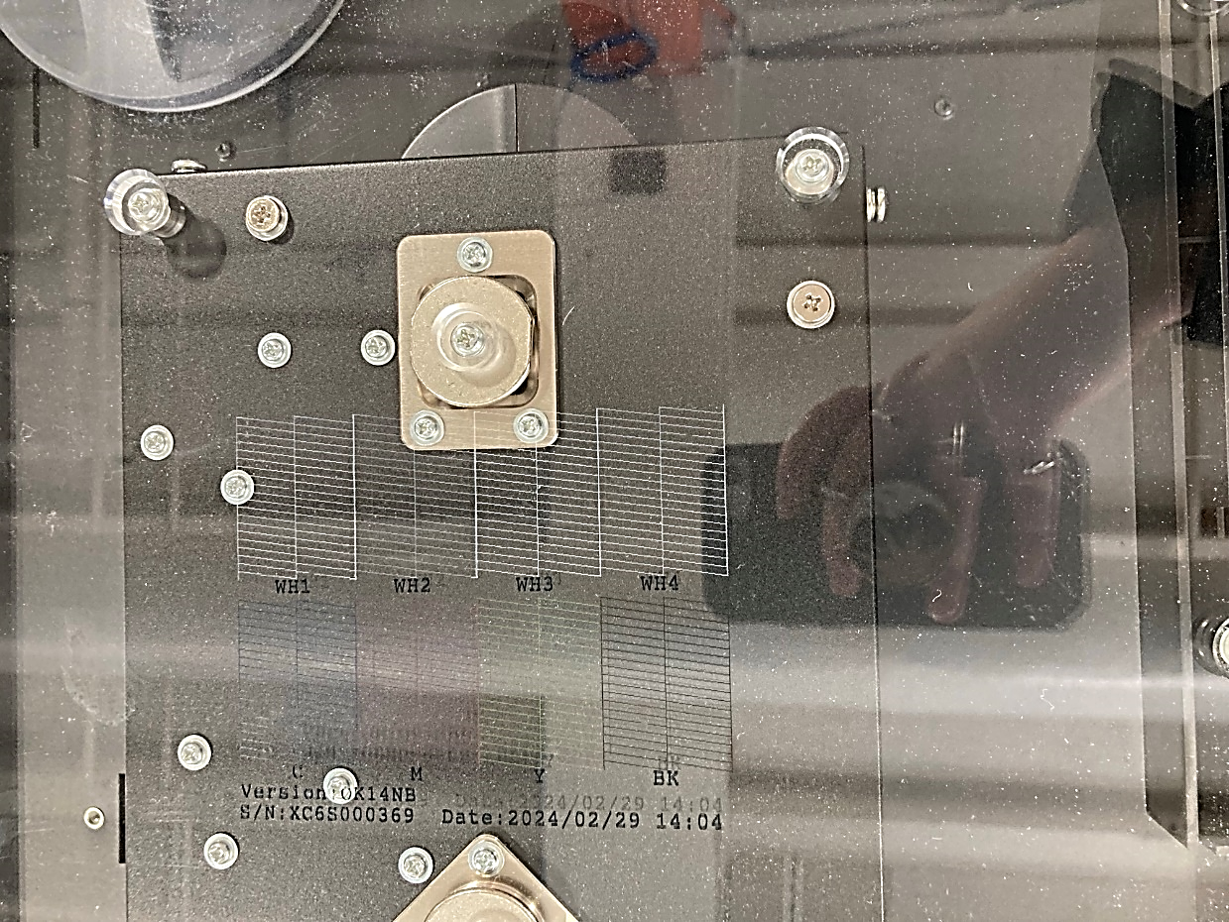
- Clean the ink off the platen with a wet paper towel and dry completely.
- Pre-press your fabric in the heat press at 350 degrees for 5 seconds to eliminate wrinkles. If there is any lint on your fabric, use a lint roller to remove it.
- The printer may prompt you to shake the ink.
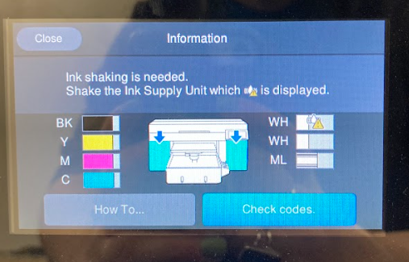
- Open the side compartment corresponding to the ink that needs shaking.
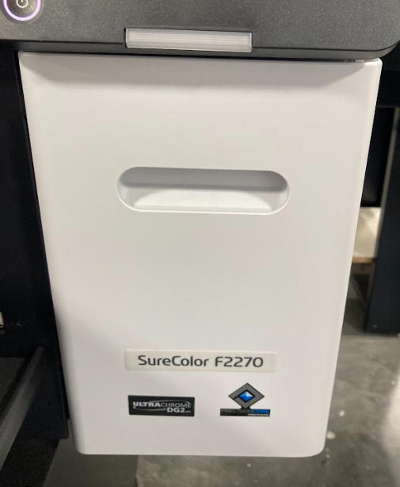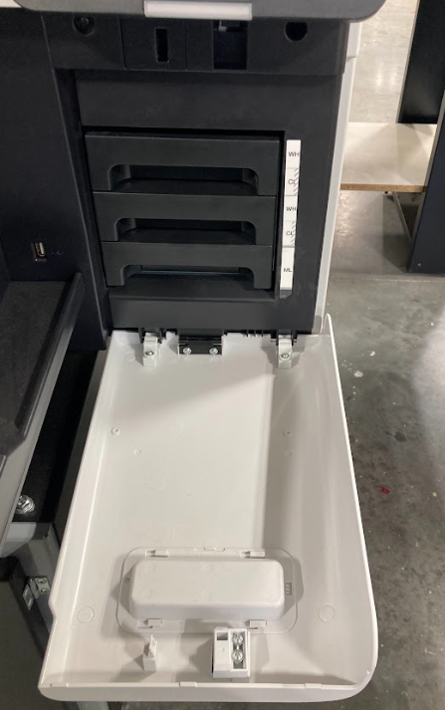
- Take out the cartridge that is shown on the screen with a yellow triangle symbol and gently tip it side to side for a few seconds.
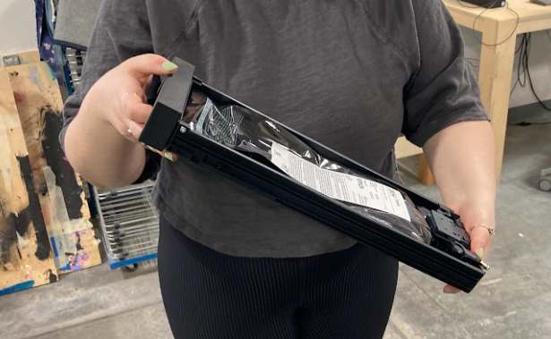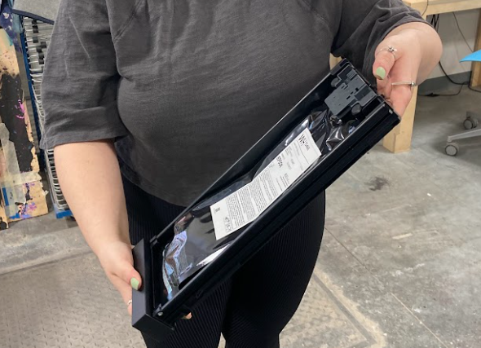
- Return the cartridge to its spot with the text facing towards you.
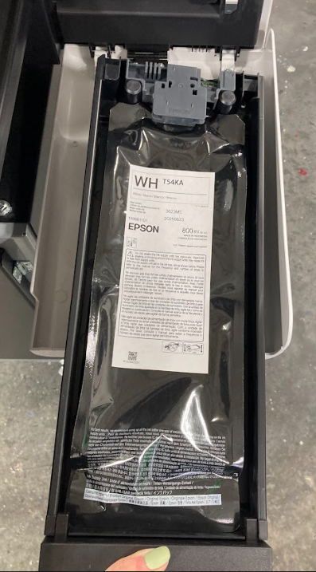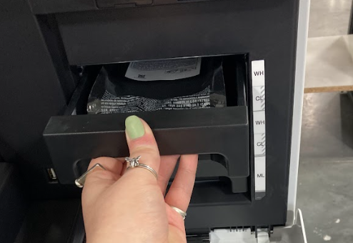
- The cartridges have sensors that the printer uses to detect whether the ink cartridge has been placed in the correct spot.
- Put your garment on the platen, with the neck facing away from the printer.
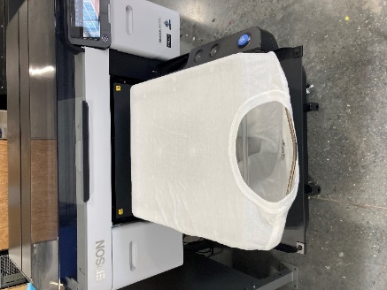
- Place the frame over your fabric, ensuring there are no wrinkles or creases.
*Ensure that your garment is centered how you desire. There are markings on the frame to guide you.
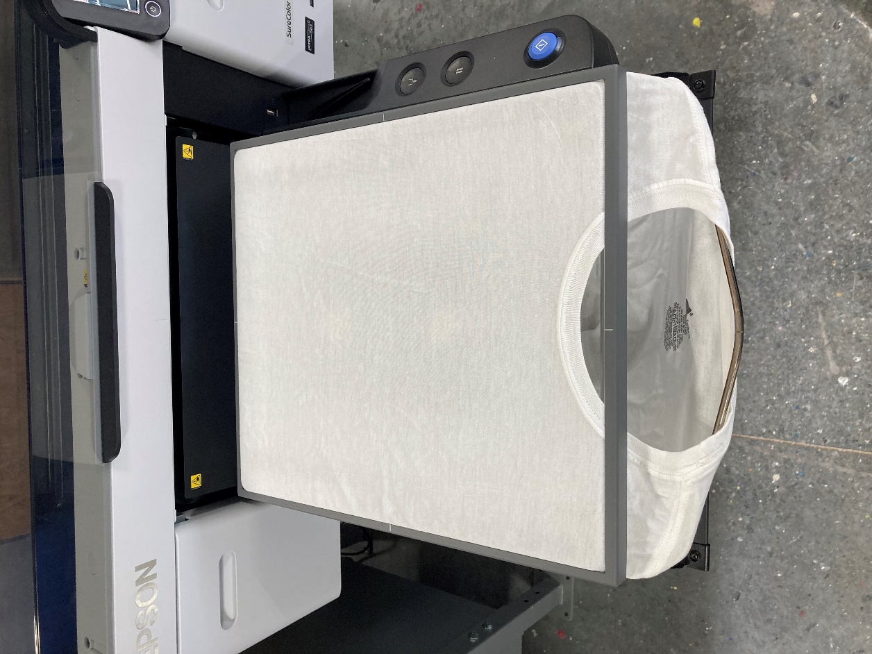
- The printer will beep and show a preview of your design. When it is ready to print the blue button will light up. Press the blue button to begin printing.
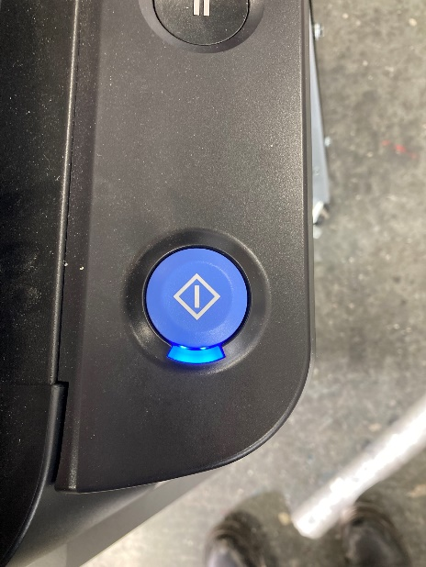
- When printing is complete, carefully remove your garment from the platen with the ink facing away from you.
*The ink is wet and will smudge if touched. If it gets on your clothes, it can permanently stain.
- Place the garment on the platen of the heat press, with the ink facing up.
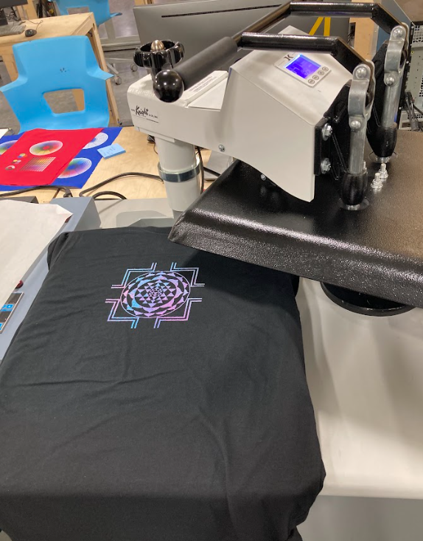
- Carefully place a piece of parchment paper over the design, covering the ink completely, then press to cure it at 350 degrees for 15 seconds
*Failure to place the parchment paper carefully may result in the ink smudging. Once it is pressed the ink cannot be removed.
- Once complete you can peel the parchment paper off and feel the ink is completely dry.
- To fully cure your garment, turn it inside out and put it in the dryer on high heat for 20-30 minutes.

Direct to Film Printing
- Turn on the heating element of the DTF curing machine. Once up to full temperature- 280 degrees- turn on the fan.
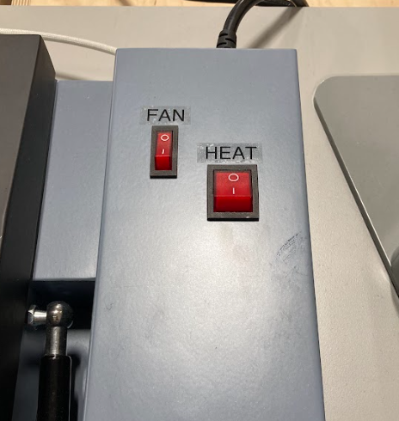
- Using the maintenance tab on the printer interface, run a light nozzle cleaning.
- Once the nozzle cleaning is complete, it will prompt you to print a pattern to check the nozzles, press the blue button on the printer interface to print the pattern.
*The pattern will print directly on the platen.
- Check the pattern for breaks in the lines for each nozzle column. Minor skips in lines will not affect the quality of your print.
- Clean the ink off the platen with a wet paper towel and dry completely.
- The printer may prompt you to shake the ink.
- Open the side compartment corresponding to the ink that needs shaking.
- Take out the cartridge that is shown on the screen and gently tip it side to side for a few seconds.
- Return the cartridge to its spot with the text facing towards you.
- The cartridges have sensors that the printer uses to detect whether the ink cartridge has been placed in the correct spot.
- Pre-press your fabric in the heat press at 350 degrees for 5 seconds to eliminate wrinkles. If there is any lint on your fabric, use a lint roller to remove it.
- Take one piece of film and place it matte side up on the platen. Secure it with 2 pieces of tape on opposite corners.
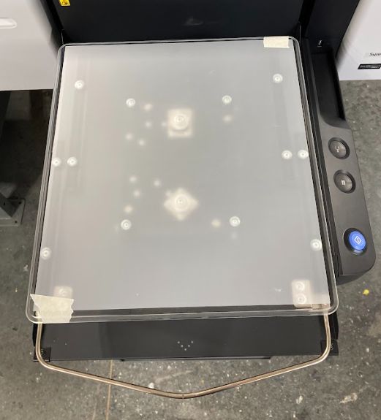
*Excess tape or using the frame to hold down the film will result in an error with the auto-height adjustments of the platen.
- Once your design has printed onto the film, carefully remove the tape and take the film off of the platen with the ink side facing away from you.
*The ink is wet and will smudge if touched. If it gets on your clothes, it can permanently stain.
- Place the film ink side up in the designated tub.
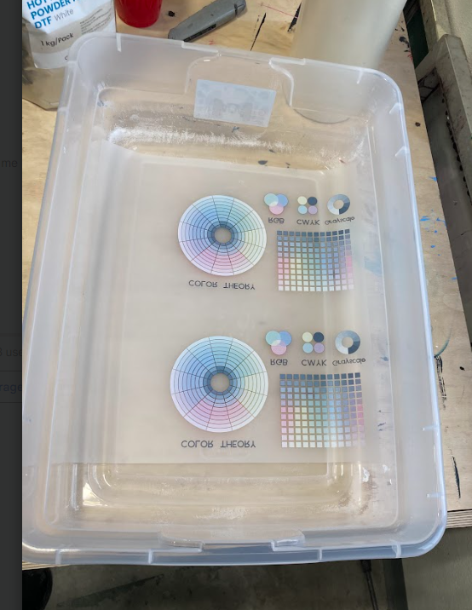
- Put on a mask and gloves before opening the bag of powder.
*This powder should not be ingested nor inhaled. Do this process in its designated area to avoid getting powder near the printer. DEFINE AREA
- Pour a small amount of DTF Curing White Powder into the sifter.
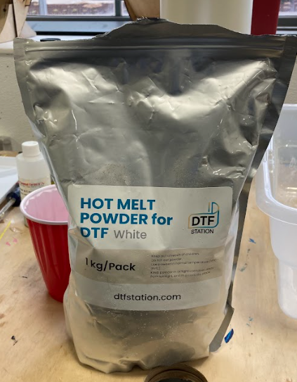
- Tap or shake the sifter to create a light dusting of powder over the entire design.
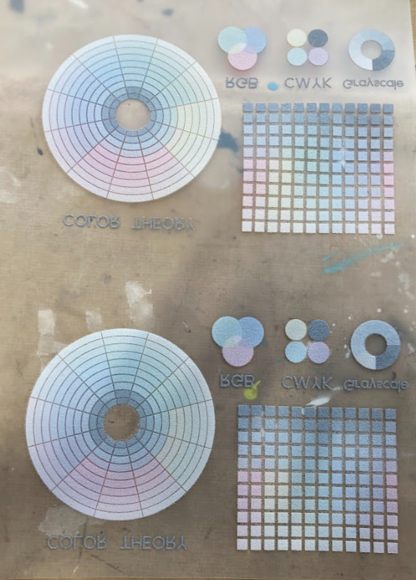
- Place the film ink side up onto the bed of the DTF curing machine and lower the lid.
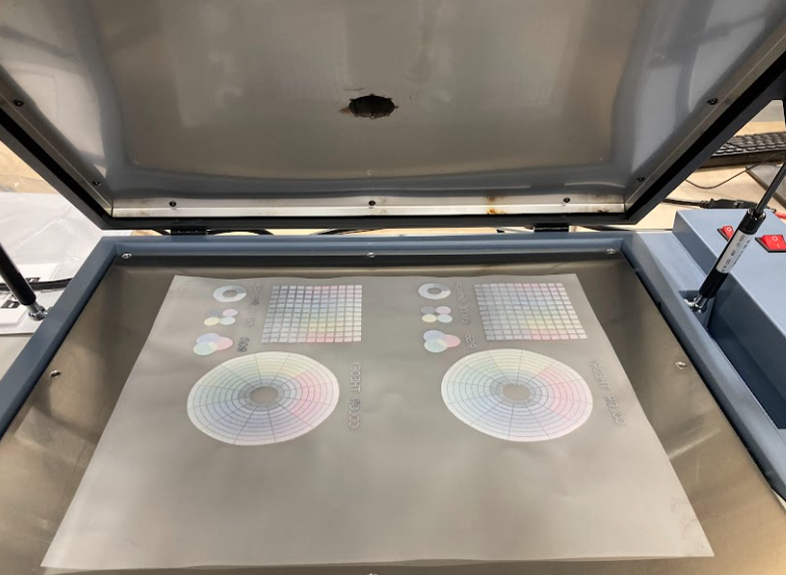
- Press the red button to start the 60 second timer.
- Once the timer goes off, lift the lid to ensure all the powder has melted. It should look crystalline and mostly clear. If not, cure more in 5 second intervals.
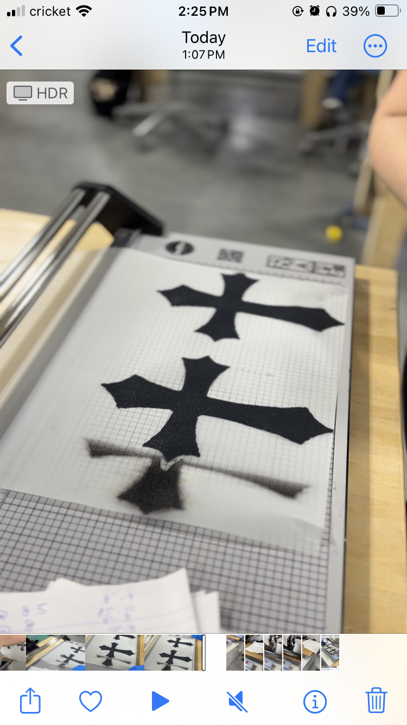
- With your fabric on the platen of the heat press, swing the arm away for ample work area.
- Place the film ink side down in the desired position on your fabric.
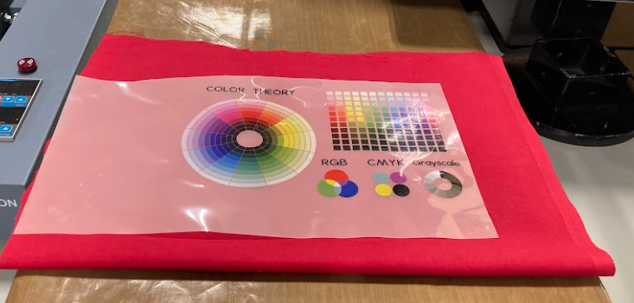
- Cover with parchment paper and cure at 350 degrees for 15 seconds.
- Once cured, swing the arm of the heat press out of the way and remove the parchment paper.
- Peel the film from your fabric in a steady, controlled, quick manner- similar to flipping a page in a book.
- To fully cure your garment, turn it inside out and put it in the dryer on high heat for 20-30 minutes.
- Once finished, pour all excess powder from the tub back into the bag. Secure the bag shut and return the powder and sifter to the tub. Return the lid on the tub.

