SOP
CREAFORM 3D SCANNER HANDYSCAN BLACK
AND VXELEMENTS 11
Training is required before using this equipment.
Reservations are required when using this equipment.

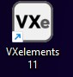

ADDITIONAL COSTS

Creaform positioning targets.
You will need to attach positioning targets to the parts to be scanned. NIS supplies the targets for 0.20¢ each.

External Flash Drive or Hard Drive
Bring your own flash drive or external hard drive to save your files for future use. Each scan can use over 1 GB of memory.

WARNING: DO NOT LOOK DIRECTLY AT THE LASER.

PHOTOSENSITIVE WARNING: STROBING EFFECT.
A very small percentage of people may experience epileptic seizures or blackouts when exposed to certain kinds of flashing lights or light patterns. These persons, or even people who have no history of seizures or epilepsy, may experience epileptic symptoms or seizures while using some functions of this scanner.
If you experience any of the following symptoms -- dizziness, altered vision, eye or muscle twitches, loss of awareness, disorientation, any involuntary movement, or convulsions -- IMMEDIATELY discontinue use and consult your physician.

PREPARING YOUR OBJECT

Open 3D Scanner Storage Case.
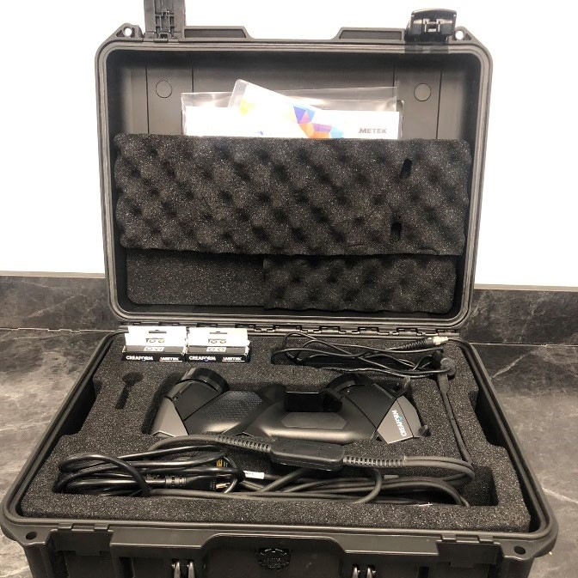

Some materials and surfaces are not able to be scanned directly. You may experience difficulty with the following surfaces:
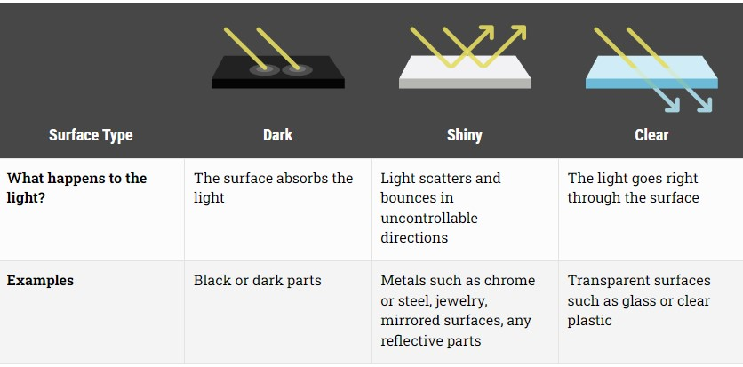

Recommendation: Always try scanning your object normally. If your object does not scan properly it will have large holes in the software. Example:
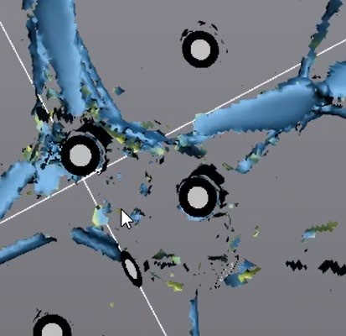


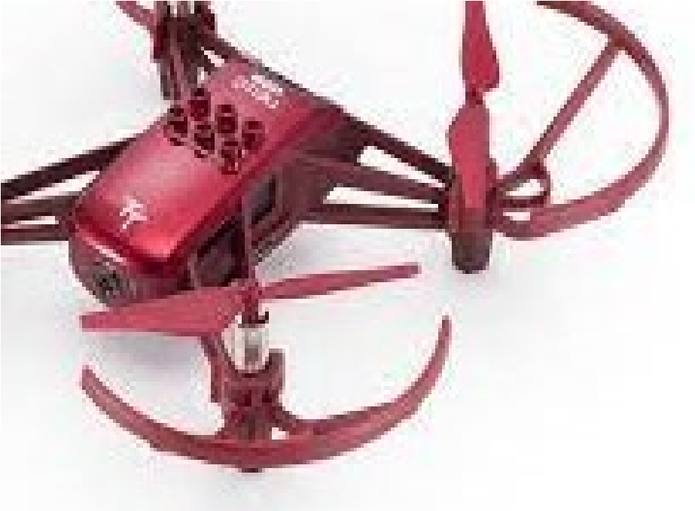
Scan (top of drone did not scan)
Top of drone (shiny red)

If your object does not scan properly you can try:
- Applying a 3D scanning spray (see NIS staff)
- Try scanning at different angles
- Covering your object with masking tape
- Painting your object

Select which targets to use.
- Less sticky (use for most surfaces)
+ More sticky (use for slippery, smooth metals, or curved surfaces)
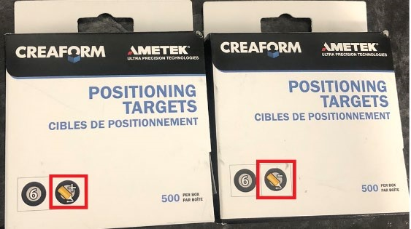

Place targets on your object. The distance between most targets should be about the distance between your pinky and pointer fingers.
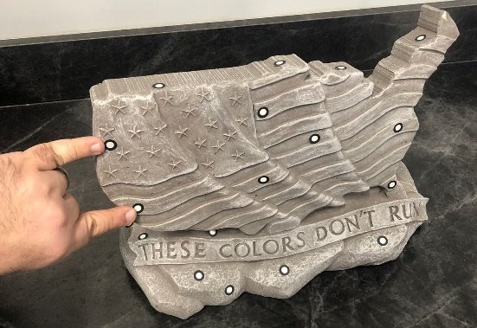
For locations with high curvature, you may need additional targets.
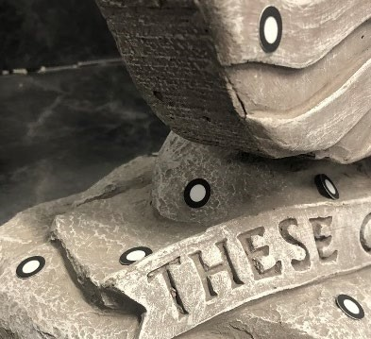
Place your object on the turntable, which should already have targets affixed. The turntable is stored in a separate location. Ask NIS staff if you need help finding it.
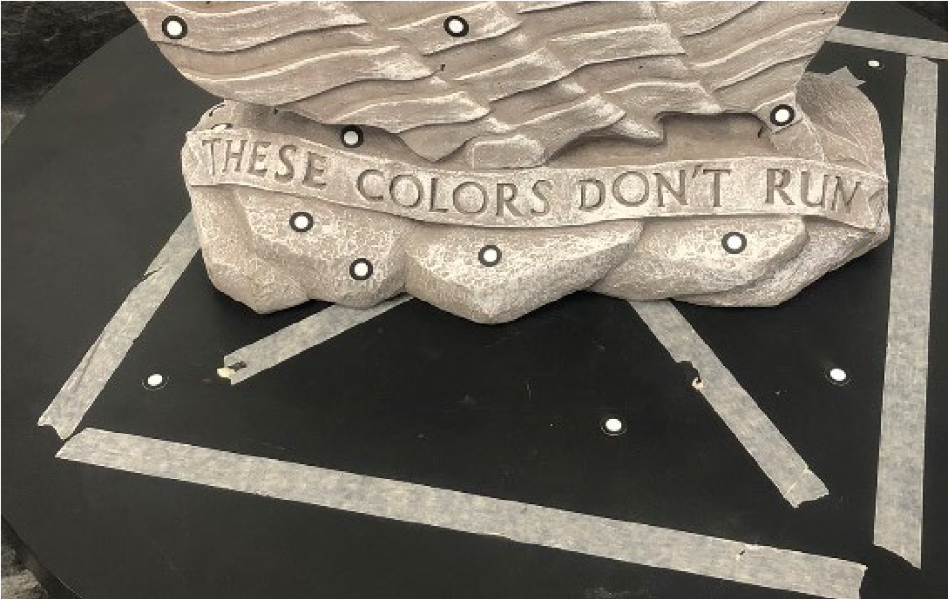

PREPARING THE SCANNER

Remove the scanner and three cords from the storage box.
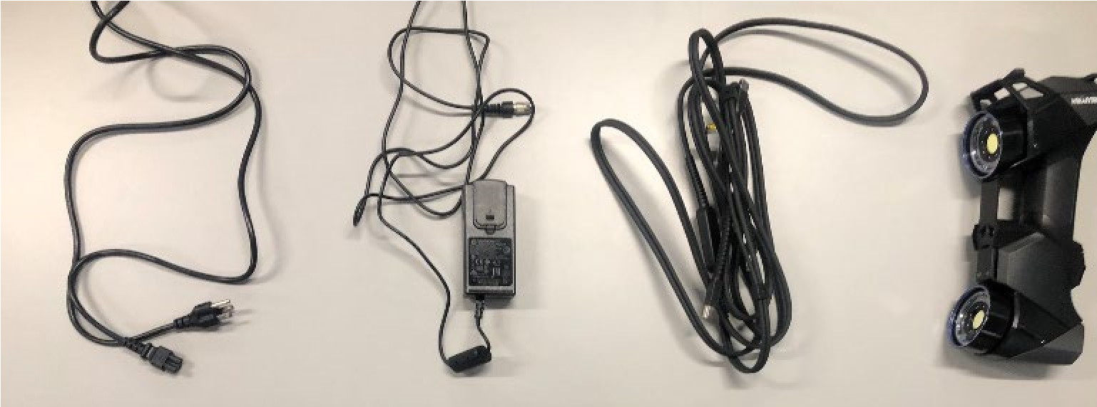

The cables are all unique. Plug each cable into the appropriate receptacles. The end of the double cable with the blue and barrel connectors plugs into the scanner.
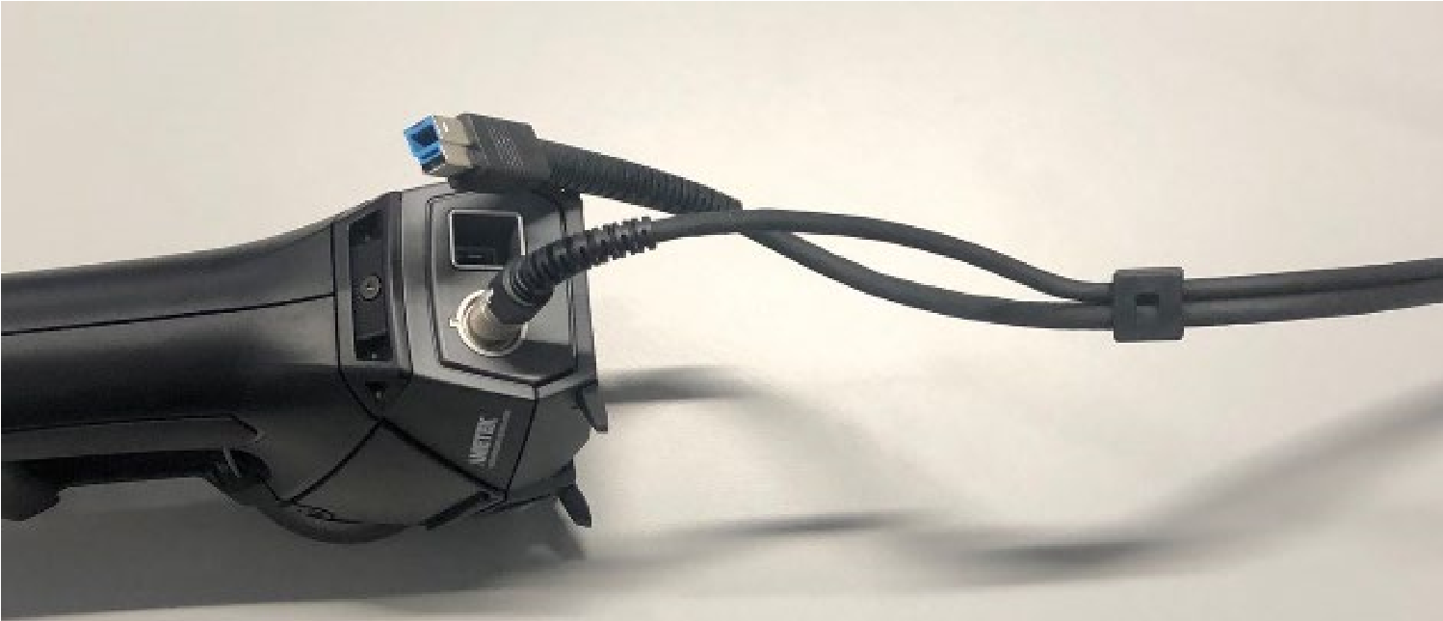

The other end of the double cable plugs into a USB port on a computer and the barrel connector leads to a wall plugin.
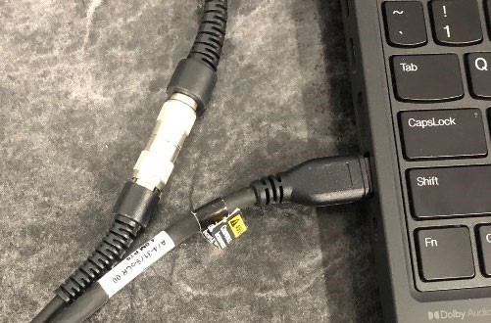

Find the USB storage case inside the large storage case. It may be stored in the top sleeve, on the underside of the lid of the case.
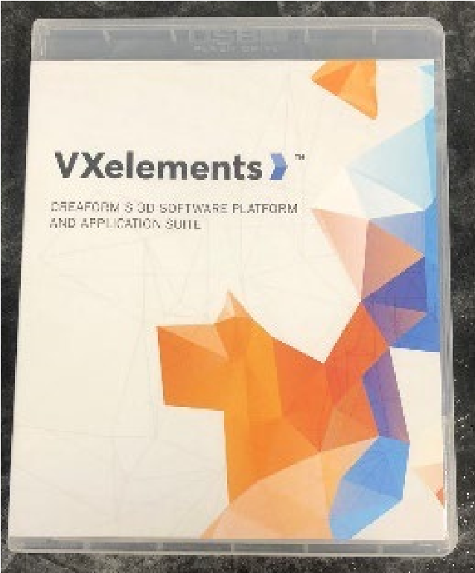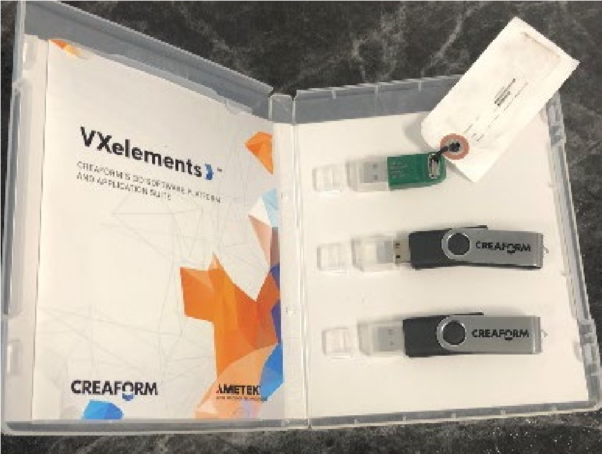
Plug the green USB stick into the computer. Without this USB stick, the software will not work properly.

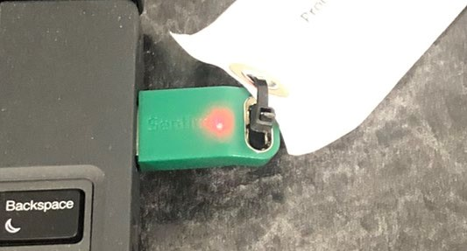

STARTING THE SOFTWARE

Open VXElements Software

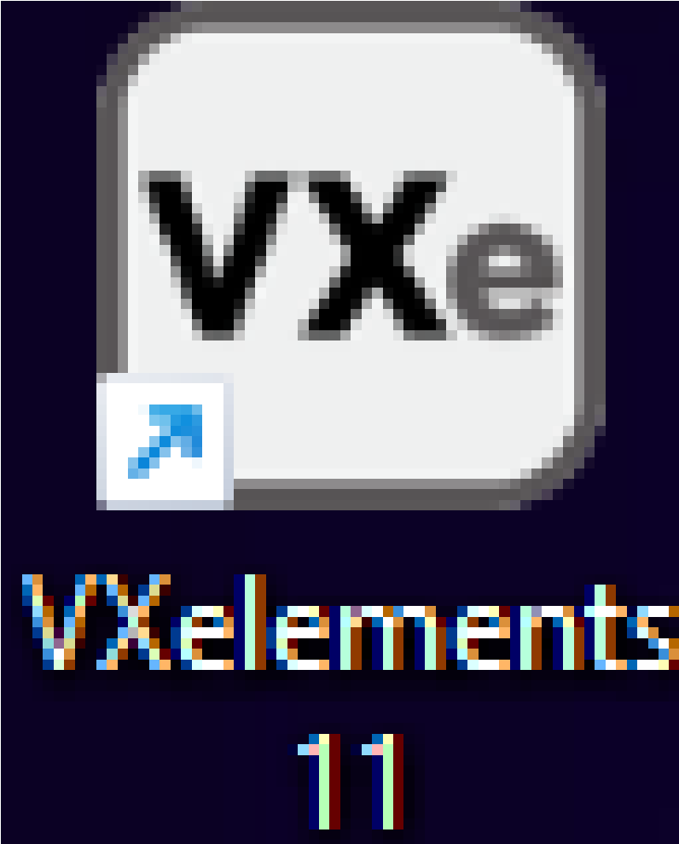

Verify that the Scanner is detected and click the Arrow-in-Circle button to start a new scan.
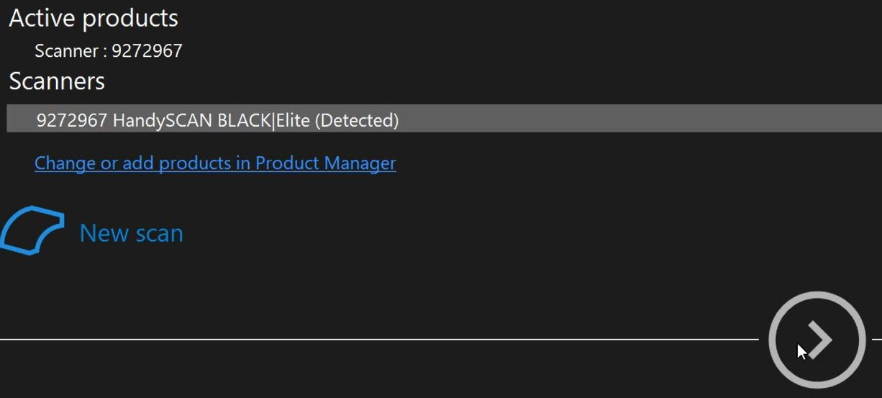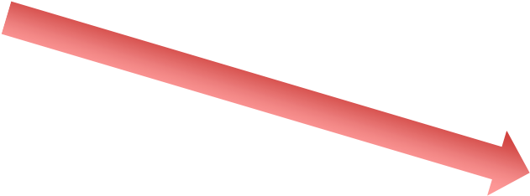

SCANNING YOUR OBJECT

Click the Scan button.


Hold the scanner and use the silver button to control the scan.
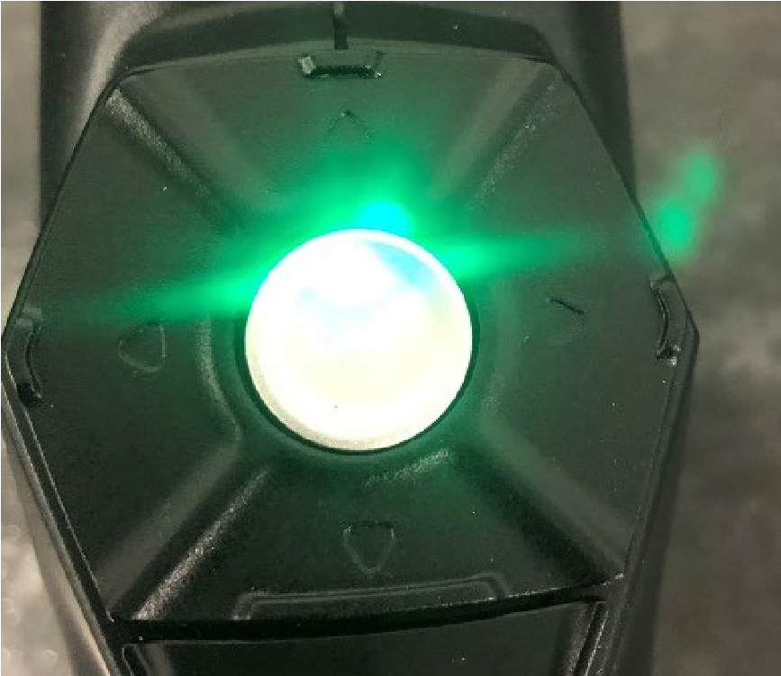
Single Click: Start/Pause/Resume the Scan
Double Click: Change scanning Mode

Move the scanner and turn the turntable to scan all parts of the object. The object should appear on the computer in real-time while you scan. Here are some guidelines to help your scan be successful:
- Color Indicator. The scanner has a large LED that will change color to indicate your position:
  - Yellow/Red – The scanner is too close to the object o Green – Perfect distance to object o Teal/Blue – The Scanner is too far from the object
  - Off – Out of range (too close or too far) or not enough targets

- Targets. The scanner must see at least three target circles at all times. If parts of your object are difficult to scan, consider adding more targets.
- Orientation. You can orient the scanner in any direction. You do not need to keep the scanner vertical or horizontal the whole time. Feel free to move and angle it however best scans your object.
- Holes. Try to fill in large holes with the scan. Don’t worry about smaller holes, we will fix those in post-processing.
- You can pause/resume scan at any time by single-clicking the silver button.
- You can change scanning modes by double-clicking the silver button.
- Start in Scanning Mode 1: Crosshatch Mode (see below).
- Finish in Scanning Mode 2: Line Mode (see below).

Scanning Mode 1: Crosshatch Mode

Start scanning with this mode. It can pick up most features of your object. You should see crosshatch-like lines on both your physical object and in the software.
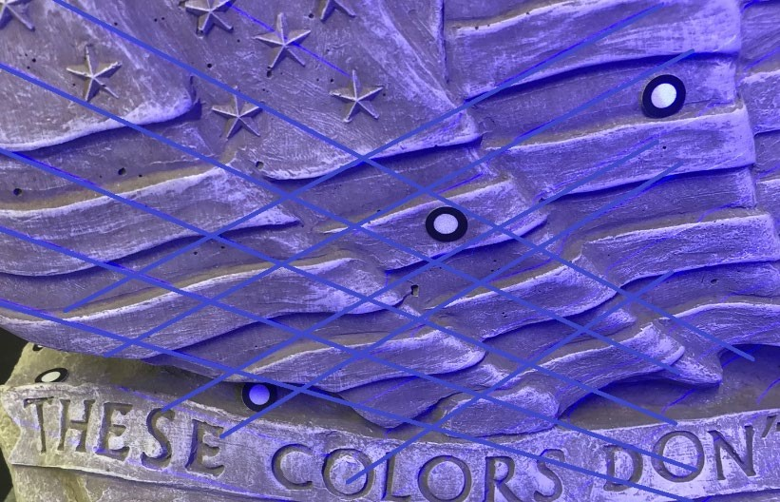

Object (Blue Crosshatch)
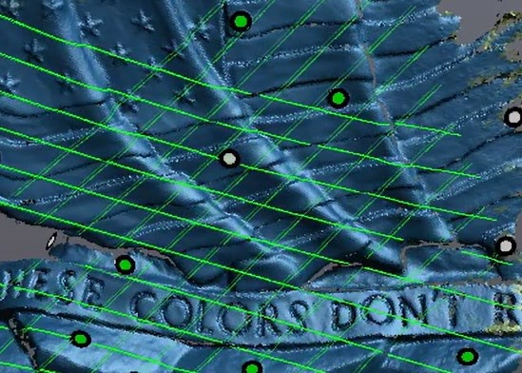
Computer (Green Crosshatch

Scanning Mode 2: Line Mode

Line mode is good for fine details, holes, and features with lots of curvature. Recommend using this mode towards the end of your scan. You should see a single line on both your physical object and in the software.
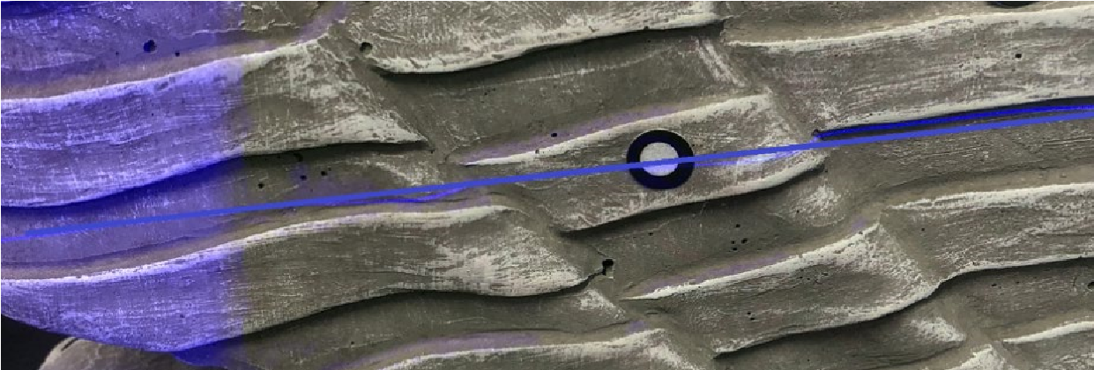

Object (Blue Line)
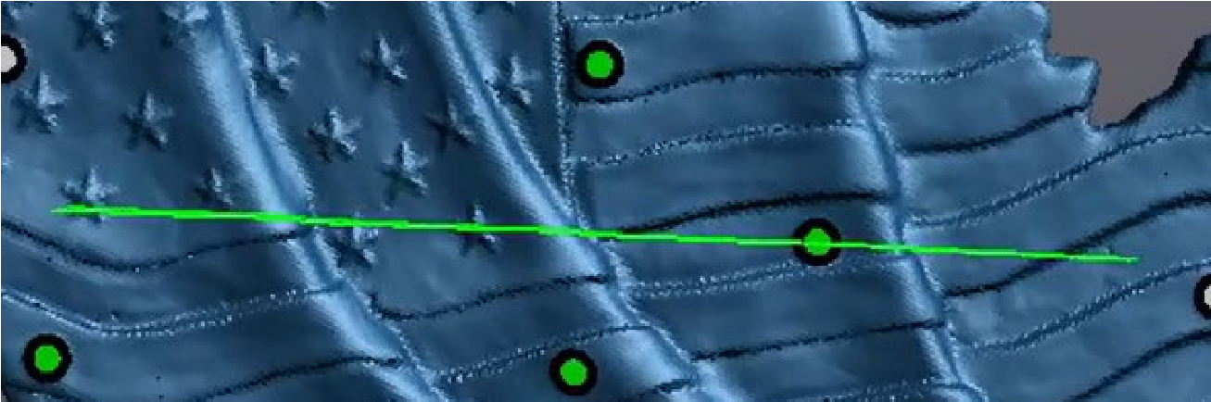

Computer (Green Line)

When you have finished scanning. Click the Scan button again.

If you need additional scans, click the add scan button. You only need to rescan if either (1) your first scan had a major mistake or (2) you need to re-orient the part to scan the bottom side.
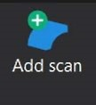

FIXING THE SCAN – REMOVE TABLE
Your scan likely includes parts of the table or wall near your scan. To remove the table select Add Clipping Plane – Per Selected Three Targets.

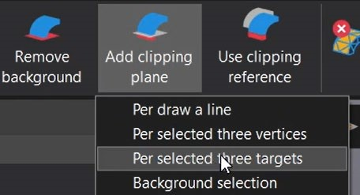

Select Three targets that are located on the table.
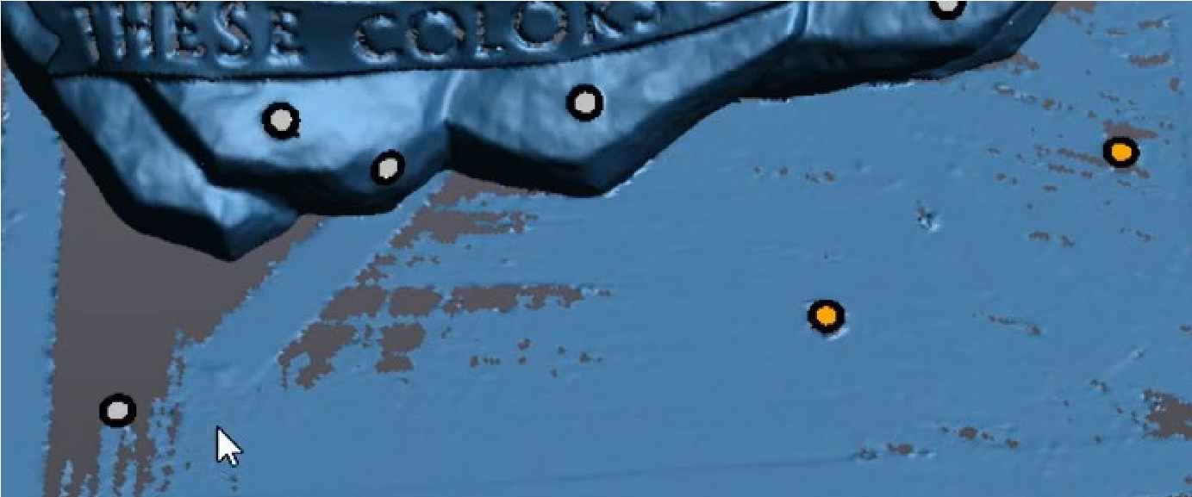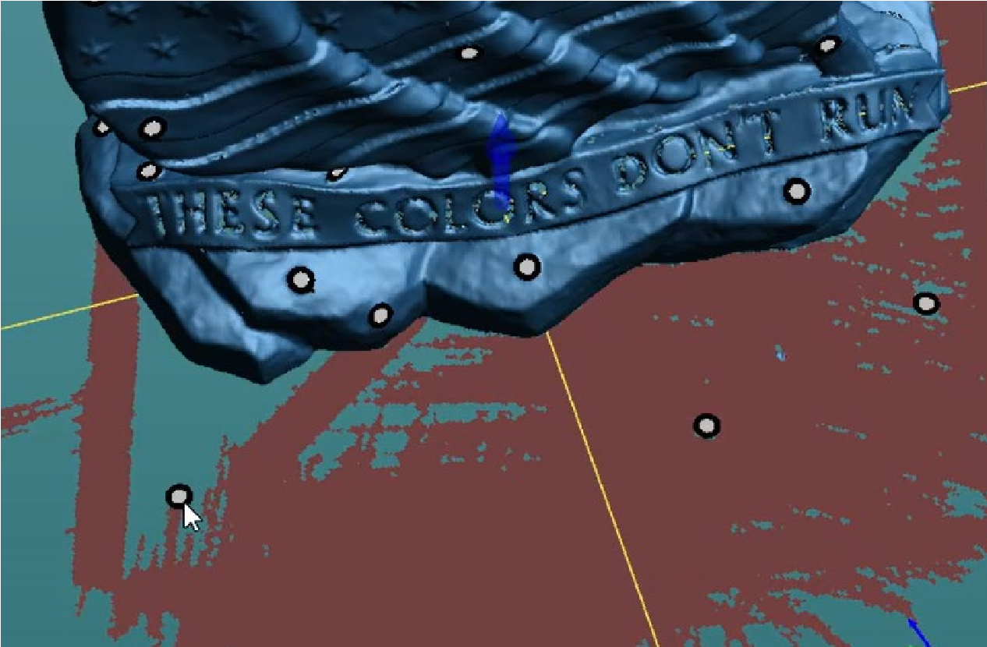

When you select the third target a clipping plane will be created.

The Red will be permanently removed when you select Create.

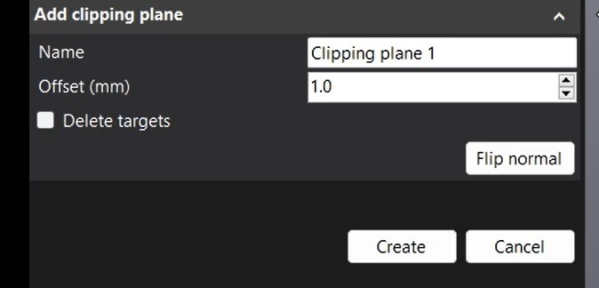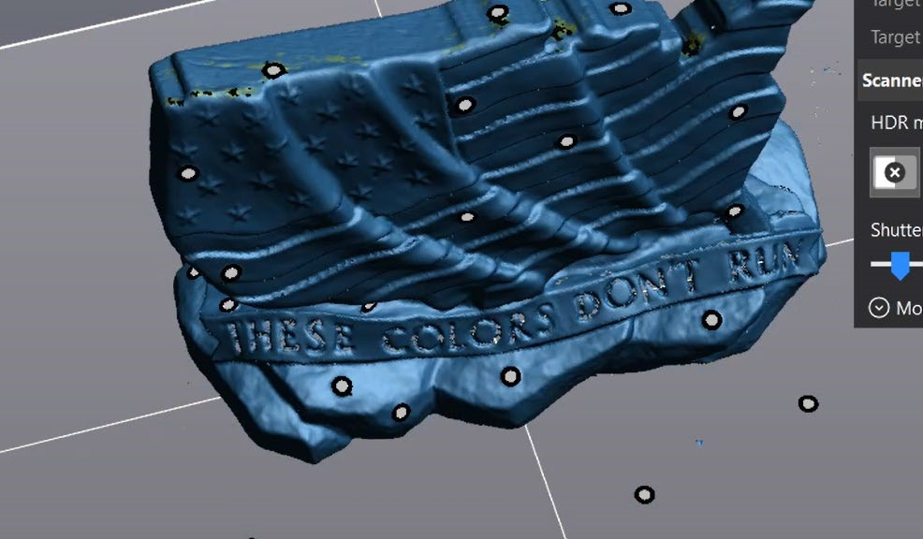

FIXING THE SCAN – REMOVE NOISE

To Select Noise (or anything) on the scan, click the selection tab to show your selection options. Recommendation: Use the Connect tool.

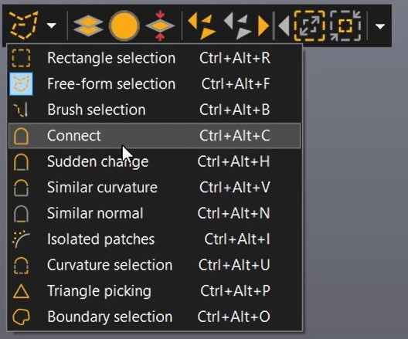

Your mouse should now change to a crosshair pattern
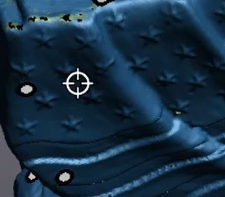

Hold Control and Left-Click your object. Your object should be highlighted yellow. The noise should still be colored blue.
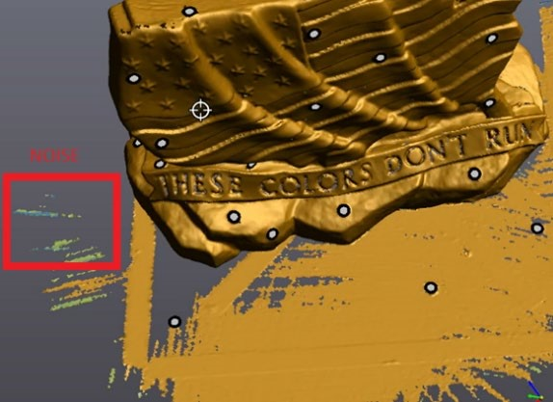

Use the Delete Triangles or Keep Only buttons. To either delete your highlighted selection or keep only your highlighted section. You may get a warning when pushing these buttons because this is a permanent change to your scan.

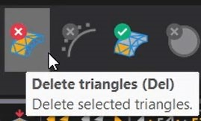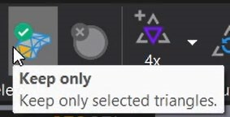

Your scan should now have deleted any non-connected noise.
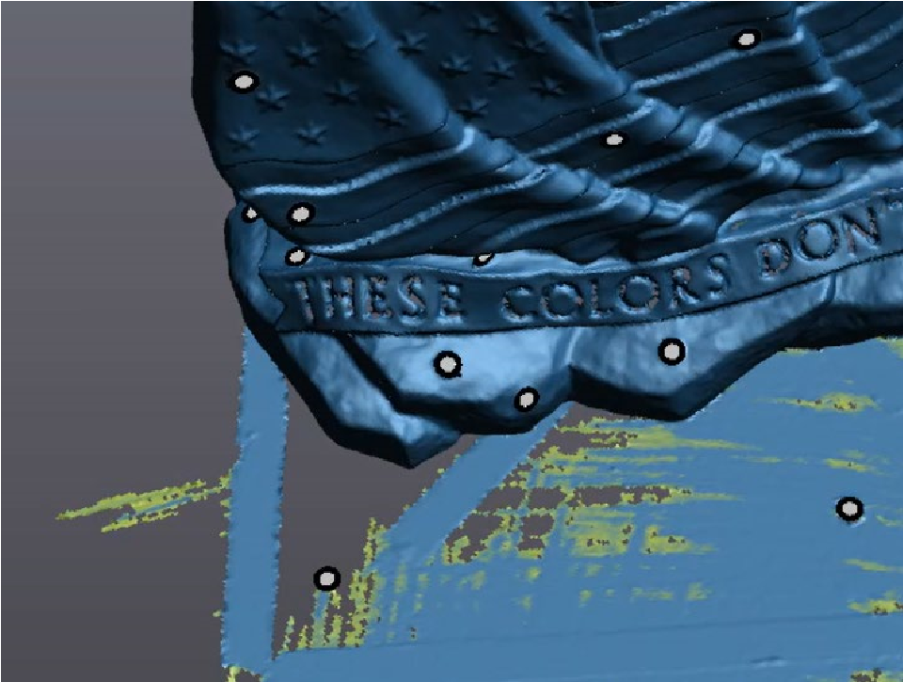

Remove any additional unwanted sections of the scan including noise, walls, or supports using the various selection tools. Once a tool is selected, you must Hold Control and then click/drag to make your selection.

MERGING SCANS

If you need to complete multiple scans for the same part, you may need to merge them. You should only need to do this step if either:
- You are scanning a very large object
- You need detailed scans of all sides of the object.
o i.e. you also need a detailed scan of the ‘bottom’ of the object.

If you only need one scan for your object, skip to the section “Fixing the Scan-Holes”

When you have multiple scans, use the eyeball indicator to turn visibility on/off. Here Scan 1 and Scan 3 are visible, while Scan 2 is not visible.
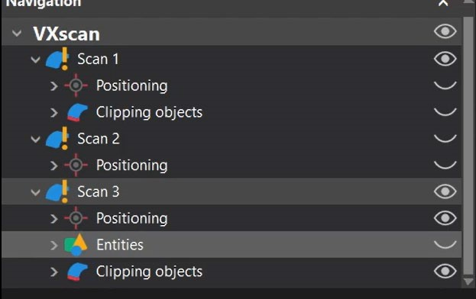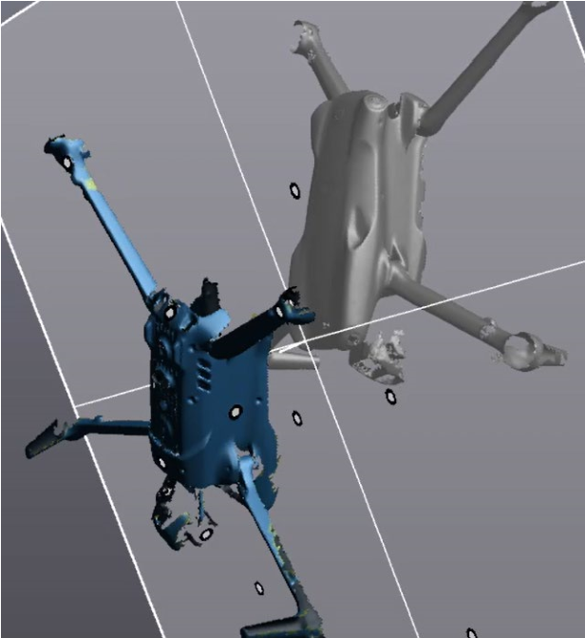

First, remove the table and noise from both scans (see previous steps). Next, we must align them together. There are multiple options to align the parts, the two most useful are Target Best Fit and Surface Best Fit.

Alignment Option 1: Target Best fit

This fit will align your scans based on the circular targets on your object. You must have some targets that are included in both scans.
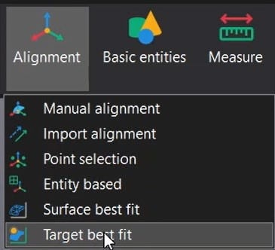

Make sure the two scans you want to merged are selected.
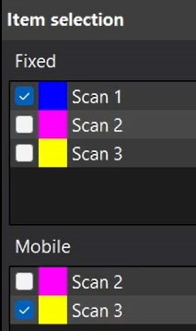
Select Manual Mode.
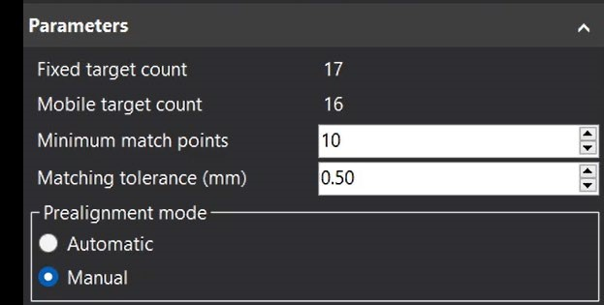
Move and rotate the scans. Click a target on one of your scans.
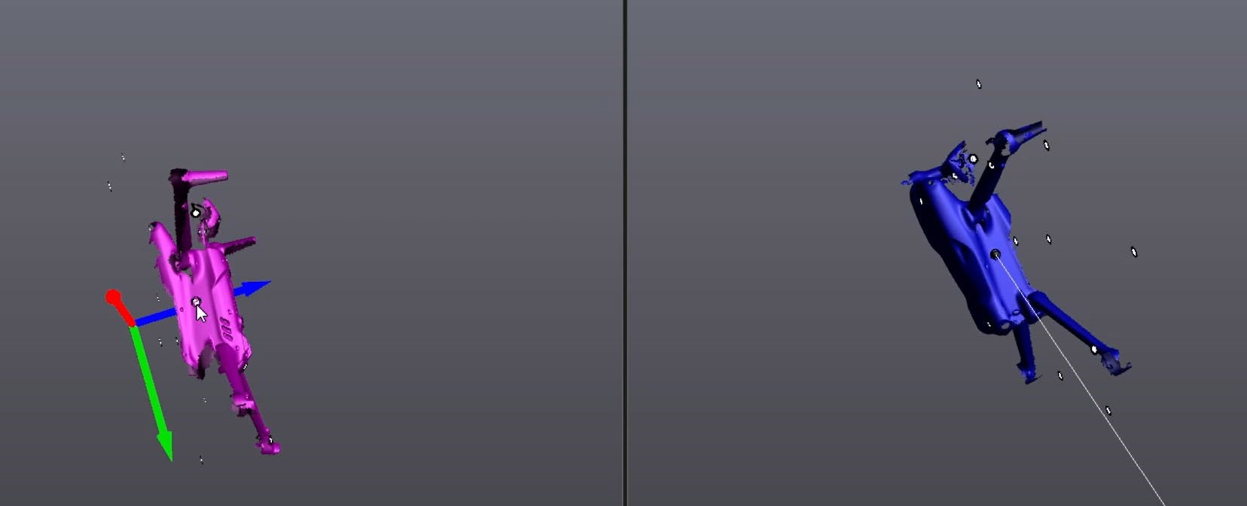

Once you click the corresponding target on the other scan, a transparent overlay will appear. It will not be aligned yet.
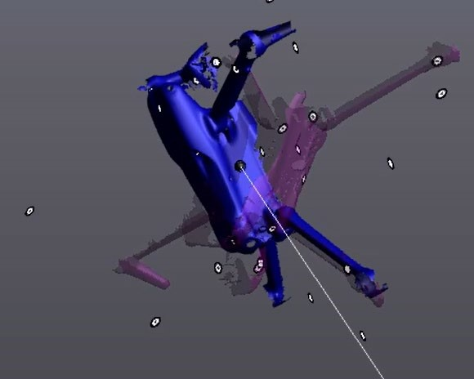

Continue selecting pair-wise corresponding targets on both scans. The transparent overlay should begin to match the fixed scan.
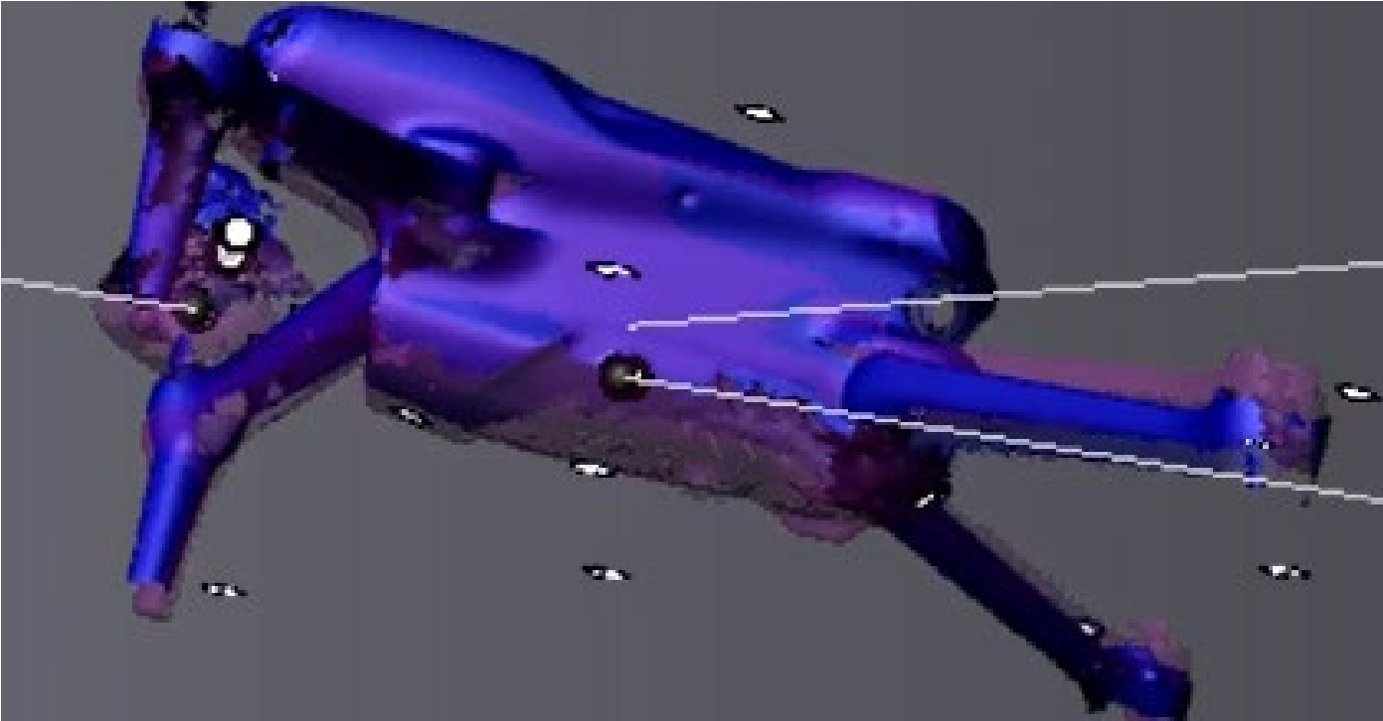

Click Preview.
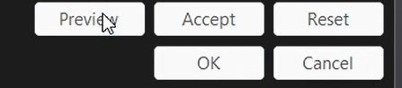

If you get this error:
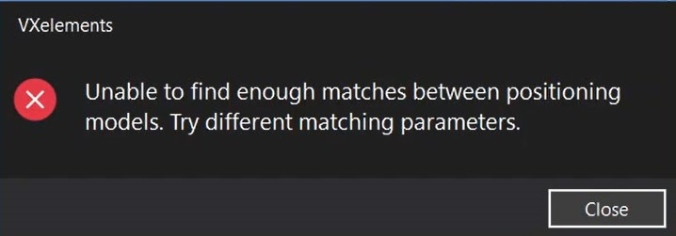

It means your scans did not align within tolerance. Decrease minimum match points.
Increase Matching tolerance (mm).
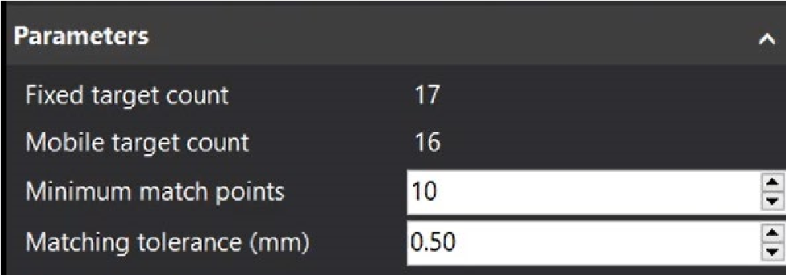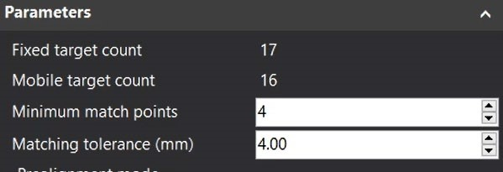
Default Settings Changed Settings
Once the preview works, both scans should now be aligned.
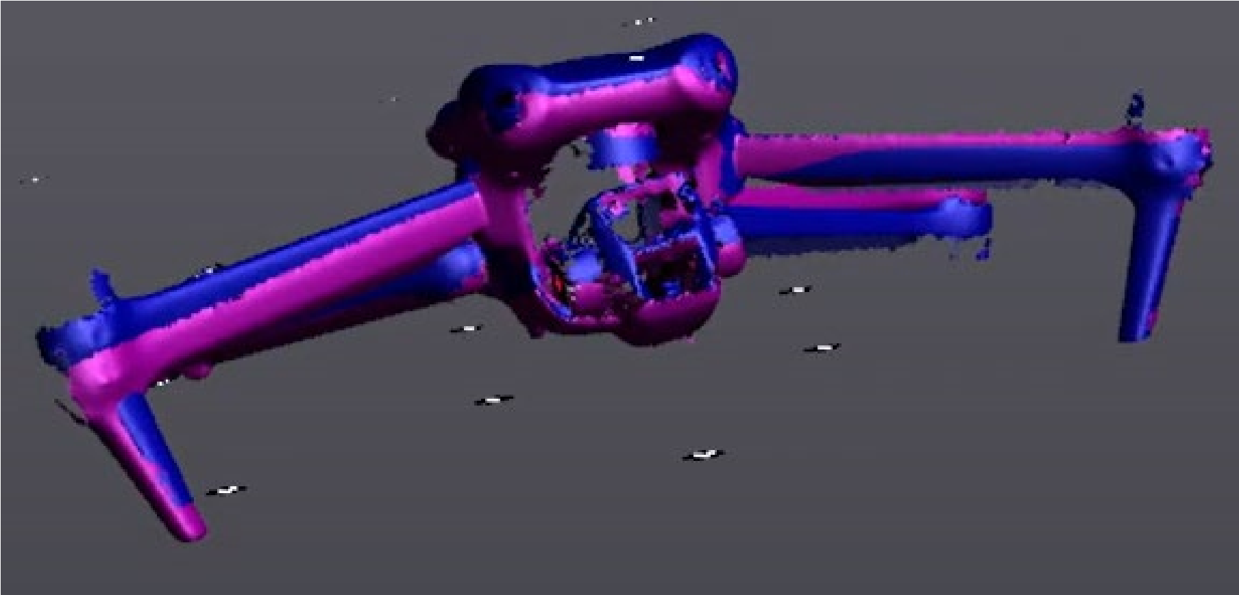

Select OK.
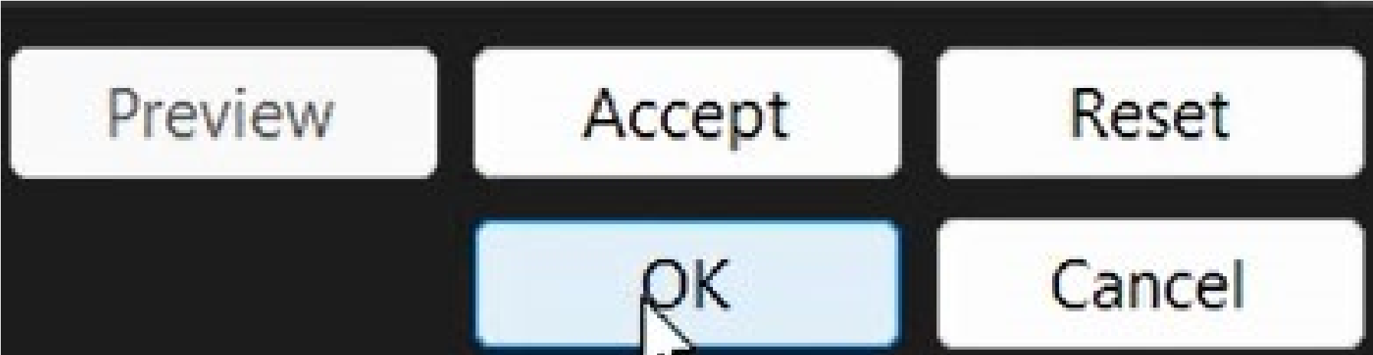

Alignment Option 2: Surface best fit

Select Alignment -> Surface best fit.
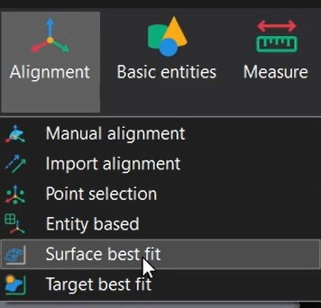

Make sure the two scans you want to merged are selected.
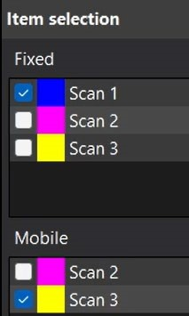

Select Manual Mode.
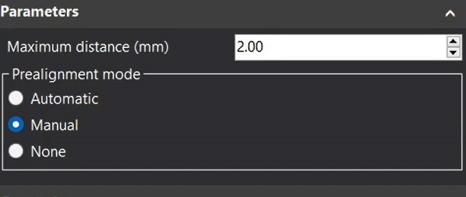

Your parts should now be in two side-by-side screens. Select a location on the first scan (yellow part) and the same location on the second scan (blue part). They should get a numeric callout and a transparent overlay should appear.
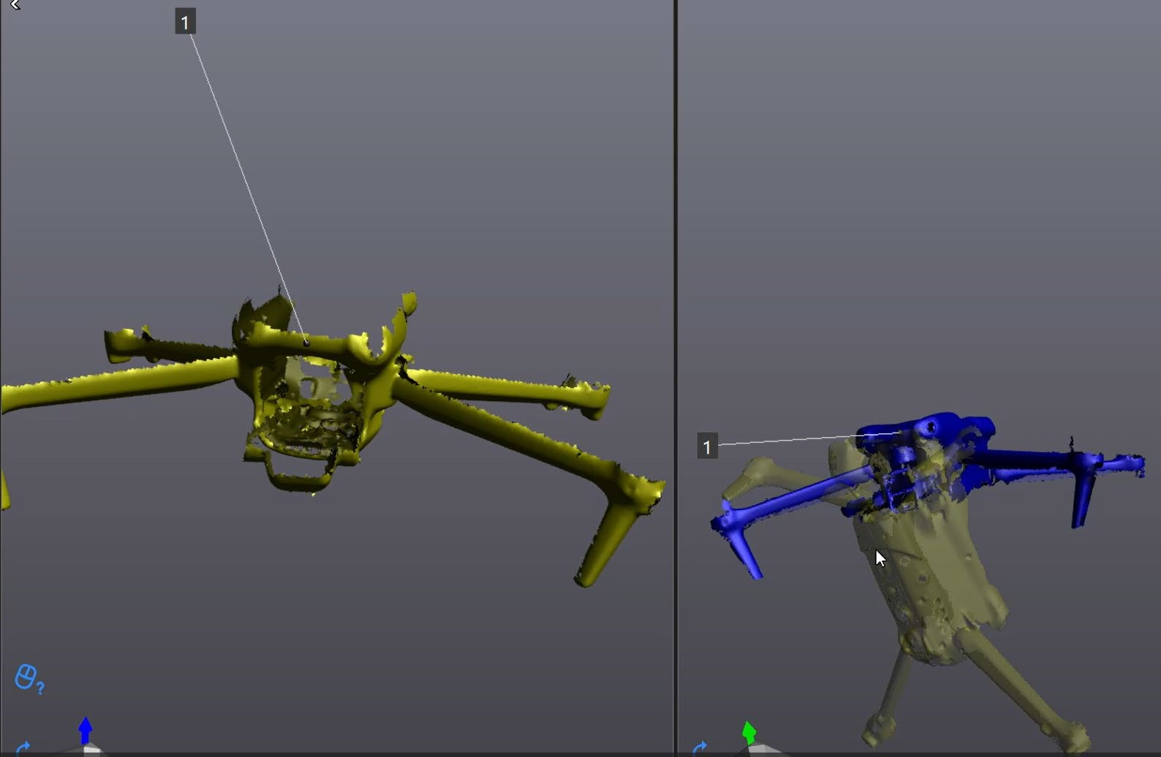

Continue selecting pairs of points, one on each scan. Try to select as close to the same location as possible. As you add more points the transparent overlay should start to conform and align with the fixed (blue) scan.
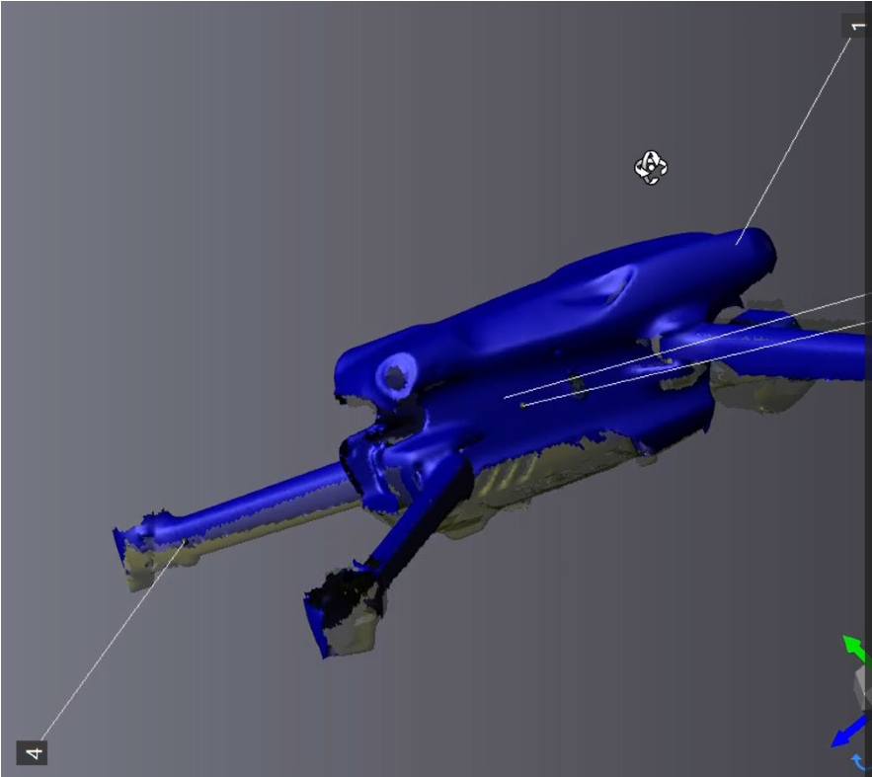

When the transparent overlay is aligned with the fixed (blue) scan. Select Best Fit.
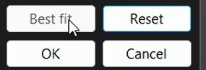

The object should have both scans in solid coloring.
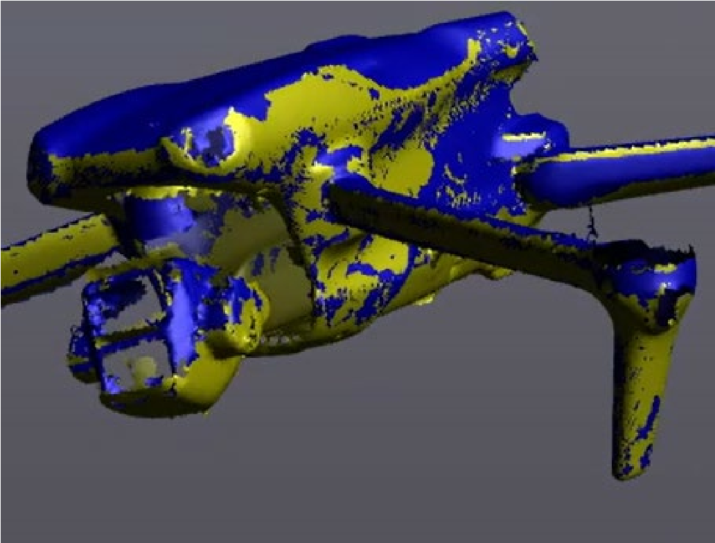

Click Ok.
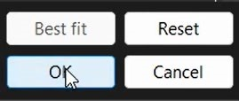

Merge Scans

Once you have aligned the scans select Merge Scans.
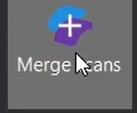

Make sure ‘Keep Original Scans’ is checked. Otherwise, your original scans will be permanently deleted.
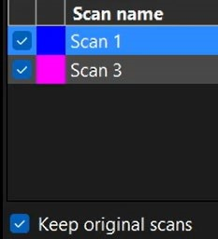
Click Accept.
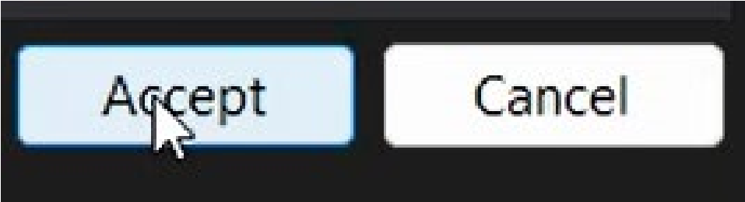

You should now have MergedScan in your navigation. Turn all other scans invisible by selecting the eyeball icons.
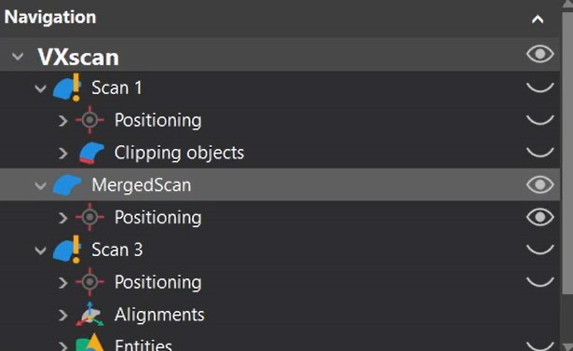

You should see the merged scan in the window.
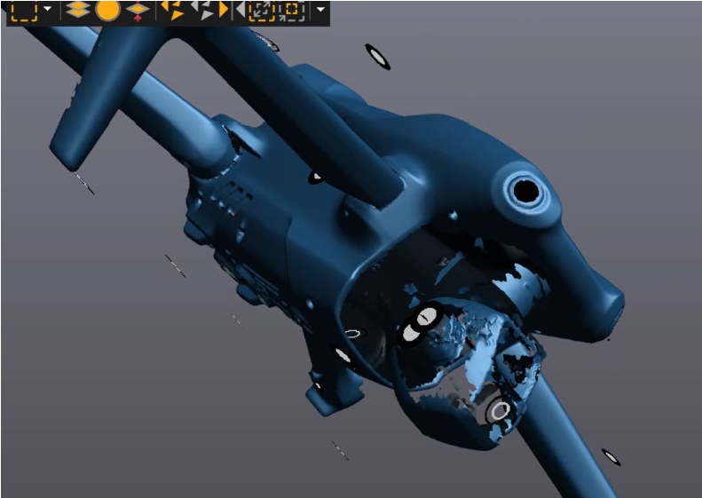

This merged scan is now ready for post-processing. Continue to the next section.

FIXING THE SCAN – HOLES

To fill holes, we must first Send Scan to VXmodel.
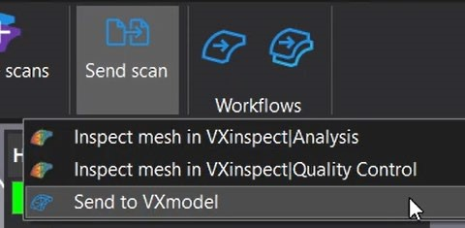
If you get this error:
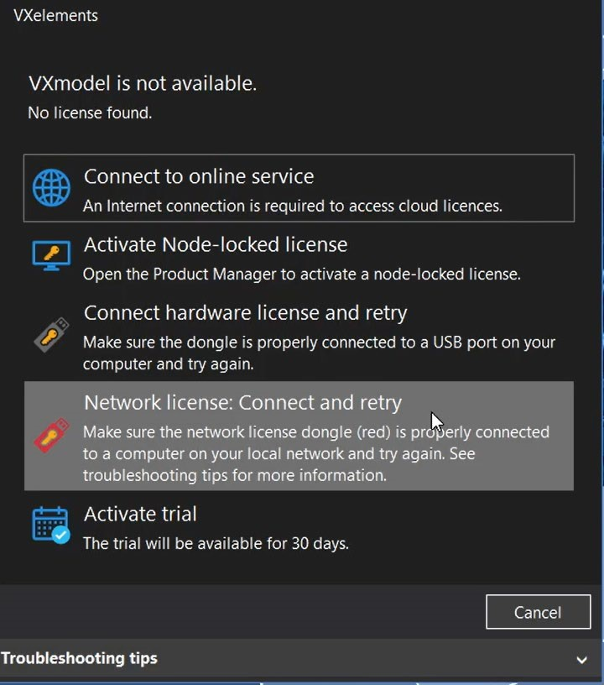

You must insert the green USB dongle into the computer (See earlier instructions). Once inserted select Connect Hardware License and Retry.

Once VXmodel has loaded correctly, select the holes tool.
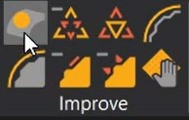

Your model should highlight holes in pink. You only need to worry about large holes.
You can ignore all the small holes, they will be fixed with an automatic process later.
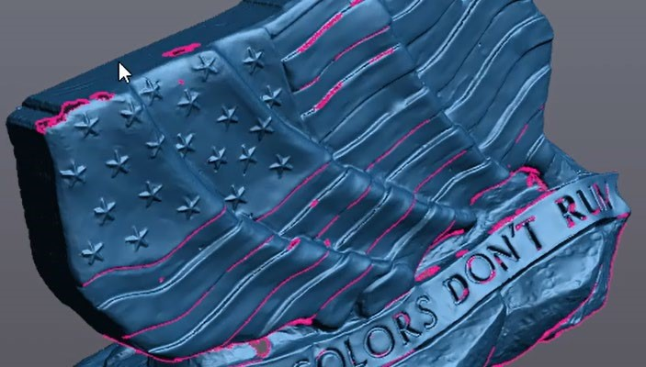

Select how you want to fill the hole: flat plane, low curvature, or high curvature.
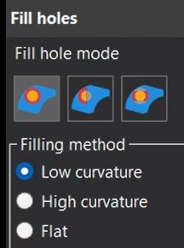

Hover over the hole you want to fill. It will highlight yellow.


Click the yellow highlight to fill the hole.
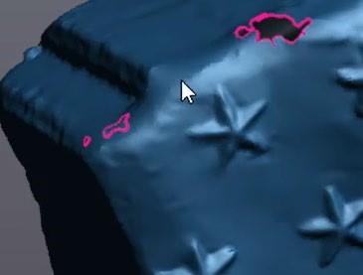

Repeat for large holes. There should be at least one large hole on the bottom of your part, where we removed the table. You can ignore all small holes for now.
For some large, irregularly shaped holes the standard hole tool will not suffice. Large holes that need curvature will struggle with the default hole tool. To fill these types of holes, use the Hole Tool – Bridge (3rd option).

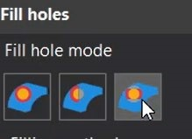

To create a bridge we must identify two bases on each side of the hole. Each base will require three clicks. The first two identify the width of the bridge’s base. The third click should select the section of the hole between the previous two clicks.
 | 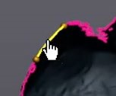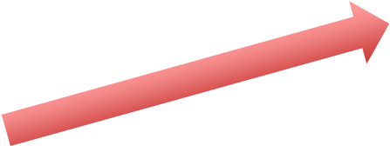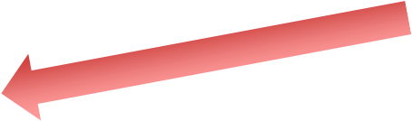  Second Click  Third Click
  First Click

First Click – Will create a small dot on your part
Second Click – Will create a second small dot on your part
Third Click – Should highlight yellow a small bridge base between the two dots

Create another bridge base on the opposite side of the hole. This will require three additional clicks just as above.
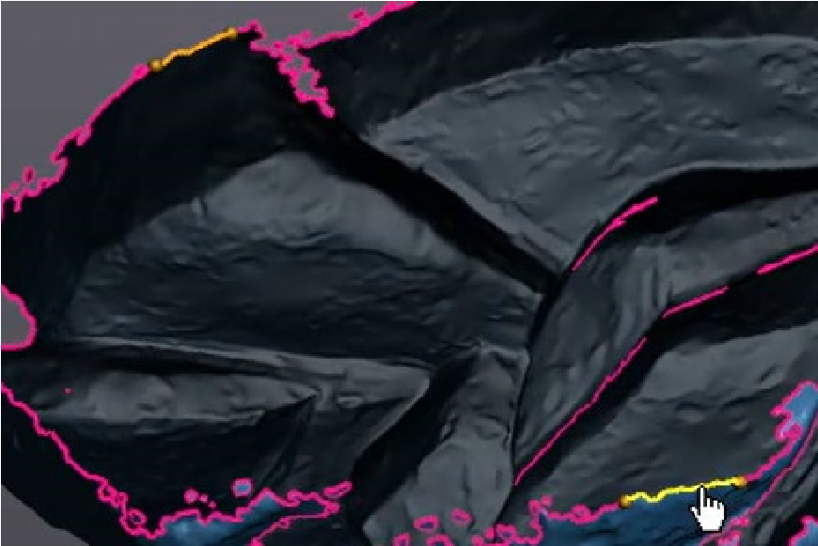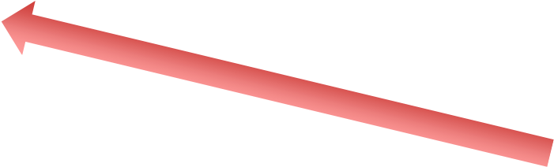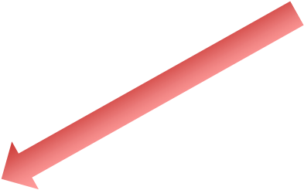

Two bases for
the bridge

The software will then connect these with either a flat or low curvature bridge (depending upon your setting).
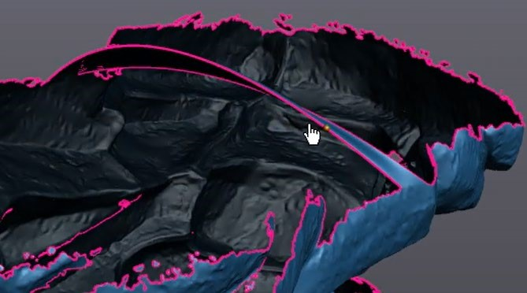

Note that the low curvature tool is very finicky. It will likely produce very awkward curves as it builds the bridge. You can always cancel or undo (Ctrl-Z) a bridge. If you need curvature, retry this process until you get a curve that you like. The goal is to make bridges across your large, irregular hole, thus dividing the large hole into several smaller holes. The new, smaller holes should be more easily filled with the standard hole tool.
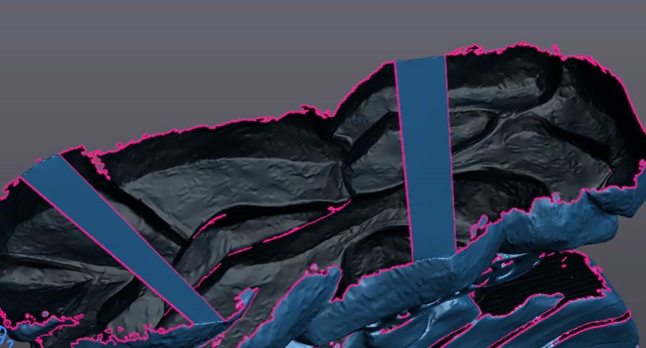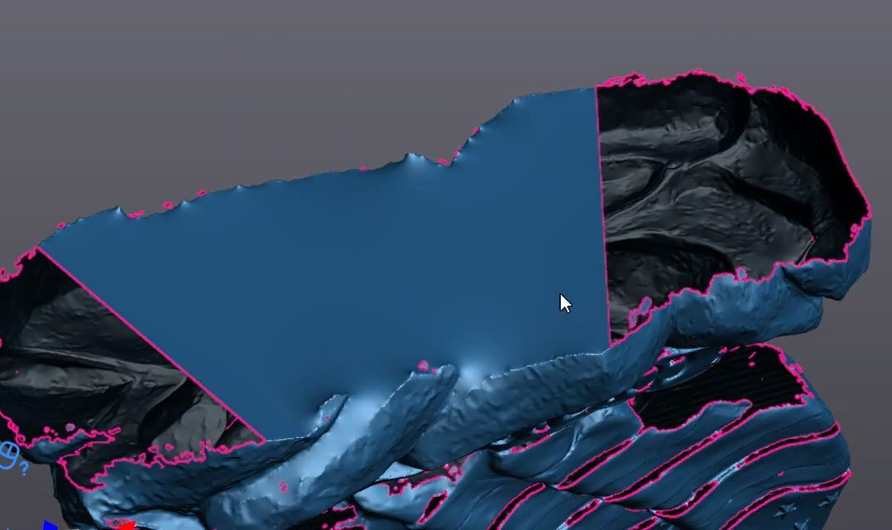

Two flat bridges Filling the smaller hole between bridges

FINISHING – REMOVE SPIKES

Now that the big holes are filled, we can apply a variety of finishing techniques to our model. Your model may have spikes. They usually occur near boundaries or where you filled large holes.
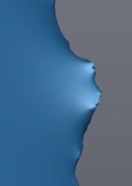

To remove the spikes, select the Remove Spike tool.
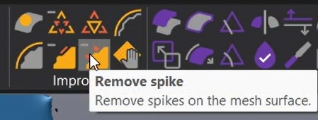

Spikes will be highlighted in red. Use the Spike Level slider to determine what size of spikes you want to remove.
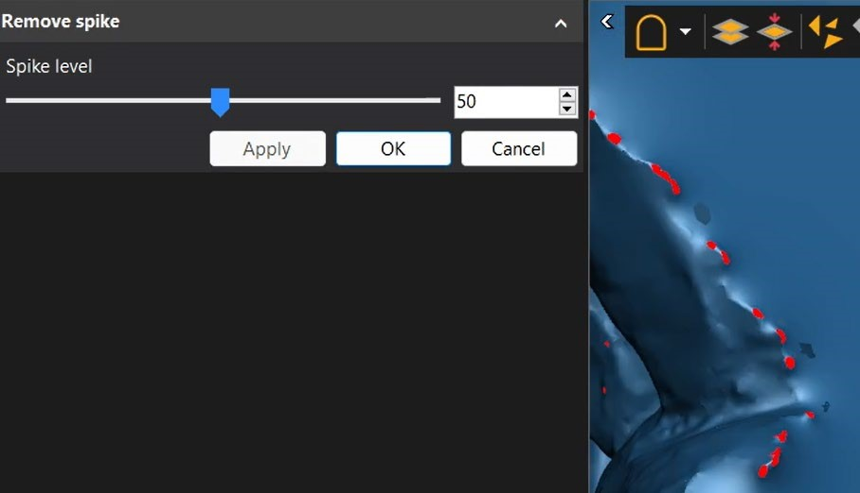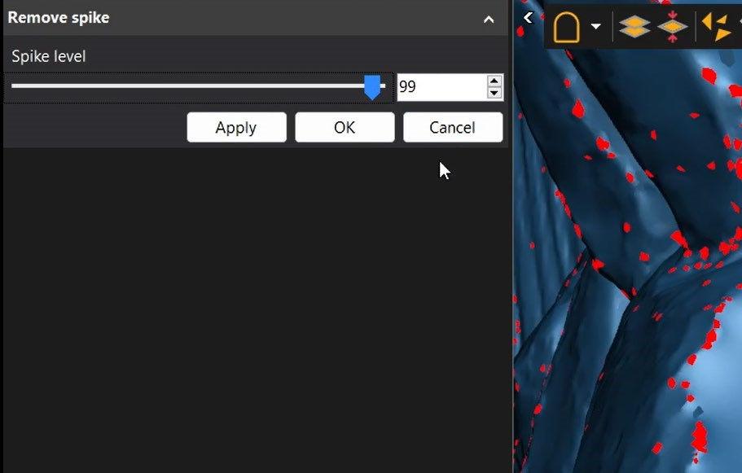

Pres OK to remove the spikes.

FINISHING – SANDING

Your model may be rougher than you desire. You can use the Sandpaper tool to sand down your model.
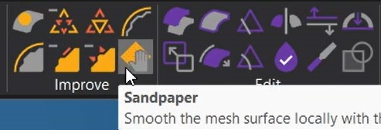

You can adjust the strength and size of your sander.
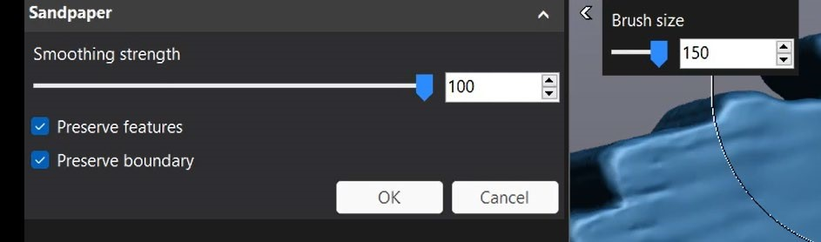

Hold Control and click & move your mouse to sand.
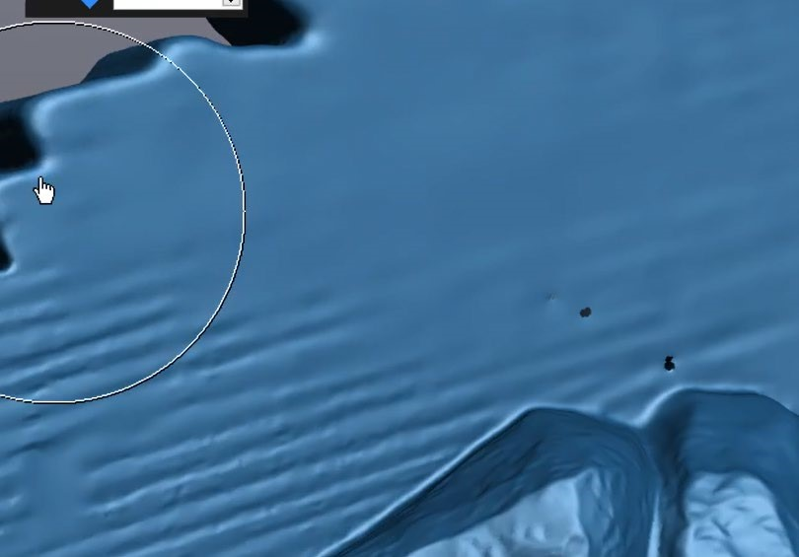

Note 1: Small holes will not sand away. You may need to fill these small holes manually before you can sand near them.

Note 2: Sanding can remove details from your model. You can always Cancel or Undo (Ctrl-Z) a sanding operation.
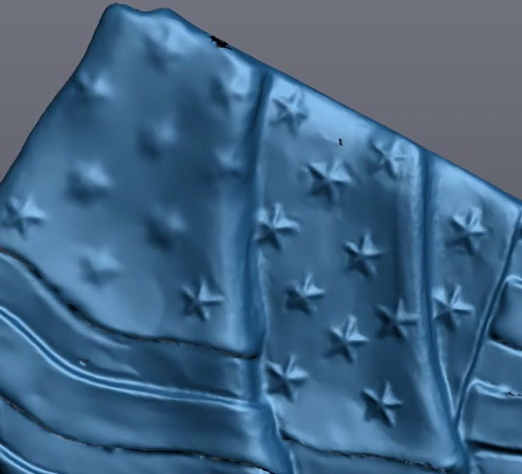

FINISHING – WATERTIGHT & 3D PRINTING

For most projects, the goal of 3D scanning is to either import the model into a CAD software (such as solidworks) or to 3D print the scan. Both require the model to be watertight (no holes).

Use the Watertight Remesh tool.
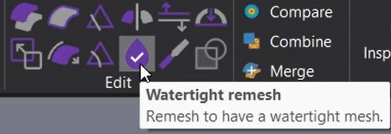

This will create a new, watertight copy of your model. Click the eyeballs to turn visibility on/off. Your original scan should be turned off (eye closed) and the watertight Remesh should be turned on (eye open).
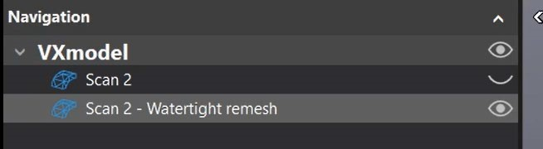

The watertight Remesh can be transferred directly to SOLIDWORKS. The computer must have a working version of SOLIDWORKS already installed.
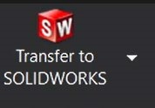

To create an STL (the file needed for 3D printing) go to File -> Export -> Mesh
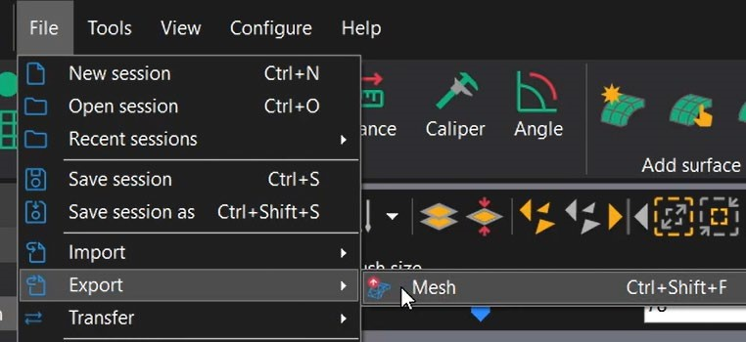

Name your file and check that it is saved as a Binary STL.

CLEANING UP

When you are finished with the 3D scanner, follow these clean-up procedures:

Unplug all cords
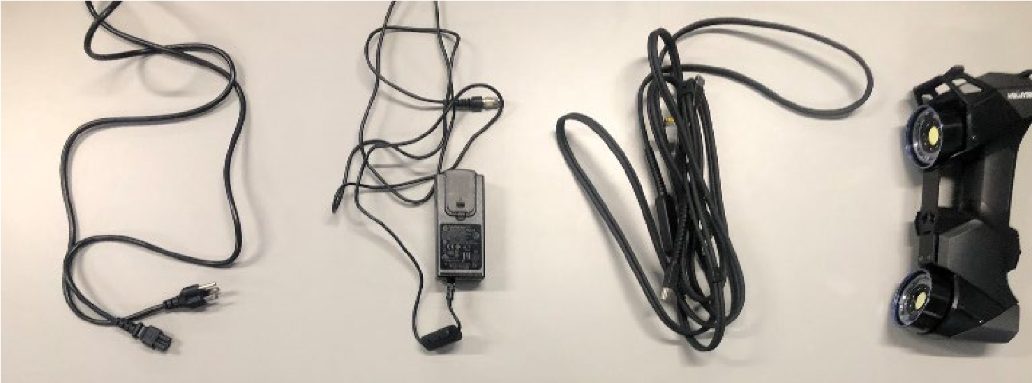

Return the Green USB stick to its storage case
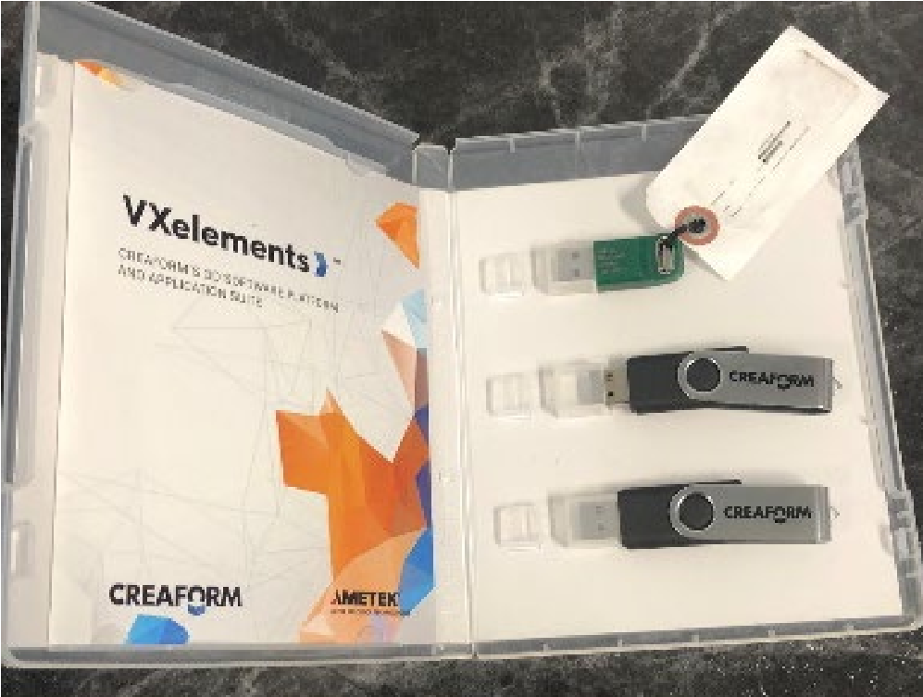

Return all parts (excluding the turn table) back into the storage case
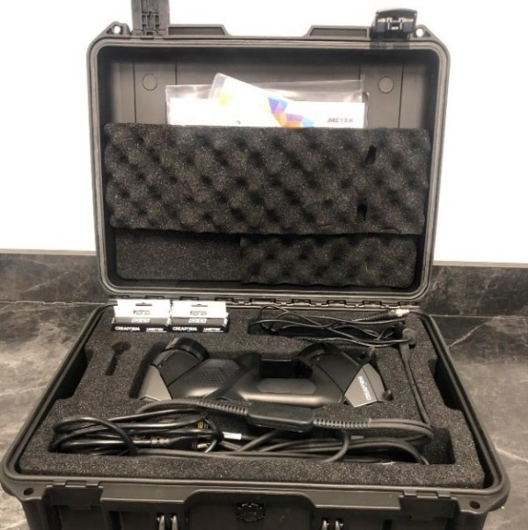
Return storage case to designated location (See NIS staff)
SOP
CREAFORM 3D SCANNER HANDYSCAN BLACK
AND VXELEMENTS 11
Training is required before using this equipment.
Reservations are required when using this equipment.

