SOP
Bambu Labs 3D Printer
OPERATION MANUAL
Training is required before using this equipment Reservations are required to use this equipment
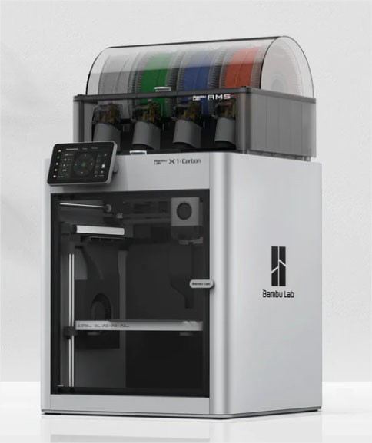

AVAILABLE MATERIALS
- PLA
- PETG
- ABS
- TPU
ONLY INNOVATION STUDIO MATERIAL MAY BE PRINTED ON THE BAMBU LABS PRINTERS
When your print is complete you must bring your print, with support, to the front desk and pay before you leave the studio

MAXIMUM PRINT AREA:
- 256mm x 256mm x 256mm (10in x 10in x 10in)

Launching Bambu Studio Software
Locate software on desktop or through search window

If prompted, complete the following steps:
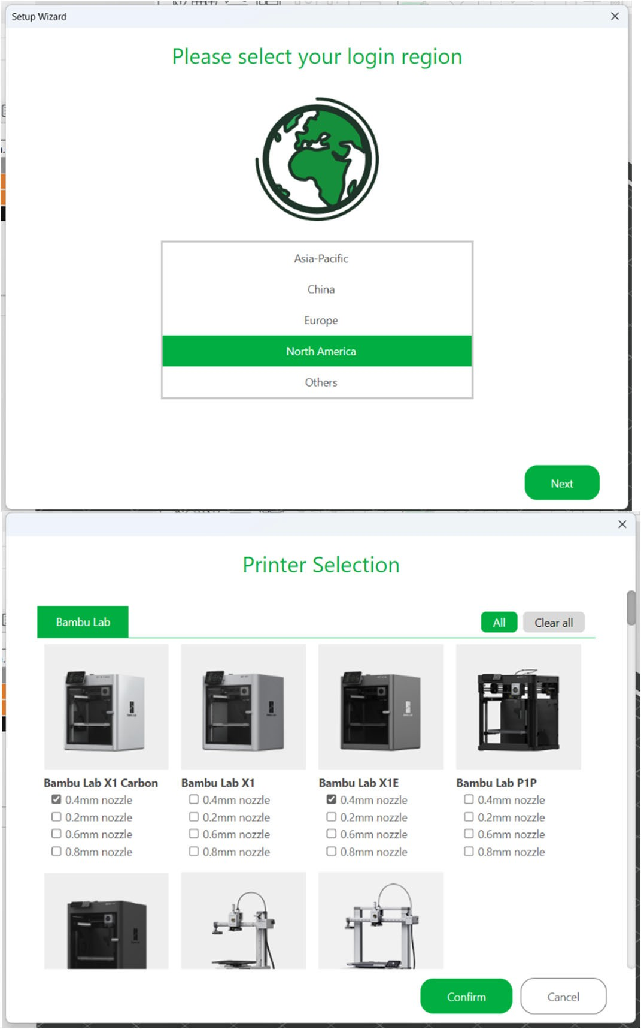
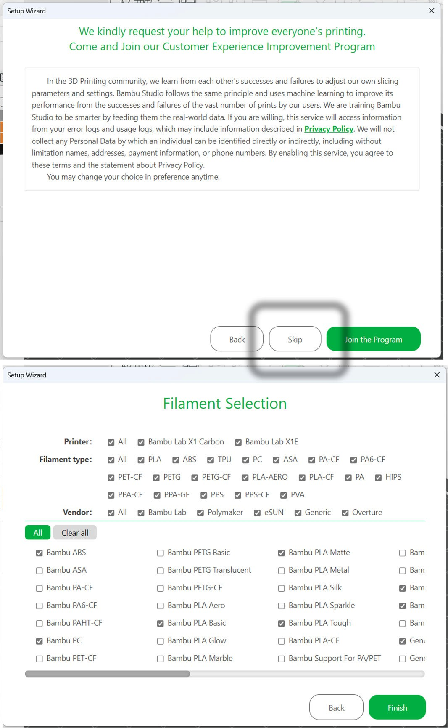
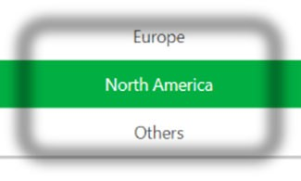
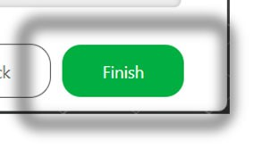
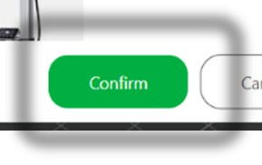
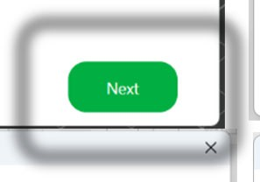

- Login
  - Username: innovationstudio@unl.edu
  - Password: 2021Transformation
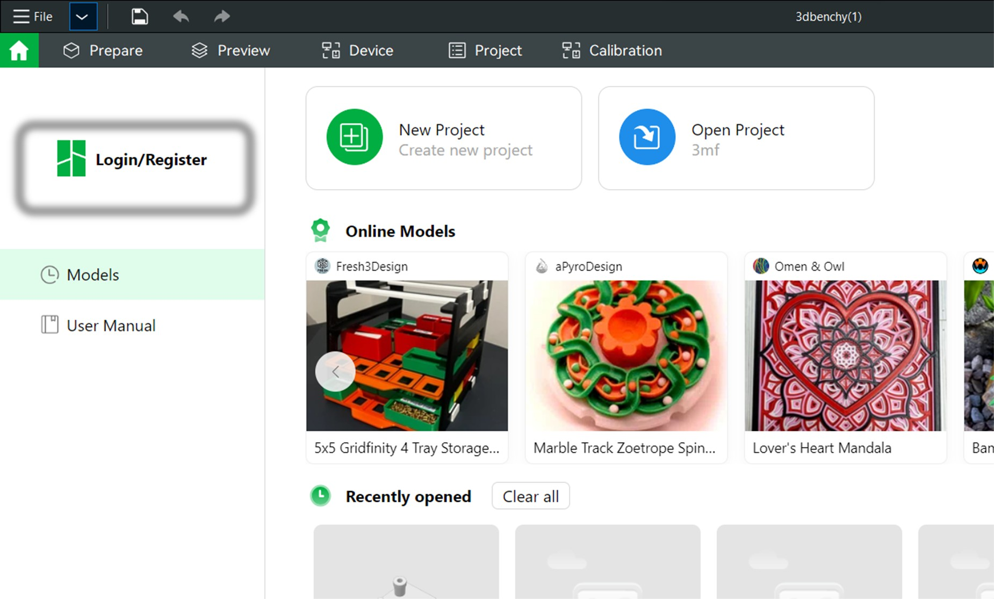
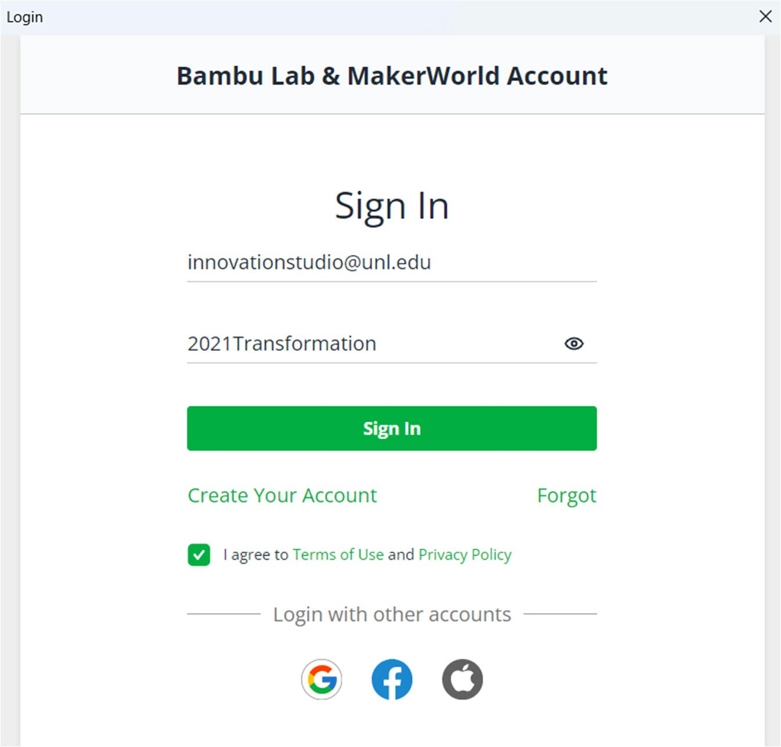

- Select yes for synchronization
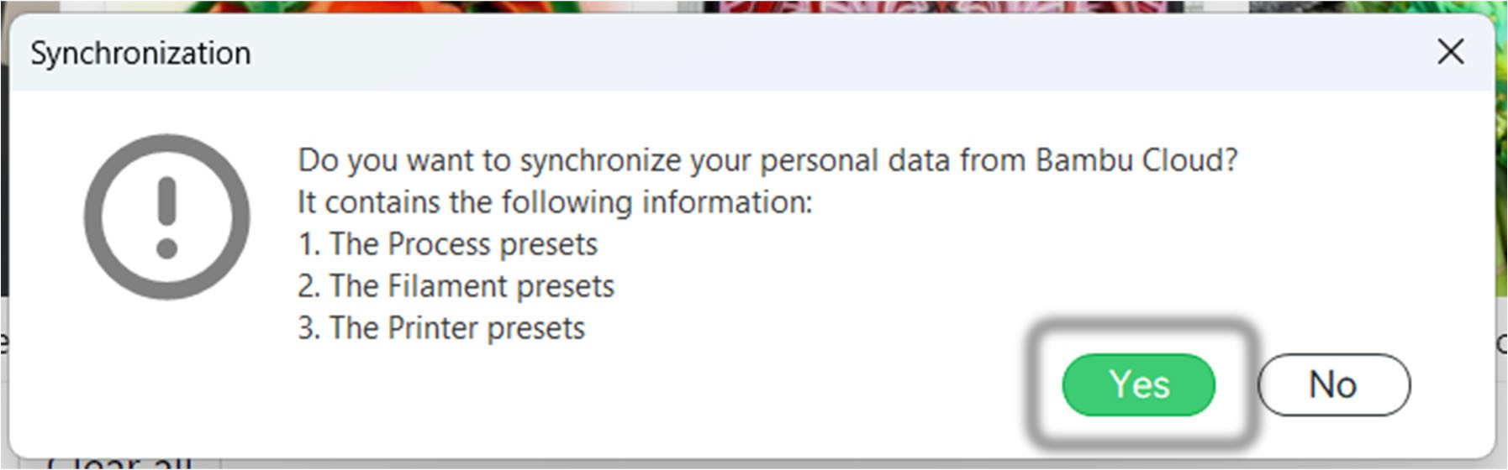

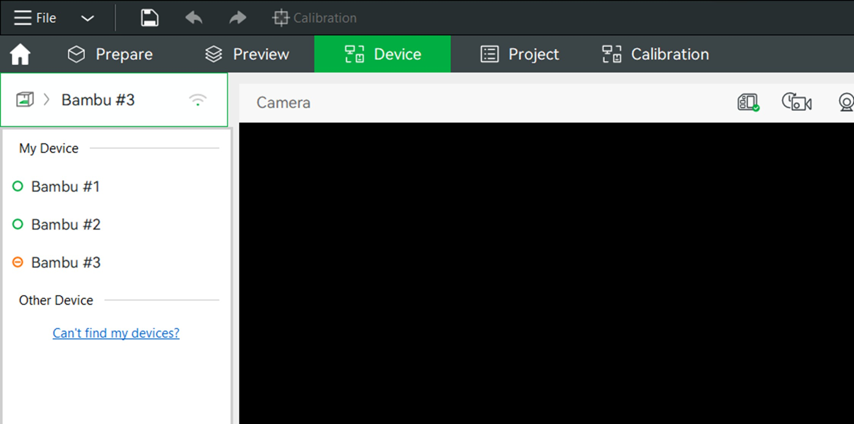
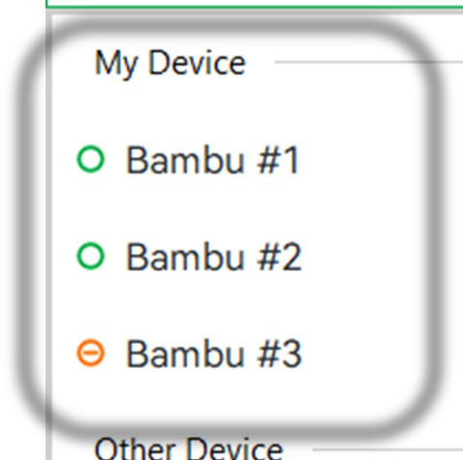
Selecting the Correct Printer
- Select “Device” tab
- Select active printer on the left
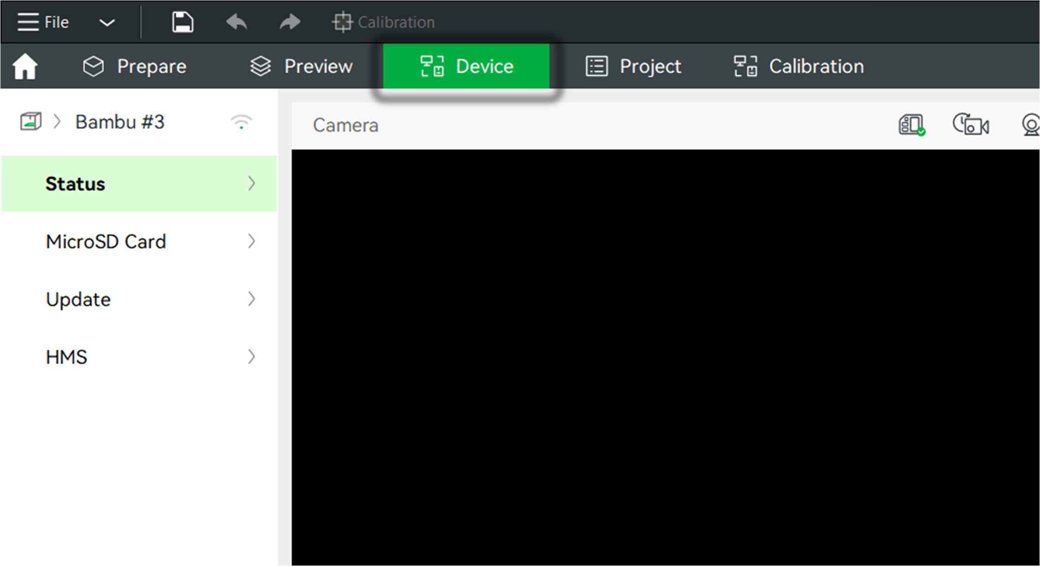
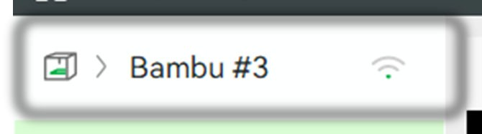
- Select the printer you reserved under “My Device”

IMPORT FILE
- Select File – Import – Import 3MF/STL/STEP…
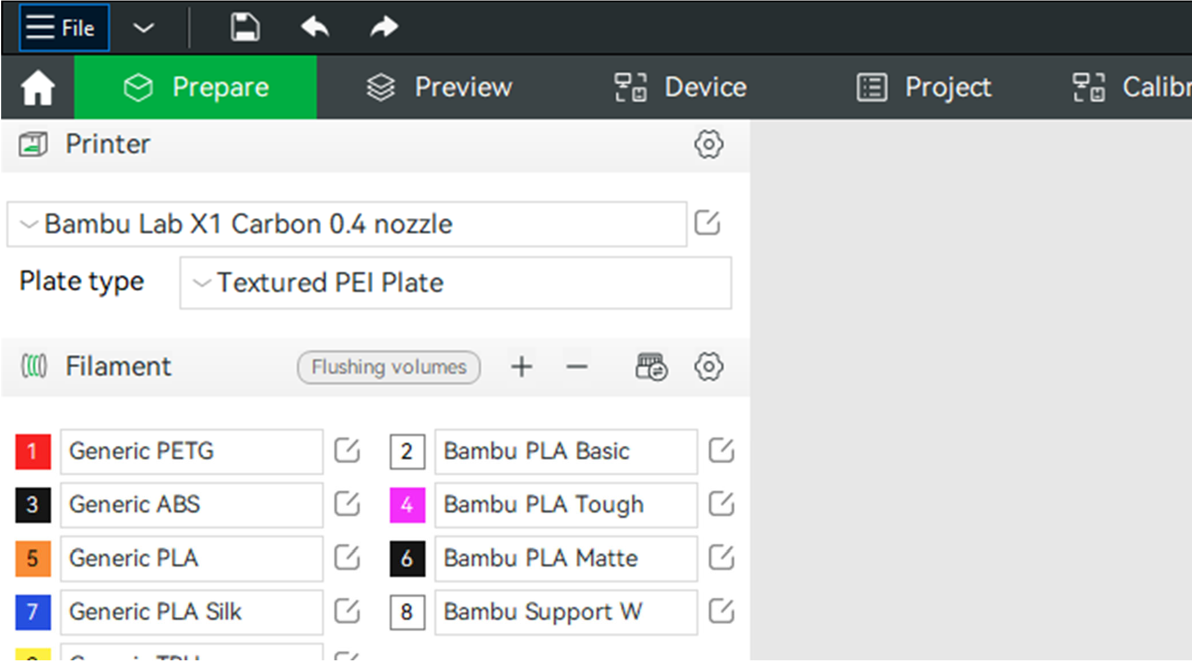
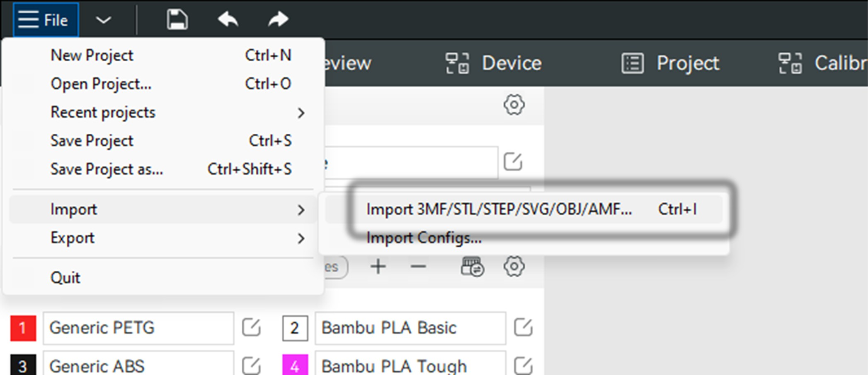
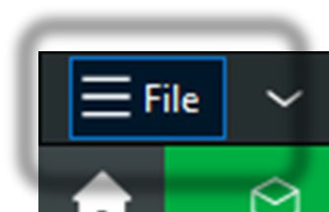
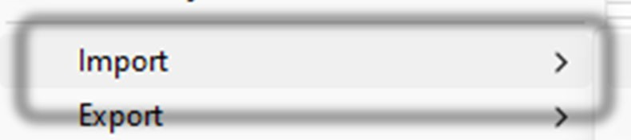

Orient Part(s)
- Click part to select
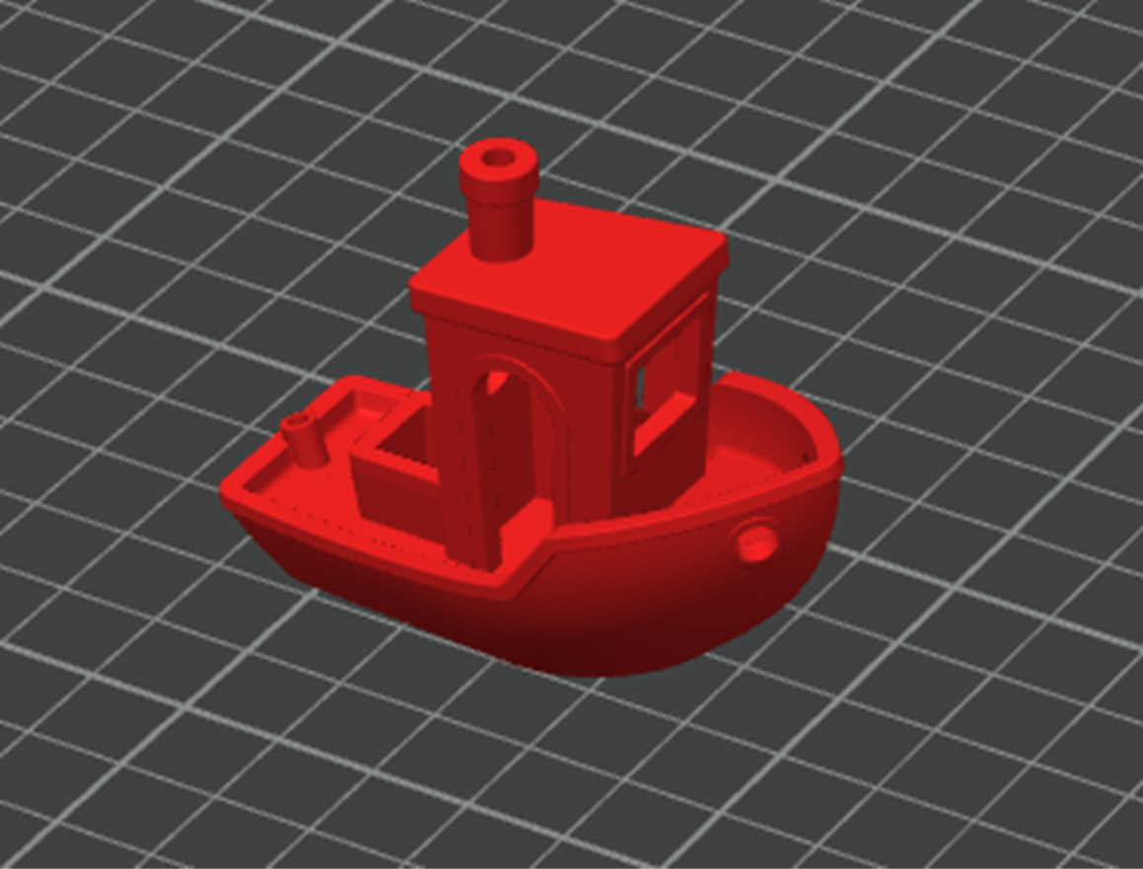
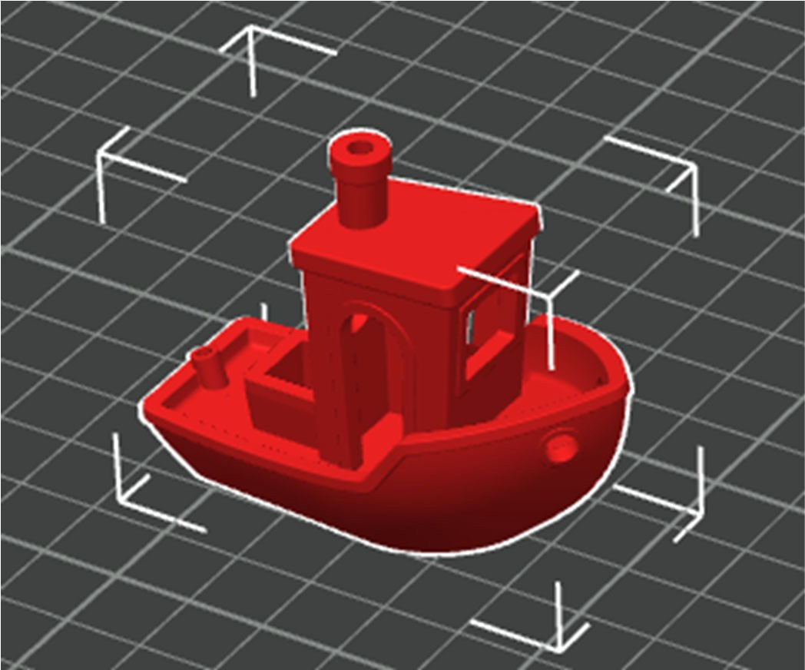
- Click and drag on selected part to move around the build plate
- With part selected lay a flat face on the build plate

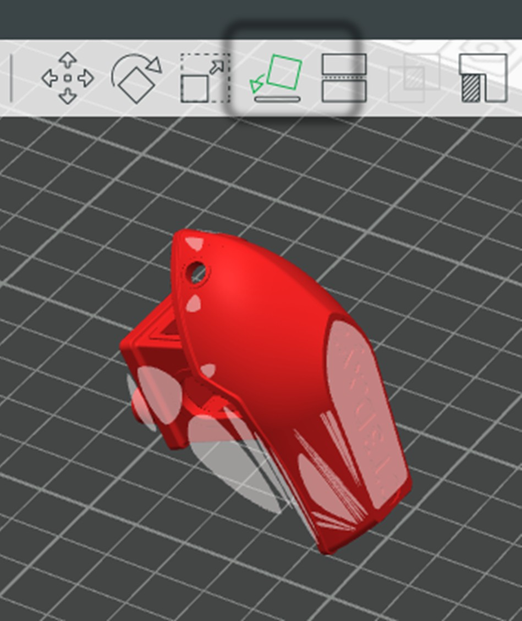
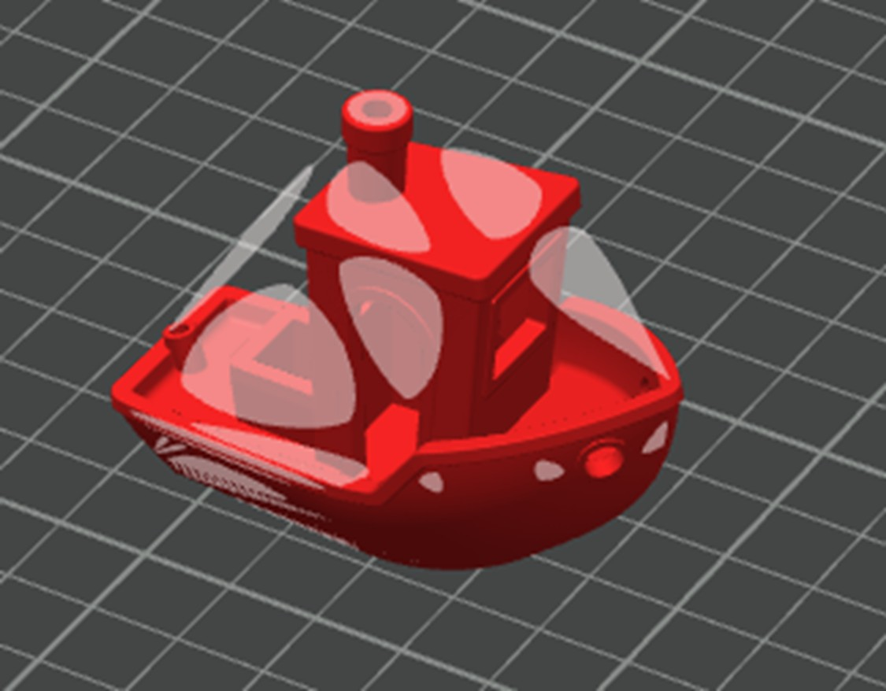

SELECTING PLATE & PRINTER TYPE
- In “Printer” drop down select the printer which matches your reservation
  - Bambu Labs X1E 0.4 nozzle OR
  - Bambu Labs X1 Carbon 0.4 nozzle
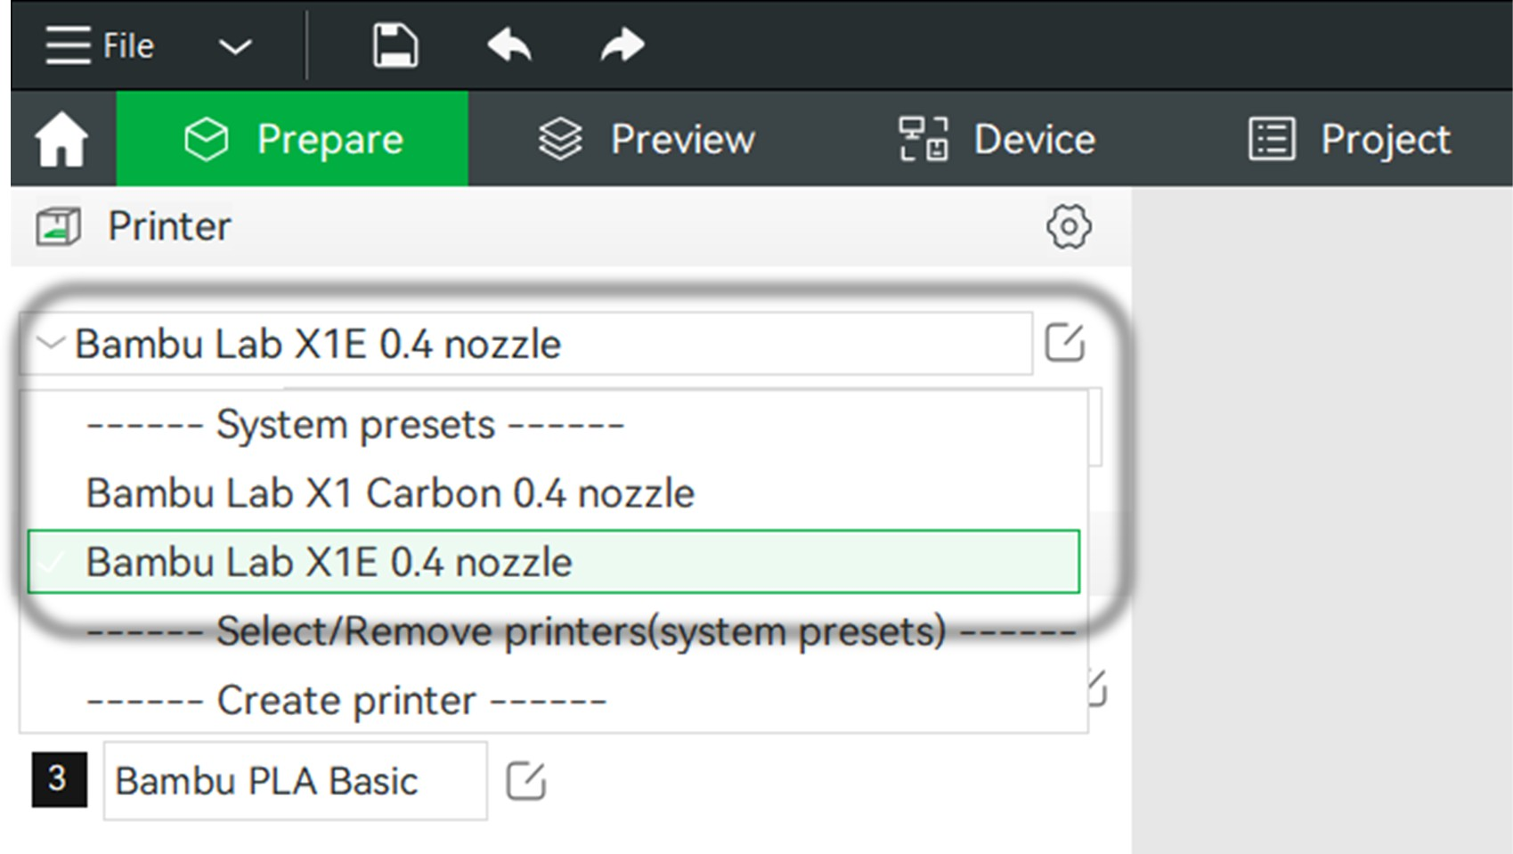
- In Plate Type Dropdown, select “Textured PEI Plate”
YOU MUST SELECT TEXTURED PEI PLATE BEFORE SENDING FILE TO THE PRINTER
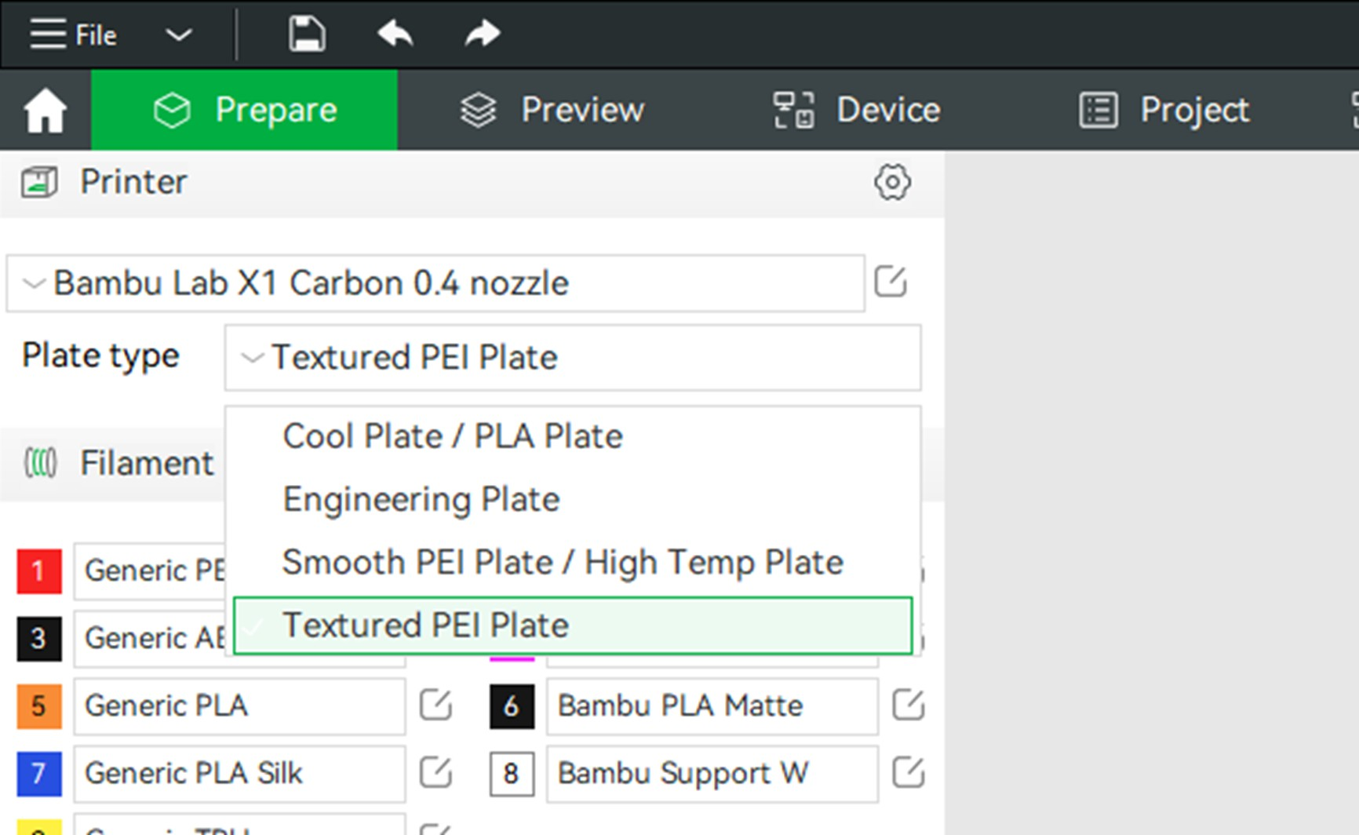
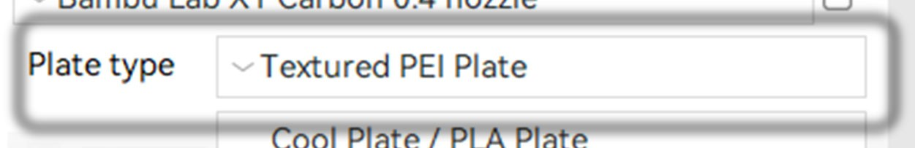
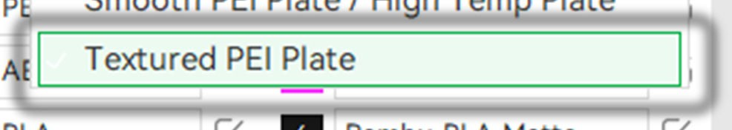

FILAMENT SELECTION
- Select AMS Button
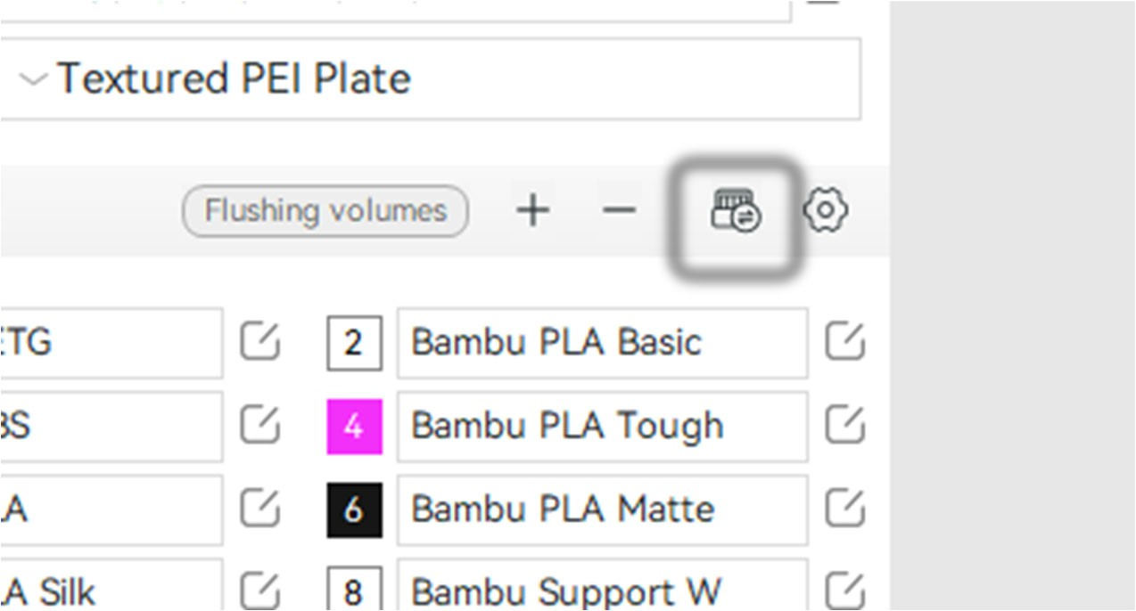
- Select Resync
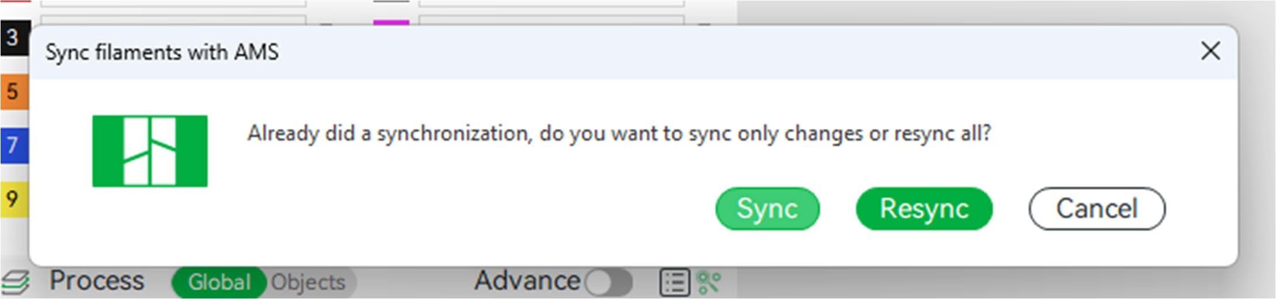
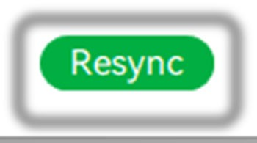
- Right click on a selected part, select change filament -> Filament …
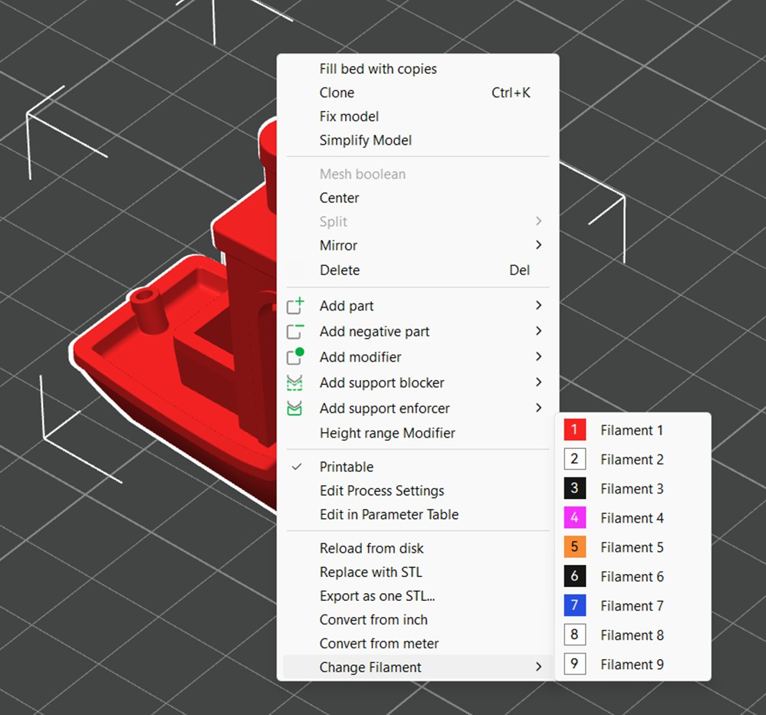
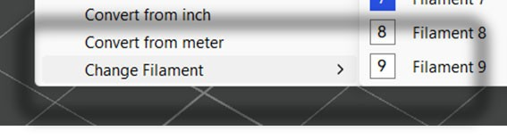
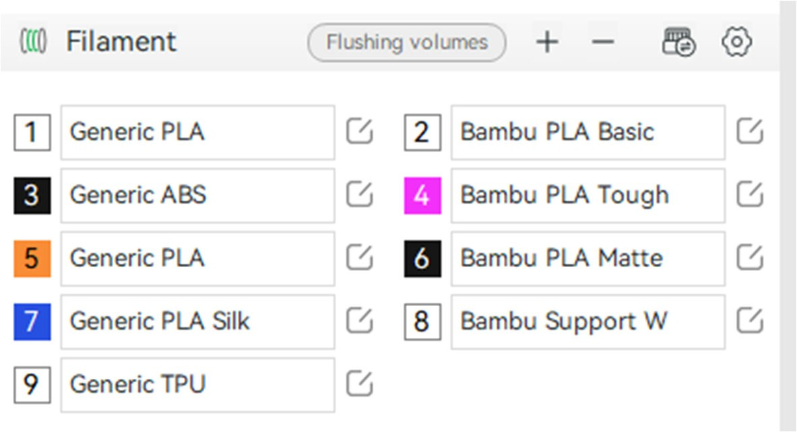
  - Select the filament corresponding to the desired filament on the “filament” tab on the left side of the screen

- If multiple parts are selected, right click and choose “Set Filament for selected items” -> Filament …
  - Select the filament(s) corresponding to the desired filament on the “filament” tab on the left side of the screen
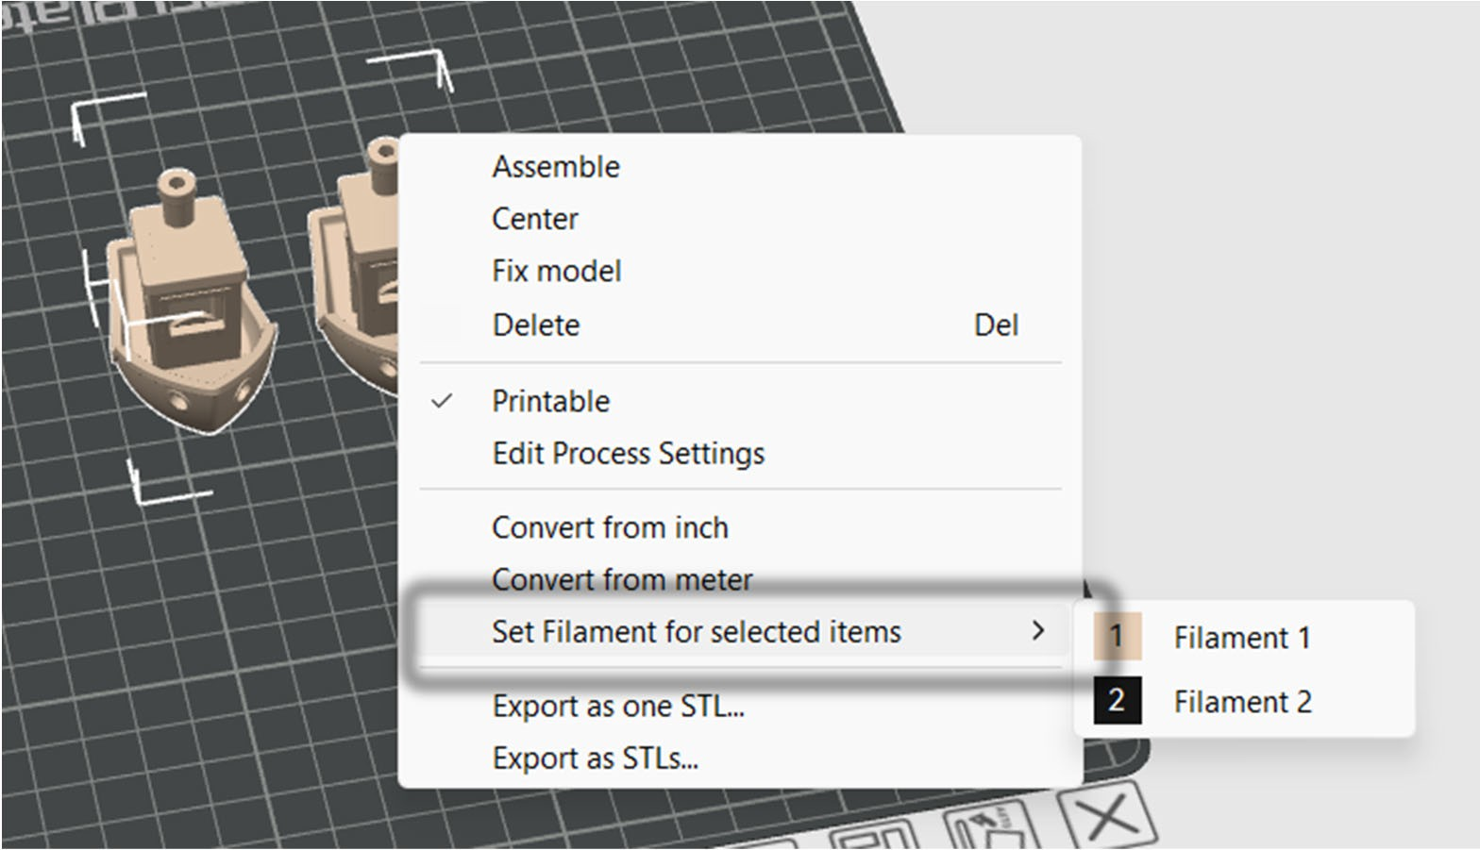
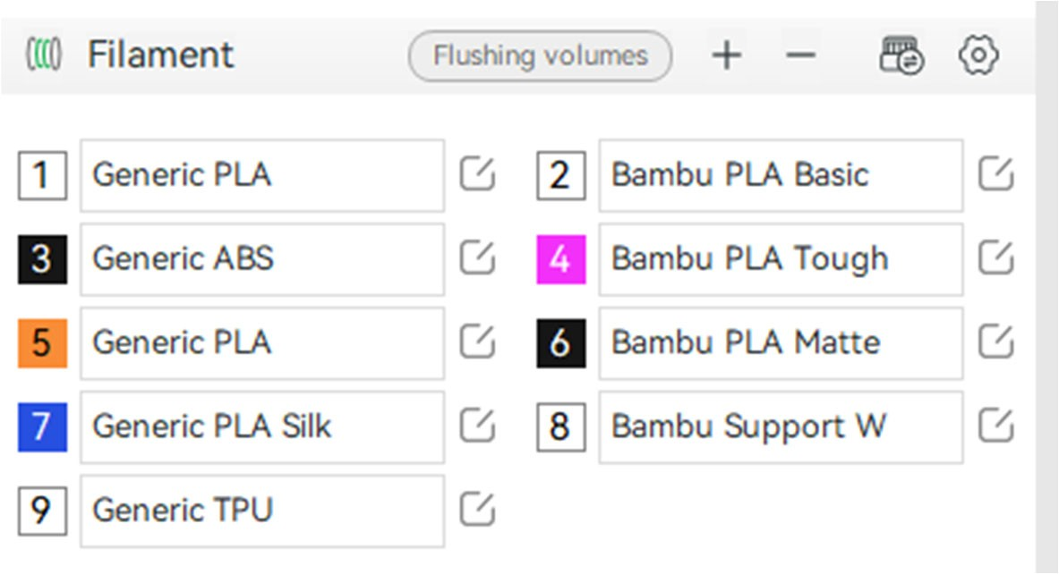

PRINT SETTINGS
- Select Layer Height from the preset dropdown
  - This adjusts settings for how detailed your model will be. It will use the same amount of material but take longer to print
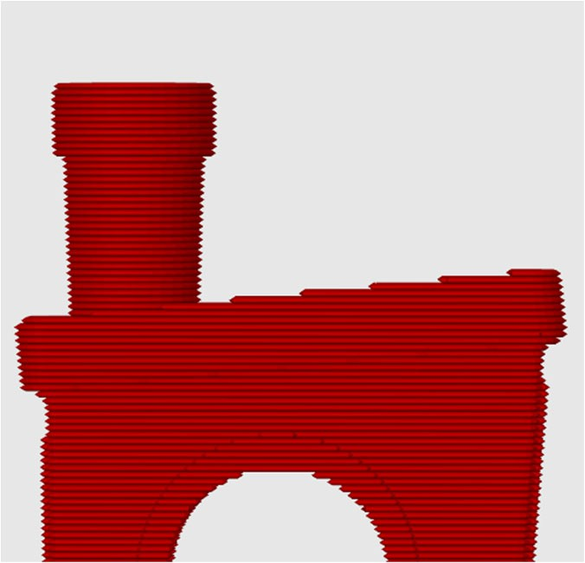
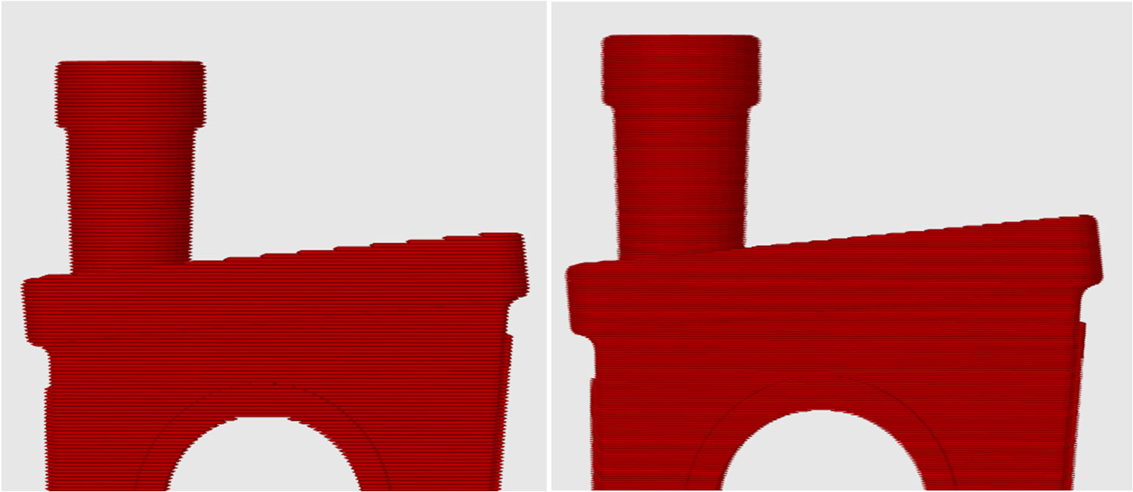
Extra Draft: 33 min Optimal: 45 min Extra Fine: 1 hr 15 min

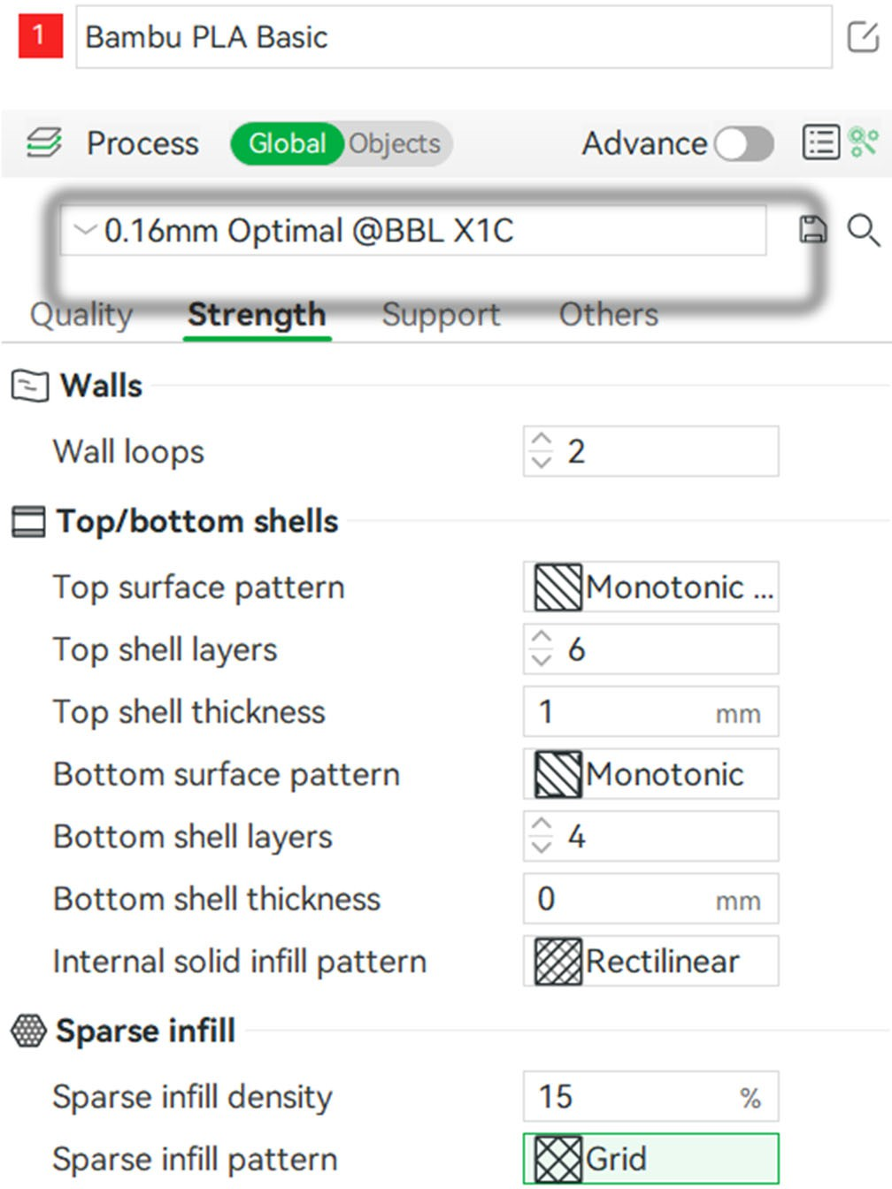
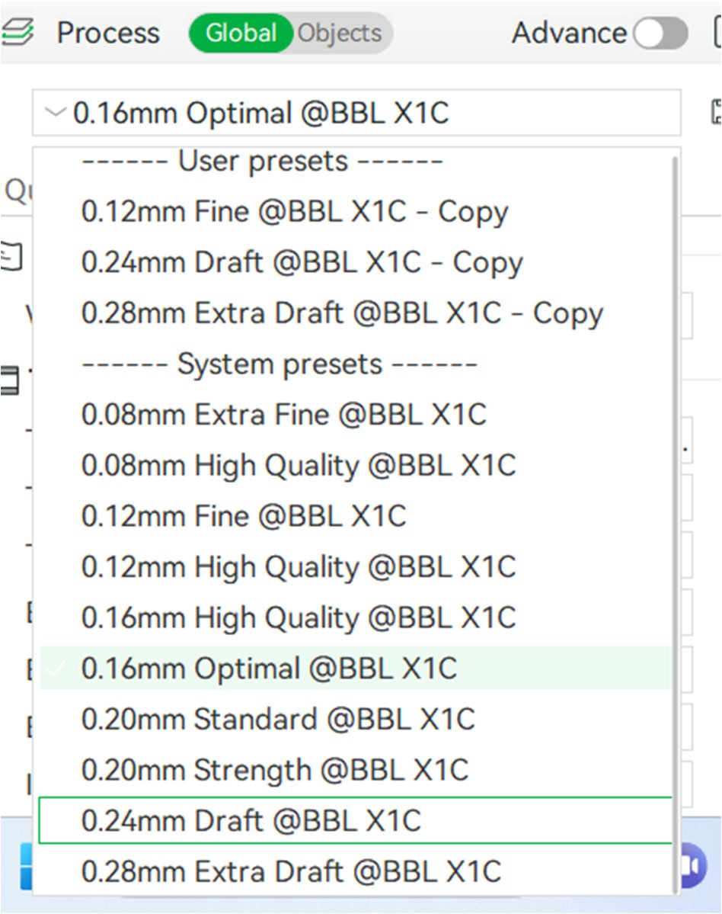
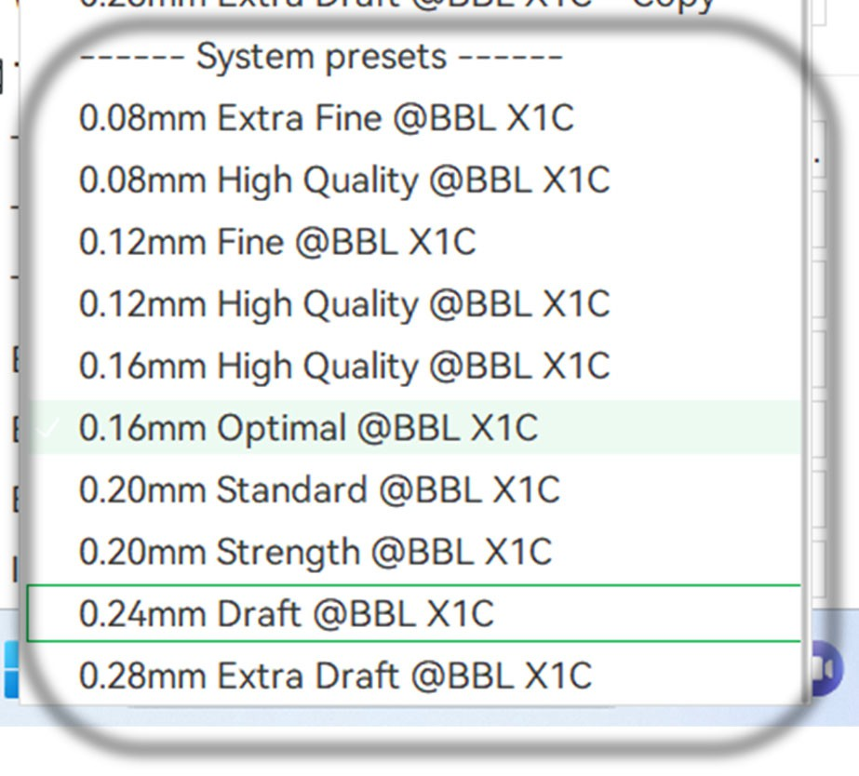

- Select “Strength”
  - Adjust Wall Loops from between “2-5”
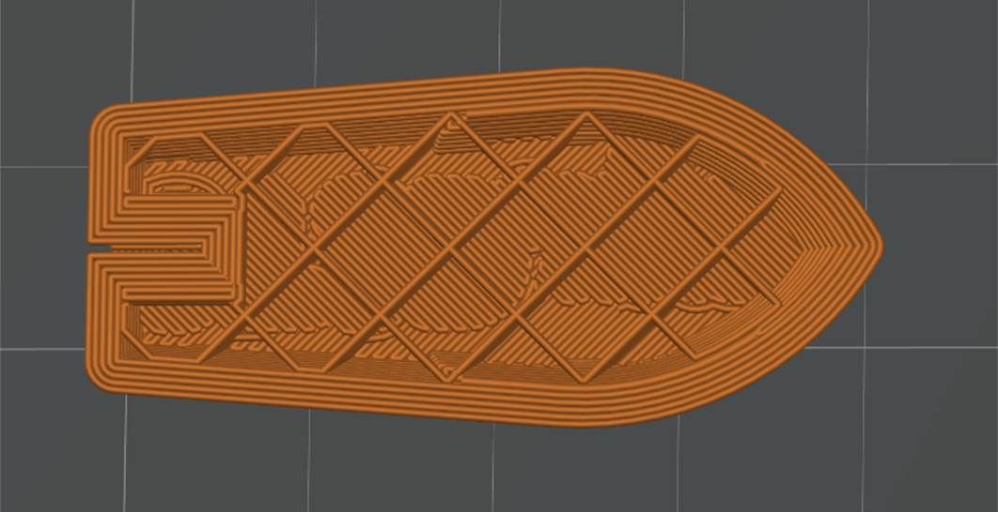
this is the most material efficient way to increase strength
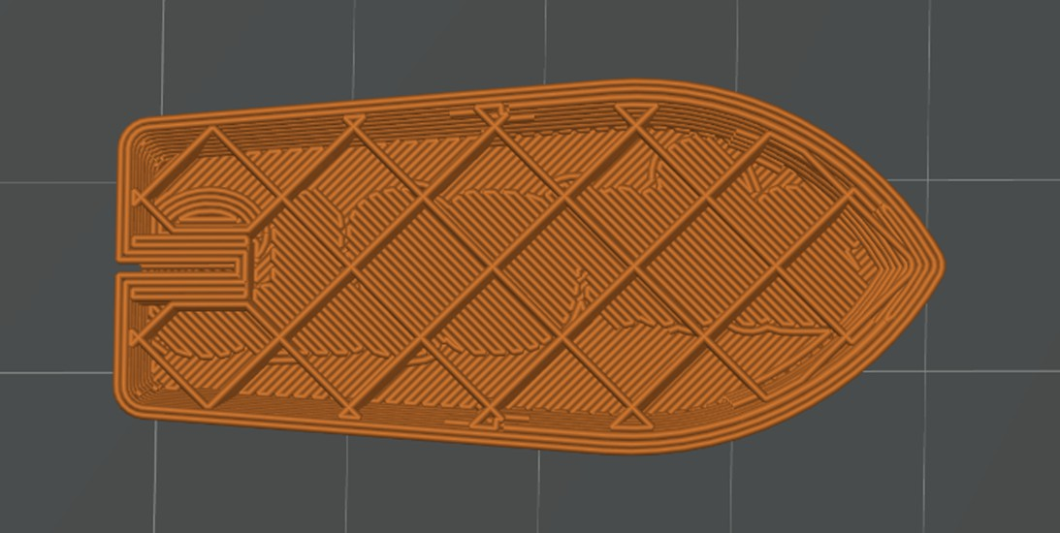
Wall loops: 2 Wall loops: 5
- Adjust “Sparse infill density” to increase strength & internal support, stay above 10% to avoid print defects

- Adjust “Sparse infill pattern” to change the internal shape for aesthetics or strength preferences
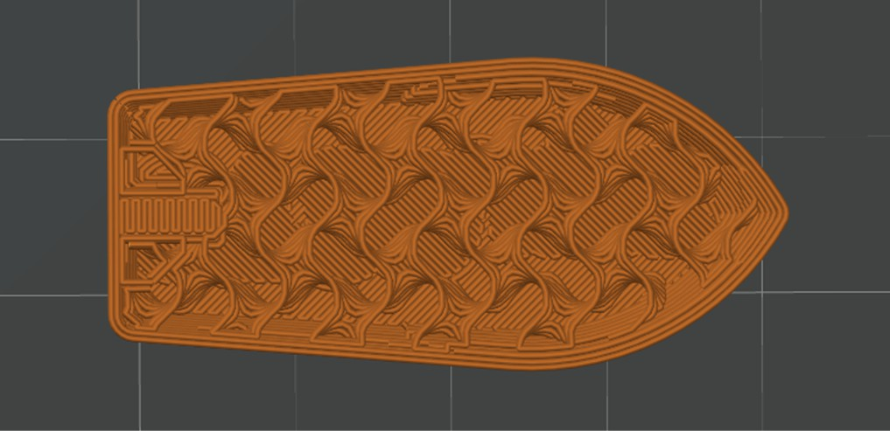

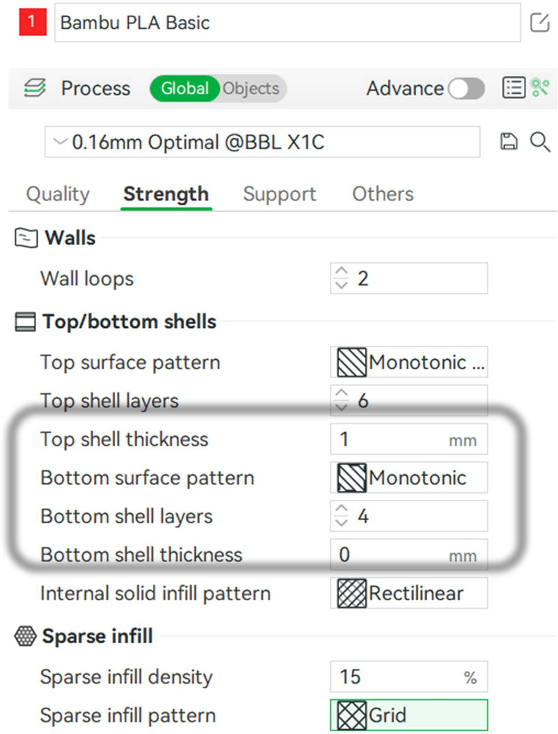
Infill: 15% Gyroid

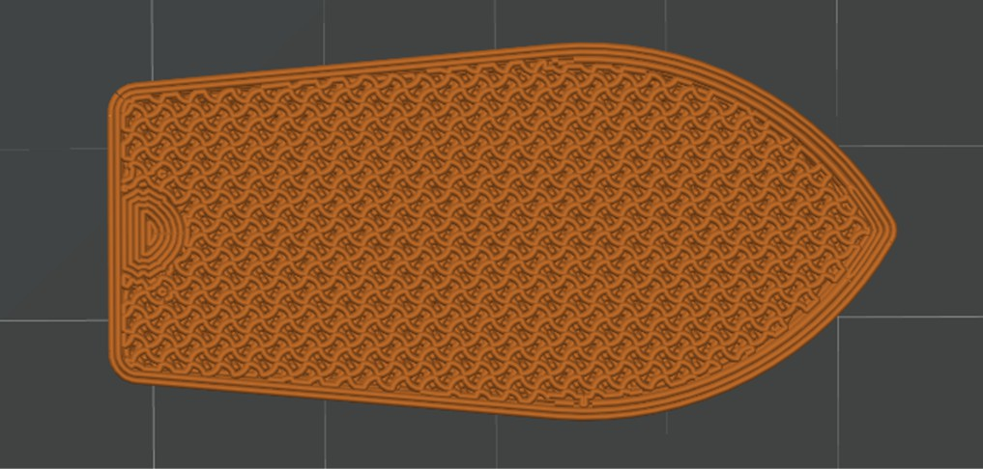

Infill: 60% Gyroid

- Enable Support
- Type -> Normal(auto), or Tree(auto)
  - Tree support will “branch” instead of build straight up and down, avoiding the need to have support build on top of your part
- Set “Threshold angle” to 45 degrees
  - This adjusts the level of over hand that will print before being supported
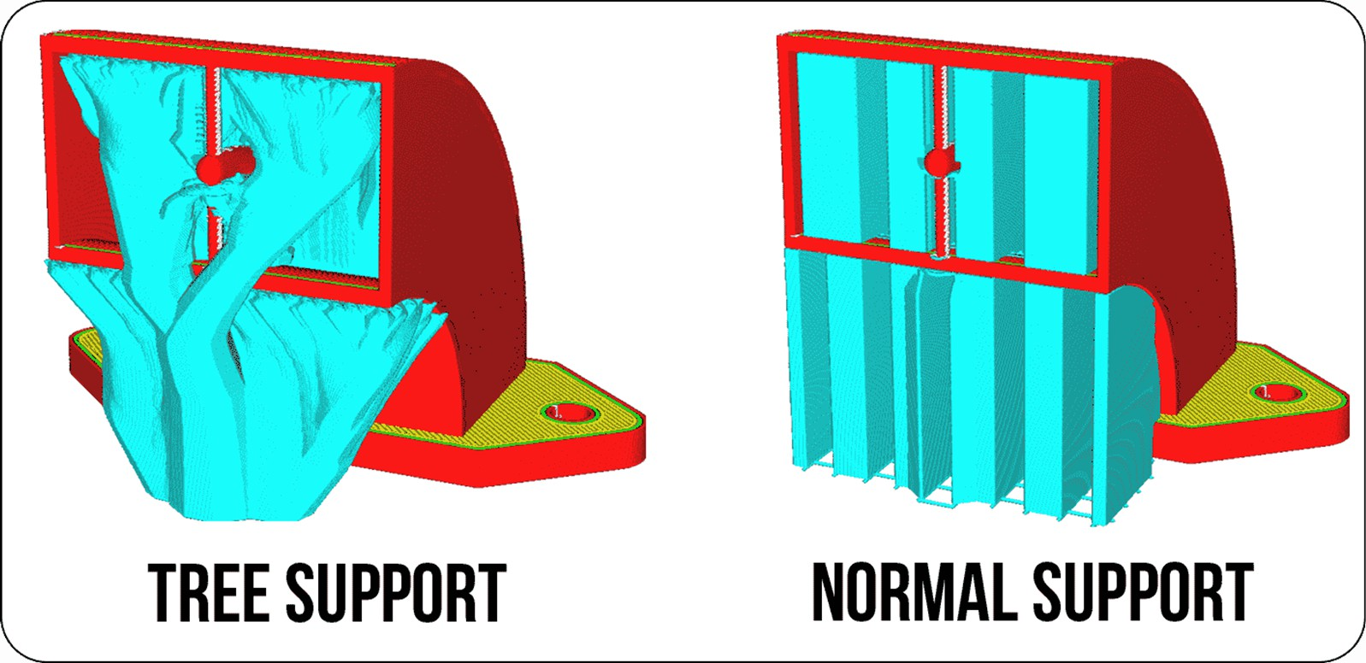
NOTE: On high res/complex models, tree support may take significantly longer to slice

Only”
- Under Others -> Bed adhesion -
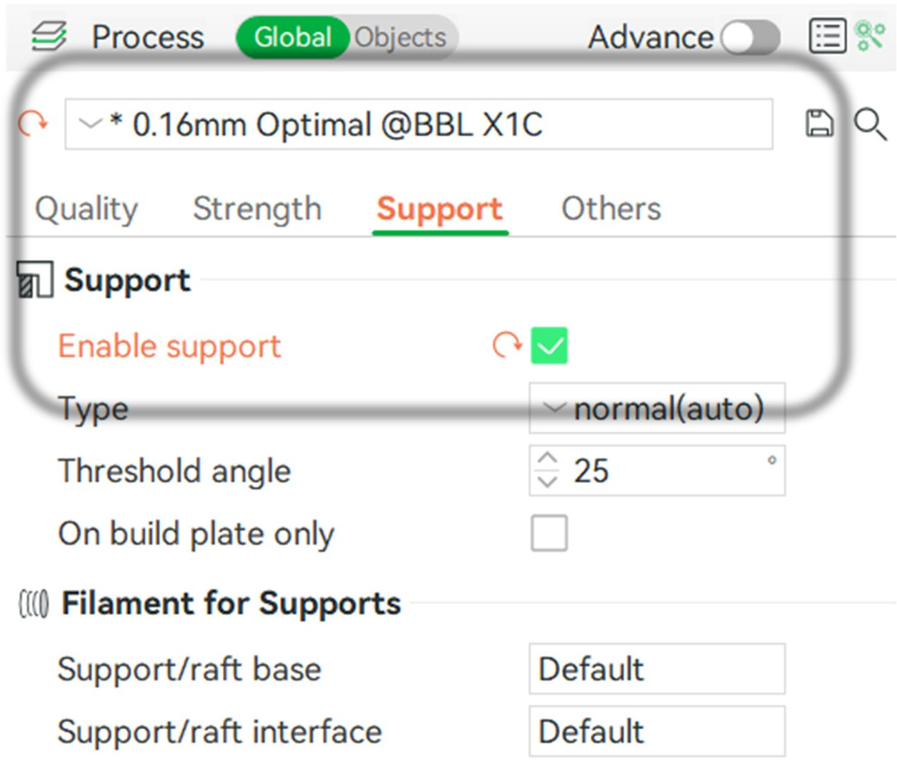
- Brim type, select “Outer Brim

  - This helps your print stick to the print bed

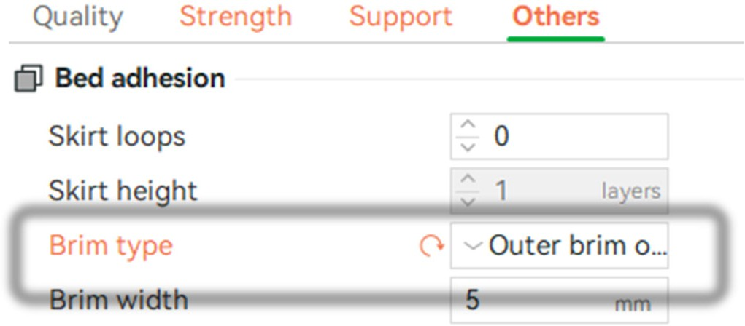

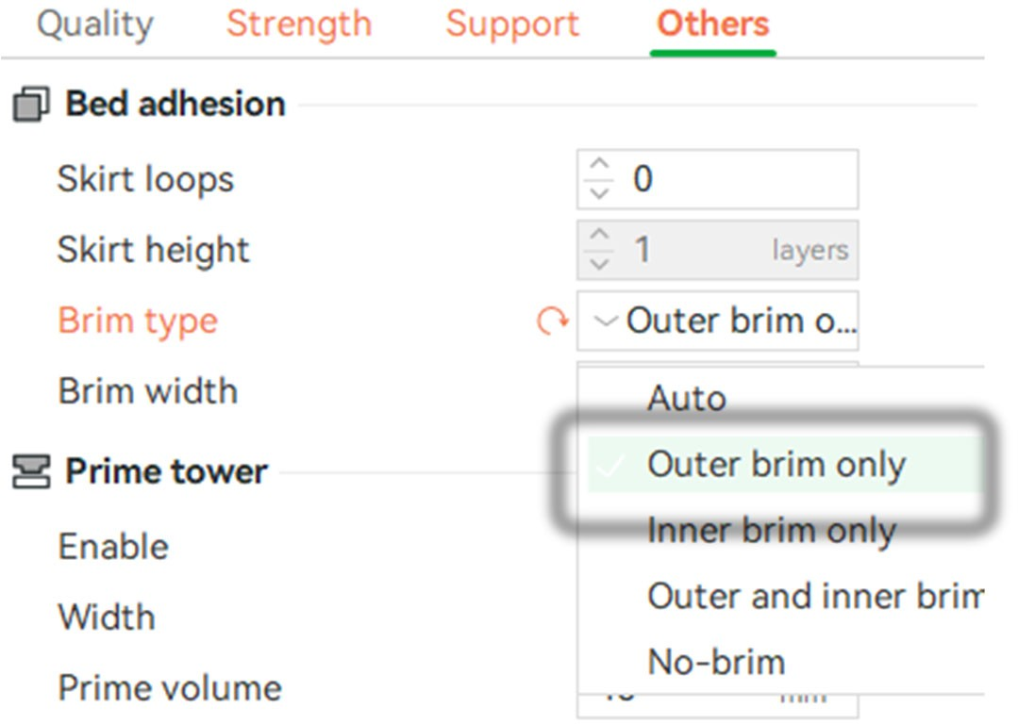

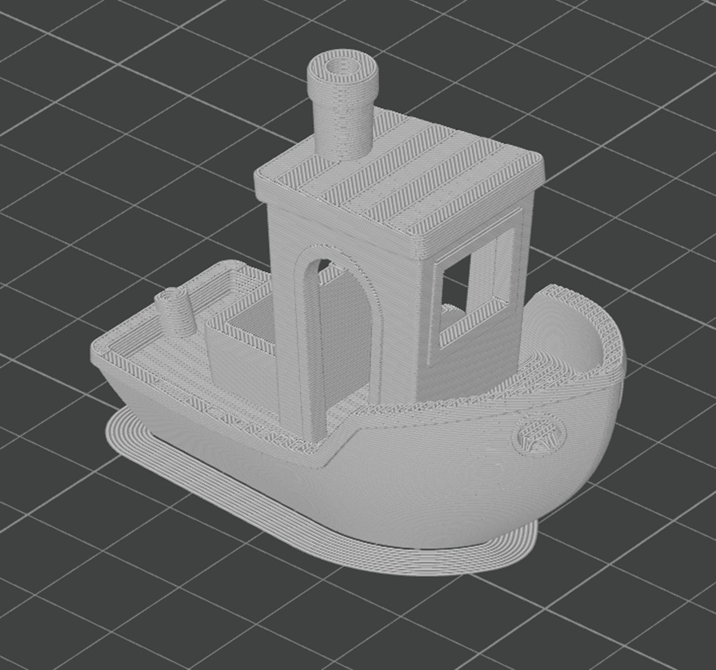

SENDING FILE TO PRINTER
- Select slice plate

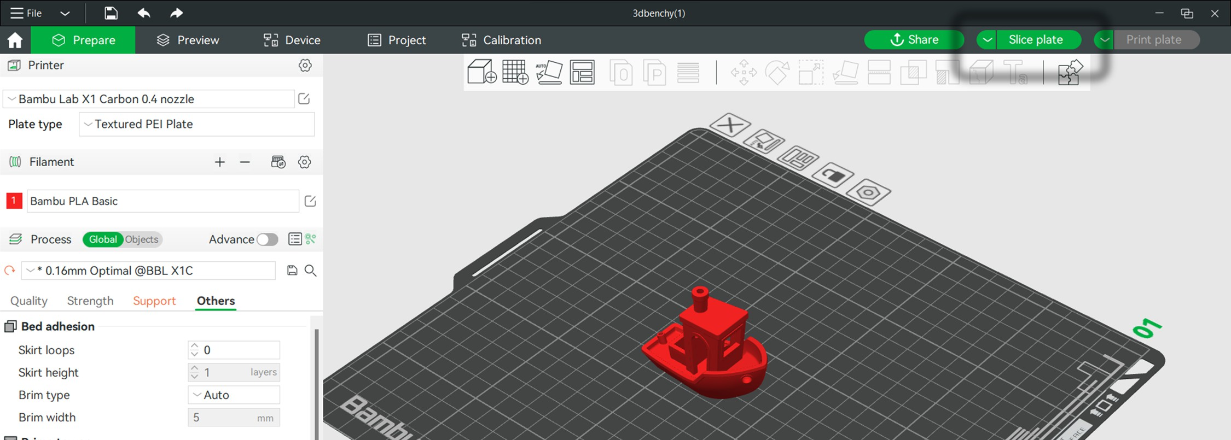
- See material estimate and total print time
THE PROVIDED COST ESTIMATE IS NOT ACCURATE MULTIPLY THE FILAMENT WEIGHT BY OUR CURRENT MATERIAL COST
- Select “print plate”
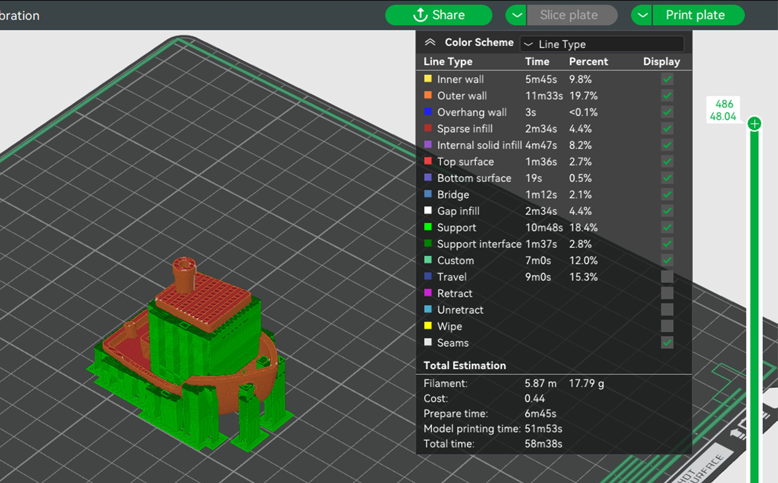
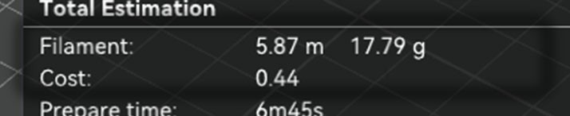
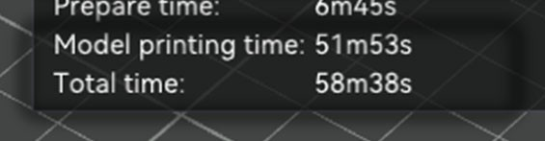
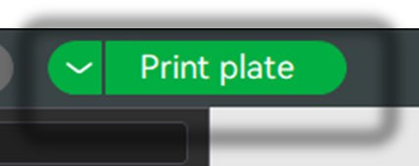

- Select the printer you have reserved

- Check “Bed Leveling”
- Check “Enable AMS” unless printing with flexible TPU
- VERIFY THE BED IS CLEARED
- Click send

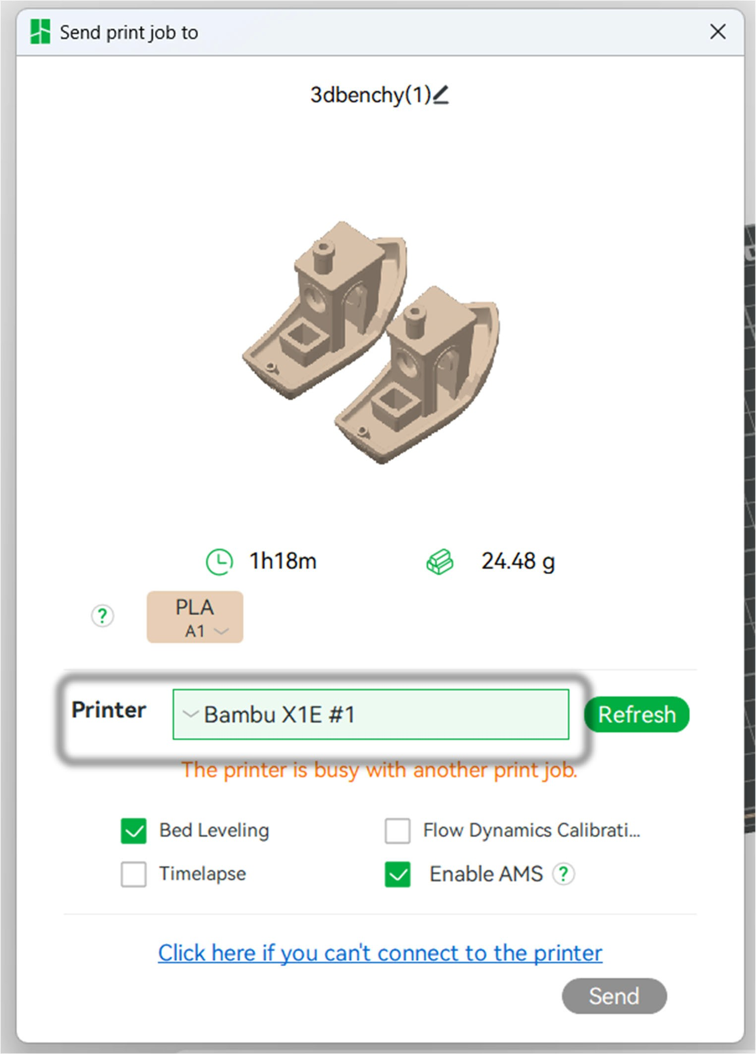
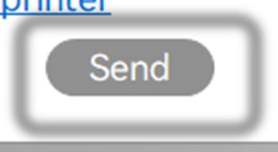

CLEAR PRINT BED

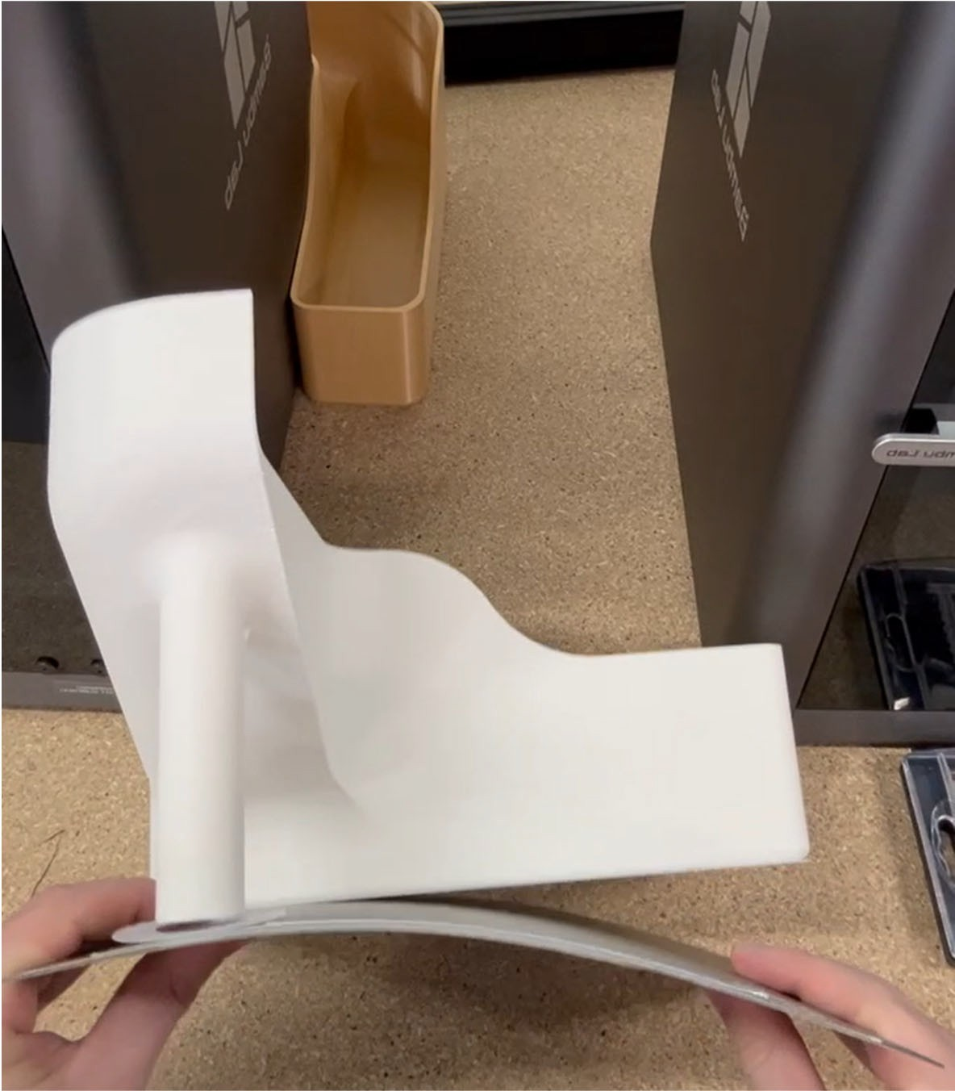
- Remove the build plate from the magnetic bed by grabbing the tab at the front and pulling up
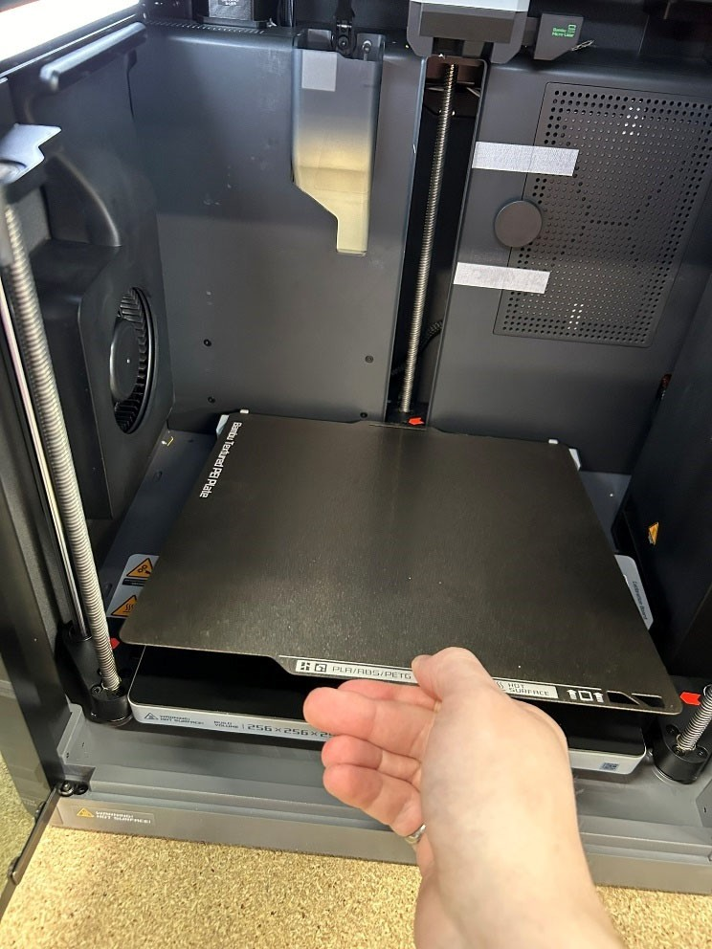

- Lightly flex bed to separate print from build plate

- Peel off any remaining material left on the build plate

- If a new print is not sticking to the build plate, DO NOT USE GLUESTICK, wipe the bed down lightly with isopropyl alcohol

- Replace build plate making sure to line it up with the back stops and to not overlap with the gray tabs on the side
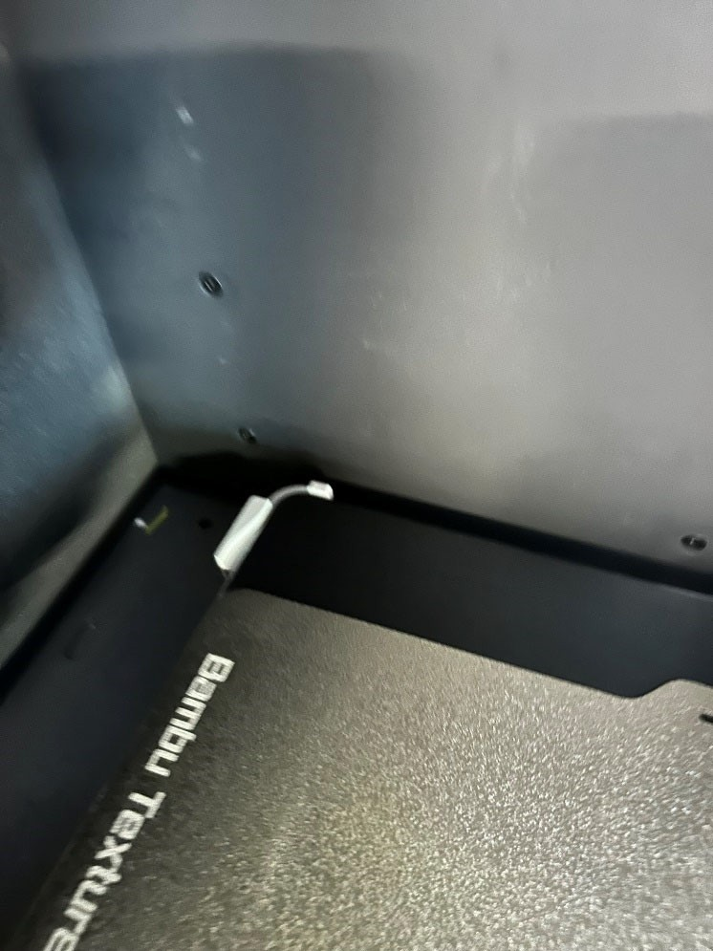
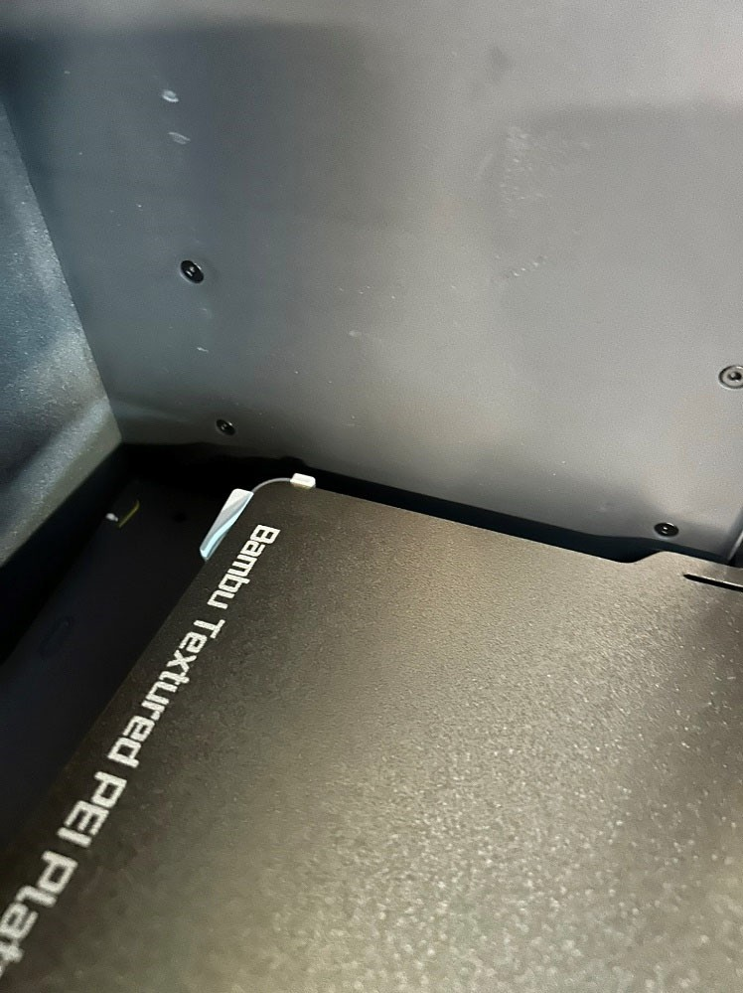

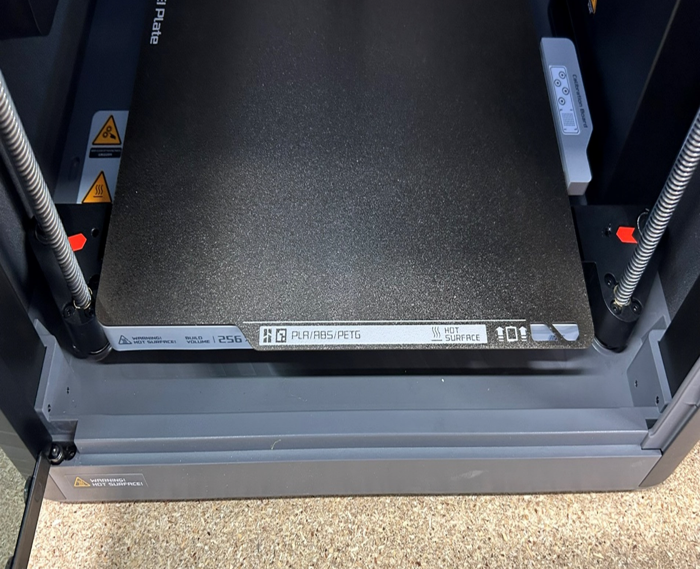
- The build plate should be placed so the tab that reads “PLA/ABS/PETG” is at the front

CHANGING FILAMENT
- Place filament spool in an empty slot on the AMS
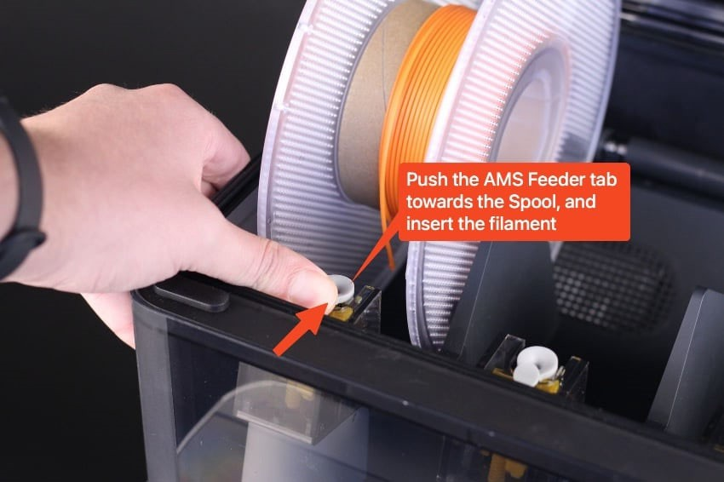
- Once the filament has been inserted about an inch, the AMS unit will begin to pull the filament and spin the spool to read the chip.

  - It should automatically update the filament in the AMS tab on the printers screen
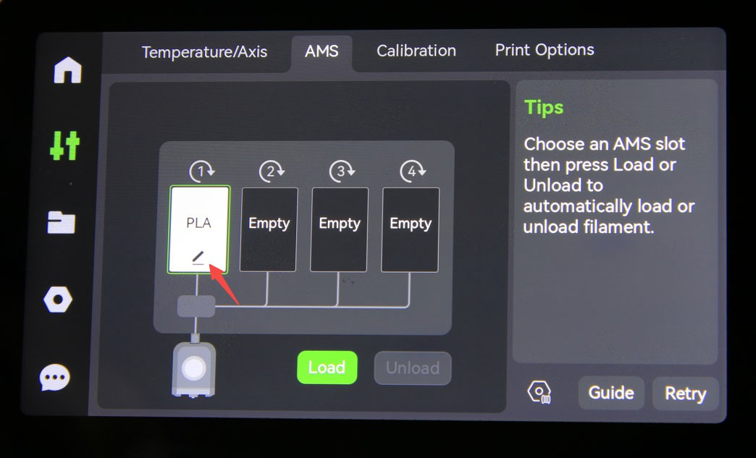
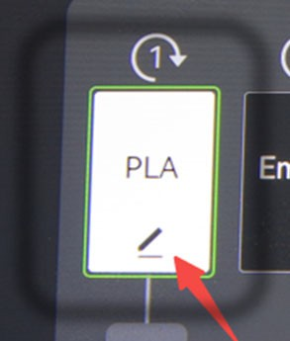

- If the filament does not automatically update, it can be manually updated by tapping the box on the screen that matches the corresponding AMS Slot
  - Select “Bambu” on the first drop-down
  - On the second drop-down choose the appropriate filament type
  - Update the color to match the filament
- Select confirm
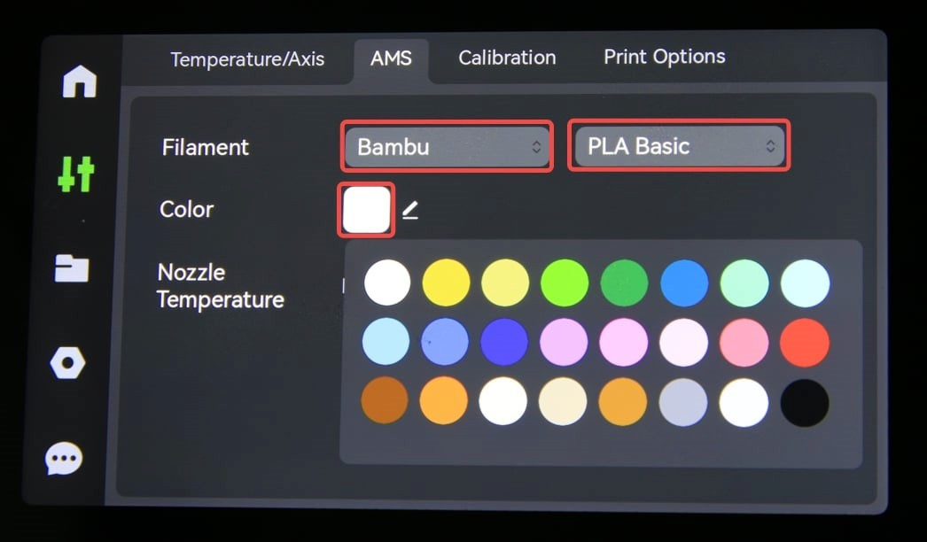
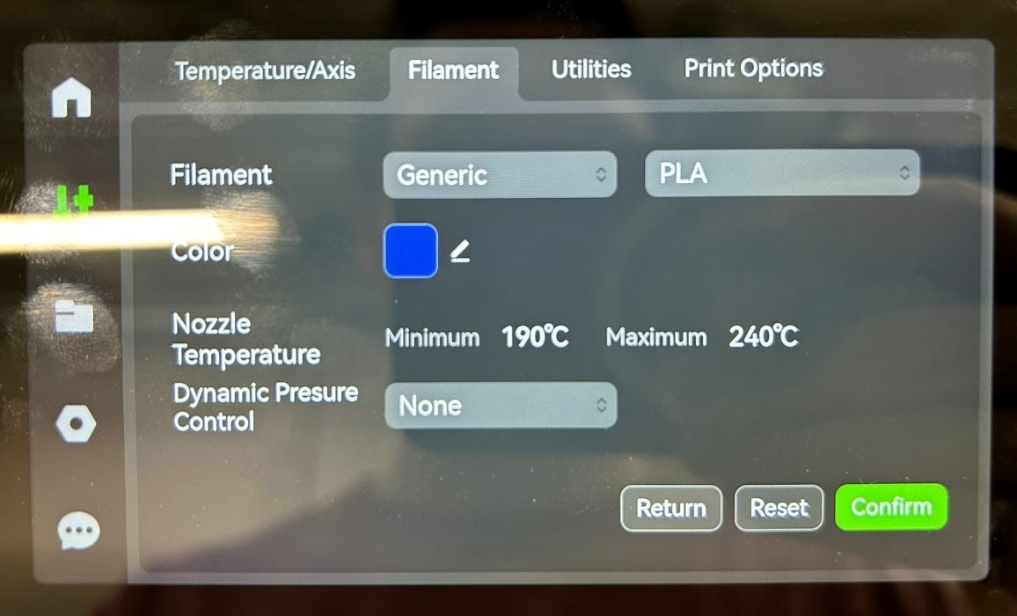
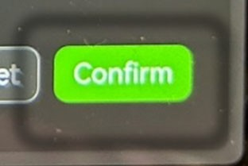

MULTICOLOR PRINTING

Colorize Your Model
- Bambu Studio provides multiple colorizing tools for various types of models.

Set filament for object/part
- Select AMS Button
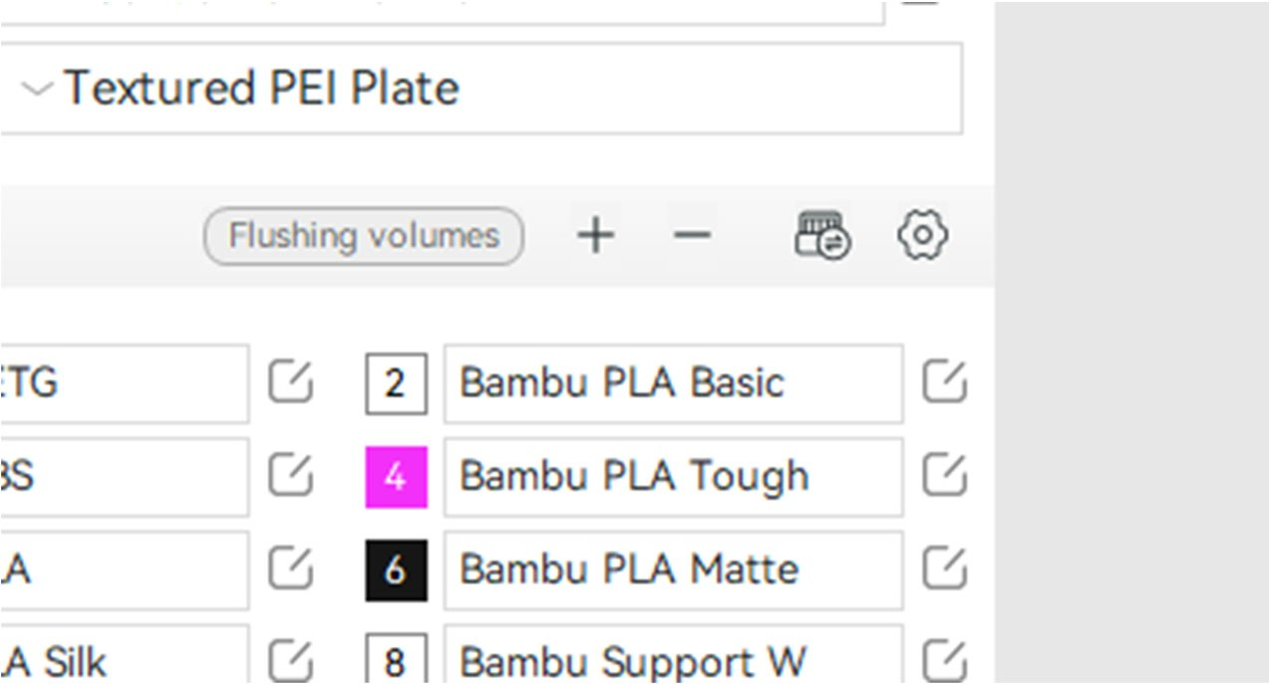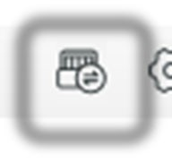
- Select Resync
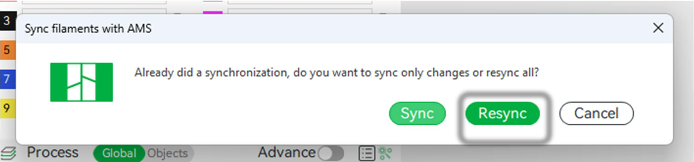

- Select filament for objects/parts in the object list on the left sidebar OR
- By right clicking as seen below
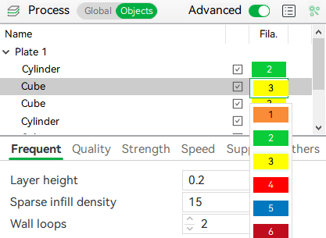
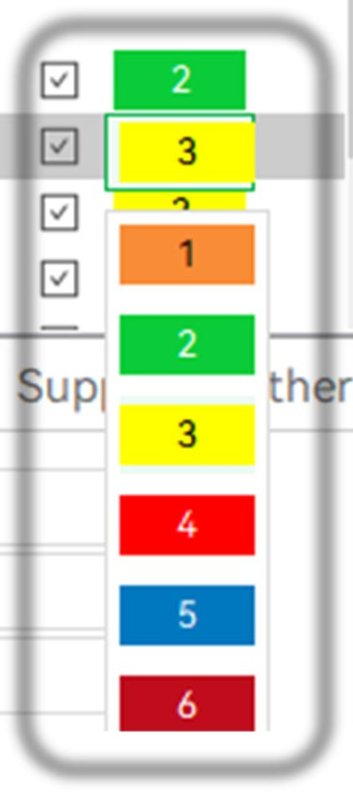
- Right click on a selected part, select change filament -> Filament …
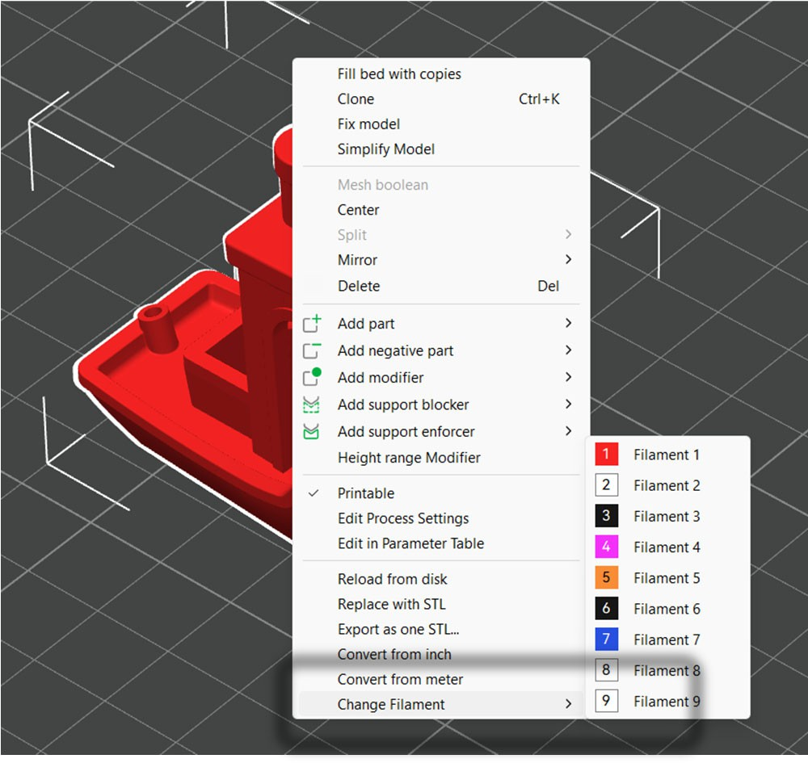
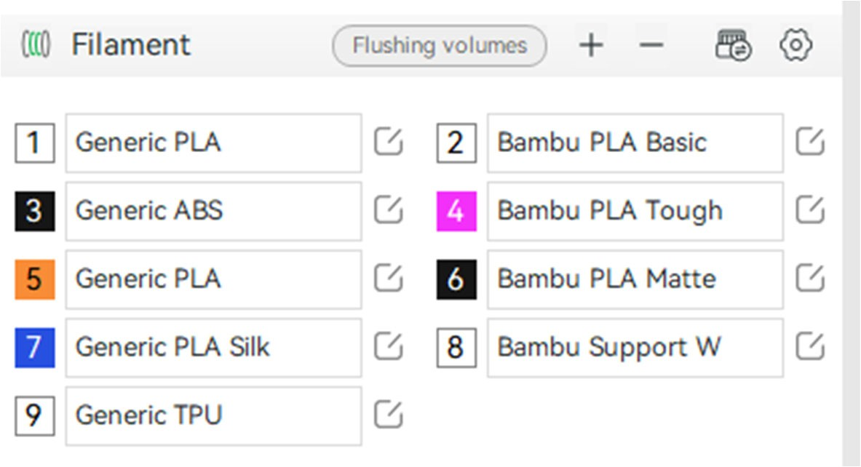
  - Select the filament corresponding to the desired filament on the “filament” tab on the left side of the screen

Paint on an Object
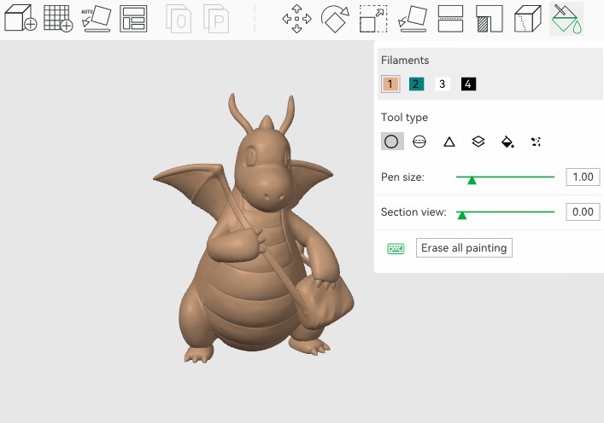
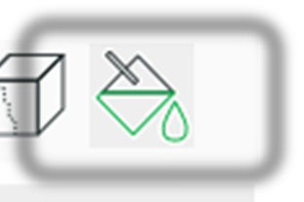
- Select an object, then select the “Color Painting” tool or by clicking the “N” on the keyboard

- Use the provided tools and different colored filaments to “Paint” the color on the model as seen above
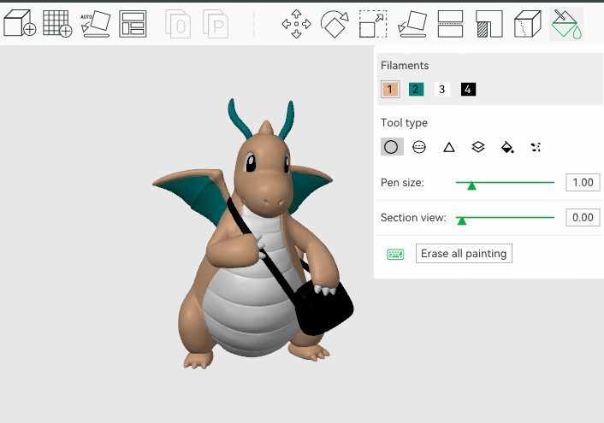
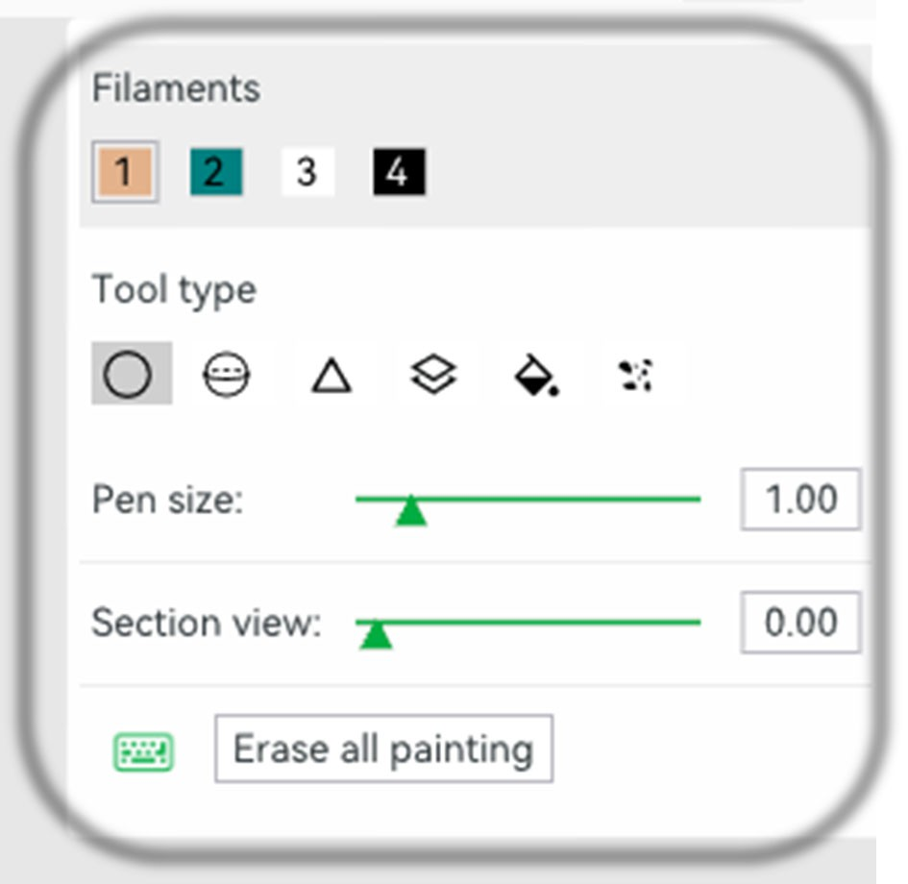
NOTE: each time in a layer the filament changes color it must purge extra material and take extra time.
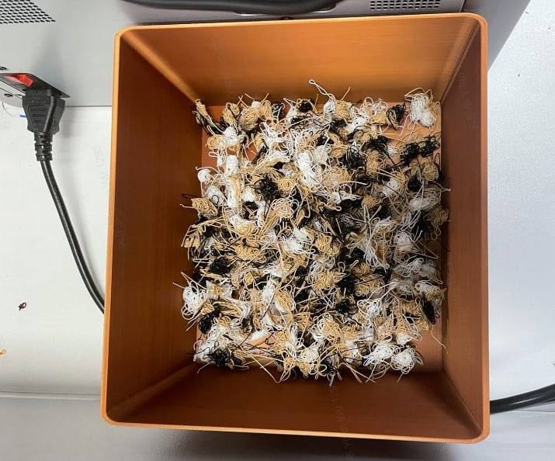

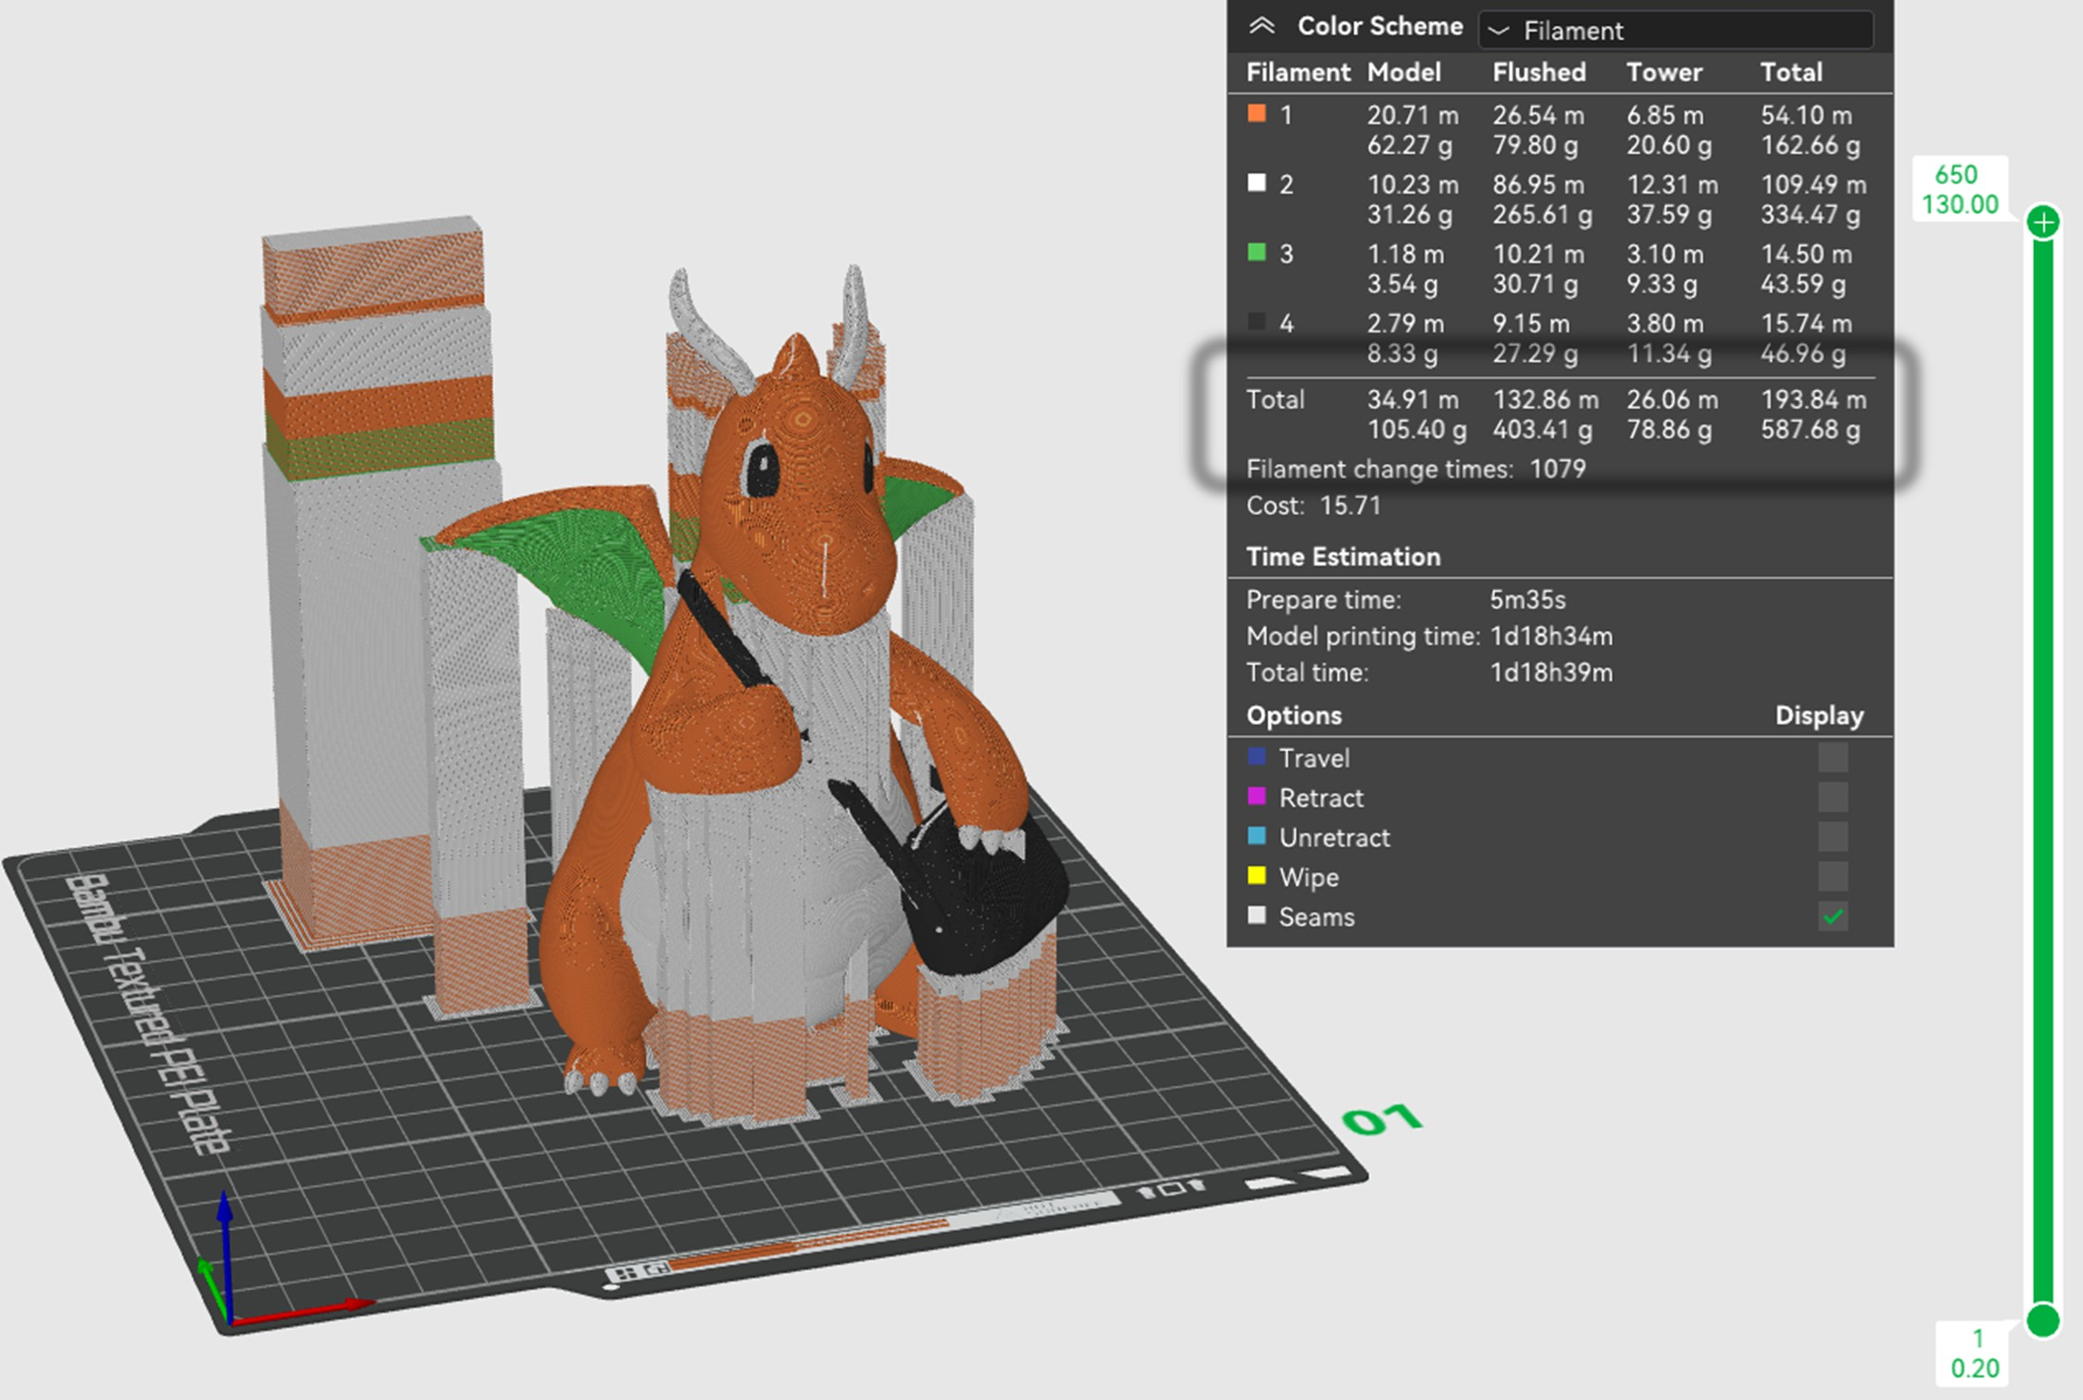
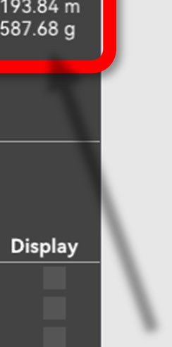
- YOU MUST TAKE A PICTURE OF THE PRINT ESTIMATE TO SHOW NIS STAFF AT CHECKOUT
  - This accounts for filament waste in multicolor printing
  - Note: in the above estimate, wasted material is 4 times the amount of printed material

.

