SOP
RICOH SP C440 DN CERAMIC DECAL PRINTER
Training is required before using this equipment
Reservations are required when using this equipment

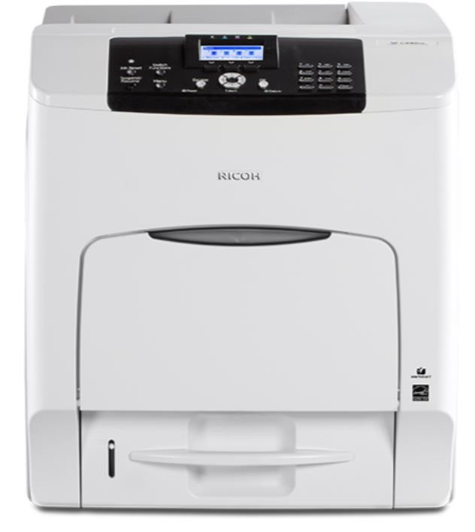

V 1.0

MATERIAL SPECIFICATIONS

The Ricoh SPC-430 will print 8.5” x 11” color decals that can be fired onto glazed ceramics. The decal paper is loaded in the printer. Do not use any other paper with this printer.

The decals cost $9.75 per sheet. Only full sheets can be printed. The cost includes the laminating paper. There is no cost to use the kiln.

PRINTING YOUR ARTWORK

Use COMPUTER #5 in the Computer Lab. This computer has the printer driver for the Ricoh Printer.

1) In Adobe Illustrator or Photoshop make sure the COLOR MODE for your artwork is CMYK. The printer will not print in RGB

You can choose CMYK for your COLOR MODE when you are creating a document in Illustrator or Photoshop.
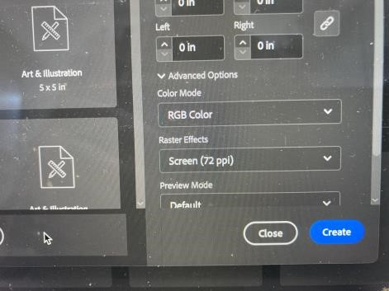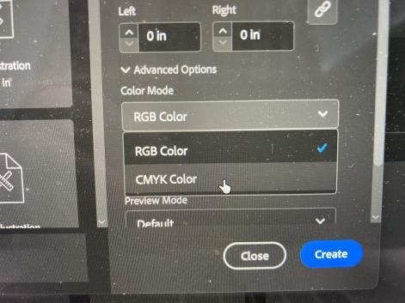

Illustrator

Photoshop
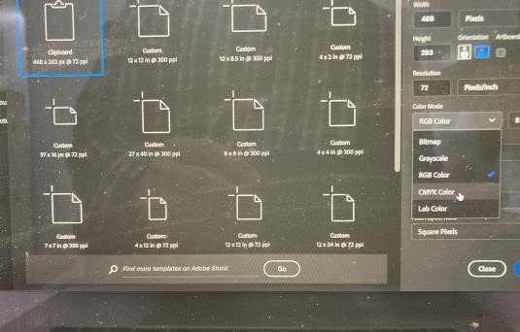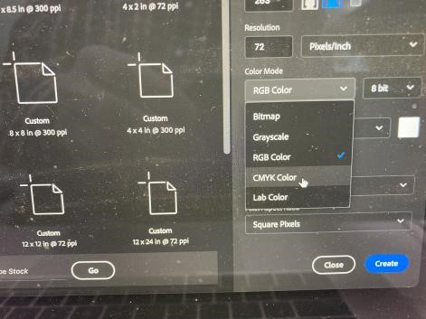

If it is an existing image that is in RGB color mode:

- you can switch to CMYK in Illustrator with FILE>DOCUMENT COLOR MODE>CMYK COLOR.

- You can switch to CMYK in Photoshop with IMAGE> MODE>CMYK COLOR.

- Mirror Your Image.

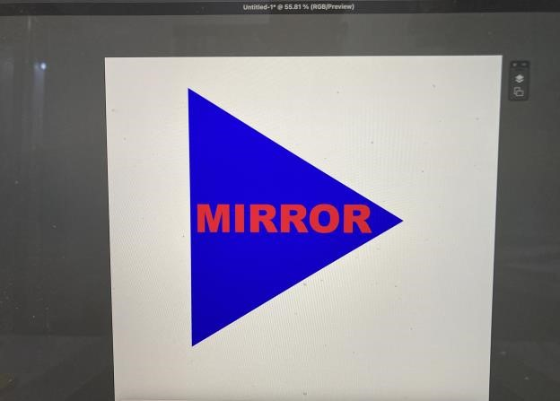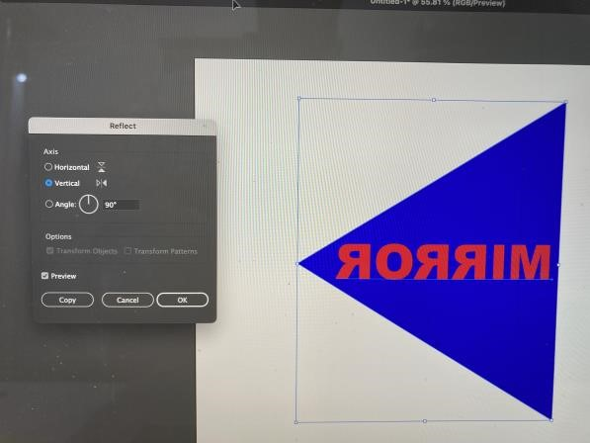

In Photoshop: IMAGE > IMAGE ROTATION > FLIP CANVAS HORIZONTAL

In Illustrator: Use the REFLECT tool. Or OBJECT > TRANSFORM > REFLECT

- If your image is smaller than 8.5”x11” you can put multiple images on the same artboard/page.

- When you are happy with your image, FILE > PRINT. Choose the RICOH SP C440DN PCL 6 as your printer.

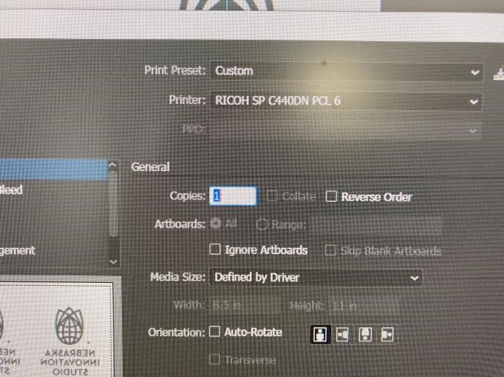

When you print, the printer will give you two error messages.

 | 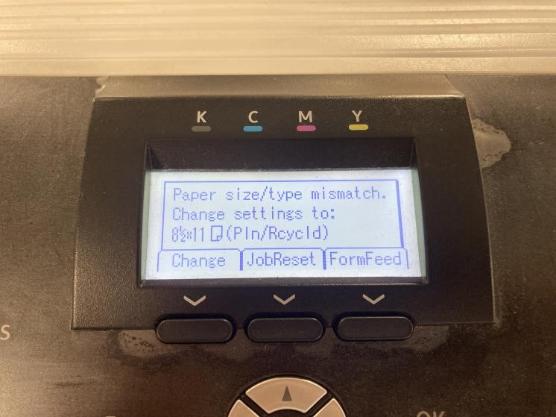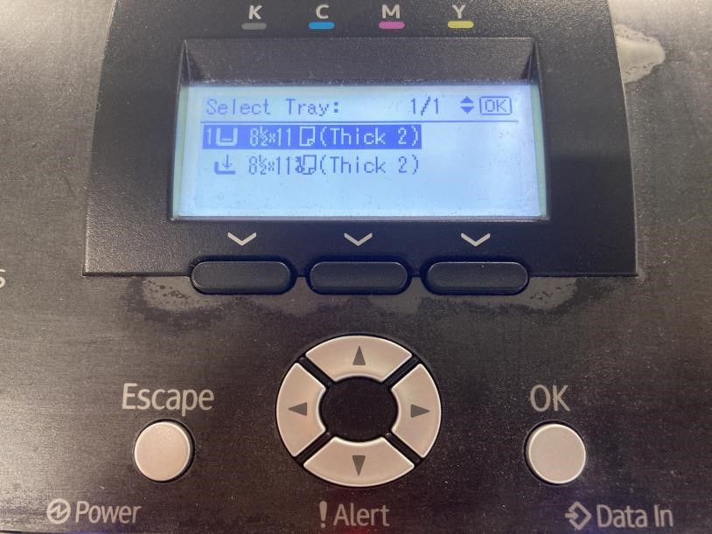
  The first error message says Paper size/type mismatch. Push the button under FormFeed.
The second error message
asks you to select a tray:
Push OK.

LAMINATING YOUR DECAL

The laminator takes a few minutes to warm up.

- Plug in the laminator.

- Set the temperature to 284 degrees. The green light will illuminate when the temperature is achieved.

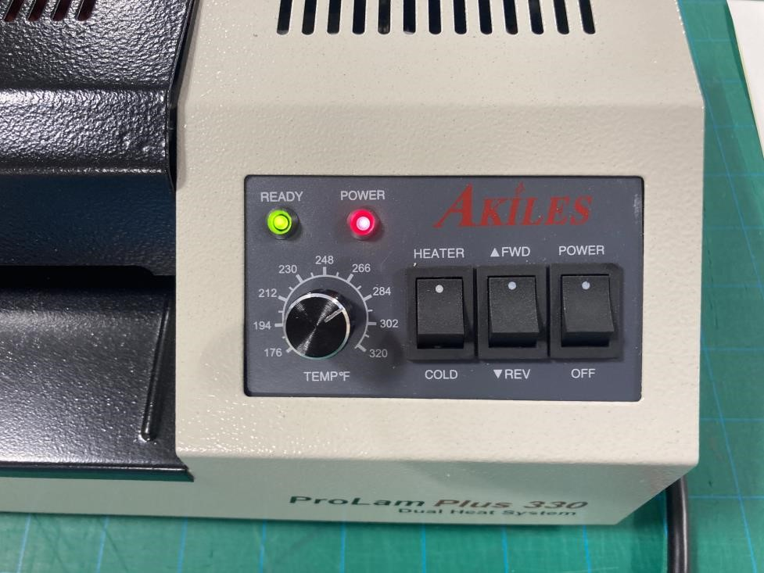

- Take your decal from the printer and affix the lamination sheet. The yellow side should be facing your image.

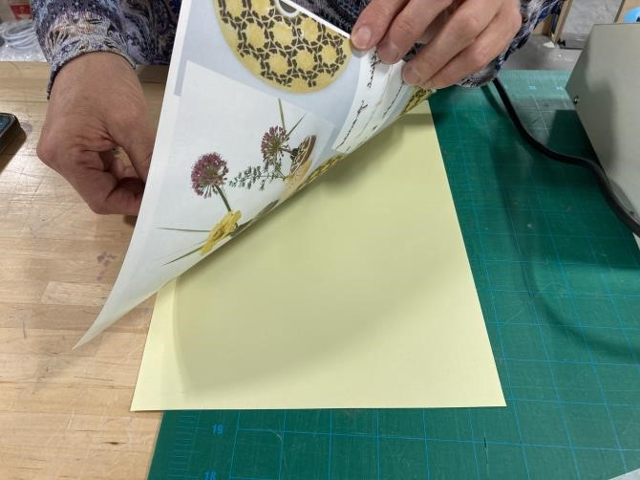

- The yellow laminator sheets are slightly longer than the decal paper. Cut off the excess.
Failure to cut this off risks a jam in the laminator.

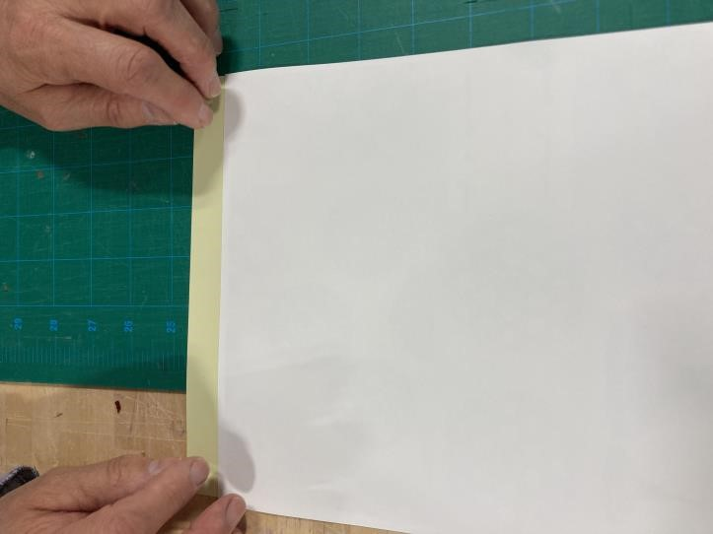

- Put the image and laminator sheet through the laminator. Flip it over (so the top and bottom are reversed) and send it through again. It’s okay if the green light turns off during this process.

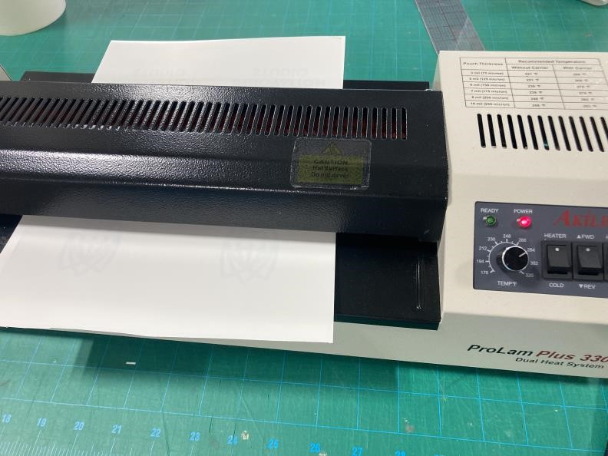

APPLYING YOUR DECAL

- If you have multiple images on the same sheet, now is the time to separate them, using scissors.

- Soak the decal you’re ready to use in a clean bowl of water.

The process will go more quickly if you use warm water in the bowl.
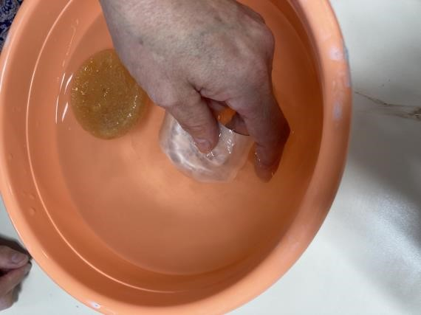

- Once it is thoroughly soaked, the decal will separate from the paper. The decal outside of your image appears yellow but will turn white when fired.

- The decal is extremely delicate and can tear if this is not done carefully.

- It’s very important there are no air bubbles, or the decal will not fire properly.

- Even when the decal is smoothed out, it will be slightly raised off the object.

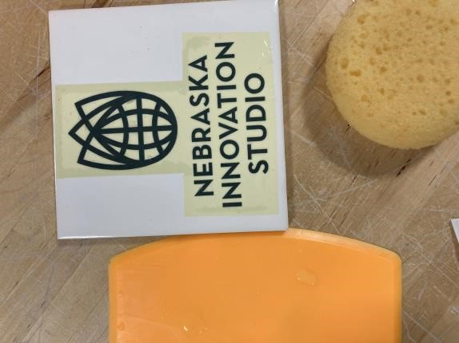

- Place the decal carefully on a clean, smooth ceramic tile, plate, mug, or other item. Use a wet sponge and the flexible squeegee to carefully smooth your decal from the inside out. When this process is done, your decal is ready to be fired.

KILN INSTRUCTIONS
Only for members cleared by NIS Staff to use the kilns

Decal Firing
Ramp/Hold
Segs 3
RA 1 - 150
°F 1 - 185
Hold 30
RA 2 - 130
°F 2 - 800
Hold 0
RA 3 - 250
°F 3 - 1580
Hold 25
ALRM 9999
complete

