SOP
48x48 CNC PLASMA CUTTER
Training is required before using this equipment
Closed Toed Shoes required
Steel Toe Protection required
Eye & Ear Protection required
Safety Gloves required
Never leave machine unattended while operating
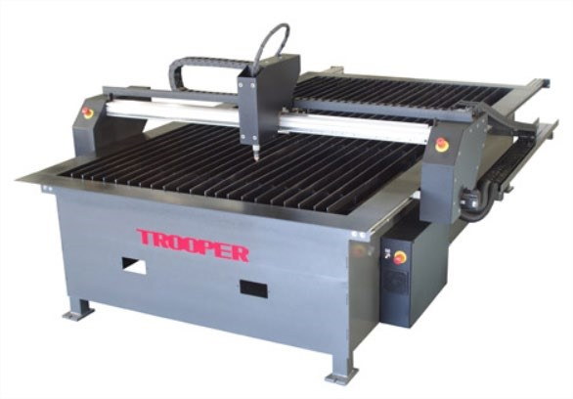

PLASMA CUTTER SPECIFICATIONS

MAXIMUM MATERIAL DIMENSIONS - 48” X 48”
MAXIMUM MATERIAL THICKNESS - ¾”
APPROVED MATERIAL - MILD STEEL, STAINLESS STEEL *ALUMINUM CANNOT BE CUT ON THIS EQUIPMENT*

YOU ARE RESPONSIBLE FOR PURCHASING CUTTING CONSUMABLES
FROM NIS.
YOU WILL NEED TO PURCHASE NOZZLES AND ELECTRODES.
NOZZLES AND ELECTRODES ARE PURCHASED AS A SET.
NOZZLES ARE AVAILABLE IN 45, 65, & 85 AMP.

- Plasma cut holes cannot be tapped. Plasma cut holes are not round and the material is hardened when plasma cut so your tap will break. If you want holes that are to be tapped use the scribe to mark a center point and drill your holes.
- The plasma cutter PC does not have internet access. All files must be imported via a personal flash drive.

CREATING YOUR FILES

The LoneStar Plasma cutter uses SheetCam and Mach3 operating software and requires a .dxf file. The following process must be followed to ensure a successful finished part.
- Use the computer lab, not the plasma cutter computer, for all file creation. All files must be saved on a personal flash drive and loaded onto plasma pc.
- Create your part file using Illustrator, AutoCad, Solidworks, VCarve, or any other software that allows .dxf file creation. It is highly recommended that you run all part files through VCarve, regardless of software used. VCarve will recognize file errors as it is a CNC software. VCarve is also the best tool for creating layers and nesting.
- Open/import your .dxf file in SheetCam and set up your material sizes, create layers and cutting processes. Once these are set run the 'post processor' to generate the required .gcode, or .tap file.
- Save your .tap file to your flash drive.
- Open your .tap file in Mach3 at the plasma cutter pc, make the final machine operational settings, and create your part.

CREATING A .DXF FILE
In order to create usable drawings in either a CAD or art application (Illustrator) certain fundamental principles must be adhered to otherwise SheetCam will not be able to manipulate the resulting file.

Outlines must be properly closed
A closed shape is any shape where the lines completely enclose an area. A square is a simple example of a closed shape. Whenever possible use shape tools rather than lines to create shapes as SheetCam will not recognize lines as shapes without further processing.
If you are using VCarve you may use ‘select open vectors’ ‘join vectors’.

Shapes must not self-intersect
A figure 8 is a self-intersecting shape. SheetCam will not cut your part as intended if your part is self-intersecting.

Convert text into lines
.dxf files cannot handle ‘true type’ fonts very well. To guarantee the cut path is exactly the same as your drawing you must convert your text into lines. This can be done by ‘exploding’ your text or using the ‘convert text to lines’ function.

Use layers
If you want to perform more than one operation on your part (i.e. using the scribe tool or cutting holes) you will need to separate these functions from your part cut. Using VCarve to create layers is the most efficient but can also be done in SheetCam. See ‘Additional Sheetcam functions’ section.

Nesting parts
If you want to cut duplicates of the same part or multiple different parts on your material at one time, you can use the nesting function in
Sheetcam, VCarve, or other design software. Vcarve is the most efficient. Nesting multiple parts will ensure that you make the best use of your material. See ‘Additional Sheetcam functions’ section.
If you are using VCarve to create your .dxf, note that there are significant differences from creating a .dxf for the plasma cutter compared to the Shopbot.
- In the job setup screen you will input the Job Size width (x) & height (y) only. The thickness & Z zero position do not apply as they are set using SheetCam.
- You do not create toolpaths as you would when using the Shopbot. Instead select your vectors until all vectors are dotted in red then go to “file/export/.dxf” and save on a flash drive.
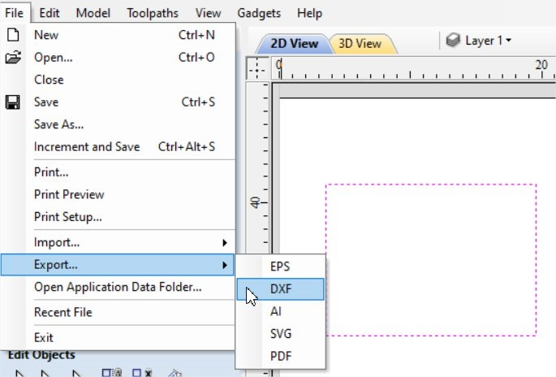
If you also want to keep the file you created and edit it in the future go to
“file/save as” to create a .crv file which can then be saved on a flash drive.

CREATING A SHEETCAM FILE
SheetCam is a CAM software used to create your tool paths, known as .gcode or .tap files. You cannot modify your part drawings in SheetCam. If you modify your drawing in your design software you must save it as a new file name. Do not save it as your original file or errors will occur. You must save your .gcode on a flash drive, bring flashdrive to the plasma pc, and load the file to the desktop.and to the desktop.
• Open Sheetcam
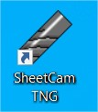
You will see three windows on the left side of the screen.
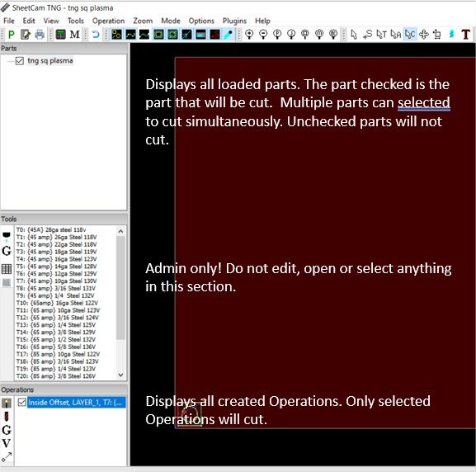

Import your .dxf file
- Go to “file/import drawing” and locate your .dxf file.

- Click ‘NO’ if you get a pop up screen
- The drawing options screen will appear. Select
  - Scaling: selection to match part creation scaling
  - Drawing position: bottom left (in most cases)
  - Check ‘Use drawing name as part name’ box
  - Click OK
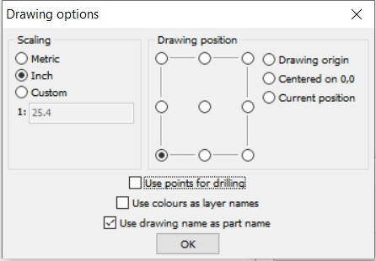
Your part will line up with the bottom left corner (0,0) edges of your material in the part view screen. This is ok. You will relocate your parts in the ‘Nesting’ function described later. When nesting parts you will need to leave enough space around and between your parts to fit on your sheet and allow for lead ins and lead outs. For more on nesting parts see ‘Additional SheetCam functions’ section.

Your part file should now appear in the top left section under ‘Parts’ and the part image should appear in the large file view window. If it does not appear in the window, make sure that the check box next to your part file is checked.

Creating layers
Every cut/scribe function must be placed on “layer” for the plasma cutting software to recognize the function you want to perform.
- Scribe functions must have their own layer and will always be performed before any cuts.
- Holes smaller than ½” are inside cuts and must be on a separate layer than all other larger holes and all outside cuts.
- Holes larger than ½” can be placed in the same layer as outside cuts.
Sheetcam automatically recognizes the correct cut to be performed.

To create layers for each part you are cutting you must follow these steps, in order. These steps must be followed for each part, individually.
- Check the box in front of the part in which you will be creating layers.
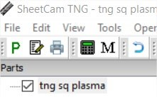
- Select ‘Edit contours’ icon in upper toolbar.
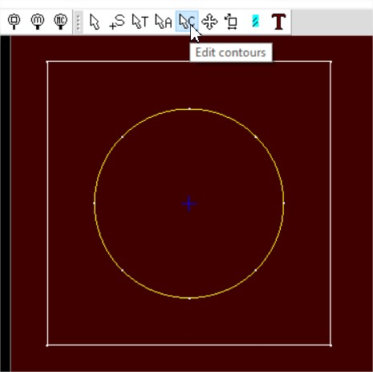
- Hover over each vector you want to put on a different layer and right click. Select the “Move To Layer” selection and either create a new layer, or move to a layer you have already created.
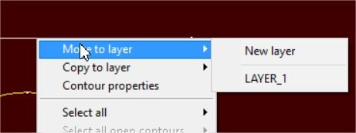
- If all your cuts can be placed on a single layer, you may use the ‘Select all’ function.
- After all cut operations have been placed on a layer you will then create ‘Operations’ for each layer.
If you create an operation that is not compatible with the table or the settings are wrong, it will be highlighted in red and show you a message saying it cannot be done.

Material cut settings (Operations)
Your cut settings and tool settings are critical to a successful job. Incorrect settings will result in parts cut incorrectly, material waste, rapid wear to your consumables, and will require excessive post processing and cleaning of your parts.
On the lower left side of the screen, under ‘Operations’, click on the wand.
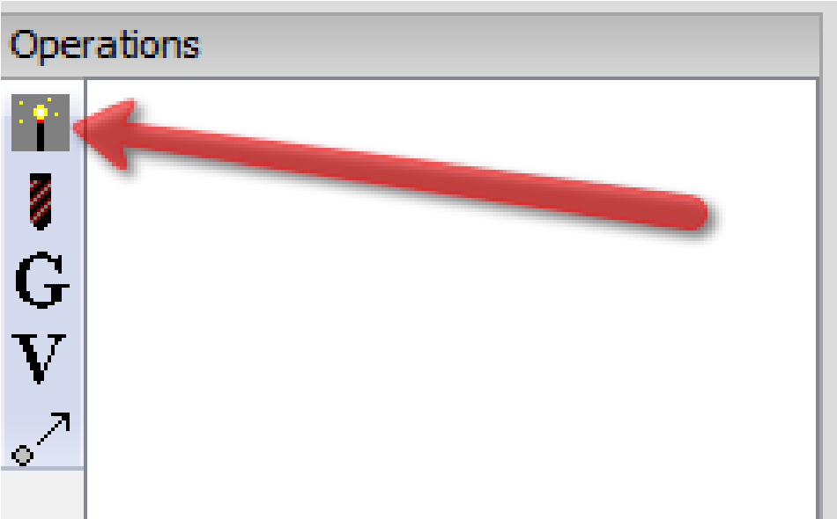
A new window will pop up that will allow you to select the parameters for your cut job.
- Change the numbered selections outlined below only.
- Separate layers must have separate Operations.
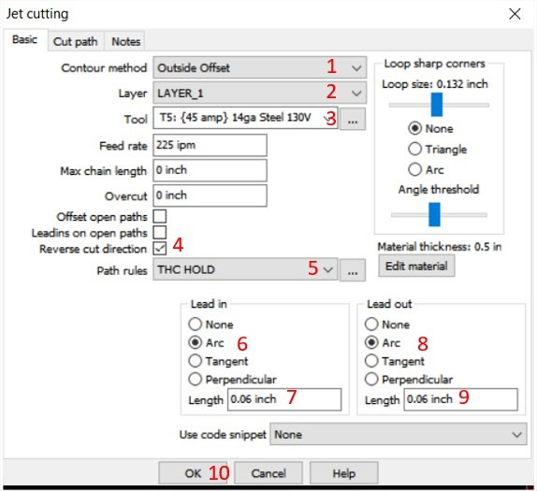

1. Contour method
- Inside Offset--Used for holes. Plasma will cut inside your line.
- Outside Offset--Used for most cuts. Plasma will cut outside your line for exterior shapes and will also automatically cut inside your line for inner shapes larger than ½”. Use this setting for 99% of your cuts.
- No Offset--Cuts on your line. Also used for Scribe.

2. Layer
Most cut files will be set up on a single layer. The exception to this is when you are using the scribe tool or cutting smaller holes for bolts. Most holes will cut very well on the same layer as your outside offset cuts. If you must create a new layer use your design software and put the smaller holes on a separate layer from your standard cuts. You will also need to select Inside offset in your contour method drop down. You can create separate layers in SheetCam. See ‘Additional SheetCam functions’ section.

3. Tool
Your tool selection is based on the gauge, or thickness, of your material and your material type (steel, stainless steel) you will be using for your job. Use a metal gauge scale or calipers and conversion chart to confirm your material thickness.
When using the scribe tool you will select ‘T100 Scribe tool’. This function must be on a separate layer and must be the first operation performed.
When you select your gauge and material type make note of the nozzle size (45, 65, 85 amp) and the volt setting for your job.
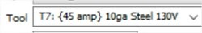
It is critical that your nozzle selection and volt settings match the material parameters given in the tool settings when cutting.
- Reverse cut direction
Verify the reverse cut direction box is checked.
- Path Rules
Verify ‘THC HOLD’ is selected.
- Lead In
Select ‘Arc’.

7. Length
The length of your lead in must be close to but not less than the
thickness of your material for Outside and Inside Offset.
8. Lead out
Select ‘Arc’.

9. Length
The length of your lead out must be close to but not less than the thickness of your material for Outside offset and half your material thickness for Inside offset.

10. Click OK

• Under the ‘Operations’ section at the bottom left of your screen will be a list of all operations you created. If any operation is highlighted in red find an NIS staff person.
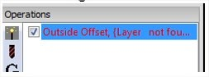

ADDITIONAL SHEETCAM FUNCTIONS
There are a number of functions that allow you to fine tune your file before cutting. These functions are added to your process after you have created your ‘Operations’.

SCRIBE TOOL
The scribe tool will “engrave” your material. It is attached to the plasma cutter and automatically locates itself based on the 0/0 position you set for your material cut functions, so no additional coordinate settings are needed.

All scribe functions MUST be performed before any cut functions.

Depending on the size and thickness of your material you may need to manually hold your material in place while scribing. When the scribe function is complete you must move away from the material while the plasma is cutting.

When creating your scribe toolpaths you will need to place all scribe toolpaths on a separate layer from your cutting toolpaths.

Regardless of which software you create your scribe layers you must also create separate ‘Operations’ for your scribe functions in Sheetcam.

NESTING
The nesting function allows you to move your parts around on your material to ensure you have the required space around each part for lead ins & lead outs, as well as set distances to your material edges. If you are nesting multiple parts it is recommended that you use VCarve. If you are nesting a couple parts you can use Sheetcam.
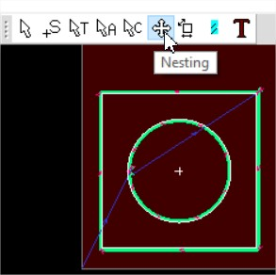
- Select the ‘Operation’ that contains the part(s) you intend to move.
- Click on the ‘Nesting’ icon.
- Use the arrow keys to move your part(s). In this example the part has been relocated to 0.3937” from the xy 0,0 (see bottom right of Sheetcam screen).
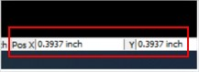

EDIT START POINTS
Start points are the locations in which the plasma cutter will make the initial pierce in your material to cut your parts. Start points are always outside or inside of your part itself.
- The plasma should never begin the cut on your part cut lines.
- You must have enough of a border around your part(s) to allow your lead in/lead out to occur on your material.
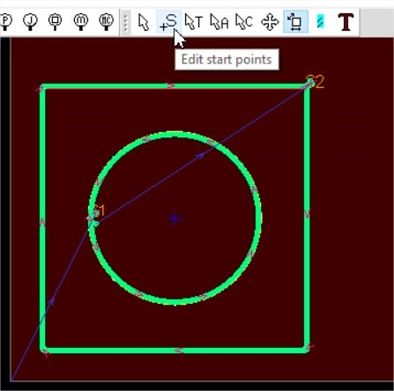
- Select the ‘Operation’ that contains the part(s) you intend to edit the start points.
- Click on the ‘Edit start points’ icon.
- Locate your mouse at the position you intend to move your start point and left click. Your start point should now move to the location you selected. Start points are designated by the letter ‘S’ followed by a number. i.e. S1, S2, etc.

SIMULATION MODE
• To check your cut file operation use the Simulation mode in SheetCam located on the right side of your upper toolbar.


CREATING A MACH3 FILE

You are now ready to run the post processor and create your .gcode, or .tap file, and send it to the Mach3 software to cut your part.
- Make sure that all parts you intend to cut have an operation assigned to them and that all files in the ‘Parts’ section have the boxes checked.
- Click on the ‘P’ icon in the upper left corner of your toolbar.
R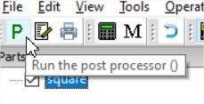
- Save your .gcode file to your flash drive. The plasma PC does not have internet access so all files must be imported using a flash drive.

OPERATING THE PLASMA CUTTER
The LoneStar Trooper plasma cutter has a capacity of cutting sheets up to ¾” thick and 48” x 48” in size. It can cut mild steel and stainless steel. It cannot cut aluminum. You must wear gloves when loading and unloading your material and parts. Safety glasses, ear protection, and steel toe protection are required at all times. You cannot leave the machine unattended when running.

CONSUMABLE SPECIFICATIONS
You must purchase your consumables from NIS. In most cases, when a
nozzle needs to be replaced, the electrode needs to be replaced.
Consumables must be installed as shown in the consumable assembly diagrams.
Mild steel and stainless steel use the same consumables but require different tool selections in the SheetCam software as the speeds and voltage setting are different.
Your cut speeds are set automatically when you select your tool in the SheetCam software and should only be adjusted after consulting an NIS staff person.
Each chart contains the following information:
- Material Thickness – Thickness of the workpiece (metal plate being cut). Measured in gauge or Imperial fraction. Always verify your material thickness with calipers or material thickness gauge.
- Best Quality Settings (cut speed and voltage) – Settings that provide the starting point for finding the best cut quality (best angle, least dross, best cut-surface finish). We recommend using Best Quality Settings for most jobs.
- Production Settings (cut speed and voltage) – 80% of the maximum speed ratings. These speeds result in the greatest number of parts cut per job time, but not necessarily the best possible cut quality.

85 AMP SHIELDED CONSUMABLES ASSEMBLY
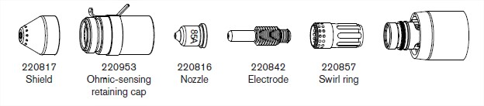

85 AMP SHIELDED MILD STEEL SETTINGS

Material Thickness | Best Quality Sett | ings | Production Sett | ings
Material Thickness | Cut Speed | Voltage | Cut Speed | Voltage
 | ipm | Volts | ipm | Volts
3/8 in | 70 | 126 | 86 | 127
1/2 in | 45 | 131 | 56 | 131
5/8 in | 35 | 134 | 37 | 133
3/4 in | 24 | 136 | 29 | 135

85 AMP SHIELDED STAINLESS STEEL SETTINGS

Material Thickness | Best Quality Settin | gs | Production Setti | ngs
Material Thickness | Cut Speed | Voltage | Cut Speed | Voltage
 | ipm | Volts | ipm | Volts
3/8 in | 65 | 126 | 80 | 125
1/2 in | 36 | 132 | 48 | 131
5/8 in | 28 | 135 | 30 | 134
3/4 in | 20 | 137 | 24 | 136

65 AMP SHIELDED CONSUMABLES ASSEMBLY

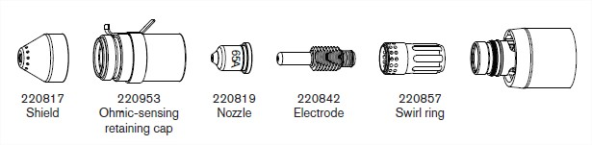

65 AMP SHIELDED MILD STEEL SETTINGS
Material Thickness | Best Quality Sett | ings | Production Setti | ngs
Material Thickness | Cut Speed | Voltage | Cut Speed | Voltage
 | ipm | Volts | ipm | Volts
3/16 in | 140 | 126 | 168 | 125
1/4 in | 90 | 127 | 116 | 127
3/8 in | 45 | 130 | 62 | 129

65 AMP SHIELDED STAINLESS STEEL SETTINGS
Material Thickness | Best Quality Setti | ngs | Production Setti | ngs
Material Thickness | Cut Speed | Voltage | Cut Speed | Voltage
 | ipm | Volts | ipm | Volts
3/16 in | 155 | 126 | 168 | 125
1/4 in | 80 | 126 | 96 | 126
3/8 in | 40 | 131 | 52 | 131

45 AMP SHIELDED CONSUMABLES ASSEMBLY
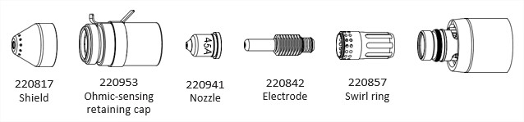

45 AMP SHIELDED MILD STEEL SETTINGS

Material Thickness | Best Quality Settings |  | Production Settings
Material Thickness | Cut Speed | Voltage | Cut Speed | Voltage
 | ipm | Volts | ipm | Volts
28GA | 350 | 128 | 500 | 128
26GA | 350 | 128 | 500 | 128
22GA | 350 | 128 | 450 | 128
18GA | 350 | 129 | 400 | 128
16GA | 350 | 130 | 400 | 129
14GA | 270 | 130 | 320 | 129
12GA | 190 | 133 | 216 | 131
10GA | 100 | 134 | 164 | 131

45 AMP SHIELDED STAINLESS STEEL SETTINGS

Material Thickness | Best Quality Setti | ngs | Production Settin | gs
Material Thickness | Cut Speed | Voltage | Cut Speed | Voltage
 | ipm | Volts | ipm | Volts
28GA | 350 | 160 | 500 | 129
26GA | 350 | 130 | 500 | 129
22GA | 350 | 130 | 450 | 129
18GA | 350 | 130 | 400 | 130
16GA | 350 | 130 | 400 | 130
14GA | 250 | 132 | 360 | 131
12GA | 140 | 132 | 206 | 131
10GA | 100 | 133 | 134 | 134

INSTALLING THE NOZZLE AND ELECTRODE
- Manually move the control head to a position that allows you to install your electrode and nozzle. Your correct nozzle (45a, 65a, 85a) is determined by the tool you selected when creating your file in SheetCam.
- Remove the wire connected to the lower black section of the cutter head by grasping the connector, not the wire, and pulling it away from the cutter head at a 45°.
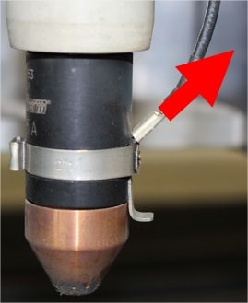
- Grasp the upper gray section of the cutter firmly in one hand and the lower black section of the cutter head firmly in the other hand and rotate the black section clockwise until it separates from the upper section.
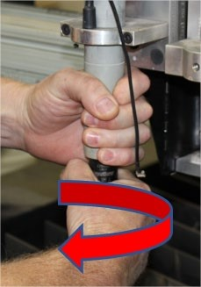
- Install your nozzle, point down, into the nozzle cup and your electrode, spring up, into the nozzle. Re-attach the nozzle assembly onto the gray housing by reversing the removal process. Make sure that both the upper gray and lower black sections are tight.
- Re-attach the wire to the connector.
- Set your voltage on the control box below the computer. Your voltage setting is determined by the tool selection you made when creating your SheetCam file. Rotate the dial until the correct voltage appears and push the dial in to set.

POWERING UP THE PLASMA CUTTER
- Turn on power to the Powermax 85 power supply located on the back upper left of the power supply.
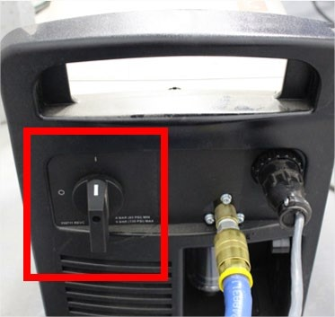
- On the front of the power supply check that the amps are set to the same amperage as your consumables (45a, 65a, 85a) and the dial is set to the second cut function.
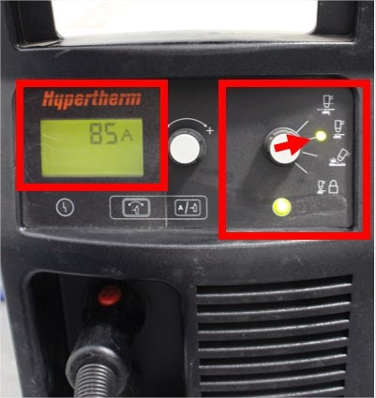
- Verify that the warning light below the amp readout screen is not lit. If lit locate an NIS staff person.
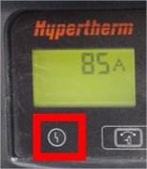

- Turn power on to the computer and voltage regulator located below the computer on middle shelf.
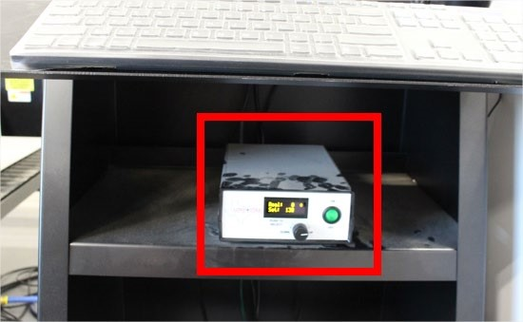
- Set the table water level by adjusting valves on back of machine.
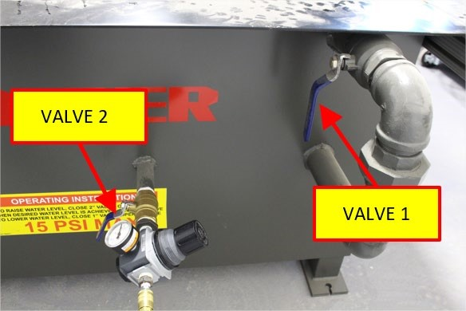
  - Verify valve 1 is closed.
  - Open valve 2 and fill bed until water is 1/2” below table lip then close valve completely.
  - Do not adjust air pressure.
- Verify that the bed slats are fully engaged in the slat holders.
- There are 3 E-Stop buttons located on the power box and on both the left and right side of the gantry. Verify all 3 are released by pulling on the buttons.
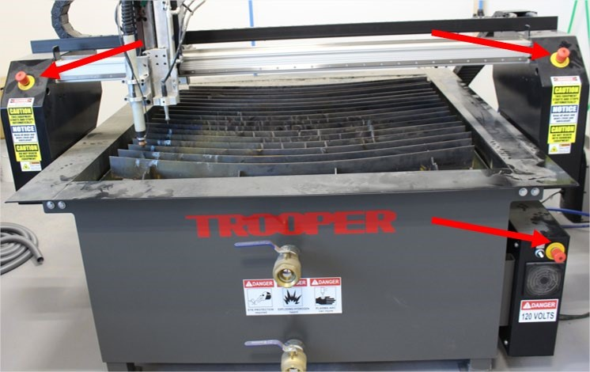
- Verify the gantry and cutter head are not at the x,y,z limit stops. If they are, manually move them away from the stops.
- Turn on the power switch located on the lower right power box.
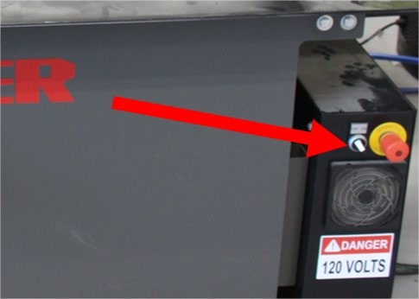

- Turn on overhead ventilation switch located just inside double doors.
- Put on your safety gloves and load your material on the plasma bed. If you need help, ask for it.

LOADING YOUR MACH3 FILE

When you initially open the Mach3 software there are several steps you must perform every time you use the software and plasma cutter.

- Turn on the pc.
- Open the Mach3 software.
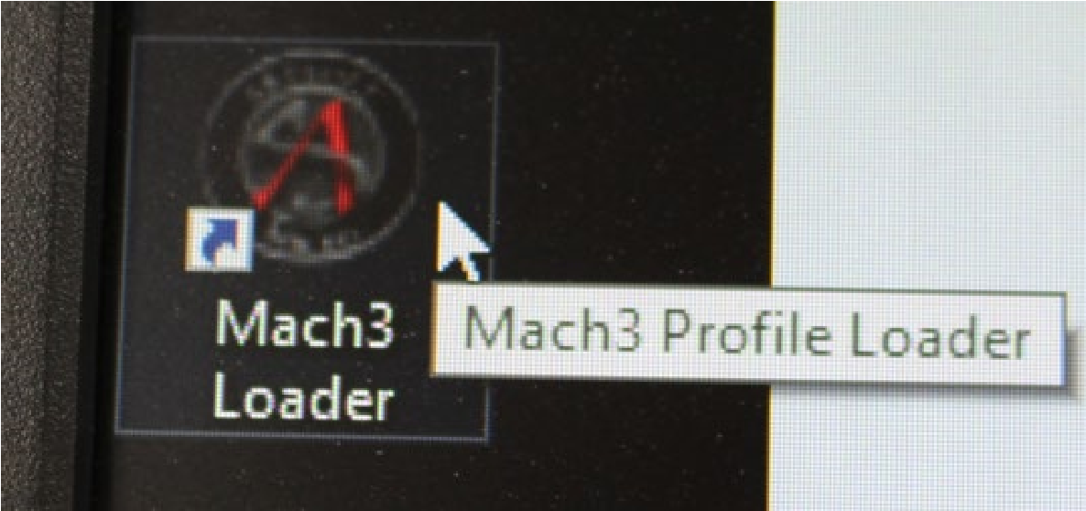
- If you get this warning then you did not power up the plasma cutter prior to opening the software. Turn on plasma cutter power then click ‘Yes’
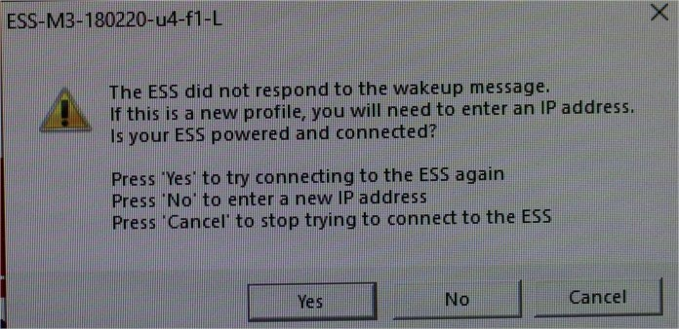
- When the software opens correctly you will see this screen.
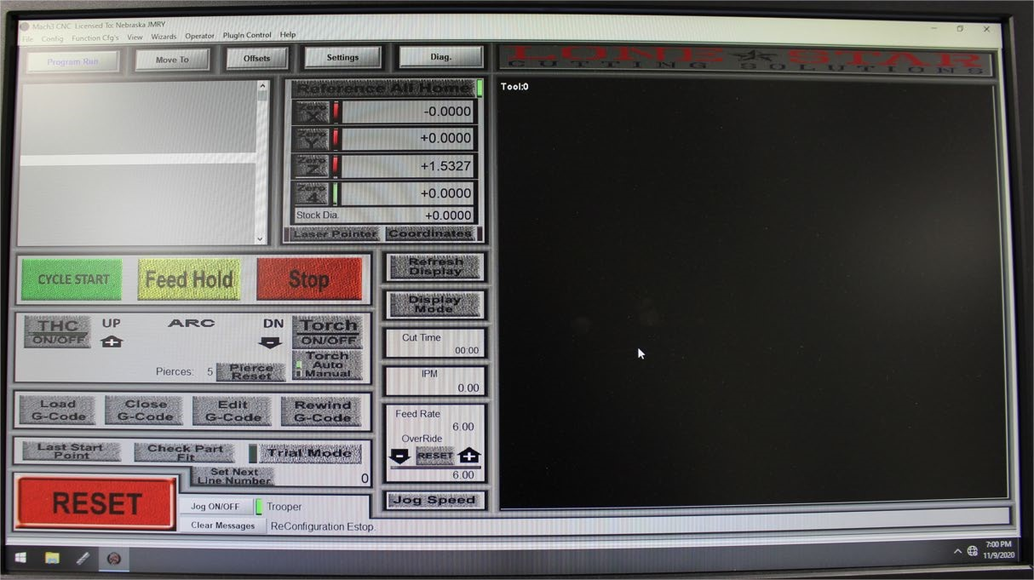

MACH3 BUTTON FUNCTIONS
It is very important you understand the function of the buttons in the Mach3 software. Depending on your cut situation, the button you push can allow you to save your job if an error occurs or start over and scrap your material. Spend a few minutes now reading through and understanding the button function and familiarizing yourself with the button locations on your screen.
*If a button is not detailed here, do not use it.*

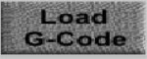

Loads your .gcode, or .tap file into Mach3.

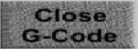
Closes the .gcode file currently loaded in Mach3.

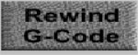
Rewinds the currently loaded .gcode file

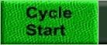
Executes the G-Code loaded into memory.


Stops motion of all axis and outputs remain active Press Cycle start to resume motion.
If an error occurs while cutting your first action.


Stops all motion and turns off all outputs.
Does not allow you to resume your cut.
This is a last resort.

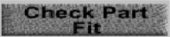
Travels cutter to verify part will fit on material.
Perform this function after .tap file loaded, home referenced, & your X,Y,Z homed.


Zeros the X axis DRO (Digital Read Out)


Zeros the Y axis DRO


Zeros the Z axis DRO

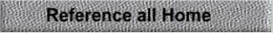
Sends cutter head to home switches
Verifies soft limits
Sets absolute machine coordinates to Zero

- A RESET button is located at the bottom right of the screen and should be flashing. To the right of the RESET button should be the statement ‘Application watchdog triggered’. If so, click the flashing RESET button. The application message should now be gone and the RESET button will stop flashing.
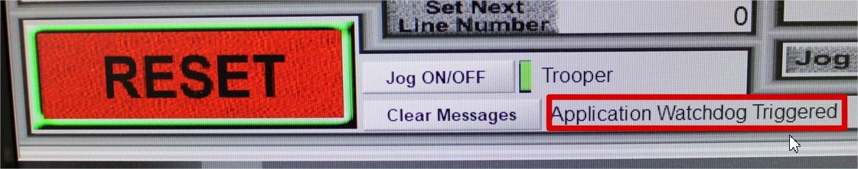
- Move the gantry and cutter head to the upper right of the table using the arrow keys until the gantry stops moving then reverse movement direction to bring them off the stops by approximately 4”. The left/right arrows moves the cutter head on the X axis and the up/down arrows moves the cutter head on the Y axis. The ‘pgup/pgdown’ buttons move the cutter head on the Z axis.
- Make sure that the cutter head is not at the soft limits before performing the next step.
- Click on the ‘Reference All Home’ button located in the upper middle of the screen above the X,Y, & Z zero displays. The gantry will now move to the machine home position located in the upper right corner of the plasma table. The X,Y, & Z red indicator lights should now turn from red to green.
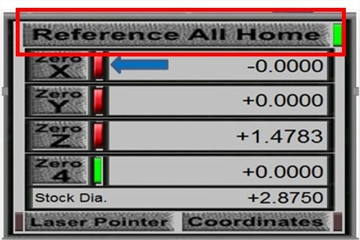
- Turn on the THC (Torch Height Control) by clicking on it once so it flashes green. This feature allows the torch to automatically read the voltage levels while cutting and adjust height for a better cut quality.
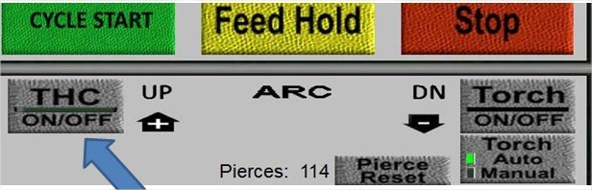
- Load your .tap file by clicking on the ‘load g-code’ button located below the ‘THC ON/OFF’ button.
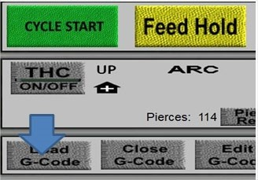
- Locate your material on the plasma bed so that the material is fully supported by the table support strips. Do not always use the table’s XY home position. As long as your material is fully supported you can locate your material anywhere on the 48x48 bed area.
- Turn on the ‘Laser Pointer’ located just below the ‘Reference All Home’ box.
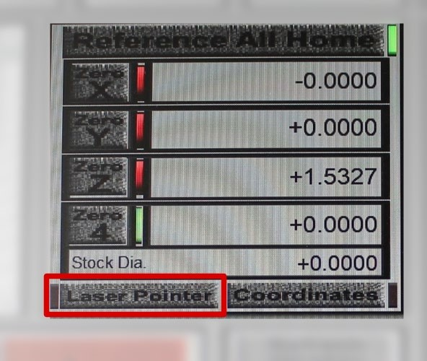
- If necessary use the keyboard ‘page up’ key to move your cutting head up to a safe distance to clear all obstructions.
- Use the keyboard ‘arrow’ keys to move the plasma head to your desired home, or 0/0 position on your material.
- Move the cutter head so that it is between 2 “ and 4” from your material surface.
- Zero out your home location by clicking on the ‘Zero X’, ‘Zero Y’ & ‘Zero Z’ buttons.
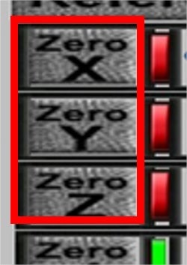
- Click the ‘REFRESH DISPLAY’ button. The X coordinate will now read ‘0’, the Y coordinate will now read 0.8036, the Z coordinate will now read ‘0’, and the lights to the right of the Zero buttons must be green. The cutter head will Z-zero off your material automatically when your cut begins. *It is critical that you perform this command or the cutter head will crash.*

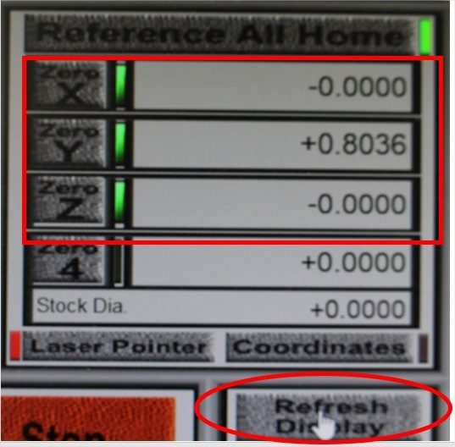
- If at anytime during your process you would like to return to your set home position click on the ‘MOVE TO’ button near the top/middle of the left display screen.
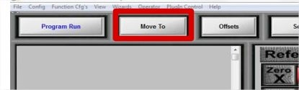
- A new screen will open on the right side of your display. Click on the ‘Zero’s’ button.
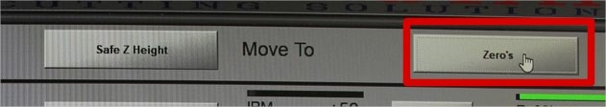

Check Part Fit & Trial Mode
Check part fit will perform a ‘ghost run’ of your files to make sure that they will fit on your material and are in the correct location. It is recommended you always run a check part fit before cutting.
Trial mode will perform a ‘ghost cut’ of your files to make sure that your operations are performed in the correct sequence and that all parts will be cut.
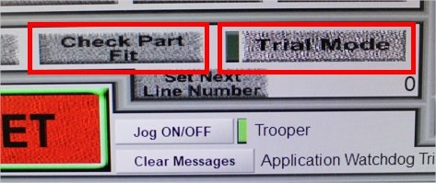

- You are now ready to cut your file. Make sure you are wearing eye and ear protection, the overhead filtration is on, and all flammables are removed from the immediate work area.
- Click the ‘CYCLE START” button located above the ‘THC ON/OFF’ button.
- Hover your cursor over the ‘FEED HOLD’ button so you can pause your job if something goes wrong. Hitting ‘STOP’ will not allow you to resume your current job. If you had to pause your job, see ‘RESTARTING A PLASMA CUT’ section for further instruction.
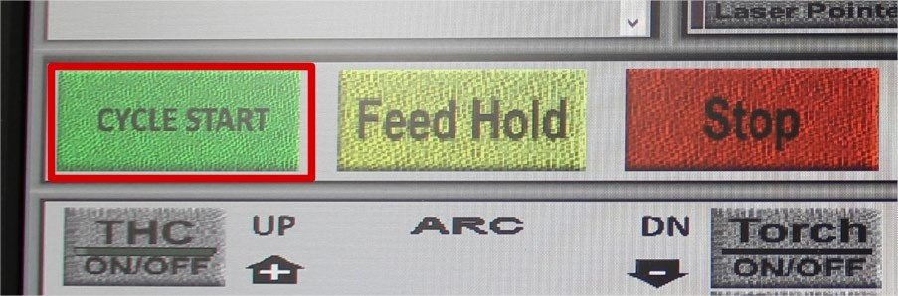

CUT QUALITY
There are several factors to consider in cut quality:
- Cut/beveled angle — The degree of angularity of the cut edge.
- Dross — The molten material that solidifies on the top or bottom of
the workpiece.
- Flatness of the cutting surface-the material can be concave or convex

CUT ANGLE
- A positive cut angle results when more material is removed from the top of the cut than from the bottom. Decrease the voltage in small increments until a square cut is obtained.
- A negative cut angle results when more material is removed from the bottom of the cut. Increase the voltage in small increments until a square cut is obtained.
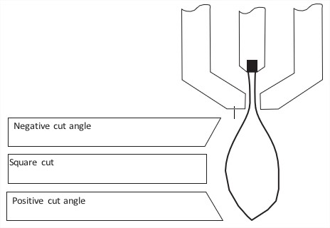

The squarest cut angle will be on the right side with respect to the forward motion of the torch. The left side will always have some degree of bevel.

DROSS
Some amount of dross will always be present when cutting with air plasma. You can minimize the amount and type of dross by adjusting your system correctly for your application.
Worn consumables (cutting nozzle & electrode) are a primary cause of excessive dross. Before making any adjustments to the cut process check for worn or oval conditions on the nozzle. (see consumable inspection chart).
Excess dross appears on the top edge of both pieces of the plate when the voltage is too low or cutting speed is too fast. Increase the voltage in small increments (2 volts or less) or decrease the cutting speed until the dross is reduced.
Excess dross appears on the bottom edge of both pieces of the plate when the voltage is too high or cutting speed is too slow. Decrease the voltage in small increments (2 volts or less) or increase the speed to reduce this type of dross.

UNLOADING YOUR PARTS
When your job is complete you will need to unload your parts, your drop, and your parts skeleton. You must wear gloves during this procedure as many of your parts will be hot and sharp.
Based on your part sizes some of your parts will fall below the cutting support strips and be submerged under water. Before removing any parts you will need to complete the bed draining process.
- Open valve 1 located on the back of the machine until the water level no longer drops.
- Close valve 1.
- Remove your parts from the support slats and expanded metal grate.
- Your parts may be wet so you may want to dry them off to prevent rust.
- Your waste must be placed in the dumpster outside the studio.

EQUIPMENT SHUTDOWN AND CLEANUP
- Wipe down the plasma cutter and mop wet areas to remove water spills.
- Power down the plasma table.
- Power down the volt control box.
- Power down the plasma power supply.
- Remove your consumables and take them with you.
- Turn off ventilation.
- Close CNC room doors.

RESTARTING A PLASMA CUT
There are circumstances in which your job may quit mid cut and you will have to restart in the middle of a job. Some common causes for a failed cut are:
- Loss of consumables during a cut. Your consumables are worn past the point of correct operation. You will need to replace your consumables.
- Shorting of the torch. The torch moves too close or too far from the material. This is most often caused by warped material or worn consumables.
- Loss of arc transfer. See NIS staff.
- Low/high air pressure. See NIS staff.

If your job stops or you stop it mid-process, you are still able to pick up where you left off. You must first identify the .gcode where your cut stopped.
- Visually identify where on your physical part where the cut stopped and reference that location on the display screen on the right side of pc monitor.
- Scroll through the code on the left side of your screen while watching the display on the right side of your screen. As you scroll you will notice a white dot moving through the image of your part file.
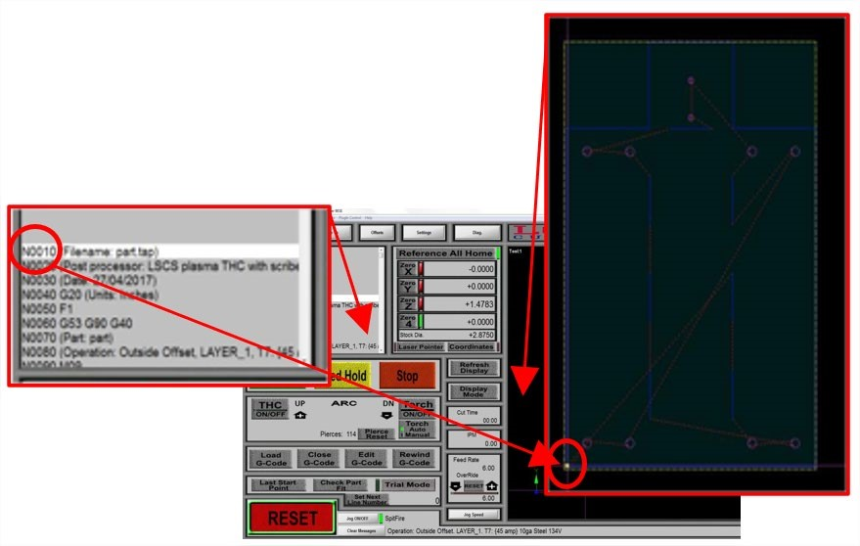
- When you identify the location where the cut stopped on the display screen stop scrolling and reference back to the .gcode list on the left side of your screen.
- Identify the M05 command that most recently appears above the code line you identified and scroll up to it.

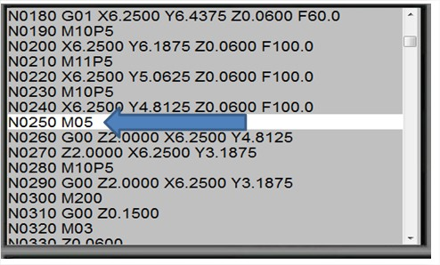

- Click the ‘Set Next Line Number’ button located to the right of the ‘RESET’ button.
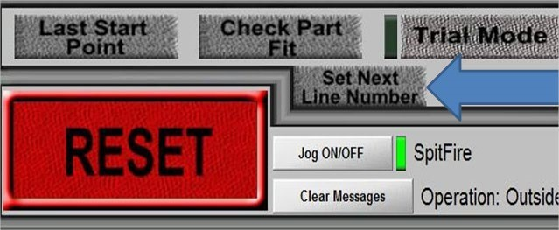

The next step in the process will depend on where in the cut the arc stopped.
- If you lost arc at the pierce point of the part, press ‘CYCLE START’. Make sure that the cutter arcs and the cut starts.
- If you lost your arc anywhere during the actual part cut and you have a piece of lighter gauge (20ga or less) scrap metal, place the scrap over the area of your part in which the cut failed and where the gcode will start.
  - Verify that the ‘THC ON/OFF’ button is flashing green (ON).
  - Press ‘CYCLE START’.
- If you lost arc anywhere during the actual part cut and you don’t have a piece of thinner gauge material, you will need to perform these steps: o Turn off the ‘THC On/Off’ button (stops flashing green).
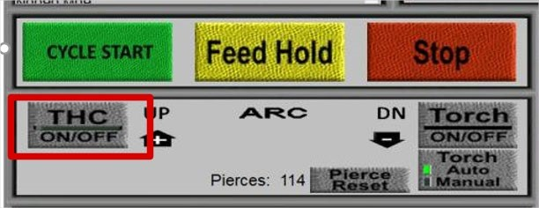
  - Press “CYCLE START’
  - As soon as the torch starts moving forward in the part cut click the ‘Torch ON/OFF’ button to stop the arc. The torch head will continue to move through your part cut without cutting.
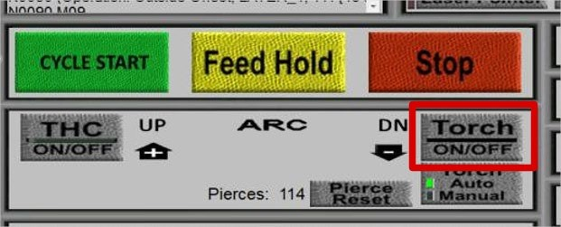
  - When the torch head is 1” to 2” away from where your initial cut failed click the ‘Torch ON/OFF’ button again to fire the torch.
  - When the arc is on cutting fresh metal click the ‘THC ON/OFF’ button again so it flashes green.
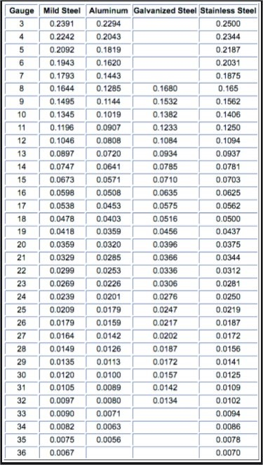

SOP
CNC PLASMA CUTTER

Nebraska Innovation Studio



