SOP
Panel Saw
Training is required before using this equipment
Closed Toed Shoes required Eye Protection required
No Loose clothing No jewelry
Long hair tied back
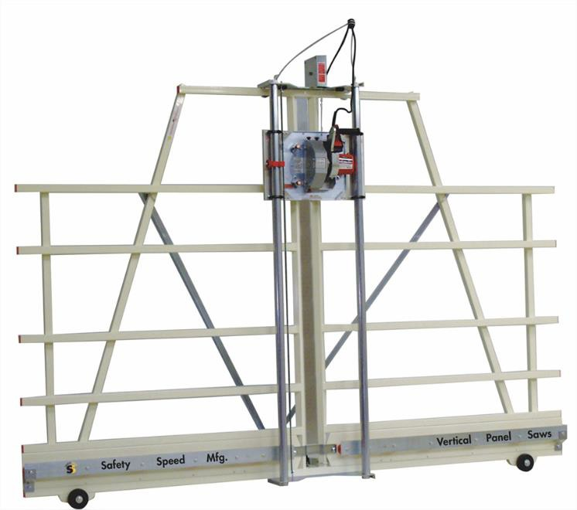

PANEL SAW COMPONENTS

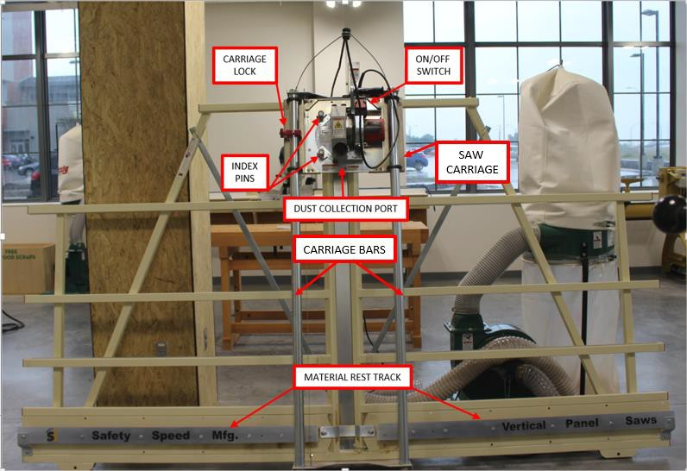

PANEL SAW CAPABILITIES
Maximum material thickness: ¾”
Maximum material width: 60”
Maximum material length: 120”
Maximum vertical cut: 48”
Types of cut: horizontal & vertical

VERTICAL CUTS
The panel saw will accept up to 60” wide material. Maximum material width (or height when your material is resting on the saw) for vertical cuts is 48”. If your material is more than 48” wide you must first make a horizontal cut.
(see “Horizontal Cuts”)

Step 1: LOADING YOUR MATERIAL
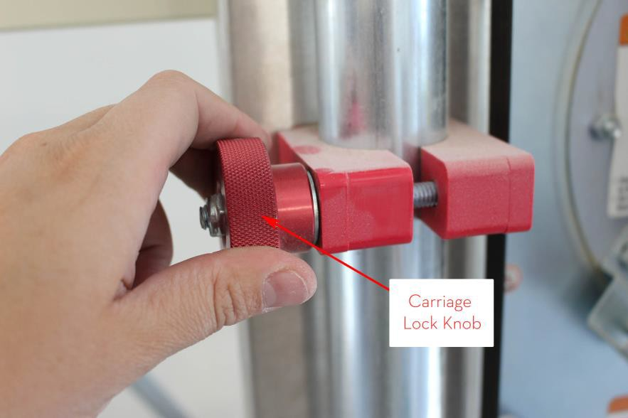
- Loosen the carriage lock knob and make sure saw is raised to the top of the carriage bars.

- Load your material onto the saw making sure that your material sits flush on the red rollers of the material rest track, with the “good” side of your material resting against the vertical saw frame, or away from you.
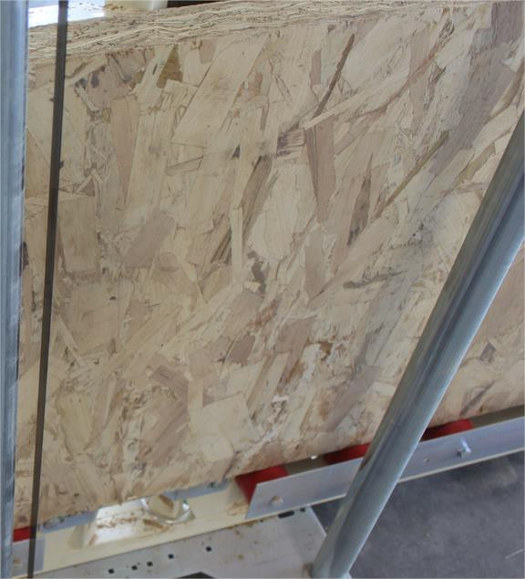

Step 2: MARKING YOUR CUT LINES

- Using a tape measure and pencil, mark a short cut line at the top edge of your material.
- Line up your cut mark with the blade by loosening the carriage lock knob and lowering the saw until you can see your mark through the dust collection port.
Make sure that you are lining up the blade to the waste side of your cut line.
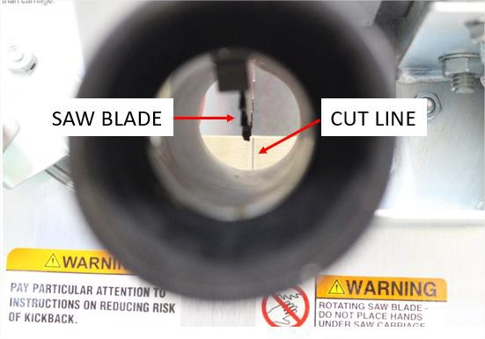
When making multiple vertical cuts at the same dimension you should place a clamp on one of the horizontal frame members to serve as a back stop for your material.
By carefully sliding your material to the clamp you will be able to repeat your premeasured cuts.
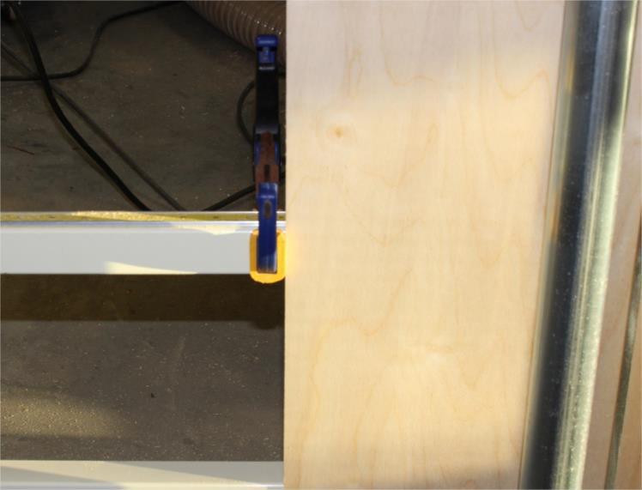


Step 3: PREPARING YOUR MATERIAL TO CUT

You must first check if your material is warped or flat. If it is flat you may proceed with cutting your material. If it is warped you should clamp your material to the saw frame as follows:

- On one side of the saw blade, place a quick grip clamp on your material so that it captures your material and the saw frame.
NEVER CLAMP YOUR MATERIAL DOWN ON BOTH SIDES OF THE SAW BLADE.
You will create a pinch point and kickback will occur. One end of your material must be able to move freely.
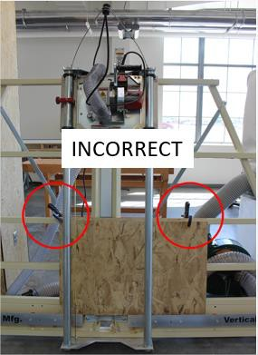
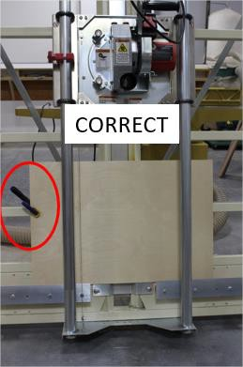

Step 4: DUST COLLECTION

Attach the vacuum hose from one of the shop vacs directly to the saw body vacuum port and turn the vacuum on. Make sure that the vacuum hose does not create an obstruction in the cutting area.
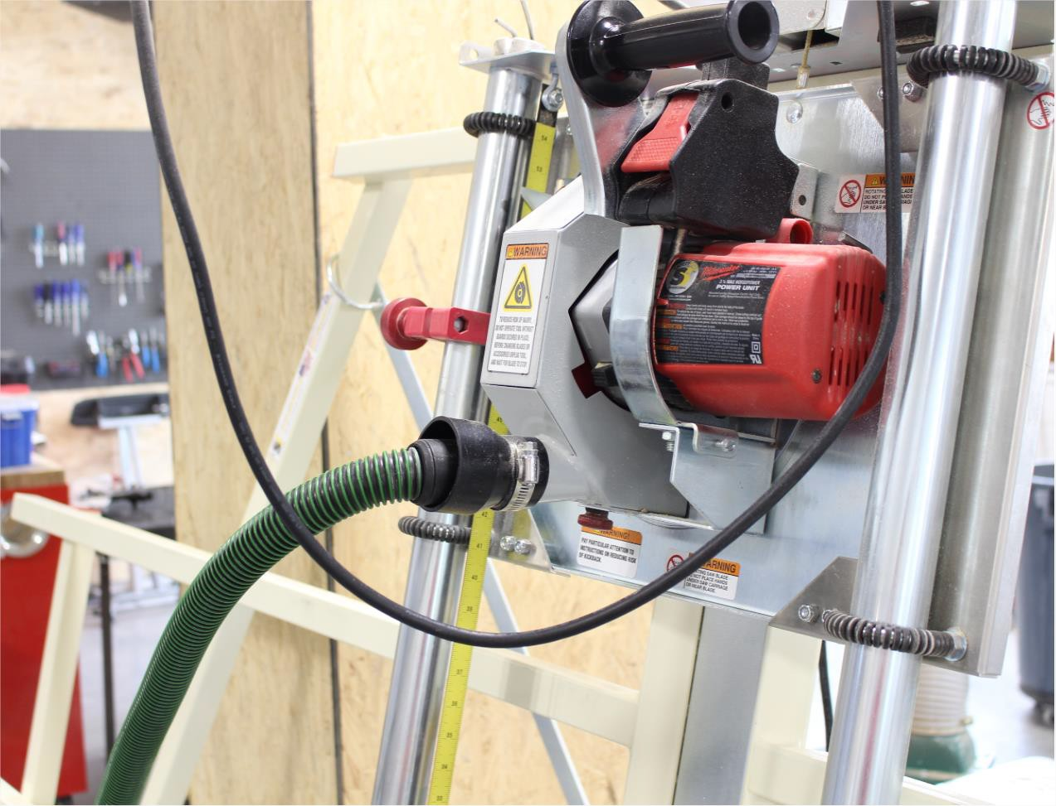


Step 5: POWERING ON THE SAW
The on/off switch pulls up to turn the machine on and pushes down to turn off the machine.

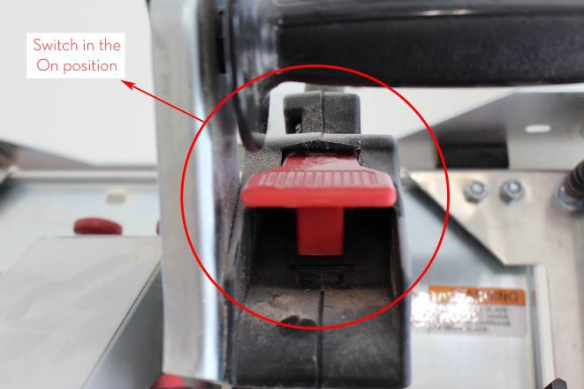
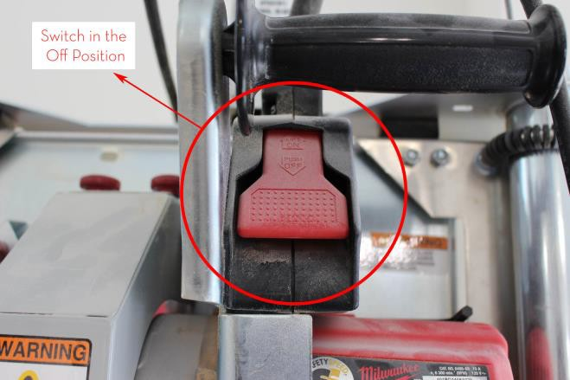

Step 6: MAKING YOUR CUT

- In order to maintain the correct leverage and avoid injury you must always cut from a full standing position. Do not crouch or squat.
- When the saw is at full speed, gently glide the blade down into your material. Push the carriage all the way down to the floor and turn off the saw. DO NOT RETURN THE CARRIAGE TO THE TOP OF THE FRAME WHILE IT IS STILL
RUNNING. Failure to operate in this manner will create kick back and damage your material.
- After the blade has stopped running return the carriage to the top of the frame, remove your material and turn off the dust collection.
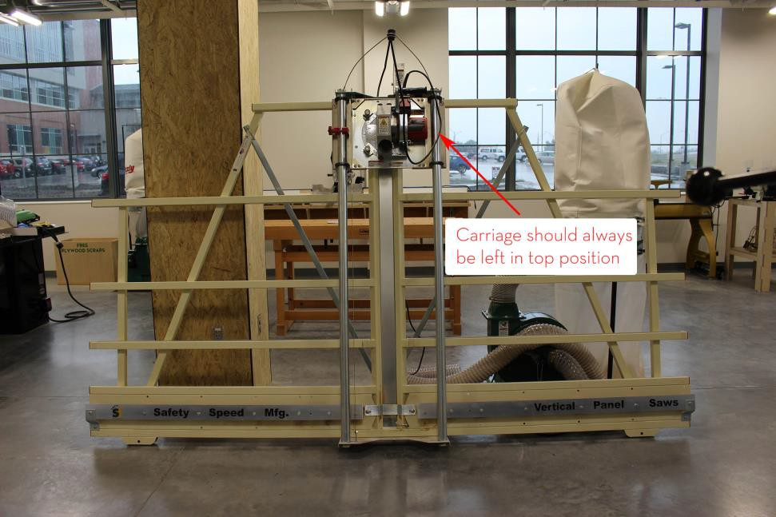

- If you are making multiple cuts, repeat the cutting process.

Step 8: CLEANUP

- Remove and store all clamps so that they do not interfere with the cutting area.
- Dispose of all material waste.
- Vacuum entire saw, saw area, and surrounding floor.
- Put away vacuum and hoses.

HORIZONTAL CUTS

The panel saw will accept up to 60” wide material (or height when your material is resting on the saw). If your material is more than 48” wide and you need to do a vertical cut you must first complete a horizontal cut.

Step 1: LOADING YOUR MATERIAL
- Loosen the carriage lock knob and make sure saw is raised to the top of the carriage bars.

- Load your material onto the saw making sure that your material:

  - Sits flush on the red rollers of the material rest track, with the “good” side of your material resting against the vertical saw frame, or away from you.
  - Is to the left or right side of the saw carriage and outside of the carriage bars.

Step 2: HORIZONTAL CUT SETUP

The panel saw should be kept in the vertical cut position unless a horizontal cut is required. In order to make horizontal cut you must rotate the saw 90 degrees clockwise or counterclockwise.

To make a horizontal cut:

- Locate the material direction arrows on the saw body.
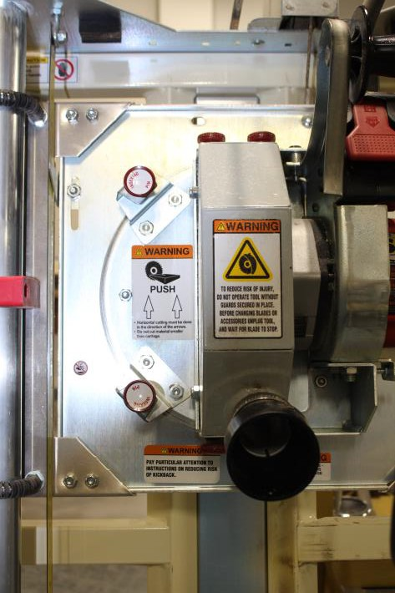


- Locate the 2 indexing pins on the front on the saw carriage housing.



YOUR MATERIAL MUST MOVE WITH THE ARROWS WHEN YOU PUSH YOUR MATERIAL THROUGH THE SAW BLADE.
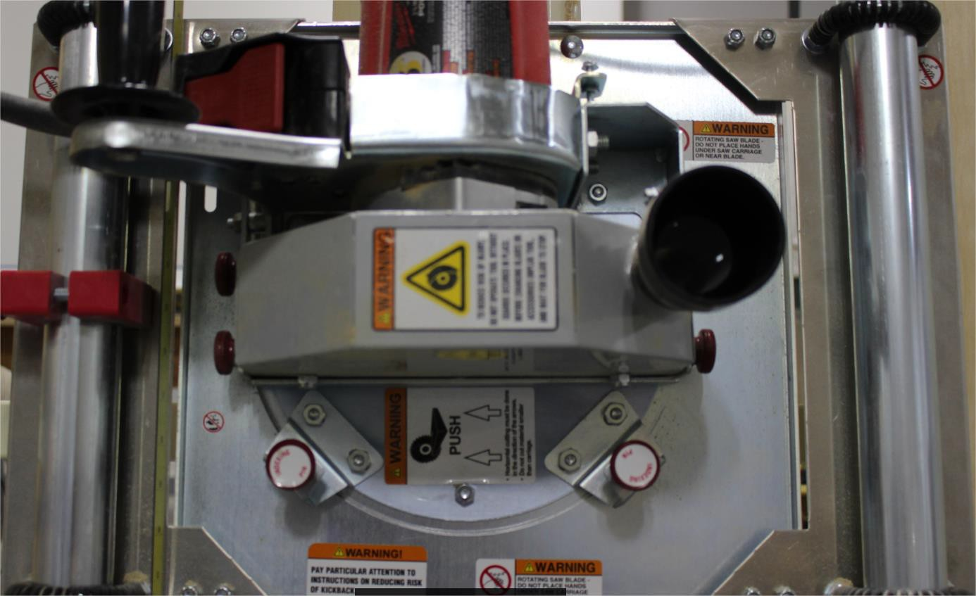


MATERIAL DIRECTION
- Pull both pins outward (toward you) and swivel the saw body either clockwise or counter clockwise so that your cut direction corresponds with the arrows.
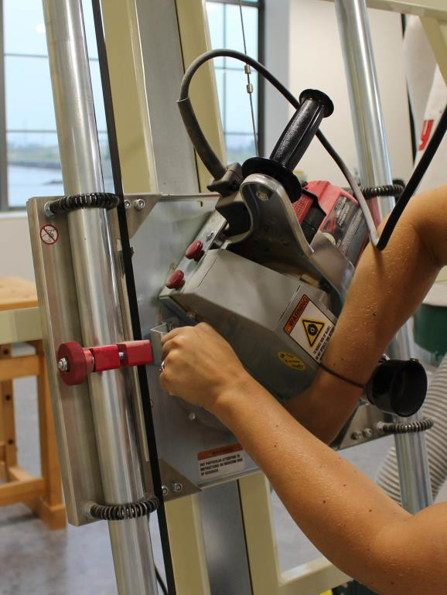

- Make sure that both pins lock into the pin locators.

Step 3: MARKING YOUR CUT LINES

  - Using a tape measure and pencil, mark a short cut line on the edge of your material where you will begin your cut.
  - Line up your cut mark with the blade by loosening the carriage lock knob and lowering the saw until you can see your mark through the dust collection port.
Make sure that you are lining up the blade to the waste side of your cut line.

  - Firmly tighten the carriage lock knob so that the saw carriage will not move when making your cuts. When making horizontal cuts the saw carriage does not move, your material moves.

Step 4: DUST COLLECTION

Attach the vacuum hose from one of the shop vacs directly to the saw body vacuum port and turn the vacuum on. Make sure that the vacuum hose does not create an obstruction in the cutting area.

Step 5: POWERING ON THE SAW
Before powering on the saw make sure that your material:

  - Is placed correctly on the material rest track and rollers.
  - Is clear of the saw blade and outside of the carriage bar zone.
The on/off switch pulls up to turn the machine on and pushes down to turn off the machine.

Step 6: MAKING YOUR CUT
When making a horizontal cut you will move your material through the saw rather than move the saw through your material, as on a vertical cut.
Before making your cut make sure that you have confirmed:

  - Your material is loaded “good side” away from you and resting on the saw frame.
  - The saw cartridge is rotated so that when you push your material through the saw your material will move with the arrows on the saw cartridge.
  - Your push hand is located on your material at the same height as the blade. Failure to do so will result in a hazardous and dangerous situation.
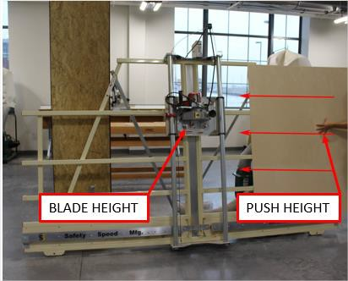

  - When your hand reaches the saw carriage housing, stop pushing your material and move to the outfeed side of the carriage. Grasp your material by placing one hand above and one hand below your cut and finish your cut by pulling your material through the saw blade.

YOUR HANDS MUST NEVER ENTER THE SAW CARRIAGE AREA.
Be aware that the top section of your material may “fall” or drop down onto the rollers after you have completed your cut.
  - Power off the saw before removing your material and making another cut.
  - Never leave the saw unattended when it is running.

Step 8: CLEANUP

  - Pull index pins and reset saw to vertical cut position.
  - Dispose of all material waste.
  - Vacuum entire saw, saw area, and surrounding floor.
  - Put away vacuum and hoses.

