MAKING CUSTOM COLOR STICKERS

Making custom color stickers is possible using the Canon printer and the Graphtec vinyl cutter in combination.

1) Start with a design in Illustrator on the vinyl cutter

The vinyl rolls are 24” inches wide but you will be adding registration marks. To be safe, make your design no more than 18” wide.

Your Illustrator file should have two layers. One layer will be what you want the vinyl cutter to cut. The second layer will be the design you want the Canon printer to print.

Cut layer Print layer

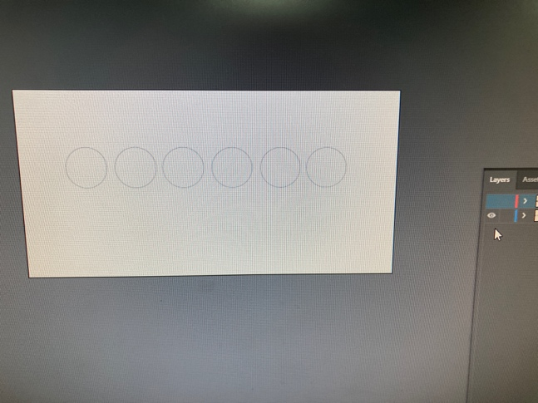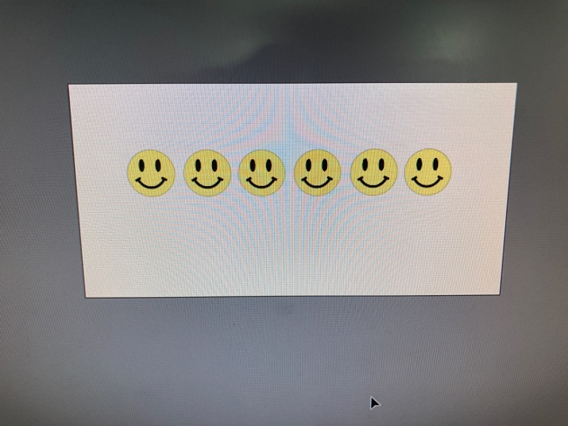

2) Add registration marks

In Illustrator, go to FILE > CUTTING MASTER 4 > REGISTRATION MARKS

Then click OK.

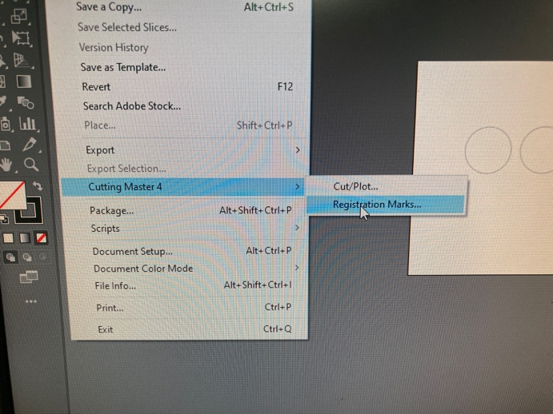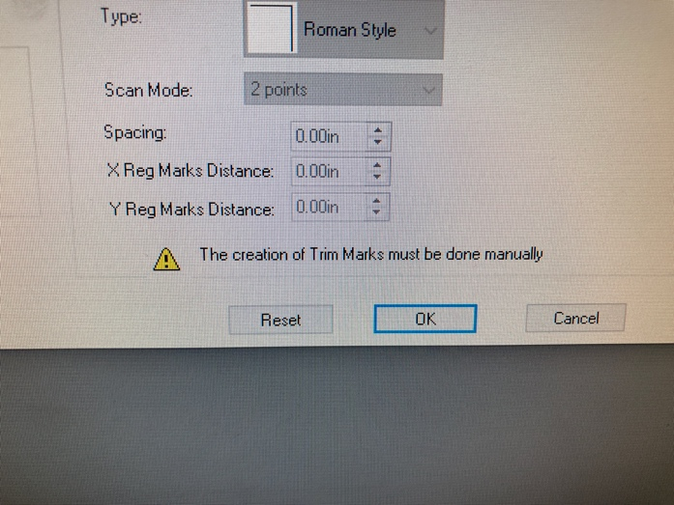

Cutting Master will add registration marks on the four corners of your design. These will show up as two new, locked layers in your Illustrator file.

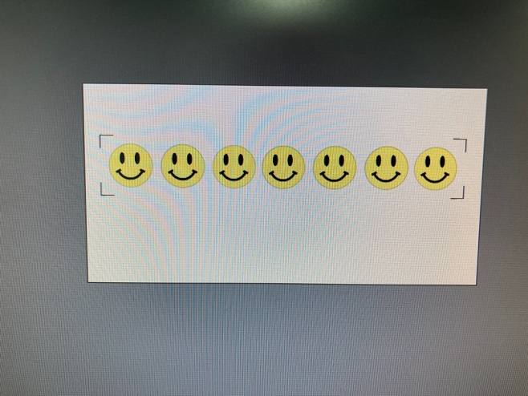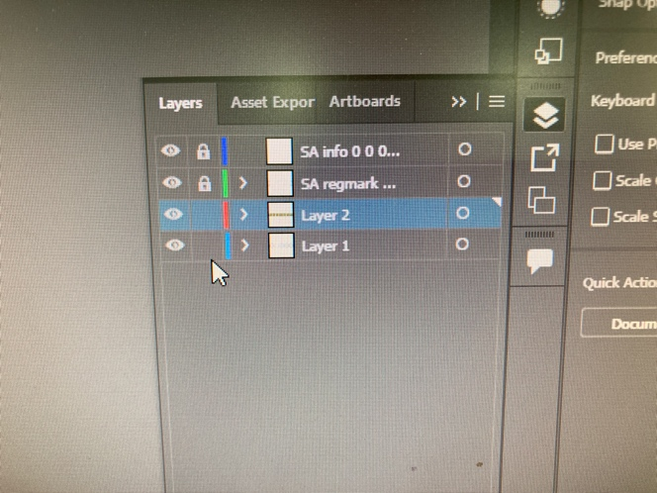

Once you’ve added registration marks, export your file for the Canon printer.
FILE > EXPORT AS > PNG. Other photo formats will also work.

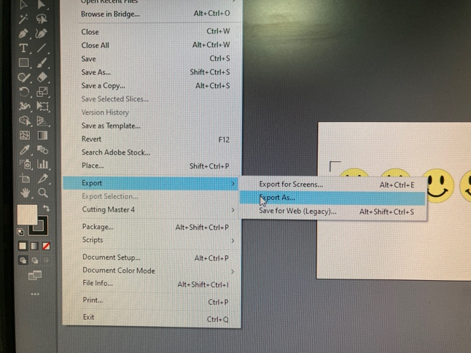

3) Take your flash drive to the Mac attached to the Canon printer

If paper is loaded in the printer, ask NIS staff to change the roll to vinyl.

In Photoshop, open your PNG file and print your design. No matter how big your design is, make sure the height is at least 6” higher than your image. Otherwise, the vinyl cutter won’t be able to read the registration marks.

Once the vinyl has printed, the printer will ask you to advance the roll. Push the ADVANCE PAPER button.

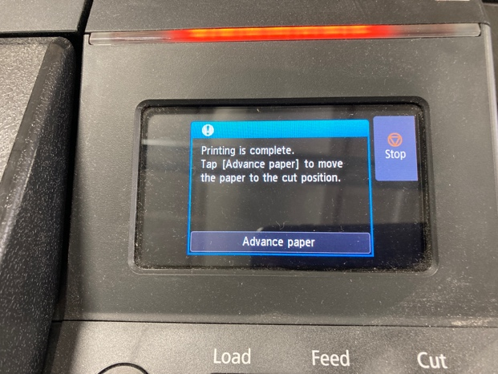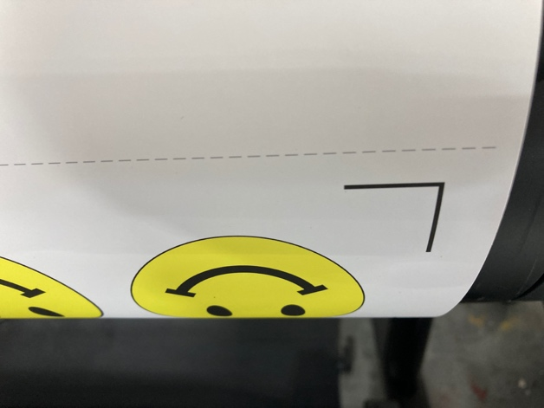

Once the vinyl is advanced, cut along the dotted line.

4) Take your printed vinyl back to the vinyl cutter

Insert the vinyl cutter into the machine, making sure it is straight across, the rollers are outside of the registration marks, and the blue blade holder is poised over the crook of the lower right registration mark.

One way to ensure the vinyl is straight across is to slide the cutter head by hand to the left to see if it lands on the same spot on the left registration mark.

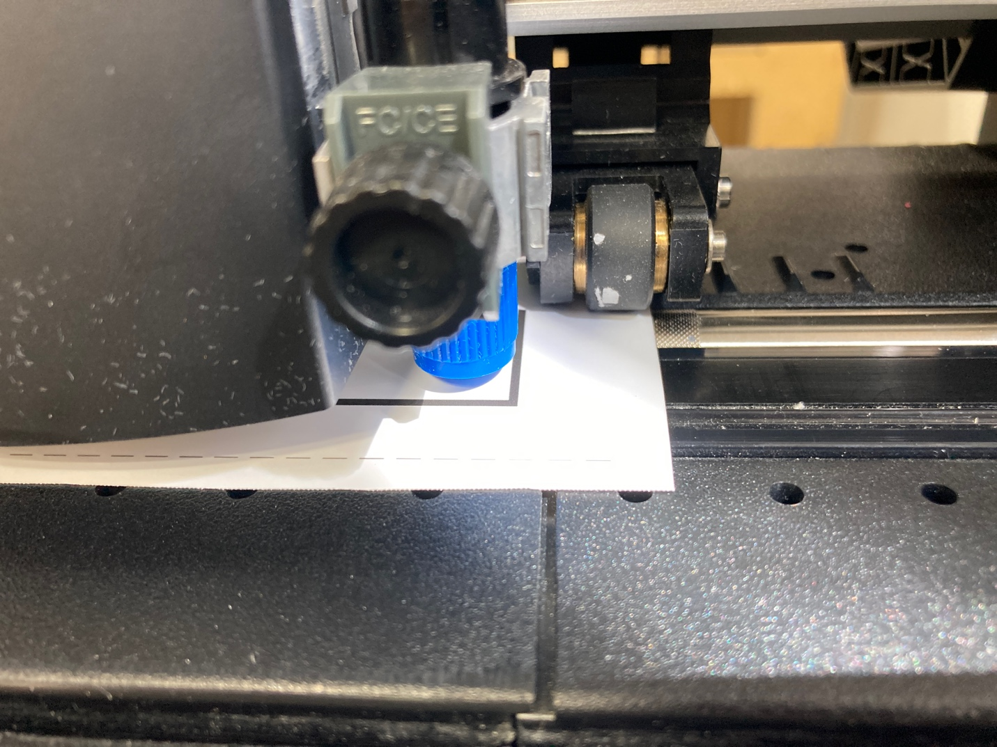

In the Illustrator file, make sure only the cut layer and registration marks are visible.

Go to FILE > CUTTING MASTER 4 > CUT PLOT and the SEND

Press 4 for CONTINUE

The vinyl cutter will find the four registration marks and then cut your design.

