SOP

3D Printers
Form 3
Training is required before using this equipment
Reservations are required when using this equipment

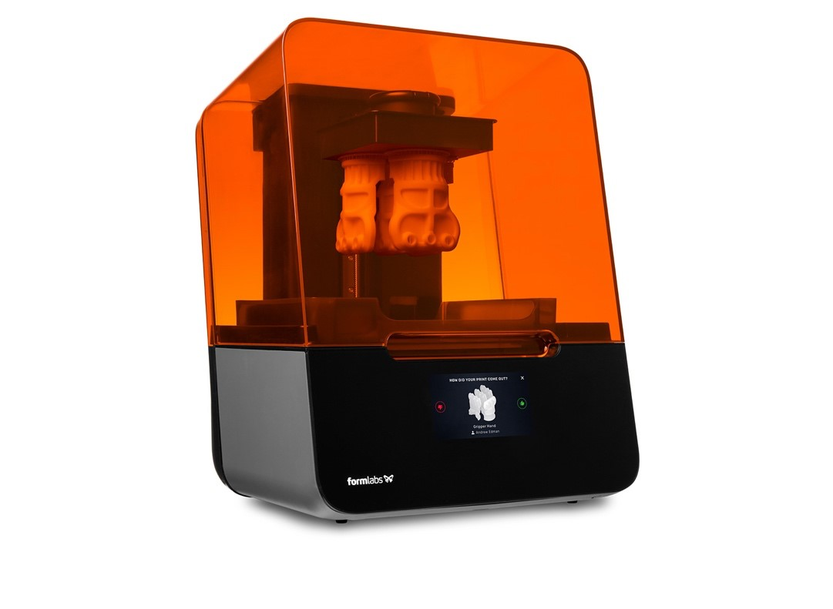

Reference Sheet
Approved Materials:
Only Formlabs brand resin may be used on this printer

Build Volume: Layer Resolution (min.):
5.7” x 5.7” x 7.3” (14.5 x 14.5 x 18.5 cm)

Layer Thickness:
25-300 microns (dependent on resin type)

Machine Accessories:
• | Form Wash | • | Form Cure

Important Information:
Resin can be a skin irritant, care should be taken to not make contact with resin

Workflow:
Download or Design
Process in Preform
Setup Machine
3D Print Object
Remove finished part(s) from printer
Clean part using Form Wash
Cure part using Form Cure
Weigh and pay
Remove supports

Software:
Formlabs Preform
Tinkercad
Fusion 360
Solidworks

Machine layout - Front

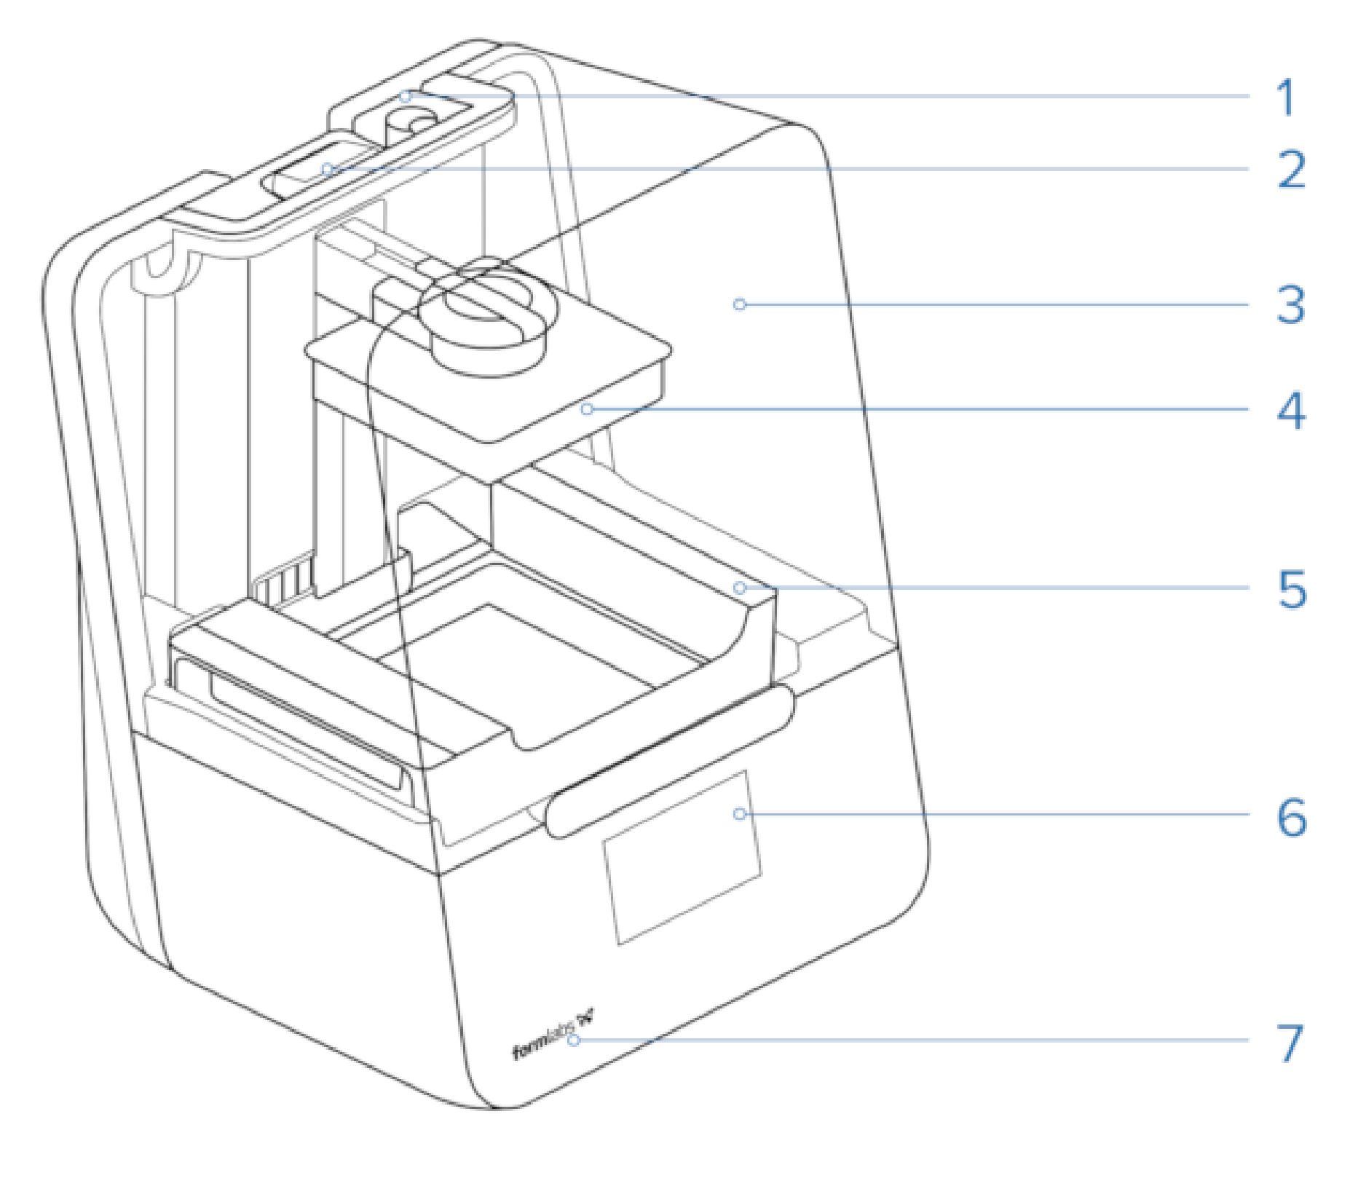
- Resin Cartridge
- Status Light
- Cover
- Build Platform
- Resin Tank
- Touchscreen
- Status Light

Removing Material Tank and Cartridge

- To change the material, begin by closing the vent on the top of the cartridge located in the back of the printer.

- Lift the cartridge up and out of the machine. Store the cartridge with the other resin cartridges.

- Pull the tank away from the back of the machine.

- Lift up with both hands to free the tank from the machine. Cover the extra tank to protect it from dust and debris while it is in storage. Store it with the other materials.

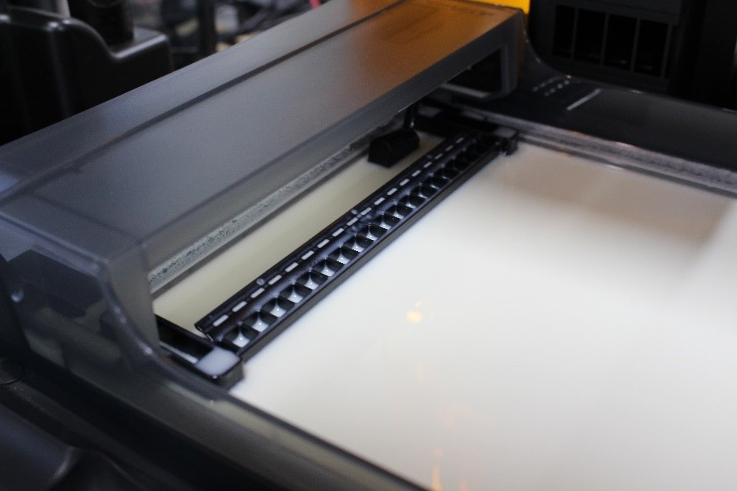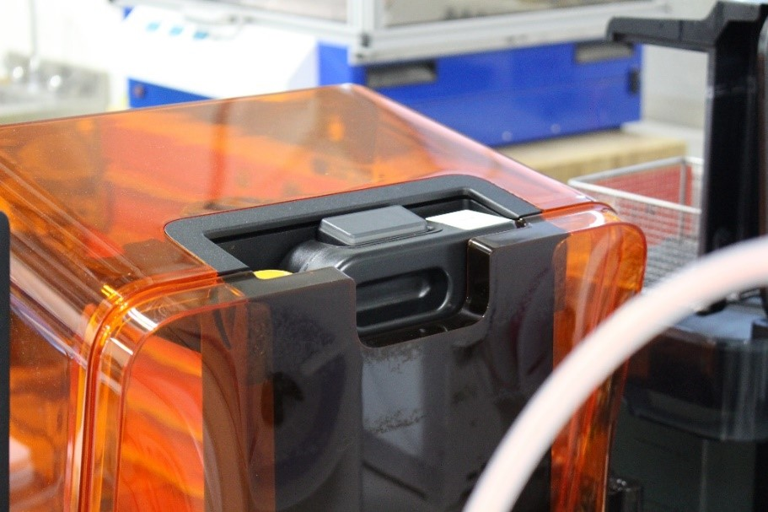

Wiper
Arm

Resin Cartridge Location

Image 1 – Inserting Material Tank

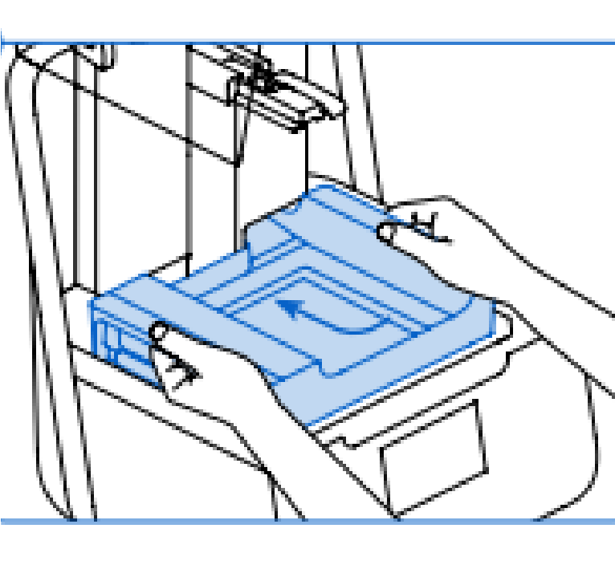
Installing Material Tank

- Select the new material and remove the temporary cover. Insert the tank and press the tank toward the back of the printer to lock it into place. The tank will click into place (image 1).

- Slide the resin cartridge into place at the back of the machine. Open the vent on top of the resin cartridge (image 2).

- Insert a build plate by lifting the central locking arm upward, sliding the build plate onto the arm, and closing the lock (image 3).

Image 2 – Inserting Resin Cartridge
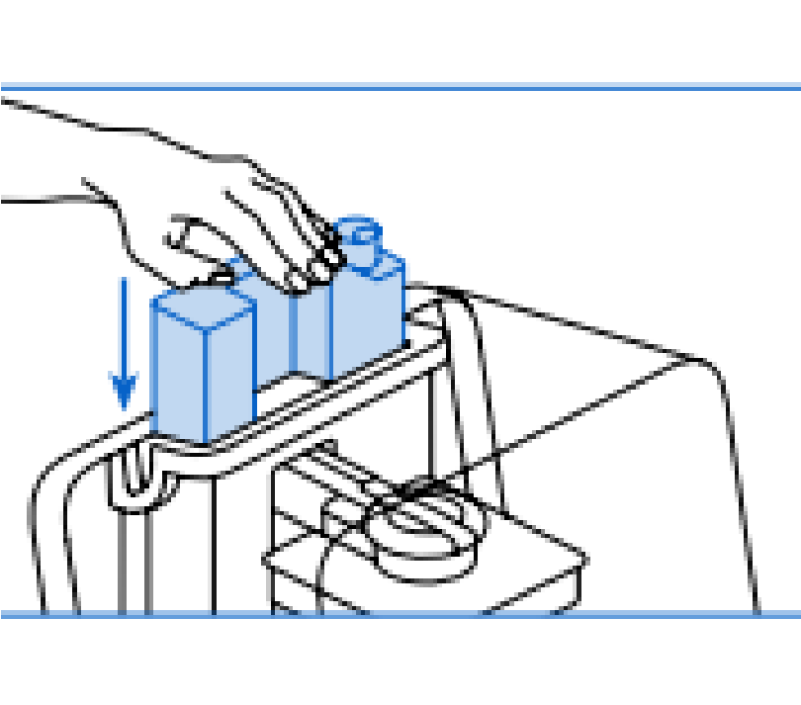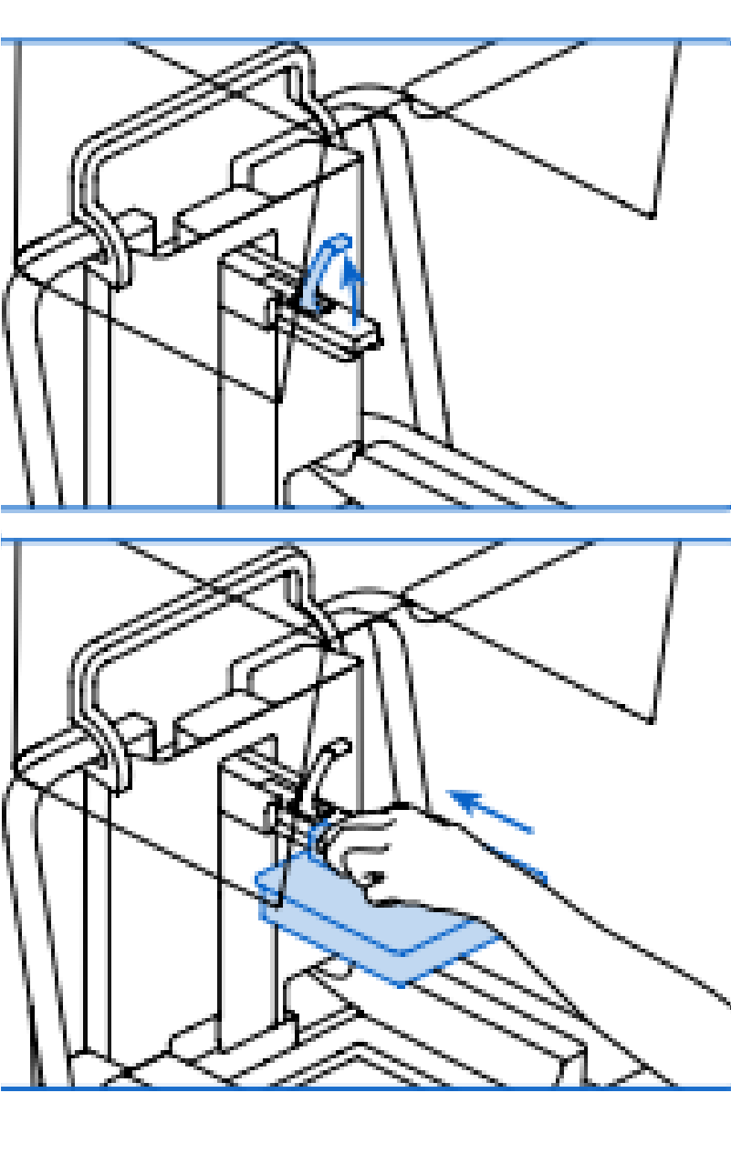

Image 3 – Inserting Build Platform

Process in FormLabs Preform

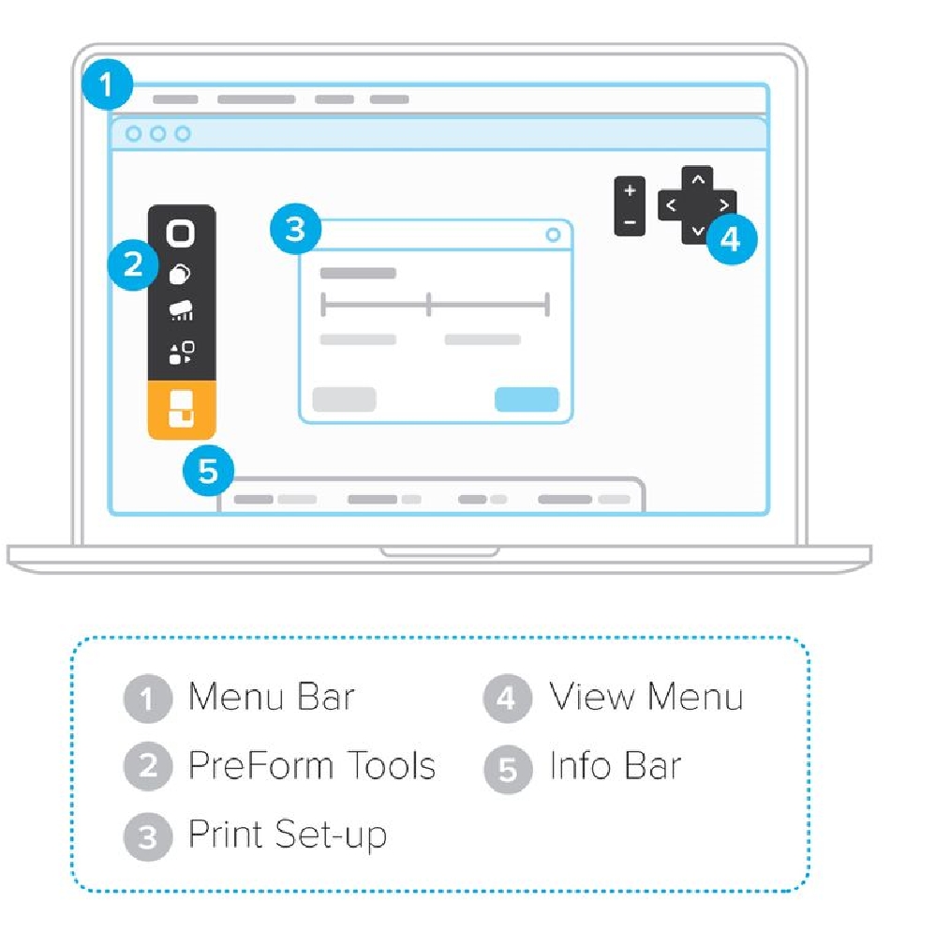
- Open Preform. A blank print area will appear. Note that the build volume is upside down in this program.

- To add the file to the build platform select File -> Open. You can also drag and drop your file into the build volume.

- To move the view around, click and hold the middle mouse button while moving the mouse to pan. Click and hold the right mouse button while moving the mouse to rotate. Scrolling up will zoom in on the cursor and scrolling down will zoom out of the cursor.

- Clicking and dragging on the object lets you move it around the build plate. Pressing delete when the model is selected will
remove it from the build plate. Clicking and dragging on the spherical icon on the object allows you to rotate the object.


- There are 6 icons in the upper left hand corner of the Preform interface.

  - The first icon is the magic wand which will automatically rotate the object to optimize it for SLA printing and add supports where needed.

  - The second icon allows the user to manually scale the object.

  - The third icon allows the user to manually rotate the object.

  - The fourth button allows the user to alter the support structure of the object.

  - The fifth icon allows the user to manually place all objects on the print bed. This button can also automatically pack all models to be a certain spacing apart (specified by the user).

  - The sixth icon is the Print button, which will send the user’s print to the printer.

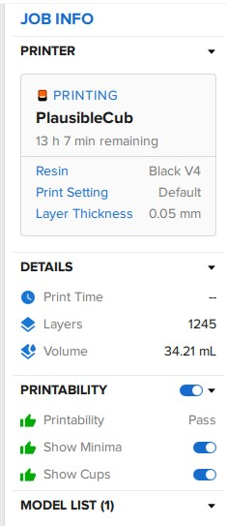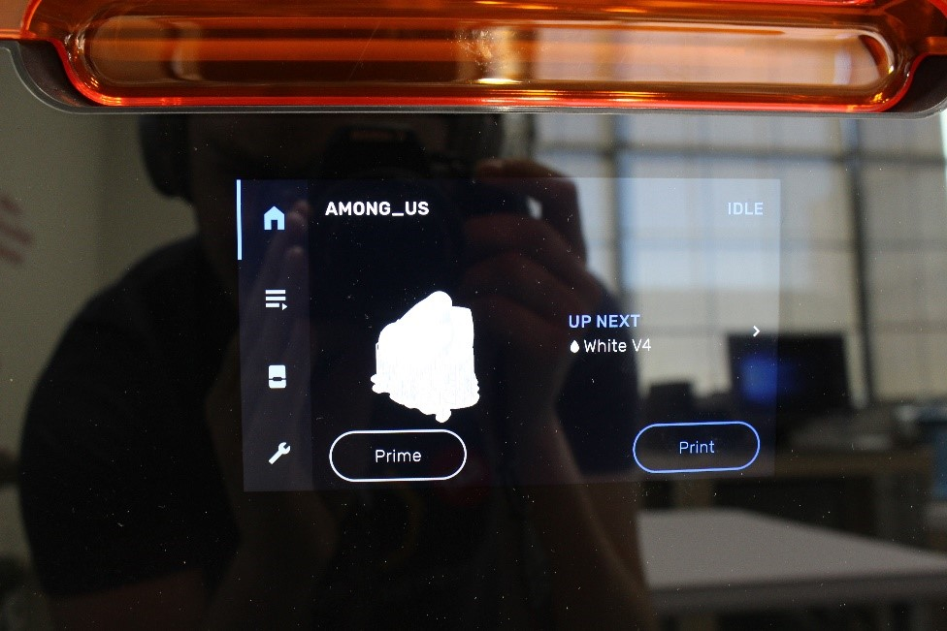
5
. The
right

of the screen shows information on the material and
layer thickness, the estimated volume and time, as well as the
“Printability” of the ob
ject.

6
. Adjust the material or
layer thickness by clicking on the
printer’s name under “Printer.”

Note that not all materials are
able to print in all thicknesses.

7
. Check the “Printability” of the object before sending it to
the

printer. Click on the

Red X or the Green Check Mark to view the
errors Preform anticipates. To correct errors, try adjusting the
support density or size until Preform shows the part is printable.

. To send the part to the printer select the sixth icon in the upper
8
left
-
hand

corner “Print” and select
“Upload Job” in the bottom
right of the pop
-
up
. The file will then be sent to the printer
interface.

.
10
To start the pr
int,
tap “Print
” on the printer’s touch screen.

11
.
At this point, the resin will begin to heat up and
will start
printing.

Print Button on Printer Touch
Screen

Cleaning Part

- When the Form 3 is finished with the print job, it will retract the build tray to the top of the machine. Remove the entire build tray by raising the lock lever and sliding the whole tray out.

- Open Form Wash by moving the dial and selecting “Open.”

- If needed adjust the time for the rinse cycle. 10 minutes is sufficient for most parts.

- Insert the whole build platform to the top of Form Wash and on screen select “Start.”

- When the rinse cycle is complete Form Wash will automatically raise. Allow the part to drip dry for several minutes before retrieving it.

- Once the part is completely dry, attach the build platform to the holding jig and use the included tools to remove the print from the build platform. Note that parts are still somewhat fragile in this state. Parts must be cured to achieve full strength.

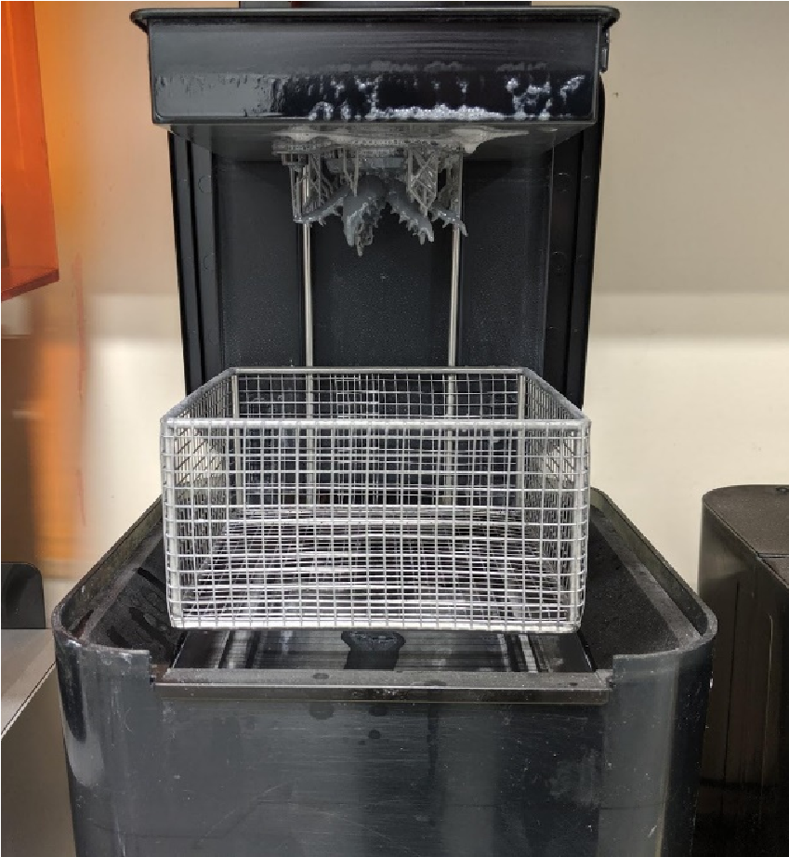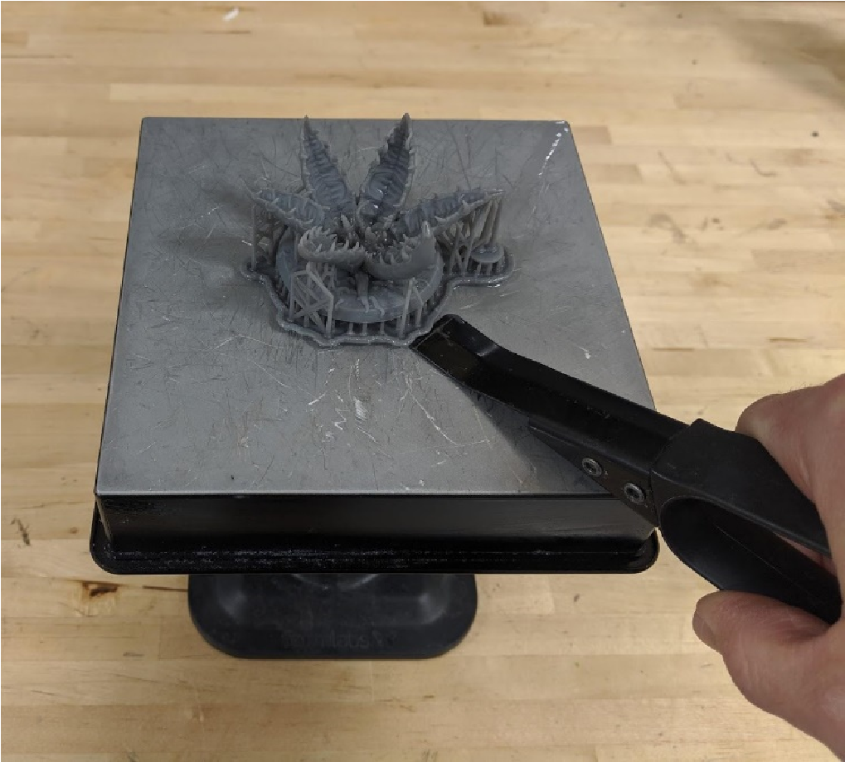

Curing Part

- Prints need additional curing after printing in order to achieve their full strength. Consult the included chart to see curing time and temperature. Adjust time and temperature on Form Cure as needed.

- Open the door on Form Cure and place the printed item in the middle of the table. Close the door and select “Start” on the control screen.

- Form Cure will preheat to the selected temperature and then begin the curing process. During this time, the part will be exposed to ultraviolet light and it will fully harden.

Cure Time and Temperature Settings
Material | Time (min) Temp (°C)
Clear V3 | 15 60
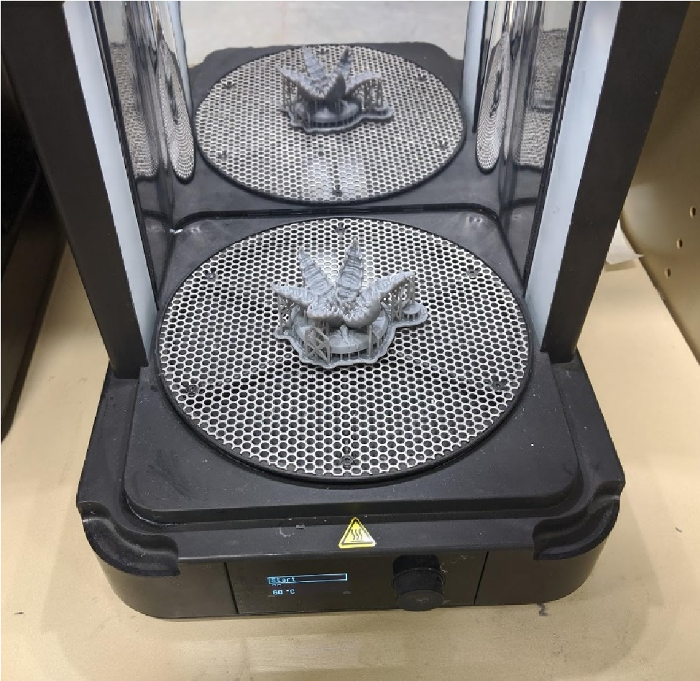
White V4 30 60
Grey V4 30 60
Black V4 30 60
Color V1 30 60
Tough V5 60 60
Durable V2 60 60
Flexible V3 15 60
High Temp V1 30 60
Rigid V1 15 80
Grey Pro V1 15 80
Dental SG V1 30 60
Dental LT Clear V1 20 80
Model V2 30 60
Castable V2 240 60
Ceramic V1 N/A N/A
Castable Wax N/A N/A

Removing Supports

Parts should be weighed before supports are removed

- After curing is complete supports may be removed. Wear safety glasses as small parts will move unexpectedly.

- Using diagonal clippers remove small pieces of supports at a time until all support pieces are gone.

- For highly cosmetic parts a hot knife may be used.

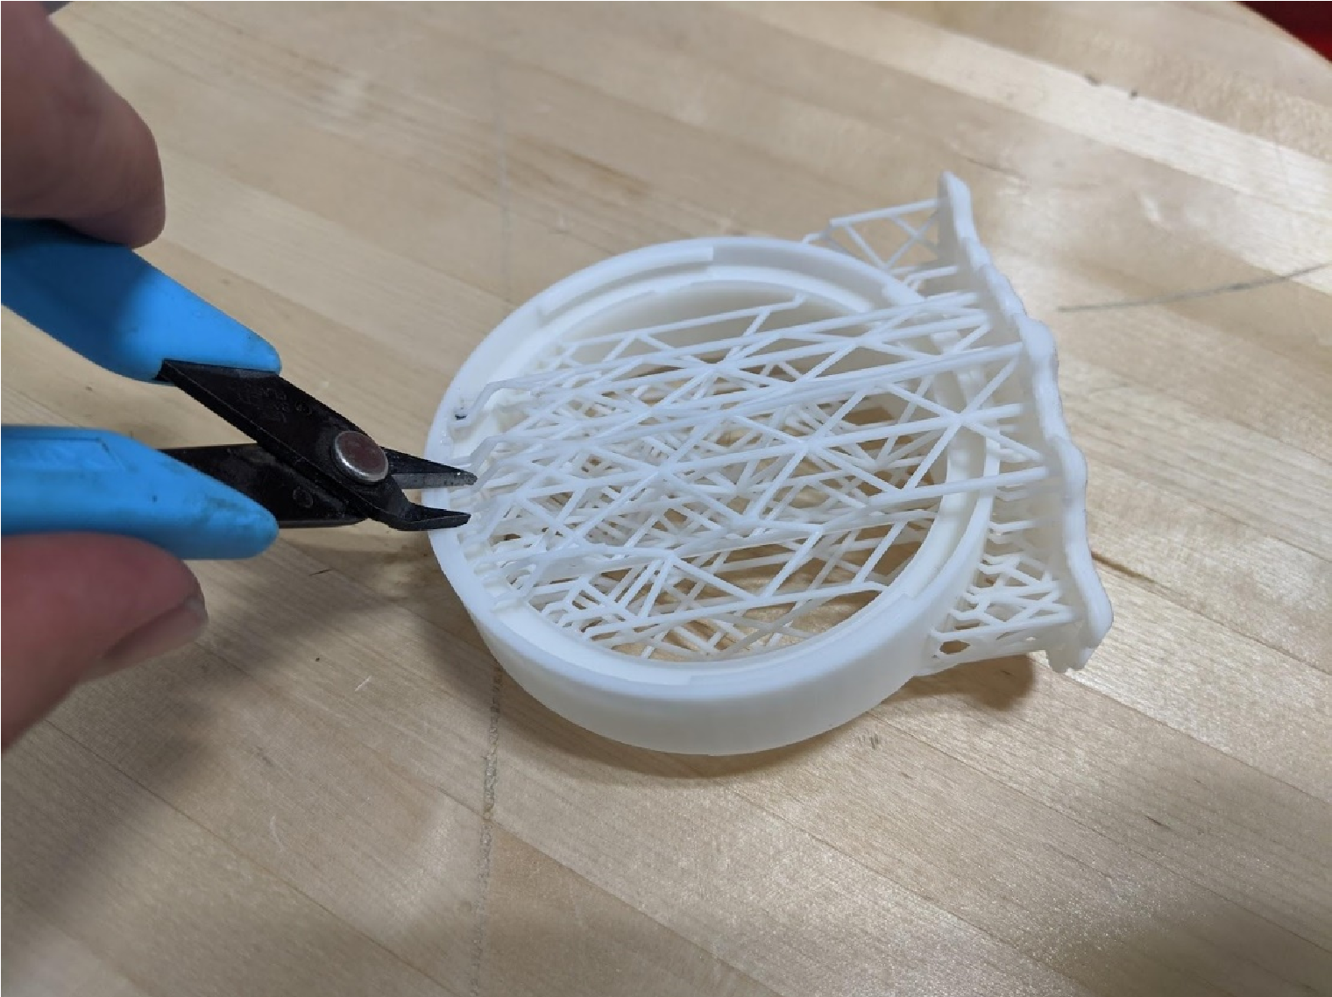

Troubleshooting

If parts come loose and fall off the build platform during printing they must be removed. Alert NIS Staff to filter the resin.

