SOP: Baby Lock Embroidery Machine

Training is required

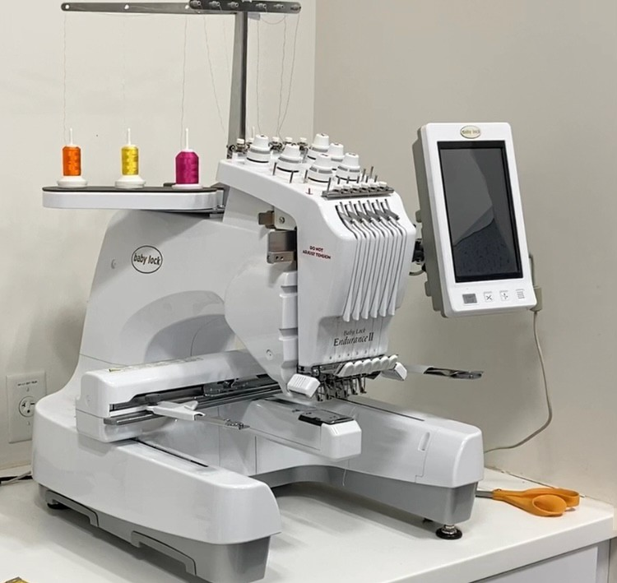

PREPARING THE EMBROIDERY MACHINE

The spools of thread are numbered 1-6. The numbering goes from right to left.
6 5 4 3 2 1
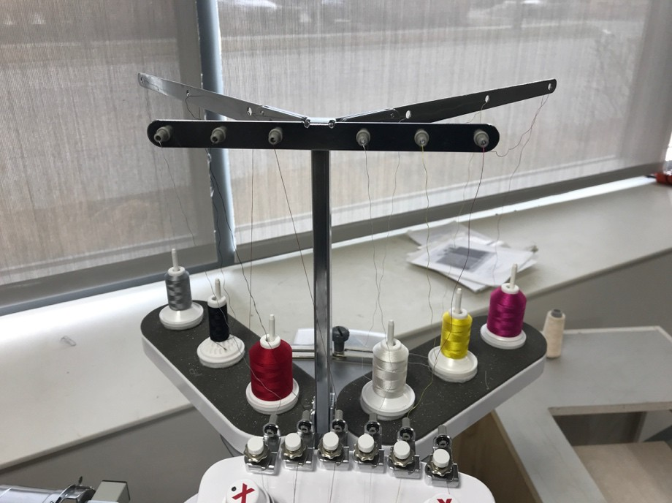

To thread the embroidery machine, follow steps one through nine as shown in the diagrams below. NOTE: In STEP 5, the thread loops once around the tensioner as shown on the machine.
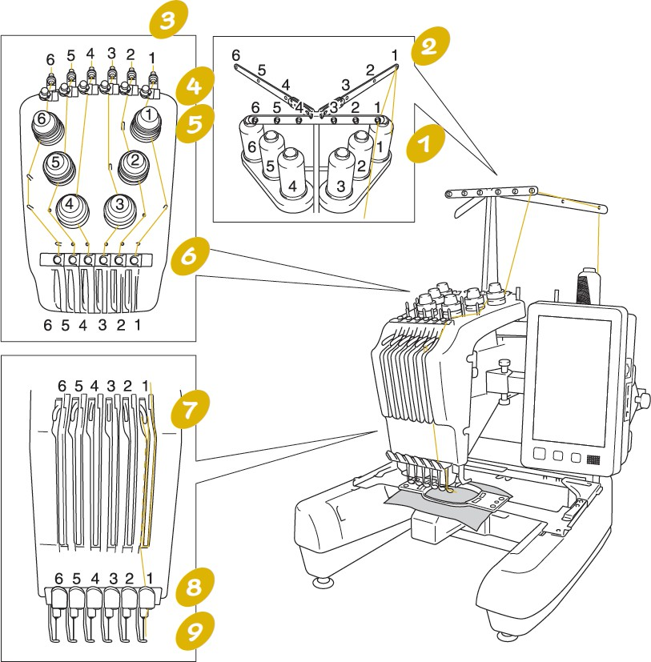

The threading path for each thread is also on the machine itself.

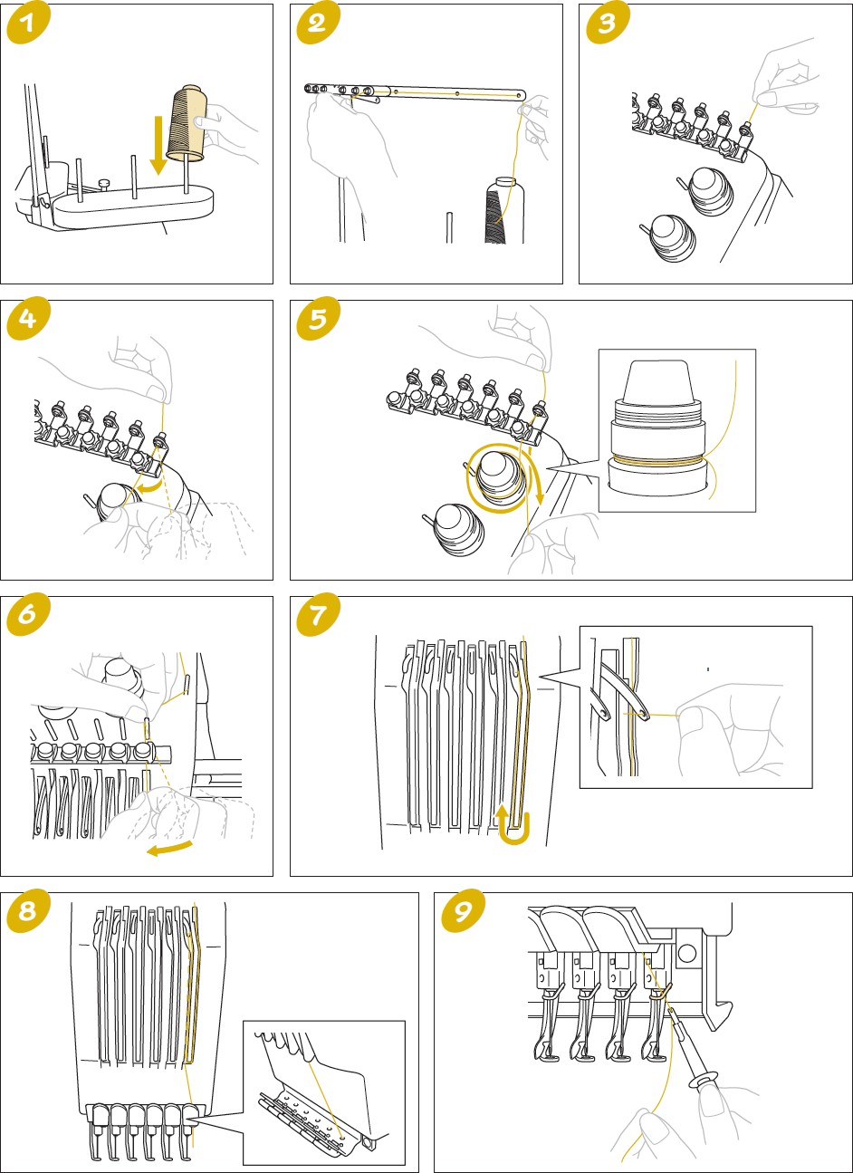

To thread a needle, first push this button.
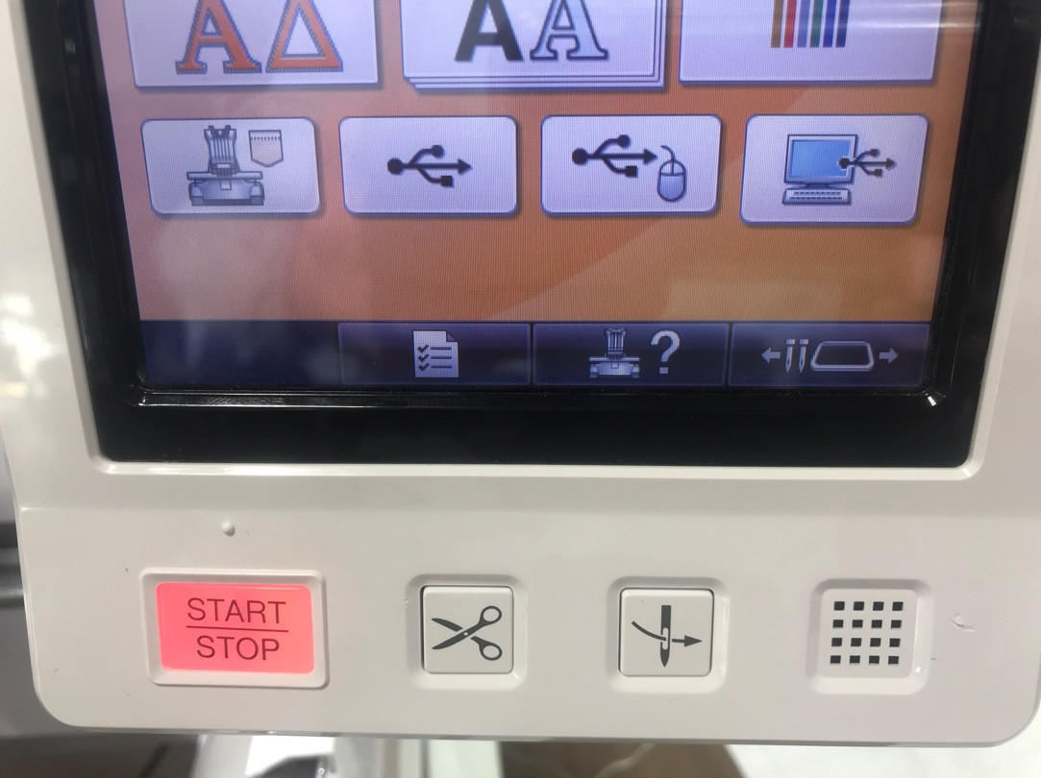
Then push the number of the needle.

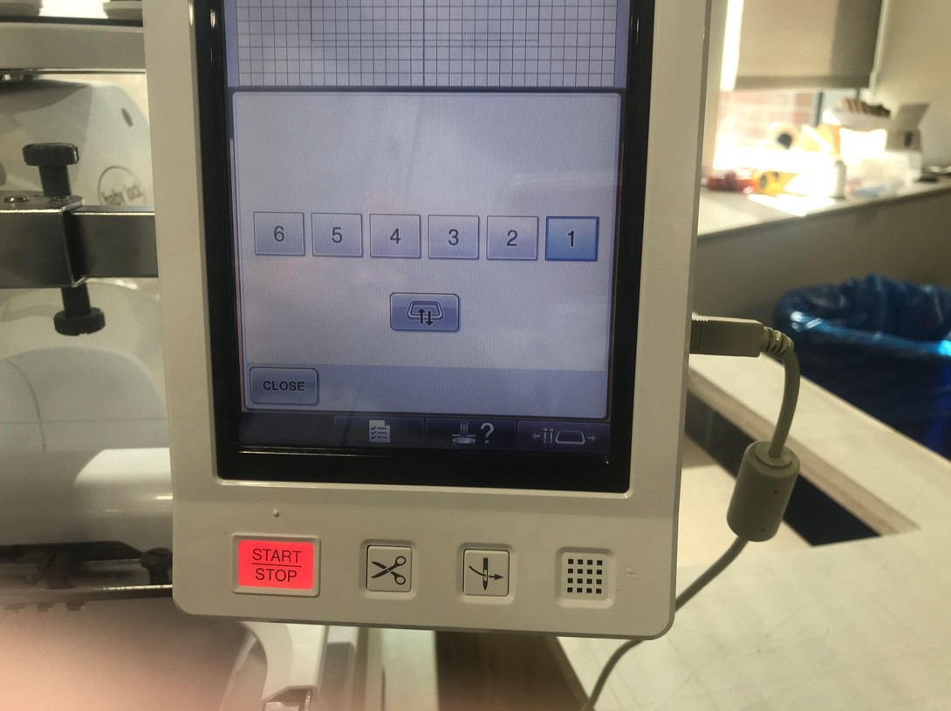
Select the needle that needs to be threaded.

Push the needle threading button
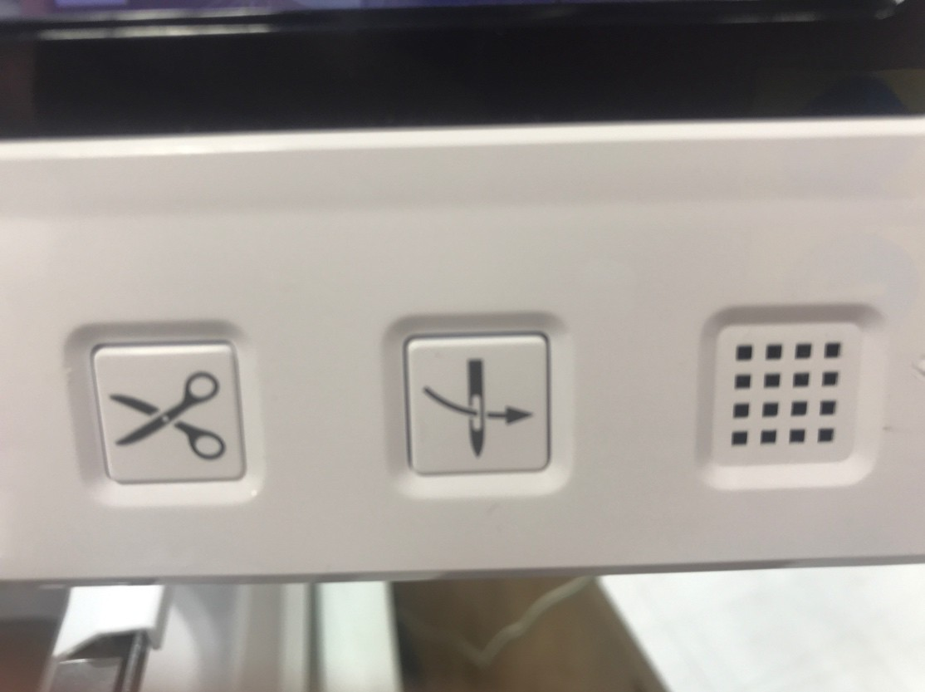
Tuck the thread behind the loop above the needle, using the threading tool
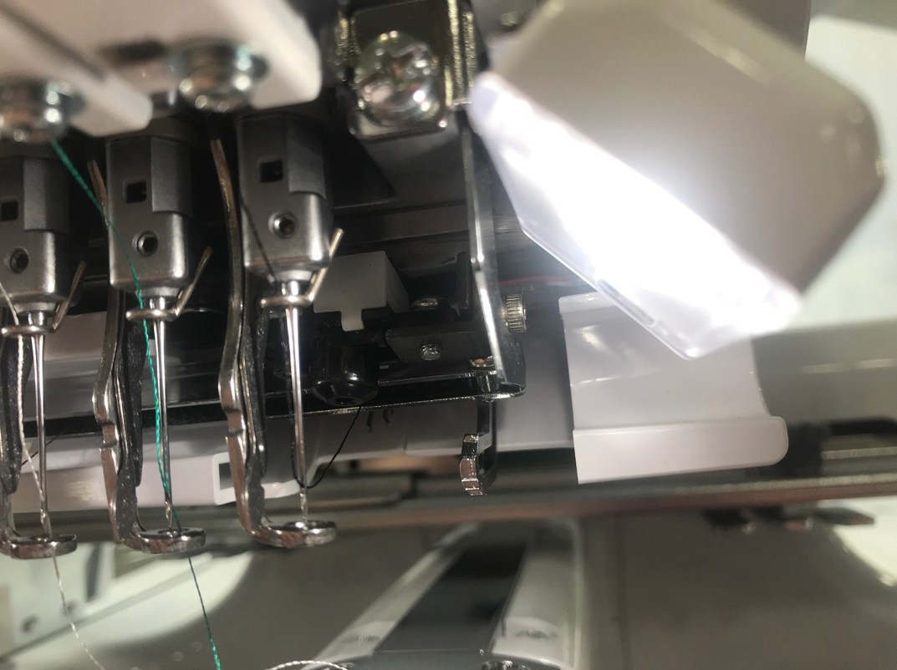

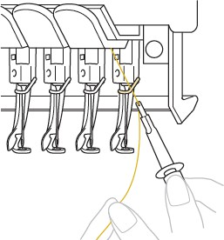

Then loop the thread under the two small hooks from right to left and loop it over to cut the thread.

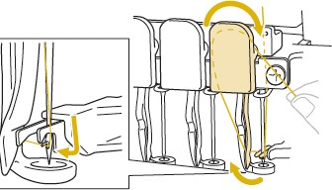

Finally, push the needle button again.

To change the bobbin, follow the steps below. NIS has pre-threaded bobbins in the SnapOn case next to the machine.
There is no charge to use NIS thread or bobbins. You are charged by the number of Inches of stabilizer you use.

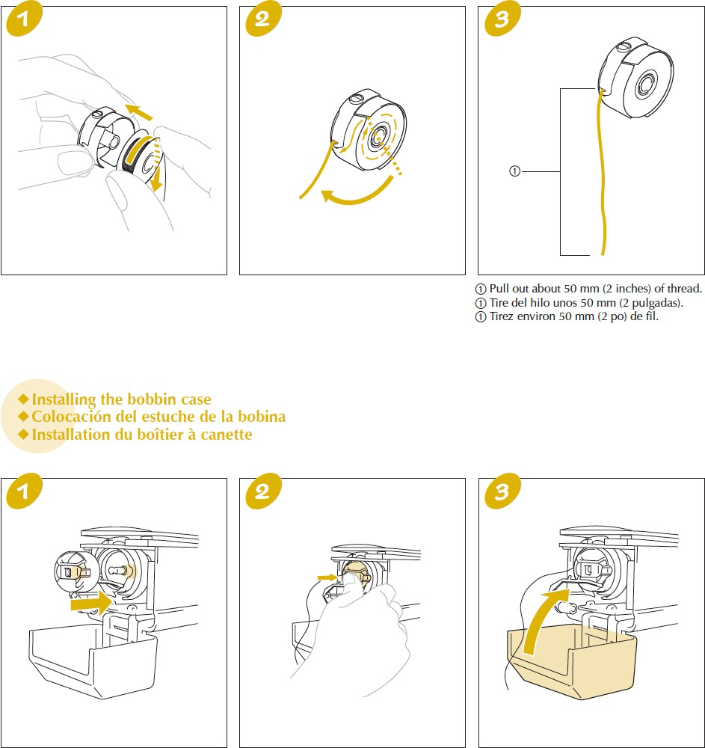

There is no charge to use NIS thread or bobbins.
You are charged by the number of inches of stabilizer you use.

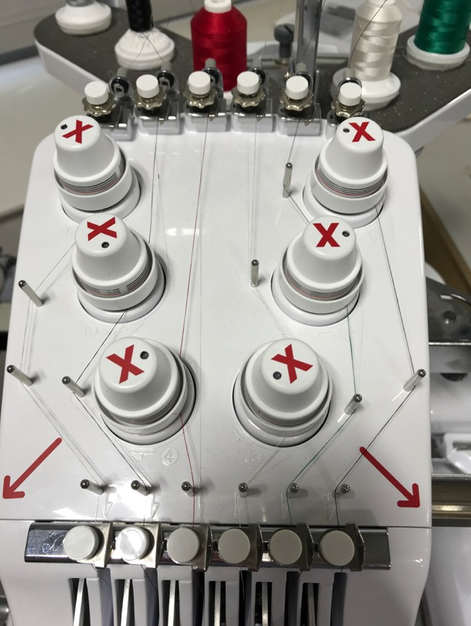
DO NOT ADJUST THE TENSION

SETTING THE COLORS

You can go into the menu to change the thread colors so they match the colors on the machine. To do that, touch the MENU button at the bottom of the screen.

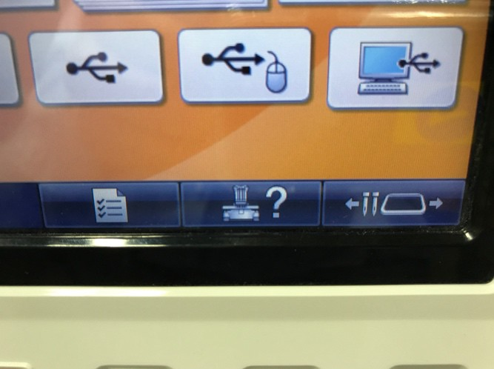

Scroll to page 3 using the right arrow at the bottom of the screen.
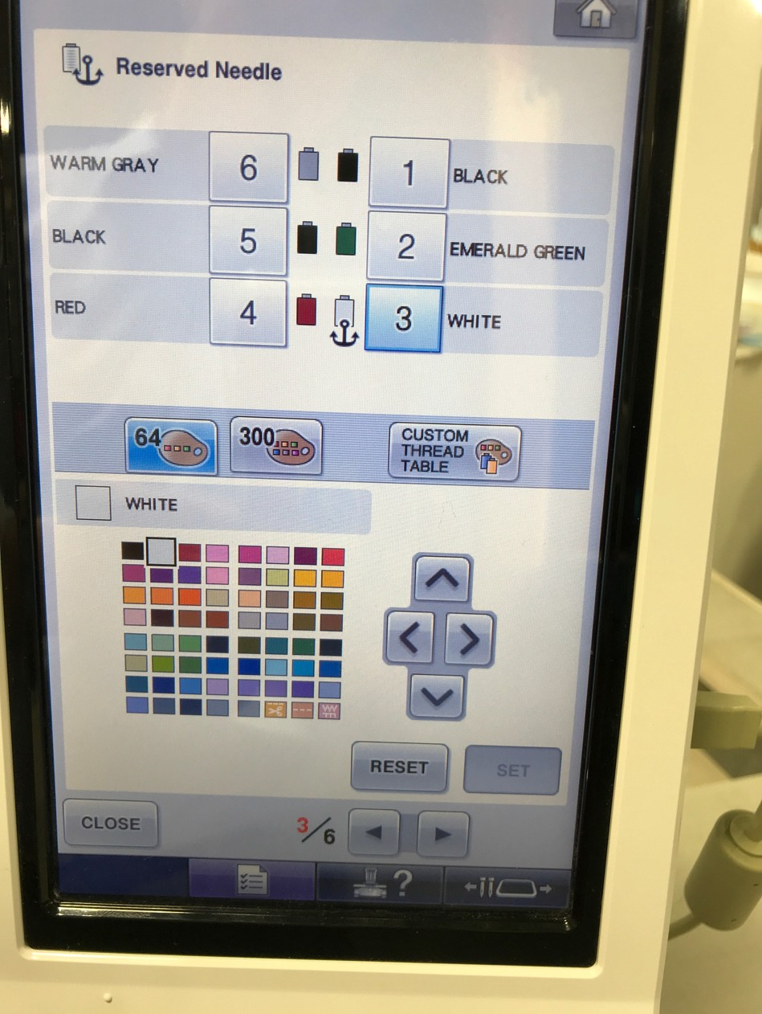
Touch the number of the needle to set the color on that needle.

Touch the color you’d like on the color grid.
Touch the SET button.
Follow these steps for each needle.
Once the needle has the anchor symbol on it, you will not be able to swap needle colors later in the process. (See page 12)
To get rid of the anchor symbol, touch the RESET button.

NOTE: The embroidery machine will function if the color of the thread and the color on the machine do not match.

IMPORTING YOUR FILE TO THE BABYLOCK

Once you’re happy with your embroidery file on the computer,
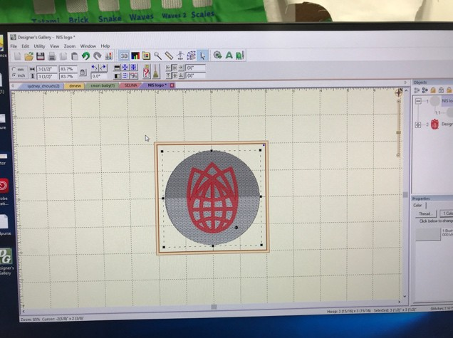
SAVE AS (STITCH AND WORKING) to the G DRIVE.
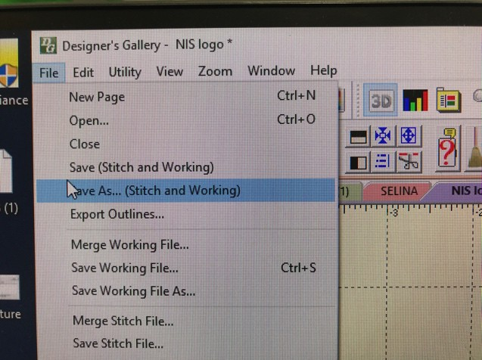
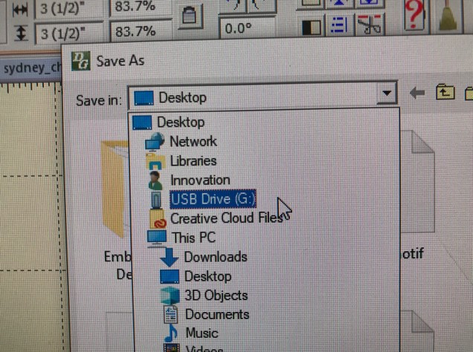
Once the file is on the G Drive, you will be able to import it into the embroidery machine using the button on the lower right corner of the Baby Lock screen.

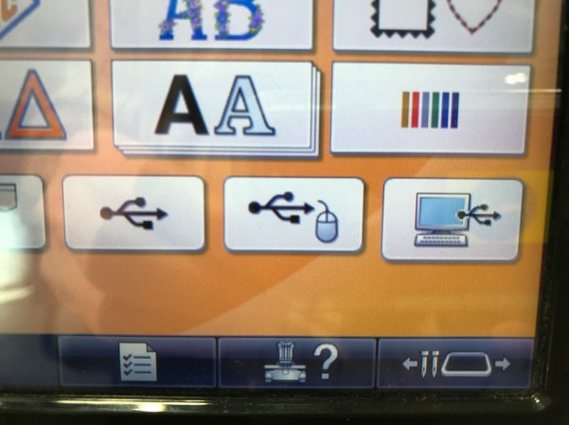
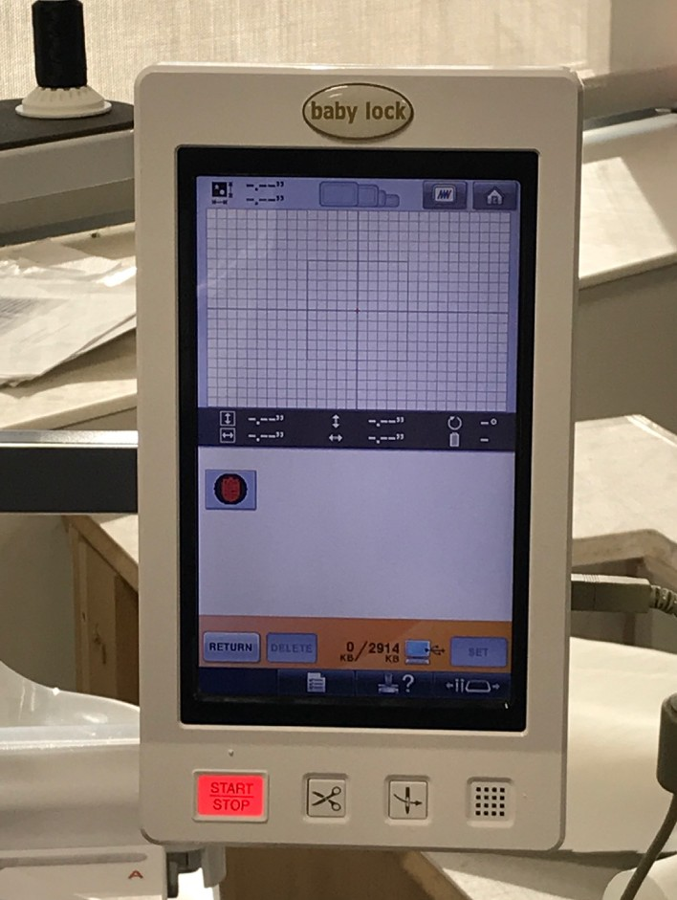
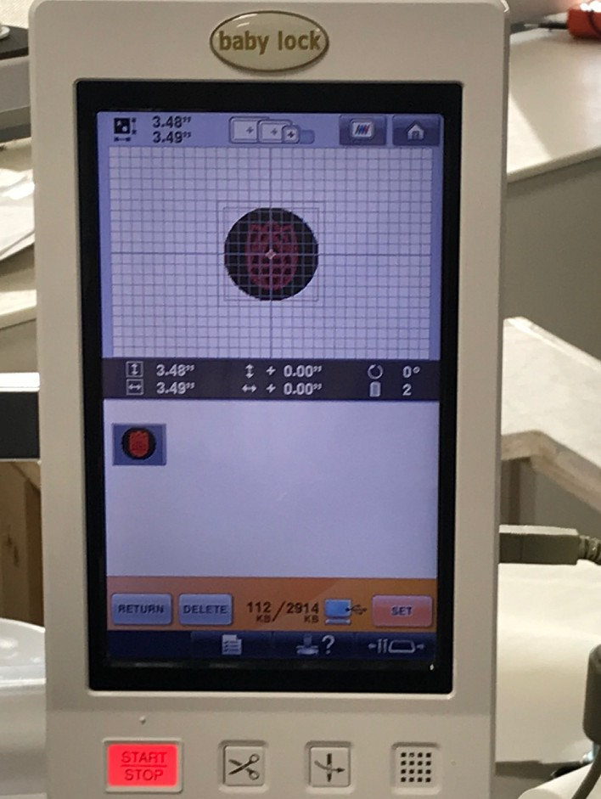
Select the icon and your project will appear in the main work area on the Babylock screen. From here, you will be able to resize your project, change the colors, rotate it, add text or other preloaded images, and make other changes. First you need to touch the SET button.

PREPARING YOUR PROJECT
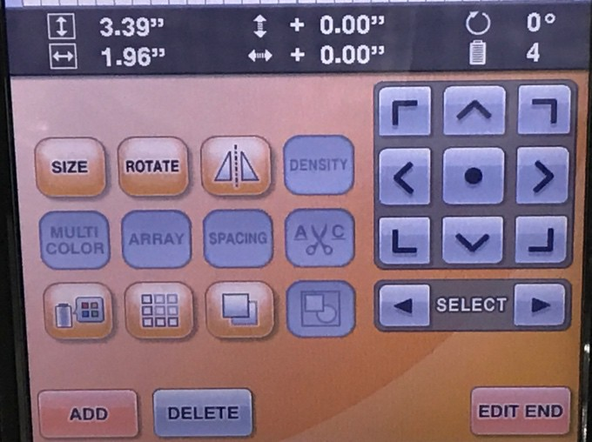
Now you can change to the size … and orientation.
You can reposition your project using these arrows.
You can add design elements or mirror your project.

CHANGING COLOR

You can change the colors in your project with this button.
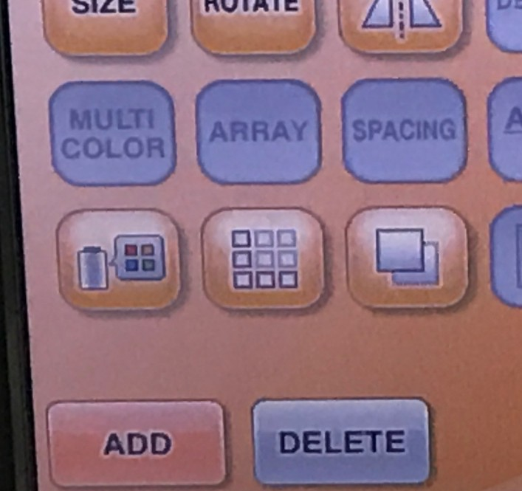

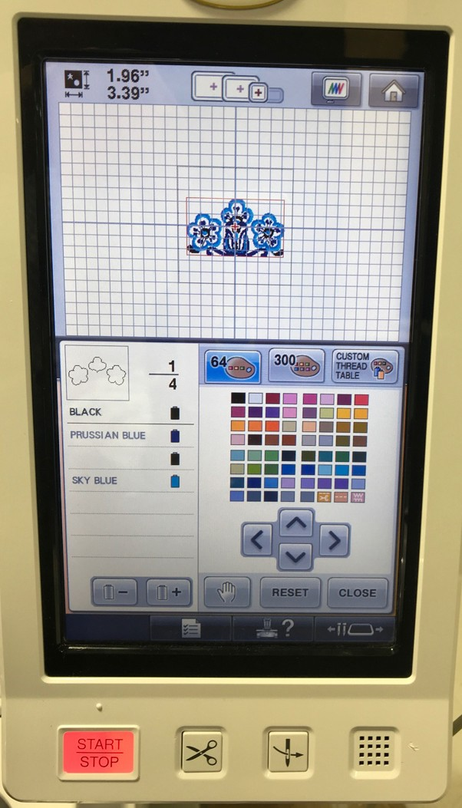
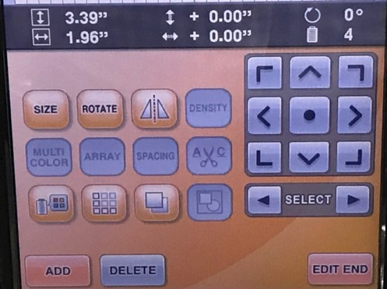
If you’re done making changes to your design, touch the EDIT END
The Babylock lists and numbers the colors for your project. This is the order the colors will embroider in your project. This does not correspond to the location of the thread on the Babylock.
You can change any and all of the colors.
The example on the left shows where the first color is located in your image and lists the color as black.
If you want to change a color, simply go to the desired color by using the + or – button and then touching the color on the right that you’d like to change it to.

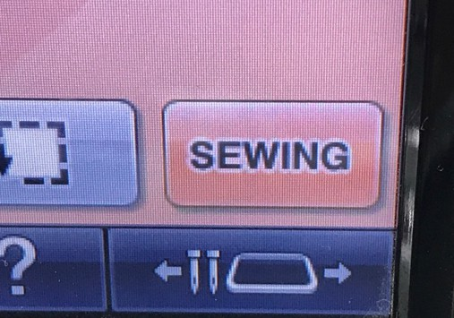
If you’re ready to start sewing, touch the SEWING button in the lower right corner of the screen.

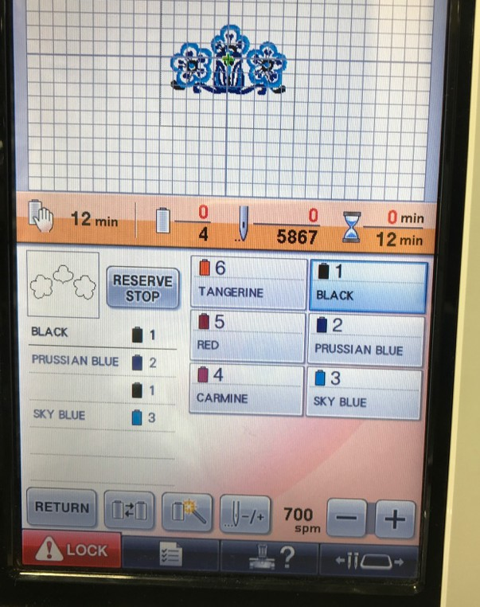
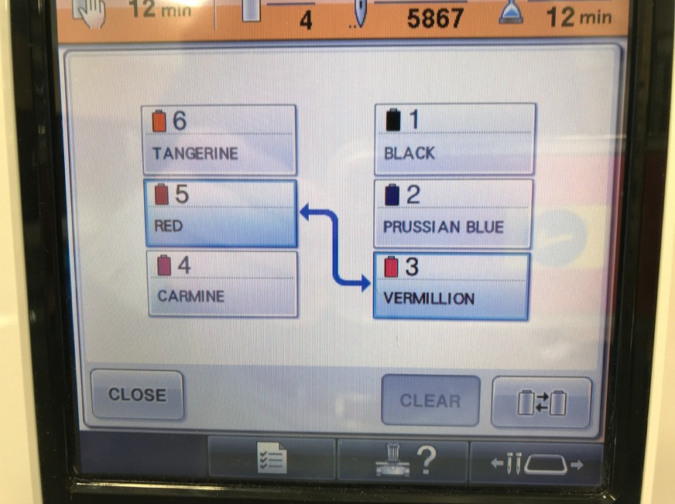
The screen will now show your artwork.
The total number of stitches. Once the project starts it will give a running total.
and the order the machine will stitch the colors. In this example, it will start with the black, then do Prussian blue before returning to black and then doing sky blue.
To reassign the spools assigned to each color, push this button

To change the embroidery speed, use the + or – signs. You may want to go slower for thick material or such specialty thread as metallic.
The screen will also show the total minutes your project will take.
Once you start embroidering, it will give a running tally of how far along you are once you start embroidering.
The screen also shows which color is associated with which spools. MAKE SURE THESE MATCH.
If they do not match, you can reassign the colors different numbered spools.

When you are ready to sew, first push the LOCK button and then START/STOP
To switch which color is assigned to which spool.

First, touch the two spools you want to switch.
Then, touch the swap icon in the lower right.

Repeat the process as needed.

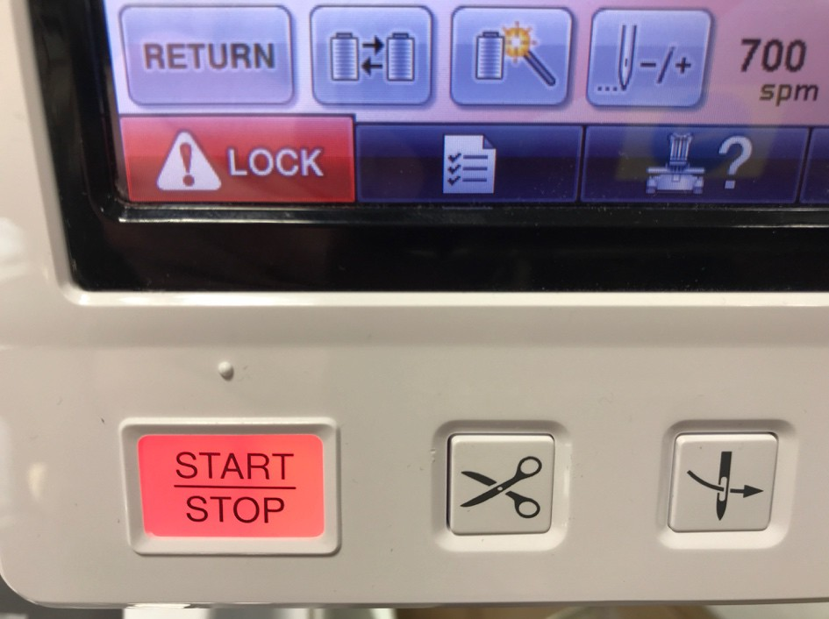

HOOPING THE FABRIC
We have 4 different size hoops or frames. Hooping works the same for all sizes. The larger half of hoop fits over the smaller one, and the embroidery stabilizer goes behind the fabric.
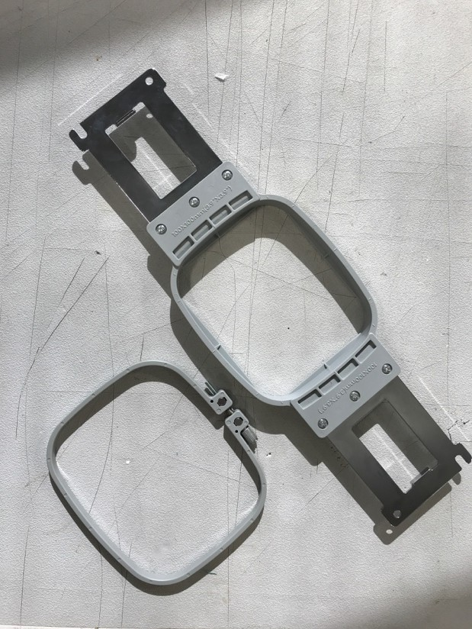
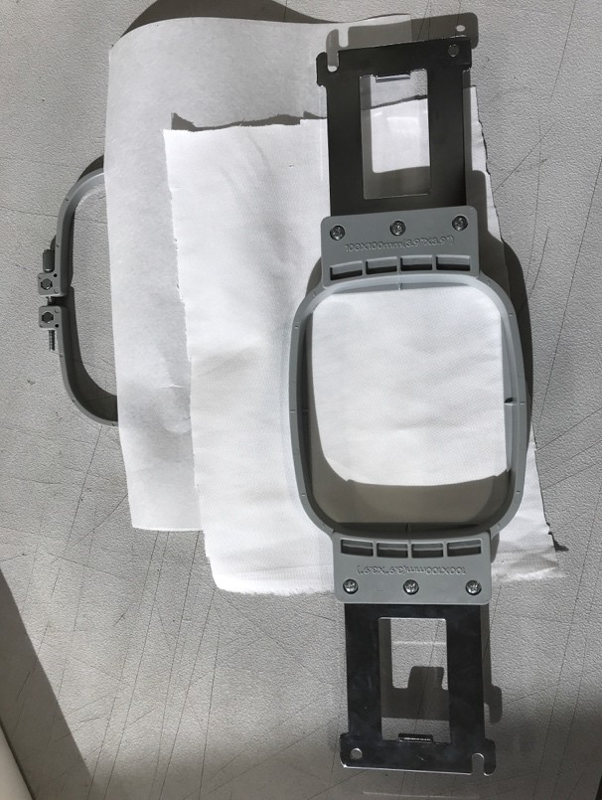

Press the larger hoop over the smaller one and pull the fabric and stabilizer taut like a drum . The bottom half of the hoop has a screw to tighten the hoop. If the fabric is too loose in the hoop, it can cause your project to fail or the needle to break.
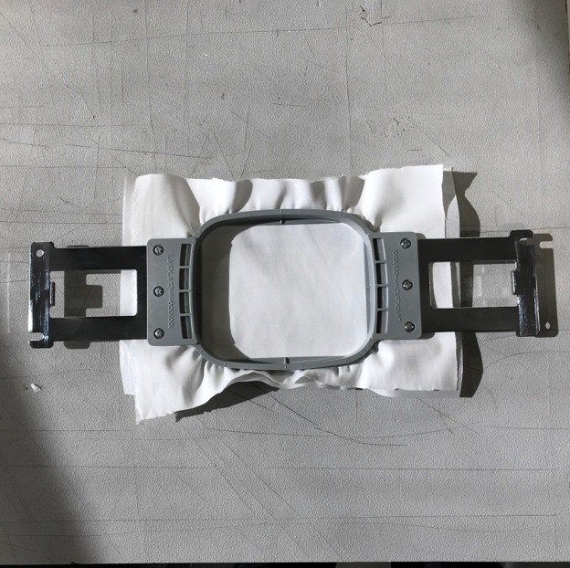
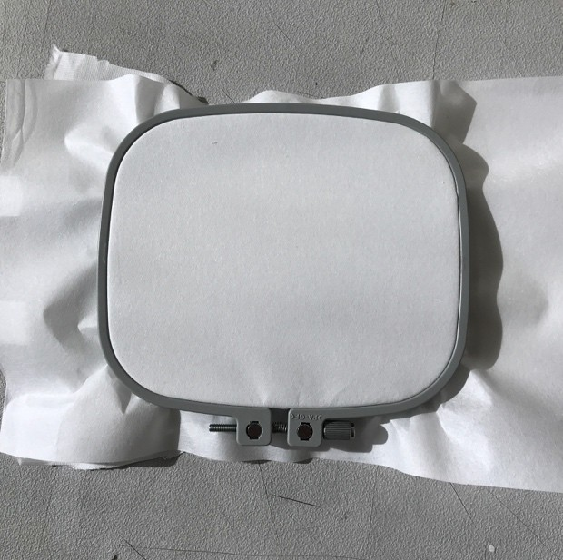
BOTTOM
TOP
Baby Lock guidance for fabric/stabilizer combinations.

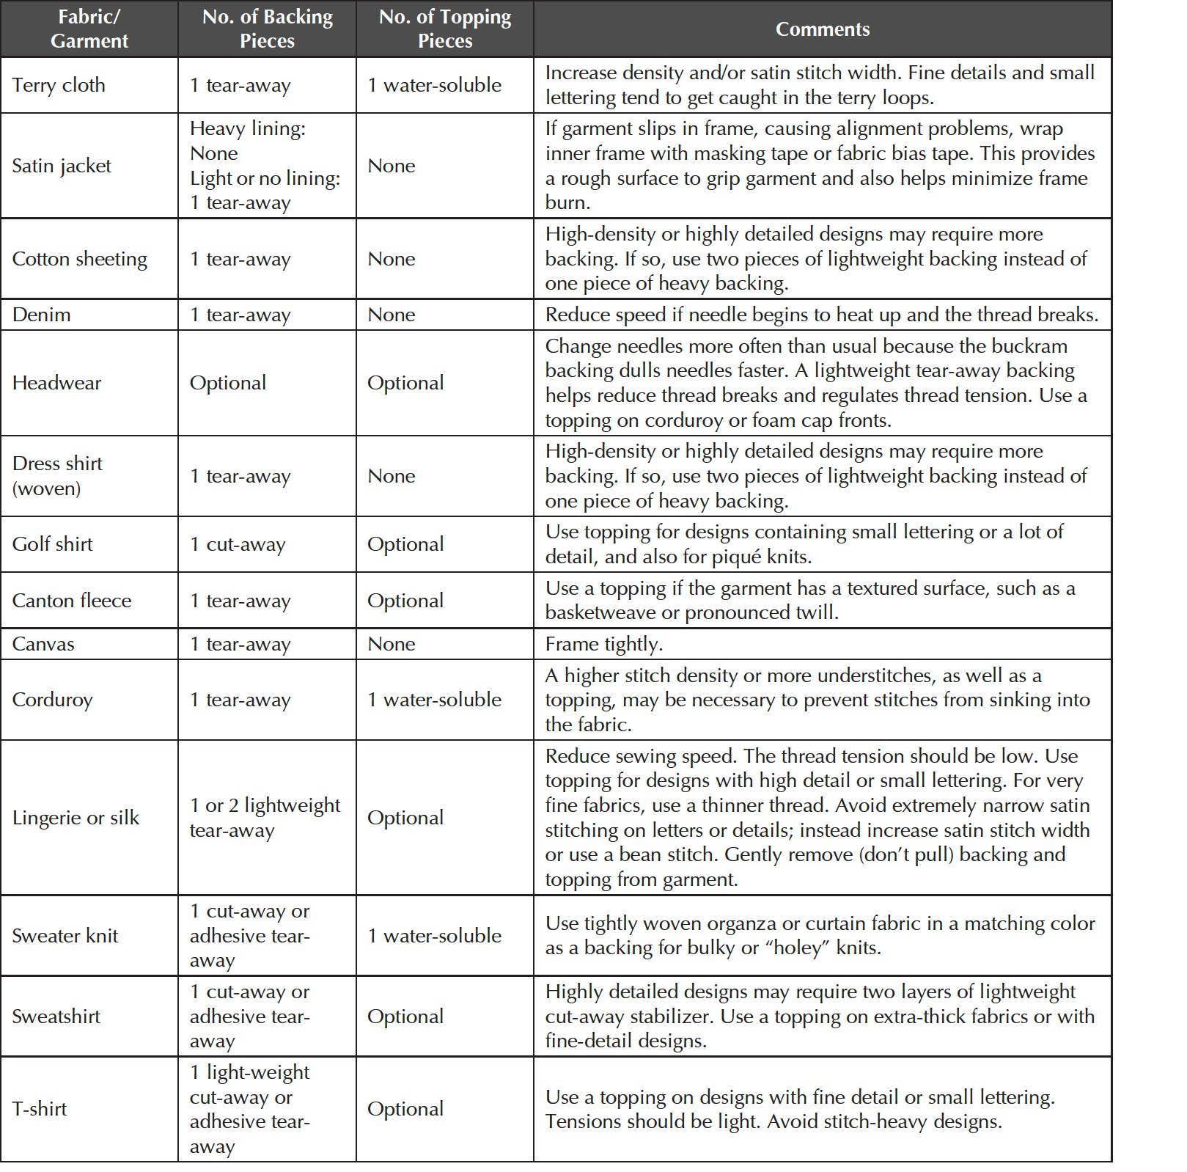

Placing your hope on the Baby Lock

The hoop should slide onto the machine and click into place. If there is excess fabric, position it so the fabric hangs off the front of the machine.

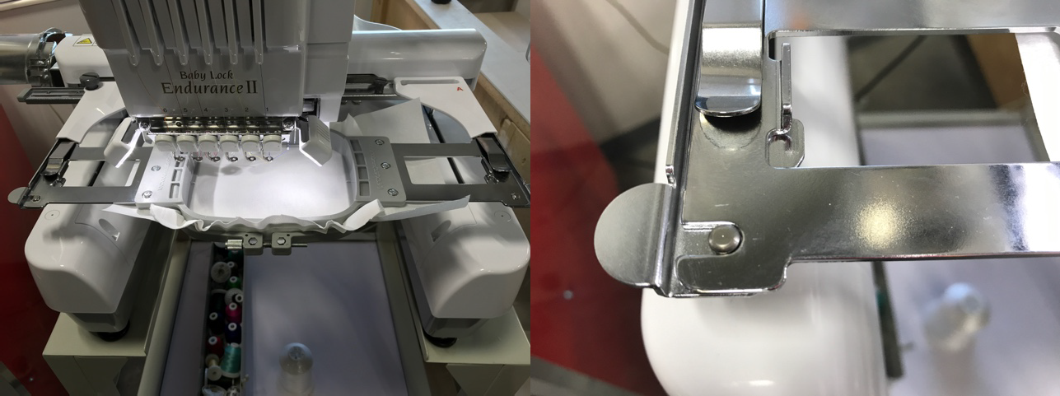
If you need to adjust the Baby Lock to accept a larger or smaller frame, loosen the two screws on the back left and slide the assembly to fit the frame. When you tighten those screws, hand tightening is sufficient.
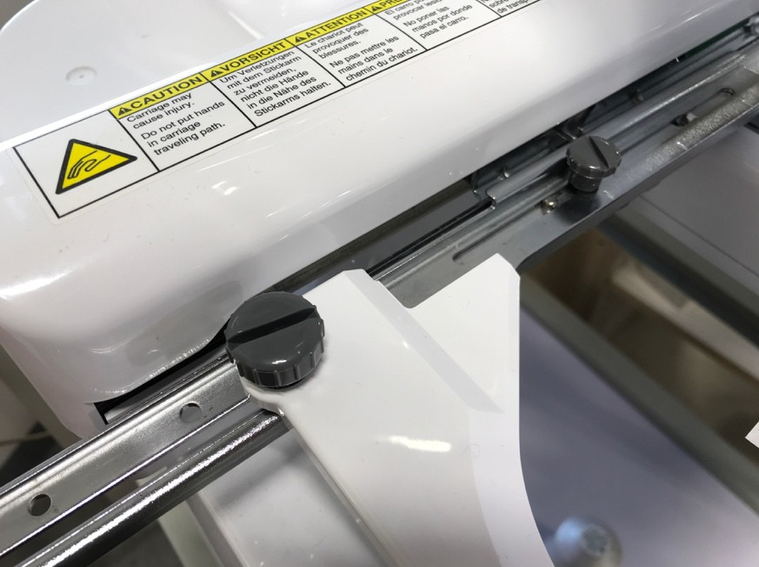
1
2
If your project is too big for the frame, you will receive a message telling you to “change to a larger frame.”

There is a limit to how much you can change the size of your project once you import it to the Baby Lock. You may have to change the size in the software and bring it back to the Baby Lock

HATS

To embroider hats, you need to change swap out the hoop assembly for the hat jig. To do that, you must first remove two screws on top toward the middle of the hoop holding.

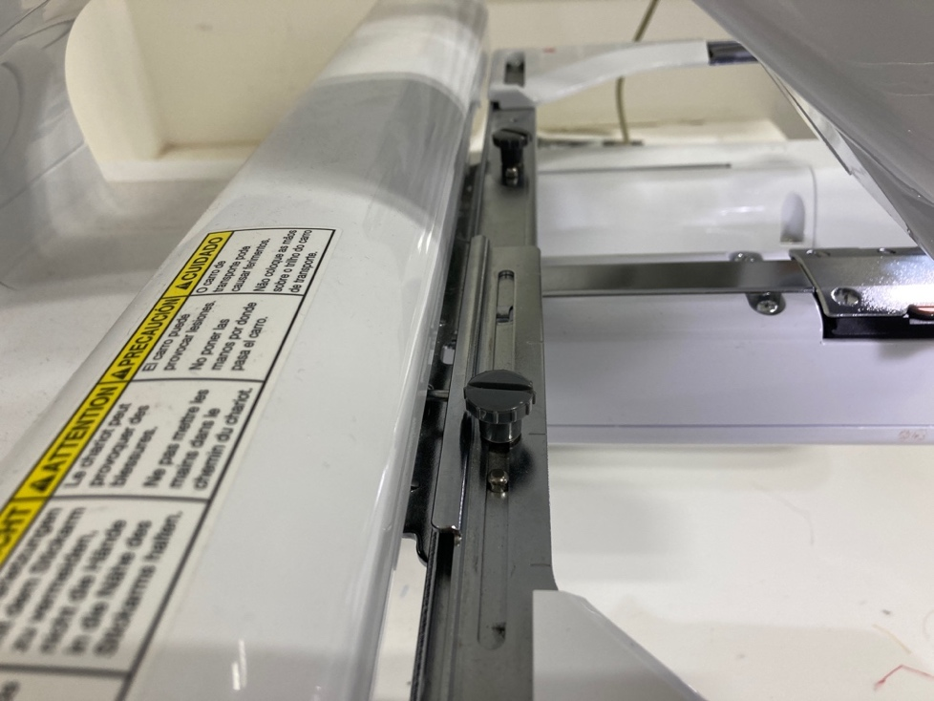

Set the screws aside. Then carefully remove the assembly by lifting it slightly above the pins holding it in place and pulling it toward you under the needles.

The hat jig is in the cabinet below the embroidery machine. Remove the two small screws from the center of the hat jig and set them aside.

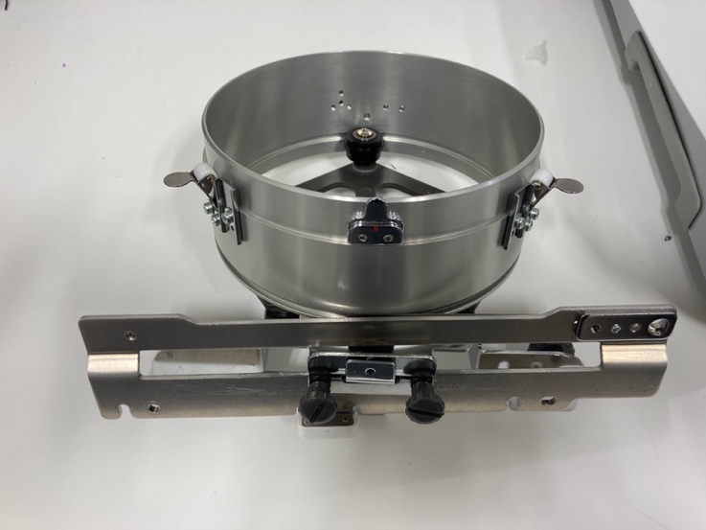
Remove these screws.

Slide the hat jig carefully under the needles. The metal bar on the hat jig slides just beneath the assembly and the hat jig fits over the pins. The screws go just to the right of each pin.

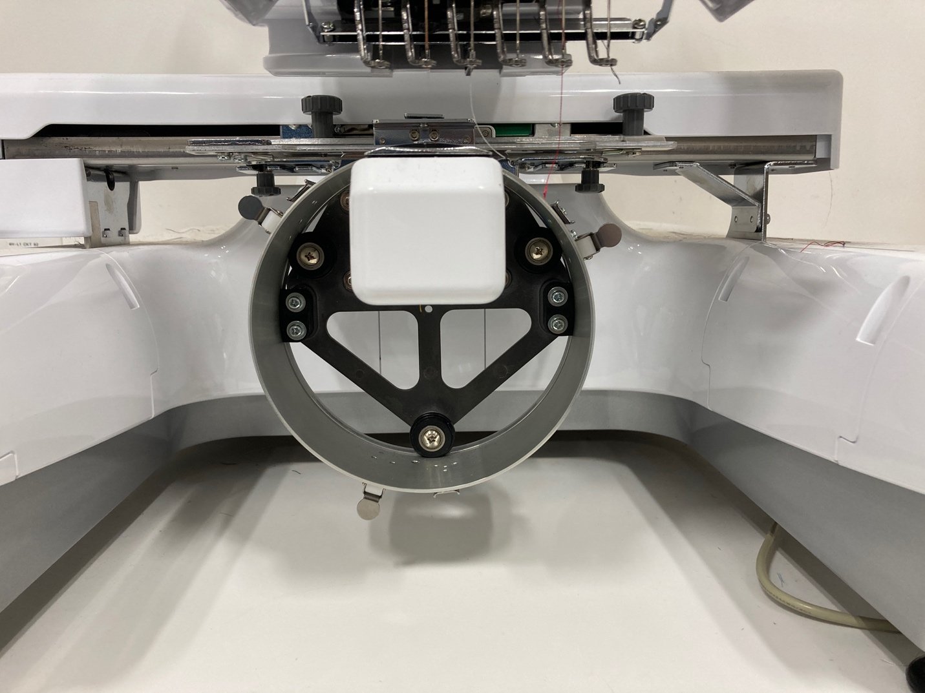

The screws you removed from the hoop holder are screwed onto the top of the hat jig, next to where the pins fit onto the assembly.

With the machine off, you should be able to push the hat jig back and forth smoothly. For an excellent video on attaching the hat jig and loading hats, click here


PUTTING YOUR CAP ON THE CAP FIXTURE

Unclamp the visor holder.
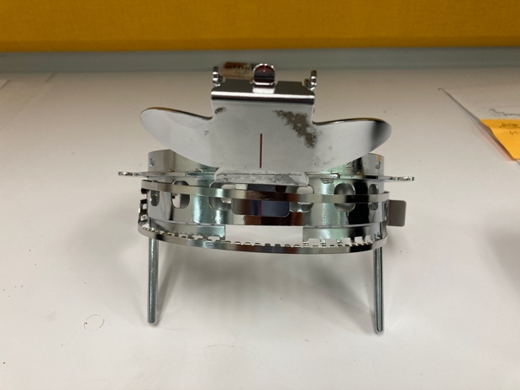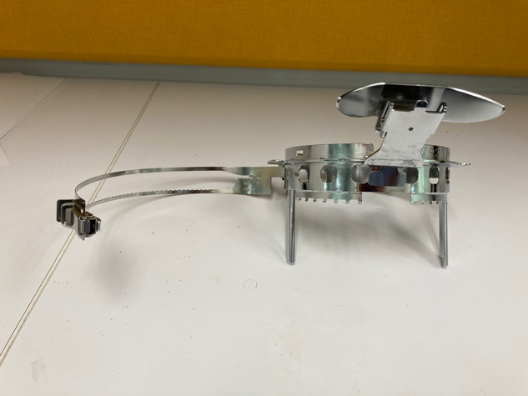

Unbuckle or unvelcro the back of the cap, which makes it easier to attach to the fixture. Flip down the sweat band.

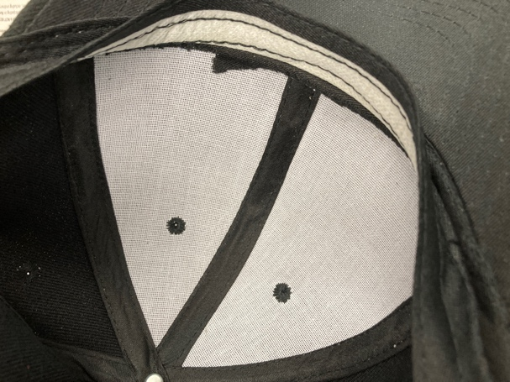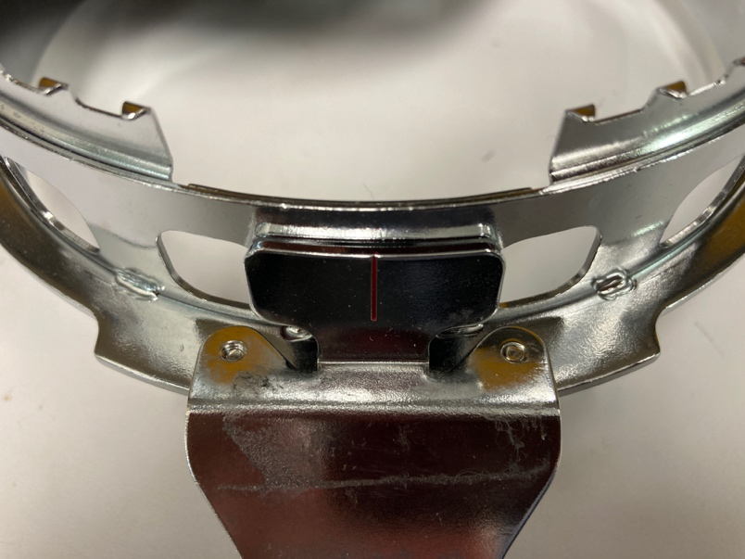

The sweat band should slide in the gap between the inside ring of the hat fixture and the tab with the red centering line.

Pull the cap down as low as it will go. Align the center of the cap with the center line on the visor holder and hook the latch without tightening it.

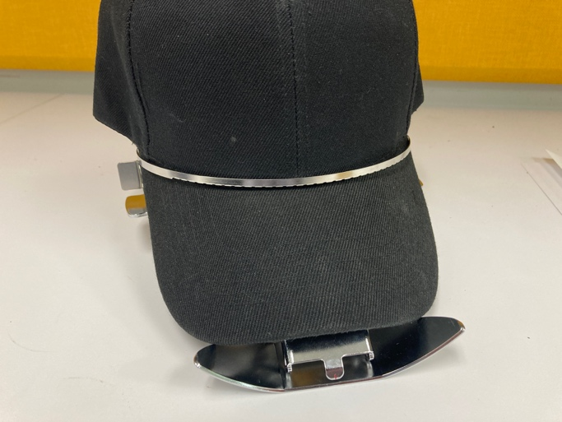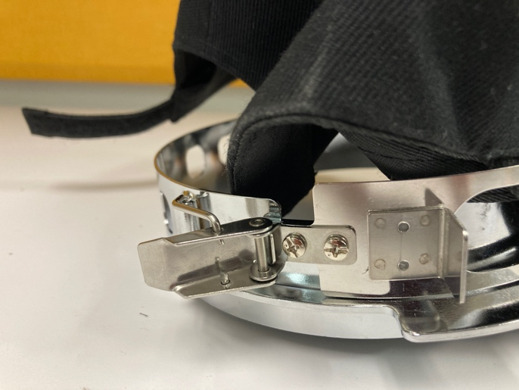

Flip the latch to tighten the hat onto the fixture. Flip the visor holder down. Now pull the lever on the side of the fixture tight.

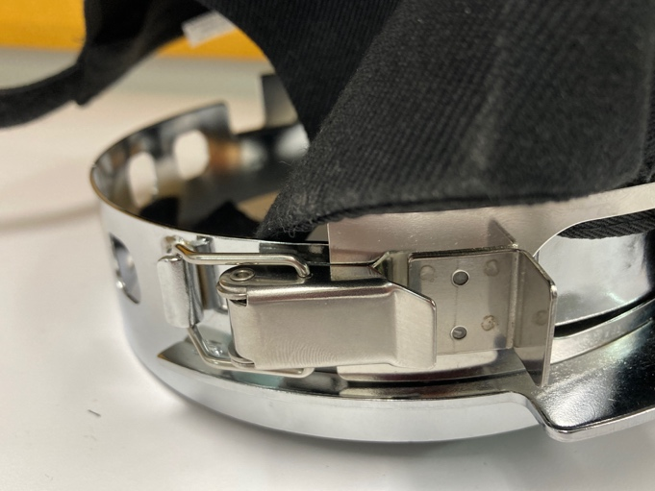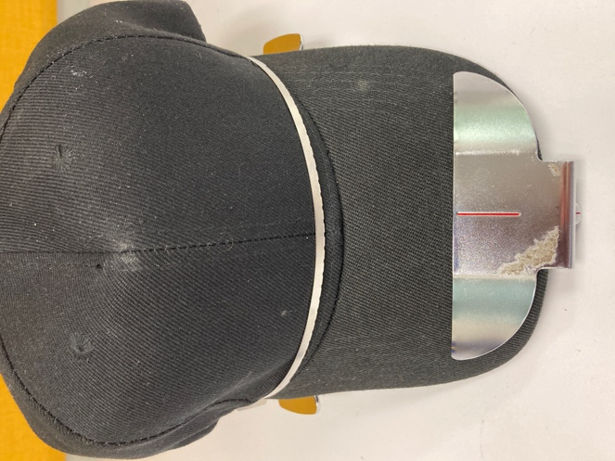

Make sure the cap is centered. Make sure the sweat band is not in the way. Your cap is now ready to attach to the embroidery machine.

You do not need stabilizer with caps.

Attach the hat assembly to the hat jig by turning it so the bill of the cap is to the right (or left) of the needle. Slip the hat under the embroidery machine and rotate the cap assembly so the bill is facing up. The small rectangular openings will slide under the white rollers and click into place.

White roller (there is another one is on the other side of the hat jig)

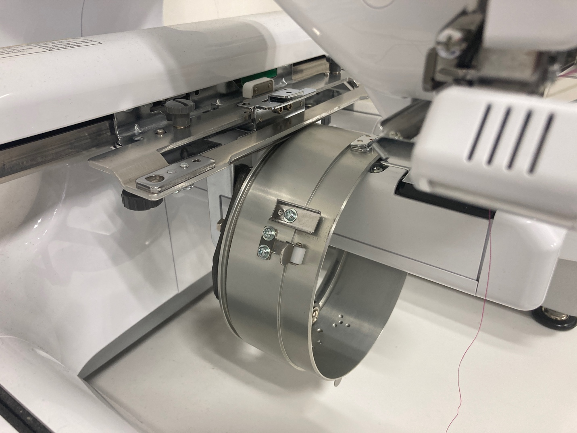

When you hit EDIT END on the control panel, your design will automatically flip upside down.

When you are done making hats, remove the hat jig and return the hoop assembly.

