SOP
CNC SHAPER ORIGIN
Training is required before using this equipment
Eye protection required

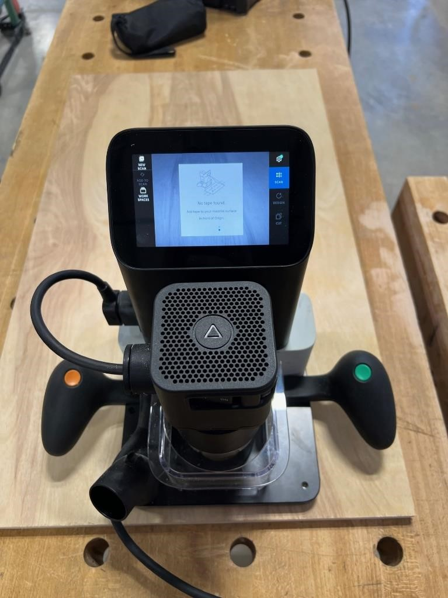

SHAPER ORIGIN COMPONENTS
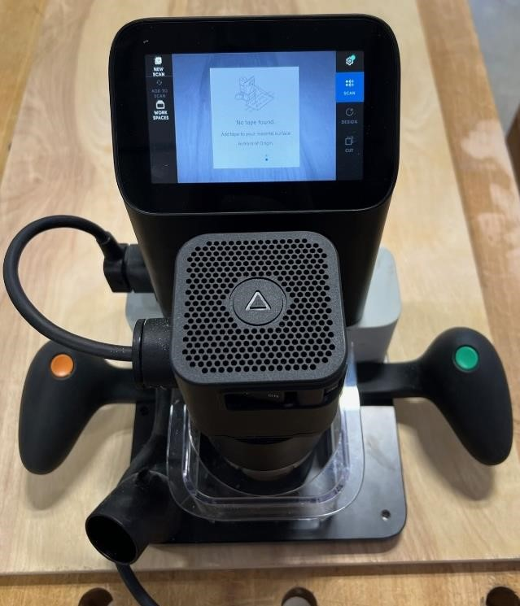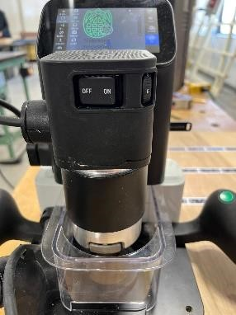

Cancel/Raise Bit

Screen Interface

Router Connection
Plug

Accept/Lower Bit

Vacuum Connection

Magnetic Dust Cover

Power On/Off

Router Speed

Adjustment

CONFIGURING YOUR FILE
- Create your design in illustrator.
  - Ensure your file is in vectors (stroke).
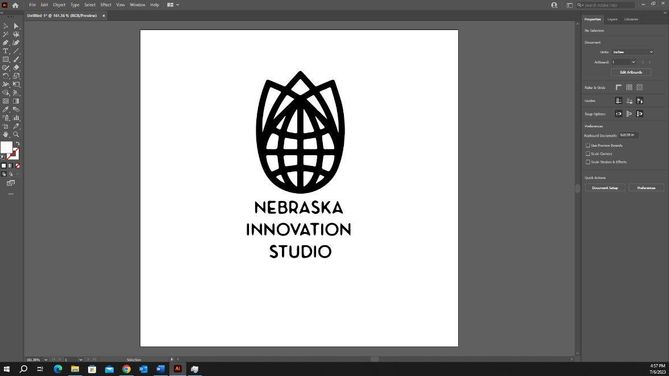

- Click on File in the top left of your screen.
- Click Save As.
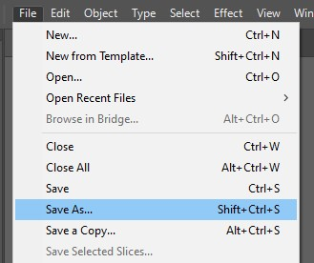

- Name your file.
- Click on the drop-down menu for ‘Save as type’.
  - Click on SVG.
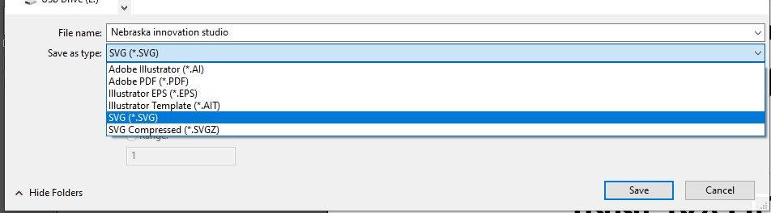

- An SVG Options menu will appear, click ‘OK’.
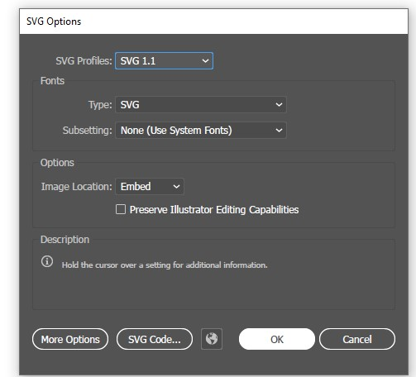
- Save your file onto your flash drive.

TAPING YOUR MATERIAL
- Take domino tape out of black bag.
  - The Shaper does not recognize incomplete dominos, only use full dominos when taping.
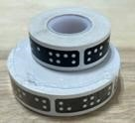
  - You will pay for each domino used. See staff for current pricing.

- The Shaper uses the dominos to recognize the cutting area. Place your dominos 4” in front of where you are wanting to cut.
- USE FULL DOMINOES ONLY
- Domino tape strips must be NO LESS than 4 dominos long.
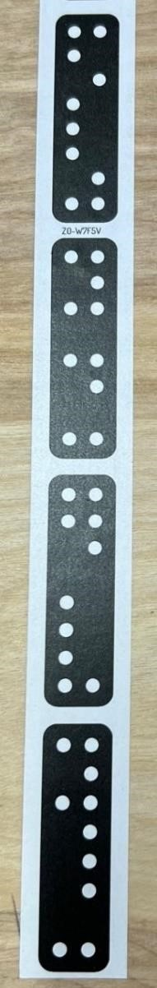

- Space each domino tape strip 4 inches apart.
  - A minimum of 2 strips is needed for Shaper to work properly. o Additional domino strips will be needed for larger designs.

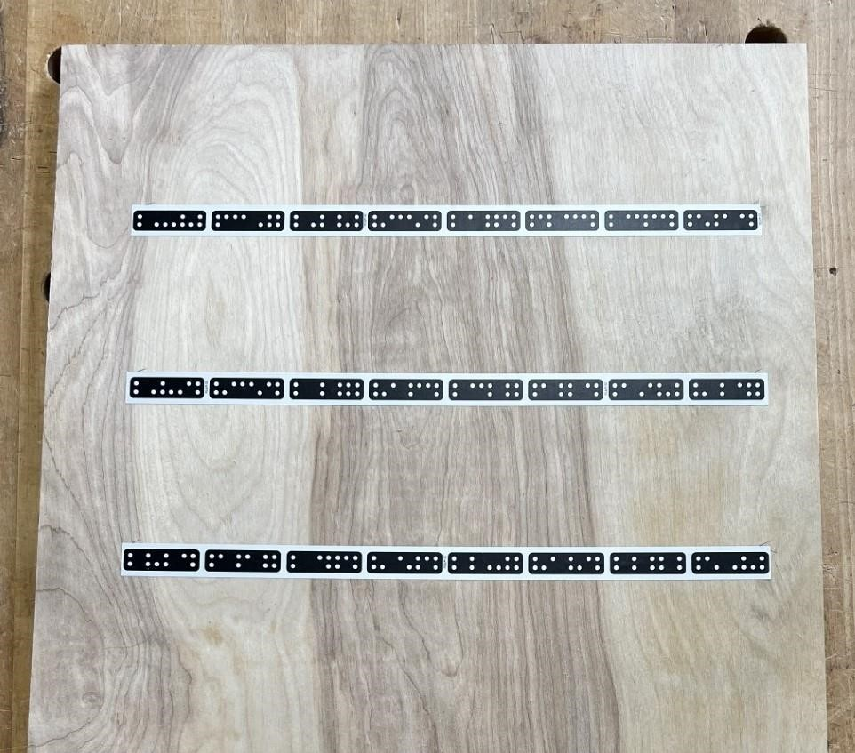

4
”

4
”

- When cutting on the x-axis domino strips must be laid out 4 inches in front of your cutting area.

INSTALLING PROBE BIT
ENSURE ROUTER IS DISCONNECTED FROM POWER SOURCE
SHAPER ORIGIN USES BITS WITH A 1/4” SHANK
- Grab open ended wrench and T wrench out of black Shaper Bag.
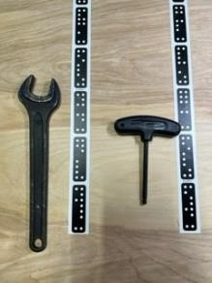

- Unplug router from chassis on left side of Shaper.
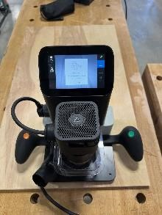

- Loosen allen screw with T wrench on right side of Shaper.
  - Do not remove screw, it should be loosened only.
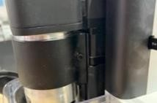
- Pull router out of chassis.
- Insert the 0.25” rod from the Shaper Bag.
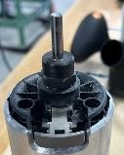
- Press and hold the grey button while tightening the nut.
  - The nut should be snug, do not over tighten.
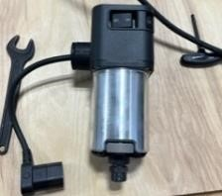

Grey Button

Nut

- Place the router into the chassis.
- Plug the cord into the Shaper chassis.

CREATING A NEW WORKSPACE
- Plug Shaper into hanging outlet.
- Select the ‘NEW SCAN’ icon on the top left of the display.
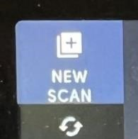
- Set the Shaper on your material.
o The Shaper should recognize your tape as a new workspace.
- Press the green button on the right handle of the Shaper.
- Move Shaper around until all the dominos you placed have turned blue and you can see your ENTIRE cutting area. o Your workspace will look similar to the image below.
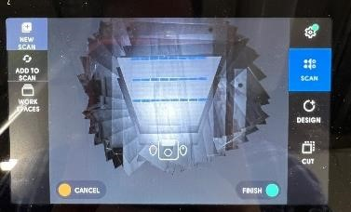

- Press the green button on the right handle once you have finished scanning your material and the dominos.

MAKING A GRID
The grid function will allow precise placement of designs on your material.
- Press the ‘GRID’ icon on the left of the screen. • Press the ‘NEW’ icon on the left of the screen.
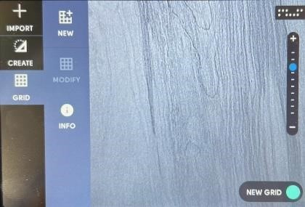

- Move Shaper slightly off your material.
- Press and hold the green button on the right handle until the bit will make good contact with the side of your material.
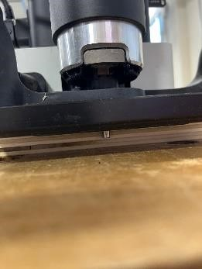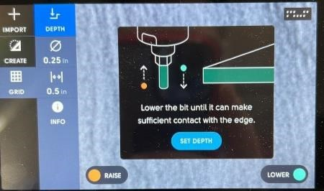

Bit should be low
enough to touch
side of material

- Press the blue ‘SET DEPTH’ icon on the screen when your depth is set.
- Move the Shaper to the bottom left of your material until the bit is touching the side of your material.
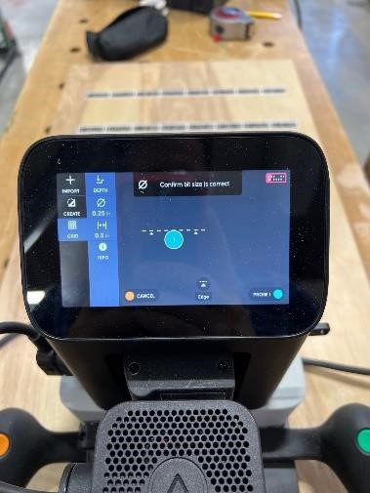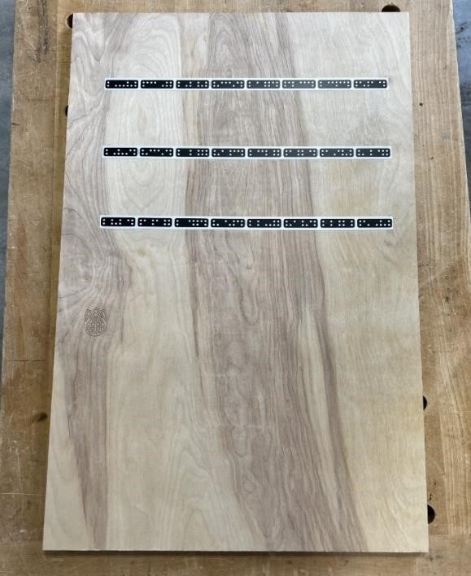
First probe
location

- Press the green button on the right handle to set the first probe.
- Move the Shaper to the bottom right of your material until the bit is touching the side of your material.
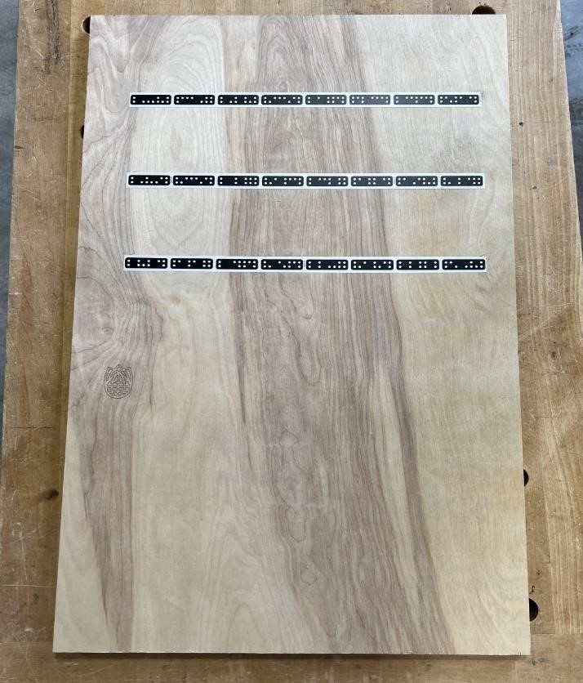

Second probe
location

- Press the green button on the right handle to set the second probe.
- Move the Shaper to the left side of your material until the bit is touching the side of your material.
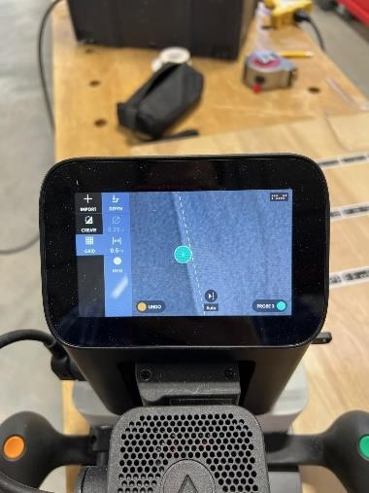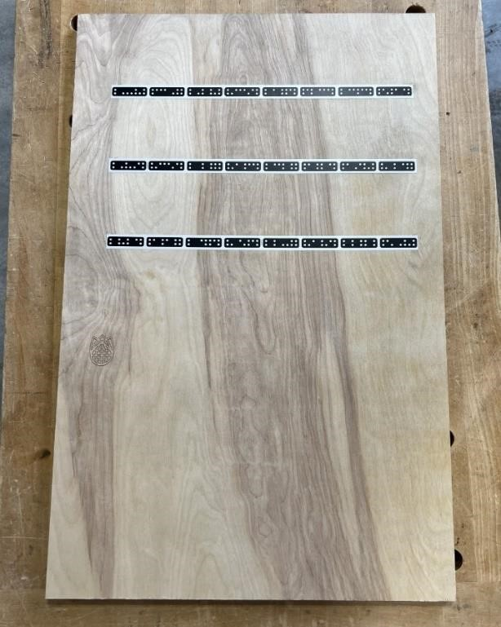

Third probe
location

- Press the green button on the right handle to set the third and final probe. o Your grid will appear and show your exact location on your material.
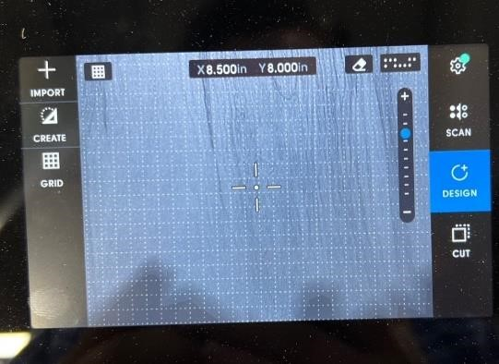
IF YOU MADE AN ERROR ON YOUR GRID, RESET AND START THE PROCESS FROM THE BEGINNING

PLACING DESIGN OBJECTS

IMPORTING YOUR DESIGN
- Place your flash drive into Shaper on the right side.
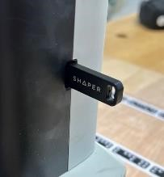

- Press the ‘IMPORT’ icon on the top left side of the screen.
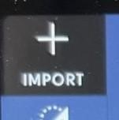

- Select your design from the menu.
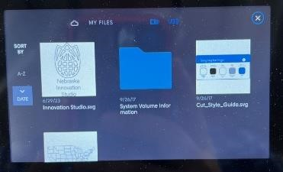

SCALING YOUR DESIGN
YOUR DESIGN WILL COME IN AS THE SIZE YOU CREATED IT
ONLY DO THIS IF YOU WANT TO CHANGE YOUR SIZING
- Press the ‘SCALE’ icon on the top left side of the screen to change the dimensions of your design.
- Press the ‘HEIGHT’ and ‘WIDTH’ icons to enter the correct size.
o Press the chain icon to allow individual scaling.
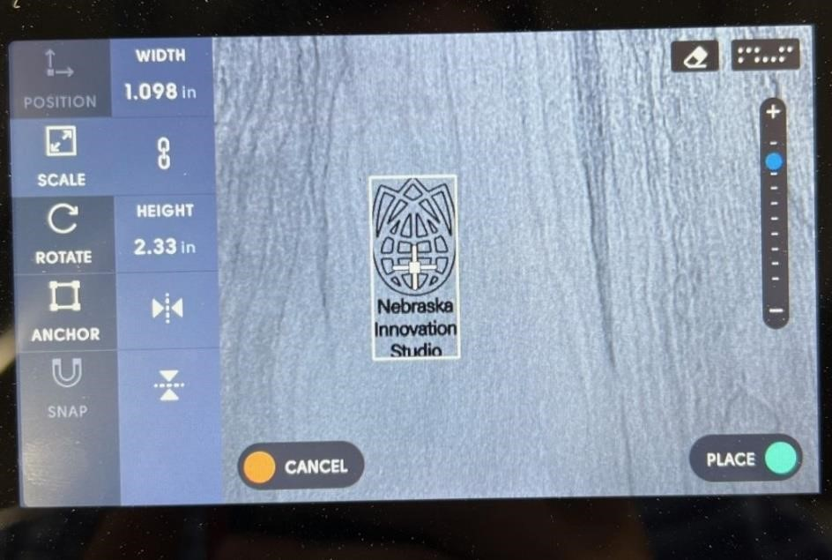

ROTATING YOUR DESIGN
• Press the ‘ROTATE’ icon to rotate your design on your workspace.
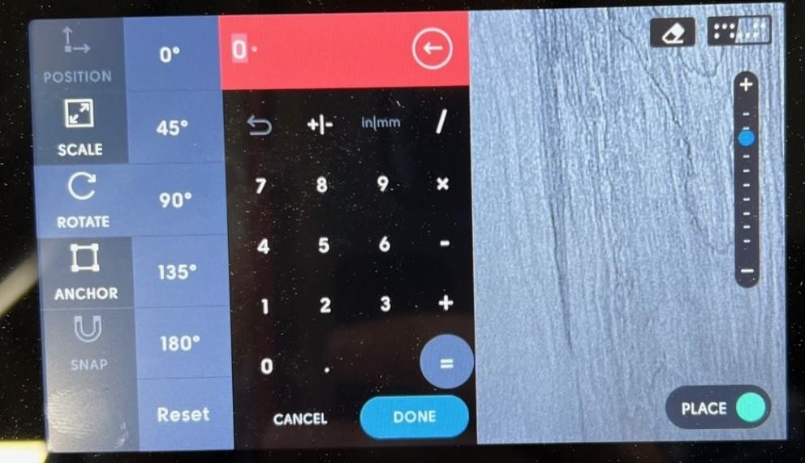

POSITIONING YOUR DESIGN
• Press the ‘POSITION’ icon on the left side of the screen to change the placement of your design.
o This will only be available after setting up a grid. o Your design will be centered at the coordinates selected.
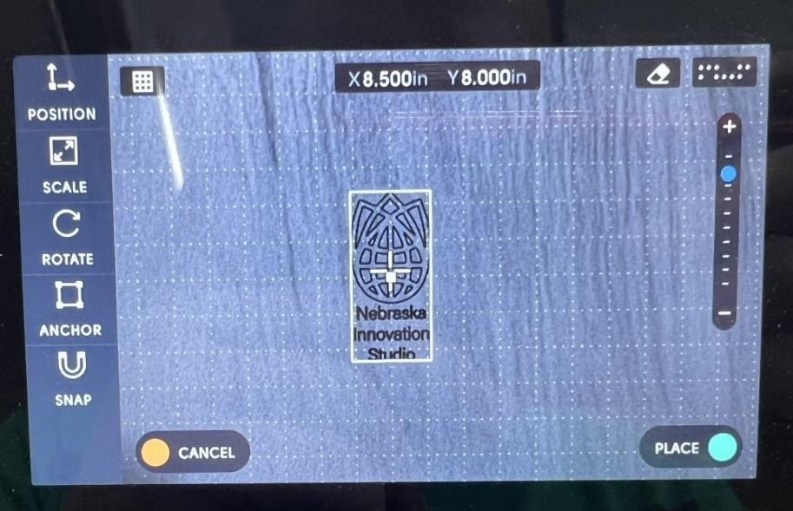

CREATING OBJECTS
CREATING OBJECTS IS USED IF YOU WANT TO DESIGN YOUR FILE ON THE SHAPER
IF YOU DESIGNED YOUR FILE USING A CAD SOFTWARE SKIP THIS STEP

CREATING A CIRCLE
- Press the ‘CREATE’ icon on the left of your screen.
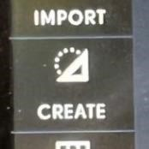
- Press the ‘CIRCLE’ icon.
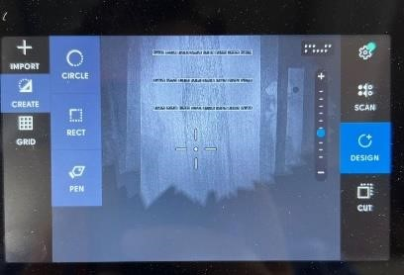

- Press the ‘DIAMETER’ icon to change the diameter of the circle.
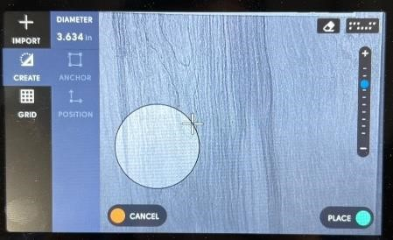
- Press the ‘POSITION’ icon to center your circle on a specific point. o This will only be available after setting up a grid.
- Press the green button on the right handle to place the circle onto the workspace.

CREATING A RECTANGLE
- Press the ‘CREATE’ icon on the left of your screen.
- Press the ‘RECTANGLE’ icon.

- Press the ‘HEIGHT’ and ‘WIDTH’ icons to change the size of the rectangle.
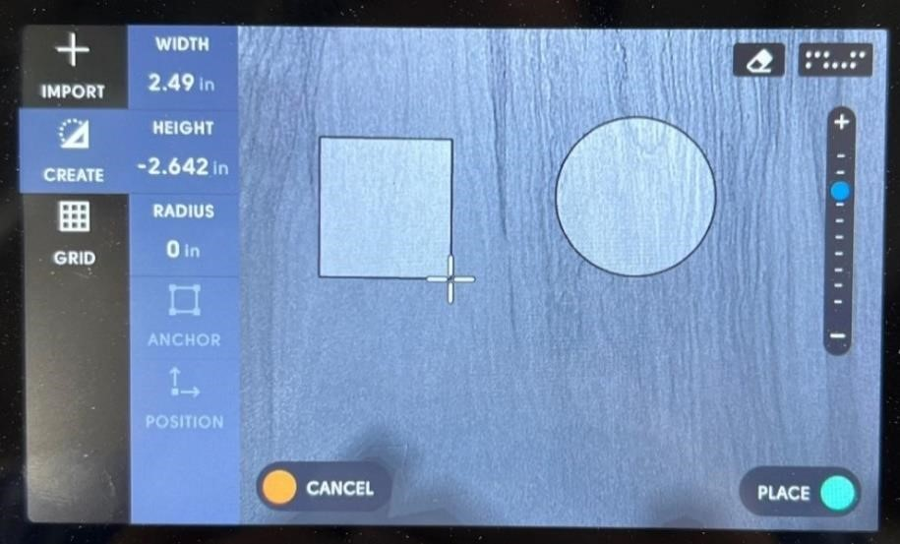
- Press the ‘POSITION’ icon to place your rectangle on a specific point.
o This will only be available after setting up a grid.
- Press the green button on the right handle to place the rectangle onto the workspace.

CHANGING ROUTER BIT
ENSURE ROUTER IS DISCONNECTED FROM POWER SOURCE
SHAPER ORIGIN USES BITS WITH A 1/4” SHANK
NIS DOES NOT SUPPLY ROUTER BITS
- Grab open ended wrench and T wrench out of black Shaper Bag.

- Unplug router from chassis on left side of Shaper.

- Loosen allen screw with T wrench on right side of Shaper.
  - Do not remove screw, it should be loosened only.
- Pull router out of chassis.
- Press and hold the grey button while loosening the nut with the wrench.
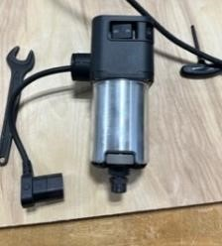

Grey Button

Nut

- Continue loosening by hand until reaching another tight spot.
- Loosen again with wrench and the bit should be free.
- Remove the 0.25” rod from the Shaper, if installed.

- Place your bit into router.
  - Ensure bit is inserted while still showing ¼” of the shaft.
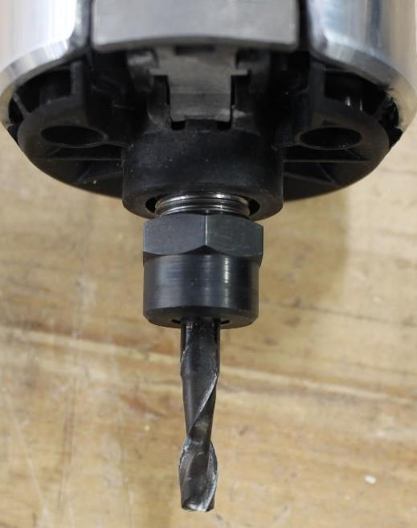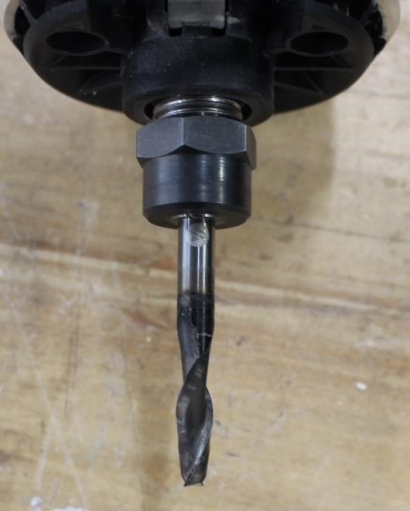
Bit is too far in

Bit is correct

- Press and hold the grey button while tightening the nut.
  - The nut should be snug, do not over tighten.

Grey Button

Nut

- Place the router into the chassis.
- Plug the cord into the Shaper chassis.

CUTTING YOUR DESIGN

SETTING YOUR Z AXIS
- Ensure the Shaper is placed fully on your material.
- Press the ‘CUT’ icon on the bottom right of the screen.
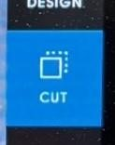

- Press the ‘Z-Touch’ icon on the left side of the screen.
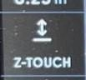

- Press the blue ‘AUTOMATIC’ icon.
o The machine will touch your material and set the Z axis.
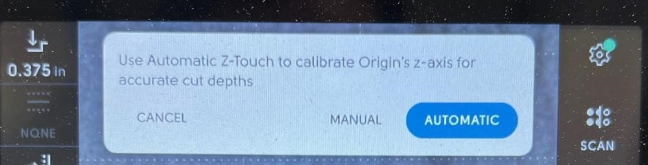

CHANGING CUT SETTINGS
- Set your cut depth by pressing the top left button.
  - Type in your desired depth or select a preset depth.
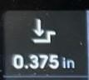
- Set your cut type by pressing the dotted square icon on the left.
  - Default is ‘ON LINE’ this is recommended for most engravings.
  - Inside and outside line will be used primarily when pocketing or cutting.


- Set your offset by pressing the third icon.
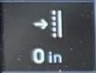

- Set the diameter of your bit by pressing the crossed-out circle icon.
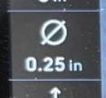
- DO NOT CHANGE THE SPEED SETTINGS
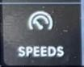
  - The normal settings are Plunge 15 and Auto 10. If they are different change them to be the standard settings.

CUT YOUR DESIGN
READ SECTION FULLY BEFORE PROCEEDING
- Plug Festool vacuum into hanging outlet.
- Connect Festool vacuum to the Shaper and turn the vacuum to manual.
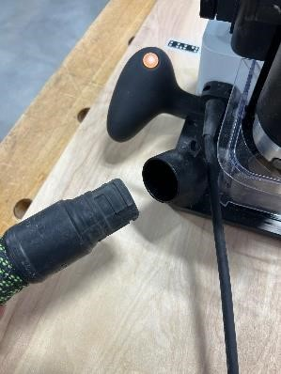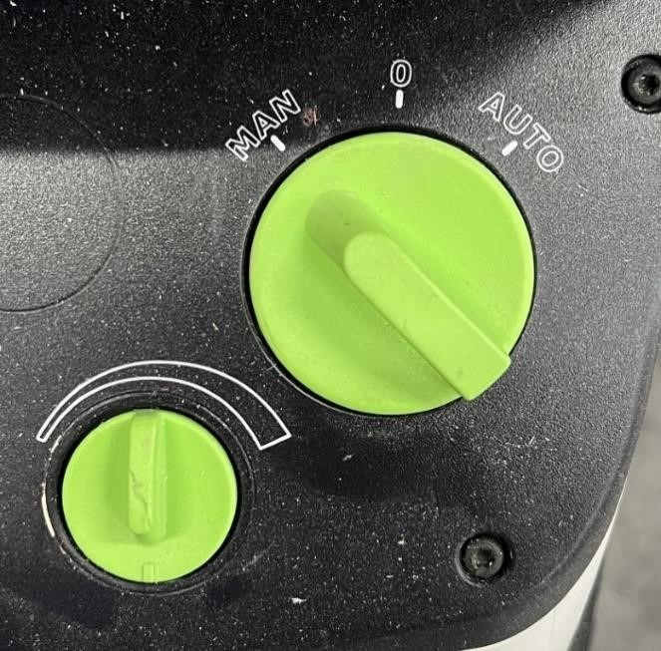
- Move Shaper over one of the lines you want to cut.
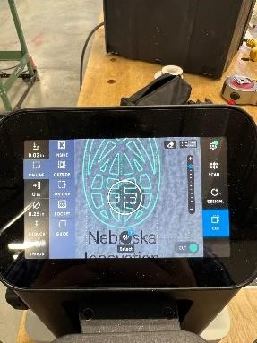
- Ensure magnetic dust collection cover is on.
- Turn the router on by pressing the ON switch on the router.

Power On

Dust
Collection

- Press the green button on the right handle to start your cut.
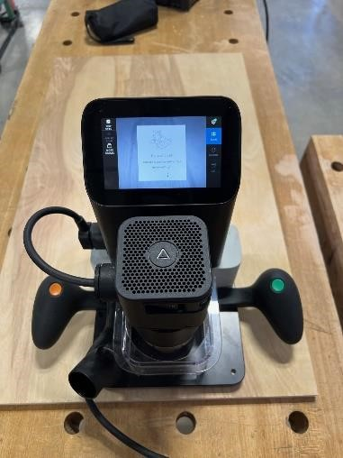

Green Button

- Move the router along the line displayed on the screen.
  - Hold the green button on the right handle for automatic movement.
- Keep router facing your domino tape strips.
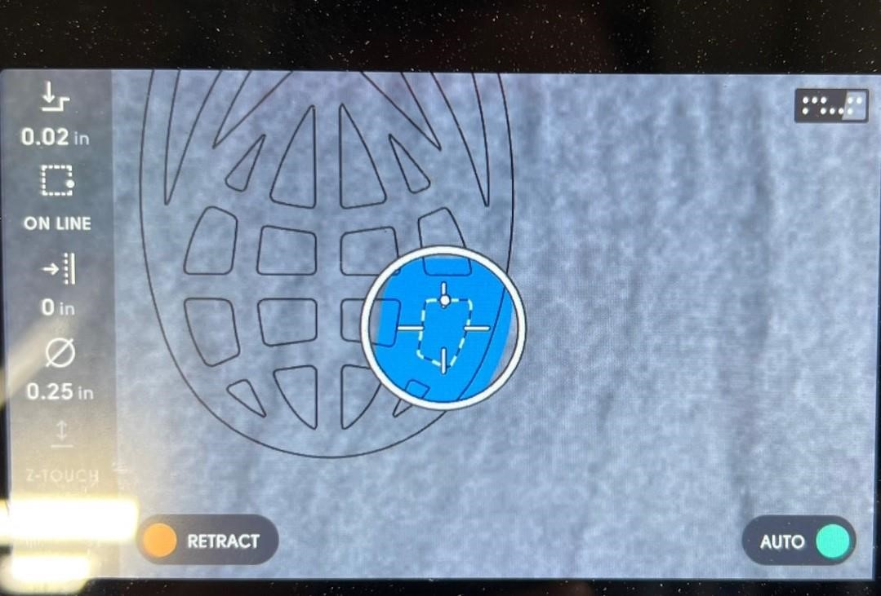

- Keep the white dot near the middle of the circle displayed on Shaper. o When the dot is near the edge an arrow will appear, move in the direction of the arrow.
  - Your design will turn blue when the line has been cut.
  - Continue cutting your lines until all lines have been cut.
- Press the orange button on the left handle when finished with your cut to retract the router.

Orange Button

- Press the off switch to turn the router off when finished.
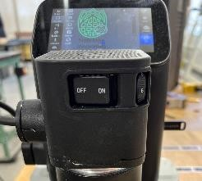

Power Off

- Turn the vacuum to O.
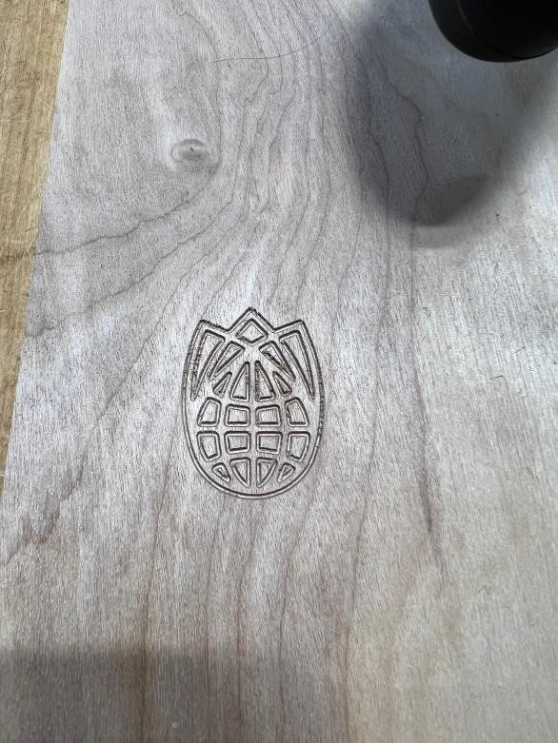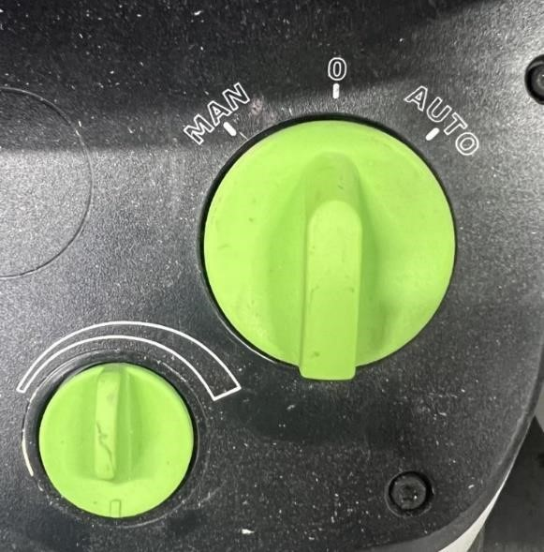

REMOVING ROUTER BIT
ENSURE ROUTER IS DISCONNECTED FROM POWER SOURCE
- Grab open ended wrench and T wrench out of black Shaper Bag.

- Unplug router from chassis on left side of Shaper.

- Loosen allen screw with T wrench on right side of Shaper. o Do not remove screw, it should be loosened only.
- Pull router out of chassis.
- Press and hold the grey button while loosening the nut with the wrench.

Grey Button

Nut

- Continue loosening by hand until reaching another tight spot.
- Loosen again with wrench and the bit should be free.
- Place the router into the chassis.
- Plug the cord into the Shaper chassis.

CLEANUP
- Vacuum your work area including table and floor.
- Clean the Shaper of all saw dust using vacuum and air gun.
- Put away all tools used.
- Place the Shaper Origin in its storage container.
- Ensure that all cords, wrenches, domino tape, and probe are in the storage container. • Place storage container in wood shop closet.

SOP
CNC SHAPER ORIGIN
OPERATOR MANUAL
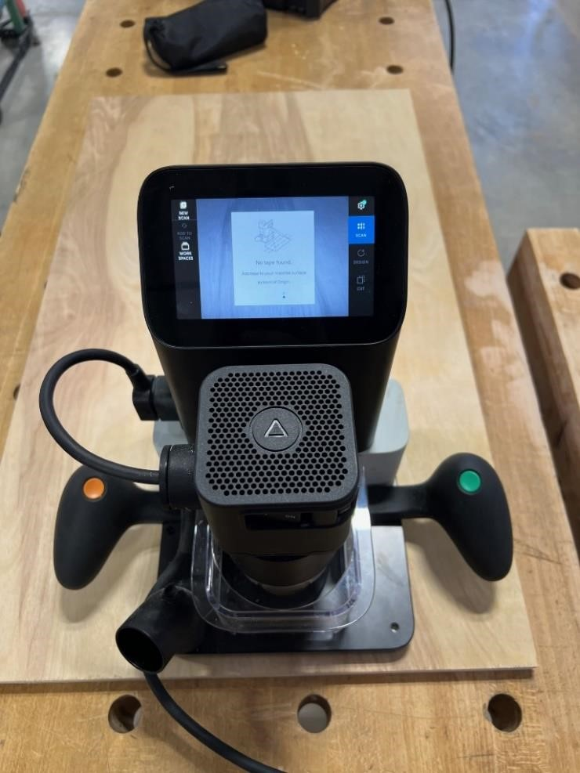
Nebraska Innovation Studio


