SOP

Belt Sander

Training is required before using this equipment

Closed Toed Shoes required Eye Protection required No Loose clothing No loose jewelry Long hair tied back

Dust mask recommended

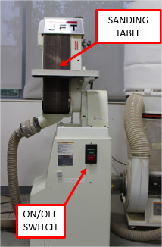
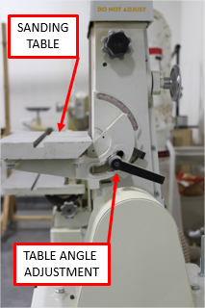
BELT SANDER COMPONENTS

There are 3 knobs located on the top, side and back of the belt sander marked “DO NOT ADJUST”. Do not adjust, turn or rotate these knobs.

These knobs are for NIS staff use only.

PRE-SANDING CHECKLIST

• Manually rotate the belt, checking for rips, tears, holes, or fraying of the belt. • Check that the belt is tensioned correctly. The belt should not make contact
with the sanding bed when rotated manually, nor should it “bubble” away from the sander.
• There should be a constant 3/32” gap between the belt and the sanding bed.
• The top guard should be securely in place and not contacting the sanding belt.

If any of these items do not pass inspection contact an NIS staff person before operating the equipment.

OPERATING THE BELT SANDER

Step 1: TILTING THE SANDING TABLE

The table can tilt from 0° to 45° downward by using the locking handle on the side of the table.
There are two positive lock stop positions: one at 0°, (or at 90° from the belt) and at 45° downward.

To Tilt the Belt Sander Table:

• Turn off the sander.
• Unlock the locking handle on the side of the table by rotating it counterclockwise. Note that the stop handle is spring loaded to allow you to loosen the handle enough to move the table.
• Slightly lift up on the sanding table and flip the stop bracket out to allow the table to rotate downward past the stop block.
• Using the pointer scale set the table to the desired angle. • Lock the handle in place by rotating it clockwise.

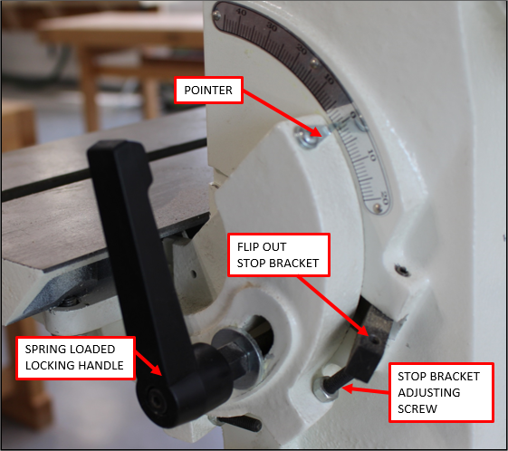
The sanding table can only be adjusted downward. You cannot adjust the sanding table upward.

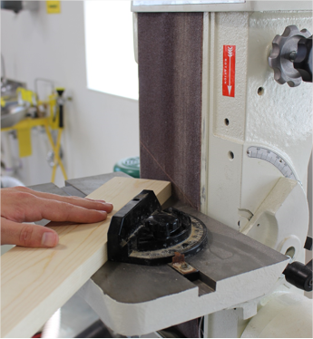
Step 2: USING THE MITER GAUGE

The miter gauge can be used to sand specified angles on your workpiece. The miter gauge, when used alone, will allow you to sand a miter angle on your workpiece. If you tilt the table and use the miter gauge you will be able to sand compound angles.

The miter gauge is stored on the side of either the belt or disc sander.

Step 3: TURN ON THE DUST COLLECTOR

The dust collector designated for the belt sander is also connected to the disc and spindle sanders. The ON/OFF switches are located at the base of the dust collector.

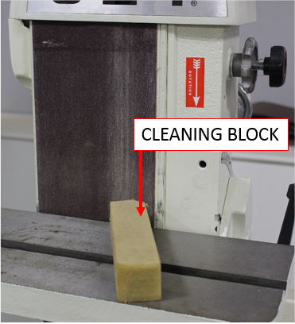
Step 4: TURN ON THE BELT SANDER

• Stand in front of the belt sander. Make sure your material is not contacting the belt before it is powered on.
• Make sure that you do not have loose clothing, hoodie strings, scarves, or any other loose or dangling items that could get caught in the belt sander.
• Notice the rotation indicator. The sander is designed to aid in holding your material down onto the sanding table.

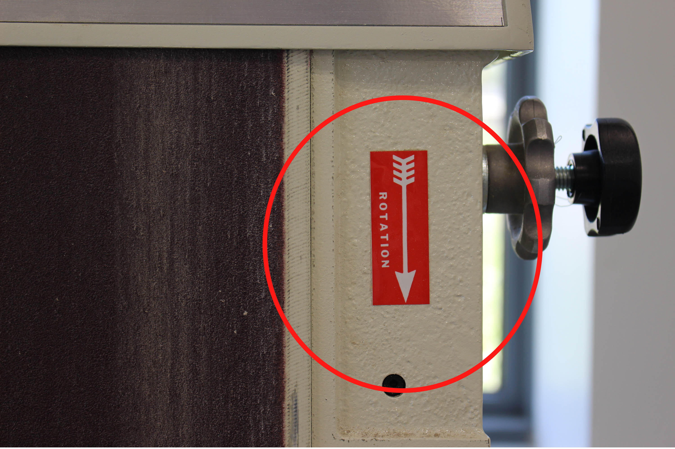
• Turn on the belt sander. If you hear grinding noises or it seems the belt is not traveling correctly turn off the belt sander immediately and contact NIS staff.
• After the motor has come up to operating speed, check the belt for wobble, runout, or any other unbalanced condition. Also check that the belt is tensioned correctly at operating speed. If any of these conditions are not met immediately shut off the sander and contact NIS staff.
• If the belt is filled with sanding dust use the cleaning block to clean the belt by resting it firmly on the sanding table and slowly moving the cleaning block into the belt.

• Slowly present your material to the sanding belt. Make sure that your material is held firmly against the sanding table and you use a slow and steady motion when approaching the belt.

Step 5: CLEANUP

• Use the cleaning block to remove debris from the belt.
• Clean up any sawdust or debris from the floor and the machine with a vacuum.
• Put away the miter gauge or any other tools you used. • Turn off the dust collection system.

